2016 Residential Lighting Report

Results of a lighting audit of 180 Australian homes

July 2016

This work is licensed under the Creative Commons Attribution 3.0 Australia Licence. To view a copy of   
this license, visit [the creative commons website.](http://creativecommons.org/licences/by/3.0/au)

The Department of Industry, Innovation and Science on behalf of the Equipment Energy Efficiency   
Program asserts the right to be recognised as author   
of the original material in the following manner:



© Commonwealth of Australia (Department of   
Industry, Innovation and Science) 2016.

material in this publication is provided for general The information only, and on the understanding that the Australian Government is providing professional advice. Before any action or decision is taken on the basis of this material the reader should obtain appropriate independent professional advice.

This document is available at [the Energy Rating website.](http://www.energyrating.gov.au)

While reasonable efforts have been made to ensure that the contents of this publication are factually correct, E3 does not accept responsibility for the accuracy or completeness of the content, and shall not be liable for any loss or damage that may be occasioned directly or indirectly through the use of, or reliance on, the contents of this publication.

Contents

Contents iii

Executive Summary 10

Background 10

Study Objectives 10

Project Scope and Methodology 10

Key Results 12

Comparison with 2010 Audit 17

Conclusions 21

1. Introduction 23

Background 23

Study Objectives 2

Project Tasks and Outputs 3

Acknowledgements 3

2. Methodology 1

Introduction 1

Methodology Overview 2

Sample Households 3

Household Recruitment and Demographics 3

Balancing the Household Sample 4

Householder Questionnaire 5

Use of Lighting 5

3. Overall Results 7

Key Findings 7

Whole House Overview 8

Technology Overview 10

Frequency Distributions of Key Parameters 15

Fixed and Plug-in Lamps 21

Overall Lighting Efficacy 21

Comparison by Region 25

4. Detailed Results by Room Type 30

Overview 30

Living 33

Living Areas - Key Parameters 33

Living Areas - Frequency Distributions 34

Sleeping 39

Indoor-other 40

Outdoor 41

5. Detailed Results by Technology 42

Overview 42

Incandescent 43

Halogen 43

Compact Fluorescent 45

Linear Fluorescent 46

LED 47

Other lighting technologies 49

Cap types, lighting technology and fittings 50

Lamp shapes 55

Number of lamps blown or no lamp present 55

6. Lamp Usage Data 57

Overview 57

Usage results 58

7. Other Data 67

Overview 67

Fixed and plug-in lamps 67

Number of switches and lamps per switch 69

Motion sensors 70

Dimmers 71

Heat lamps 75

House ceiling height and air volume 75

8. Comparison with the 2010 Audit 77

Overview 77

Sample Comparison 77

Recruitment 77

Sample Size 78

Housing stock characteristics 79

Lighting Comparison 80

Overview 80

Lamp Count 82

Differences in lighting parameters 83

Differences in recording usage 86

Other parameters 87

9. References 88

Appendix A: Detailed Methodology 89

Classification of Rooms 89

Classification of Lamps 91

Fitting and Connection Classification 91

Lamp Technology Classification 93

Notes and assumptions during audits 95

Assumed Efficacy Values by Technology 97

Data Validation 101

Appendix B: Sample Weighting 102

Appendix C: Householder Questionnaire Results 104

Introduction 104

Results 104

Demographics 104

Changes to lighting 108

Lighting preferences 111

Selected comments by householders and auditors 117

Householder comments 117

Auditor comments 118

Appendix D: Household Questionnaire Survey Instrument 121

Appendix E: Sample Household Audit Reports 130

APPENDIX F: LIGHTING FIELD GUIDE

List of tables

Table 1: Average House Summary – key characteristics 12

Table 2: Summary of dimmers and lamps in 2016 audit 17

Table 3: Average House Summary – key characteristics 9

Table 4: Average House Summary – room type characteristics 10

Table 5: Average House Summary - lamp number and characteristics by technology 14

Table 6: Share of house type by region from the 2011 census 25

Table 7: Headline parameters by region from the 2016 lighting audit (unweighted) 26

Table 8: Headline parameters by region from the 2016 lighting audit (weighted by region) 26

Table 9: Indoor parameters by region (unweighted) 26

Table 10: Indoor parameters by region (weighted by region) 27

Table 11: Share of lighting technologies by region (unweighted) 27

Table 12: Share of lighting technologies by region (weighted by region) 27

Table 13: Lighting efficacy by region 28

Table 14: Impact of lighting replacement programs and lighting renovations 28

Table 15: Key lighting parameters by location 31

Table 16: Average House Summary - lamp number and characteristics by technology and location 32

Table 17: Share of houses by lamp count per house by lighting technology 42

Table 18: Detailed results – incandescent technology 43

Table 19: Detailed results – mains voltage halogen technology 44

Table 20: Detailed results – extra low voltage halogen technology 44

Table 21: Detailed results – compact fluorescent technology (integral lamps) 45

Table 22: Detailed results – compact fluorescent technology (separate lamps) 46

Table 23: Detailed results – straight linear fluorescent technology 47

Table 24: Detailed results – circular linear fluorescent technology 47

Table 25: Detailed results – LED directional (mains voltage) 48

Table 26: Detailed results – LED directional (extra low voltage) 48

Table 27: Detailed results – LED non-directional 49

Table 28: Detailed results – heat lamps 49

Table 29: Detailed results – cannot identify low efficacy 50

Table 30: Detailed results – cannot identify high efficacy 50

Table 31: Identified cap types by lamp technology 51

Table 32: Share of identified cap types by lighting technology 52

Table 33: Identified cap types by lamp fitting type 53

Table 34: Count of lamp fitting type by lighting technology 54

Table 35: Summary of lamp shapes by lighting technology 55

Table 36: Missing or blown lamp - number by space 56

Table 37: Average House Summary – usage distribution by technology: whole house (unweighted) 59

Table 38: Average House Summary – usage distribution by technology: whole house (weighted) 60

Table 39: Average House Summary – usage distribution by technology: living areas (weighted) 61

Table 40: Average House Summary – usage distribution by technology: sleeping areas (weighted) 62

Table 41: Average House Summary – usage distribution by technology: indoor other areas (weighted) 63

Table 42: Average House Summary – usage distribution by technology: outdoor areas (weighted) 64

Table 43: Number of fixed and plug-in lamps by technology and location 68

Table 44: Number of switches and lamps per switch by technology (weighted) 70

Table 45: Sensor switches by location 71

Table 46: Lamps controlled by sensor switches by technology (unweighted) 71

Table 47: Summary of dimmers and lamps in 2016 audit 72

Table 48: Average House Summary - dimmer location and number of lamps per dimmer 73

Figure 36: Distribution of lamps per dimmer for ELV technologies 74

Table 50: Summary of indoor floor area, volume and ceiling height by location 76

Table 51: Sample composition for 2010 and 2016 audits 78

Table 52: Census 2011 breakdown of house type by audit region 79

Table 53: Comparison of indoor house floor area for 2010 and 2016 audits 79

Table 54: Changes in indoor house floor area between 2010 and 2016 audits 79

Table 55: Share of lighting technologies in 2010 and 2016 81

Table 56: Comparison of lamp counts for 2010 and 2016 audits 83

Table 57: Changes in lamp counts between 2010 and 2016 audits 83

Table 58: Assumed 2010 efficacy by technology and revised values for comparison 86

Table 59: Changes in other lighting parameters between 2010 and 2016 audits 87

Table 60: Fitting and connection classification and identification notes 91

Table 61: Technology type, cap, transformer and identification 93

Table 62: Lamp shape and identification notes 95

Table 63: Factors used to estimate lamp efficacy 98

Table 64: National sample characteristics before and after weighting 103

Table 65: Question 14a – how often do you adjust the light level using dimmers? 112

Table 66: Question 14c – types of lamps found to not work with dimmers 112

List of figures

Figure 1: Share of lamp technology (count) in an average house 13

Figure 2: Overview of key parameters for lighting in Australian homes in 2016 14

Figure 3: House floor area versus total house lighting use weighted efficacy 15

Figure 4: Average usage per lamp per day by lighting technology 16

Figure 5: Share of lighting technologies in 2010 and 2016 18

Figure 6: Imports of different lamp types from 2002 to 2015 19

Figure 7: Estimated changes in lighting energy consumption from 2010 to 2016 20

Figure 8: Share of useful light output by technology in 2010 and 2016 20

Figure 9: Overview of key parameters for lighting in Australian homes in 2016 11

Figure 10: Share of lamp technology (count) in an average house (weighted) 12

Figure 11: Share of lamp power in an average house (weighted) 13

Figure 12: Share of lamp light output (lumens) in an average house (weighted) 13

Figure 13: Distribution of total lamps per house for all houses 15

Figure 14: Distribution of total indoor rooms for all houses 16

Figure 15: Distribution of total indoor floor area for all houses 16

Figure 16: Distribution of total indoor power density for all houses 17

Figure 17: Distribution of total lumens for all houses 18

Figure 18: Floor area versus total power – all houses 19

Figure 19: Floor area versus total lumens – all houses 19

Figure 20: Average house – indoor lighting density 20

Figure 21: House floor area versus total house average lighting efficacy 22

Figure 22: House floor area versus total house lighting use weighted efficacy 23

Figure 23: Average efficacy of lamps versus efficacy weighted by use – all houses 24

Figure 24: Distribution of lamps counts in living areas for all houses 34

Figure 25: Distribution of fixed lamps in living areas for all houses 34

Figure 26: Distribution of plug-in lamps in living areas for all houses 35

Figure 27: Distribution of living rooms per house for all houses 36

Figure 28: Distribution of living area floor area (m2) for all houses 36

Figure 29: Distribution of living area power density for all houses 37

Figure 30: Distribution of living area total lumens for all houses 38

Figure 31: Distribution of living area lighting density for all houses 38

Figure 32: Distribution of lamp usage in an average home (all lamps) 58

Figure 33: Share of energy consumption (Wh/day) in an average house 65

Figure 34: Share of light used (lm-h/day) in an average house 66

Figure 35: Average usage per lamp per day by lighting technology 66

Table 49: Breakdown of dimmers and lamps for flush mounted downlights and indoor spotlights 74

Figure 37: Share of lighting technologies in 2010 and 2016 80

Figure 38: Imports of different lamp types from 2002 to 2015 81

Figure 38: Comparison of technology share from 2010 to 2016 audits 84

Figure 39: Comparison of watts share by technology for 2010 and 2016 audits 84

Figure 40: Comparison of lumens share by technology for 2010 and 2016 audits 84

Figure 41: Comparison of energy share by technology for 2010 and 2016 audits 85

Figure 42: Comparison of light usage share by technology for 2010 and 2016 audits 85

Figure 43: Assumed efficacy value for lamps recorded in the 2016 lighting audit 99

Figure 44: Question 2 – what year was your house built? 104

Figure 45: Question 4 – in what year did you move into this house (if not a new home)? 105

Figure 46: Question 5 – in what year were the last major renovations or additions? 105

Figure 47: Question 6 – how many people live in your home? 106

Figure 48: Question 7 – age breakdown of residents in your home 106

Figure 49: Breakdown of household structure 107

Figure 50: Breakdown of total household income ranges 107

Figure 51: Dwelling type and tenure 108

Figure 52: Question 9 - rooms where lighting was affected by renovations in the last 10 years 108

Figure 53: Question 10 – have any organisations visited in the past 5 years to replace lights? 109

Figure 54: Question 10c – how many lamps were replaced? 109

Figure 55: Question 11a – rooms affected by recent major lighting changes 110

Figure 56: Question 11b – reasons for recent major lighting changes 110

Figure 57: Question 12 – main information sources for lighting 111

Figure 58: Question 13 – main reason for selecting recently purchased lamps 111

Figure 59: Question 14a – how often do you adjust the light level using dimmers? 112

Figure 60: Question 15 – what lighting technologies do you have in your home? 113

Figure 61: Question 16 – issues with compact fluorescent lamps 113

Figure 62: Question 17 – issues with LED lamps 114

Figure 63: Question 18 – how do you normally purchase replacement lamps? 114

Figure 64: Question 19 – where do you normally purchase replacement lamps? 115

Figure 65: Question 20 – where do you normally purchase new light fittings? 115

Figure 66: Question 21 – what factors are important when selecting new lamps? 116

Figure 67: Question 22a – why was the lamp returned? 116

**ABBREVIATIONS**

|  |  |
| --- | --- |
| ABS | Australian Bureau of Statistics |
| CFL | Compact Fluorescent Lamp |
| DIIS | Department of Industry, Innovation and Science |
| E3 | Equipment Energy Efficiency Committee |
| EES | Energy Efficient Strategies |
| Efficacy | Measure of the efficiency of a light source (in lm/W) |
| ELV | Extra Low Voltage |
| LED | Light Emitting Diode |
| LFL | Linear Fluorescent Lamp |
| lm | Lumen, measure of total light output |
| m2 | Square metres of floor area |
| MCE | Ministerial Council on Energy |
| MEPS | Minimum Energy Performance Standards |
| W | Watts |
| Wh | Watt-hours, a measure of energy consumption |

Executive Summary

Background

This report documents the results of the second lighting audit of Australian homes, commissioned by the Department of Industry, Innovation and Science (DIIS) and E3. Audits were conducted in the first half of 2016. The only other previous comprehensive data collection on household lighting was the first household lighting audit conducted in late 2010 and early 2011.

Minimum Energy Performance Standards (MEPS) have been introduced for a range of lighting technologies since 2001. Further energy efficiency regulations are being contemplated by governments and the information collected by this study provides crucial data to regulators on the characteristics of the stock of lamps in Australia and their usage.

This survey provides a deeper understanding and quantitative data concerning the stock of installed lighting technologies and provides data on trends in the stock of lamps from 2010 to 2016. This data will help policy makers better understand not only the installed residential lighting stock, but also householder attitudes and user behaviour, to allow program improvements and enable better targeting of resources.

Study Objectives

The general objectives of this project were to:

* obtain permission from a representative group of Australian households to conduct a detailed lighting audit of their homes;
* document the characteristics of all lamps found in each house;
* record information provided by householders on the usage of each lamp found;
* measure the size and document each room type found in each house;
* establish a solid benchmark of lighting characteristics from which to evaluate the impact of future proposed lighting regulations.

Another key objective was to document changes in the stock of lamps and their characteristics between the first audit in 2010 and the second audit in 2016.

Project Scope and Methodology

The main components of the 2016 lighting audit were:

* Recruitment – DIIS contracted an independent market research organisation, Purple Corporation, to recruit suitable households to participate in the audit.
* The recruitment company provided a range of demographic data with details of the recruited households.
* Households in 5 regions were recruited to participate[1] (Melbourne, Gippsland, Sydney, Newcastle and Brisbane), resulting in 180 completed lighting audits.
* Three teams of auditors were trained to conduct audits independently in the three states.
* Auditors contacted recruited households to arrange a suitable time for a walk through audit of houses, recording data about every light in the dwelling.
* Householders were asked to complete a questionnaire that provided some household data and other related information such as lighting preferences and issues.
* Householders were asked to estimate the use of each light in the house, which was then recorded as part of the audit data set.

On visiting each house, auditors would record the following data:

* Information about each room in the house including it mains use, location, floor area, ceiling height;
* Information on each light in each room including the light fitting, the lamp technology, lamp colour (warm or cool) and the lamp power;
* Other details were recorded such as number of lamps per switch, whether or not a dimmer was present, whether or not a movement sensor was present on each light.

All data from the audit was loaded to an SQL database to allow detailed analysis to be undertaken. While there was an active process in the selection of households in order to meet broad demographic targets to match the census, inevitably, the final sample was short of some household types and had over sampled other household types. These factors are very difficult to control in a relatively small sample where there is a high drop-out rate. Based on the overall sample, a weighting factor was developed for each house to ensure that the overall results were a more accurate reflection of the likely national results for all Australian homes, based on the most recent census (2011). Most data included in this report has been weighted in accordance with these national demographic weighting factors (except where noted).

Key Results

The key results from the 2016 lighting audit are included in Table 1.

Table : Average House Summary – key characteristics

|  |  |  |
| --- | --- | --- |
| Average House | Unweighted | Weighted |
| Number of houses | 180 | 180 |
| Number of Lamps | 39.7 | 36.6 |
| Number of Switches | 25.0 | 23.7 |
| Total Watts | 1335 | 1246 |
| Watts per Lamp - total | 33.7 | 34.1 |
| Number of Rooms - total | 14.9 | 14.5 |
| Total Floor Area (m2) | 146.8 | 140.0 |
| Number of Rooms - indoor | 12.4 | 12.1 |
| Floor Area – indoor m2 | 129.7 | 124.3 |
| Lights/m2 - indoor | 0.24 | 0.23 |
| Lights/Room - indoor | 2.6 | 2.4 |
| Watts indoor | 921 | 856 |
| W/m2 total - indoor | 6.8 | 6.6 |
| W/m2 Fixed - indoor | 6.1 | 5.9 |
| W/m2 Plug - indoor | 0.7 | 0.7 |
| Lumens indoor | 21243 | 19984 |
| Lighting Density Indoor (lm/m2) (excl. HL) | 164 | 161 |

Note: All tables and figures in this report exclude heat lamps, except where noted. Weighted values are in accordance with national demographic weighting factors. Gernally only weighted values are reported except where otherwise noted.

The share of lamp technologies found in the 2016 lighting audit is shown in Figure 1. Low efficacy technologies (incandescent and halogens) now make up 45% of the stock of installed lamps while high efficacy technologies now make up 55% of the stock of installed lamps. All figures and tables in this report exclude heat lamps except where noted.

Figure 1: Share of lamp technology (count) in an average house

Lamp Count Technology
12.7%  Incandescent (tungsten)
16.7%  Halogen - mains voltage
14.6%  Halogen - ELV
30.7%  CFL - integral ballast
0.3%  CFL - separate ballast
7.3%  Linear fluorescent
1.6%  Circular fluorescent
7.9%  LED directional
4.3%  LED directional ELV
3.0%  LED non-directional
0.1%  Other
0.7%  Cannot identify low eff
0.1%  Cannot identify high eff


Note: All valves have been weighted in accordance with national demographic weighting factors, but have not taken into account usage patterns. Excludes heat lamps.

There are several aspects of importance when considering the impact of different lighting technologies:

* Lamp count: this is a rough indicator of how prevalent a particular technology is in the stock – it is a primary indicator of how many lamps are out there;
* Total watts (units: watts (W)): this shows the potential power consumption of all lights – it is useful because it shows the relative importance of different technologies in terms of ***potential*** energy consumption (rather than actual energy consumption)
* Total lumens (units: lumens (lm)): this shows the potential light output of all lights if they were all on at once – it is useful because it shows the relative importance of different technologies on ***potential*** lighting use
* Daily Energy Consumption (units: watt-hours per day (Wh/day)): This is a very useful parameter as it takes the power consumed by each lamp and multiplies it by the nominated (***actual***) usage time per day (in hours) to give an estimate of energy consumption – this is a very important parameter that determines the economics (energy operating cost) and environmental impact of lighting.
* Daily Light Usage (units: Lumen-hours per day (lm.h/day)): The is a very important parameter as it is a measure of the light output of each lamp multiplied by the nominated usage time per day (in hours) to give an estimate of total amount of light used - this is a very important parameter as it relates to the total energy service provided by lighting.

In order to obtain a clearer picture of how these parameters impact on the provision of lighting services in the home, the main lighting technologies have simplistically been split into two categories: *low efficacy* (mainly incandescent (tungsten) and halogen = red) and *high efficacy* (linear, circular and compact fluorescent and LED = blue). In round figures, the efficacy of the *high efficacy* lamps is about 5 times higher than *low efficacy* lamps (this means they consume 20% of the energy for the same light output). Figure 2 illustrates each of the five key parameters listed above in terms of the split between high efficacy and low efficacy lighting technologies in Australian homes.

Figure 2: Overview of key parameters for lighting in Australian homes in 2016

5 pie charts as follows:
Low efficacy
Count Watts Lumens Energy Light
44.8% 73.7% 34.6% 62.3% 24.2%
High Efficacy 
Count Watts Lumens Energy Light
55.2% 26.3% 65.4% 37.7% 75.8%


Note: All valves have been weighted in accordance with national demographic weighting factors. Energy and light usage take into account usage patterns nominated by householders – see Section 6. Excludes heat lamps.

The key observations are as follows:

* High efficacy lamps now make up 55% of the total stock of residential lights;
* High efficacy lamps only account of about 25% of the total installed lamp power, as low efficacy lamps have a much higher power rating for an equivalent light output;
* High efficacy lamps now account for about two-thirds of the potential total light output in homes (not taking usage patterns into account);
* High efficacy lamps are only responsible for just over one third of the estimated energy consumption of lamps in Australian homes once usage patterns are taken into account;
* In contrast to their energy consumption, high efficacy lamps provide more than 75% of the total amount of light used in Australian homes;
* Despite only providing less than one quarter of the total amount of light used in Australian homes, low efficacy lamps still account for over 60% of the total lighting energy consumption.

Detailed analysis reveals that, when weighted by nominated usage levels, the efficacy of lamps that are operated during normal use is somewhat higher than the average efficacy of all lamps that are installed (assuming equal use for each lamp). This means that many householders tend to install high efficacy lamps more often in high use areas. To some extent, the higher level of diffusion of high efficacy lamps into higher use sockets is not surprising as high efficiency lamps generally also have much long lives. Phased-out tungsten filament lamps in high use areas will have long since failed. This trend is also likely to be a reflection of some positive influence of energy efficiency policies to improve lighting efficacy through consumer information campaigns and the removal of some low efficacy options.

There is a huge variation in the overall efficacy of lamps installed in households, irrespective of whether this is weighted by use or not. Many houses are already highly efficient in terms of the lighting technologies they have installed, while other houses are poor. Figure 3 shows the total lighting efficiency (weighted by overall use for each lamp, as nominated by the householder) for each of the 180 audit houses. A total lighting efficacy of less than 30 lm/W is poor while a value of over 55 lm/W is very good. This figure illustrates the lack of correlation with the size of the house but also confirms the large potential in energy reduction that could still be achieved by installation of more efficient lighting sources in many homes. It also suggests that a substantial minority of households choose not to use high efficacy lamps or they are uninterested in (or ignorant of) adopting more efficient technologies (irrespective of economics) and that a majority of households could still make substantial improvements to their overall lighting efficacy.

Figure 3: House floor area versus total house lighting use weighted efficacy

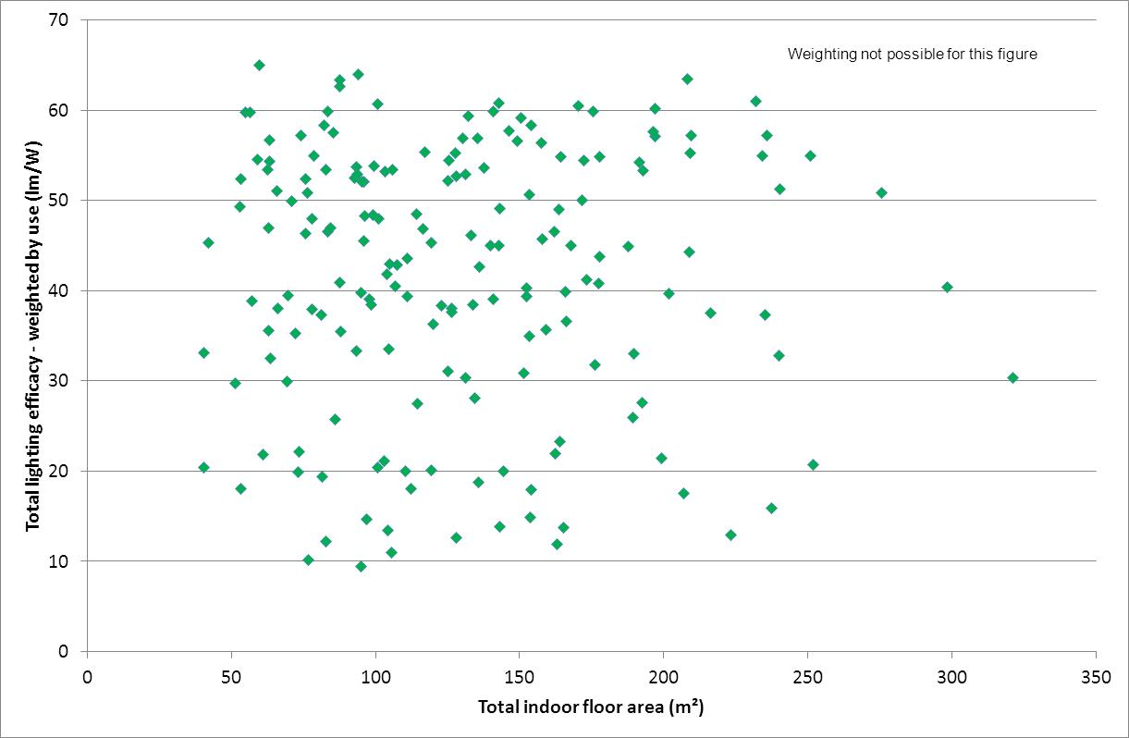

Note: Each point represents a participating household. Efficacy values are weighted by use – assumes all lamps are used as stated by householders. Excludes heat lamps. Demographic weightings are not applied to data in this figure.

Average usage per lamp per day by lighting technology, as estimated from the 2016 lighting audit, is illustrated in Figure 4. This clearly shows that in most cases high efficacy lamps tend to be used more than low efficacy lamps (based on stated householder use for each lamp), although the difference is modest. It should be noted that where a lamp could not be definitively identified within a light fixture by the lighting auditor due to various reasons (e.g. sealed, obscured fixture; inaccessible location[2]), the auditor undertook a number of investigative steps in order to ascertain whether the lamp was a high efficacy (LED, LFL, CFL) or low efficacy (incandescent, halogen) lamp. These lamps are recorded as “cannot identify high efficacy” or “cannot identify low efficacy” and analysed separately to lamps where the technology has been clearly identified. Details on the techniques used to differentiate low and high efficacy technologies that could not be otherwise identified is set out in Appendix A (Detailed Methodology) and Section 5 (Detailed Results by Lamp Technology). Note that “Other” lighting technology was rarely used: there were only 6 in that category out of a total of 7448 lamps covered by the audit.

Figure 4: Average usage per lamp per day by lighting technology

Hours/d Technology
0.53 Incandescent (tungsten)
0.86 Halogen - mains voltage
1.18 Halogen ELV
1.20 CFL - integral ballast
1.16 CFL - separate ballast
1.27 Linear fluorescent
1.79 Circular fluorescent
1.57 LED directional
1.35 LED directional ELV
1.99 LED non-directional
0.28 Heat Lamp
1.21 Other
1.02 Cannot identify low eff
1.81 Cannot identify high eff
1.08 Average all lights


Note: All valves have been weighted in accordance with national demographic weighting factors.

A total of 68 houses in the sample had dimmers present. The average number of dimmers per house was 1 per house across the whole sample (including houses without dimmers), but for houses with dimmers, the average number of dimmers was 2.6 per house. The average number of lamps per dimmer was 2.5 per dimmer, giving a total of 6.6 lamps per house controlled by dimmers (in those houses with dimmers). The most common technology controlled by dimmers was extra low voltage halogen, while other common technologies were incandescents, halogen mains voltage, CFLs and LED directional (mains voltage). The key dimmer parameters are set out in Table 2. This suggests that some householders may be converting from extra low voltage halogen to LED mains voltage downlights to avoid issues with dimmers or they may remove dimmers with LED lamps. Most extra low voltage halogens and a sizable majority of the LED directional lamps will be flush mounted downlights.

Table : Summary of dimmers and lamps in 2016 audit

|  |  |  |
| --- | --- | --- |
| Technology | Share of Dimmers | Lights/ dimmer |
| Incandescent (tungsten) | 13.6% | 1.8 |
| Halogen - mains voltage | 19.4% | 1.9 |
| Halogen - low voltage | 37.0% | 3.3 |
| CFL - integral ballast | 9.9% | 1.5 |
| Circular fluorescent | 1.8% | 1.0 |
| LED directional - mains voltage | 11.1% | 3.0 |
| LED directional - low voltage | 3.1% | 4.6 |
| LED non-directional | 0.3% | 2.0 |
| Mixed technology on dimmer | 3.8% |  |

At a regional level, there were few significant differences in lamp technologies or total lighting efficacy. Sydney appeared to have significantly more incandescent and ELV halogen lamps in service when compared to other regions. Melbourne had a significantly higher share of LED lamps than other regions, but Newcastle also had more LEDs than average. More than 30% of households in Victoria had participated in VEET lighting replacement programs and analysis of the data found that, on average, these houses had roughly a 50% higher total lighting efficacy than non-participating houses in the same state.

Comparison with 2010 Audit

One of the key parameters of interest between the 2010 and 2016 audits is the change in the underlying share of energy efficient lamps over time. In 2010, LED lamps existed but made up only 1.4% of the lighting stock, mostly in the form of novelty lighting and applications such as night lights for children. Since then, LEDs have become mainstream and have are now the dominant technology in the new luminaire downlight market (common in new homes and major renovations). However, a large stock of extra low voltage halogen lamps still remains and there are still substantial sales of replacement ELV halogen lamps, despite LED replacements being readily available. Figure 5 illustrates the changes in the main lighting technology share in houses from 2010 to 2016.

Figure 5: Share of lighting technologies in 2010 and 2016

Two pie charts 2010 in the left and 2016 on the right
2010 2016 Technology
1% 15% LED
26% 15% ELV Halogen
23% 13% Incand-escent
9% 17% MV Halogen
31% 31% CFL
9% 9% Lin Fluorescent


Note: All values are raw sample averages and have not been weighted by demographic factors. Technology categories have been simplified for this comparison.

It is important to note that the survey of lighting stock in 2010 is not necessarily representative of lighting stock prior to the impact of the policy to phase-out inefficient lighting through the introduction of minimum energy performance standards (announced, with some immediate retailer and consumer response in 2007, implemented early 2009), and the impact of state government based energy efficiency obligations schemes that were also active well before 2010. Import data in Figure 6 indicates that prior to 2010 there had already been a significant increase in the market share of CFLs and a significant reduction in incandescent lamps. Mains voltage halogens also increased after 2008.

In overall terms, the share of linear fluorescents and CFLs has not changed in the past 6 years with a constant aggregate market share of 40% for these two technologies. There are, however, two important trends that are visible in this data. Firstly, incandescent lamp share has fallen significantly from 23% to 13% share while mains voltage halogen lamps share has increased from 9% to 17%. This shows that incandescent lamps have mostly been displaced by mains voltage halogen lamps since the last survey in 2010 (following the incandescent lamp ban in 2009). Mains voltage halogen lamps are 30% more efficient when compared to incandescents. LED for general lighting (non-directional) still only makes up 3% of the stock (this is included in the LED total share of 15% shown above) even though there has been a significant increase in available models in the market. This data suggests that there has been little improvement in lighting efficacy for general lighting over the past 6 years (noting that this is not representative of the full impact of lighting efficiency policy since 2007). The trends in the stock across the two lighting audits are broadly consistent with the sales data available shown in Figure 6.

Figure 6: Imports of different lamp types from 2002 to 2015

A line chart showing annual imports of 4 different lamp types from 2002 to 2015.

Incandescent lamps were at about 80 million per annum until 2007 then dropped rapidly to 20 million by 2009 and fell slowly to less than 10 million by 2015.

CFL sales were at about 12 million per annum until 2005 then jumped to over 30 million by 2007 then declined slowly to 12 million by 2015.

ELV Halogens grew steadily from 10 million per year in 2002 to 20 million in 2010, then declined afterwards falling to 5 million by 2015.

Mains voltage halogens had steady sales of 4 million per year to 2008 then climbed to 22 million by 2011 falling slightly after that to 17 million in 2015. 

The second important trend is that extra low voltage halogen lamp share has fallen from 26% to 15% while LED lamp share has increased from 2% to 15% (12% is LED directional). This suggests that low voltage halogen lamps are slowly being displaced by LED lamps. Most low voltage halogens, and a sizable majority of the LED directional lamps, will be flush mounted downlights. This data suggests that there has been a significant improvement in lighting efficacy for task and directional lighting due to the halogen to LED transition. LEDs are being installed in new homes/renovations but also under voluntary state schemes like VEET. LED share is significantly higher in Melbourne than other regions. Despite this trend, almost 50 million extra low voltage halogen lamps currently remain installed in Australian homes and sales are still around 5 million ELV halogen bulbs per annum.

In terms of the estimated energy consumption, high efficacy lamps appear to be making a significant impact. Lighting energy consumption in 2010 was estimated to be about 1900 Wh/day, while in 2016, this is estimated to have fallen to 1150 Wh/day, a fall of about 40% (excludes energy used by heat lamps). Detailed analysis suggests that about a 10% of the fall was due to demographic factors (larger share of households in semi-detached housing and apartments, which are smaller and use less lighting energy), while about a 30% of the fall was due to an increased penetration and higher use of lighting from high efficacy lamp technologies.

Figure 7: Estimated changes in lighting energy consumption from 2010 to 2016

Energy Wh/day
2010 2016 Type
1506 714 Low efficacy
383 432 High Efficacy


An important consideration is that high efficacy lighting supplied 57% of the total amount of light used in 2010 yet only accounted for 20% of the energy consumption. By 2016, high efficacy lighting supplied 76% of the total amount of light used, yet only accounted for 38% of the energy consumption. This means that low efficacy lighting is only providing a small fraction of total amount of light used as shown Figure 8, yet it still dominates energy consumption as shown in Figure 7, indicating a still unrealised large energy saving potential from efficient lighting technologies.

Figure 8: Share of useful light output by technology in 2010 and 2016

Two pie charts, 2010 left and 2016 right
Light output share by technology type
2010 2016 Type
43% 24.2% Low efficacy
57% 75.8% High Efficacy

Conclusions

Lighting is a complex issue, with householder habits and attitudes, lighting configuration and lamp technology all having a large impact on the potential to reduce residential lighting energy consumption through improved energy efficiency. Lighting in the home is used for a wide range of purposes, and the technical and user requirements vary by installation. Anecdotally, the general knowledge and understanding of lighting technologies and choices also varies greatly at the householder level, and this adds another layer of complexity when attempting to increase the efficiency of installed lighting stock through information and awareness campaigns alone. Many households are keen to be more energy efficient, but a majority of households are unlikely to be able to understand many of the complex issues required to make sound decisions with respect to efficient lighting. A significant minority of households will never have any interest in energy efficiency or economics.

The 2016 audit found a surprising number of incandescent lamps still in the household stock. However, these appear to be mostly in low use areas (there is no suspicion or evidence that there are illicit supplies of new incandescent lamps available). Mains voltage halogens are displacing incandescent lamps as the cheapest lighting technology for general lighting and together these still have a significant penetration. Only a small share of general lighting is currently LED. The share of linear fluorescent and CFL has remained static for the past six years. However, it would appear that extra low voltage halogen downlights are declining in number, driven by a number of factors. These include state government and other agency programs (such as Vic: VEET; NSW: ESS; ACT: EEIS; SA: REES) as well as private replacement schemes, user driven retrofits of LED lamps and the now common use LED downlights in new homes. New downlight luminaires are thought to be now almost exclusively LED (major renovations and new homes), but these only impact on a few percent of the total stock each year. The installed stock of ELV halogen is still significant, with more than 50% of the estimated stock of 100 million downlights Australia being halogen.

Compact fluorescent lamps (CFLs) are now mainstream and make up about 30% of the household lighting stock. However, the share of CFLs and linear fluorescent lamps has not changed from 2010 to 2016. It appears that a significant minority of users do not like some aspects of CFL lamps, such as their starting characteristics, low initial light output, issues with fitting compatibility and their fragile design. Some users think that they are still too expensive in terms of capital cost, but this suggests a poor understanding of economics. Details of consumer responses with respect to CFL issues are provided in Appendix C.

LEDs are continuing to make significant improvements in efficacy, with mainstream new, off-the-shelf, general lighting lamps able to achieve over 100 lm/W. While the cost of LED downlights are now competitive and are in significant quantities on the retail shelves, LED for general lighting is still relatively expensive and their penetration is still small (even though the lifetime economics in high use areas is very favourable). LED downlights are competitive in the new downlight luminaire market, but this is a relatively small share of total sales. While consumers perceive that there are fewer technical issues with LED lamps (which may be in part due to lack of experience, as 40% of households still have no LEDs installed) the purchase cost is still seen as a significant barrier penetration. While LED prices are likely to fall in future and their efficacy will no doubt increase, the rate of penetration is likely to be limited by the availability of very cheap halogen lamps.

The 2016 lighting audit gives a comprehensive picture of lighting in households by room type, as well as the power and technology of lamps. Retrofitting of lighting to increase overall efficiency levels is not always a straight forward task, in part due to householder attitudes, knowledge levels and the lack of inter-changeability of some lamp types due to technical limitations with respect to installed lighting systems (e.g. existing dimmers, transformers etc.). However, a very wide range of LED lamp types are now available and this provides a much broader range of high efficacy options, compared to what has been available in the past.

In overall terms, it would appear that there is the potential to increase total lighting efficacy by at least three fold in many houses that currently have lower efficacy lamps and as much as six fold in very low efficacy houses. Less efficient homes have an average total lighting efficacy of around 15 lm/W (when weighted by use), while those categorised as efficient homes have already achieved a total lighting efficacy of over 60 lm/W.

The 2016 lighting audit has provided valuable insight into the complexities of residential lighting. The information in this report will support policy makers as they introduce further lighting policies to facilitate improved energy efficient practices in lighting.

1. Introduction

Background

This report documents the results of the second lighting audit of Australian homes, commissioned by the Department of Industry, Innovation and Science (DIIS) and conducted in the first half of 2016. The only other previous comprehensive data collection on household lighting was conducted during the first household lighting audit in late 2010 and early 2011 (EES, 2013). Prior to these studies, not a great deal was known about Australian’s lighting energy consumption, or the lighting technologies that made up the lighting stock. It is estimated that lighting in homes consumes between 5% and 15% of the average household electricity budget, although this will differ depending on the makeup of the installed lighting technologies and user behaviour (EES, 2008). The rapid growth of high efficiency LED lighting may be reduce this energy consumption into the future, depending on the rate of penetration.

The Australian Bureau of Statistics publication ABS4602 – Environmental Issues; Energy Use and Conservation, contains some very basic information about the number of fluorescent lights (i.e. total fluorescent lighting, not split between linear and compact types) in homes, but no information on the details of where they are located or their power (ABS4602). Other than this ABS publication, there has been no study that explicitly documents the lighting characteristics of Australian homes. Understanding the stock of lighting is essential when proposing regulations concerning different lighting technologies and it also provides a good baseline that can be used to assess future impacts of regulations and changes in technology.

In 2007, Australia announced a phase-out on the sale of incandescent lamps, with the intention of increasing the general efficiency of the installed lighting stock of Australian homes (DEWHA, 2008). Australia has been working to improve the efficiency of lighting through the introduction of minimum energy performance standards (MEPS) for lighting products since 2001. MEPS have been introduced for a range of lighting technologies, including, with the details set out in the relevant standards as follows:

* ballasts for fluorescent lamps – AS.NZS4783;
* linear fluorescent lamps – AS/NZS4782;
* compact fluorescent lamps – AS/NZS4847;
* transformers and electronic step-down converters for electronic extra low voltage lamps – AS/NZS4879; and
* incandescent and halogen lamps – AS/NZS4934.

Further efficiency regulations are being contemplated and the information collected by this study provides crucial data to regulators on the characteristics of the stock of lamps in Australia and their usage.

The 2016 audit comes at a fortuitous time. The original household lighting audit was conducted in 2010, a year after the ban on most incandescent (tungsten filament) lamps came into place and shortly after MEPS were introduced for CFLs. Since 2010, further categories of incandescent lamps have been phased out while more recently, LED lighting has become fully commercialised and the efficacy has been climbing rapidly while the costs have been falling. LED lights only appeared on the market in significant numbers in around 2011 and by 2016 they had made a significant (but still modest) impact on the lighting stock installed in households in Australia.

This survey provides a deeper understanding and quantitative data concerning the stock of installed lighting technologies and provides data on trends in the stock of lamps from 2010 to 2016. It provides a comprehensive picture of what types of lighting householders like to install in different rooms, as well as the power and luminous flux (light output) of lamps they use (and therefore installed lighting levels). This data will help policy makers better understand not only the installed residential lighting stock, but also householder attitudes and user behaviour, to allow program improvements and enable better targeting of resources.

Study Objectives

This report documents the second lighting audit of Australian homes. This audit was primarily concerned with quantification of the stock of lamps currently installed in households and the documentation of their characteristics. The results obtained from this audit will greatly assist in providing a basis for a preliminary assessment of the energy efficiency potential of improved lighting technologies.

The general objectives of this audit were to:

* obtain permission from a representative group of Australian households to conduct a detailed lighting audit of their homes;
* document the characteristics (lamp type and technology, lamp shape, fitting type, motion sensor function, dimmer function, cap type, transformer type, power) of all lamps found in each house;
* record usage of each lamp found;
* measure the size and document each room type found in each house;
* identify lighting types that are particularly interesting (now and in the future) when considering their potential usage patterns, lamp power and ownership trends; and
* establish a solid benchmark of lighting characteristics from which to evaluate the impact of future proposed lighting regulations.

The data on lamps, lighting fixtures and rooms were collected by trained auditors during a physical audit of 180 homes in 5 regions. In addition, householders were asked to fill in a detailed questionnaire regarding a range of lighting issues, including preferences, issues and sources of information. Data on a range of demographic parameters for each household such as house type, tenure, number of residents, income range and work status was also collected. Householders were also asked to estimate the usage of every light in their home.

Another key objective was to document changes in the stock of lamps and their characteristics between the first audit in 2010 and the second audit in 2016.

Project Tasks and Outputs

This report documents the findings of the 2016 lighting audit of Australian homes. The audit covered some 180 houses, including 40 houses in Queensland (Brisbane), 70 houses in New South Wales (30 in Newcastle and 40 in Sydney), and 70 houses in Victoria (40 in Melbourne and 30 in Gippsland). Fieldwork was undertaken in the period February to May 2016. A total of 7448 individual operational lamps were recorded during the survey. In additional there were another 261 lamp sockets where the lamp was blown, missing or not working for some reason (an average of 1.45 per house). Lighting characteristics were identified in the field with the assistance of field identification manuals, and the data was recorded and then later validated. Further discussion concerning the field identification manuals used in the study can be found in Appendix F (separate volume).

The main project tasks and outputs were to:

* Undertake lighting audits on households that were recruited by an independent recruitment agency
* Record all data collected on site electronically and upload to a central server (including household questionnaires)
* Check, clean and load all data to a central database for analysis
* Conduct a wide range of different analysis on the 2016 data to establish key characteristics of the current lighting stock
* Compile and report questionnaire data collected from participants
* Undertake an assessment of key changes since the first lighting of Australian homes in 2010
* Prepare this report for DIIS and E3
* Provide raw data and selected output tables to DIIS and E3.

Acknowledgements

Project management was undertaken by Lloyd Harrington of Energy Efficient Strategies. This report was prepared by Lloyd Harrington of Energy Efficient Strategies with assistance from Hilary Harrington. Householder audit reports were managed by Hilary Harrington. A great deal of technical guidance and advice throughout the project was provided by Steve Coyne of Light Naturally and Steven Beletich of Beletich Associates, including measurement procedures, training, data validation and comments on the report and their invaluable technical assistance is gratefully acknowledged. The majority of the data management and data cleaning was conducted by Robert Harrington of Energy Efficient Strategies. Field measurements in Victoria were carried out by Hilary Harrington of Energy Efficient Strategies. Field measurements in NSW were carried out by Richard Collins of Punchline Energy (contracted via Beletich Associates). Field measurements in Queensland were carried out by Helen O’Brien and Gemma Coyne of Light Naturally. Dianne Glass of Energy Efficient Strategies assisted with report formatting and WCAG compliance.

Householders were primarily recruited via Purple Corporation, who was contracted directly by DIIS to undertake this role. Recruited householder details were then provided to the EES team.

The authors would like to thank the 180 participating households that volunteered their time and dwelling for the survey, as well as all other householders that volunteered for the study but were not selected for an audit.

Members of Department of Industry, Innovation and Science (DIIS) and the E3 Committee are also thanked for their guidance throughout the project. The project manager was Tim Govey and the lighting team head was Karen Moloney, both of DIIS. David Boughey of DIIS provided valuable comments on the draft report.

While this report was commissioned by government, any views expressed are those of the authors. While the authors have taken every care to accurately report and analyse the data collected during the survey, the authors are not responsible for any use or misuse of data and information provided in this report or any loss arising from the use of this data.

2. Methodology

Introduction

The 2016 lighting audit of Australian homes was contracted by the Department of Industry, Innovation and Science (DIIS) and E3 at the end of 2015. The objective of the audit was to obtain comprehensive data on the lighting systems installed in Australian homes. This audit builds on the first audit of Australian homes conducted in 2010. The main components of the 2016 audit were:

* Recruitment – DIIS contracted an independent market research organisation, Purple Corporation, to recruit suitable households to participate in the audit. Participating households were not offered any cash incentive to participate, but were offered a full lighting audit report with recommendations on how to improve their overall lighting efficacy.
* Purple Corporation provided a range of demographic data with details of the recruited households.
* A total of 180 households in 5 regions (Melbourne, Gippsland, Sydney, Newcastle and Brisbane) were sought to participate in the audit[3].
* Three teams of auditors were trained to conduct audits independently in the three states.
* Auditors contacted recruited households to arrange a suitable time for a walk through audit of houses, recording data about every light in the dwelling.
* Householders were asked to complete a questionnaire that provided some household data and other related information such as lighting preferences and issues.
* Householders were asked to estimate the use of each light in the house, which was then recorded as part of the audit data set.

All audit data was recorded in a bespoke audit spreadsheet. This included a wide range of checks and validation of the data. On completion, audit sheets were uploaded to a central data server and were checked by a lighting expert. Where necessary, clarifications and adjustments to the data were made in consultation with the relevant auditor. Auditors consulted with lighting experts by phone and using photos in cases where lighting systems that were unusual or identification was unclear. Additional data checks and validation was undertaken as data was loaded to the SQL database.

The lighting questionnaire was loaded into an electronic form for further analysis. Once all data was uploaded and checked, householders were given the detailed results of their lighting audit, including recommendations for replacement of higher use and low efficiency lamps. A sample householder report is included in Appendix E. The remainder of this chapter sets out the detailed data collection instruments and technical information that was collected as part of the lighting audit.

Methodology Overview

The lighting survey required the collection of an extensive range of data and information concerning the lighting in homes. This data was recorded using a spreadsheet, and in most cases used specific validation rules depending on the lamp technology or lamp shape selected. The field auditors were trained in luminaire and lamp identification, and it was rare that issues arose with this aspect of the data collection.

The following data was recorded at a room level:

* Room ID;
* Room type;
* Location (indoor or outdoor);
* Floor area (in m2);
* Ceiling height (in m);
* Any notes on usage or missing lamps.

Indoor rooms were classified into living and non-living categories (see next section).

The following list of data was recorded for each lamp:

* House ID;
* Lamp number;
* Room ID;
* Switch number;
* Whether the switch controlled several lamps;
* Lamp connection type (fixed or plug in);
* Dimmer function present;
* Motion sensor function present;
* Fitting type;
* Colour (warm white or cool white);
* Lamp technology;
* Lamp shape;
* Lamp cap type (where identified);
* Lamp transformer type (where identified);
* Lamp power;
* Flag to indicate source of lamp power (labelled, measured or estimate);
* Hours of use per day for the lamp (information provided by the householder at the end of the audit); and
* Any comments or notes regarding the specific lamp.

Appendix A sets out in detail the specific considerations and rules concerning classification of both rooms and lamps and the estimation of lamp efficacy by technology.

Sample Households

Household Recruitment and Demographics

The 2010 sample was recruited via a wide range of methods including word of mouth, emails, media (radio), snowball and use of social media. For the 2016 audit, the Department of Industry, Innovation and Science contracted Purple Corporation to recruit households for the lighting audit. No houses from the 2010 audit were to be included in the sample, so no longitudinal comparisons are possible. The brief was for Purple Corporation to provide a balanced sample of households that broadly matched the average demographic profile in each region, based on the 2011 census. It is understood that no fee was to be offered to householders for participation. However, the householders were offered a detailed lighting audit for their home with recommendations for changing inefficient lights that were frequently used.

As Purple Corporation were only providing households that had agreed to the original conditions (no payment, lighting audit provided), it was originally estimated that only an additional 10 houses in each region would be required to attain to sample target. However, after some way through the audits it became clear that there was a significant dropout rate, particularly in Melbourne and Sydney. Despite the agreed conditions of participation, a sizable minority of recruited houses clearly expected payment for participation and declined to participate when it was clarified that there was no cash payment. Another sizable minority of recruited houses were extremely difficult to contact or could never be contacted by the auditors despite multiple phone calls, texts and emails. Purple Corporation were commissioned by DIIS to increase the number of households provided in order to reach the target number in each region. The number of households recruited by Purple Corporation were:

* Brisbane – 72 houses (target 40 houses)
* Gippsland – 41 houses (target 30 houses)
* Melbourne – 81 houses (target 40 houses)
* Newcastle – 50 houses (target 30 houses)
* Sydney – 73 houses (target 40 houses).

The effective dropout rate in Sydney and Melbourne was more than 50%. The dropout rate in Brisbane was slightly lower (around 40%) and the dropout rate in Newcastle and Gippsland was significantly lower (around 30%). Towards the end of the project, it was necessary for EES to approach a total of about 30 additional households (with permission from DIIS) because there was still a small shortfall in some regions, despite several additional samples being provided by Purple Corporation. In the end a total of 10 households were audited from these additional households.

Purple Corporation provided basic demographic data collected from the householders as follows:

* Occupation
* Age
* Work suburb
* Household type
* Number of people in the household
* Work status
* Household income range
* Dwelling type
* Tenure.

The number of people living in the household was confirmed via the householder questionnaire with additional data on age split of residents. The dwelling type was confirmed by the auditor at the time of the audit. Around 5/180 dwellings were classified differently by the auditor after the audit was completed, when compared to the house type recorded by Purple (which was provided by the householder).

The recruitment process, although at arms-length in 2016, ended up being much more demanding and resource intensive for the auditors, for reasons set out above. While more random in nature, it is the qualitative opinion of the report authors that the 2016 recruitment process appeared to deliver a dominance of particular types of households that were not necessarily representative of expected mix of household types and attitudes across all Australian households.

Balancing the Household Sample

Another problem that was identified well into the project was that for the audits completed, particularly in Sydney and Melbourne, there were more flats and attached houses than expected and fewer separate houses than expected, as compared to the target proportion by region as defined in the 2011 census. These parameters are difficult to control when there is a high dropout rate of participants. In order to rebalance the sample as far as possible, the final 25% of homes audited in each region were actively selected to balance up the parameters of house type (separate house, attached house or apartment) and tenure (renting, owned with mortgage, owned without a mortgage), as far as was possible within the constraints of available households.

Four dwelling characteristics, with population data available, have been identified as most relevant to control in order to get a representative and balanced sample:

* Number of residents in dwelling
* Household income (corrected for wage changes since 2011 census)
* Ownership status (owned outright, under mortgage or renting)
* Dwelling structure (freestanding house, townhouse/semi, apartment/unit).

A comparison of the participant and population characteristics for these four variables shows that, while the dwelling structure distribution in the sample is very close to that for the Australian population, the survey significantly undercounts single resident dwellings and probably low income dwellings.

In order to further improve the representativeness of the survey results, each response was weighted to more closely align with population parameters for the above four dwelling characteristics. Weights for each household were calculated for both the geographic region surveyed and for Australia as a whole. Given the need to weight all four dwelling characteristics in parallel, the weights were carried out using the RIM weighting method. The population data used for the regional weighting calculations was the ABS 2011 census data for Greater Brisbane, Melbourne and Sydney and the appropriate regional data for Gippsland and Newcastle/Central Coast regions. Total Australia census data was used for the overall weighting. Household income data was corrected for changes in average household income since the census. More detail in the RIM weighting approach is included in Appendix B.

The weighting approach calculated a regional and a national weighting for each participant household in the survey. This increases or decreases the weight of individual households to more closely match the prevalence of the individual household characteristics in the census. Depending on the analysis being conducted, a national weighting has usually been applied to the results included in this report. Regional weightings have only been applied where inter-regional comparisons have been conducted (see Section 3). One issue is that the 2010 and the 2016 lighting audits were conducted 4 or 5 years after the most recent census, which does make it difficult to accurately match some of the more rapidly changing characteristics, such as the share of apartments in the large cities.

Householder Questionnaire

In addition to the physical lighting audit of homes, householders were asked to complete a detailed lighting questionnaire. This contained information on the household and the dwelling, recent changes to lighting systems, issues or problems with lighting, purchasing preferences and the main sources of information on lighting issues. A copy of the household questionnaire survey instrument is included in Appendix D. Detailed analysis of the results from the questionnaire are included in Appendix C.

Use of Lighting

During the development of the lighting audit tool for the 2016 survey, a range of alternative methods to quantify usage were tried on several households to assess their salience, simplicity, robustness and ease of understanding. The most effective and simplest approach turned out to ask the householder to nominate the average hours of use per day for each lamp as a number between 0 and 24 (or any decimal). This is easy to understand for the householder and most were able to quickly nominate a typical usage level for each lamp as the auditor ran through the list of all lamps that were included in the audit in around five seconds for each light (remembering that an average house may have between 10 and 150 lights). The lighting audit sheet was set up so that where there were multiple lights in a single switch, then only a single usage value was required for the first light in the group.

The advantage of the 2016 approach was that it allowed householders to nominate a much finer gradation of use for each light in a format that was simple and was easy to comprehend (when compared to the 2010 audit). It also provides a method to quantitatively estimate the energy consumption of lights in each house as the lamp power for each lamp had already been documented in the audit. Having specific hours of use for each light allowed energy savings to be calculated when a lower efficiency lamp was replaced with a higher efficiency technology option. These types of recommendations were included in the householder report.

Any usage parameter nominated by householders will be prone to some error or subjectivity. Many of the audits were conducted in summer and early autumn during daylight saving (in NSW and Victoria), so this naturally colours the respondents’ perception of the hours of use for lighting. A similar survey in winter may yield higher usage results. Auditors found the most considered answers were obtained from couples together that discussed usage of each light (this obviously takes longer). Quite a few single respondents also provided what appeared to be answers in the realistic range. However, around one third of respondents appeared to give answers that were somewhat unrealistic (mostly too low, a couple too high). There is no way to assess the accuracy of the current responses without detailed in house monitoring, which is not practical or realistic for this project. So at this stage, the householder responses have been accepted as being reasonable, with no adjustments made for outliers. However, this approach does provide a very robust assessment of the relative use of lights in the house, which is critical when assessing efficacy “in normal use” in the home (taking account of which lamps are used more and which are used less), even if the absolute usage levels have some uncertainty associated with them.

3. Overall Results

Key Findings

The sample was selected on the basis of broad demographic values provided by the recruitment company. However, inevitably, the selected sample does not match the demographic composition desired, so detailed analysis (set out in Section 2) calculated a weighting for each individual household included in the sample to better reflect national characteristics. Generally, results for the nationally weighted sample are reported. Unweighted values are provided where noted. Data that has been regionally weighted is included in the section on that covers inter-regional comparisons. The methodology for sample weighting is set out in Appendix B.

The two important findings for the survey were that the average house had 36.6 lamps each with an average power of 34.1 watts (excludes heat lamps). The average number of rooms per house was found to be 14.5, with a total floor area of a house was 140 m2 and 124.3 m2 if only indoor rooms and spaces are considered. The number of lamps per m2 for indoor areas was found to be 0.23, and the power density was almost 6.6 Watts/m2 for indoor areas. Fixed lamps contributed 5.9 Watts/m2 to this total. The average lighting density was found to be 156 lm/m2 for living areas, 132 lm/m2 for sleeping areas and 211 lm/m2 for indoor-other areas (excluding heat lamps), based on total light output for all relevant lights. A weighted average lighting density of 161 lm/m2 is estimated for all indoor areas (excluding heat lamps). Note that these lighting density values assume that all lights are on at once. No account is taken of losses through luminaires and fittings. These figures provide an initial picture of the power and illumination levels of Australian houses (assuming all lights were on) and provide a benchmark of the lighting stock of Australian households in 2016.

For lamp technologies, the findings are also very interesting. The most common lamp type in an average house was compact fluorescent (CFL), at around 31% share. An average CFL had a power of almost 13.7 Watts. The next most common lamp type was found to be mains voltage halogens, with a share of 17% and an average power of 51.6 W. Extra low voltage halogens had 14.6% share with an average power of 39.1 Watts per lamp[4]. Surprisingly, 12.7% of lamps were found to be incandescent (tungsten filament) with an average power of about 72 Watts. Linear and circular fluorescent lamps also had a share of around 8.9%, at an average of around 31.3 Watts each[5]. In total LED types (directional and non-direction, including extra low voltage) made up a total of around 15% of all lamps, made of up 12.2% LED directional (mostly downlights) and 3% LED non-directional (general lighting). The average power of all LED lamps was 8.2W. These findings paint a stark picture, with relatively inefficient technologies[6] still making up 45% of the stock of installed lamps found in the average house.

The technology that contributed the highest share of the lumens (total light output) for the average house was CFL, with 30% of total lumens. Linear and circular fluorescent lamps had a lumen share of about 25%. All LED technologies were found to have a lumen share of 11%. Incandescent lamps had a 10% share, while extra low voltage halogens also had a 10% share. Finally, mains voltage halogens were found to have a 14% lumen share. This shows that the share of light output across the four major lighting technologies is more evenly spread than is reflected by the number of lights present by technology.

The majority of lamps in the average Australian house were fixed lamps, at 32.9 per house (90% of all lamps), with the remaining 3.6 per home being plug-in. The plug in lamps were made up of about 0.6 incandescents, 0.8 mains voltage halogen, 0.2 extra low voltage halogen and 1.3 CFL, with most of the remaining 0.4 plug-in lamps being LED.

In summary, comparatively inefficient technologies in fixed lighting points were found, in aggregate, to still make up a significant share of lighting in a typical Australian home. However, the share of total light output is more evenly spread across the four major lighting technologies.

Whole House Overview

The average number of lamps was 36.6 per house, which operate on an average number of 23.7 switches. The total power with all lights on was 1246 W per house (all values exclude heat lamps). The average number of rooms per house was 14.5, with an average total floor area of 140 m2 (including some outdoor areas, 124.3 m2 for indoor areas only). The average number of lamps per m2 was 0.23 (indoor areas), with an average number of lamps per room found to be around 2.4. The average power density of all lamps was 6.6 Watts/m2 (indoor areas). The average total light output per house was found to be almost 20,000 Lumens (excluding heat lamps and outdoor areas). These overall findings are shown in Table 3.

Table : Average House Summary – key characteristics

|  |  |  |
| --- | --- | --- |
| Average House | Unweighted | Weighted |
| Number of houses | 180 | 180 |
| Number of Lamps | 39.7 | 36.6 |
| Number of Switches | 25.0 | 23.7 |
| Total Watts | 1335 | 1246 |
| Watts per Lamp - total | 33.7 | 34.1 |
| Number of Rooms - total | 14.9 | 14.5 |
| Total Floor Area (m2) | 146.8 | 140.0 |
| Number of Rooms -indoor | 12.4 | 12.1 |
| Floor Area – indoor m2 | 129.7 | 124.3 |
| Lights/m2 - indoor | 0.24 | 0.23 |
| Lights/Room - indoor | 2.6 | 2.4 |
| Watts indoor (excluding heat lamps) | 921 | 856 |
| W/m2 total - indoor | 6.8 | 6.6 |
| W/m2 Fixed - indoor | 6.1 | 5.9 |
| W/m2 Plug - indoor | 0.7 | 0.7 |
| Lumens indoor (excluding heat lamps) | 21243 | 19984 |
| Lighting Density Indoor (lm/m2) (excl. HL) | 164 | 161 |

Note: All values exclude heat lamps. Weighting is in accordance with national demographic weighting factors.

Table 4 shows the breakdown of lighting in the major room types of the average house. The most prevalent room type in homes were ‘indoor-other’ rooms (remembering that this room type is an aggregation of several individual room types, including bathrooms, hallways and a range of other service areas that are used less frequently). This was followed by sleeping and living, with outdoor being the least common. Note that in the case of outdoor spaces, many of these do not have a floor area (e.g. veranda or garden), so the share of spare for outdoor may be understated in many cases. The room type with the largest floor area was found to be living, accounting for almost half of all indoor spaces. Sleeping was the next largest with Indoor-other being the smallest total floor area (but being the most numerous room type).

Living areas also had the largest number of lamps, but not the highest power density or lighting density. Instead, indoor-other rooms had the highest power density at 11.2 Watts/m2 as well as the highest lighting density (note that this excludes heat lamps). Sleeping areas had both the lowest power density and lowest lighting density.

Living areas were found to have the highest average number of fixed lamps (12.3), followed by indoor-other, outdoor and sleeping. Almost the opposite was found for plug lamps, with sleeping areas found to have the highest average number (2.2 lamps), followed by living, outdoor and indoor-other.

Table : Average House Summary – room type characteristics

|  |  |  |  |  |  |  |
| --- | --- | --- | --- | --- | --- | --- |
| Average by Room Type | Living | Sleeping | Indoor-other | All indoor | Outdoor | Total |
| Number of Rooms | 3.2 | 3.3 | 5.7 | 12.1 | 2.4 | 14.5 |
| Floor Area (m2) | 56.7 | 39.3 | 28.3 | 124.3 | 15.7 | 140.0 |
| Share Indoor Floor Area | 45.6% | 31.6% | 22.7% | 100.0% |  |  |
| Number of Lamps | 13.2 | 7.8 | 8.1 | 29.1 | 7.4 | 36.6 |
| Number of Fixed Lamps | 12.3 | 5.6 | 8.0 | 25.9 | 7.1 | 32.9 |
| Number of Plug Lamps | 1.0 | 2.2 | 0.1 | 3.3 | 0.3 | 3.6 |
| Power Density Indoor (Watts/m2) | 6.8 | 5.5 | 11.2 | 7.4 | N/A | N/A |
| Lighting Density Indoor (lm/m2) | 156.2 | 131.5 | 210.6 | 160.7 | N/A | N/A |

Note: All valves have been weighted in accordance with national demographic weighting factors, but have not taken into account usage patterns. Excludes heat lamps.

Technology Overview

It is useful to initially take a high level overview of the makeup of lighting technologies in a typical home. There are several aspects of importance when considering the impact of different lighting technologies:

* Lamp count: this is a rough indicator of how prevalent a particular technology is in the stock – it is a primary indicator of how many lamps are out there;
* Total watts (units: watts (W)): this shows the potential power consumption of all lights – it is useful because it shows the relative importance of different technologies in terms of ***potential*** energy consumption (rather than actual energy consumption)
* Total lumens (units: lumens (lm)): this shows the potential light output of all lights if they were all on at once – it is useful because it shows the relative importance of different technologies on ***potential*** lighting use
* Daily Energy Consumption (units: watt-hours per day (Wh/day)): This is a very useful parameter as it takes the power consumed by each lamp and multiplies it by the nominated (***actual***) usage time per day (in hours) to give an estimate of energy consumption – this is a very important parameter that determines the economics (energy operating cost) and environmental impact of lighting.
* Daily Light Usage (units: Lumen-hours per day (lm.h/day)): The is a very important parameter as it is a measure of the light output of each lamp multiplied by the nominated usage time per day (in hours) to give an estimate of total amount of light used - this is a very important parameter as it relates to the total energy service provided by lighting.

The issue of lighting usage and energy consumption is explored in more detail in Section 6. During the lighting audit, some 14 different lighting technologies were identified, as set out in Appendix A. In order to obtain a clearer picture of how these parameters impact on the provision of lighting services in the home, the main lighting technologies have simplistically been split into two categories: *low efficacy* (mainly incandescent (tungsten) and halogen = red) and *high efficacy* (linear, circular and compact fluorescent and LED = blue). In round figures, the efficacy of the *high efficacy* lamps is about 5 times higher than *low efficacy* lamps (this means they consume 20% of the energy for the same light output). Figure 9 illustrates each of the five key parameters listed above in terms of the split between high efficacy and low efficacy lighting technologies in Australian homes (noting that efficacy of each lamp as recorded is used to calculate these aggregate values).

Figure 9: Overview of key parameters for lighting in Australian homes in 2016

5 pie charts as follows:
Low efficacy
Count Watts Lumens Energy Light
44.8% 73.7% 34.6% 62.3% 24.2%
High Efficacy 
Count Watts Lumens Energy Light
55.2% 26.3% 65.4% 37.7% 75.8%


Note: All valves have been weighted in accordance with national demographic weighting factors. Energy and light usage take into account usage patterns nominated by householders – see Section 6.

The key observations are as follows:

* High efficacy lamps now make up 55% of the total stock of residential lights;
* High efficacy lamps only account of about 25% of the total installed lamp power, as low efficacy lamps have a much higher power rating for an equivalent light output;
* High efficacy lamps now account for about two-thirds of the potential total light output in homes (not taking usage patterns into account);
* High efficacy lamps are only responsible for just over one third of the estimated energy consumption of lamps in Australian homes once usage patterns are taken into account;
* In contrast to their energy consumption, high efficacy lamps provide more than 75% of the total amount of light used in Australian homes;
* Despite only providing less than one quarter of the total amount of light used in Australian homes, low efficacy lamps still account for over 60% of the total lighting energy consumption.

Table 5 shows the count of lamps, total watts and total lumens by technology an average house (nationally weighted data). As the efficacy of each technology is quite different, the share of lamps, the share of power and share of total light output are all quite different as illustrated in Figure 10, Figure 11 and Figure 12.

Figure 10: Share of lamp technology (count) in an average house (weighted)

Lamp Count Technology
12.7%  Incandescent (tungsten)
16.7%  Halogen - mains voltage
14.6%  Halogen - ELV
30.7%  CFL - integral ballast
0.3%  CFL - separate ballast
7.3%  Linear fluorescent
1.6%  Circular fluorescent
7.9%  LED directional
4.3%  LED directional ELV
3.0%  LED non-directional
0.1%  Other
0.7%  Cannot identify low eff
0.1%  Cannot identify high eff


Note: All valves have been weighted in accordance with national demographic weighting factors, but have not taken into account usage patterns. Excludes heat lamps.

Figure 11: Share of lamp power in an average house (weighted)

Total Watts Technology
27.0% Incandescent (tungsten)
25.3% Halogen - mains voltage
20.4% Halogen - ELV
12.4% CFL - integral ballast
0.1% CFL - separate ballast
8.3% Linear fluorescent
1.6% Circular fluorescent
1.7% LED directional
1.1% LED directional ELV
1.0% LED non-directional
0.0% Other
1.0% Cannot identify low eff
0.0% Cannot identify high eff


Note: All valves have been weighted in accordance with national demographic weighting factors, but have not taken into account usage patterns. Excludes heat lamps.

Figure 12: Share of lamp light output (lumens) in an average house (weighted)

Total Lumens Technology
10.2% Incandescent (tungsten)
13.9% Halogen - mains voltage
9.8% Halogen - ELV
29.8% CFL - integral ballast
0.3% CFL - separate ballast
21.5% Linear fluorescent
3.6% Circular fluorescent
4.7% LED directional
2.7% LED directional ELV
2.8% LED non-directional
0.0% Other
0.6% Cannot identify low eff
0.1% Cannot identify high eff


Note: All valves have been weighted in accordance with national demographic weighting factors, but have not taken into account usage patterns. Excludes heat lamps.

Table : Average House Summary - lamp number and characteristics by technology

|  |  |  |  |  |  |  |  |  |  |  |  |  |  |  |
| --- | --- | --- | --- | --- | --- | --- | --- | --- | --- | --- | --- | --- | --- | --- |
| Average Per House | Incand-escent. | Halogen MV | Halogen ELV | CFL integral | CFL  plug-in | Linear Fluor-escent | Circular Fluor-escent | LED Direct-ional | LED Direct-ional ELV | LED Non Direct-ional | Other | Cannot identify low eff | Cannot identify high eff | Total |
| Number of Lamps | 4.6 | 6.1 | 5.3 | 11.2 | 0.1 | 2.7 | 0.6 | 2.9 | 1.6 | 1.1 | 0.0 | 0.3 | 0.1 | 36.6 |
| Number Share | 12.7% | 16.7% | 14.6% | 30.7% | 0.3% | 7.3% | 1.6% | 7.9% | 4.3% | 3.0% | 0.1% | 0.7% | 0.1% | 100% |
| Watts Total | 335.9 | 315.1 | 254.0 | 154.1 | 1.8 | 103.5 | 20.5 | 21.0 | 13.8 | 12.6 | 0.4 | 12.9 | 0.6 | 1246 |
| Watts Share | 27.0% | 25.3% | 20.4% | 12.4% | 0.1% | 8.3% | 1.6% | 1.7% | 1.1% | 1.0% | 0.0% | 1.0% | 0.0% | 100% |
| Watts per Lamp | 72.4 | 51.6 | 47.6 | 13.7 | 18.7 | 38.6 | 35.9 | 7.3 | 8.8 | 11.4 | 12.2 | 48.5 | 11.4 | 34.1 |
| Lumens Total | 2999 | 4084 | 2875 | 8730 | 78 | 6282 | 1042 | 1364 | 784 | 822 | 3 | 176 | 40 | 29279 |
| Lumens Share | 10.2% | 13.9% | 9.8% | 29.8% | 0.3% | 21.5% | 3.6% | 4.7% | 2.7% | 2.8% | 0.0% | 0.6% | 0.1% | 100% |
| Estimated lm/W * | 8.9 | 13.0 | 11.3 | 56.7 | 43.2 | 60.7 | 50.9 | 65.0 | 56.7 | 65.0 | 9.1 | 13.6 | 65.0 | 27.7 |
| Fixed lamps | 4.0 | 5.3 | 5.2 | 9.9 | 0.1 | 2.5 | 0.6 | 2.8 | 1.5 | 0.9 | 0.0 | 0.2 | 0.0 | 32.9 |
| Plug in lamps | 0.6 | 0.8 | 0.2 | 1.3 | 0.0 | 0.2 | 0.0 | 0.1 | 0.1 | 0.2 | 0.0 | 0.1 | 0.0 | 3.6 |
| Energy (Wh/day) | 141 | 254 | 306 | 187 | 2 | 127 | 38 | 33 | 18 | 26 | 1 | 12 | 1 | 1145 |
| Light Output  (lm-h/day) | 1250 | 3195 | 3477 | 10618 | 103 | 7782 | 1900 | 2160 | 1053 | 1661 | 5 | 153 | 79 | 33437 |

Note: All valves have been weighted in accordance with national demographic weighting factors, but have not taken into account usage patterns. Efficacy in lm/W. Excludes heat lamps. Note that average efficacy of all lighting technologies cannot be calculated directly from average watts and average lumens.

Frequency Distributions of Key Parameters

All figures have been weighted in accordance with national demographic weighting factors, except where noted.

The average number of lamps per house (X axis), split into frequency bins, versus the number of houses within each bin, is shown in Figure 13. The most common total number of lamps in houses was in the range 15 to 40 lamps, with around 75% of houses having between 10 and 50 lamps. There was a wide range of total lamp numbers, with the highest total found to be 160 lamps.

Figure 13: Distribution of total lamps per house for all houses

% Lamps per house
1.8% 1-10
24.0% 11-20
17.3% 21-30
19.8% 31-40
13.8% 41-50
6.9% 51-60
6.0% 61-70
5.8% 71-80
1.5% 81-90
2.1% 91-100
0.4% 101-110
0.0% 111-120
0.2% 121-130
0.0% 131-140
0.0% 141-150
0.4% 151-160
0.0% 161-170


Figure 14 shows the average number of rooms per house (indoor rooms only). The most common number of rooms per house was 14 (around 15% of all houses). The bulk of houses had between 8 and 18 rooms. The minimum number of rooms in a house was 3 (due to an open space living area in a flat), and the maximum was 27.

Figure 14: Distribution of total indoor rooms for all houses

% Rooms per house
0.0% 2
0.0% 3
2.3% 4
2.7% 5
6.3% 6
3.2% 7
6.5% 8
12.2% 9
6.7% 10
6.3% 11
5.5% 12
8.6% 13
14.9% 14
4.6% 15
4.2% 16
4.2% 17
4.4% 18
1.4% 19
2.4% 20
0.6% 21
1.4% 22
0.8% 23
0.0% 24
0.0% 25
0.8% 26


Figure 15 shows the average indoor floor area per house. The most common floor area (around 23% of houses) was greater than 76 m2 and less than 100 m2. The majority of houses had between 60 m2 and 200 m2 of floor area. The minimum floor area was about 40 m2 and the maximum was about 450 m2.

Figure 15: Distribution of total indoor floor area for all houses

% Floor area
0.0% 0<A≤25
1.7% 25<A≤50
18.6% 50<A≤75
17.4% 75<A≤100
14.3% 100<A≤125
16.3% 125<A≤150
15.0% 150<A≤175
7.9% 175<A≤200
4.0% 200<A≤225
3.1% 225<A≤250
0.8% 250<A≤275
0.5% 275<A≤300
0.4% 300<A≤325


Note: Includes all house types (including attached and apartments).

Figure 16 shows the average power density of lighting in W per m2 for indoor spaces. About 38% of the houses had a power density between of less than 5 W/m2 (current BCA requirement for new homes), while 44% of houses had a power density of between 5 and 10 W/m2 . About 18% of the houses had a power density value of above 10 W/m2.

Figure 16: Distribution of total indoor power density for all houses

% Power Density
0.0% 0<W/m²≤1
1.4% 1<W/m²≤2
8.3% 2<W/m²≤3
12.2% 3<W/m²≤4
16.6% 4<W/m²≤5
15.0% 5<W/m²≤6
9.2% 6<W/m²≤7
6.1% 7<W/m²≤8
10.7% 8<W/m²≤9
3.0% 9<W/m²≤10
4.1% 10<W/m²≤11
4.0% 11<W/m²≤12
1.5% 12<W/m²≤13
2.0% 13<W/m²≤14
1.1% 14<W/m²≤15
1.2% 15<W/m²≤16
1.5% 16<W/m²≤17
0.0% 17<W/m²≤18
0.0% 18<W/m²≤19
0.6% 19<W/m²≤20
1.5% 20<W/m²≤21


Note: Building Code of Australia (BCA) requirement is a maximum of 5W/m2 for new housing and is shown in red – a total of 38.4% of houses meet this requirement. Excludes heat lamps.

Figure 17 shows the range of lumen totals by house. Lighting in houses was found to have a large lumen range, with the most common value found to be 10,000 to 15,000 lumens with all lights on. The minimum number of lumens in a house was less than 5,000 and the maximum was up to 65,000 lumens.

Figure 17: Distribution of total lumens for all houses

%       Total indoor lumems
1.7% 0<lm≤5000
11.8% 5000<lm≤10000
23.1% 10000<lm≤15000
18.0% 15000<lm≤20000
19.1% 20000<lm≤25000
11.0% 25000<lm≤30000
7.9% 30000<lm≤35000
4.1% 35000<lm≤40000
1.1% 40000<lm≤45000
0.0% 45000<lm≤50000
1.3% 50000<lm≤55000
0.4% 55000<lm≤60000
0.6% 60000<lm≤65000


Note: Excludes heat lamps.

One of the key drivers for total watts and total lumens will generally be floor area – larger houses tend to have more lights and therefore these (potentially) consume more energy and produce more light. This effect is illustrated in Figure 18 and Figure 19. There is clearly a large variation in watts and lumens for a given house size. However, these figures do not show whether there is any significant correlation between lighting efficacy and floor area at a household level.

Figure 18: Floor area versus total power – all houses

An X-Y scatter chart with indoor floor area on the X axis and total indoor lamp power on the Y axis.

General trend shows 400W at 50m² fanning out to 3500W at 300m², bit with a broader distribution at 250m² ranging from 1000W to 3000W 

Note: Excludes heat lamps.

Figure 19: Floor area versus total lumens – all houses

An X-Y scatter chart with indoor floor area on the X axis and total indoor lamp lumens on the Y axis.

General trend shows 10000lm at 50m² fanning out to 60000lm at 300m², bit with a broad distribution at 250m² 
ranging from 25000lm to 60000lm and total indoor lamp power on the Y axis.


Note: Excludes heat lamps.

Figure 20 shows the lighting density (i.e. total lamp lumens per floor area in in lm/m2) for all indoor areas. The average lighting density had a large range from 50 up to 480 lm/m2, although most houses lay in the range 120 to 220 lm/m2. It is important to note that this is based on the total lumen output of all lamps, assuming they are all on (excluding heat lamps) (which would rarely be the case in normal use) and assuming no losses in transmission through the luminaire and onto surfaces. The lighting level on a horizontal surface (more typically the measure of useful light levels in a room in lux) is estimated to be around half of these values (given losses via the luminaire and onto surfaces, as set out in the methodology). So practical lighting levels in a home, given that all lamps are rarely on at the same time, are probably in the range 50 to 150 Lux in most cases. While there are no standards for lighting levels in the residential sector, the AS/NZS 1680 series of standards suggests a range of 40 to 80 lux for general lighting in commercial applications, with an absolute minimum of 20 lux. Task lighting levels (e.g. for reading and writing) are higher at around 240 lux. The AS 1428 set of standards also set out recommended lighting levels for access and mobility. Informal guidelines for the residential sector suggest lighting levels in the range 40 to 100 lux are acceptable for general lighting, and this matches well with the audit findings (noting that householders would rarely use all available lights in an occupied area).

Figure 20: Average house – indoor lighting density

% Lumen Density
0.0% 0<lm/m²≤20
0.0% 20<lm/m²≤40
1.7% 40<lm/m²≤60
1.5% 60<lm/m²≤80
5.7% 80<lm/m²≤100
10.6% 100<lm/m²≤120
13.7% 120<lm/m²≤140
18.7% 140<lm/m²≤160
17.4% 160<lm/m²≤180
8.7% 180<lm/m²≤200
10.3% 200<lm/m²≤220
4.7% 220<lm/m²≤240
1.6% 240<lm/m²≤260
0.9% 260<lm/m²≤280
1.1% 280<lm/m²≤300
3.3% 300<lm/m²≤400


Note: Excludes heat lamps.

Fixed and Plug-in Lamps

Fixed lamps are defined as lamps that are permanently installed and hard wired in the ceiling (normally), walls or floor of a house – these make up the majority of all lamps in an average home – around 90% of lights in the 2016 audit were fixed. Decisions concerning the placement, makeup, technology and mood of the fixed lighting are usually made at the design phase(s) of a house. This can be either when the house is first built or during a renovation. Lighting decisions made during these times make a massive impact on the effectiveness and overall energy consumption of a house’s lighting system. Details of fixed and plug-in lights by room are given in Table 4.

Plug lamps are defined as lamps that are connected to a power outlet (general purpose outlet) and may be installed at any location around a house. They are generally placed on flat surfaces (i.e. tables, desks, floors) although they may also be found in a permanently installed form (but can still be disconnected from the mains – range hoods are a good example). Plug lamps can help to alter the light levels or mood of a space. Due to their flexibility, householders may use plug lamps to help alleviate poor fixed lighting design decisions (too much, not enough or not the right type of light) or to provide task lighting (e.g. for reading or on a desk). Plug lamps generally are able to have multiple forms of lamp technology installed (mostly incandescent, halogen, compact fluorescent or LED) depending on cap type and design, although the configuration, power limitations, connectors and available clearance can dictate the type of replacement lamps in certain fittings. This increases the ease of retrofitting choices of generic plugs such as bayonet (B22) and Edison screw (E27) types. B15 and E14 caps were also relatively common for plug in lamps.

The most common location for plug-in lamps is sleeping areas (bedside and desk lamps in bedrooms and study) and the remaining plug lamps are mostly found in living areas (most common being table lamps and standard lamps).

The most common type of plug-in lamp found in the average house is compact fluorescent (1.3 per house). 0.8 plug-in lamps per house were mains voltage halogen, while 0.6 plug-in lamps per house were incandescent. LED represented about 0.4 plug-in lamps per house while extra low voltage halogen lamps had 0.2 plug-in lamps per house.

Overall Lighting Efficacy

An alternative way of looking at data on lamp efficacy is to plot floor area versus total average lumens/watt for each house surveyed, as illustrated in Figure 21. This shows a large spread in efficacy from 10 to 60 lm/W. Larger houses over 200 m2 tend to have a slightly lower efficacy, although this trend is fairly weak. This figure illustrates that the practical potential for improvement in average household lighting efficacy is more than 300%, from less than 20 lm/W in many houses, to around 60 lm/W.

The energy used for lighting in the home will depend on which lights are used, their efficacy and their duration of use. However, there is no doubt that the lighting technologies available for installation in the home (as well as their placement in use) will have a major impact on overall lighting energy consumption. To explore this facet, data on overall house lighting efficacy was calculated by summing the efficacy of each lamp times its use (efficacy times the nominated use in hours per day), divided by the total hours of use for all lamps in the household as illustrated in Figure 22.

Figure 21: House floor area versus total house average lighting efficacy

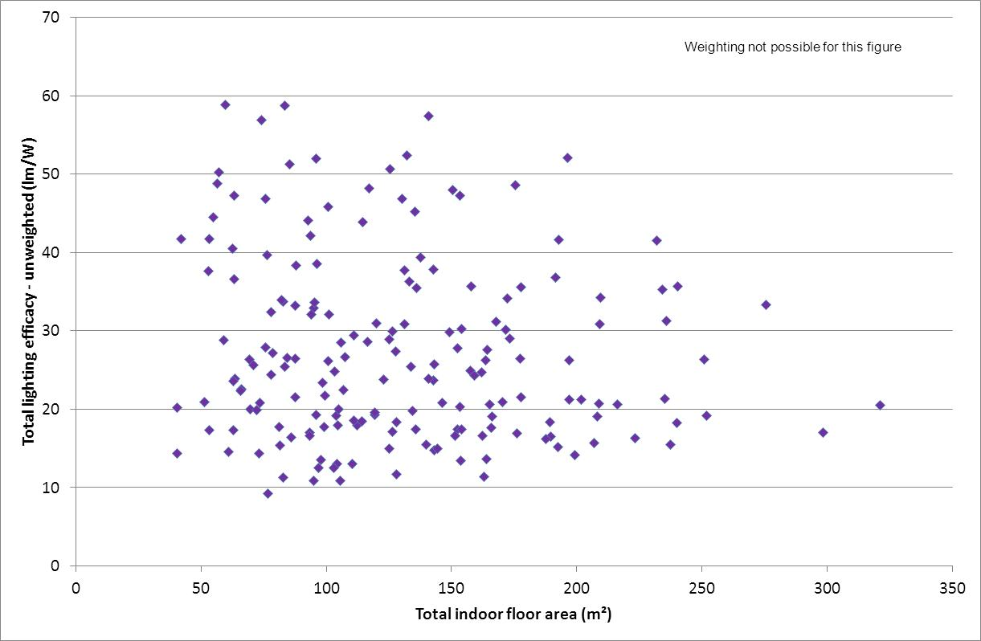

Note: values are not weighted by use – assumes all lamps are used equally. Excludes heat lamps. Demographic weightings are not applied to data in this figure.

Figure 22: House floor area versus total house lighting use weighted efficacy



Note: values are weighted by use – assumes all lamps are used as stated by householders. Excludes heat lamps. Demographic weightings are not applied to data in this figure.

The most important observation from this data is that that, when weighted by nominated usage levels, the efficacy of lamps as used is significantly higher than the average efficacy of lamps as installed. The mostly likely explanation for this is that that technologies with lower efficacy tend to have shorter lifetimes, which increases incidence of lamp replacement in high use areas, which in turn creates more opportunity for a householder to choose an efficient lamp (with a longer life). Some householders will also understand the efficacy and operating costs of different lamp technologies and this may influence, to some extent, the use of high efficacy lamps more and low efficacy lamps less where there are alternative options in the same space.

The impact of usage is quite significant on overall efficacy. Based on the unweighted data, most houses have an average efficacy of less than 30 lm/W. However, once the nominated usage levels are applied, the majority of households sit well above 30 lm/W. Quantitatively, the unweighted efficacy (with national sample weighting applied) is 27.7 lm/W, while the use weighted efficacy (with national sample weighting applied) is 42.5 lm/W, an increase of more than 50% (note that these values exclude heat lamps). This improvement in efficacy when weighted by use appears to be very consistent by region. There are of course a large number of households that have few or no high efficiency lamps – in those cases the usage pattern will have little impact on the use weighted efficacy. Conversely, when all lamps in a house are high efficacy, usage patterns also have little impact on the use weighted efficacy.

To illustrate the variation at a house level, which is considerable, a plot of efficacy unweighted by use (X axis) has been plotted against efficacy weighted by use (Y axis) in Figure 23. Many houses exhibit a significant increase in average efficacy when lamp use is taken into account. However, this effect is diminished for houses where the unweighted efficacy is very low (no efficient lamps present) or very high (all lamps are efficient). Surprisingly, many houses with only moderate average unweighted efficacy can achieve very high efficacy values during normal use.

Figure 23: Average efficacy of lamps versus efficacy weighted by use – all houses

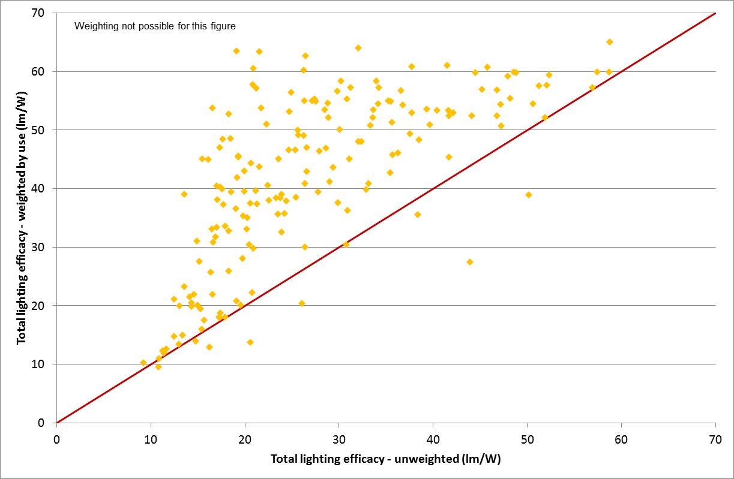

Note: Brown line represents equal efficacy for unweighted versus efficacy weighted by use.

Houses in Figure 23 that have an efficacy weighted by use that lies well above the red line must have a small number of high efficacy lamps (because the average efficacy is low) that are used for longer periods (because the use weighted efficacy is high). This suggests that just a few lamps in each house dominate total use (and energy) and that the efficacy of these lamps is very important. Analysis of audit data for each light confirms that only 23% of all lamps are used more 2 hours a day – these will have a significant impact on the overall efficacy weighted by use. There are around 6 houses where the efficacy weighted by use is lower than the average efficacy of all lights, so a decline in use weighted efficacy (compared to average efficacy) is possible, but rare. This figure also illustrates the value of targeting efficiency programs at higher usage lights and the value of raising the overall efficacy of the lighting stock. As noted above, high efficacy lamps may find their way into higher usage areas of the homes as most of CFLs and LEDs have much longer lives than incandescent and halogens. Also, some householders understand the economic benefits of actively selecting and installing high efficacy lamps in higher use areas. However, the cost of LEDs at this stage is likely to be limiting their diffusion rate, despite their very long life. And despite the availability of a wide range of high efficacy lamp options and the economic benefits that arise from their use, many households appear to overlook these technologies when replacing lamps.

Comparison by Region

The 2016 lighting audit covered five regions as follows:

* Brisbane: 40 houses
* Gippsland: 30 houses
* Melbourne: 40 houses
* Newcastle: 30 houses
* Sydney: 40 houses.

This section sets out a comparison of the characteristics of these houses by region. Given the relatively small sample size by region, there will be some uncertainty in the regional parameters calculated for comparison, as the mix of houses in each region cannot be fully controlled or balanced, even when regional weightings are applied (see Appendix B). To some extent, the sample bias within each region has been partly redressed by the application of regional weighting factors, although there are limitations given the small sample size. Limits have been placed on the range of weightings that have been generated by the analysis.

There are also some fundamental and inherent differences between these regions, which to some extent are reflected in the comparative results of the lighting audit. For example, the proportion of apartments and semi-detached dwellings is very high in Sydney and, to a lesser extent, Melbourne. These house types are considerably smaller than separate houses, so this will impact on the regional average floor area. Newcastle has strong working class origins and the average house size for separate houses is considerably smaller than for other regions. Share of house type by region from the 2011 census is shown in Table 6. Each region is quite different and none are precisely representative of the national average. A range of other demographic factors also vary by region, such as income, tenure and household size. Each of these factors will exert some influence on the regional averages.

Table : Share of house type by region from the 2011 census

|  |  |  |  |  |  |  |
| --- | --- | --- | --- | --- | --- | --- |
| House type | Brisbane | Gippsland | Melbourne | Newcastle | Sydney | National |
| Separate house | 79% | 90% | 72% | 88% | 60% | 75% |
| Semi-detached, terrace house, townhouse | 9% | 3% | 12% | 7% | 13% | 10% |
| Flat, unit or apartment | 12% | 7% | 16% | 5% | 27% | 15% |

Given these caveats and limitations on the direct comparison between regions, some headline data at a regional level has been compiled. Both unweighted (raw sample averages) and data weighted by regional and national demographic weighting factors (see Appendix B) has been shown for comparison.

Table : Headline parameters by region from the 2016 lighting audit (unweighted)

|  |  |  |  |  |  |  |  |
| --- | --- | --- | --- | --- | --- | --- | --- |
| Parameter | Weighting | Count | No. Lights | No. Switches | Sum Watts | No. Rooms | Floor Area |
| Brisbane | None | 40 | 40.0 | 27.8 | 1431 | 16.1 | 185.3 |
| Gippsland | None | 30 | 40.2 | 26.0 | 1267 | 15.5 | 145.2 |
| Melbourne | None | 40 | 42.2 | 25.8 | 1356 | 14.5 | 139.3 |
| Newcastle | None | 30 | 37.6 | 23.3 | 1327 | 15.3 | 142.6 |
| Sydney | None | 40 | 38.0 | 21.8 | 1274 | 13.3 | 120.2 |
| Total | None | 180 | 39.7 | 25.0 | 1335 | 14.9 | 146.8 |

Note: Floor area includes outdoor areas.

Table : Headline parameters by region from the 2016 lighting audit (weighted by region)

|  |  |  |  |  |  |  |  |
| --- | --- | --- | --- | --- | --- | --- | --- |
| Parameter | Weighting | Count | No. Lights | No. Switches | Sum Watts | No. Rooms | Floor Area |
| Brisbane | Region | 40 | 31.1 | 23.2 | 1122 | 13.9 | 156.8 |
| Gippsland | Region | 30 | 36.8 | 24.3 | 1204 | 14.7 | 137.4 |
| Melbourne | Region | 40 | 45.4 | 27.8 | 1496 | 15.3 | 147.4 |
| Newcastle | Region | 30 | 32.4 | 20.3 | 1123 | 14.4 | 129.1 |
| Sydney | Region | 40 | 35.0 | 20.0 | 1182 | 12.9 | 115.0 |
| Total | National | 180 | 36.6 | 23.7 | 1246 | 14.5 | 140.0 |

Note: Floor area includes outdoor areas.

Table : Indoor parameters by region (unweighted)

|  |  |  |  |  |  |  |  |  |
| --- | --- | --- | --- | --- | --- | --- | --- | --- |
| Parameter | Weighting | No. Rooms | Floor Area | Lights /m2 | Lights /Room | W/m2 | W/m2 Fixed | W/m2 Plug |
| Brisbane | None | 13.1 | 140.0 | 0.22 | 2.4 | 6.6 | 5.7 | 0.9 |
| Gippsland | None | 13.5 | 135.9 | 0.22 | 2.2 | 5.6 | 5.0 | 0.6 |
| Melbourne | None | 12.9 | 133.4 | 0.27 | 2.8 | 7.6 | 6.9 | 0.6 |
| Newcastle | None | 12.0 | 124.5 | 0.23 | 2.4 | 6.9 | 6.3 | 0.6 |
| Sydney | None | 10.8 | 115.1 | 0.28 | 2.9 | 7.1 | 6.3 | 0.8 |
| Total | None | 12.4 | 129.7 | 0.24 | 2.6 | 6.8 | 6.1 | 0.7 |

Table : Indoor parameters by region (weighted by region)

|  |  |  |  |  |  |  |  |  |
| --- | --- | --- | --- | --- | --- | --- | --- | --- |
| Parameter | Weighting | No. Rooms | Floor Area | Lights /m2 | Lights /Room | W/m2 | W/m2 Fixed | W/m2 Plug |
| Brisbane | Region | 11.3 | 117.7 | 0.21 | 2.2 | 5.9 | 5.0 | 0.9 |
| Gippsland | Region | 12.7 | 129.2 | 0.21 | 2.2 | 5.7 | 5.0 | 0.7 |
| Melbourne | Region | 13.6 | 139.5 | 0.27 | 2.7 | 7.5 | 7.0 | 0.5 |
| Newcastle | Region | 11.5 | 113.6 | 0.22 | 2.2 | 6.4 | 5.8 | 0.6 |
| Sydney | Region | 10.7 | 112.2 | 0.27 | 2.8 | 6.4 | 5.7 | 0.7 |
| Total | National | 12.1 | 124.3 | 0.23 | 2.4 | 6.6 | 5.9 | 0.7 |

The next obvious parameter to examine is the overall share of lamp technology by region. This has been somewhat simplified into seven basic lighting categories as set out in Table 11 and Table 12.

Table : Share of lighting technologies by region (unweighted)

|  |  |  |  |  |  |  |  |  |
| --- | --- | --- | --- | --- | --- | --- | --- | --- |
| Parameter | Weighting | Incandescent | Halogen mains | Halogen ELV | CFL | Linear Fluorescent | LED | Other |
| Brisbane | None | 12.7% | 18.9% | 11.3% | 29.7% | 11.8% | 12.9% | 2.8% |
| Gippsland | None | 10.0% | 16.8% | 12.0% | 35.2% | 9.2% | 16.5% | 0.3% |
| Melbourne | None | 13.6% | 17.7% | 12.8% | 25.9% | 6.5% | 22.9% | 0.8% |
| Newcastle | None | 10.3% | 12.8% | 17.6% | 30.3% | 10.0% | 19.1% | 0.0% |
| Sydney | None | 17.3% | 14.9% | 23.3% | 28.7% | 5.7% | 10.1% | 0.0% |
| Total | None | 13.1% | 16.4% | 15.3% | 29.6% | 8.5% | 16.2% | 0.9% |

Table : Share of lighting technologies by region (weighted by region)

|  |  |  |  |  |  |  |  |  |
| --- | --- | --- | --- | --- | --- | --- | --- | --- |
| Parameter | Weighting | Incandescent | Halogen mains | Halogen ELV | CFL | Linear Fluorescent | LED | Other |
| Brisbane | Region | 13.6% | 21.8% | 6.1% | 31.4% | 11.8% | 10.5% | 4.8% |
| Gippsland | Region | 10.9% | 18.7% | 12.7% | 35.0% | 10.0% | 12.3% | 0.5% |
| Melbourne | Region | 13.0% | 15.7% | 14.1% | 27.7% | 7.7% | 21.3% | 0.6% |
| Newcastle | Region | 10.6% | 15.0% | 18.7% | 31.5% | 7.7% | 16.5% | 0.0% |
| Sydney | Region | 16.9% | 16.0% | 22.4% | 32.2% | 5.0% | 7.5% | 0.0% |
| Total | National | 12.7% | 16.7% | 14.6% | 31.0% | 8.9% | 15.2% | 1.0% |

The results on technology share show a remarkably uniform penetration by technology across the states. The noticeable points of difference are that Sydney appears to have significantly higher incandescent and halogen penetration when compared to other regions as well as lower linear fluorescent and lower LED. This trend is not evident in Newcastle. Melbourne has a significantly higher LED share, but the CFL share is lower, which means that the average efficacy is similar to other regions. The final comparison is the overall efficacy of lighting by region. Both average efficacy of all lamps (not weighted by use) and average efficacy weighted by use is shown in Table 13.

Table : Lighting efficacy by region

|  |  |  |  |  |  |  |  |  |
| --- | --- | --- | --- | --- | --- | --- | --- | --- |
| Parameter | Weighting =🡺 | Average efficacy (no use) | Average efficacy (with use) | Ratio  (no use /with use) | Weighting =🡺 | Average efficacy (no use) | Average efficacy (with use) | Ratio  (no use /with use) |
| Brisbane | None | 27.9 | 44.4 | 1.59 | Regional | 27.9 | 43.2 | 1.55 |
| Gippsland | None | 29.6 | 44.4 | 1.50 | Regional | 28.9 | 42.7 | 1.48 |
| Melbourne | None | 25.3 | 40.8 | 1.61 | Regional | 26.4 | 42.9 | 1.62 |
| Newcastle | None | 28.5 | 43.8 | 1.54 | Regional | 26.5 | 41.9 | 1.58 |
| Sydney | None | 26.1 | 36.4 | 1.40 | Regional | 28.3 | 41.2 | 1.46 |
| Total | None | 27.3 | 41.7 | 1.53 | National | 27.7 | 42.5 | 1.53 |

Note: All efficacy units are in lm/W.

The householder questionnaire asked whether any organisations had come to visit in the last five years to replace light bulbs. The questionnaire also asked householders whether had been any major changes to the lighting systems in the past five years. Table 14 sets out the headline results at a regional level.

Table : Impact of lighting replacement programs and lighting renovations

|  |  |  |  |  |  |
| --- | --- | --- | --- | --- | --- |
| Parameter | Brisbane | Gippsland | Melbourne | Newcastle | Sydney |
| Total houses | 40 | 30 | 40 | 30 | 40 |
| Houses visited – lamp replacement | 7 | 10 | 14 | 3 | 3 |
| Share visited | 18% | 33% | 35% | 10% | 8% |
| Lamps replaced/house | 7.3 | 19.7 | 24.8 | 11.3 | 5.0 |
| Unweighted efficacy participants | 23.6 | 37.1 | 30.0 | 34.3 | 23.9 |
| Unweighted efficacy other houses | 28.8 | 25.9 | 22.7 | 27.8 | 26.3 |
| Weighted efficacy participant houses | 42.9 | 56.0 | 52.0 | 54.3 | 36.9 |
| Weighted efficacy other houses | 44.8 | 38.6 | 34.7 | 42.6 | 36.4 |
| Improvement unweighted efficacy | -18% | +43% | +32% | +23% | -9% |
| Improvement weighted efficacy | -4% | +45% | +50% | +27% | +1% |
| Major lighting renovation in last 5 years | 8 | 3 | 7 | 7 | 12 |
| Renovation % of sample | 20% | 10% | 18% | 23% | 30% |
| Weighted efficacy renovated houses | 50.4 | 56.5 | 51.5 | 45.9 | 37.0 |
| Weighted efficacy other houses | 42.9 | 43.0 | 38.5 | 43.2 | 36.1 |
| Improvement weighted efficacy | +17% | +31% | +34% | +6% | +3% |

Notes: Efficacy values are lm/W. Weighted values take into account householder nominated usage of each lamp. All values exclude heat lamps.

There are a number of key points of interest in Table 14.

* Around one third of all houses appear to have been visited in Victoria (presumably under the VEET scheme) whereas only about 10% of houses have been visited in the other states (there is no formal scheme in NSW or Queensland but private and NGO operators may be present).
* The average number of lamps replaced in Victoria was about 20 to 25, whereas this is 5 to 11 in the other states.
* Houses that claim to have had a visit in Victoria are on average 40% to 50% higher efficacy (unweighted and weighted) when compared with houses that had not had a visit.
* Houses that claim to have had a visit in Newcastle are on average 25% higher efficiency (unweighted and weighted) when compared with houses that had not had a visit (note that this is a small sample of just 3 houses or 10% so there may be some sample bias).
* Houses that claim to have had a visit in Sydney and Brisbane showed no improvement in efficacy (unweighted and weighted) when compared with houses that had not had a visit (again note the relatively small sample for each).
* Houses that indicated that they had undertaken major renovations in the past 5 years in Victoria are on average 30% higher efficacy (weighted) when compared with houses that had not had a visit.
* Houses that indicated that they had undertaken major renovations in the past 5 years in Brisbane are on average about 15% higher efficacy (weighted) when compared with houses that had not had a visit.
* Houses that indicated that they had undertaken major renovations in the past 5 years in NSW are on average about 5% higher efficacy (weighted) when compared with houses that had not had a visit.

This data suggests that programs such as VEET, which have reached more than 30% of Victorian households, are having a significant impact on the overall lighting efficacy in the residential sector. The impact of major lighting upgrades also appears to have the potential to improve overall efficacy to some extent. The result in Victoria for renovations may reveal some cross correlation between VEET visits and the interpretation of major lighting changes (7 out of 24 respondents in Victoria answered yes to both questions) rather than a state specific improvement in lighting efficacy from renovations in Victoria, but the rate of renovation was lower than in other states.

4. Detailed Results by Room Type

Overview

Results are reported for the room aggregations as outlined in Section 2. It is important to understand not only the results for the whole house, but also for these individual room types, as key trends and findings may only become apparent after analysis has been completed for this level. Detailed results from the survey are split into several sections:

* Living rooms;
* Sleeping rooms;
* Indoor-other rooms; and
* Outdoors.

A range of characteristics are reported for each room type, corresponding with the key interests concerning lighting (note that usage related aspects are reported in Section 6):

* Numbers and electrical connection:
* Lamp numbers;
* Switch numbers;
* Lamp numbers – fixed, plug;
* Lamp share – fixed, plug.
* Room and area:
* Number of rooms;
* Floor area;
* Room share;
* Area share;
* Lamps per m2;
* Lamps per room.
* Watts:
* Total Watts;
* Power Density (Watts/m2);
* Power Density (Watts/m2) – fixed, plug.
* Lumens:
* Lumens total;
* Lighting Density (lm/m2);
* Lighting Density (lm/m2) – fixed, plug.

These key parameters are set out in Table 15 and Table 16.

Table : Key lighting parameters by location

|  |  |  |  |  |  |
| --- | --- | --- | --- | --- | --- |
| Parameter | Whole house | Living | Sleeping | Indoor Other | Outdoor |
| Number of Lamps | 36.6 | 13.2 | 7.8 | 8.1 | 7.4 |
| Number of Switches | 23.7 | 6.7 | 6.1 | 6.3 | 4.6 |
| Number of Fixed Lamps | 32.9 | 12.3 | 5.6 | 8.0 | 7.1 |
| Number of Plug Lamps | 3.6 | 1.0 | 2.2 | 0.1 | 0.3 |
| Number of Rooms | 14.5 | 3.2 | 3.3 | 5.7 | 2.4 |
| Floor Area (m2) | 140.0 | 56.7 | 39.3 | 28.3 | 15.7 |
| Share of all Rooms | 100% | 21.9% | 22.6% | 39.2% | 16.4% |
| Share of all Floor Area | 100% | 40.5% | 28.1% | 20.2% | 11.2% |
| Lamps per m2 (indoor) | 0.23 | 0.23 | 0.20 | 0.29 | N/A |
| Lamps per Room | 0.10 | 4.3 | 2.4 | 1.4 | N/A |
| Total Watts | 1246.2 | 385.9 | 214.2 | 255.6 | 390.4 |
| Power Density (Watts/m2) – Fixed Lamps indoor | 6.7 | 6.3 | 4.1 | 11.1 | N/A |
| Power Density (Watts/m2) – Plug Lamps indoor | 0.7 | 0.6 | 1.4 | 0.1 | N/A |
| Lumens | 29279 | 8859 | 5172 | 5954 | 9295 |
| Lighting Density (lm/m2) – Fixed Lamps indoor | 157.0 | 149 | 107 | 243 | N/A |
| Lighting Density (lm/m2) – Plug Lamps indoor | 15.1 | 12 | 28 | 2 | N/A |

Note: All valves have been weighted in accordance with national demographic weighting factors, but have not taken into account usage patterns. Excludes heat lamps.

Table : Average House Summary - lamp number and characteristics by technology and location

|  |  |  |  |  |  |  |  |  |  |  |  |  |  |  |
| --- | --- | --- | --- | --- | --- | --- | --- | --- | --- | --- | --- | --- | --- | --- |
| Average Per House | Incand-escent. | Halogen MV | Halogen ELV | CFL integral | CFL  plug-in | Linear Fluor-escent | Circular Fluor-escent | LED Direct-ional | LED Direct-ional ELV | LED Non Direct-ional | Other | Cannot identify low eff | Cannot identify high eff | Total |
| Whole house count | 4.6 | 6.1 | 5.3 | 11.2 | 0.1 | 2.7 | 0.6 | 2.9 | 1.6 | 1.1 | 0.0 | 0.3 | 0.1 | 36.6 |
| Living lamp count | 1.2 | 2.3 | 2.8 | 3.4 | 0.0 | 0.5 | 0.3 | 1.5 | 0.9 | 0.4 | 0.0 | 0.1 | 0.0 | 13.2 |
| Sleeping lamp count | 0.9 | 1.4 | 0.9 | 3.1 | 0.0 | 0.2 | 0.1 | 0.4 | 0.3 | 0.4 | 0.0 | 0.1 | 0.0 | 7.8 |
| Indoor-other count | 1.0 | 1.3 | 1.1 | 3.0 | 0.0 | 0.4 | 0.2 | 0.6 | 0.3 | 0.1 | 0.0 | 0.1 | 0.0 | 8.1 |
| Outdoor lamp count | 1.5 | 1.1 | 0.5 | 1.7 | 0.0 | 1.6 | 0.0 | 0.4 | 0.1 | 0.2 | 0.0 | 0.1 | 0.0 | 7.4 |
| Whole house Watts | 335.9 | 315.1 | 254.0 | 154.1 | 1.8 | 103.5 | 20.5 | 21.0 | 13.8 | 12.6 | 0.4 | 12.9 | 0.6 | 1246 |
| Living Watts | 45.1 | 108.8 | 133.6 | 45.1 | 0.7 | 15.8 | 11.4 | 10.4 | 7.7 | 5.1 | 0.0 | 2.1 | 0.1 | 386 |
| Sleeping Watts | 40.1 | 68.4 | 43.5 | 42.0 | 0.0 | 6.6 | 2.4 | 2.6 | 2.4 | 2.8 | 0.4 | 2.9 | 0.1 | 214 |
| Indoor-other Watts | 72.7 | 57.1 | 52.7 | 42.5 | 0.7 | 12.5 | 5.1 | 4.7 | 3.0 | 0.7 | 0.0 | 3.8 | 0.1 | 256 |
| Outdoor Watts | 178.0 | 80.8 | 24.3 | 24.5 | 0.4 | 68.6 | 1.5 | 3.2 | 0.7 | 4.0 | 0.0 | 4.1 | 0.2 | 390 |
| Whole house Lumens | 2999 | 4084 | 2875 | 8730 | 78 | 6282 | 1042 | 1364 | 784 | 822 | 3 | 176 | 40 | 29279 |
| Living Lumens | 399 | 1359 | 1515 | 2551 | 26 | 945 | 581 | 678 | 441 | 329 | 0 | 27 | 8 | 8859 |
| Sleeping Lumens | 365 | 906 | 486 | 2367 | 1 | 385 | 128 | 170 | 134 | 182 | 3 | 38 | 6 | 5172 |
| Indoor-other Lumens | 631 | 706 | 598 | 2419 | 31 | 733 | 253 | 306 | 167 | 48 | 0 | 52 | 10 | 5954 |
| Outdoor Lumens | 1604 | 1114 | 277 | 1392 | 19 | 4219 | 79 | 210 | 42 | 262 | 0 | 59 | 16 | 9295 |

Note: All valves have been weighted in accordance with national demographic weighting factors, but have not taken into account usage patterns.

Living

These are generally the high use areas of a house, and as such, are one of the most interesting areas in terms of lighting technologies and lighting levels. It is expected that householders would spend the largest amount of time in these areas, both during the day and evening hours. Unlike sleeping areas, living areas are focal points of household activity for the purposes of cooking, eating, entertainment and family activities. The living area is an aggregation of the:

* Dining;
* Kitchen;
* Lounge;
* Kitchen/Living; and
* Living-other.

The living area analysis presented here has been split into two sections – average values and frequency distributions – for different lamp and room characteristics.

Living Areas - Key Parameters

Table 15 and Table 16 show all the key parameters. The average number of lamps in living areas was just over 13 per house, with 12.3 of these being fixed lamps. Lamps in living areas were found on 6.7 switches, indicating that around 2 lamps were controlled by each switch.

The average number of living rooms per house was just over 3 per house, although this includes open space living areas as well. The average living room floor area per house was found to be 57 m2, a sizeable proportion of the total space in a house. The share of all floor area shows this more clearly, as living areas made over 40% of the average house. There were around 4.3 lamps per room, with 0.23 lamps per m2.

Total watts in living rooms was 386 per house, with the majority due to fixed lamps (almost 90%). Plug lamps only contributed around 10% of the share of total Watts. The power density for living rooms was found to be 6.3 Watts/m2. Again, most of this average was due to fixed lamps.

The average lumen output in living areas was almost 9,000, with the majority due to fixed lamps (over 90%). Lighting density in living areas had an average of 160 lm/m2, with the majority of this (almost 149 lm/m2) being due to fixed lamps.

Of the houses sampled, some 43 had a separate kitchen. A separate kitchen is defined as a space that is separate from adjacent living areas (usually with its own walls and often a door). 139 houses had open plan kitchens (noting that 2 houses in the sample had 2 kitchens). Open plan kitchens often had no clear boundary or delineation between the kitchen itself, and the adjacent living area. Lights were often providing illumination to both spaces, so it was not always possible to allocate a specific light to one space or the other. In some cases, kitchens and adjacent living areas were counted as a single space (kitchen/living). While it is possible to calculate specific lighting parameters for separate kitchens, this only represents less than 25% of households, so is of limited value.

Living Areas - Frequency Distributions

Figure 24 shows the number of lamps (both fixed and plug) in the living areas of houses. The highest percentage of houses (around 13%), had more than 6 and up to 8 lamps. Although numbers ranged significantly, the majority of houses were found to have more than 4 and up to 22 lamps in living areas. A smaller number of houses had more than 30 lamps.

Figure 24: Distribution of lamps counts in living areas for all houses

% Lamps in living area
1.7% 1-2
10.6% 3-4
9.5% 5-6
13.3% 7-8
11.3% 9-10
7.5% 11-12
7.2% 13-14
7.9% 15-16
9.3% 17-18
6.1% 19-20
4.7% 21-22
1.5% 23-24
0.8% 25-26
2.4% 27-28
2.1% 29-30
3.8% 31-40
0.5% 41-50
0.0% 51-60


Figure 25 shows the number of fixed lamps found in living areas in houses. Around half of houses were found to have less than 10 fixed lamps in living areas. Only a handful of houses had more than 30 lamps in living areas.

Figure 25: Distribution of fixed lamps in living areas for all houses

% Fixed lamps in living area
3.9% 1-2
16.7% 3-4
8.7% 5-6
8.2% 7-8
13.0% 9-10
6.4% 11-12
9.3% 13-14
7.0% 15-16
8.2% 17-18
4.5% 19-20
3.7% 21-22
1.0% 23-24
2.3% 25-26
1.7% 27-28
1.9% 29-30
3.3% 31-40
0.2% 41-50
0.0% 51-60


Figure 26 shows the number of plug lamps found in living areas in houses. Most houses (77%), had none or only 1 plug lamp. Another 13% of houses were found to have 2 plug lamps, with a smaller number having either 3 or 4. A small percentage of houses had between 5 and 9.

Figure 26: Distribution of plug-in lamps in living areas for all houses

% Plug in lamps in living area
47.3% 0
29.9% 1
12.6% 2
4.4% 3
3.3% 4
0.6% 5
1.4% 6
0.0% 7
0.4% 8
0.2% 9
0.0% 10


Figure 27 shows the number of living rooms per house. About 34% of houses were found to have 3 living areas (most probably a kitchen and a lounge). About 25% had 2 or 4 living areas, with about 10% having 5 or more. When comparing to the 2010 audit, it should be noted that in most houses with an open plan kitchen, the kitchen/living was counted as a single space whereas in 2016 the kitchen was usually separately recorded from any open plan living area (even though in practical terms these were the same space).

Figure 27: Distribution of living rooms per house for all houses

% Living room count per house
0.0% 0
4.1% 1
25.6% 2
34.2% 3
24.7% 4
8.9% 5
0.9% 6
1.5% 7
0.0% 8
0.0% 9
0.0% 10


Figure 28 shows the average living room floor area per house. Living area floor areas from 25m2 to 75m2 were common. The minimum floor area was around 20 m2, and the maximum was found to be around 150 m2.

Figure 28: Distribution of living area floor area (m2) for all houses

% Floor area m²
2.9% 0<A≤25
9.7% 25<A≤30
11.8% 30<A≤35
8.3% 35<A≤40
7.3% 40<A≤45
5.2% 45<A≤50
9.2% 50<A≤55
5.2% 55<A≤60
7.0% 60<A≤65
5.0% 65<A≤70
7.5% 70<A≤75
3.8% 75<A≤80
2.4% 80<A≤85
1.8% 85<A≤90
4.5% 90<A≤95
3.5% 95<A≤100
4.3% 100<A≤125
0.6% 125<A≤150


Figure 29 shows the average power density for living areas. About two thirds of houses had a lower power density (up to 7W/m2) centred on about 4 W/m2, while the remaining third had half of houses a higher power density (above 7W/m2) centred on about 12 W/m2. This suggests very different diffusion of efficient lighting technologies in each group.

Figure 29: Distribution of living area power density for all houses

% Living area power density W/m²
1.7% 0<W/m²≤1
6.3% 1<W/m²≤2
13.0% 2<W/m²≤3
16.6% 3<W/m²≤4
10.8% 4<W/m²≤5
6.6% 5<W/m²≤6
11.1% 6<W/m²≤7
2.7% 7<W/m²≤8
4.4% 8<W/m²≤9
3.8% 9<W/m²≤10
8.0% 10<W/m²≤12
5.1% 12<W/m²≤14
2.3% 14<W/m²≤16
3.4% 16<W/m²≤18
2.1% 18<W/m²≤20
1.2% 20<W/m²≤22
0.4% 22<W/m²≤24
0.5% 24<W/m²≤26


Figure 30 shows the range of total lumens in living areas in houses. This is of limited value as the total lumens will be strongly correlated to floor area. Most houses lay in the range 6,000 to 18,000 lumens. When comparing these values to the 2010 audit, it needs to be understood that lumen output was probably somewhat overestimated in 2010 due to fairly simplistic assumptions on efficacy by technology. In general terms, lighting levels from 2010 need to be scaled by about 0.8 to be equivalent to 2016 levels (although this varies by technology). This is discussed in more detail in the section that compares 2010 to 2016 results (Section 8).

Figure 30: Distribution of living area total lumens for all houses

% Living area light output lm
3.7% 0<lm≤2000
8.2% 2000<lm≤4000
19.6% 4000<lm≤6000
16.9% 6000<lm≤8000
14.3% 8000<lm≤10000
13.6% 10000<lm≤12000
8.2% 12000<lm≤14000
6.3% 14000<lm≤16000
5.1% 16000<lm≤18000
2.4% 18000<lm≤20000
0.4% 20000<lm≤22000
0.4% 22000<lm≤24000
0.6% 24000<lm≤26000
0.0% 26000<lm≤28000
0.0% 28000<lm≤30000
0.4% 30000<lm≤32000
0.0% 32000<lm≤34000
0.0% 34000<lm≤36000


Figure 31 shows the lighting density for the living areas in houses. The majority of houses had an average lighting density in the range 100 and 200 lm/m2. About 16% of houses were below these lighting density levels and about 22% of houses were above these levels.

Figure 31: Distribution of living area lighting density for all houses

% Living area lighting density lm/m²
1.7% 20<lm/m²≤40
3.0% 40<lm/m²≤60
8.2% 60<lm/m²≤80
4.3% 80<lm/m²≤100
10.9% 100<lm/m²≤120
12.3% 120<lm/m²≤140
15.6% 140<lm/m²≤160
10.4% 160<lm/m²≤180
11.5% 180<lm/m²≤200
5.7% 200<lm/m²≤220
3.4% 220<lm/m²≤240
2.1% 240<lm/m²≤260
5.1% 260<lm/m²≤280
1.1% 280<lm/m²≤300
4.2% 300<lm/m²≤400
0.0% 400<lm/m²≤500
0.5% 500<lm/m²≤600


Sleeping

It is expected that householders would spend a reasonably large amount of time in sleeping areas, although in differing periods of the day/night. Many of the hours will be during sleep periods with no lighting. The sleeping area is an aggregation of the:

* Bedroom; and
* Study (this was included as these spaces were assumed to have a similar interest and use profile as bedrooms and often these were used interchangeably).

Bedroom lighting use may differ from study lighting use, although it is not expected to affect the analysis as the prevalence of these rooms is fairly low.

Table 15 and Table 16 show all the key parameters for sleeping areas. The average number of lamps was found to be just about 8 per house, with 5.6 of these being fixed lamps (around 75%). These lights were found on 6.1 switches.

The average number of sleeping rooms per house was found to be 3.3 (almost 23% of all rooms). The average sleeping room floor area per house was 39.3 m2, almost 30% of the average house. There were just over 2.4 lamps per room, with 0.2 lamps per m2.

Sleeping rooms had a total average of 214 Watts per house, with the majority of these due to fixed lamps (around 75%). The power density for sleeping rooms was found to be 5.5 Watts/m2, with 4.1 Watts/m2 of this being due to fixed lamps.

The average lumen output was around 5100, with around 80% this from fixed lamps. Sleeping areas had a lighting density of 135 lm/m2, with the majority of this (80%) being from fixed lamps.

Indoor-other

These are a collection of ‘intermediate use’ areas of a house, which for lighting may mean ‘on/off’ type use for short durations in many cases. It is not expected that there would be any strong pattern to this usage (time of day or otherwise), even by room type, except for bathrooms.

The indoor-other area is an aggregation of the:

* Bathroom;
* Foyer-inside;
* Hallway;
* Laundry;
* Stairwell;
* Storage Room;
* Toilet;
* Walk-in Robe; and
* Other-inside.

This rather eclectic mix of rooms has been aggregated into one space, as it is expected that analysis at an individual room level (for any room type) would not provide useful or meaningful results. Compared to living or sleeping areas, these are normally small sized rooms, probably with a lower number of lamps per room and on average are likely to have fairly low usage. However, this category of room type is the most numerous in an average home.

Table 15 and Table 16 show all the key parameters for indoor-other areas. The average number of lamps was just 8 per house, with most being fixed lamps (around 99%). These lights were found on 6.3 switches.

On average there were almost 6 indoor-other rooms per house, with a total average floor area of around 28 m2. The share of all rooms was almost 40%, with the share of floor area found to make up just over 20% of the average house. There were 1.4 lamps per room, with 0.29 lamps per m2.

Total lamp power was 256 W per house, with the majority of these due to fixed lamps (99%). Indoor-other rooms had a power density of 11 Watts/m2, with almost all of this being due to fixed lamps. These figures exclude heat lamps.

The average lumens in indoor-other spaces was almost 6,000, with most of this being due to fixed lamps (around 99%). Indoor-other rooms had a lighting density of 243 lm/m2, with almost all of this being due to fixed lamps. These figures exclude heat lamps.

Outdoor

These are a collection of probably rare and intermediate use areas of a house, which for lighting may mean either ‘on/off’ type use for short durations (including through sensors), or infrequent use in many cases. The outside area is an aggregation of:

* Garage;
* Other-outside;
* Outside-general; and
* Veranda.

Table 15 and Table 16 show all the key parameters for outdoor areas. The average number of lamps was 7.4 per house, with around 7.1 of these being fixed lamps (95%). Outdoor area lights were controlled by 4.6 switches.

There was an average of 2.4 outdoor ‘spaces’ (distinct areas in which lamps were located) per house. However, in many cases these included large areas or areas they were not well defined (garden, backyard, front of house etc.). The average floor area per house was about 15.7 m2 (garages, some sheds and under house areas), but it needs to be noted that the floor area of many outdoor spaces was not recorded as there was no logical or distinct boundary that could be measured, so the outdoor floor area is often not measured (or may be ill defined) and the values that are recorded needs to be treated with some caution as they are incomplete. The share of all floor area for outdoor areas was 11% of the average house (noting the above caveats). There were just over 3 lamps per space.

Outdoor areas had an average total power of just over 390 W per house, with the majority due to fixed lamps (almost 95%).

The average Lumens was around 9,000 with 95% being due to fixed lamps. The results for this space type are influenced by the prevalence of higher power incandescent and halogen (mains voltage) spotlights (not currently subject to MEPS), which are often used to light up outdoor areas for short periods and occasionally for entertainment.

5. Detailed Results by Technology

Overview

The mix of lamp technology has a large influence on the lighting energy consumption of a house. Different technologies have differing efficacy levels and sometimes different dominant fitting types. Size, lamp shape and direction of light output are the most important factors that impact on the ability to retrofit when attempting to increase the general efficiency of lighting. They also impact on the ability of the householder to alter the lighting makeup or mood of their house. Figure 10, Figure 11 and Figure 12 give a detailed breakdown of lamp count, power and lumens by technology. This section provides more detail on each of the main lighting technologies found in Australian homes.

The values reported in this section give the average number of lamps per house, when averaged across all houses. The number of lamps per house varies considerably by technology. Some of the headline data in terms of the count of houses by number of lamps per house is given in Table 17. The distribution by technology needs to be considered when analysing each technology. For example, only 7% of houses do not have any CFLs, while about 40% of houses have no LED lamps at all. Almost 60% of houses now have no halogen ELV lights installed.

Table : Share of houses by lamp count per house by lighting technology

|  |  |  |  |  |  |  |
| --- | --- | --- | --- | --- | --- | --- |
| Lamps/ house | Incand. | Halogen mains | Halogen ELV | CFL | Linear Fluoro | Any LED |
| None | 17.0% | 15.3% | 58.3% | 7.4% | 33.4% | 39.9% |
| 1 to 4 | 45.8% | 35.2% | 16.3% | 18.2% | 46.1% | 28.4% |
| 5 to 9 | 24.3% | 25.4% | 8.2% | 20.8% | 17.2% | 13.3% |
| 10 to 19 | 9.4% | 19.3% | 8.0% | 39.6% | 2.7% | 11.3% |
| 20 to 29 | 3.2% | 3.8% | 2.8% | 8.7% | 0.6% | 2.6% |
| 30 to 39 | 0.2% | 0.6% | 3.3% | 3.7% | 0.0% | 2.7% |
| 40 to 49 | 0.0% | 0.0% | 3.1% | 1.2% | 0.0% | 1.3% |
| 50 to 74 | 0.0% | 0.4% | 0.0% | 0.4% | 0.0% | 0.4% |
| 75 to 99 | 0.0% | 0.0% | 0.0% | 0.0% | 0.0% | 0.2% |

Note: All valves have been weighted in accordance with national demographic weighting factors, but have not taken into account usage patterns. All columns add to 100%.

Incandescent

Incandescent lamps are the original technology for producing light using electricity. They produce light by heating a tungsten filament to a high temperature until it glows. In terms of the general conversion of energy to light, this technology is low efficacy due to the high amount of heat produced by the process. Australian Governments introduced regulations to phase out incandescent as a mainstream lighting technology in 2009, however some types (MV reflector, and candle, decorative and fancy round ≤ 25W) are currently outside the scope of MEPS and remain available.

Table 18 shows the findings for incandescent lamps, by household area. Incandescent lamps made up about 12% of lamps, with 4.6 lamps per house.

Table : Detailed results – incandescent technology

|  |  |  |  |  |  |
| --- | --- | --- | --- | --- | --- |
| Parameter | Whole house | Living | Sleeping | Indoor-other | Outdoor |
| Number of Lamps | 4.6 | 1.2 | 0.9 | 1.0 | 1.5 |
| Watts Total | 335.9 | 45.1 | 40.1 | 72.7 | 178.0 |
| Watts per Lamp | 72.4 | 38.9 | 43.2 | 72.3 | 115.3 |
| Lumens Total | 2999 | 399 | 365 | 631 | 1604 |
| Lumens per lamp | 647 | 343 | 394 | 628 | 1039 |
| Estimated Efficacy lm/W | 8.9 | 8.8 | 9.1 | 8.7 | 9.0 |

Halogen

Halogen lamps produce light by heating a metal filament to a high temperature until it glows (similar to incandescent lamps), although they also contain a small amount of halogen gas inside a sealed capsule to increase filament lifetime and which allows operating temperature to increase (and therefore intensity). Halogen lamps are also similar to incandescent lamps in that electrical energy to light conversion is relatively poor due to the amount of heat produced. However, halogen lamps are slightly more efficient than incandescents.

Many householders appear to hold misconceptions concerning halogen lamps that they are an energy efficient form of lighting. This was found in a significant minority of households.

Halogen downlights (MR16) were very popular in the 2010 audit, but they are starting to be replaced by LED options. In the 2010 audit, mains voltage halogens (both MR16 types and more general lighting service lamps) were fairly unusual, however mains voltage halogen for general lighting are now fairly common in houses, being the cheapest replacement lamp type.

This section outlines the findings for both mains voltage and extra low voltage halogen lamps.

Table 19 shows the findings for mains voltage halogen lamps, by household area. Mains voltage halogen lamps made up 16% of all lamps in houses, with just over 6 per house. The majority of these were general lighting lamps.

Table : Detailed results – mains voltage halogen technology

|  |  |  |  |  |  |
| --- | --- | --- | --- | --- | --- |
| Parameter | Whole house | Living | Sleeping | Indoor-other | Outdoor |
| Number of Lamps | 6.1 | 2.3 | 1.4 | 1.3 | 1.1 |
| Watts Total | 315.1 | 108.8 | 68.4 | 57.1 | 80.8 |
| Watts per Lamp | 51.6 | 47.0 | 48.6 | 44.9 | 73.0 |
| Lumens Total | 4084 | 1359 | 906 | 706 | 1114 |
| Lumens per lamp | 669 | 587 | 643 | 555 | 1007 |
| Estimated Efficacy lm/W | 13.0 | 12.5 | 13.2 | 12.4 | 13.8 |

Table 20 shows the findings for extra low voltage halogen lamps, by household area. Extra low voltage halogen lamps made up 14% of all lamps in houses, with 5.3 per house, which is a significant decline since 2010. Most of this technology will be flush mounted downlights, with some being desk lamps and applications such as range hoods.

Table : Detailed results – extra low voltage halogen technology

|  |  |  |  |  |  |
| --- | --- | --- | --- | --- | --- |
| Parameter | Whole house | Living | Sleeping | Indoor-other | Outdoor |
| Number of Lamps | 5.3 | 2.8 | 0.9 | 1.1 | 0.5 |
| Watts Total | 254.0 | 133.6 | 43.5 | 52.7 | 24.3 |
| Watts per Lamp | 47.6 | 47.5 | 47.3 | 47.4 | 48.6 |
| Lumens Total | 2875 | 1515 | 486 | 598 | 277 |
| Lumens per lamp | 539 | 539 | 529 | 538 | 554 |
| Estimated Efficacy lm/W | 11.3 | 11.3 | 11.2 | 11.3 | 11.4 |

Note: The power and efficacy values include the power associated with transformer losses. The average nominal power of all ELV halogen lamps (before transformer losses are added) is 39.1W.

Compact Fluorescent

Compact fluorescent lamps use standard fluorescent technology. Compact fluorescent lamps have both electrical connections at one end (so called ‘single ended’ lamps, which have at least several, and sometimes many, bends in the tube), while linear fluorescent lamps have electrical connections at each end (so called ‘double-ended’ lamps, usually straight tubes, but they can be circular). Fluorescent lamps use an electric discharge to excite mercury vapour atoms inside a tube, which in turn emits ultraviolet light. The UV light interacts with the surface of the tube, which is coated with a phosphorescent substance, causing it to fluoresce, and thereby creating visible light on the outside of the tube. Unlike incandescent and halogen lamps, this physical reaction is substantially more efficient at converting electricity to visible light.

Fluorescent lamps can produce different colours of light, ranging from warm colours similar to incandescent lamp technologies (2700k to 3000K colour temperature – warm white) to cool white (usually around 4500K or more – so called daylight). The colour depends on the mix of phosphors used in the lamp coating. Most fluorescent lamps may take a little bit of time to reach full light output, especially in cold ambient conditions. The light distribution may also be different, depending on the tube configuration and lamp orientation.

Compact fluorescent lamps have much lower power use compared to both incandescent and halogen lamps (lower running costs), and therefore generally have lower associated CO2 emissions. They also have increased lifetimes. For these reasons, there has been a push by both energy retailers and government (at all levels) to increase household ownership and installation of compact fluorescent lamps.

Table 21 shows the findings for integral compact fluorescent lamps, by household area. Integral lamps are where the lamp and the ballast cannot be separated. Table 22 shows the findings for separate compact fluorescent lamps (a separate ballast and plug in replacement lamp). These were found in some houses, but were relatively rare. Compact fluorescent lamps in aggregate were found to make up almost 30% of all lamps in houses, with over 11 per house.

Table : Detailed results – compact fluorescent technology (integral lamps)

|  |  |  |  |  |  |
| --- | --- | --- | --- | --- | --- |
| Parameter | Whole house | Living | Sleeping | Indoor-other | Outdoor |
| Number of Lamps | 11.2 | 3.4 | 3.1 | 3.0 | 1.7 |
| Watts Total | 154.1 | 45.1 | 42.0 | 42.5 | 24.5 |
| Watts per Lamp | 13.7 | 13.5 | 13.4 | 14.2 | 14.1 |
| Lumens Total | 8730 | 2551 | 2367 | 2419 | 1392 |
| Lumens per lamp | 778 | 761 | 756 | 805 | 804 |
| Estimated Efficacy lm/W | 56.7 | 56.6 | 56.4 | 56.9 | 56.9 |

Table : Detailed results – compact fluorescent technology (separate lamps)

|  |  |  |  |  |  |
| --- | --- | --- | --- | --- | --- |
| Parameter | Whole house | Living | Sleeping | Indoor-other | Outdoor |
| Number of Lamps | 0.1 | 0.0 | 0.0 | 0.0 | 0.0 |
| Watts Total | 1.8 | 0.7 | 0.0 | 0.7 | 0.4 |
| Watts per Lamp | 18.7 | 17.7 | 17.0 | 16.9 | 26.0 |
| Lumens Total | 78 | 26 | 1 | 31 | 19 |
| Lumens per lamp | 808 | 659 | 594 | 806 | 1203 |
| Estimated Efficacy lm/W | 43.2 | 37.3 | 34.9 | 47.8 | 46.3 |

Linear Fluorescent

Linear fluorescent lamps, colloquially known as ‘tubes’, work in the same manner as compact fluorescent lamps. They are also much better at the general conversion of energy to light, due to the low amount of heat produced (currently better than most other domestic technologies, except newer LED). In general terms, linear fluorescent lamps are more efficient than CFLs due to the larger tube surface area and the straight tube configuration. For this study, straight and circular double ended lamps are separately reported, but are generally referred to as linear fluorescents.

The technology has been in service for a long time, and historically they were widely used in kitchens and living areas in homes, although they are less common in newer homes. Linear fluorescents are widely used in commercial settings such as offices and shops. Linear fluorescent lamps tend to produce a cool white light compared to an incandescent lamp, which householders can view as ‘harsh’, although warm white models are now common. This lighting technology appears to be more often installed in spaces where task lighting rather than mood lighting is required (kitchens and garages are good examples).

Table 23 shows the findings for linear fluorescent lamps (straight tubes), by household area while Table 24 shows the findings for circular fluorescent lamps by household area. Linear fluorescent lamps (straight tubes) made up 7% of all lamps in houses while circular fluorescent lamps made up 1.5%.

Table : Detailed results – straight linear fluorescent technology

|  |  |  |  |  |  |
| --- | --- | --- | --- | --- | --- |
| Parameter | Whole house | Living | Sleeping | Indoor-other | Outdoor |
| Number of Lamps | 2.7 | 0.5 | 0.2 | 0.4 | 1.6 |
| Watts Total | 103.5 | 15.8 | 6.6 | 12.5 | 68.6 |
| Watts per Lamp | 38.6 | 34.5 | 34.8 | 31.9 | 41.8 |
| Lumens Total | 6282 | 945 | 385 | 733 | 4219 |
| Lumens per lamp | 2346 | 2062 | 2049 | 1873 | 2572 |
| Estimated Efficacy lm/W | 60.7 | 59.8 | 58.8 | 58.7 | 61.5 |

Table : Detailed results – circular linear fluorescent technology

|  |  |  |  |  |  |
| --- | --- | --- | --- | --- | --- |
| Parameter | Whole house | Living | Sleeping | Indoor-other | Outdoor |
| Number of Lamps | 0.6 | 0.3 | 0.1 | 0.2 | 0.0 |
| Watts Total | 20.5 | 11.4 | 2.4 | 5.1 | 1.5 |
| Watts per Lamp | 35.9 | 38.0 | 34.2 | 33.0 | 33.6 |
| Lumens Total | 1042 | 581 | 128 | 253 | 79 |
| Lumens per lamp | 1825 | 1933 | 1795 | 1651 | 1740 |
| Estimated Efficacy lm/W | 50.9 | 50.8 | 52.5 | 50.0 | 51.9 |

LED

Light Emitting Diodes, commonly known as LED lamps, are relative new comers to lighting in the residential sector. Historically, this technology has been used for signalling (i.e. in appliances – mode lights) and they have tended to be red, yellow or green in colour, rather than as a pure white light source. Technical development of blue LED lights in recent years has meant that LED lights are now widely available for domestic and commercial applications. LEDs can work by mixing 3 coloured LEDs together to make white light (less common and lower efficacy due to lower efficacy of red and greed LEDs), or more commonly use a blue LED (with significant output in the UV spectrum) in combination with a fluorescent material to make white light (similar to fluorescent lamps). While the assumed efficacy of the stock of LEDs in this report is around 65 lm/W, the newest commercially available mainstream products are over 100 lm/W. A range of commercially available systems can now achieve 150 lm/W and it is expected that mainstream products will exceed 200 lm/W by 2020 (laboratory results are already at about 350 lm/W).

LED lamps are now a realistic alternative to other types of general domestic lighting. Costs have been falling rapidly and efficacy has been climbing steeply. LED lamps are still relatively expensive for general service lights, but they are rapidly becoming more affordable as sales volumes increase. New installations of downlights (new luminaires) are now almost all LED. The technology is continuing to go through rapid developments (both in terms of efficacy improvements and price reductions).

The following tables show the findings for LED lamps by household area. LED lamps made up 14.5% of all lamps in houses, with an average of 5.6 per house. LED lamps have been split into LED directional mains voltage (Table 25 - mostly downlights), LED directional extra low voltage (Table 26- mostly downlights, usually a replacement for an ELV halogen downlight) and LED non-directional (Table 27 - a mixture of general lighting service and a range of fluorescent replacements, usually mains voltage). The assumed efficacy of extra low voltage systems is lower due to transformer/driver losses.

Table : Detailed results – LED directional (mains voltage)

|  |  |  |  |  |  |
| --- | --- | --- | --- | --- | --- |
| Parameter | Whole house | Living | Sleeping | Indoor-other | Outdoor |
| Number of Lamps | 2.9 | 1.5 | 0.4 | 0.6 | 0.4 |
| Watts Total | 21.0 | 10.4 | 2.6 | 4.7 | 3.2 |
| Watts per Lamp | 7.3 | 7.1 | 6.6 | 7.3 | 8.8 |
| Lumens Total | 1364 | 678 | 170 | 306 | 210 |
| Lumens per lamp | 474 | 460 | 430 | 474 | 574 |
| Estimated Efficacy lm/W | 65.0 | 65.0 | 65.0 | 65.0 | 65.0 |

Table : Detailed results – LED directional (extra low voltage)

|  |  |  |  |  |  |
| --- | --- | --- | --- | --- | --- |
| Parameter | Whole house | Living | Sleeping | Indoor-other | Outdoor |
| Number of Lamps | 1.6 | 0.9 | 0.3 | 0.3 | 0.1 |
| Watts Total | 13.8 | 7.7 | 2.4 | 3.0 | 0.7 |
| Watts per Lamp | 8.8 | 9.0 | 8.8 | 9.7 | 5.3 |
| Lumens Total | 784 | 441 | 134 | 167 | 42 |
| Lumens per lamp | 499 | 519 | 492 | 543 | 298 |
| Estimated Efficacy lm/W | 56.7 | 57.4 | 55.9 | 55.7 | 56.8 |

Table : Detailed results – LED non-directional

|  |  |  |  |  |  |
| --- | --- | --- | --- | --- | --- |
| Parameter | Whole house | Living | Sleeping | Indoor-other | Outdoor |
| Number of Lamps | 1.1 | 0.4 | 0.4 | 0.1 | 0.2 |
| Watts Total | 12.6 | 5.1 | 2.8 | 0.7 | 4.0 |
| Watts per Lamp | 11.4 | 12.5 | 7.5 | 7.5 | 17.4 |
| Lumens Total | 822 | 329 | 182 | 48 | 262 |
| Lumens per lamp | 741 | 813 | 489 | 490 | 1130 |
| Estimated Efficacy lm/W | 65.0 | 65.0 | 65.0 | 65.0 | 65.0 |

Other lighting technologies

A range of other lighting technologies were present in households. Heat lamps were present in about 50% of homes and all were located in bathrooms. These use an incandescent reflector lamp to provide heat in the shower recess. Typically these have a rated power of 275W, although some other power levels were present in some cases. Typically these were in banks of 2 (one switch) or 4 (two switches). Details for heat lamps are shown in Table 28. Note that the primary purpose of these lamps is heating rather than lighting.

Table : Detailed results – heat lamps

|  |  |  |  |  |  |
| --- | --- | --- | --- | --- | --- |
| Parameter | Whole house | Living | Sleeping | Indoor-other | Outdoor |
| Number of Lamps | 1.7 | 0.0 | 0.0 | 1.7 | 0.0 |
| Watts Total | 473.9 | 0.0 | 0.0 | 473.9 | 0.0 |
| Watts per Lamp | 277.4 | 0.0 | 0.0 | 277.4 | 0.0 |
| Lumens Total | 4849 | 0 | 0 | 4849 | 0 |
| Lumens per lamp | 2838 |  |  | 2838 |  |
| Estimated Efficacy lm/W | 10.2 |  |  | 10.2 |  |

In a few cases, it was not possible to definitively identify a lighting technology. This was usually where a lamp was located in an inaccessible position or behind a diffuser or cover than could not be readily removed. In these cases, auditors went through a series of steps to identify whether the lighting technology was likely to be low efficacy (incandescent or halogen) or high efficacy (fluorescent or LED). Parameters such as colour, switch-on characteristics, switch off characteristics, heat emitted, brightness, power (for plug-in lamps) and light frequency (flicker meter) were all assessed. In cases where the lamp was probably and incandescent or halogen, the lamp was assigned as *Cannot Identify Low Efficacy* and where the lamp was probably LED or fluorescent, the lamp was assigned as *Cannot Identify High Efficacy*. Compact fluorescent lamps with an electronic ballast can be definitively identified with a flicker meter (high frequency signal). Low frequency signals were either CFLs in magnetic ballasts or LEDs (linear fluorescents were generally readily identifiable by their shape). Low efficacy lamps were assumed to be halogen and high efficacy lamps were assumed to be LED. Appendix A provides more detail and background on identification. The results are shown in Table 29 and Table 30.

Table : Detailed results – cannot identify low efficacy

|  |  |  |  |  |  |
| --- | --- | --- | --- | --- | --- |
| Parameter | Whole house | Living | Sleeping | Indoor-other | Outdoor |
| Number of Lamps | 0.3 | 0.1 | 0.1 | 0.1 | 0.1 |
| Watts Total | 12.9 | 2.1 | 2.9 | 3.8 | 4.1 |
| Watts per Lamp | 48.5 | 38.4 | 41.9 | 52.7 | 58.7 |
| Lumens Total | 176 | 27 | 38 | 52 | 59 |
| Lumens per lamp | 660 | 496 | 544 | 717 | 845 |
| Estimated Efficacy lm/W | 13.6 | 12.9 | 13.0 | 13.6 | 14.4 |

Table : Detailed results – cannot identify high efficacy

|  |  |  |  |  |  |
| --- | --- | --- | --- | --- | --- |
| Parameter | Whole house | Living | Sleeping | Indoor-other | Outdoor |
| Number of Lamps | 0.1 | 0.0 | 0.0 | 0.0 | 0.0 |
| Watts Total | 0.6 | 0.1 | 0.1 | 0.1 | 0.2 |
| Watts per Lamp | 11.4 | 8.8 | 7.5 | 13.1 | 15.5 |
| Lumens Total | 40 | 8 | 6 | 10 | 16 |
| Lumens per lamp | 741 | 574 | 488 | 849 | 1010 |
| Estimated Efficacy lm/W | 65.0 | 65.0 | 65.0 | 65.0 | 65.0 |

Cap types, lighting technology and fittings

The lamp cap connects the lamp to the light fitting and the electricity supply. Understanding lamp cap types is important when considering retrofit options for lighting in homes. A wide range of cap types are available, dependent to a large extent on the technology and the light fitting (see Appendix A). This section sets out the available information collected during the 2016 audit.

As a general rule, auditors did not touch or remove lamps from the light fitting, so there were many cases where the lamp cap was not definitively identified. However, in a significant number of cases, the lamp cap could be identified where the base was visible, or where the householder was able to identify the cap type (through knowing or showing a replacement lamp). Cap types are mainly of interest for mains voltage lamps where different technologies can provide the same service in the same light fitting using a compatible cap. Some lamp types require specific input voltage requirements, so cap types can be used to limit the type of lamp that can be used in a luminaire or fitting to ensure that they are compatible (e.g. low voltage halogen, various fluorescent lamps). Therefore the cap type can also be used to determine whether the lamp is ELV or mains power and in some cases, the lighting technology.

The following lamps types all use the same cap type, so there is no value in separately reporting the audit findings:

* Halogen extra low voltage and LED extra low voltage all use G4-5.3 (12V) caps
* CFL plug in lamps with separate ballasts all use standard caps (depending on the lamp power and size) (the more common caps include 2G11, G24q, G24d and GR10q – see AS/NZS4783.1)
* Linear fluorescent lamps (and LED replacements in a fluorescent lamp luminaire) all use G13 caps (double ended FD lamps)
* Circular fluorescent lamps (and LED replacements in a fluorescent lamp luminaire) all use G10q caps
* Virtually all heat lamps use E27 caps.

Table 31 shows the share of cap types that were identified by lighting technology. The share of cap type, where identified by lighting technology, is shown in Table 32. A total of 61/1160 LEDs were integrated lamps (i.e. had no cap) across the three LED technologies.

Table : Identified cap types by lamp technology

|  |  |  |  |
| --- | --- | --- | --- |
| Technology | Total | Cannot identify | Identified |
| Incandescent (tungsten) | 932 | 500 | 46.4% |
| Halogen - mains voltage | 1172 | 593 | 49.4% |
| Halogen – extra low voltage | 1092 | 420 | 61.5% |
| CFL - integral ballast | 2089 | 839 | 59.8% |
| LED directional (mains) | 687 | 550 | 19.9% |
| LED directional (ELV) | 268 | 49 | 81.7% |
| LED non-directional | 205 | 87 | 57.6% |

Note: Sample is not weighted to take account of demographic factors.

Table : Share of identified cap types by lighting technology

|  |  |  |  |  |  |  |  |  |  |
| --- | --- | --- | --- | --- | --- | --- | --- | --- | --- |
| Tech | B15 | B22 | E14 | E27 | G4-5.3 (12V) | GU10 (240V) | R7 | Other | No cap |
| Incandescent (tungsten) | 16.9% | 43.3% | 9.3% | 30.6% | 0.0% | 0.0% | 0.0% | 0.0% | 0.0% |
| Halogen - mains voltage | 2.2% | 34.7% | 7.4% | 6.4% | 0.0% | 41.8% | 4.7% | 2.8% | 0.0% |
| Halogen ELV | 0.0% | 0.0% | 0.0% | 0.0% | 100% | 0.0% | 0.0% | 0.0% | 0.0% |
| CFL - integral ballast | 1.2% | 80.1% | 2.7% | 15.0% | 0.0% | 0.9% | 0.0% | 0.1% | 0.0% |
| LED directional | 0.0% | 0.0% | 1.5% | 2.9% | 0.0% | 73.7% | 0.0% | 0.7% | 21.2% |
| LED directional ELV | 0.0% | 0.0% | 0.0% | 0.0% | 93.2% | 0.0% | 0.0% | 0.0% | 6.8% |
| LED non-directional | 0.0% | 32.2% | 14.4% | 28.8% | 0.0% | 0.0% | 0.0% | 10.2% | 14.4% |

Note: No cap is for integrated LED lamps with no replacement parts. Sample is not weighted to take account of demographic factors. Rows add to 100%.

Table 33 shows identified cap types by lamp fitting type. This is useful information with respect to lamp retrofits.

Table : Identified cap types by lamp fitting type

| Tech | B15 | B22 | E14 | E27 | G4-5.3 (12V) | GU10 (240V) | N/A | No cap | Other | R7 | Cannot identify |
| --- | --- | --- | --- | --- | --- | --- | --- | --- | --- | --- | --- |
| Batten Holder | 18 | 263 | 0 | 7 | 0 | 0 | 1 | 0 | 0 | 0 | 118 |
| Batten Holder with Shade | 0 | 262 | 0 | 6 | 0 | 0 | 6 | 0 | 0 | 1 | 125 |
| Bedside Lamp | 13 | 117 | 40 | 23 | 5 | 0 | 7 | 4 | 0 | 0 | 130 |
| Chandelier | 40 | 158 | 34 | 7 | 0 | 0 | 0 | 0 | 0 | 0 | 110 |
| Desk Lamp | 1 | 9 | 9 | 7 | 16 | 1 | 4 | 2 | 0 | 0 | 51 |
| Downlight/Flush Mounted | 0 | 19 | 0 | 38 | 738 | 153 | 24 | 46 | 0 | 0 | 1036 |
| Fan Light | 0 | 42 | 0 | 39 | 0 | 12 | 9 | 0 | 0 | 8 | 102 |
| Fixed Floor Light | 0 | 0 | 0 | 0 | 0 | 0 | 0 | 0 | 0 | 0 | 16 |
| Floodlight/ External Spotlight | 0 | 0 | 0 | 91 | 0 | 14 | 5 | 2 | 10 | 8 | 204 |
| Floor/Standard Lamp | 2 | 33 | 9 | 31 | 4 | 1 | 4 | 0 | 1 | 4 | 44 |
| Garden Light | 0 | 11 | 0 | 0 | 0 | 0 | 1 | 0 | 6 | 0 | 11 |
| Heat Lamp Unit | 0 | 5 | 0 | 51 | 0 | 0 | 310 | 0 | 0 | 0 | 68 |
| Indoor Spotlight | 0 | 36 | 1 | 21 | 52 | 136 | 0 | 4 | 5 | 0 | 150 |
| Linear batten/strip | 0 | 0 | 0 | 0 | 0 | 0 | 492 | 3 | 0 | 0 | 34 |
| Nightlight | 0 | 0 | 0 | 0 | 0 | 0 | 4 | 0 | 0 | 0 | 0 |
| Other | 0 | 9 | 0 | 0 | 0 | 1 | 7 | 0 | 0 | 0 | 17 |
| Oyster | 0 | 158 | 0 | 15 | 0 | 0 | 117 | 0 | 0 | 0 | 256 |
| Pendant | 0 | 121 | 18 | 21 | 0 | 12 | 1 | 0 | 1 | 0 | 96 |
| Rangehood | 2 | 4 | 8 | 2 | 12 | 6 | 7 | 0 | 0 | 0 | 167 |
| Skylight-with-lamp | 0 | 1 | 0 | 0 | 0 | 0 | 1 | 0 | 0 | 0 | 2 |
| Table Lamp | 4 | 63 | 16 | 8 | 0 | 0 | 2 | 0 | 0 | 0 | 29 |
| Under bench | 0 | 0 | 0 | 0 | 20 | 0 | 3 | 0 | 0 | 0 | 54 |
| Uplight | 0 | 0 | 0 | 0 | 29 | 0 | 0 | 0 | 0 | 0 | 14 |
| Wall Light | 21 | 116 | 1 | 28 | 0 | 18 | 4 | 0 | 1 | 6 | 204 |

Note: No cap is for integrated LED lamps with no replacement parts. Sample is not weighted to take account of demographic factors. Total lamps = 7,448.

Table 34 shows lamp fitting by lighting technology.

Table : Count of lamp fitting type by lighting technology

| Lighting Technology | Incandescent (tungsten) | Halogen - mains voltage | Halogen ELV | CFL - integral ballast | CFL - separate ballast | Linear fluorescent | Circular fluorescent | LED directional | LED directional ELV | LED non-directional | Heat Lamp | Other | Cannot identify low eff | Cannot identify high eff |
| --- | --- | --- | --- | --- | --- | --- | --- | --- | --- | --- | --- | --- | --- | --- |
| Batten Holder | 89 | 67 | 0 | 244 | 0 | 0 | 0 | 0 | 0 | 6 | 0 | 0 | 0 | 1 |
| Batten Holder with Shade | 56 | 73 | 0 | 254 | 0 | 0 | 1 | 0 | 0 | 11 | 0 | 0 | 4 | 1 |
| Bedside Lamp | 77 | 76 | 5 | 146 | 0 | 2 | 0 | 6 | 2 | 20 | 0 | 4 | 1 | 0 |
| Chandelier | 133 | 76 | 0 | 128 | 0 | 0 | 0 | 0 | 0 | 12 | 0 | 0 | 0 | 0 |
| Desk Lamp | 11 | 27 | 22 | 20 | 1 | 2 | 0 | 5 | 3 | 8 | 0 | 0 | 1 | 0 |
| Downlight/Flush Mounted | 16 | 175 | 915 | 201 | 20 | 0 | 1 | 503 | 201 | 20 | 0 | 0 | 2 | 0 |
| Fan Light | 8 | 34 | 0 | 144 | 0 | 0 | 3 | 0 | 0 | 17 | 0 | 0 | 6 | 0 |
| Fixed Floor Light | 3 | 0 | 0 | 0 | 0 | 0 | 0 | 13 | 0 | 0 | 0 | 0 | 0 | 0 |
| Floodlight/External Spotlight | 181 | 104 | 0 | 11 | 0 | 0 | 0 | 33 | 0 | 0 | 0 | 0 | 5 | 0 |
| Floor/Standard Lamp | 22 | 28 | 4 | 65 | 2 | 0 | 0 | 3 | 0 | 7 | 0 | 1 | 1 | 0 |
| Garden Light | 3 | 4 | 3 | 12 | 0 | 0 | 0 | 0 | 0 | 6 | 0 | 0 | 1 | 0 |
| Heat Lamp Unit | 69 | 13 | 0 | 37 | 0 | 0 | 0 | 3 | 0 | 2 | 309 | 0 | 1 | 0 |
| Indoor Spotlight | 21 | 187 | 58 | 45 | 0 | 0 | 0 | 66 | 26 | 2 | 0 | 0 | 0 | 0 |
| Linear batten/strip | 2 | 0 | 0 | 0 | 0 | 487 | 1 | 0 | 1 | 38 | 0 | 0 | 0 | 0 |
| Nightlight | 0 | 0 | 0 | 0 | 0 | 0 | 0 | 0 | 0 | 0 | 0 | 0 | 0 | 4 |
| Other | 14 | 4 | 0 | 4 | 0 | 0 | 0 | 0 | 0 | 5 | 0 | 1 | 4 | 2 |
| Oyster | 38 | 68 | 0 | 308 | 0 | 0 | 103 | 3 | 0 | 13 | 0 | 0 | 12 | 1 |
| Pendant | 32 | 63 | 0 | 154 | 0 | 0 | 0 | 4 | 0 | 16 | 0 | 0 | 1 | 0 |
| Rangehood | 70 | 69 | 12 | 19 | 2 | 5 | 0 | 25 | 2 | 4 | 0 | 0 | 0 | 0 |
| Skylight-with-lamp | 0 | 0 | 0 | 3 | 0 | 0 | 0 | 0 | 0 | 0 | 0 | 0 | 1 | 0 |
| Table Lamp | 23 | 23 | 1 | 65 | 0 | 0 | 0 | 1 | 0 | 7 | 0 | 0 | 1 | 1 |
| Under bench | 0 | 4 | 60 | 0 | 0 | 3 | 0 | 7 | 2 | 1 | 0 | 0 | 0 | 0 |
| Uplight | 0 | 1 | 4 | 2 | 0 | 0 | 0 | 5 | 31 | 0 | 0 | 0 | 0 | 0 |
| Wall Light | 64 | 76 | 8 | 227 | 0 | 0 | 0 | 10 | 0 | 10 | 0 | 0 | 1 | 3 |

Note: Sample is not weighted to take account of demographic factors. Total lamps = 7,448.

Lamp shapes

Lamp shape is an important consideration when attempting to retrofit a specific technology in a luminaire. The overall results of lamp shape by major lighting technologies are included in Table 35.

Table : Summary of lamp shapes by lighting technology

|  |  |  |  |  |
| --- | --- | --- | --- | --- |
| Lamp shape | Incandescent (tungsten) | Halogen mains | Halogen ELV | LED non-directional |
| A shape | 36% | 33% | 0% | 42% |
| Candle | 14% | 6% | 0% | 10% |
| Fancy Round | 7% | 4% | 0% | 3% |
| Globe | 1% | 0% | 0% | 3% |
| Filament | 1% | 0% | 0% | 1% |
| Capsule/pilot | 8% | 12% | 8% | 5% |
| Reflector | 31% | 39% | 92% | 0% |
| Other | 2% | 7% | 1% | 34% |
| Total lamps | 932 | 1172 | 1085 | 205 |

Note: Sample is not weighted to take account of demographic factors.

Around 70% of integral ballast CFLs were found to spirals while 23% were bare sticks. The remaining CFLs were a range of shapes, including candles, globes and reflectors.

Number of lamps blown or no lamp present

It wasn’t unusual to find fittings in houses with blown or no lamp installed. There is a mix of reasons why this occurs:

* householders intended to change the lamp, but hadn’t got around to it;
* the lamp was in an area where light wasn’t needed and therefore a lamp hadn’t been installed or replaced, or there was too much light (intentional de-lamping);
* the lamp was inaccessible (this occurred in spaces with very high ceilings, for example)
* the fitting was a multi-lamp array, and the householders had made a conscious decision not to install all lamps (due to energy, light requirements or other reasons).

Table 36 shows the findings for missing or blown lamps by number and space. There was 1.45 missing or blown lamp on average per house, equating to about 4% in addition to all working lamps in a house. During the audit, the room where the missing/blown lamp was found was always recorded. However, details of the light flitting type were not usually recorded and such details were not ported into the database.

Table : Missing or blown lamp - number by space

|  |  |  |  |  |  |
| --- | --- | --- | --- | --- | --- |
| Average Per House | Whole House | Living | Sleeping | Indoor-other | Outdoor |
| Number of Lamps | 1.45 | 0.56 | 0.29 | 0.28 | 0.32 |
| Number Share* | 3.8% | 4.2% | 3.7% | 2.9% | 4.3% |

Note: Sample is not weighted to take account of demographic factors. Sample share shown is percentage of missing/not working lights in addition to all working lamps in a house.

A review of regional data showed that the number of lamps blown or missing in Brisbane was significantly higher than other regions at 2.6 per house. Data for other regions was Gippsland 1.8, Melbourne 1.1, Newcastle 1.3 and Sydney 0.45 lights per house blown or missing. It is unclear why there would be any difference between regions.

6. Lamp Usage Data

Overview

User behaviour is the largest driver of energy consumption in lighting: if a light is switched off, it isn’t using any energy (there are some exceptions, but generally this is true[7]). Investigating and understanding user behaviour is generally a difficult task. For the 2016 audit, householders were asked to nominate the usage (in hours per day on average over a year) that each light was on for every light in the house. This usage data was then recorded against each lamp by the auditor in the audit instrument. While this took a little while to complete, it did provide excellent quantitative data on usage. The auditor was able to systematically ask about every light that had been logged during the audit.

While this method is considered to be reasonably robust, there are a number of caveats and limitations that need to be noted. Firstly, this type if survey, while comprehensive, relies on recall to provide an accurate answer. This type of recall can be quite inaccurate in some cases as it is difficult to make such an assessment over a whole year. There is also probably some inherent bias in the responses as householders are aware that the lighting audit is examining energy and efficiency, so there may be an unconscious tendency to understate the hours of use to look as environmentally friendly as possible. Another factor is that most of the audits were conducted in summer and early autumn when days are longer – this may bias householder responses to some extent.

The general impression, after discussion with auditors, was that some householders appear to underestimate the use of the main lights in the house by a considerable margin, while others appear to give what appear to be fairly realistic assessments of usage. While there is no quantitative data to support our view, it is estimated that hours of use may be underestimate by as much as 50% in some houses and about 25% overall. Note that no overall adjustment to the lighting use has been made in the values reported. The under-estimation (where it occurs) appears to be most important on the higher usage lights in living areas. Nominated usage of low usage lights is probably reasonably accurate.

Some auditors found that when usage of each light was asked of couples together, that this elicited some discussion and generally a consensus value (that appeared to be more realistic) was eventually recorded. However, this did make this part of the audit a little slower (typically 5 sec per light without discussion, around 15 sec per light with discussion).

Despite the obvious limitations of this method in terms of absolute accuracy, it does provide an extremely robust assessment of the relative use of each light in each house. This is very important in assessing the efficacy of lighting as used (rather than as installed). Applying data on usage allows an estimate of the lighting energy consumption to be made, as well as a quantitative assessment of the lighting service provided. These are very valuable pieces of data that were not available from the previous lighting audit in 2010.

Usage results

Usage is most usefully broken down into frequency distribution tables. This provides a better sense of the variation in use than can be provided by mean usage values (which are important, but provide little insight). The key results (unweighted) are set out in Table 37, while the results weighted in accordance with national demographic weighting factors for whole house and by location are set out Table 38 to Table 42.

This data shows that about half of all lamps are used less than 0.5 hours a day, while 22% of lamps are used two hours or more per day, as illustrated in Figure 32.

Figure 32: Distribution of lamp usage in an average home (all lamps)

% lamps Hours used per day
20% 0≤ h < 0.05
24% 0.05≤ h < 0.25
6% 0.25≤ h < 0.5
13% 0.5≤ h < 1
13% 1≤ h < 2
23% 2≤ h < 24.1


Note: Includes all lamps, usage in hours per day, data has been weighted in accordance with national demographic weighting factors.

Table : Average House Summary – usage distribution by technology: whole house (unweighted)

|  |  |  |  |  |  |  |  |  |  |  |  |  |  |  |
| --- | --- | --- | --- | --- | --- | --- | --- | --- | --- | --- | --- | --- | --- | --- |
| Average Usage Per House (h/day) | Incand-escent. | Halogen MV | Halogen ELV | CFL integral | CFL  plug-in | Linear Fluor-escent | Circular Fluor-escent | LED Direct-ional | LED Direct-ional ELV | LED Non Direct-ional | Other | Cannot identify low eff | Cannot identify high eff | Total |
| 0≤ h < 0.05 | 252 | 232 | 192 | 380 | 11 | 124 | 13 | 91 | 64 | 15 | 3 | 4 | 0 | 1381 |
| 0.05≤ h < 0.25 | 321 | 337 | 265 | 429 | 0 | 141 | 19 | 129 | 44 | 28 | 0 | 17 | 2 | 1732 |
| 0.25≤ h < 0.5 | 71 | 57 | 63 | 142 | 0 | 29 | 4 | 33 | 2 | 10 | 0 | 1 | 1 | 413 |
| 0.5≤ h < 1 | 87 | 183 | 123 | 338 | 2 | 60 | 12 | 75 | 28 | 39 | 0 | 7 | 4 | 958 |
| 1≤ h < 2 | 102 | 155 | 147 | 284 | 7 | 38 | 17 | 135 | 30 | 43 | 1 | 5 | 4 | 968 |
| 2≤ h < 24.1 | 99 | 208 | 302 | 516 | 5 | 107 | 44 | 224 | 100 | 70 | 2 | 8 | 2 | 1687 |
| Sum of lamps | 932 | 1172 | 1092 | 2089 | 25 | 499 | 109 | 687 | 268 | 205 | 6 | 42 | 13 | 7139 |
| Average h/day/lamp | 0.60 | 0.90 | 1.23 | 1.24 | 0.96 | 1.31 | 2.02 | 1.59 | 1.43 | 1.87 | 1.17 | 0.92 | 2.57 | 1.20 |
| Watt-hours/day | 167 | 279 | 362 | 201 | 2 | 135 | 45 | 45 | 19 | 23 | 1 | 9 | 2 | 1290 |
| Lumen-hours/day | 1473 | 3391 | 4118 | 11421 | 111 | 8366 | 2254 | 2951 | 1084 | 1492 | 5 | 125 | 161 | 36952 |
| Houses with tech. | 151 | 153 | 79 | 166 | 7 | 117 | 46 | 70 | 28 | 53 | 4 | 21 | 9 |  |

Note: Valves in this table are raw unweighted values. Rows 2 to 7 are a lamp count by technology for the given usage levels in column 1. Apart from this table, all remaining tables in this section have been been weighted in accordance with national demographic weighting factors. Excludes heat lamps.

Table : Average House Summary – usage distribution by technology: whole house (weighted)

|  |  |  |  |  |  |  |  |  |  |  |  |  |  |  |
| --- | --- | --- | --- | --- | --- | --- | --- | --- | --- | --- | --- | --- | --- | --- |
| Average Usage Per House (h/day) | Incand-escent. | Halogen MV | Halogen ELV | CFL integral | CFL  plug-in | Linear Fluor-escent | Circular Fluor-escent | LED Direct-ional | LED Direct-ional ELV | LED Non Direct-ional | Other | Cannot identify low eff | Cannot identify high eff | Total |
| 0≤ h < 0.05 | 239 | 215 | 178 | 392 | 6 | 127 | 10 | 74 | 67 | 12 | 3 | 6 | 0 | 1330 |
| 0.05≤ h < 0.25 | 288 | 308 | 249 | 406 | 0 | 135 | 18 | 111 | 49 | 25 | 0 | 18 | 2 | 1608 |
| 0.25≤ h < 0.5 | 57 | 62 | 55 | 146 | 0 | 32 | 5 | 18 | 3 | 11 | 0 | 1 | 1 | 390 |
| 0.5≤ h < 1 | 76 | 172 | 105 | 321 | 1 | 54 | 15 | 53 | 37 | 37 | 0 | 7 | 3 | 883 |
| 1≤ h < 2 | 97 | 153 | 125 | 280 | 5 | 38 | 15 | 91 | 31 | 36 | 0 | 6 | 3 | 880 |
| 2≤ h < 24.1 | 78 | 188 | 249 | 474 | 5 | 97 | 41 | 172 | 95 | 79 | 2 | 10 | 1 | 1489 |
| Sum of lamps | 835 | 1098 | 961 | 2019 | 17 | 482 | 103 | 519 | 283 | 199 | 6 | 48 | 10 | 6580 |
| Average h/day/lamp | 0.53 | 0.86 | 1.18 | 1.20 | 1.16 | 1.27 | 1.79 | 1.57 | 1.35 | 1.99 | 1.21 | 1.02 | 1.81 | 1.15 |
| Watt-hours/day | 141 | 254 | 306 | 187 | 2 | 127 | 38 | 33 | 18 | 26 | 1 | 12 | 1 | 1145 |
| Lumen-hours/day | 1250 | 3195 | 3477 | 10618 | 103 | 7782 | 1900 | 2160 | 1053 | 1661 | 5 | 153 | 79 | 33437 |
| Houses with tech. | 151 | 153 | 79 | 166 | 7 | 117 | 46 | 70 | 28 | 53 | 4 | 21 | 9 |  |

Note: All valves have been weighted in accordance with national demographic weighting factors. Rows 2 to 7 are a lamp count by technology for the given usage levels in column 1. Excludes heat lamps.

Table : Average House Summary – usage distribution by technology: living areas (weighted)

|  |  |  |  |  |  |  |  |  |  |  |  |  |  |  |
| --- | --- | --- | --- | --- | --- | --- | --- | --- | --- | --- | --- | --- | --- | --- |
| Average Usage Per House (h/day) | Incand-escent. | Halogen MV | Halogen ELV | CFL integral | CFL  plug-in | Linear Fluor-escent | Circular Fluor-escent | LED Direct-ional | LED Direct-ional ELV | LED Non Direct-ional | Other | Cannot identify low eff | Cannot identify high eff | Total |
| 0≤ h < 0.05 | 81 | 46 | 72 | 95 | 4 | 5 | 6 | 21 | 22 | 6 | 0 | 6 | 0 | 363 |
| 0.05≤ h < 0.25 | 50 | 90 | 105 | 89 | 0 | 15 | 3 | 41 | 12 | 7 | 0 | 0 | 0 | 413 |
| 0.25≤ h < 0.5 | 17 | 28 | 20 | 36 | 0 | 1 | 0 | 11 | 0 | 1 | 0 | 0 | 1 | 116 |
| 0.5≤ h < 1 | 9 | 62 | 57 | 74 | 1 | 8 | 7 | 11 | 30 | 3 | 0 | 0 | 0 | 263 |
| 1≤ h < 2 | 29 | 68 | 64 | 69 | 3 | 7 | 5 | 41 | 15 | 10 | 0 | 0 | 1 | 313 |
| 2≤ h < 24.1 | 22 | 122 | 187 | 240 | 0 | 45 | 33 | 140 | 73 | 47 | 0 | 4 | 1 | 915 |
| Sum of lamps | 209 | 417 | 506 | 604 | 7 | 82 | 54 | 265 | 153 | 73 | 0 | 10 | 3 | 2383 |
| Average h/day/lamp | 0.69 | 1.32 | 1.61 | 1.80 | 0.44 | 3.80 | 2.60 | 2.42 | 1.82 | 3.16 | 1.00 | 1.54 | 5.26 | 1.86 |
| Watt-hours/day | 28 | 128 | 220 | 86 | 0 | 62 | 29 | 26 | 14 | 16 | 0 | 4 | 1 | 613 |
| Lumen-hours/day | 242 | 1426 | 2508 | 4919 | 13 | 3806 | 1490 | 1660 | 816 | 1024 | 0 | 51 | 64 | 18019 |
| Houses with tech. | 80 | 116 | 61 | 132 | 4 | 43 | 33 | 48 | 21 | 30 | 1 | 6 | 4 |  |

Note: All valves have been weighted in accordance with national demographic weighting factors. Rows 2 to 7 are a lamp count by technology for the given usage levels in column 1.

Table : Average House Summary – usage distribution by technology: sleeping areas (weighted)

|  |  |  |  |  |  |  |  |  |  |  |  |  |  |  |
| --- | --- | --- | --- | --- | --- | --- | --- | --- | --- | --- | --- | --- | --- | --- |
| Average Usage Per House (h/day) | Incand-escent. | Halogen MV | Halogen ELV | CFL integral | CFL  plug-in | Linear Fluor-escent | Circular Fluor-escent | LED Direct-ional | LED Direct-ional ELV | LED Non Direct-ional | Other | Cannot identify low eff | Cannot identify high eff | Total |
| 0≤ h < 0.05 | 42 | 70 | 31 | 109 | 0 | 9 | 1 | 19 | 11 | 3 | 3 | 0 | 0 | 297 |
| 0.05≤ h < 0.25 | 45 | 56 | 48 | 69 | 0 | 10 | 1 | 9 | 18 | 8 | 0 | 1 | 1 | 265 |
| 0.25≤ h < 0.5 | 11 | 3 | 7 | 33 | 0 | 0 | 0 | 2 | 3 | 6 | 0 | 0 | 0 | 67 |
| 0.5≤ h < 1 | 23 | 44 | 17 | 99 | 0 | 2 | 5 | 11 | 6 | 9 | 0 | 3 | 0 | 219 |
| 1≤ h < 2 | 16 | 40 | 23 | 116 | 0 | 1 | 1 | 18 | 0 | 23 | 0 | 2 | 2 | 242 |
| 2≤ h < 24.1 | 29 | 41 | 39 | 137 | 0 | 12 | 6 | 12 | 11 | 18 | 2 | 6 | 0 | 312 |
| Sum of lamps | 167 | 253 | 165 | 563 | 0 | 34 | 13 | 71 | 49 | 67 | 5 | 13 | 2 | 1403 |
| Average h/day/lamp | 0.73 | 0.80 | 1.07 | 1.25 | 4.00 | 1.61 | 1.86 | 0.94 | 1.03 | 1.56 | 1.22 | 2.08 | 0.72 | 1.10 |
| Watt-hours/day | 28 | 57 | 46 | 53 | 0 | 11 | 5 | 3 | 1 | 4 | 1 | 6 | 0 | 213 |
| Lumen-hours/day | 256 | 776 | 507 | 2986 | 4 | 657 | 228 | 175 | 76 | 247 | 5 | 72 | 3 | 5992 |
| Houses with tech. | 77 | 85 | 41 | 149 | 1 | 15 | 10 | 23 | 10 | 30 | 3 | 6 | 2 |  |

Note: All valves have been weighted in accordance with national demographic weighting factors. Rows 2 to 7 are a lamp count by technology for the given usage levels in column 1.

Table : Average House Summary – usage distribution by technology: indoor other areas (weighted)

|  |  |  |  |  |  |  |  |  |  |  |  |  |  |  |
| --- | --- | --- | --- | --- | --- | --- | --- | --- | --- | --- | --- | --- | --- | --- |
| Average Usage Per House (h/day) | Incand-escent. | Halogen MV | Halogen ELV | CFL integral | CFL  plug-in | Linear Fluor-escent | Circular Fluor-escent | LED Direct-ional | LED Direct-ional ELV | LED Non Direct-ional | Other | Cannot identify low eff | Cannot identify high eff | Total |
| 0≤ h < 0.05 | 24 | 20 | 45 | 76 | 2 | 22 | 3 | 14 | 11 | 1 | 0 | 0 | 0 | 219 |
| 0.05≤ h < 0.25 | 57 | 85 | 68 | 137 | 0 | 9 | 10 | 32 | 18 | 4 | 0 | 9 | 0 | 431 |
| 0.25≤ h < 0.5 | 15 | 14 | 19 | 61 | 0 | 0 | 4 | 4 | 0 | 1 | 0 | 1 | 0 | 118 |
| 0.5≤ h < 1 | 31 | 51 | 23 | 98 | 1 | 13 | 4 | 26 | 1 | 3 | 0 | 2 | 1 | 253 |
| 1≤ h < 2 | 35 | 38 | 28 | 84 | 3 | 15 | 5 | 23 | 16 | 3 | 0 | 1 | 1 | 252 |
| 2≤ h < 24.1 | 19 | 21 | 18 | 84 | 1 | 11 | 2 | 17 | 9 | 6 | 0 | 0 | 0 | 187 |
| Sum of lamps | 181 | 229 | 200 | 541 | 7 | 70 | 28 | 116 | 55 | 18 | 0 | 13 | 2 | 1460 |
| Average h/day/lamp | 0.66 | 0.61 | 0.58 | 0.96 | 1.00 | 0.82 | 0.56 | 0.75 | 0.89 | 1.37 | NULL | 0.25 | 0.66 | 0.77 |
| Watt-hours/day | 45 | 38 | 33 | 39 | 1 | 10 | 3 | 4 | 3 | 1 | 0 | 1 | 0 | 177 |
| Lumen-hours/day | 396 | 477 | 372 | 2221 | 28 | 574 | 150 | 244 | 147 | 48 | 0 | 14 | 6 | 4676 |
| Houses with tech. | 85 | 79 | 42 | 142 | 3 | 40 | 22 | 33 | 14 | 11 | 0 | 8 | 3 |  |

Note: All valves have been weighted in accordance with national demographic weighting factors. Rows 2 to 7 are a lamp count by technology for the given usage levels in column 1.

Table : Average House Summary – usage distribution by technology: outdoor areas (weighted)

|  |  |  |  |  |  |  |  |  |  |  |  |  |  |  |
| --- | --- | --- | --- | --- | --- | --- | --- | --- | --- | --- | --- | --- | --- | --- |
| Average Usage Per House (h/day) | Incand-escent. | Halogen MV | Halogen ELV | CFL integral | CFL  plug-in | Linear Fluor-escent | Circular Fluor-escent | LED Direct-ional | LED Direct-ional ELV | LED Non Direct-ional | Other | Cannot identify low eff | Cannot identify high eff | Total |
| 0≤ h < 0.05 | 92 | 80 | 31 | 112 | 0 | 91 | 0 | 19 | 23 | 2 | 0 | 1 | 0 | 451 |
| 0.05≤ h < 0.25 | 135 | 77 | 28 | 111 | 0 | 100 | 4 | 29 | 0 | 5 | 0 | 7 | 1 | 499 |
| 0.25≤ h < 0.5 | 13 | 16 | 9 | 15 | 0 | 31 | 1 | 1 | 0 | 3 | 0 | 0 | 0 | 90 |
| 0.5≤ h < 1 | 13 | 16 | 7 | 50 | 0 | 31 | 0 | 4 | 0 | 22 | 0 | 2 | 2 | 147 |
| 1≤ h < 2 | 16 | 6 | 9 | 10 | 0 | 14 | 4 | 10 | 0 | 0 | 0 | 3 | 0 | 72 |
| 2≤ h < 24.1 | 9 | 4 | 5 | 12 | 3 | 29 | 0 | 2 | 2 | 8 | 0 | 0 | 0 | 75 |
| Sum of lamps | 278 | 199 | 90 | 312 | 3 | 295 | 8 | 66 | 25 | 42 | 0 | 13 | 3 | 1333 |
| Average h/day/lamp | 0.21 | 0.27 | 0.32 | 0.34 | 3.00 | 0.63 | 0.50 | 0.30 | 0.15 | 0.89 | NULL | 0.35 | 0.33 | 0.37 |
| Watt-hours/day | 39 | 32 | 8 | 9 | 1 | 44 | 1 | 1 | 0 | 5 | 0 | 1 | 0 | 141 |
| Lumen-hours/day | 356 | 515 | 90 | 492 | 58 | 2744 | 32 | 82 | 14 | 342 | 0 | 17 | 6 | 4750 |
| Houses with tech. | 100 | 75 | 19 | 106 | 1 | 84 | 6 | 22 | 4 | 10 | 0 | 8 | 3 |  |

Note: All valves have been weighted in accordance with national demographic weighting factors. Rows 2 to 7 are a lamp count by technology for the given usage levels in column 1.

Once usage has been weighted against individual lamp characteristics such as power consumption and light output, an interesting pattern emerges. The first observation is that inefficient lighting technologies (primarily incandescent and halogen) account for around two thirds of the lighting energy consumption in an average home. In contrast, these technologies only provide less than one quarter of the useful light output (in lumen-hours). While low efficacy technologies are present in significant numbers in the stock, they tend to be used much less than high efficacy technologies. Despite this, they still dominate total lighting energy consumption. This illustrates that there is still a significant energy saving potential for lighting in the residential sector.

Figure 33: Share of energy consumption (Wh/day) in an average house

Energy Wh/day Technology
12.3% Incandescent (tungsten)
22.2% Halogen - mains voltage
26.8% Halogen - ELV
16.3% CFL - integral ballast
0.2% CFL - separate ballast
11.0% Linear fluorescent
3.3% Circular fluorescent
2.9% LED directional
1.6% LED directional ELV
2.2% LED non-directional
0.0% Other
1.0% Cannot identify low eff
0.1% Cannot identify high eff


Note: All valves have been weighted in accordance with national demographic weighting factors.

Figure 34: Share of light used (lm-h/day) in an average house

Light Usage lm-h/day Technology
3.7% Incandescent (tungsten)
9.6% Halogen - mains voltage
10.4% Halogen - ELV
31.8% CFL - integral ballast
0.3% CFL - separate ballast
23.3% Linear fluorescent
5.7% Circular fluorescent
6.5% LED directional
3.2% LED directional ELV
5.0% LED non-directional
0.0% Other
0.5% Cannot identify low eff
0.2% Cannot identify high eff


Note: All valves have been weighted in accordance with national demographic weighting factors.

Average usage per lamp per day by technology is illustrated in Figure 35.

Figure 35: Average usage per lamp per day by lighting technology

Hours/d Technology
0.53 Incandescent (tungsten)
0.86 Halogen - mains voltage
1.18 Halogen ELV
1.20 CFL - integral ballast
1.16 CFL - separate ballast
1.27 Linear fluorescent
1.79 Circular fluorescent
1.57 LED directional
1.35 LED directional ELV
1.99 LED non-directional
0.28 Heat Lamp
1.21 Other
1.02 Cannot identify low eff
1.81 Cannot identify high eff
1.08 Average all lights


Note: All valves have been weighted in accordance with national demographic weighting factors.

7. Other Data

Overview

A wide range of data was collected during the 2016 lighting. Some of these parameters do not directly affect lighting efficacy, but many are of general interest from a policy perspective. These include:

* Fixed and plug in lamps by technology and location
* Number of switches and lamps per switch
* Motion sensors
* Dimmers
* Heat lamps
* Ceiling height.

This data is set out in the following sections.

Fixed and plug-in lamps

Lighting in homes is made up of two primary connection types – fixed (hard wired) and plug-in type lamps. Fixed lamps are permanently installed in the ceiling (normally), walls or floor of a house and are connected to mains electricity. Plug lamps are defined as lamps that can be moved and installed in any free power outlet. They are generally placed on flat surfaces (i.e. tables, desks, floors) although they may also be found in a permanently installed form (although still able to be disconnected from the mains).

Overwhelmingly, fixed lamps made up the bulk of connection types for all technologies and locations around the home. The exception was in sleeping areas, where plug-in lamps tended to have a higher share of the total lamp count, mainly due to the presence of beside lamps and desk lamps in a study. A detailed breakdown of fixed and plug-in lamps by technology and location is set out in Table 43.

Table : Number of fixed and plug-in lamps by technology and location

|  |  |  |  |  |  |  |  |  |  |  |  |  |  |
| --- | --- | --- | --- | --- | --- | --- | --- | --- | --- | --- | --- | --- | --- |
| Average Per House | Incand-escent. | Halogen MV | Halogen ELV | CFL integral | CFL  plug-in | Linear Fluor-escent | Circular Fluor-escent | LED Direct-ional | LED Direct-ional ELV | LED Non Direct-ional | Other | Cannot identify low eff | Cannot identify high eff |
| Fixed Lamps - whole house | 3.99 | 5.30 | 5.18 | 9.93 | 0.09 | 2.50 | 0.57 | 2.80 | 1.47 | 0.88 | 0.00 | 0.20 | 0.03 |
| Plug Lamps - whole house | 0.65 | 0.80 | 0.16 | 1.29 | 0.01 | 0.18 | 0.00 | 0.08 | 0.10 | 0.23 | 0.03 | 0.06 | 0.03 |
| Fixed Lamp Share - whole house | 86.0% | 86.8% | 97.1% | 88.5% | 91.1% | 93.4% | 99.3% | 97.1% | 93.5% | 79.1% | 0.0% | 75.8% | 50.5% |
| Fixed Lamps - living | 0.99 | 2.09 | 2.79 | 2.90 | 0.03 | 0.45 | 0.30 | 1.46 | 0.84 | 0.37 | 0.00 | 0.03 | 0.00 |
| Plug Lamps - living | 0.17 | 0.22 | 0.02 | 0.46 | 0.01 | 0.01 | 0.00 | 0.01 | 0.01 | 0.03 | 0.00 | 0.03 | 0.01 |
| Fixed Lamp Share - living | 85.6% | 90.3% | 99.4% | 86.4% | 82.5% | 97.5% | 100.0% | 99.3% | 99.1% | 91.4% | 0.0% | 51.4% | 0.0% |
| Fixed Lamps - sleeping | 0.49 | 0.90 | 0.80 | 2.36 | 0.00 | 0.16 | 0.07 | 0.34 | 0.25 | 0.19 | 0.00 | 0.04 | 0.00 |
| Plug Lamps - sleeping | 0.44 | 0.51 | 0.12 | 0.77 | 0.00 | 0.03 | 0.00 | 0.06 | 0.02 | 0.18 | 0.03 | 0.03 | 0.01 |
| Fixed Lamp Share - sleeping | 52.7% | 63.7% | 86.6% | 75.5% | 0.0% | 85.7% | 94.6% | 85.5% | 91.0% | 50.9% | 0.0% | 62.0% | 0.0% |
| Fixed Lamps - other indoor | 1.00 | 1.24 | 1.10 | 2.96 | 0.04 | 0.38 | 0.15 | 0.65 | 0.31 | 0.10 | 0.00 | 0.07 | 0.01 |
| Plug Lamps - other indoor | 0.01 | 0.04 | 0.01 | 0.04 | 0.00 | 0.01 | 0.00 | 0.00 | 0.00 | 0.00 | 0.00 | 0.00 | 0.00 |
| Fixed Lamp Share - other indoor | 99.0% | 97.2% | 98.9% | 98.7% | 100.0% | 97.4% | 100.0% | 100.0% | 100.0% | 100.0% |  | 100.0% | 100.0% |
| Fixed Lamp - outdoor | 1.51 | 1.07 | 0.49 | 1.70 | 0.02 | 1.51 | 0.05 | 0.35 | 0.07 | 0.22 | 0.00 | 0.06 | 0.02 |
| Plug Lamps - outdoor | 0.03 | 0.03 | 0.00 | 0.03 | 0.00 | 0.13 | 0.00 | 0.02 | 0.07 | 0.01 | 0.00 | 0.01 | 0.00 |
| Fixed Lamp Share - outdoor | 98.0% | 96.8% | 99.3% | 98.5% | 100.0% | 92.1% | 100.0% | 95.5% | 50.0% | 94.2% |  | 83.4% | 100.0% |

Note: All valves have been weighted in accordance with national demographic weighting factors, but have not taken into account usage patterns.

Number of switches and lamps per switch

The number of switches in a house has an impact on lamp use and behaviour. Multiple lamps on single switches in a space will increase overall energy consumption, compared to the same lights on multiple switches (depending on how those lamps are used). This is especially important for high use areas like living spaces. Individual lamp switching enables the user to have greater flexibility, depending on their lighting requirements. The highest ratio of lamps per switch was for halogen downlights (2.5 lamps per switch), compounding the energy impact of this technology. Extra low voltage halogens are being actively replaced by LED downlights (a more balanced mixture of mains voltage and extra low voltage) and the lamps per switch for these technologies were found to be the same.

Table 44 show the number of switches per lamp by space type. For the average house, 23.7 switches were found for around 38.2 lamps, giving an average of 1.6 lamps per switch. Living areas had the highest number of lamps per switch at 2, with outdoor areas just under 2 lamps per switch. Indoor-other areas had 1.3 lamps per switch, while sleeping areas had 1.4 lamps per switch.

Table : Number of switches and lamps per switch by technology (weighted)

|  |  |  |  |
| --- | --- | --- | --- |
| Technology | Number of Lamps* | Number of Switches* | Lamps per Switch** |
| Incandescent (tungsten) | 4.64 | 3.20 | 1.45 |
| Halogen - mains voltage | 6.10 | 3.96 | 1.54 |
| Halogen ELV | 5.34 | 2.10 | 2.55 |
| CFL - integral ballast | 11.22 | 8.62 | 1.30 |
| CFL - separate ballast | 0.10 | 0.06 | 1.55 |
| Linear fluorescent | 2.68 | 1.57 | 1.71 |
| Circular fluorescent | 0.57 | 0.52 | 1.10 |
| LED directional | 2.88 | 1.16 | 2.48 |
| LED directional ELV | 1.57 | 0.60 | 2.62 |
| LED non-directional | 1.11 | 0.77 | 1.45 |
| Other | 0.03 | 0.03 | 1.00 |
| Cannot identify low efficacy | 0.27 | 0.25 | 1.08 |
| Cannot identify high efficacy | 0.05 | 0.05 | 1.07 |
| Mixed technology | Included | 0.49 | Included |
| Total | 36.55 | 23.37 | 1.56 |

Note: All valves have been weighted in accordance with national demographic weighting factors.

Motion sensors

Motion sensors are generally installed on lights for security or ease of use reasons (reduces the requirement to use a switch). As an external security measure they are quite common and are usually sold as a package with one or more lamps controlled by a single sensor. They are rare on internal lamps, although may be found in areas like the pantry or toilet, where householders go regularly but for short periods.

Table 45 shows the share of motion sensors by location (for all lamps). Note that only three areas of the house have been reported here (as well as the whole house), as motion sensors were not found in sleeping areas. It would appear that motion sensors are a management tool sometimes used by householders, mostly in outdoor situations.

Table : Sensor switches by location

|  |  |  |  |  |
| --- | --- | --- | --- | --- |
| Parameter | Whole House | Living | Indoor-other | Outdoor |
| Sample sensor switches (unweighted) | 98 | 1 | 3 | 94 |
| Motion sensor lamps per house | 0.80 | 0.01 | 0.01 | 0.78 |
| Motion sensors per house | 0.48 | 0.01 | 0.01 | 0.46 |
| Average lamps per sensor | 1.67 | 1.00 | 1.00 | 1.70 |

Note: All valves have been weighted in accordance with national demographic weighting factors.

Table 46 lists the lamp types that are controlled by motion sensors. The most common technologies are incandescent and mains voltage halogen, with CFL and LED less common. Negligible numbers of other lamp technologies appear to be used with motion sensors.

Table : Lamps controlled by sensor switches by technology (unweighted)

|  |  |  |
| --- | --- | --- |
| Technology | Count | Share |
| Incandescent (tungsten) | 64 | 39% |
| Halogen - mains voltage | 41 | 25% |
| Halogen ELV | 4 | 2% |
| CFL - integral ballast | 24 | 15% |
| CFL - separate ballast | 0 | 0% |
| Linear fluorescent | 4 | 2% |
| Circular fluorescent | 0 | 0% |
| LED directional | 21 | 13% |
| LED directional ELV | 1 | 1% |
| LED non-directional | 4 | 2% |
| Other | 0 | 0% |
| Cannot identify low eff | 0 | 0% |
| Cannot identify high eff | 0 | 0% |
| Total | 163 | 100% |

Note: Raw data - no demographic weighting factors have been applied to these values.

Dimmers

Dimmers can be an important lighting control tool that householders use to adjust lamp brightness levels to their requirements. Dimmers reduce the power of the lamp and thereby similarly reduce the light intensity. Most operate by chopping the voltage waveform to the lamp using a thyristor or TRIAC – this technology works well on incandescent and quartz halogen technologies (resistance based lamps). Fluorescent technologies for dimming require specialised internal electronics. This generally means that many existing dimmers may not work with some compact fluorescent. Some LED lamps are designed for use with dimmers, but sometimes require specific lamp and dimmer combinations to avoid flicker. Experience of householders with dimmers is set out in the questionnaire responses in Appendix C.

A total of 68 houses in the sample had dimmers present. The average number of dimmers per house was 1 per house across the whole sample (including houses without dimmers), but for houses with dimmers, the average number of dimmers was 2.6 per house. The average number of lamps per dimmer was 2.5 per dimmer, giving a total of 6.6 lamps per house controlled by dimmers (only in houses with dimmers). The most common technology controlled by dimmers was extra low voltage halogen, while other common technologies were incandescents, halogen mains voltage, CFLs and LED directional (mains voltage). The key dimmer parameters are set out in Table 47. This suggests that some householders may be converting from halogen extra low voltage to LED mains voltage downlights to avoid issues with dimmers or they may remove dimmers with LED lamps. Most extra low voltage halogens and a sizable majority of the LED directional lamps will be flush mounted downlights.

Table : Summary of dimmers and lamps in 2016 audit

|  |  |  |  |  |
| --- | --- | --- | --- | --- |
| Technology | Share of Dimmers | Lights/ dimmer | Std dev lights/ dimmer | Max lights/ dimmer |
| Incandescent (tungsten) | 13.6% | 1.8 | 2.1 | 10 |
| Halogen - mains voltage | 19.4% | 1.9 | 1.5 | 7.5 |
| Halogen - low voltage | 37.0% | 3.3 | 1.6 | 7 |
| CFL - integral ballast | 9.9% | 1.5 | 0.6 | 3 |
| Circular fluorescent | 1.8% | 1.0 | 0.0 | 1.0 |
| LED directional - mains voltage | 11.1% | 3.0 | 1.3 | 5 |
| LED directional - low voltage | 3.1% | 4.6 | 1.8 | 7 |
| LED non-directional | 0.3% | 2.0 | 0.0 | 2 |
| Mixed technology on dimmer | 3.8% |  |  |  |

Notes: The values for maximum lights per dimmer and standard deviation of lights per dimmer are calculated on a per house average for those house with one or more of the light technology that are controlled by a dimmer. In some houses, the number of lamps per dimmer will certainly be larger than the maximum values shown, but these are representative of likely range to be expected.

Table 48 shows the average number of lamps on dimmers and the number of dimmers by location and technology. An average of 2.5 lamps controlled by 0.96 dimmers were found per house, predominately in living areas (1.4 lamps and 0.4 dimmers in the average house). Sleeping areas had an average of 0.6 lamps on dimmers and 0.3 dimmers per house, while indoor-other and outdoor areas were found to have less than 0.3 lamps on dimmers and less than 0.15 dimmers per house each on average.

Dimmers were found most commonly on extra low voltage halogen lamps, at 1.2 lamps per house and 0.36 dimmers per house. The majority of dimmers on these halogen lights were in living areas and sleeping areas. Extra low voltage halogen lamps in indoor-other and outdoor areas had dimmers, although they were less common than other areas.

Incandescent lamps were also found to have dimmers, with mains voltage halogen lamps found to have dimmers at similar levels. Compact fluorescent and LED lamps had dimmers, although these were rare at a household and individual room level.

Table : Average House Summary - dimmer location and number of lamps per dimmer

|  |  |  |  |  |  |  |  |  |
| --- | --- | --- | --- | --- | --- | --- | --- | --- |
| Parameter | Incand-escent | Halogen MV | Halogen ELV | CFL integral | LED Dir | LED Dir ELV | LED Non-Dir | Total |
| Whole House lamps on dimmers | 0.25 | 0.37 | 1.22 | 0.15 | 0.33 | 0.14 | 0.01 | 2.49 |
| Living lamps on dimmers | 0.07 | 0.18 | 0.83 | 0.03 | 0.17 | 0.13 | 0.01 | 1.42 |
| Sleeping lamps on dimmers | 0.05 | 0.16 | 0.20 | 0.08 | 0.10 | 0.00 | 0.00 | 0.59 |
| Indoor-other lamps on dimmers | 0.05 | 0.02 | 0.13 | 0.00 | 0.05 | 0.00 | 0.00 | 0.26 |
| Outdoor lamps on dimmers | 0.09 | 0.01 | 0.06 | 0.04 | 0.01 | 0.01 | 0.00 | 0.22 |
| Whole House dimmer count | 0.14 | 0.19 | 0.37 | 0.10 | 0.11 | 0.03 | 0.00 | 0.96 |
| Living lamps dimmer count | 0.02 | 0.07 | 0.21 | 0.02 | 0.05 | 0.03 | 0.00 | 0.40 |
| Sleeping lamps dimmer count | 0.04 | 0.11 | 0.06 | 0.05 | 0.03 | 0.00 | 0.00 | 0.31 |
| Indoor-other lamps dimmer count | 0.03 | 0.01 | 0.07 | 0.00 | 0.02 | 0.00 | 0.00 | 0.14 |
| Outdoor lamps dimmer count | 0.05 | 0.01 | 0.03 | 0.02 | 0.00 | 0.00 | 0.00 | 0.12 |
| Whole House lamps per dimmer | 1.85 | 1.90 | 3.31 | 1.52 | 3.00 | 4.62 | 2.00 | 2.59 |
| Living lamps per dimmer | 3.76 | 2.68 | 4.06 | 1.63 | 3.08 | 4.97 | 2.00 | 3.57 |
| Sleeping lamps per dimmer | 1.09 | 1.44 | 3.10 | 1.46 | 3.25 |  |  | 1.91 |
| Indoor-other lamps per dimmer | 1.80 | 3.00 | 1.95 | 1.00 | 1.96 |  |  | 1.91 |
| Outdoor lamps per dimmer | 1.84 | 1.00 | 1.82 | 1.65 |  | 2.50 |  | 1.86 |
| Households with dimmer/tech present | 18 | 23 | 25 | 13 | 10 | 4 | 1 | 68 |

Note: Values for lamps on dimmers and dimmer count by location in the home are averaged across all houses (including those without dimmers). Total includes some technologies not listed in this table; occurrence of dimmers on these other technologies was rare. Lamps per dimmer are for those houses that have dimmers for that technology. Dimmer counts have been weighted in accordance with national demographic weighting factors. House counts are raw and have not been weighted by demographic factors.

Table 49: Breakdown of dimmers and lamps for flush mounted downlights and indoor spotlights

|  |  |  |  |  |  |  |
| --- | --- | --- | --- | --- | --- | --- |
| Lamp Technology | Flush mounted downlights - lamps | Flush mounted downlights - lamps with dimmers | Flush mounted downlights - dimmers | Indoor spotlight - lamps | Indoor spotlight - lamps with dimmers | Indoor spotlight - dimmers |
| Total | 11.44 | 2.14 | 0.68 | 2.33 | 0.18 | 0.04 |
| Incandescent (tungsten) | 0.09 | 0.03 | 0.02 | 0.12 | 0.00 | 0.00 |
| Halogen - mains voltage | 0.97 | 0.04 | 0.02 | 1.04 | 0.14 | 0.04 |
| Halogen ELV | 5.08 | 1.25 | 0.41 | 0.32 | 0.04 | 0.01 |
| CFL - integral ballast | 1.12 | 0.00 | 0.00 | 0.25 | 0.00 | 0.00 |
| LED directional | 3.91 | 0.82 | 0.24 | 0.51 | 0.00 | 0.00 |
| LED non-directional | 0.11 | 0.00 | 0.00 | 0.01 | 0.00 | 0.00 |
| Other | 0.04 | 0.00 | 0.00 | 0.08 | 0.00 | 0.00 |

Note: These values are unweighted, so do not exactly match the values in Table 48. All values are per house averaged across the whole sample. Mains voltage halogens were predominantly GU10 cap for these fittings while extra low voltage halogen were mostly G4-5.3. See Table 32 for a detailed breakdown of lamp cap by technology. For LED flush mounted downlights, about one quarter were GU10 caps and about three quarters were G4-5.3. For LED indoor spotlights, about two thirds were GU10 caps and about one third were G4-5.3. Multiplying the values in the table by 180 will yield an estimate of the total number of lamps and dimmers by type in the sample.

Figure : Distribution of lamps per dimmer for ELV technologies

ELV Halogen ELV LED 
Count Count Lamps per dimmer
3 0 1
4 0 2
4 1 3
7 2 4
5 0 5
0 0 6
2 1 7-8


Note: Includes raw count of houses in the sample of 180 houses – no demographic weighting is applied.

Heat lamps

Heat lamps are normally found in bathrooms. They have been included as a separate lighting technology in this report, but it should be noted that their main function is as a source of radiant heat. Heat lamps are generally not included with lighting and lamp totals. Where present, there were normally two or four 275 Watt lamps installed in a fitting, often with a separate general light source lamp installed at their centre (especially where four heat lamps were found). The light source lamp (where present) usually had a separate switch. Most heat lamps were switched in pairs of lamps. Anecdotally, it appears that these lights may be sometimes used as a source of light in addition to heat, depending on user behaviour. As a heat source they are probably seasonal in use, with the highest use periods likely to correspond with the colder months.

A total of 80 out of 180 houses had heat lamps installed in bathrooms, and there were a total of 309 heat lamps recorded in the survey, an average of 1.7 for every house or 3.8 per house counting only those with heat lamps. All heat lamps were found in indoor-other areas and they were exclusively in bathrooms. On average, 2 heat lamps were found per switch (heat lamp switches only).

House ceiling height and air volume

The 2016 auditor used a laser ruler to measure room size. This enabled the dimensions to be quickly and accurately assessed and recorded in the audit survey instrument. A range of validation rules were developed that put up flags where room sizes were outside the expected range (too small or too large). This enabled the auditor to double check measurements on site before departure.

One additional piece of information that was collected in the 2016 audit (not collected previously) was ceiling height. A laser ruler allowed this to be quickly recorded for each room. The overwhelming majority of indoor rooms in houses have flat ceilings, so this number is very robust and accurate. In the few cases where there was a sloped ceiling (most commonly cathedral ceilings, but occasionally step changes in ceiling height), the auditor took a ceiling height measurement that was representative of the average height or at the height where the ceiling lights were installed. For multi-level ceiling, rooms were broken into sub-rooms with a fairly uniform ceiling height.

Table 50 sets out the results of floor area, internal air volume and ceiling height by location in an average home. The air volume does not take into account the volume of furniture or other fixtures in the room, so this may be a slight overestimate. This data may be useful for a range of purposes such as building shell modelling and estimates of lighting performance in-situ.

Table : Summary of indoor floor area, volume and ceiling height by location

|  |  |  |  |  |
| --- | --- | --- | --- | --- |
| Parameter | Living | Sleeping | Indoor-other | All indoor |
| Floor area m2 | 56.7 | 39.3 | 28.3 | 124.3 |
| Volume m3 | 149.5 | 101.9 | 74.0 | 325.3 |
| Average ceiling height m | 2.64 | 2.59 | 2.62 | 2.62 |

Note: All valves have been weighted in accordance with national demographic weighting factors.

8. Comparison with the 2010 Audit

Overview

The first lighting audit of Australian homes was undertaken in 2010. This provided the first in-depth snapshot of the stock of lighting used in Australian homes. The 2010 audit was conducted by EES for the Department of Climate Change and Energy Efficiency and covered some 150 homes in four regions: Melbourne, Gippsland, Sydney and Brisbane. A few houses in the 2010 sample included Central Coast of NSW, although this was not formally identified as a separate region in that study. The 2010 lighting audit was also conducted in conjunction with a standby audit, which measured the low power model electrical characteristics of every plug-in appliance in the home. This section sets out the key similarities and differences between the 2010 lighting audit and the 2016 lighting audit.

Sample Comparison

Recruitment

The 2010 audit sample was recruited through a wide range of approaches, including contacts through government officers, utilities, radio interviews and announcements and newspaper advertisements. This ensured that a wide range of household types nominated themselves for the audit. About 250 household volunteered for an audit, with a final selection of 150 households that were picked to closely balance the sample to the 2006 census (the latest data available at the time). Despite this process, there was some shortfall of low income households. Because households had volunteered for the lighting audit (and a standby audit at the same time), generally households were cooperative and there was only a small drop-out rate. There were some concerns that self-selection for such an audit may bias the sample to some extent. No demographic weighting factors were developed or applied to the 2010 sample.

For the 2016 audit, households were recruited by a market research organisation called Purple Corporation. The mix of households was supposed to be controlled to broadly match the 2011 census. The drop-out rate was unclear at the start, so an additional 10 spare households were provided for each region. Well into the audit a number of issues became apparent. The drop-out rate was much higher than originally anticipated (more than 50% in the large cities) so Purple Corporation had to increase the list of recruited houses substantially (this was done in several bites). Despite the increased size of the recruited list, some shortfall at the end was still apparent. EES recruited around 10 households overall to make up the final sample.

The other issue was that the mixture of sample households recruited was not particularly representative of the regions, especially in Sydney and Melbourne, where too many apartments and attached dwellings were provided and insufficient separate houses. So towards the end of the audit, there was active selection of households that best matched the mix of demographic factors in the census. The main demographic variables that were controlled in the household selection were house type (separate, attached or apartment) and tenure (owned, mortgage or renting). Income and household size were not controlled.

Despite active control of the selection process during the 2016 audit, there was still a shortfall of single person households and low income households in the overall sample. In order to correct for this to some extent, statistical weighting factors were developed for each household to boost the impact of under-represented household types and reduce the impact of over-represented household types. However, it is very hard to control multiple parameters in a sample with high drop-out rates. See Appendix B for more details the demographic weighting procedure. Demographic weighting of the sample was not undertaken in 2010 so all values reported from that survey are raw sample averages.

Sample Size

The most obvious difference between the 2010 and 2016 audits was the sample size and composition. Table 51 sets out the sample details for both audits.

Table : Sample composition for 2010 and 2016 audits

|  |  |  |  |  |  |  |  |  |
| --- | --- | --- | --- | --- | --- | --- | --- | --- |
| Region | Total 2010 | Separate houses 2010 | Attached houses 2010 | Apartments 2010 | Total 2016 | Separate houses 2016 | Attached houses 2016 | Apartments 2016 |
| Brisbane | 43 | 38 | 4 | 1 | 40 | 34 | 2 | 4 |
| Melbourne | 53 | 36 | 8 | 9 | 40 | 26 | 7 | 7 |
| Gippsland | 18 | 18 | 0 | 0 | 30 | 26 | 4 | 0 |
| Newcastle | 0 | 0 | 0 | 0 | 30 | 27 | 1 | 2 |
| Sydney | 36 | 25 | 6 | 5 | 40 | 20 | 9 | 11 |
| Total | 150 | 117 | 18 | 15 | 180 | 133 | 23 | 24 |

The most striking difference is the increased share of apartments and attached houses in Sydney in 2016. The 2011 census shows that these types of housing now make up about 40% of all housing in the greater Sydney region (attached houses were somewhat over-represented in the final sample and separate houses somewhat under-represented). Data for the 2011 census by audit region is set out in Table 52.

Table : Census 2011 breakdown of house type by audit region

|  |  |  |  |  |  |
| --- | --- | --- | --- | --- | --- |
| Census | Brisbane | Gippsland | Melbourne | Newcastle | Sydney |
| Separate house | 79% | 90% | 72% | 88% | 60% |
| Attached house | 9% | 3% | 12% | 7% | 13% |
| Apartment | 12% | 7% | 16% | 5% | 27% |

Housing stock characteristics

The housing stock characteristics can be compared between the 2010 sample and the 2016 sample. Because the mixture of housing types is changing over time, it is more useful to compare the attributes of the different house types as set out in Table 53.

Table : Comparison of indoor house floor area for 2010 and 2016 audits

|  |  |  |  |  |  |  |  |  |
| --- | --- | --- | --- | --- | --- | --- | --- | --- |
| Region | Total 2010 | Separate houses 2010 | Attached houses 2010 | Apartments 2010 | Total 2016 | Separate houses 2016 | Attached houses 2016 | Apartments 2016 |
| Brisbane | 149.1 | 157.7 | 84.0 | 83.4 | 140.0 | 151.5 | 100.5 | 62.1 |
| Melbourne | 131.4 | 150.9 | 101.4 | 80.4 | 133.4 | 154.7 | 123.2 | 64.7 |
| Gippsland | 147.3 | 147.3 |  |  | 135.9 | 143.4 | 87.3 |  |
| Newcastle |  |  |  |  | 124.5 | 132.5 | 62.8 | 47.0 |
| Sydney | 134.9 | 156.2 | 110.9 | 57.4 | 115.1 | 152.9 | 79.3 | 75.5 |
| Total | 139.2 | 153.7 | 100.7 | 72.9 | 129.7 | 146.9 | 95.2 | 67.7 |

Note: all values are raw sample averages and have not been weighted by demographic factors.

The changes from 2010 to 2016 are set out in Table 54.

Table : Changes in indoor house floor area between 2010 and 2016 audits

|  |  |  |  |
| --- | --- | --- | --- |
| Region | Change separate houses 2010-16 | Change attached houses 2010-16 | Change apartments 2010-16 |
| Brisbane | -3.9% | 19.6% | -25.6% |
| Melbourne | 2.5% | 21.4% | -19.5% |
| Gippsland | -2.7% |  |  |
| Newcastle |  |  |  |
| Sydney | -2.1% | -28.5% | 31.7% |
| Total | -4.4% | -5.5% | -7.1% |

Note: all values are raw sample averages and have not been weighted by demographic factors.

Interestingly, there was little change in the average indoor floor area for separate houses between 2010 and 2016 for the four common regions, with all houses being within 4% of the previous averages. Note that the average size of houses in Newcastle and the NSW Central Coast appear to be about 10% smaller than separate houses in capital cities and Gippsland homes are about 5% smaller than separate houses in capital cities. This is not surprising given the working class background of Newcastle as a region and the generally lower income of regional areas.

For attached houses, the 2016 sample was about 20% larger in Brisbane and Melbourne and about 30% smaller in Sydney. These are based on relatively small numbers of dwellings in Brisbane so there may be some sample bias. In contrast, apartments were about 20% to 25% smaller in Brisbane and Melbourne and about 30% larger in Sydney when compared to the 2010 sample averages. It is unclear whether these are real trends that are being reflected by region.

Lighting Comparison

Overview

One of the key parameters of interest between the 2010 and 2016 audits is the change in the underlying share of energy efficient lamps over time. In 2010, LED lamps made up only 1.4% of the lighting stock, mostly in the form of novelty lighting and applications such as night lights for children. Since then, LEDs have become mainstream and have are now the dominant technology in the new luminaire downlight market (common in new homes and major renovations). However, a large stock of low voltage halogen lamps still remains and there are still substantial sales of replacement ELV halogen lamps, despite LED replacements being readily available. Table 55 and Figure 37 illustrate the changes in the main lighting technology share in houses from 2010 to 2016.

Figure 37: Share of lighting technologies in 2010 and 2016

Pie charts with technology share by audit year
2010 2016 Technology
1% 15% LED
26% 15% ELV Halogen
23% 13% Incandescent
9% 17% MV Halogen
31% 31% CFL
9% 9% Lin Fluorescent


Note: all values are raw sample averages and have not been weighted by demographic factors.

Table : Share of lighting technologies in 2010 and 2016

|  |  |  |
| --- | --- | --- |
| Technology | 2010 | 2016 |
| LED | 1% | 15% |
| Halogen ELV | 26% | 15% |
| Incandescent | 23% | 13% |
| Halogen Mains | 9% | 17% |
| CFL | 31% | 31% |
| Linear Fluorescent | 9% | 9% |

Note: all values are raw sample averages and have not been weighted by demographic factors.

It is important to note that the survey of lighting stock in 2010 is not necessarily representative of lighting stock prior to the impact of the policy to phase-out inefficient lighting through the introduction of minimum energy performance standards (announced, with some immediate retailer and consumer response in 2007, implemented early 2009), and the impact of state government based energy efficiency obligations schemes that were also active well before 2010. Import data in Figure 38 indicates that prior to 2010 there had already been a significant increase in the market share of CFLs and a significant reduction in incandescent lamps. Mains voltage halogens also increased after 2008.

Figure 38: Imports of different lamp types from 2002 to 2015

A line chart showing annual imports of 4 different lamp types from 2002 to 2015.

Incandescent lamps were at about 80 million per annum until 2007 then dropped rapidly to 20 million by 2009 and fell slowly to less than 10 million by 2015.

CFL sales were at about 12 million per annum until 2005 then jumped to over 30 million by 2007 then declined slowly to 12 million by 2015.

ELV Halogens grew steadily from 10 million per year in 2002 to 20 million in 2010, then declined afterwards falling to 5 million by 2015.

Mains voltage halogens had steady sales of 4 million per year to 2008 then climbed to 22 million by 2011 falling slightly after that to 17 million in 2015. 

In overall terms, the share of linear fluorescents and CFLs has not changed in the past 6 years with a constant aggregate market share of 40% for these two technologies. There are, however, two important trends that are visible in this data. Firstly, incandescent lamp share has fallen significantly from 23% to 13% share while mains voltage halogen lamps share has increased from 9% to 17%. This shows that incandescent lamps have mostly been displaced by mains voltage halogen lamps since the last survey in 2010 (following the incandescent lamp ban in 2009). Mains voltage halogen lamps are 30% more efficient when compared to incandescents. LED for general lighting (non-directional) still only makes up 3% of the stock (this is included in the LED total share of 15% shown above) even though there has been a significant increase in available models in the market. This data suggests that there has been little improvement in lighting efficacy for general lighting over the past 6 years (noting that this is not representative of the full impact of lighting efficiency policy since 2007). The trends in the stock across the two lighting audits are broadly consistent with the sales data available shown in Figure 38Figure 6.

The second important trend is that extra low voltage halogen lamp share has fallen from 26% to 15% while LED lamp share has increased from 2% to 15% (12% is LED directional). This suggests that low voltage halogen lamps are slowly being displaced by LED lamps. Most low voltage halogens, and a sizable majority of the LED directional lamps, will be flush mounted downlights. This data suggests that there has been a significant improvement in lighting efficacy for task and directional lighting due to the halogen to LED transition. LEDs are being installed in new homes/renovations but also under voluntary state schemes like VEET. LED share is significantly higher in Melbourne than other regions. Despite this trend, almost 50 million extra low voltage halogen lamps currently remain installed in Australian homes and sales are still around 5 million ELV halogen bulbs per annum.

Lamp Count

The lamp count in 2016 appears to have declined to some extent, through both changes in the demographic drivers (smaller householders, more apartments) and the sample composition (better balanced and larger sample in 2016). This difference is even larger when demographic weighting is applied to the 2016 (this boosts the prevalence of low income and single person households, which reduces the weighted sample averages slightly). Lamp counts by house type for 2010 and 2016 audits are set out in Table 56.

Table : Comparison of lamp counts for 2010 and 2016 audits

|  |  |  |  |  |  |  |  |  |
| --- | --- | --- | --- | --- | --- | --- | --- | --- |
| Region | Total 2010 | Separate houses 2010 | Attached houses 2010 | Apartments 2010 | Total 2016 | Separate houses 2016 | Attached houses 2016 | Apartments 2016 |
| Brisbane | 52.6 | 55.5 | 33.5 | 19.0 | 40.0 | 43.8 | 26.0 | 14.5 |
| Melbourne | 45.2 | 53.3 | 33.3 | 23.8 | 42.2 | 46.5 | 47.6 | 20.9 |
| Gippsland | 44.3 | 44.3 |  |  | 40.2 | 43.0 | 22.0 |  |
| Newcastle |  |  |  |  | 37.6 | 40.6 | 11.0 | 11.0 |
| Sydney | 44.4 | 50.4 | 40.0 | 20.0 | 38.0 | 52.2 | 31.7 | 17.4 |
| Total | 47.1 | 52.0 | 35.6 | 22.2 | 39.7 | 44.8 | 33.4 | 17.4 |

Note: All values are raw sample averages and have not been weighted by demographic factors. Excludes heat lamps.

It appears that the lamp count for all house types and regions has decreased between 2010 and 2016 except for separate houses in Sydney and Gippsland, which have remained roughly stable. There appears to be a large increase in the lamps in attached houses in Melbourne, but this may be influenced by one particularly large attached house (out of a total of 8), which was in fact the largest house surveyed in Melbourne.

Table : Changes in lamp counts between 2010 and 2016 audits

|  |  |  |  |
| --- | --- | --- | --- |
| Region | Change separate houses 2010-16 | Change attached houses 2010-16 | Change apartments 2010-16 |
| Brisbane | -21.1% | -22.4% | -23.7% |
| Melbourne | -12.7% | 43.1% | -12.3% |
| Gippsland | -3.1% |  |  |
| Newcastle |  |  |  |
| Sydney | 3.5% | -20.8% | -13.2% |
| Total | -13.9% | -6.0% | -21.7% |

Note: all values are raw sample averages and have not been weighted by demographic factors.

Differences in lighting parameters

It is useful to compare data for all of the key lighting parameters such as count (stock), power consumption and light output. Other parameters that are of key interest are energy consumption and lighting energy service. The changes in these parameters are illustrated in Figure 39 to Figure 43. All values exclude heat lamps.

Figure 39: Comparison of technology share from 2010 to 2016 audits

2010          2010 Lamp Count
Low efficacy 59%
High Efficacy 41%

2016          2016 Lamp Count
Low efficacy 44.8%
High Efficacy 55.2%



Figure 40: Comparison of watts share by technology for 2010 and 2016 audits

2010          2010 Total Watts
Low efficacy 83%
High Efficacy 17%

2016         2016 Total Watts
Low efficacy 73.7%
High Efficacy 26.3%



Figure 41: Comparison of lumens share by technology for 2010 and 2016 audits

2010            2010 Total Lumens
Low efficacy 47%
High Efficacy 53%

2016          2016 Total Lumens
Low efficacy 34.6%
High Efficacy 65.4%



Figure 42: Comparison of energy share by technology for 2010 and 2016 audits

2010          2010 Energy Wh/day
Low efficacy 80%
High Efficacy 20%

2016          2016 Energy Wh/day
Low efficacy 62.3%
High Efficacy 37.7%


Figure 43: Comparison of light usage share by technology for 2010 and 2016 audits

2010         2010 Light Usage lm.h/day
Low efficacy 43%
High Efficacy 57%

2016           2016 Light Usage lm.h/day
Low efficacy  24.2%
High Efficacy  75.8%



The key point of interest is that in 2010, efficient lighting supplied about 57% of the total light usage requirements in homes. By 2016, this had increased to 76%. Using the estimated conversion factors set out in the next section, the energy consumption for lighting is estimated to have declined from 1890 Wh/day in 2010 to 1145 Wh/day in 2016, a decrease of about 40% (note that this excludes heat lamps and a proportion will be due to sample and demographic changes). While there is some uncertainty surrounding this number, it does seem to suggest that there has been a significant decline in energy consumption for lighting in the residential sector between 2010 and 2016. The average efficacy of all lamps in 2010 (ignoring usage patterns) was 21.1 lm/W (using revised efficacy values set out below) and the average efficacy of all lamps in 2016 (ignoring usage patterns) was 27.7 lm/W, suggesting a 30% increase in average efficacy without taking usage patterns into account. It is important to note that average efficacy for all houses is a non-linear value and cannot be readily estimated from the average lumens and average power for an average house. Note also that some energy savings over this period would also have been achieved through the transition from tungsten filament to mains voltage halogen lamps and the phasing out of ELV halogen lamps above 37W.

The lumen output values in Figure 39 have been adjusted slightly from the values published in the 2010 report. This is because the assumed efficacy assigned in 2010 was based on a fairly simplistic approach, rather than detailed laboratory and test data used in the 2016 audit. The result was that light output was somewhat over-estimated for some technologies. Table 58 sets out the original assumed efficacy and the revised efficacy for the calculation of light output and light energy service. In overall terms, the revised values result in a 20% reduction in assumed light output when weighted across the product mix present in 2010. The adjustments mainly affect incandescent, halogen and linear fluorescent technologies.

Table : Assumed 2010 efficacy by technology and revised values for comparison

|  |  |  |  |  |  |
| --- | --- | --- | --- | --- | --- |
| Parameter | Incandescent | Halogen | CFL | Linear fluorescent | LED |
| Original lm/W | 12 | 16 | 55 | 90 | 60 |
| Revised lm/W | 8.9 | 12 | 56.7 | 61 | 60 |

Interestingly, after this lumen adjustment, the total lumen-hours and the lumen-hours per square meter have remained fairly consistent across the two audits, which provide some confidence that the energy improvement estimated above is based on real changes in the efficacy of the lighting stock.

Differences in recording usage

In the 2010 audit, householders were asked to nominate the usage of each light in the home according to one five usage levels as listed in the dot points below. While this does provide a relative measure of how much each light is used, it is quite a subjective and fairly coarse way of recording usage by lamp. The approach was selected in 2010 as it was thought that a more detailed gradation would be too onerous on the householder. A detailed study by Harrington (2011) looked at individual lamp monitoring data for 15 lamps in each of 5 houses over a year and matched this to the 2010 audit usage responses to determine an equivalent hours of use as follows:

* Frequent Long (2.5 hours per day)
* Frequent Short (0.8 hours per day)
* Occasionally (0.7 hours per day)
* Rare (0.35 hours per day).

This approximate conversion has been used where comparison of usage is made between the 2010 and 2016 audits.

As noted elsewhere in this report, auditors asked the householder to record the typical usage in hours per day for each lamp in the house. This is necessarily a somewhat subjective assessment, but it does provide a reasonable basis for estimating energy and lighting energy service requirements and provides a robust basis for determining which lamps are used more heavily during normal use.

Other parameters

A range of other parameters have been compared between the 2010 and 2016 audit. These are set out in Table 59. It appears that there has been a decline in the number of lamps controlled by motion sensors and dimmers and the number of motion sensor and dimmers in the stock. There also appears to be a decline in the number of heat lamps, which may be partly due to an increases share of attached houses and flats, which tend to have fewer heat lamps. The number of lamps per switch has remained constant across the two audits. The number of switches has declined in part because of the higher share of share of attached houses and flats, which tend to have fewer total lamps.

Table : Changes in other lighting parameters between 2010 and 2016 audits

|  |  |  |
| --- | --- | --- |
| Other parameters | 2010 | 2016 |
| Switches per house | 30.0 | 24.5 |
| Lamps per switch | 1.6 | 1.6 |
| Motion sensors per house | 0.96 | 0.48 |
| Lamps on motion sensors | 1.6 | 0.8 |
| Dimmers per house | 1.66 | 0.96 |
| Lamps on dimmers | 4.4 | 2.5 |
| Heat lamps per house | 2.2 | 1.7 |

9. References

ABS2004.0 - *Census Place of Enumeration Profiles*, Australian Bureau of Statistics, [www.abs.gov.au](http://www.abs.gov.au)

ABS4602 - *Environmental Issues: Energy Use and Conservation, Mar 2014*, Australian Bureau of Statistics, [www.abs.gov.au](http://www.abs.gov.au)

ABS6523.0 - *Household Income and Wealth, Australia, 2013-14*, Australian Bureau of Statistics, [www.abs.gov.au](http://www.abs.gov.au)

See <https://infostore.saiglobal.com> for more details on AS/NZS standards

AS 1428 (series), *Design for access and mobility*

AS/NZS 1680.1, *Interior and workplace lighting - General principles and recommendations*. Other parts of this standard cover specific applications and locations.

AS/NZS 4782.1, Double*-capped fluorescent lamps - Performance specifications - General (IEC 60081)*

AS/NZS 4782.2, *Double-capped fluorescent lamps - Performance specifications - Minimum Energy Performance Standard (MEPS)*

AS/NZS4783.1, *Performance of electrical lighting equipment - Ballasts for fluorescent lamps - Method of measurement to determine energy consumption and performance of ballasts lamp circuits*

AS/NZS4783.2, *Performance of electrical lighting equipment - Ballasts for fluorescent lamps - Energy labelling and minimum energy performance standards requirements*

AS/NZS 4847.1, Self ballasted lamps for general lighting services - Test methods - Energy performance

AS/NZS 4847.2, *Self ballasted lamps for general lighting services - Minimum Energy Performance Standards (MEPS) requirements*

AS/NZS 4879.1, *Performance of transformers and electronic step-down convertors for ELV lamps - Test method - Energy performance*

AS/NZS 4879.2, *Performance of transformers and electronic step-down convertors for ELV lamps - Minimum Energy Performance Standards (MEPS) requirements*

AS/NZS 4934.1, *Incandescent lamps for general lighting service - Test methods - Energy performance*

AS 4934.2, *Incandescent lamps for general lighting services - Minimum Energy Performance Standards (MEPS) requirements*

AS/NZS61231, *International lamp coding system (ILCOS) (IEC61231)*

DEWHA 2008, *Consultation Regulatory Impact Statement: Proposal to Phase-out Inefficient Incandescent Light Bulbs*, Department of Environment, Water, Heritage and the Arts with Syenca Consulting and Beletich Associates, available from <http://www.energyrating.gov.au/document/consultation-regulatory-impact-statement-proposal-phase-out-inefficient-incandescent-light>

EES 2008, *Energy Use in the Australian Residential Sector 1986 – 2020*, prepared by Energy Efficient Strategies for the Department of Environment, Water, Heritage and the Arts, June 2008, see <http://www.energyrating.gov.au/document/report-energy-use-australian-residential-sector-1986-2020>

EES, 2013 – *2010 Residential Lighting Report*, prepared by Energy Efficient Strategies for the Department of Industry, April 2013, <http://www.energyrating.gov.au/document/report-2010-residential-lighting>

Harrington (2011), *Analysis of Lighting Data from the Pilot Residential End-Use Monitoring Program (REMP)*, R Harrington and L Harrington, for the Department of Climate Change and Energy Efficiency, internal paper, November 2011.

Appendix A: Detailed Methodology

This appendix sets out the detailed methodology used to classify rooms and lamps during the 2016 audit. It also provides technical background in how lamp efficacy for each lamp type and size was calculated.

Classification of Rooms

Upon entering a room, the first step was to correctly identify the use of the space and note its characteristics. The householder was consulted if this was unclear from observation. A laser tape measure was used to accurately calculate the floor area of the room (Bosch PLR30 or better), with the final measurement noted in the data collection spreadsheet. Irregular shaped rooms were broken into segments. The room height was also measured and recorded. A room ID was assigned (according to the order that rooms were entered).

Room identification during the field research was undertaken according to the following list of rules:

* Bathroom: contains a shower and/or bath (may contain a toilet);
* Bedroom: contains a bed and/or is clearly intended as a space for a bed;
* Dining: contains a table and/or chairs that could be or is intended to be used for meals;
* Foyer-inside: used as an entryway to the house;
* Garage: used for car storage and/or as a work space;
* Hallway: used primarily as a passageway to other rooms;
* Kitchen (separate): contains cooking appliances and/or refrigerator and/or sink and/or pantry space as a separate room;
* Kitchen (open plan): contains cooking appliances and/or refrigerator and/or sink and/or pantry space as part of a continuous space that is a combination of both a kitchen and lounge, dining or living-other;
* Laundry: contains a washing machine and/or clothes dryer and/or spaces clearly intended for the installation of these appliance types;
* Living-other: may contain a lounge suite and/or similar chairs and/or home entertainment equipment, but is additional to the main lounge or dining space (includes games rooms, gym etc.);
* Lounge: contains a lounge suite and/or similar chairs and/or home entertainment equipment;
* Media room: space dedicated to screen or sound entertainment systems;
* Other-inside: a space that is inside the house that does not meet the criteria for any other internal space listed;
* Other-outside: a space that is outside the house that does not meet the criteria for any other external space listed;
* Outside-general: a space that is external to the house and is neither a garage or veranda and doesn’t have an obvious and defined use (i.e. shed – which would be identified as Other-outside);
* Pantry: used as a space for storing food and/or kitchen appliances, usually adjoining a kitchen;
* Stairwell: space around stairs for multi-level dwellings (often has high ceiling height);
* Storage Room: a space used only for storing items (not suitable for other uses);
* Study: contains a working space with a computer and/or desk and/or home office equipment (may contain a guest bed);
* Toilet: contains a toilet, but does not contain a shower/bath (may contain a sink);
* Veranda: an area covered by roofing that is clearly attached to the house, may be used as an external entryway to the house (there may be more than one veranda for a house, although only spaces that have installed lighting are noted);
* Walk-in Robe: used as a space for storing clothes that includes hanging and/or shelving for clothes (needs to be large enough to walk in), usually attached to a bedroom.

These rules provided a simple identification system of room types. For kitchens, the general rule was if there was a clear structural divide in the space (i.e. a part wall) the room was classified as a separate room. In an open plan kitchen that had no partition, it was assumed that lights in one space would be used to illuminate the other space (e.g. kitchen lights on while watching television, etc.).

The other room naming and identification issue involved ‘unusual’ spaces (e.g. under house, multi-purpose rooms). Spaces under the house were generally classified as outdoor except where they were connected to the main part of the house and had a floor and ceiling. Each was dealt with on a case by case basis. Generally, the ‘dominant’ space type was selected and a note was made in the data collection sheet.

In the analysis of the collected data, room types (and therefore data) were aggregated into the following classifications:

* Living: Dining, Kitchen, Lounge, Living-other, Media-room, Pantry;
* Sleeping: Bedroom, Study;
* Indoor-other: Bathroom, Foyer-inside, Hallway, Laundry, Other-inside, Stairwell, Storage Room, Toilet, Walk-in Robe;
* Outdoor: Garage, Other-outside, Outside-general, Veranda.

This classification enabled more detailed analysis by broad usage type. A cross tab of lighting type for all individual room types recorded would be too fine to draw useful conclusions (as there would be too few room and lights for many of the room types). However, the raw data has been retained so that more detailed analysis might be undertaken as required. This data also allow information on the distribution of house floor area by room type, which may be useful for other applications. House air volume was also calculated.

Classification of Lamps

Lamp classification followed a series of steps, governed by experience, within the requirements of speed and accuracy. The basic steps in the classification process are detailed below.

Fitting and Connection Classification

The first step in lamp classification was to identify the fitting in which the lamp was installed. Fitting types have a major influence on the type of lamp technology, the globe shape and cap that can be installed, and the options for lamp retrofit. Lamp fitting types fall into a range of categories, as outlined in Table 60 below. While identification for most fitting types is relatively self-evident, there are similarities between a number of fittings that can complicate this process. More details on fittings are included in the Lighting Field Guide (Appendix F).

Table : Fitting and connection classification and identification notes

| Technology Type | Connection Type | Identification Notes |
| --- | --- | --- |
| Batten Holder | Fixed | A bare fitting, normally fixed directly to the ceiling. Only the lamp holder and lamp will be present. May have more than one lamp. |
| Batten Holder with Shade | Fixed | A bare fitting, normally fixed directly to the ceiling, with the lamp surrounded with a shade – this may be solid, translucent or opaque. May have more than one lamp. |
| Bedside Lamp | Plug | Reading lamp normally found in bedrooms next to a bed. |
| Chandelier | Fixed | Usually a ceiling mounted pendant but with 3 or more lamps |
| Desk Lamp | Plug | A multi-purpose task lamp, may have swivels, hinges or flex to allow repositioning of the lamp spot. May have a lamp shade or reflector. Differentiated from a table lamp through appearance – task orientated rather than decorative and omnidirectional. May have more than one lamp (rare). |
| Downlight/Flush Mounted | Fixed | Recessed and flush with ceiling. Gimble mounts can rotate to direct light at an angle (can also shine all walls – called wall washers). |
| Fan Light | Fixed | Light built into the base/hub of a roof fan (variation of a pendant) |
| Fixed Floor Light | Fixed | Recessed and installed flush with the floor surface. Normally include a hard opaque or translucent cover to protect the lamp from damage. |
| Floodlight/External Spotlight | Fixed/Plug | Installed outside the house, may be directional through the use of a hinge, swivel or gimbal. May have more than one lamp, normally high power. |
| Floor/Standard Lamp | Plug | May be decorative or task orientated, may have swivels, hinges or flex to allow repositioning of lamp spot. May have lamp shade or reflector. Total fitting length disallows placement on a table or desk. May have more than one lamp. |
| Garden Light | Fixed/Plug | Installed outside the house, decorative rather than task orientated. May provide light for movement a night, not intended for task lighting. |
| Heat Lamp Unit | Fixed | Normally found in bathrooms, may comprise of two or more heating lamps, usually also includes a general lighting lamp. |
| Indoor Spotlight | Fixed | Not installed flush, may be found on the ceiling or wall. Can change orientation through the use of a hinge, swivel or gimbal. May have more than one lamp. Rail or tracks are common. Extra low voltage transformer usually visible on the fitting for ELV systems, otherwise will be mains voltage (GU10). Exposed conducting rails or conducting wires will indicate extra low voltage. |
| Linear batten/strip | Fixed/Plug | Linear or circular fluorescent or LED, can be suspended, surface mounted or flush mounted. May or may not have a diffuser (cover) |
| Nightlight | Plug | Intended for ambience, may provide some utility (allow movement at night – e.g. children). May have a sensor, light gauge or timer. May be coloured. |
| Other | Fixed/Plug | Generally specialised task lighting – example is a handheld work light. Does not meet the criteria for any other fitting category. |
| Oyster | Fixed | Lamp holder with a fixed cover (any material) where the lamp is completely enclosed. Ceiling mounted only, may have more than one lamp. |
| Pendant | Fixed | Any type of hanging fitting, may have one or two lamps, may be covered (with any material) or uncovered |
| Rangehood | Fixed/Plug | Installed over stoves in kitchens, often also includes a fan function. May have more than one lamp. |
| Skylight-with-lamp | Fixed | Opening through the ceiling allowing natural light to enter, only recorded where an electric light was present |
| Table Lamp | Plug | A decorative lamp, generally fixed spot. Lamp may be bare, enclosed or have a shade. Differentiated from a desk lamp through appearance – decorative and omnidirectional rather than task orientated. May have more than one lamp. |
| Under bench | Fixed | Lamp or lamps mounted under a cupboard or shelf to give stronger light on a work surface or bench (usually in a kitchen, could be a workshop, often a strip light or flush mounted downlights) |
| Uplight | Fixed | Wall mounted fitting that is positioned so that the light output is directed up towards the ceiling. |
| Wall Light | Fixed | Wall mounted only, lamp may be bare, enclosed (or installed flush) or have a shade. Omnidirectional, may be internal or external. |

Connection type was an important factor to identify, as it denotes whether the lamp can be disconnected from the mains and/or moved. The connection types noted in Table 60 are the most common type by fitting type, but the actual connection type for each lamp was recorded based on an assessment by the auditor on site. Plug fittings obviously provide a larger degree of user flexibility in terms of providing useful (task) lighting and changing the ambience, intensity, energy consumption or mood of lighting in a space. Plug fittings allow householders to configure the lighting in a space to suit their personal preference, without the need to undertake any resource intensive changes to the fixed lighting.

Lamp Technology Classification

Once the fitting type was established, the second step was to identify and document the lamp technology. Understanding the prevalence of different lamp technologies was one of the key objectives of this project. Different technologies have different energy profiles, and therefore the overall lighting efficiency of a house will vary.

Technologies fall into a range of types as outlined in Table 61. ‘Other’, ‘Cannot Identify Low Efficiency’ and ‘Cannot Identify High Efficiency’ were also valid choices for the auditors in cases that it was not possible to establish the exact lighting technology. ‘Other’ was rarely used (6 in total). In most cases where a cover could not be removed, it was possible to identify the lamp as low or high efficiency through start-up characteristics, heat, colour, and light modulation frequency. Differentiation of low and high efficiency options provides more useful information for policy makers. Validation rules were used when inputting data into the data collection sheets, meaning that incorrect cap or transformer combinations could not be selected for a given lighting technology. More details on lighting technology and cap types are included in the Lighting Field Guide (Appendix F).

Table : Technology type, cap, transformer and identification

| Technology Type | Common Cap Types | Transformer Type | Identification Notes |
| --- | --- | --- | --- |
| Incandescent (tungsten) | E14, E27, B15, B22 | N/A | No halogen capsule – large filament. If frosted envelope (wire cannot be seen), incandescent have a longer, linear light source as the wire becomes hot. Always warm yellow colour. Almost always mains voltage. |
| Halogen – mains voltage | E14, E27, B15, B22, GU10 | N/A | Look for small halogen capsule at centre of lamp. If frosted envelope (capsule cannot be seen), halogens have a smaller point source of light. Always warm yellow colour. |
| Halogen – extra low voltage (ELV) | GU/GX5.3, G4 | Magnetic or electronic transformer | Look for small halogen capsule at centre of lamp. Lamps marked as “12 V” or connected to transformer (lamp age can also give some indication on transformer type). Check pin connectors with the householder. |
| Compact Fluorescent – integral ballast | E14, E27, B15, B22, GU10 | N/A | Look for fluorescent tube (FB*). |
| Compact Fluorescent – separate ballast | 2-Pin, 4-Pin | Magnetic or electronic ballast | Pin cap (single cap) (FS*). Ballast type identified by flicker meter. |
| Linear Fluorescent | G5, G13 | Magnetic or electronic ballast | Double ended cap (FD *), electronic or ferromagnetic ballast, T12, T8 or T5 lamps. Ballast type identified by flicker meter. |
| Circular Fluorescent | G10q | Magnetic or electronic ballast | Double ended cap (double cap) (FDC *) , electronic or ferromagnetic ballast, T12, T8 or T5 lamps. Ballast type identified by flicker meter. |
| LED non-directional | E14, E27, B15, B22 | N/A | LEDs now come in an almost infinite number of shapes and configurations. Many non-directional LED lamps will have a diffuser or frosted glass. Usually mains. |
| LED directional | E27, B22, GU10, GU/GX5.3 | N/A mains or ELV magnetic or electronic transformer | Typically have a cluster of diodes. Some may have integrated light (no replacement lamp). Distinctive yellow colour of diodes may be visible when off. May be extra low voltage or mains voltage. Voltage differentiated where possible. |
| Heat Lamp | E27 | N/A | Typically very large, usually in bays of 2 or 4 lamps (switched in banks of 2), usually tungsten filament (these are usually Reflector – R shape). Most common is 275W although may be other powers. |

Notes: * Codes as per AS/NZS61231: International lamp coding system (ILCOS).

For all fluorescent lamp technologies, (linear, circular and compact fluorescent), a so called “flicker meter” was used to establish whether the ballast was ferromagnetic (mains frequency) or electronic (high frequency). Each auditor used an Osram Discriminator, which was a piece of equipment that analyses the underlying modulation frequency of the light waveform to establish the ballast type. A red signal indicates low frequency (ferromagnetic) (50Hz or 100Hz) and a green signal indicates high frequency (electronic, >2kHz). This provides a definitive and non-intrusive assessment of the ballast type for all fluorescent systems. Some investigation found that incandescent and halogen lamps always appeared to give a red signal on the flicker meter (low frequency), even when an electronic transformer is used on extra low voltage halogen. For LED lights, the signal could be red or green, so this is somewhat indeterminate. The flicker meter results do provide some information on the likely technology in cases where the lamp could not be directly viewed.

Table 62 shows the lamp shape and the likely technologies plus some identification notes. Some shapes have a range of technologies that are applicable, complicating identification in the field. Although there are a limited number of technologies that can use a particular shape, these are often very similar looking when installed in a fitting. A good example of this is the halogen reflector types (MR16). Fitting types can also cause the identification of technology shapes to be problematic – oyster fittings (complete coverage) are a good example of this, as it is usually impossible to view the lamp inside. Note that some LED lights have integrated lamps that cannot be replaced, so there is no lamp as such for these fittings. Validation rules were used when inputting data into the data collection sheets, meaning that shape types were limited by the lamp technology selected. More details on lamps shapes are included in the Lighting Field Guide (Appendix F).

Table : Lamp shape and identification notes

| Shape | Typical Technology | Shape Notes |
| --- | --- | --- |
| A-Shape | Incandescent, Halogen, LED | Pear, tubular and mushroom shaped. Clear or frosted. |
| Fancy round or globe | Incandescent, Halogen, LED | Spherical shape, can be small or large, <50mm classified as fancy round, ≥50mm classified as globe, can be clear or frosted |
| Candle | Incandescent, Halogen, LED | Lamp tapers to a point. Clear or frosted. |
| Reflector - PAR | Incandescent, Halogen, CFL, LED | Large diameter, even shaped cone |
| Reflector - MR | Incandescent, Halogen, CFL, LED | MR (multi-facetted reflector) lamps – highly reflective metal reflector in a cone shape, common in halogen downlights, diameter in eighth’s of an inch (MR16 is 50mm diameter, MR10 is 30mm). LEDs may not have a reflective cone, but these are still classified as MR |
| Reflector – R | Incandescent, Halogen, LED | Any type of directional lamp that is not PAR or MR type (heat lamps are normally this shape) – other types of reflector are also included in this type for the audit |
| Pilot | Incandescent, Halogen, LED | Small size. |
| Double ended | Halogen, LED | Lamp is installed on fittings at both ends. |
| Capsule | ELV Halogen, LED | Pin type fitting installation. |
| CFL Bare Stick | Compact fluorescent | Specific technology shape. |
| CFL Bare Spiral | Compact fluorescent | Specific technology shape. |
| Filament Lamps | LED or Tungsten filament | Large bulbs, decorative, typically lower light output |
| Linear or circular tubes | Fluorescent, LED replacement battens | Standard lengths and diameters |

Notes and assumptions during audits

There are a number of assumptions that were applied during audits and analysis of the data survey. These helped with data validation and to keep the analysis procedures relatively simple. The key assumptions and standards used are outlined below.

***Technology and shape field identification***: generally, identification of lamp technology was a straight forward task. When a lamp had a fitting that completely enclosed the globe, this was more difficult. Turning the switch on and off at times helped to show the overall shape of the lamp (especially in the case of stick or spiral compact fluorescent lamps), or helped to indicate the filament type (usually apparent in the case of incandescent lamps).

***Unknown technology***: fixed lamps with a technology that could not be ascertained with certainty were classified as either high or low efficacy. A range of parameters, such as on and off behaviour, colour, light output and light frequency (flicker meter), was used to make a judgement. The householder was also consulted. Plug lamps had their power consumption measured, which provided some information on the likely technology.

***Cap identification***: cap identification was sometimes difficult due to ceiling heights and fitting types. Generally auditors were not to touch lamps or fittings (due to safety considerations) so there were many cases where the cap was not identified. Householders were consulted in cases where the cap was not visible.

***Transformer identification***: identifying the transformer type of extra low voltage halogen lamps was a difficult task. Transformers are installed in the ceiling cavity for downlights and these were not accessible. Where there was definitive evidence that the transformer was magnetic or electronic (information from the householder, transformer visible), this data was included in the audit. Otherwise the transformer was marked as unknown. Many ELV LED retrofit lamps used the existing luminaire and transformer.

***Ballast identification***: the use of a flicker meter (that assesses the underlying supply frequency of the light) gave a definitive assessment of ballasts for virtually all plug-in compact, linear and circular fluorescent lamps. Of the 633 plug-in CFL and linear/circular fluorescent lamps, only 70 could not have their ballast identified. Integral CFLs were assumed to have an electronic ballast (this was not routinely checked).

***Halogen voltage and power***: For flush mounted downlights, it is not possible to visually distinguish extra low voltage (ELV) from mains voltage MR16 lamps. The householder was consulted and shown a lamp with GU10 pins (240V) and a lamp with G4-5.3 pins to assess whether the lamp was mains voltage or extra low voltage. For indoor spotlights, a transformer is usually visible on or near tracks or rails if extra low voltage, otherwise mains voltage is assumed. For the power of MR16 lamps, recent installations and new houses were assumed to be 35W, while older systems were assumed to be 50W. Householders were asked whether they had any spare bulbs and how recently lamps had been replaced in order to estimate the power.

***Default power levels***: for all technologies, standard power levels for all lighting technologies were included in lamp identification sheet. Default values were included for a range of applications and room sizes by technology where marking on the lamp were not present or not visible. These assumptions were reviewed and revised with advice from lighting experts during data validation. For unusual or strange light fittings, audits took photos and consulted lighting experts before finalising the audits.

Assumed Efficacy Values by Technology

Efficacy is the amount of light emitted by a lamp, measured in lumens, as a ratio of the watts consumed to produce it. This is a measure of lighting effectiveness and essentially ‘replicates’ the notion of efficiency (as found in appliances). The higher the lumens/watt, the higher the efficacy level of a particular lighting technology and the better it is at providing useful light for a given energy input. However, the amount of useful light emitted from a lamp will depend on a range of factors such as the luminaire in which it is housed (impact of diffusers or covers, reflectors etc.) and the direction of the light emitted will vary depending on the lamp shape, the type of lamp and its orientation.

In the 2010 study, an assumed fixed efficacy for each lighting technology was assigned, based on typical values for the stock. For the 2016 study, a more sophisticated approach was adopted, based on an analysis of typical efficacy values from a wide range of lamp testing conducted over several years. This takes into account efficacy changes that occur with changes in the size of the lamp - for many lamps types efficacy improves as lamp output increases. The main factors are set out in Table 63. The generalised equation for determining luminous efficacy is as follows:

Luminous efficacy (lm/W) = 

Where:

EM is the efficacy log multiplier given in Table 63

EA is the efficacy log adder given in Table 63

Power is the nominal power marked on the lamp and “ln” is the natural log (Base e)

B is a factor of 0.7 for mains voltage reflector lamps (to take account of reflector optical efficiency), otherwise 1.0 for all other lamps.

The overall lumen output is then the luminous efficacy times the lamp power.

Because some lamps use ballasts or transformers for extra low voltage supply, the power consumed by the lamp may need to be adjusted to take into account fixed or variable losses from the associated lamp control gear in order to estimate the power and energy consumption. The adjusted lamp power is given as follows:

Adjusted Power = 

PM is the efficacy multiplier given in Table 63

PA is the efficacy adder given in Table 63

Power is the power marked on the lamp.

The resulting efficacy for a range of different lamp technologies across a range of typical power levels available are illustrated in Figure 44.

Table : Factors used to estimate lamp efficacy

| Technology | Efficacy Log Multiplier EM | Efficacy Log Adder EA | Power Multiplier PM | Power Adder PA | Ballast/ Transformer/ Comment |
| --- | --- | --- | --- | --- | --- |
| Incandescent (tungsten) | 3.0509 | -2.5553 | 1 | 0 | None |
| Halogen - mains voltage | 3.2054 | 0.8855 | 1 | 0 | None |
| Halogen – extra low voltage | 3.2054 | 1.8855 | 1.25 | 0 | Magnetic |
| Halogen - extra low voltage | 3.2054 | 1.8855 | 1.075269 | 0 | Electronic |
| Halogen - extra low voltage | 3.2054 | 1.8855 | 1.162634 | 0 | Cannot identify |
| CFL - integral ballast | 10.361 | 29.131 | 1 | 0 | Included |
| CFL - separate ballast | 10.361 | 29.131 | 1 | 6 | Magnetic |
| CFL - separate ballast | 10.361 | 29.131 | 1 | 1 | Electronic |
| CFL - separate ballast | 10.361 | 29.131 | 1 | 6 | Cannot identify |
| Linear fluorescent | 0 | 75 | 1 | 8 | Magnetic |
| Linear fluorescent | 0 | 75 | 1 | 1 | Electronic |
| Linear fluorescent | 0 | 75 | 1 | 8 | Cannot identify |
| Circular fluorescent | 0 | 60 | 1 | 8 | Magnetic |
| Circular fluorescent | 0 | 60 | 1 | 1 | Electronic |
| Circular fluorescent | 0 | 60 | 1 | 8 | Cannot identify |
| LED directional (12V) | 0 | 65 | 1.25 | 0 | Magnetic (12V) |
| LED directional (12V) | 0 | 65 | 1.075269 | 0 | Electronic (12V) |
| LED directional (12V) | 0 | 65 | 1.162634 | 0 | Cannot identify |
| LED directional | 0 | 65 | 1 | 0 | Mains none |
| LED non-directional | 0 | 65 | 1 | 0 | Mains none |
| Heat Lamp | 3.0509 | -2.5553 | 1 | 0 | None |
| Other | 3.2054 | 0.8855 | 1 | 0 | Halogen |
| Cannot identify low eff | 3.2054 | 0.8855 | 1 | 0 | Halogen |
| Cannot identify high eff | 1 | 0 | 0 | 65 | LED |

In some cases, the lamp power could be measured directly via a plug in power meter (AD-Power Wattman model HPM-100A, compliant with IEC62301). This was particularly useful where a lamp had no markings or where the lamp was sealed in a case. Of course this was only possible for plug type lamps. The plug in power meter recorded total power for the lamp and any associated control gear. Where a measured value was recorded, this was used in preference to any marked value. In a handful of cases, extra low voltage halogen lamps and some extra low voltage LED lamps were measured via the plug in meter (mostly desk lamps). The power reading therefore includes the transformer losses. In these cases, the nominal lamp power was estimated by rearranging the adjusted power equation above before the lumen output was calculated. A similar approach was also taken for the one plug in CFL lamp measured during the audit.

Figure 44: Assumed efficacy value for lamps recorded in the 2016 lighting audit

X-Y chart with lamp power on X axis and lamp efficacy on Y axis. Example data are shown below.
Power Efficacy Technology
25 7.3 Incandescent (tungsten)
40 8.7 Incandescent (tungsten)
60 9.9 Incandescent (tungsten)
75 10.6 Incandescent (tungsten)
100 11.5 Incandescent (tungsten)
28 11.6 Halogen - mains voltage
42 12.9 Halogen - mains voltage
53 13.6 Halogen - mains voltage
72 14.6 Halogen - mains voltage
23 9.9 Halogen - low voltage
41 11.4 Halogen - low voltage
58 12.4 Halogen - low voltage
9 51.9 CFL - integral ballast
13 55.7 CFL - integral ballast
18 59.1 CFL - integral ballast
23 61.6 CFL - integral ballast
15 31.1 CFL - separate ballast
17 34.9 CFL - separate ballast
24 44.3 CFL - separate ballast
22 47.7 Linear fluorescent
36 58.3 Linear fluorescent
44 61.4 Linear fluorescent
48 62.5 Linear fluorescent
30 44.0 Circular fluorescent
40 48.0 Circular fluorescent
48 50.0 Circular fluorescent
9 65.0 LED non-directional
14 65.0 LED non-directional
18 65.0 LED non-directional
25 65.0 LED non-directional
11 65.0 LED non-directional
18 65.0 LED non-directional
23 65.0 LED non-directional
5 60.5 LED directional (12V)
8 60.5 LED directional (12V)
12 60.5 LED directional (12V)
4 65.0 LED non-directional
9 65.0 LED non-directional
12 65.0 LED non-directional
15 70.0 Linear fluorescent
29 72.4 Linear fluorescent
37 73.0 Linear fluorescent
41 73.2 Linear fluorescent
23 57.4 Circular fluorescent
33 58.2 Circular fluorescent
41 58.5 Circular fluorescent
20 7.3 Halogen - mains voltage
35 8.6 Halogen - mains voltage
50 9.4 Halogen - mains voltage
75 10.3 Halogen - mains voltage
100 11.0 Halogen - mains voltage
150 11.9 Halogen - mains voltage
75 7.4 Incandescent (tungsten)
100 8.0 Incandescent (tungsten)
150 8.9 Incandescent (tungsten)
275 10.2 Incandescent (tungsten)
10 46.7 CFL - separate ballast
12 49.5 CFL - separate ballast
19 56.0 CFL - separate ballast


Note: Values plotted are as set out in Table 63. All values include impact of control gear such as ballasts or ELV transformers, where present.

The values assumed are typical of the stock of lamps installed. This should also be representative of new products for most products other than LED, where the efficacy is still increasing rapidly and is expected to do so into the future. *Cannot identify low efficiency* was assumed to be equivalent to mains voltage halogen while *Cannot identify high efficiency* was assumed to be equivalent to LED.

If the lamp was blown, not working or missing, then this was recorded as no lamp in the audit sheet (effectively a separate lamp type with no power consumption and no light output). Where the householder indicated that a blown lamp had only recently failed and that they intended to replace it soon, the lamp was counted as if it were working normally and that the lamp would be replaced as like for like. There were two methods of recording blown or missing lamps. The first was to include the lamp in the audit sheet but with the technology *No lamp*. The second method was to enter a value into the room sheet that indicated how many lamps in a specific room were not working. So data is available on the room type where lamps were not working, but no specific data on the fitting or technology type were recorded in the final database. All data that quotes the number of lamps relates to lamps that were functioning (or would be once short term replacements are completed).

The details of heat lamps were recorded during the survey. These have been excluded from the overall audit results as they are considered to be heaters rather than lamps for illumination. Section 8 does include some technical detail on the heat lamps that were found during the audit.

The effective amount of useful light that falls onto a surface on the floor is likely to be about half of the total lumen output for each lamp (the reduced light output is due to luminaire losses and absorption onto other surfaces). The lumen values reported in this study are the total light output for the assumed lamp technology efficacies and do not include any assumed losses from luminaires. While the lighting intensity is normally measured in Lux (units lm/m2), the values of light density calculated and reported in the remainder of this report use the total light about per m2 of floor area in a room. This has been called lighting density (rather than Lux) and the practical Lux levels achieved are likely to be somewhat less than these reported values.

Where lighting density values are reported for a particular room type, then this is the calculated lighting density level assuming that all lights are on. Of course, this is somewhat higher than normal use as all lights are rarely on at the same time, so typical lighting density levels during normal use will be somewhat lower than the values reported. While some outdoor spaces had a measured floor area, generally outdoor lights were higher power and most had no practical floor areas associated with them, so lighting density values cannot be sensibly determined for these spaces. Therefore, all reported lighting density values in this report exclude lights and spaces classified as outdoor type.

Data was recorded on the number of light switches in a house. Where more than one light was activated by a single switch, this was recorded as a single switch. No data was recorded on two way or three way switches as these do not affect the energy consumption. Lights on a common switch were all tagged with the same usage level when this was nominated by the householder. Where data on missing lamps was recorded in the Light sheet, then data on the relevant switch was also included in the total switch count. Where missing lamps were recorded in the Room sheet only, no data on switches for these specific lights was recorded. However, in many cases missing lamps were often part of a bank of lights or a chandelier, so the relevant switch was included in the total switch count.

It should also be noted that where average values are reported in this study, then underlying these values is a range or distribution of values. For some parameters the distribution of values has been examined in some detail, but for many parameters no attempt has been made at characterising the shape of these distributions. This may be a fruitful area for further analysis.

Data Validation

All data was recorded electronically during the audit with a range of filters and validations built into the data collection instrument. A wide range of standard lamp power values for different technologies were provided to auditors in the survey instrument to assist them in selecting the correct values. Each audit file was independently checked by the project manager as they were loaded to the central server and any anomalies or outstanding issues were resolved with the auditor within a few days. Additional data cleaning and validation was also undertaken on the dataset as it was loaded to the central database for analysis. Data validation rules during database import were very strict to ensure that anomalies were eliminated from the data as far as possible. This involved standardising each data component (lamp shape, cap type, etc.) according to what the most probable entry should have been. Unlikely combinations were reviewed again manually and the auditor was consulted where necessary. Such inconsistencies were generally rare. There were also a range of checks on total of number of lamps, watts and lumens in each of the standard room classifications to ensure that all records for all houses were included in the overall and house level analyses.

Appendix B: Sample Weighting

The sample for this survey is geographically stratified and is derived from survey respondents recruited to interview panels managed by Purple Corporation. The response rate for participants provided was about 60% overall, but the rate was less than 50% in large capital cities and as high as 70% in regional areas. As auditing is an expensive undertaking, cost considerations and the labour involved in each household survey have meant that the overall sample size is relatively small (total 180 households). As far as possible, households were selected to broadly match household type and tenure to the 2011 census values for the relevant region. The final sample is as follows:

* Brisbane 40
* Gippsland 30
* Melbourne 40
* Newcastle/Central Coast 30
* Sydney 40.

Four dwelling characteristics have been identified as most relevant to this study:

* Number of residents in dwelling – 1,2,3 4 or more
* Household income – four categories, corrected for wage changes since census
* Tenure – owned outright, under mortgage or renting
* Dwelling structure – freestanding house, townhouse/semi, unit/apartment.

A comparison of the participant and population characteristics for these four variables shows that, while the dwelling structure distribution in the sample is very close to that for the Australian population, the survey significantly undercounts single resident dwellings and low income dwellings.

In order to further improve the representativeness of the survey, results for each household was weighted to more closely align with population parameters for the above four dwelling characteristics. Weights have been calculated for Australia as a whole and for each geographic region surveyed.

Given the need to weight using all four dwelling characteristics, the calculation of weights was carried out using the RIM weighting method in the survey package of R statistical software (<http://r-survey.r-forge.r-project.org/survey/>). No significant correlation was found in the sample data between any of the four weighting variables.

Given the relatively small sample, it was found that RIM weighting, in line with common practice where maximum weights that were trimmed to no more than the median plus 6 x the interquartile range, generated some large weighting values for some houses that were under-represented at a regional level. This appeared to unduly skew the regional sample results to some extent. So weights were trimmed to the range 0.3 to 3.0 to avoid domination by a few extreme weights in these relative small samples. This restriction had little impact on the national weighting as the overall sample was more balanced and few weighted were outside of the range 0.3 to 3.0 in any case, but it did appear to improve the regional weighting to some extent (which is only used for inter-regional comparisons in 2016). The results of the sample before and after national weighting has been applied is shown in Table 64.

The population data used for the weighting calculations is from the 2011 Census Place of Enumeration Profiles (ABS 2004.0) for national weighting was for all Australian households. For regional weightings, data for Greater Brisbane (3GBRI), Melbourne (2GMEL) and Sydney (1GSYD) and for Gippsland (CED215) and Newcastle/Central Coast regions (UCL102004 & UCL102002) was used. Household income data from the Census was updated using the post 2011 changes to the national proportion in each income category reported in ABS6523.0.

Table : National sample characteristics before and after weighting

|  |  |  |  |  |
| --- | --- | --- | --- | --- |
| Parameter | Value | Total sample | Australia (2011 Census data) | Sample after weighting |
| Residents | 1 | 11% | 26% | 22% |
| Residents | 2 | 40% | 33% | 35% |
| Residents | 3 | 21% | 16% | 17% |
| Residents | 4 or more | 28% | 25% | 26% |
| Income | <$30k | 7% | 16% | 15% |
| Income | $31k to $50k | 10% | 16% | 14% |
| Income | $51k to $90k | 32% | 21% | 22% |
| Income | >$90k | 52% | 46% | 48% |
| Tenure | Outright ownership | 39% | 33% | 33% |
| Tenure | Mortgage | 34% | 36% | 37% |
| Tenure | Renting | 27% | 31% | 30% |
| Structure | Freestanding house | 74% | 75% | 75% |
| Structure | Townhouse/semi | 13% | 10% | 10% |
| Structure | Apartment/unit | 13% | 15% | 15% |

Similar weighting values were calculated for each region as well. However, these were generally only used to make inter-regional comparisons in Section 3.

Appendix C: Householder Questionnaire Results

Introduction

Each householder was given a paper questionnaire to complete while the auditor undertook the physical audit of lights in the house. The questionnaire consisted of 23 questions, with some having multiple parts. A copy of the survey instrument is included as Appendix D. This should be consulted to check on the exact wording of each question and the type of responses permitted. On completion of the questionnaire, the auditor provided any assistance that the householder needed to complete the questionnaire. The auditor then checked the questionnaire and entered the results electronically into an on-line form. This Appendix shows the results of analysis of this questionnaire. All data in this Appendix is based on raw responses and no demographic weighting factors have been applied.

Results

Demographics

Questions 1 to 7 covered basic demographic and building shell data for the household. Some additional demographic data was supplied by Purple Corporation.

Figure 45: Question 2 – what year was your house built?

4% ≤1900
3% 1900-1920
9% 1920-1940
20% 1940-1960
26% 1960-1980
23% 1980-2000
14% 2000-2016


Question 3 asked whether the householder moved into this house as a new home: 11% = yes. The remaining 89% of respondents indicated the year they moved in.

Figure 46: Question 4 – in what year did you move into this house (if not a new home)?

1% ≤1960
0% 1960-1970
2% 1970-1980
6% 1980-1990
13% 1990-2000
24% 2000-2010
41% 2010-2016


Figure 47: Question 5 – in what year were the last major renovations or additions?

1% ≤1950
1% 1950-1960
2% 1960-1970
3% 1970-1980
2% 1980-1990
9% 1990-2000
18% 2000-2010
21% 2010-2016


Figure 48: Question 6 – how many people live in your home?

Residents, Count, %
1 20 11%
2 72 40%
3 37 21%
4 29 16%
5 12 7%
6 6 3%
7 3 2%
8 1 1%


Figure 49: Question 7 – age breakdown of residents in your home

Count of houses with residents by age bracket
Residents Adults (>20)/Teens (15-19)/Teens (10-14)/(up to 9)
1 31 42 34 49
2 111 9 4 13
3 27 0 1 3
4 8 0 0 2
5 3 0 1 0


Figure 50: Breakdown of household structure

Household type Count %
Single, children 19 11%
Single, sharehouse 20 11%
Single, alone 15 8%
Couple, children 68 38%
Couple, alone 33 18%


Figure 51: Breakdown of total household income ranges

Household Income Count %
<$30,000 6 4.0%
$30,001 - $50,000 15 9.9%
$50,001 - $70,000 25 16.6%
$70,001 - $90,000 24 15.9%
$90,001 - $110,000 24 15.9%
$110,001 - $150,000 27 17.9%
$150,001 - $200,000 20 13.2%
>$200,000 10 6.6%


Note: Share of households where income data was provided. 29 households (16%) of households did not nominate a total household income range and these are excluded from the distribution.

Figure 52: Dwelling type and tenure

Count % Dwelling type
134 74.4% Free-standing house
12 6.7% Townhouse or Villa
26 14.4% Apartment or Unit
  
Count % Ownership of Dwelling
64 35.6% Owner, wholly-owned
60 33.3% Owner, with mortgage
46 25.6% Renting


Changes to lighting

Questions 8 to 11 explored whether there had been any significant changes to the lighting systems in the house, including renovations and visits of state efficiency schemes. Question 8 asked whether there were any major renovations in the past 10 years that impacted on lighting: 28% of households said yes. Question 9 allowed selection of multiple rooms.

Figure 53: Question 9 - rooms where lighting was affected by renovations in the last 10 years

Count % Room
37 73% Bathroom
26 51% Bedroom
38 75% Kitchen
21 41% Dining
29 57% Lounge
11 22% Study
2 4% Toilet
4 8% Laundry
4 8% Pergola


Note: Includes only those houses that responded yes to Question 8.

In response to Question 10, 21% of household had had a visit in the past 5 years to replace light bulbs. However, this varied considerably at the state level. About one third of Victorian houses had been visited, with much lower rates in NSW and Queensland. More discussion on regional and state comparisons is included in Section 3.

Figure 54: Question 10 – have any organisations visited in the past 5 years to replace lights?

Visited? VIC NSW QLD
Yes 34% 9% 18%
No 53% 71% 70%
Unsure 13% 11% 13%


Figure 55: Question 10c – how many lamps were replaced?

Lamps replaced VIC NSW QLD
≤5 0 1 4
5-9 6 1 1
10-19 7 2 0
20-29 1 0 1
30-49 4 0 0
50-99 2 0 0
Average lamps 27.2 12.3 8.5


Question 10d asked whether lamps were free: 81% were free, 3% subsidised and 16% were full price. Question 10e asked what type of lamps were targeted: 33% said halogen downlights, 59% said incandescents and 7% said both. Question 10f asked what type of lamps were installed: 31% said LED, 58% said CFL and 12% said both.

Question 11 asked whether there were any many changes to lighting in the past 5 years: of the 161 responses 23% yes, 68% no and 9% unsure. More discussion on regional and state comparisons is included in Section 3. Q11a and Q11b allowed multiple responses.

Figure 56: Question 11a – rooms affected by recent major lighting changes

Bathroom 18 10%
Bedroom 21 12%
Dining 17 9%
Kitchen 24 13%
Lounge 19 11%
Study 9 5%
Other 0 0%


Figure 57: Question 11b – reasons for recent major lighting changes

Count % Reason
23 13% Part of a refurbishment
6 3% Changed the location of the light fittings
10 6% The lights didn't work
14 8% Didn't like the style / design of the fixtures
12 7% Wanted a different type of light / amb.
12 7% Wanted more light 
39 22% Better energy efficiency


Lighting preferences

Questions 12 to 22 covered lighting preferences and information sources. Many of the questions permit multiple responses – see the survey instrument in Appendix D.

Figure 58: Question 12 – main information sources for lighting

Count % Info sources
73 41% Friends / family homes
61 34% Advice from lighting retail store
88 49% Advice from an electrician
41 23% Advice from builder / renovator
38 21% TV Shows
21 12% Magazines
70 39% Websites
21 12% Display homes
88 49% Government energy efficiency information


Figure 59: Question 13 – main reason for selecting recently purchased lamps

Count % Reason
64 36% Price
47 26% Same as lamp it replaced
41 23% Design / style
41 23% Brighter light
23 13% Softer light
26 14% Colour appearance
1 1% Mercury content
106 59% Energy efficiency


Question 14 asked whether householders had any dimmers: 33% said yes (59 out of 178 responses, auditors actually recorded dimmers present in 68 houses = 38%).

Figure 60: Question 14a – how often do you adjust the light level using dimmers?

adjust dimmers? Living Non-living
Regularly  26% 14%
Sometimes 28% 30%
Never  47% 57%


Table : Question 14a – how often do you adjust the light level using dimmers?

|  |  |  |
| --- | --- | --- |
| Dimmer adjustment | Living | Non-Living |
| Regularly | 26% | 14% |
| Sometimes | 28% | 30% |
| Never | 47% | 57% |

Note: n = 58

Question 14b found that 51% (of 57 responses) said that certain lights did not work with dimmers.

Table : Question 14c – types of lamps found to not work with dimmers

|  |  |
| --- | --- |
| Technology | Share |
| LED | 25% |
| CFL | 15% |
| LED & CFL | 3% |
| Neither | 56% |

Note: n = 59

Figure 61: Question 15 – what lighting technologies do you have in your home?

36% Incandescent light bulbs (tungsten filament)
37% Halogen light bulbs (mains voltage)
9% Incandescent reflector lamps
4% Mains voltage halogen reflector lamps
48% Compact Fluorescent Lamp (CFL)
27% Linear or Circular Fluorescent tube
24% Halogen downlights
9% CFL downlights
29% LED downlights
19% LED light bulbs
8% LED floodlights
4% LED integrated luminaires


Figure 62: Question 16 – issues with compact fluorescent lamps

% CFL Problems
11% Still too expensive
19% Too dim when they initially start
19% Take too long to warm up to full brightness
13% Light output is too low
1% Light distribution is in the wrong direction
8% Shape incompatible with existing fitting
8% Too easy to break
12% Don't last very long
6% Don't work with a dimmer
6% Don't like the colour appearance
2% Mercury content
44% No issues


Figure 63: Question 17 – issues with LED lamps

% LED Problems
17% Still too expensive
0% There is a delay before start
6% Light output is too low
1% Light distribution is in the wrong direction
0% Shape incompatible with existing fitting
6% Don't work with a dimmer
0% Don't work with the existing transformer
2% They flicker even with no dimmer
2% They cause interference with the TV/radio
5% Don't last very long
3% Don't like the colour appearance
58% No issues


Figure 64: Question 18 – how do you normally purchase replacement lamps?

% Purchase lamps
77% As required
17% Bulk buy in advance
19% When they are reduced in price / on offer
0% Don't know


Figure 65: Question 19 – where do you normally purchase replacement lamps?

% Purchase lamps from?
62% Grocery
59% Hardware
18% Specialty
6% Department
5% appliance
4% wholesalers
7% Online
2% scheme
3% electrician


Figure 66: Question 20 – where do you normally purchase new light fittings?

% Purchase light fittings?
55% Hardware
41% Specialty
13% Department
6% appliance
6% wholesalers
6% Online
9% electrician


Figure 67: Question 21 – what factors are important when selecting new lamps?

Importance
Not at all/ Somewhat/Very Factor
5% 47% 47% Price
49% 39% 8% Brand
5% 37% 58% Wattage
13% 40% 44% Lumens
12% 49% 36% Colour temperature
52% 28% 11% Colour rendering
5% 27% 67% Energy efficiency
14% 38% 45% Environment friendliness
39% 32% 23% Mercury
32% 33% 28% Health impacts
6% 36% 57% Lifetime
7% 24% 64% Fitting
57% 19% 17% Dimmer
42% 26% 26% Transformer
33% 44% 17% Warm up
36% 37% 21% Previous



Question 22 asked whether householders had ever returned a lamp for a refund: 26% yes.

Figure 68: Question 22a – why was the lamp returned?

% Why was the lamp returned? 
11% Failed early
4% Wrong colour
15% Not compatible with lighting fitting
3% Flickered
1% Did not work with dimmer


Selected comments by householders and auditors

Householders were provided the opportunity to make comments on lighting issues. Auditors were also able to add comments on particular issues or misunderstandings that the householder appeared to have with respect to lighting. A small selection of comments is included below. These provide a feel for the key issues and drivers for some houses.

Householder comments

Each dot point is for a different house. The comments are in a random order in terms of house and region.

* LEDs provide a nice light - we haven't had them long enough to see a difference in bills. A shame they don't work with dimmers.
* We are most concerned with energy savings.
* As we are renting we do not have a choice of light fittings except for our own lamps.
* Wish to replace all lamps with LEDs. Cannot source B15 candle LEDs which are dimmable.
* Planning to change all downlights to LED.
* Long life is important.
* It's too complicated! I just want the light to work and for it to be efficient, effective and environmentally friendly.
* We have basically used what has always been there.
* Very keen to be more energy efficient and to save money on bills.
* We mainly use compact fluorescent and don't turn on the halogen lights.
* We like the new 10W LED downlights.
* I find that the lights these days last longer than normal and save people money in the long run, and don't break easily.
* A simple web site with easy to understand information would assist in selection and use of lamps.
* Gradually changing to LEDs.
* Still have a chandelier and prefer to run on original globes (25 watt candle globes x 12).
* We tried to go with the best, most environmentally friendly, efficient lighting as recommended by our electrician 6 years ago. Not sure that we would make the same choices today.
* Not too fussy about aesthetical appeal as long as it does its job and is not excessive in energy consumption.
* Renting so light fittings out of our control except for table, floor and bedside lamps.
* I would rather pay extra for quality and safety.
* Packages should explain the difference between lumens and watts or at least why bother putting both on the pack.
* Do LED's and CFL's use more amperage than incandescents?
* Have looked into LEDs but price and word of mouth about heat/reliability meant none were purchased.
* Try to replace with LED lights if fittings are compatible.

Auditor comments

Each dot point is for a different house. Three different auditors made the comments, which are in a random order in terms of house and region.

* Saw LEDs as expensive and could not be put on dimmer lights, which was important.
* Was not aware that LEDs with B22 fittings now exist.
* Very conscious of turning lights off whenever possible.
* Relies heavily on electricians, had all dimmers removed by electricians.
* Very conscious of light technologies, constantly replaces old lamps with more efficient options & keeps up with latest technologies, prefers cool light.
* Very enthusiastic about lighting efficiency.
* Very low understanding of lamp technology. It appears that blown lamps are only replaced by an electrician.
* Very conscious of usage and power costs.
* Little understanding of lamp tech and "trust" electricians and retail outlets on supply and install.
* Extremely frugal with light use. Understands that there is little point in changing low use lamps to high efficiency.
* The householder is confused about the lighting.
* Did not know that mains halogen drew so much power. Buying LEDs when on special.
* Waiting for relative to come and change lights.
* Installed all the downlights because they are planning to sell the house and believe downlights will increase the value. They never used downlights themselves. Installed CFL MR16s because they were significantly cheaper than the LEDs.
* Rented apartment so no choice for fixed fittings.
* Appeared to be little interest in changing technology unless there was a failure or new fitting installed.
* Household very conscious about electricity usage.
* Householder very keen to be more efficient.
* Very conscious about being energy efficient.
* The householder has no idea whatsoever about lighting technology and simply replaces lamps with what was fitted.
* Seemed to be relatively unaware of lamp technologies, but was pleased to hear about the LED lamp they had. Eager to learn more.
* Very into energy efficiency of virtually everything in the dwelling.
* Very interested in energy efficiency.
* No idea about lamp types.
* No idea about technologies.
* A little knowledge of technology but had a large collection of lamp types.
* No understanding of lighting technology. Highly unlikely any changes would be made to fittings or technology.
* Somewhat interest in technology. Low light usage. Watch TV with lights off.
* Seemed to be aware of lamp technologies.
* Technology and savings appear to be of low interest.
* Openly stated that they know nothing about the type of lamps installed.
* Thinking about selling, so may not be overly concerned with report results.
* Not really aware of technology; replace with like for like.
* No idea about technology.
* Seems genuinely interested in lighting and technology. Chose LEDs for colour and energy saving.
* Very interested in savings on energy bills.
* Interested in energy efficient information.
* House owner very conscious of energy efficient lighting.
* Very interested in saving energy.
* Not really aware of technologies. Has not changed a lamp since moving in.
* Interested in options. The downlights blow annoyingly frequently.
* Interested in energy efficiency, would like to save more.
* Mentioned that she has had trouble with finding a more energy efficient globe for the chandelier in the dining room, takes 12 candles.
* Did not seem overly concerned about lighting technologies and would probably just follow any advice.
* Seemed interested in efficiency in general.
* Lots of lights left on all the time – little regard for use.
* Scant knowledge of technologies, but interested to learn.
* Seems concerned with the poor lighting from the CFL downlights.
* Extremely knowledgeable about lighting technologies. Plans to change halogen downlights to LEDs but needs scaffolding.
* Is aware that LEDs are better and will probably swap out halogen downlight to LED in the future.
* Interested in energy efficiency and likely to follow recommendations.
* Interested in learning more and looking forward to the report.
* Not particularly aware of technologies.
* Said many of the LEDs and halogens intermittently flicker and a bang on the ceiling fixes it!
* Owner not familiar with lighting. Replaces any globe in any fitting as required.
* Did not seem to be aware of technologies or what was in fittings.
* Owner very interested in the program.
* Owner didn't like double ended halogens in fan, difficult to replace, broke easily.
* Not really concerned about fixed lighting and were not particularly aware of what was in them.
* Owner is really interested in energy efficiency.
* Fixed lighting fixtures are managed by the retirement village operator.
* Will probably swap out all downlight to mains LEDs and reduce quantity rather than replace existing fittings.
* Not aware of power differences between technologies.
* Finds the LEDs installed quite dim. These are clustered conventional LEDs.
* Very interested in the program. Is very conscious of turning lights off when not in use.
* Is aware of lighting technologies.
* They know the existing downlights are "bad". Did not realise there were LED replacements that could be used with existing transformers.
* Seemed aware of technologies.
* Was quite aware about LEDs and those installed were a conscious decision with new fittings and replacement lamps.

Appendix D: Household Questionnaire Survey Instrument

The following eight pages set out the lighting questionnaire that audit participants were asked to complete. Responses were digitised by auditors and were compiled for analysis. The results are set out in Appendix C.

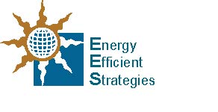Australian Government | Department of Industry, Innovation and Science logo
E3 Lighting Audit 2016

House ID_________

*(entered by auditor)*

Introduction

Thank you for agreeing to participate in the Lighting Energy Efficiency Audit and Survey, which is designed to deliver a better understanding of lighting energy and lighting technologies used within Australian homes. It has been commissioned by Australian Governments. This short questionnaire will help us to understand recent changes in lighting in your home as well as your preferences for different types of lighting.

Note: All information collected in this survey will be stored separately from any personal information (name, address etc.) so it will not be possible to identify you from this survey data. Please fill in this survey to the best of your ability without assistance. The auditor can provide any guidance once you have completed the survey, if required.

|  |  |
| --- | --- |
| HOUSE PROFILE *Insert answers here* | |
| 1. Please enter your postcode |  |
| 2. What year (approximately) was your house built? |  |
| 3. Did you move into this house as a new home? | Yes  No |
| 4. If no, what year (approximately) did you move into this house? |  |
| 5. What year (approximately) was the last major renovation and/or addition? (if any) |  |
| 6. Including yourself, how many people normally live in your home? |  |
| 7. Please provide an age breakdown of the people that normally live here: | |
| * Adults (20 years and over) * Older teenagers (15 to 19 years) * Younger teenagers (10 to 14 years) * Children (up to 9 years) |  |
|  |
|  |
|  |

|  |  |  |
| --- | --- | --- |
| RECENT CHANGES TO LIGHTING | | |
| 8. If there was a major renovation and/or addition in the past 10 years, were the lighting systems replaced or upgraded during that renovation? | Yes  No  Unsure  *If NO/Unsure – go to Q10* | |
| 9. If there were changes to lighting, which rooms did it affect?  *(auditor will enter room numbers afterwards)*  *(Other) ____________________________________________* | Bathroom  Bedroom  Dining  Kitchen  Lounge Rm  Study  Other *(*🡸 *please list)* |  |
| 10. Have any organisations installed efficient lamps in your home in the last 5 years? | Yes  No  Unsure  *If NO/Unsure – go to Q11* | |
| 10a. If yes, what year did they visit? |  | |
| 10b. And if you can remember, what was the name of the scheme or organisation that provided this service? |  | |
| 10c. Approximately, how many lamps were replaced? |  | |
| 10d. Were the lamps changed for free or did you have to pay? | Free  Subsidised  Full Price |  |
| 10e. What types of lamps were removed as part of this replacement service?  *[tick all that apply]*  *(Other) ____________________________________________* | Incandescent Lamps  Halogen Downlights  Other *(*🡸 *please list)* | |
| 10f. What type of lamps were installed as part of this replacement service:  *[tick all that apply]*  *(Other) ____________________________________________* | CFLs  LEDs  Linear Fluorescent  Other *(*🡸 *please list)* | |
| 11. In addition to the above changes, have there been any major changes to lighting in any part of your house in the past 5 years? | Yes  No  Unsure  *If NO/Unsure – go to Q12* | |
| 11a. If yes, please indicate which rooms were affected:  (*Auditor will enter room numbers)*  *(Other) ____________________________________________* | Bathroom  Bedroom  Dining  Kitchen  Lounge Rm  Study  Other *(*🡸 *please list)* |  |

|  |  |
| --- | --- |
| 11b. Please indicate the main reasons for changing the lighting:  *[Tick all that apply]* | |
| * Part of a refurbishment |  |
| * Changed the location of the light fittings |  |
| * The light(s) didn't work |  |
| * Didn’t like style / design of the fixtures |  |
| * Wanted a different type of light/ambience |  |
| * Wanted more light |  |
| * Better energy efficiency |  |

|  |  |
| --- | --- |
| LIGHT PREFERENCES AND USAGE | |
| 12. In general, what are the most important sources of information in relation to how you would like lighting in your home to look and work? *[Tick all that apply]* | |
| * Friends / family homes |  |
| * Advice from lighting retail store |  |
| * Advice from an electrician |  |
| * Advice from builder / renovator |  |
| * TV Shows |  |
| * Magazines |  |
| * Websites |  |
| * Display homes |  |
| * Government energy efficiency information |  |
| Others (please list) _______________________________________________________ | |
| 13. Thinking about lamps (light bulbs) you have recently installed, what made you select them?  *[Tick all that apply]* | |
| * Price |  |
| * Same as lamp it replaced |  |
| * Design/style |  |
| * Brighter light |  |
| * Softer light |  |
| * Colour appearance |  |
| * Mercury content |  |
| * Energy efficiency |  |
| Others (please list) _______________________________________________________ | |

|  |  |  |
| --- | --- | --- |
| 14. Do any have dimmers on any of the lights on your house? | Yes  No  Unsure  *If NO/Unsure – go to Q15* | |
| 14a. If yes, indicate how often you adjust the light level using the dimmers: | | |
| * In living areas: | Regularly  Sometimes  Rarely/Never |  |
| * In non-living areas | Regularly  Sometimes  Rarely/Never |  |
| 14b. If you have dimmers, have you found that certain lamp types are unable to work with the dimmer? | Yes  No | |
| 14c. If Yes, list the lamp types that have been a problem *[Tick all that apply]*  Other: _____________________________________________ | CFLs  LEDs  Other *(*🡸 *please list)* | |

|  |  |
| --- | --- |
| **GENERAL LAMP PREFERENCES:** The final questions are about the lamps or globes you use in your home. | |
| 15. Please indicate which of the following types of lamp technologies you currently use in your house?   *[Tick only the technologies you are sure you have]:* | |
| * Incandescent light bulbs (tungsten filament) |  |
| * Halogen light bulbs (mains voltage) |  |
| * Incandescent reflector lamps |  |
| * Mains voltage halogen reflector lamps |  |
| * Compact Fluorescent Lamp (CFL) |  |
| * Linear or Circular Fluorescent tube |  |
| * Halogen downlights |  |
| * CFL downlights |  |
| * LED downlights |  |
| * LED light bulbs |  |
| * LED floodlights |  |
| * LED integrated luminaires |  |

|  |  |
| --- | --- |
| 16. With respect to Compact Fluorescent Lamps (CFLs), please indicate whether you have had any issues or problems in recent years: *[Tick any that apply]* | |
| * Still too expensive |  |
| * Too dim when they initially start |  |
| * Take too long to warm up to full brightness |  |
| * Light output is too low |  |
| * Light distribution is in the wrong direction |  |
| * Shape and size were not compatible with existing fitting, so fitting had to be changed/modified |  |
| * Too easy to break |  |
| * Don’t last very long |  |
| * Don’t work with a dimmer |  |
| * Don’t like the colour appearance |  |
| * Mercury content |  |
| Others (please list)_______________________________________________________ | |
| * No issues |  |

|  |  |
| --- | --- |
| 17. With respect to LED lamps, please indicate whether you have had any issues or problems in recent years: *[Tick any that apply]* | |
| * Still too expensive |  |
| * There is a delay before the start |  |
| * Light output is too low |  |
| * Light distribution is in the wrong direction |  |
| * Shape and size were not compatible with existing fitting, so fitting had to be changed/modified |  |
| * Don’t work with a dimmer   + Won’t dim   + Flicker |  |
| * Didn’t work with the existing transformer |  |
| * They flicker even with no dimmer |  |
| * They cause interference with the TV/radio |  |
| * Don’t last very long |  |
| * Don’t like the colour appearance |  |
| Others (please list)_______________________________________________________ | |
| * No issues |  |

|  |  |
| --- | --- |
| 18. How do you normally purchase replacement lamps (light bulbs) for your house? *[Tick all that apply]* | |
| * As required |  |
| * Bulk buy in advance |  |
| * When they are reduced in price / on offer |  |
| * Don’t know |  |
| Others *[Please list]* ­­­­­­­­­­­_______________________________________________________ | |

|  |  |
| --- | --- |
| 19. Where do you tend to buy your replacement lamps? (light bulbs) *[Tick all that apply]* | |
| * Grocery store / supermarket |  |
| * Hardware store / home improvement store |  |
| * Specialty lighting store |  |
| * Department Store |  |
| * Electrical appliance retailer |  |
| * Electric trade wholesalers |  |
| * Online (web) |  |
| * House visits (spares from replacement schemes) |  |
| * Supplied by electrician |  |
| Others *[Please list]* ­­­­­­­­­­­______________________________________________________ | |

|  |  |
| --- | --- |
| 20. Where do you tend to buy your light fittings? *[Tick all that apply]* | |
| * Hardware store / home improvement store |  |
| * Specialty lighting store |  |
| * Department Store |  |
| * Electrical appliance retailer |  |
| * Electric trade wholesalers |  |
| * Online (web) |  |
| * Supplied by electrician |  |
| Others *[Please list]* ­­­­­­­­­­­______________________________________________________ | |

|  |  |  |  |
| --- | --- | --- | --- |
| 21. When you buy new lamps (light bulbs), please indicate the importance of each of the following factors when making your choice? *[You only need to mark factors that you have considered]* | | | |
| Factor | Not at all important | Somewhat important | Very important |
| Purchase price |  |  |  |
| Brand |  |  |  |
| Lamp Wattage |  |  |  |
| Light output of lamp (lumens) |  |  |  |
| Colour appearance of the lamp (colour temperature)  (warm white or cool white) |  |  |  |
| Colour rendering of the lamp (CRI)[8] |  |  |  |
| Running cost / energy efficiency |  |  |  |
| Environmental friendliness |  |  |  |
| Whether or not contains mercury |  |  |  |
| Health impacts of lighting |  |  |  |
| Lifetime / how long it lasts |  |  |  |
| Compatibility of shape/size with light fitting |  |  |  |
| Compatibility with a dimmer |  |  |  |
| Compatibility with transformer (downlight) |  |  |  |
| Warm up times/ how fast it illuminates |  |  |  |
| The lamp type that was used previously |  |  |  |

|  |  |
| --- | --- |
| 22. Have you ever returned a lamp (light bulb) for refund/replacement soon after it was purchased? | YES  NO  *If No go to Q23* |
| 22a. If yes, why was it returned? *[Tick all that apply]* | |
| * Failed early |  |
| * Wrong colour |  |
| * Not compatible with lighting fitting |  |
| * Flickered |  |
| * Did not work with the dimmer |  |
| Others *[Please list]* ____________________________________________________ | |

|  |
| --- |
| 23. Do you have any further comments on your use of lights, choice of light fittings or choice of lamps?  _________________________________________________________________________  _________________________________________________________________________  _________________________________________________________________________ |

Thank you for your participation in this important research.

You will be sent a lighting audit for your house within 7 working days. Would you prefer the audit report to be sent by: [Select one option]

Email (PDF):  Paper (post):   
  
If email, please enter your preferred email address: ________________________________

If paper (post), please enter your preferred postal address: ______________________________________________________________________________________________________________________________________________________

*End of questionnaire*

Appendix E: Sample Household Audit Reports

The following 18 pages set out three sample lighting audits that were provided to householders. The identity and location of the households has been masked.

The following houses are examples of:

X01 – high efficacy lighting

X02 – average efficacy lighting

X03 – low efficacy lighting

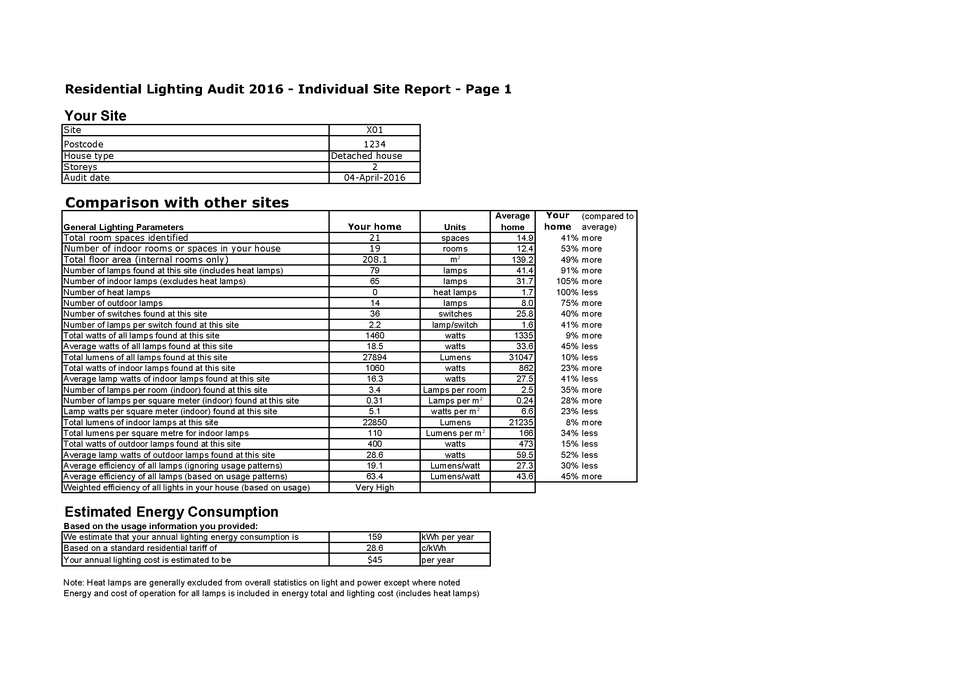

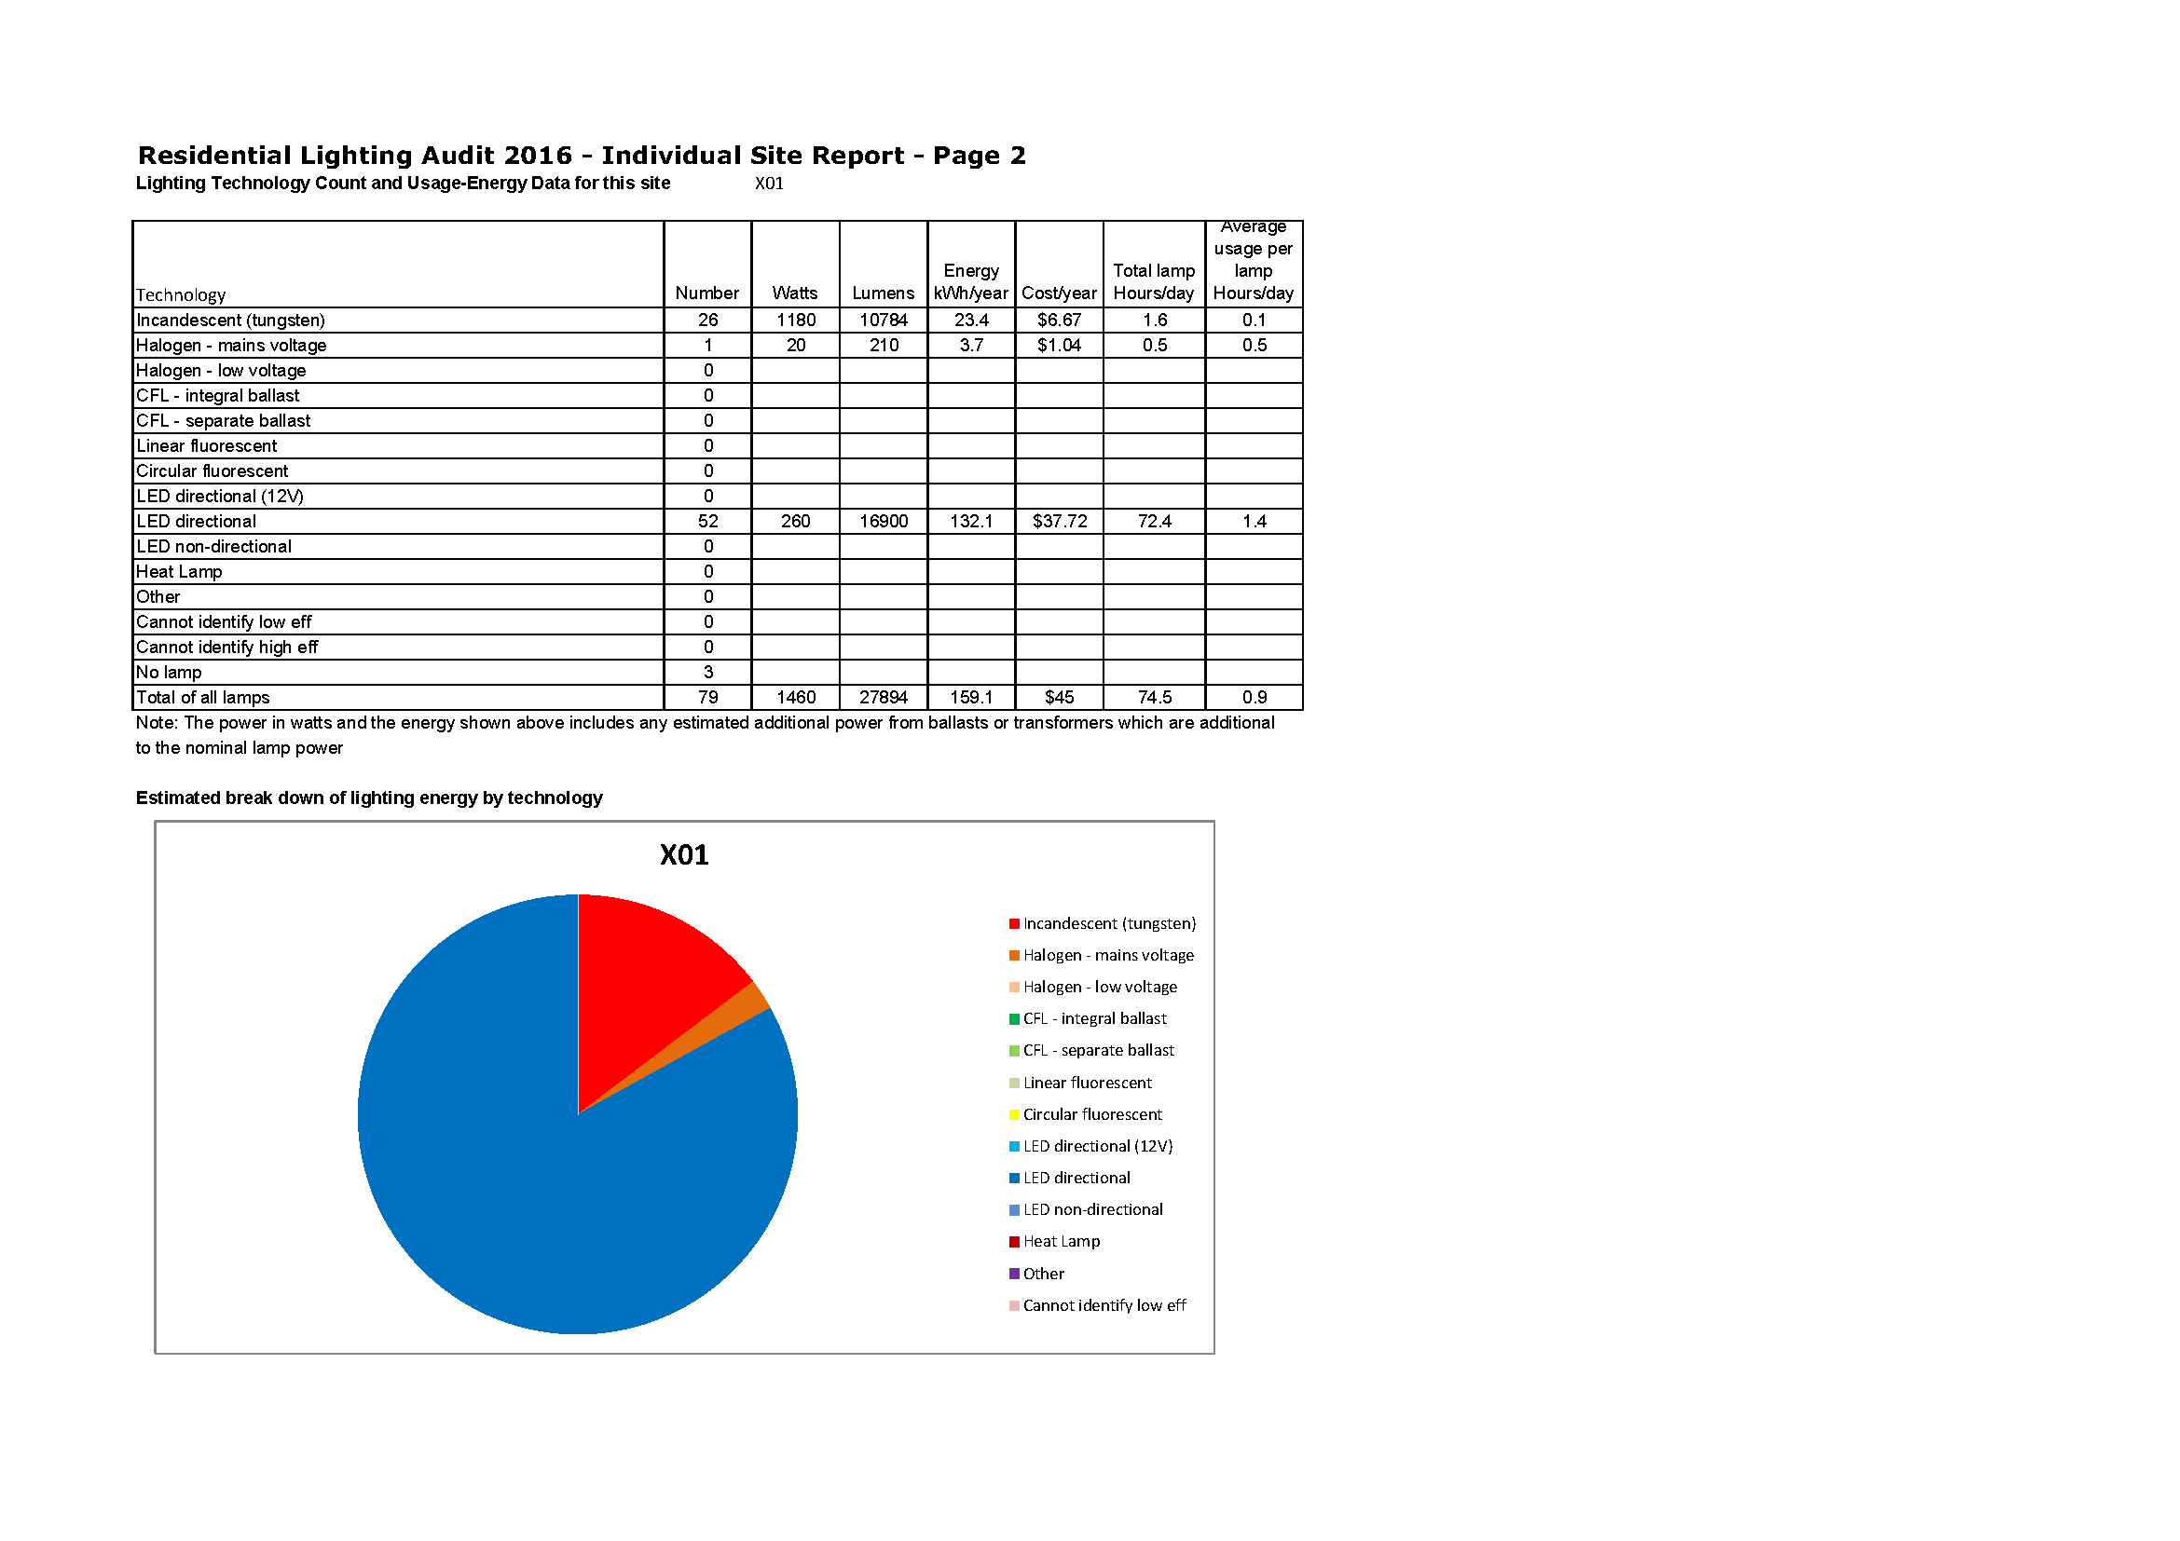

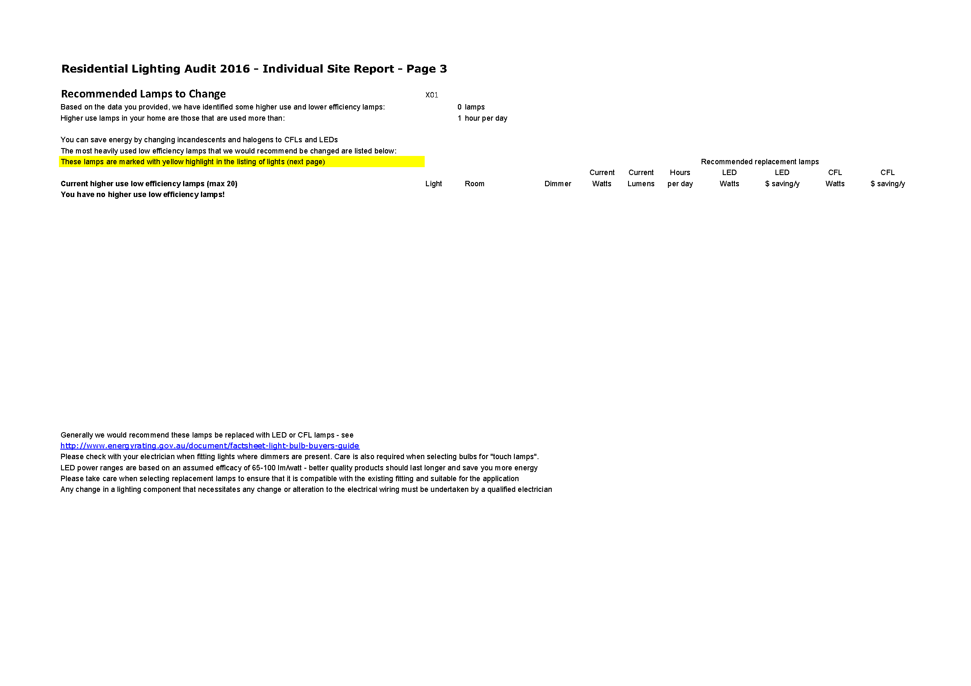

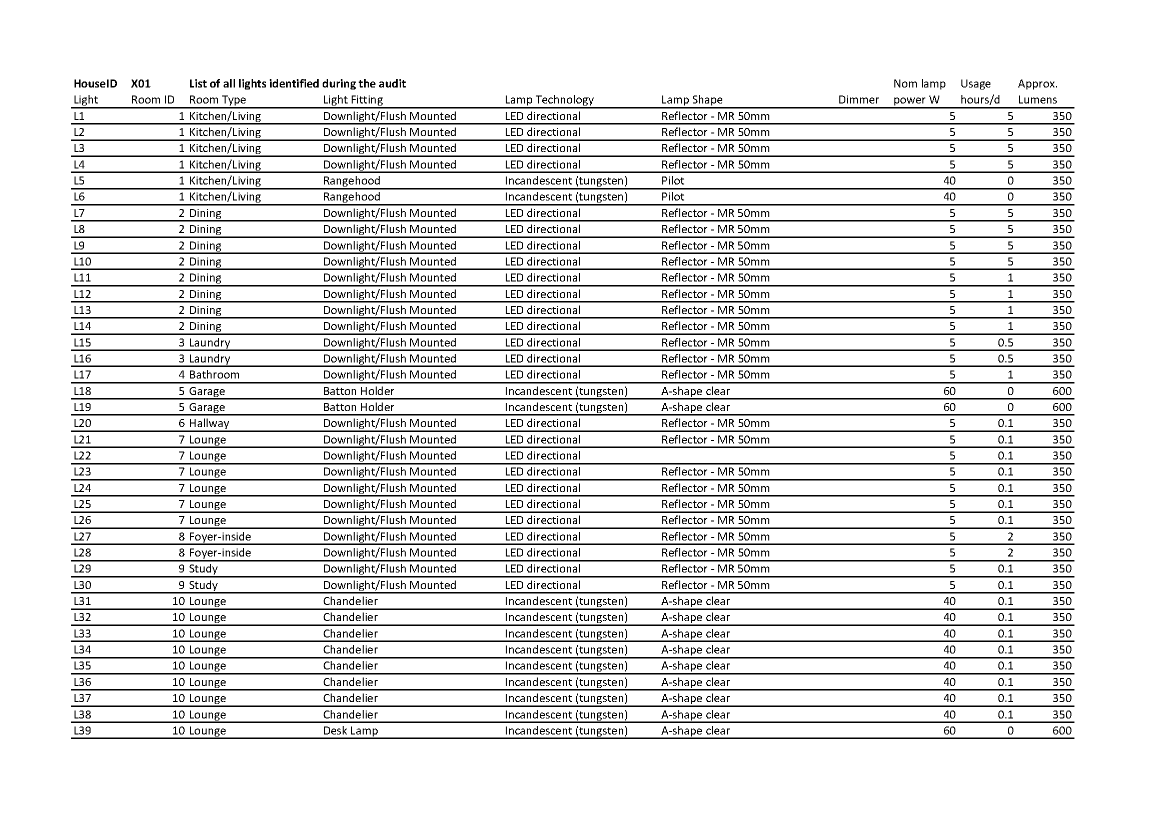

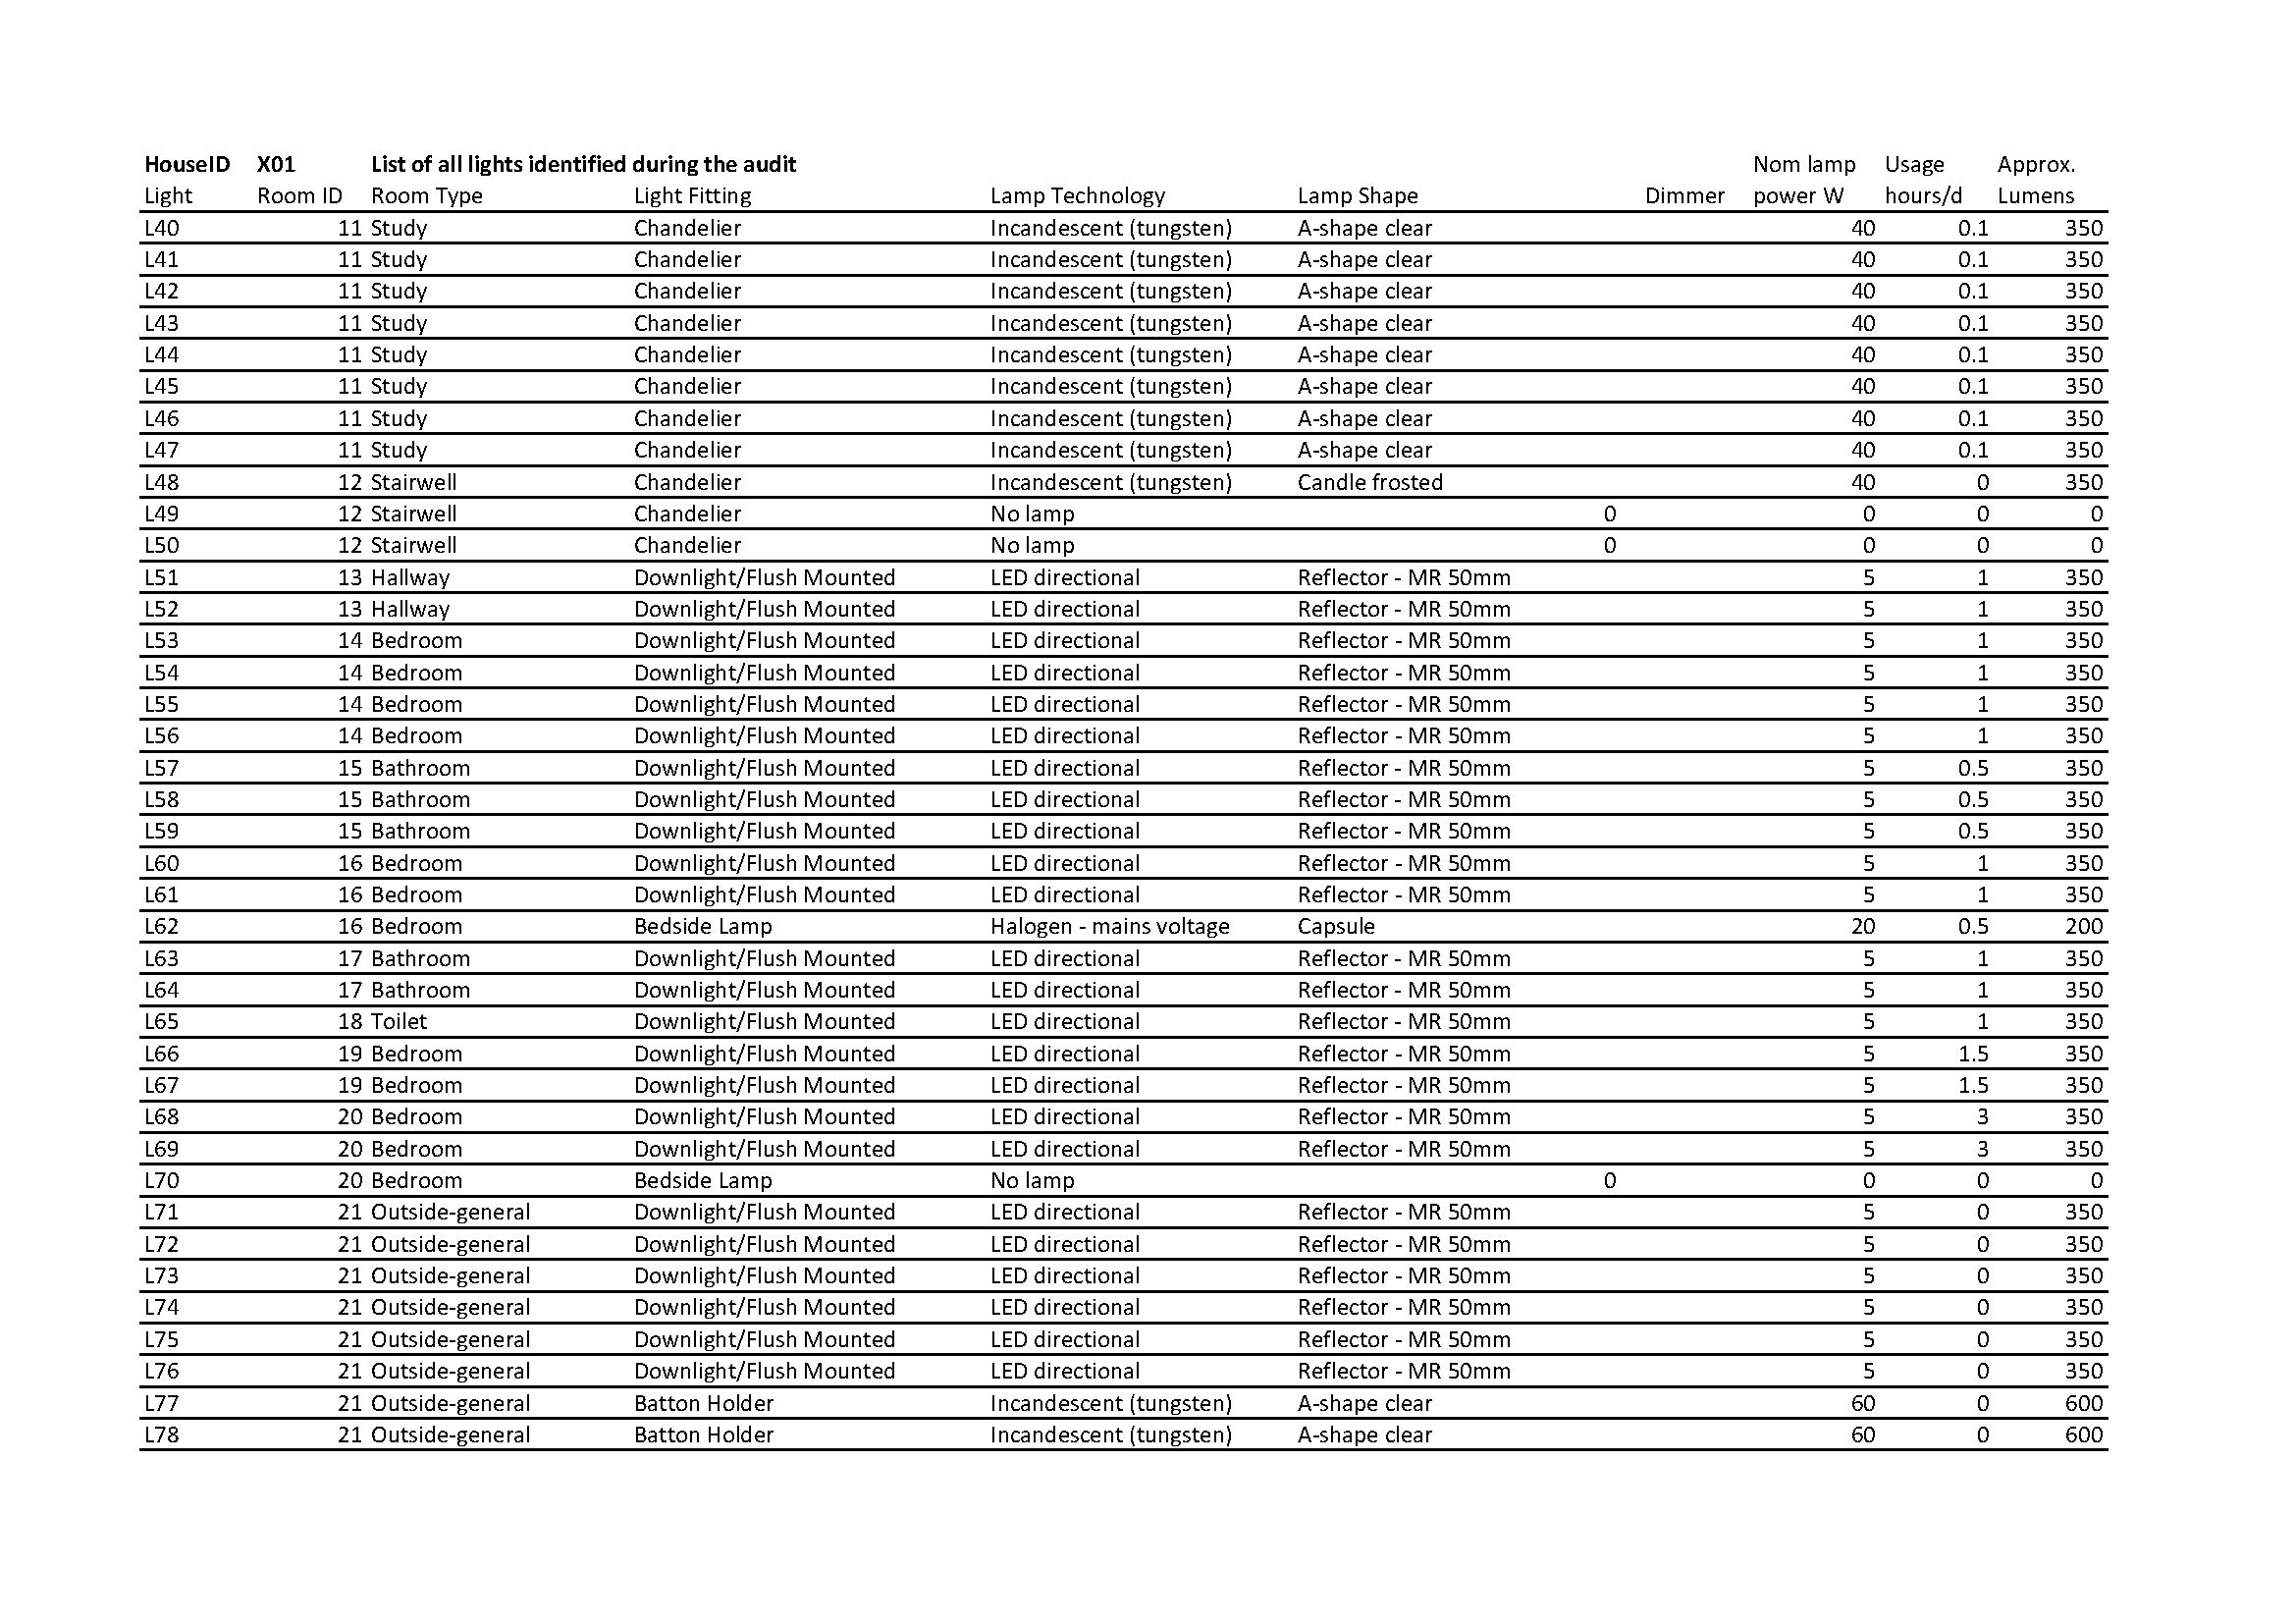

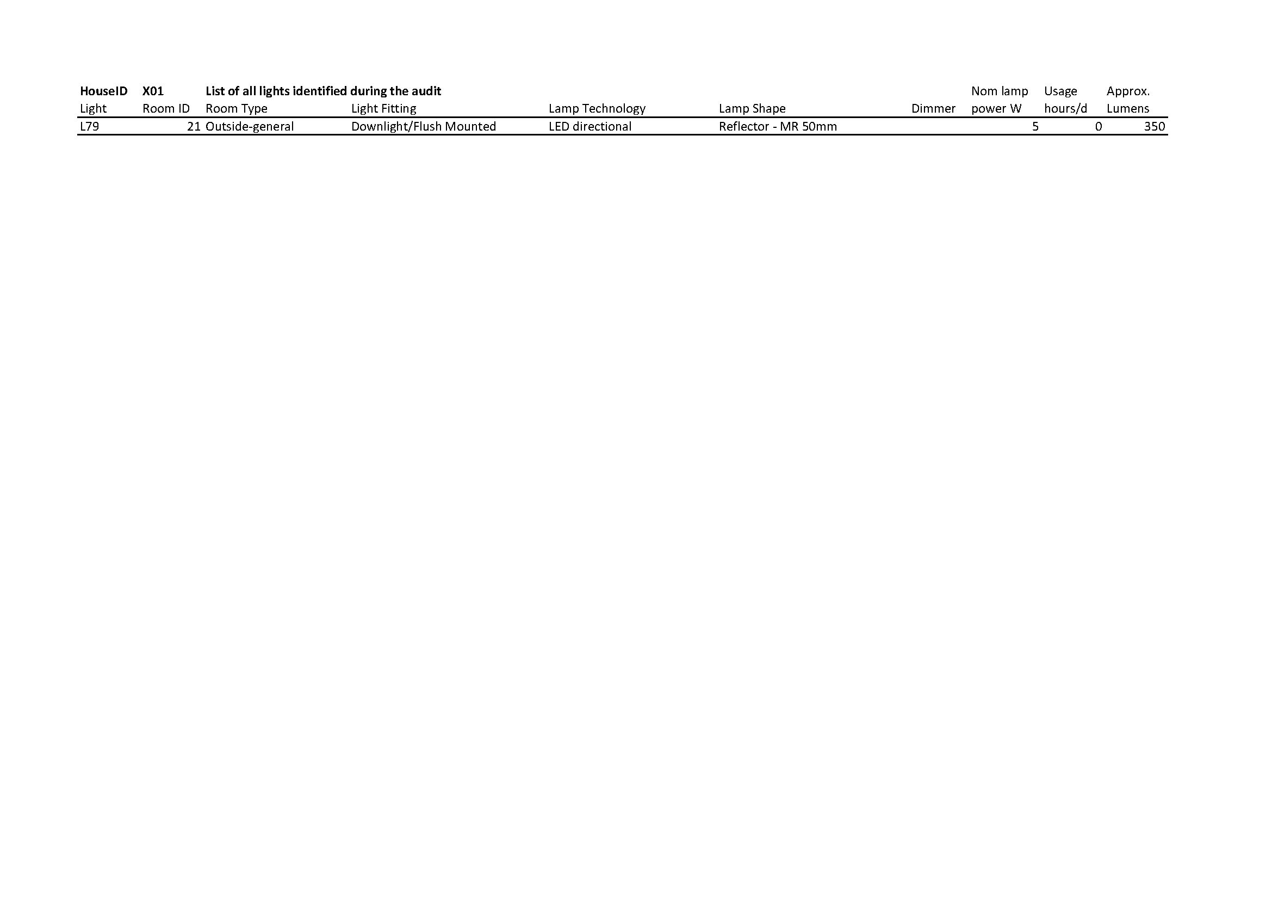

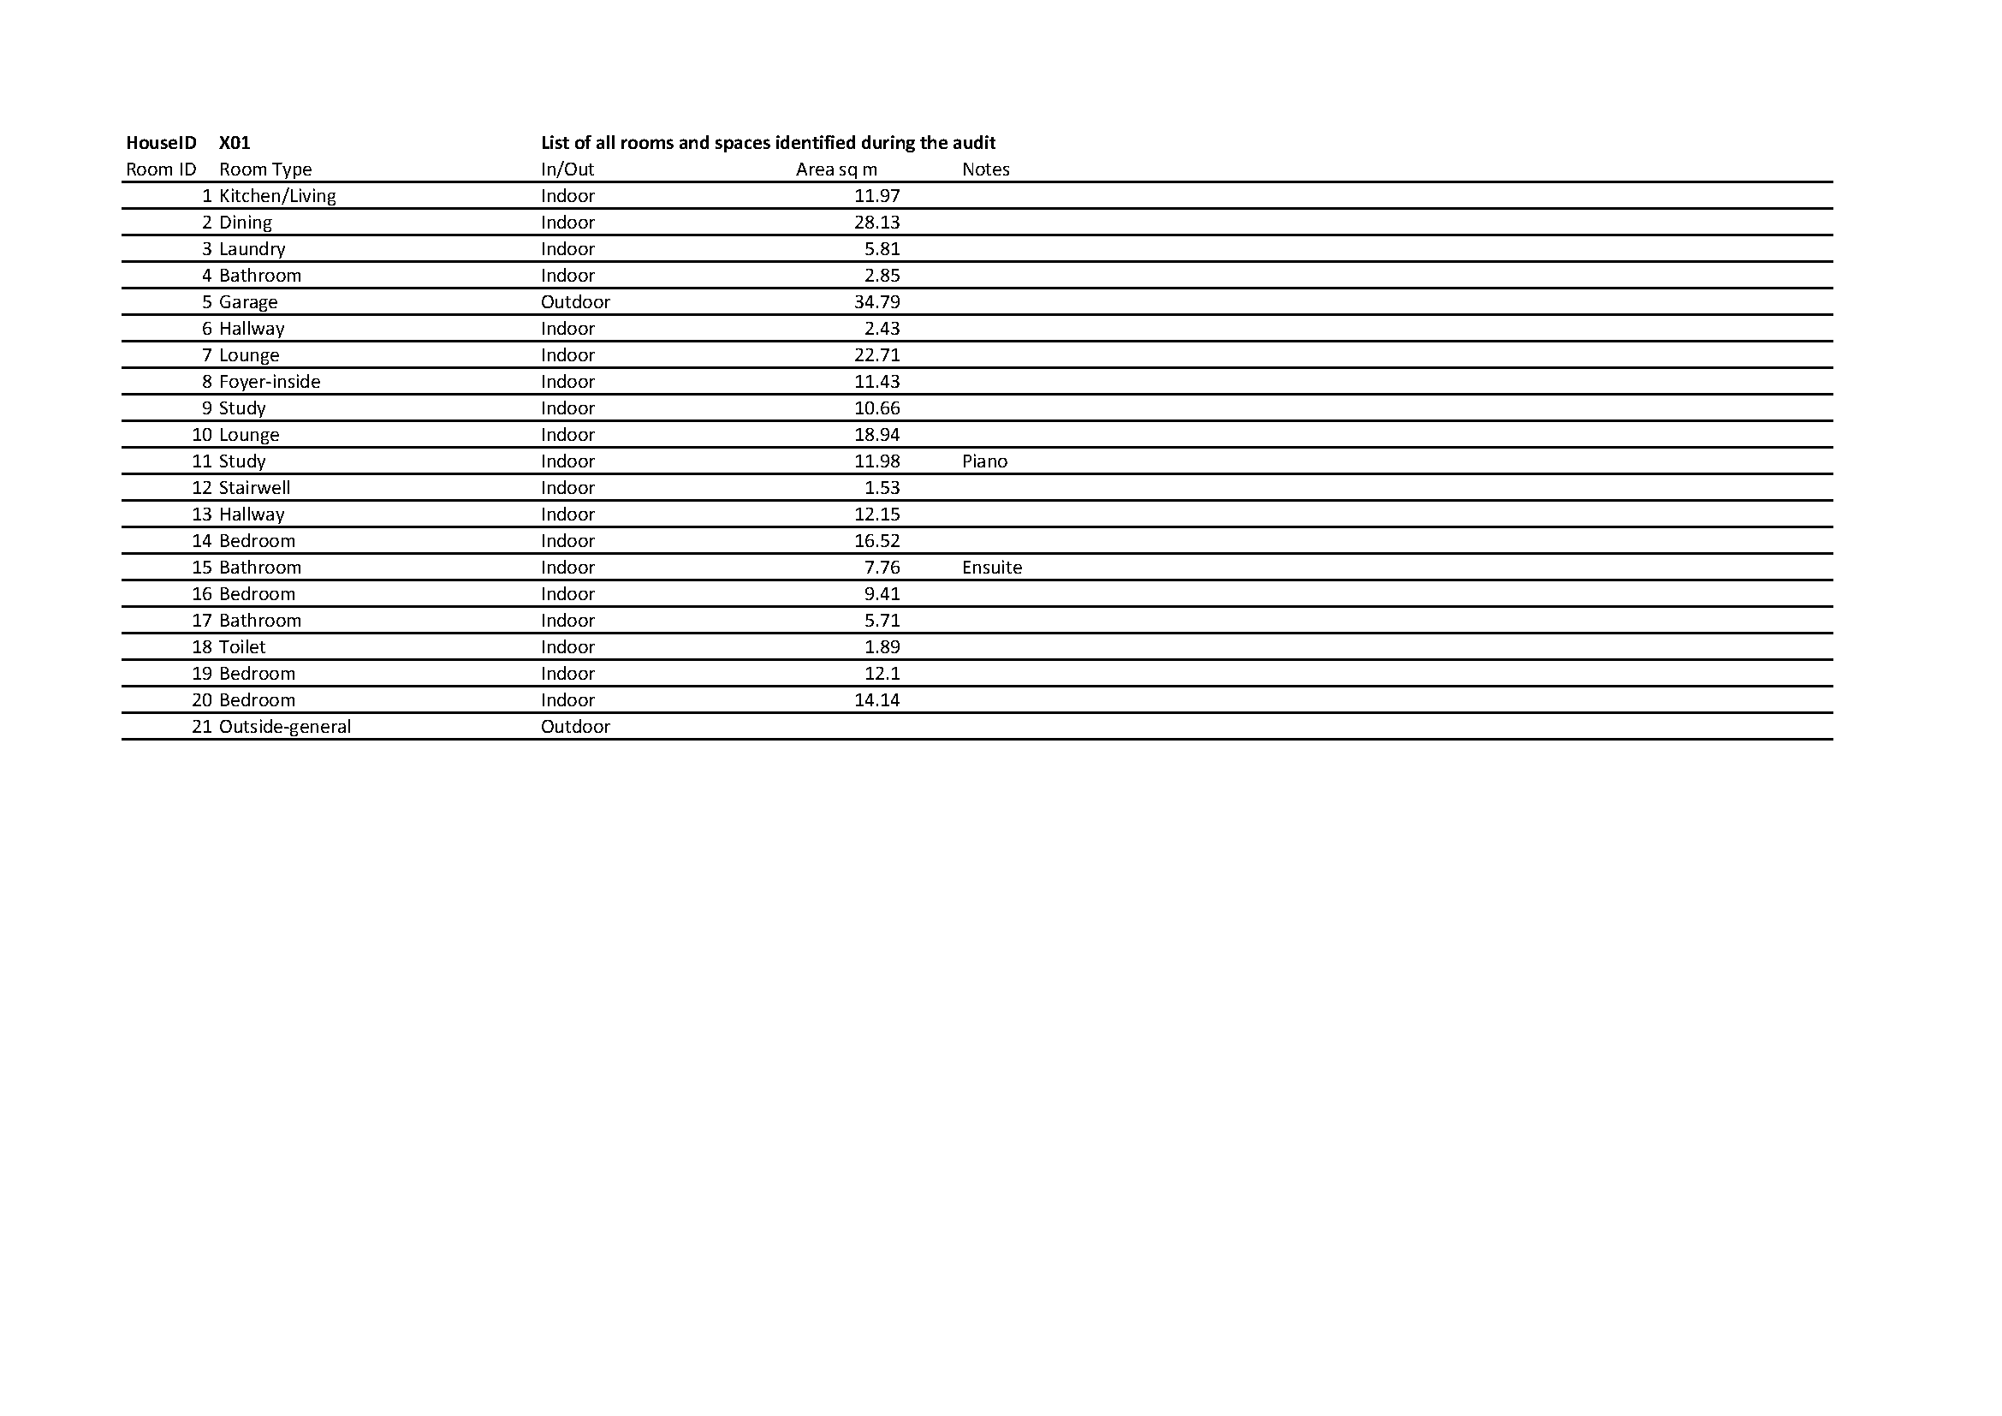

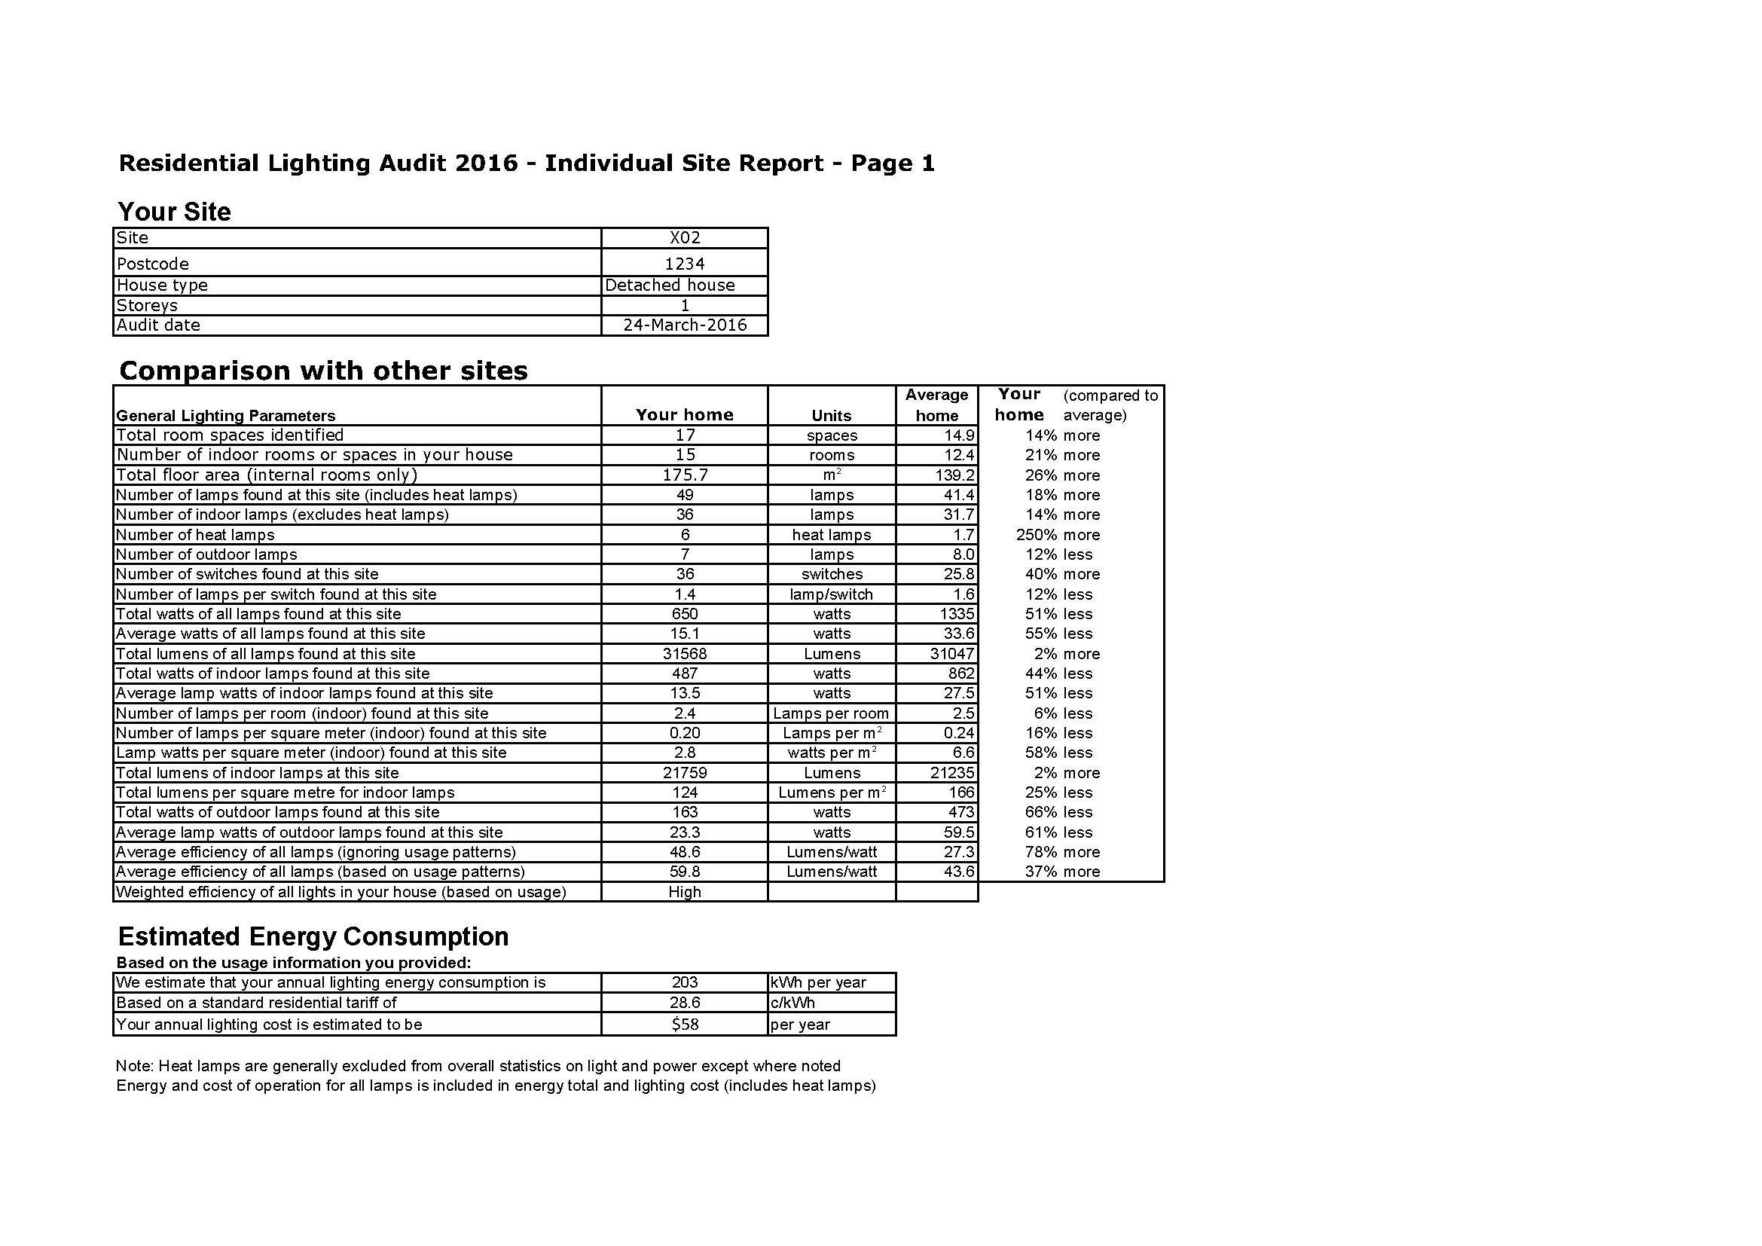

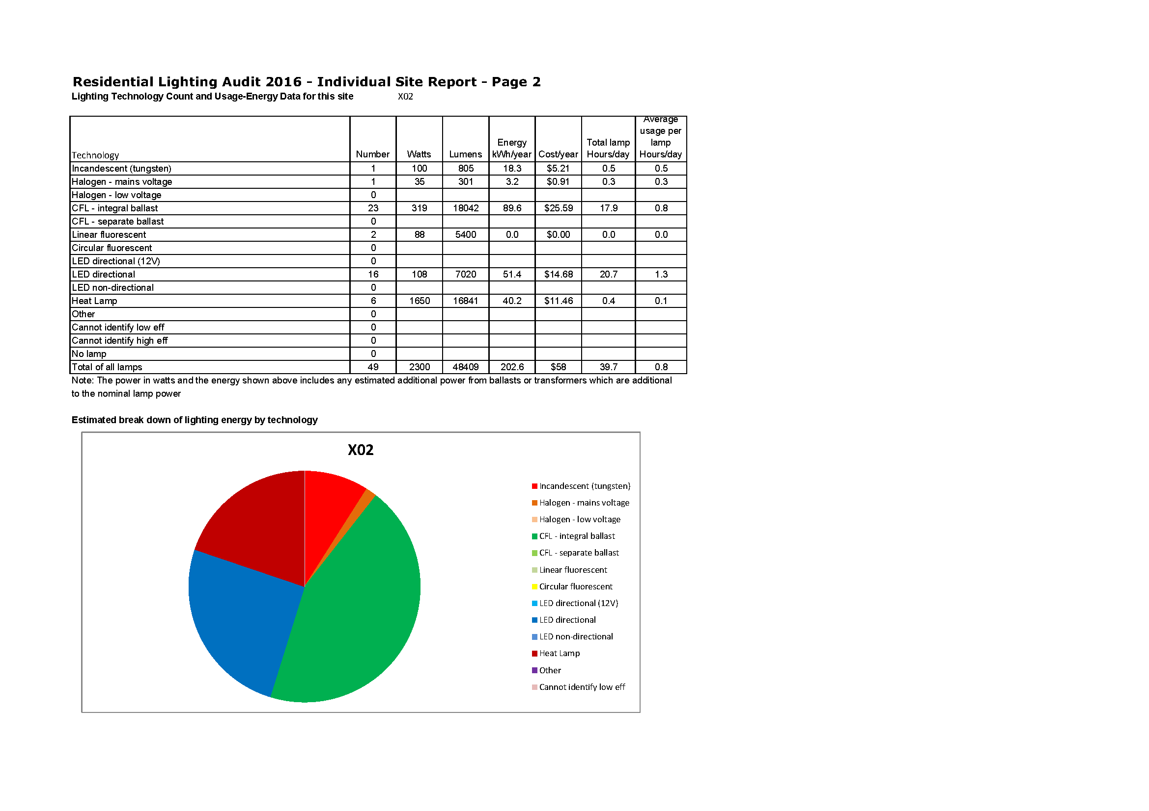

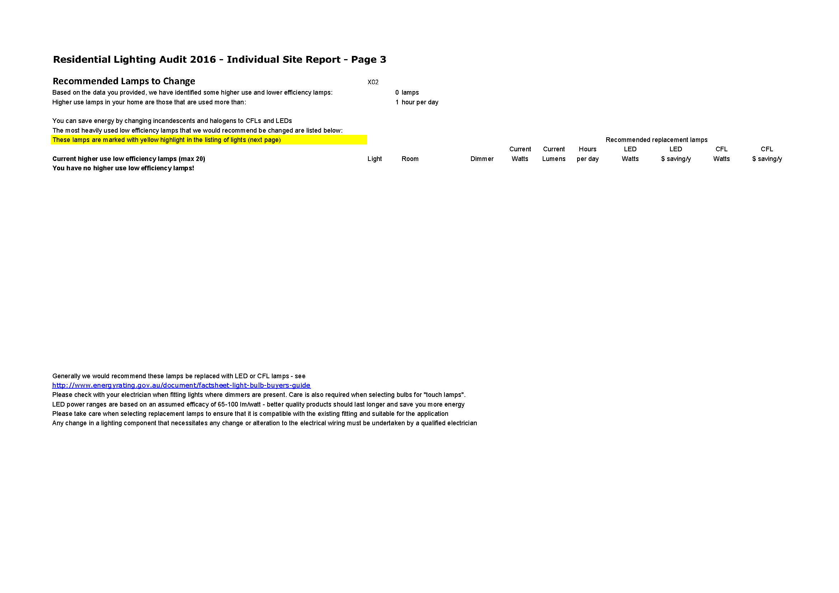

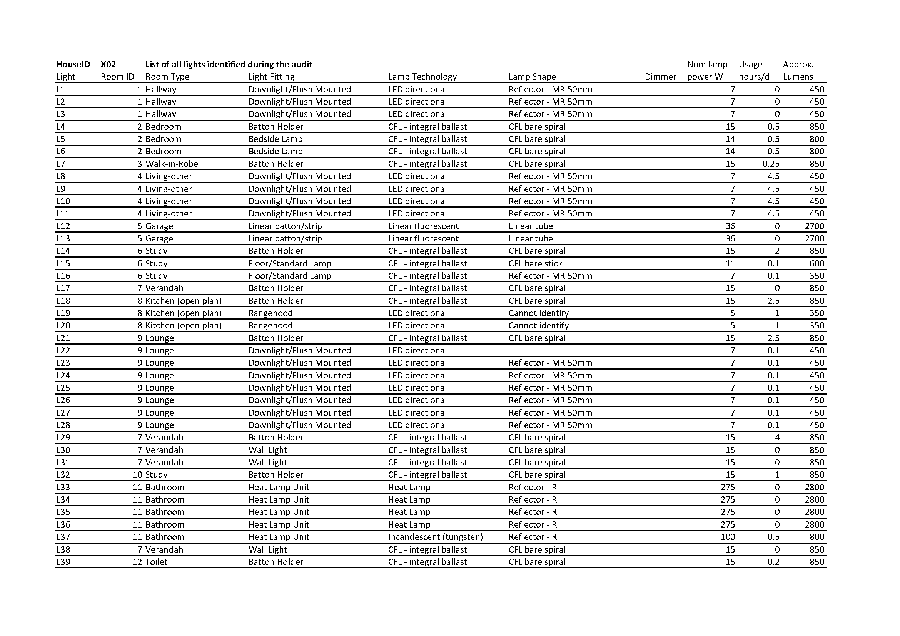

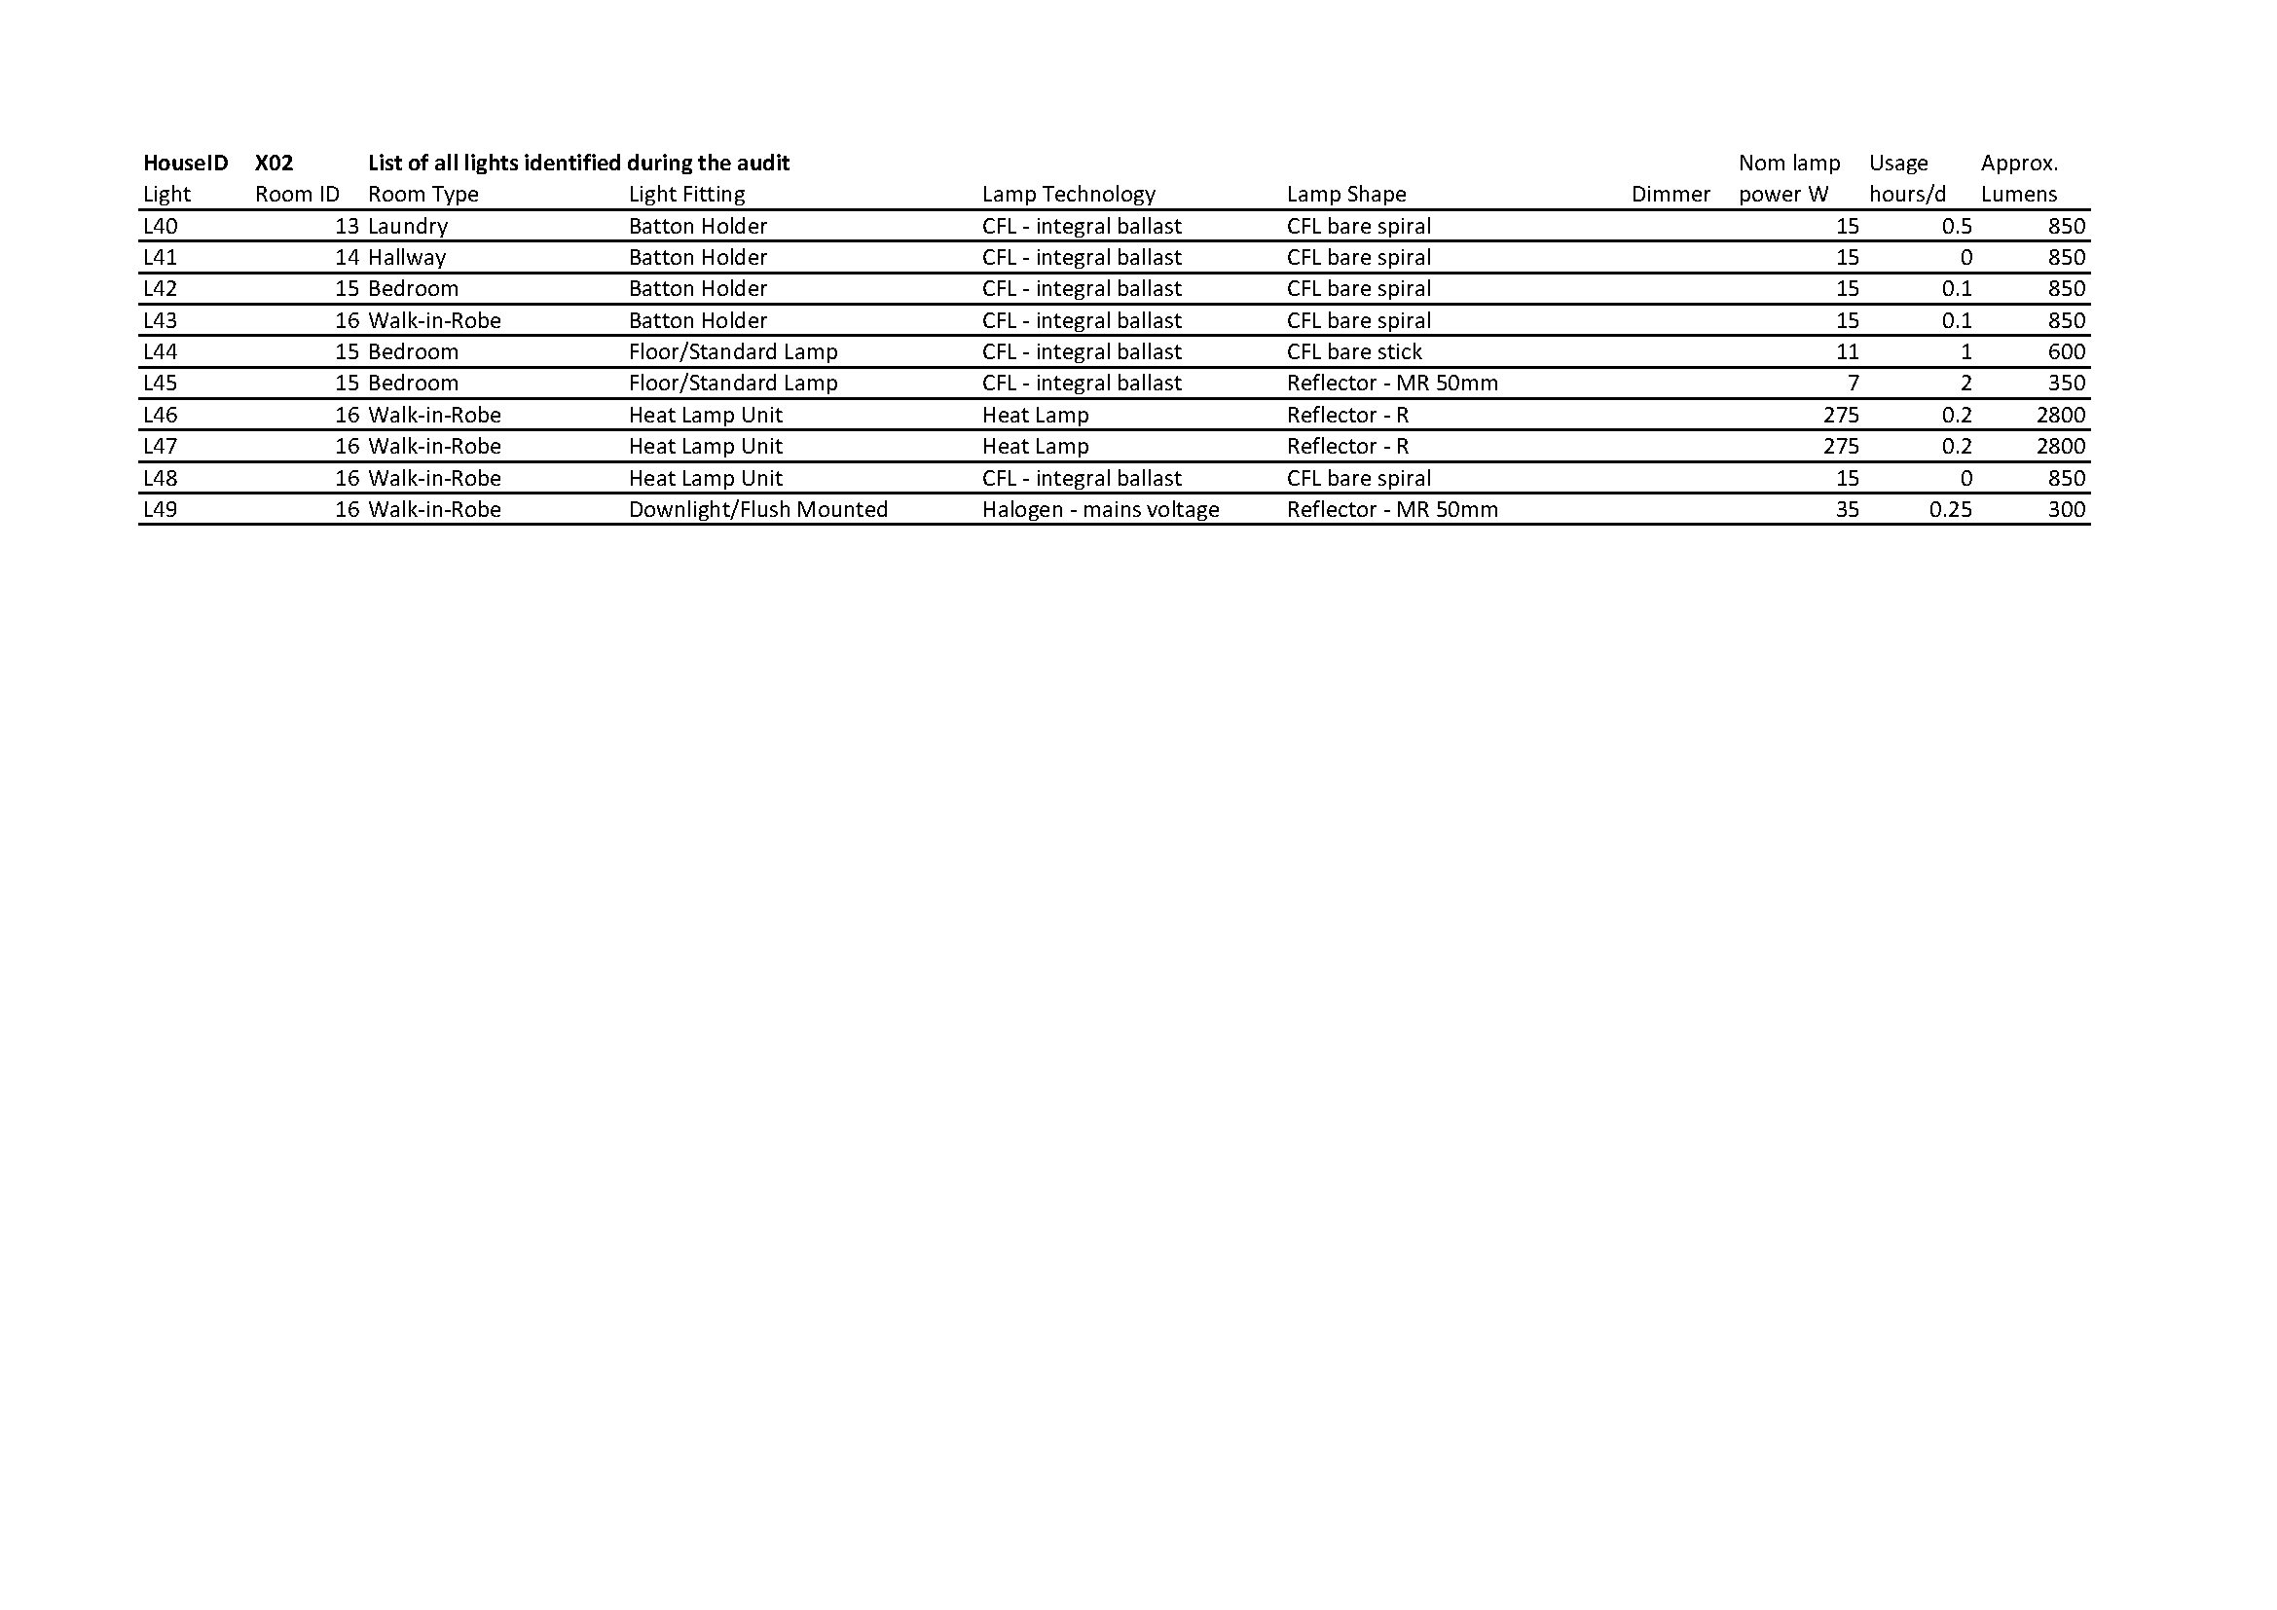

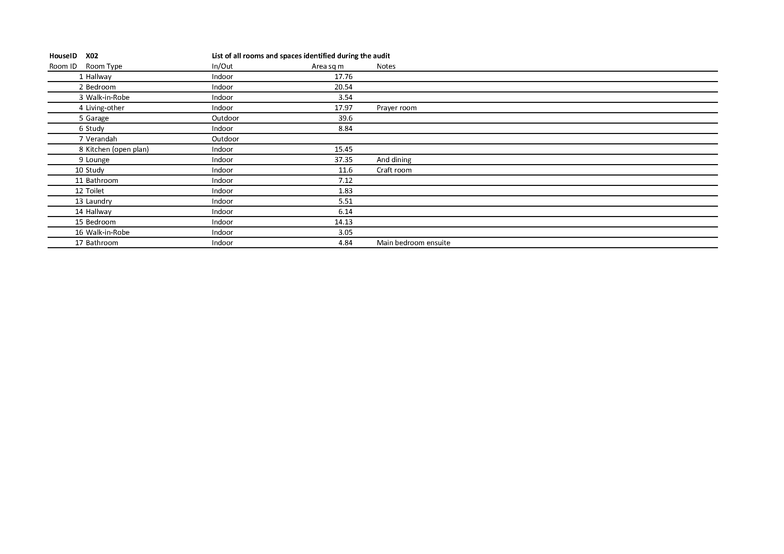

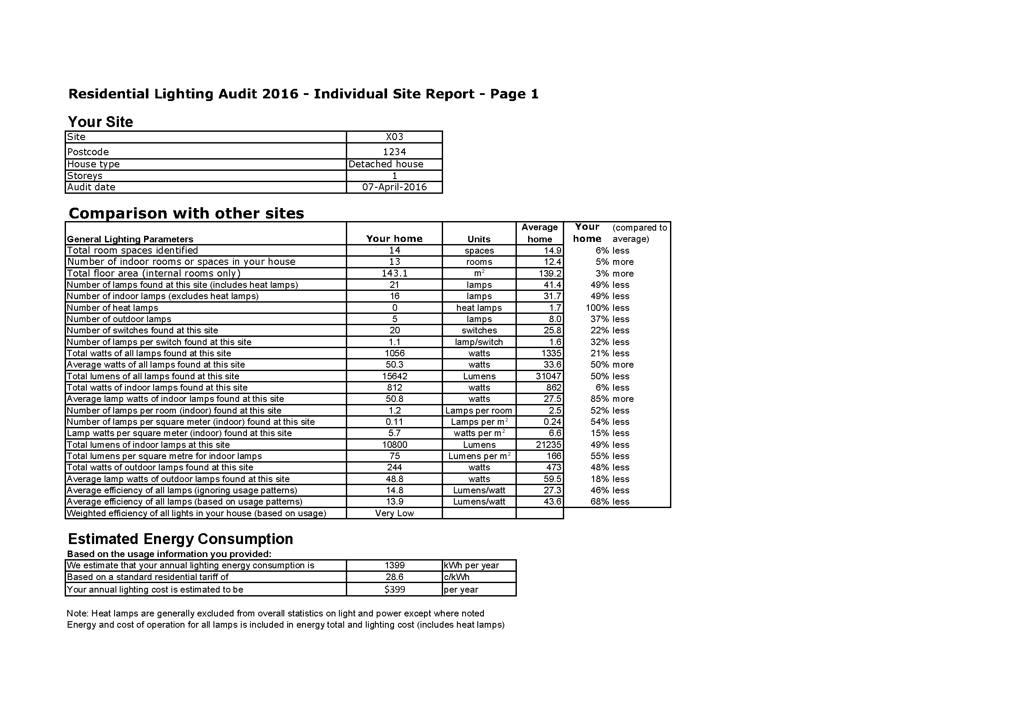

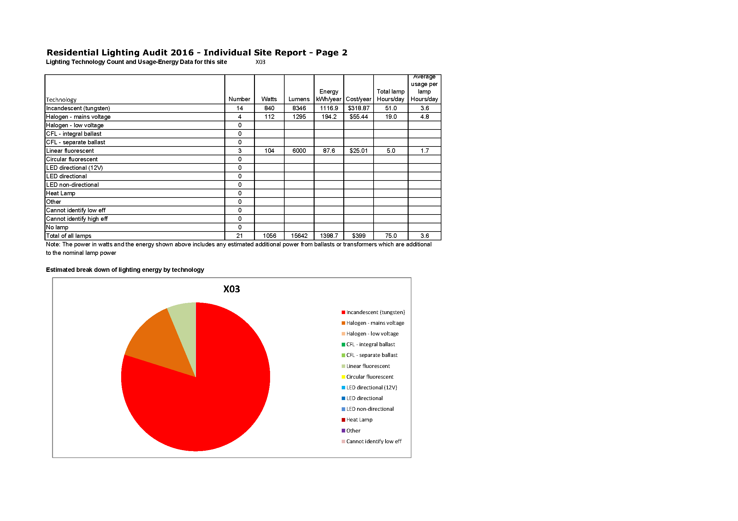

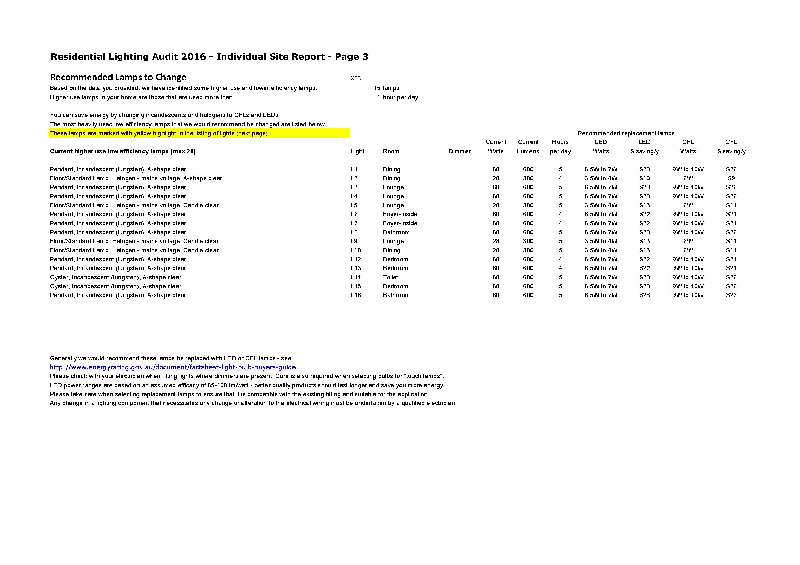

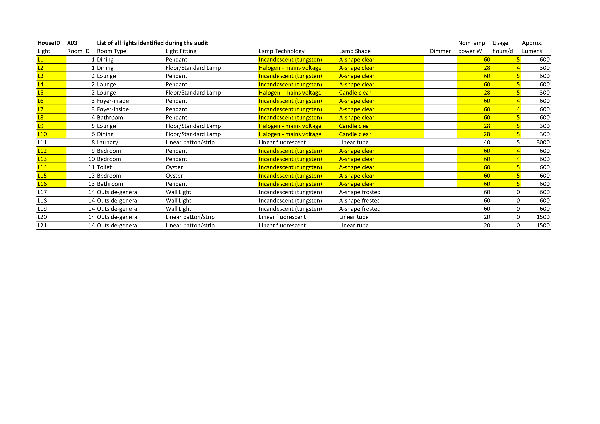

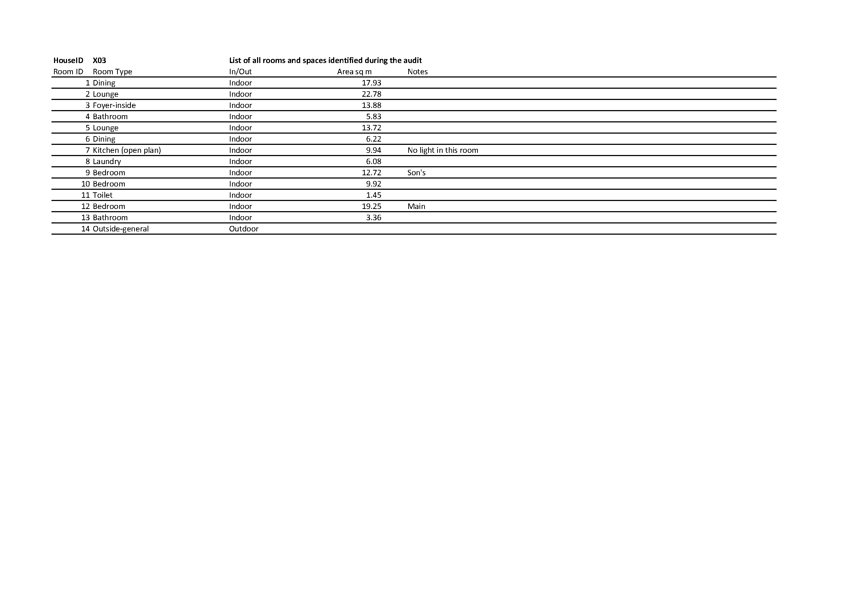

Appendix F: Lighting Field Guide

The following 18 pages are the Lighting Field Guide.

2016 Residential Lighting Report

APPENDIX F – Lighting Field Guide

June 2016

This work is licensed under the Creative Commons Attribution 3.0 Australia Licence. To view a copy of   
this license, visit [the creative commons website.](http://creativecommons.org/licences/by/3.0/au)

The Department of Industry, Innovation and Science on behalf of the Equipment Energy Efficiency   
Program asserts the right to be recognised as author   
of the original material in the following manner:

Creative Commons Licensing - By Attribution

© Commonwealth of Australia (Department of   
Industry, Innovation and Science) 2016.

The material in this publication is provided for general information only, and on the understanding that the Australian Government is providing professional advice. Before any action or decision is taken on the basis of this material the reader should obtain appropriate independent professional advice.

This document is available at [the Energy Rating website.](http://www.energyrating.gov.au)

While reasonable efforts have been made to ensure that the contents of this publication are factually correct, E3 does not accept responsibility for the accuracy or completeness of the content, and shall not be liable for any loss or damage that may be occasioned directly or indirectly through the use of, or reliance on, the contents of this publication.

Contents

Contents iii

Lighting Field Guide 4

Lighting Field Guide – Lamp Fittings 4

Lighting Field Guide – Lamp Technology 10

Lighting Field Guide – Lamp Shape 13

Lamp Cap 16

Transformer 17

Lighting Field Guide

Lighting Field Guide – Lamp Fittings

| Fitting | Pictures | Notes |
| --- | --- | --- |
| Batten Holder | Bare light globe, attached directly to the ceiling | A bare fitting, normally fixed directly to the ceiling |
| Batten Holder with Shade | Light attached directly to the ceiling, within a flat bathroom fan fitting Light globe attached directly to ceiling, surrounded by a shade | A bare fitting, normally fixed directly to the ceiling, with a surrounding shade |
| Linear batten /Strip | Linear (long tube) light, with a translucent cover/diffuser  Linear (long tube) light, with a cover that directs light downwards  Linear (long tube) light attached to the wall with no cover | Linear fluorescent or LED, can be suspended, surface mounted or flush mounted. May or may not have a diffuser (cover) |
| Oyster | Semi-transparent, hemispherical fitting that attaches directly to the ceiling (or wall) to enclose the light globeCylindrical fitting with a semi-transparent base, that attaches directly to the ceiling | Batten Holder with cover (of any material), ceiling mounted only |
| Pendant | Light hanging one metre from the ceiling by a cable or rod - this fitting reflects light back up onto the ceiling Light hanging one metre from the ceiling by a cable or rod - semi-transparent fitting encloses the light globeLight hanging one metre from the ceiling by a cable or rod - cone-shaped fitting reflects light downwards | Any type of hanging fitting, may have one or two lamps, may be covered (with any material) or uncovered |
| Chandelier | Light hanging one metre from the ceiling by a rod, with three (or more) individual light globes stemming from this central point, within the horizontal planeEither a large number of small light globes stemming from a central attachment on the ceiling, or one light globe attached to the ceiling with a large number of glass diamonds hanging to refract the light. | Usually a pendant but with 3 or more lamps |
| Downlight/Flush Mounted | 5 centimetre diameter silver hemispherical fitting that sits on the plane of the ceiling to produce downward-directed light Larger silver hemispherical fitting that contains light globes, and sits on the plane of the ceiling to produce downward-directed light 5 centimetre diameter silver hemispherical fitting that sits on the plane of the ceiling but can be rotated to direct light at a specific angle | Recessed and flush with ceiling. Gimble mounts can rotate to direct light at an angle (can also shine all walls – called wall washers).  Gimble mounting requires a larger hole (90mm) and this type of fitting usually means that the lamp is more likely to be extra low voltage. |
| Indoor Spotlight  (includes track lights) | Two 5-centimetre diameter silver hemispherical fittings attached to a rail, with no transformer visible Single 5-centimetre diameter silver hemispherical fitting attached to a metal stem with no transformer present Single 5-centimetre diameter silver hemispherical fitting attached directly to its transformer  Two 5-centimetre diameter silver hemispherical fittings attached to a rail - transformer present midway along the railing 5-centimetre diameter silver hemispherical fitting attached to a rail - transformer not visible | Not flush mounted, may have a gimble fitting (allowing tilting of the lamp), may be mounted on tracks or rails (to allow adjustment), multiple lamps are usually on a single switch (does not include gimble mounted flush mounted downlights).  Extra low voltage transformer usually visible on the fitting for ELV systems (example left lower), otherwise will be mains voltage (GU10). Exposed conducting rails or conducting wires (bottom photo) will indicate ELV. |
| Uplight | Fitting shaped like one quarter of a hemisphere, attached to the wall to reflect light upwards | Directional fitting, which directs light upwards on the wall and roof. Wall mounted |
| Wall Light | Light globe encased in a glass-sided prism, attached to the wall Cylindrical fitting that encases a light globe, attached to the wall | Wall mounted only |
| Fixed Floor Light | Square light fitting fixed on the plane of the wall, several inches above the floor. Lights fixed in the wall at floor level to direct light across the floor. | Fixed in the wall at floor level (skirting). Used in theatres and galleries. Will not be very common in houses. |
| Desk Lamp | Light globe inside a hemispherical fitting to direct light downwards - attached to a malleable stem to allow manipulation of the light direction Light globe inside a cone shaped fitting to direct light downwards - attached to a malleable stem to allow manipulation of the light direction 10 centimetre long compact fluorescent stick globe inside a half-capsule fitting, which directs light downwards - attached to a malleable stem to allow manipulation of the light direction | Plug in, multi task lamp intended to be placed in a desk or table (task light), can be many different technologies |
| Table Lamp | Light globe is entirely enclosed within a semi-transparent, glass spherical fitting attached to a heavy base. Light globe attached to a stem and base, but concealed by a cylindrical, opaque shade with an open top and bottom | Plug in, decorative rather than task orientated |
| Floor/Standard Lamp | 1.5 metre tall, three-legged lamp stand with the light globe concealed by an open ended, cylindrical lamp shade1.5 metre tall lamp stand rising from a large circular base at floor level, with an opaque, spherical fitting enclosing the light globe | Plug in, can be decorative or task orientated. Generally lamp is set some distance from base |
| Fan Light | Semi-transparent, cylindrical lamp fitting encloses the globe, which is attached to the underside of a ceiling fan | Light built into the base/hub of a roof fan (variation of a pendant) |
| Under Bench Lamp | No picture | Lamp or lamps mounted under a cupboard or shelf to give stronger light on a work surface or bench (usually in a kitchen, could be a workshop, often a strip light) |
| Heat Lamp Unit | 4 large clear glass heat lamps with their bases partially prodtruding through a square in-ceiling fitting, with a 5th smaller a shaped (pear-shaped) light globe in the centre of the fitting.  Square heat-lamp and fan fitting attached to the ceiling - half of the square encloses a fan, the other half contains two adjacent heat lamps | Normally only found in bathrooms, may comprise of two or more heating lamps (2 or 4 lamps options are common). Usually the fitting also has a separate general lighting lamp which is on a separate switch |
| Nightlight | White rectangular prism that emits light is attached directly to a powerpoint | Plug in, may be coloured, provides ambience rather than useful light |
| Rangehood | Light fitting is flush mounted with the underside of a rangehood - the light globe is fitted within the body of the rangehood | Normally found in kitchens, may comprise of one or more lights – may be activated by switch or by pulling the range hood out |
| Floodlight/External Spotlight | Two PAR floodlights (cone shaped with glass faces) point in different directions from their attachment on a wall. Rectangular-faced, linear halogen floodlight attached to a motion sensor Rectangular-faced, LED floodlight | Normally outside lighting, may be directional, usually high wattage/ high light output, may include motion detectors |
| Garden Light | Light globe encased in a prism with glass sides, on a tall lamp post amongst trees | Outside lighting, decorative rather than task orientated, can include path lights and general outdoor illumination |
| Novelty Light (Ignore for lamp technology audit purposes) | No picture example – these fittings are generally plug in and not permanent | Decorative rather than task orientated, example include Fibreoptic lights, Lava lamps, Christmas lights, Fairy lights |
| Pool Lights | No picture example – normally found only in in-ground pools | Lamps mounted in a pool, under the surface of the water |
| Other | Handheld, plug-in light with a half-capsule encasing the light-globe - reflective backing produces a more directed light source. | Give explanation – can include skylight with a lamp, work lamps etc. |

Lighting Field Guide – Lamp Technology

What is the technology of the LIGHT SOURCE at the centre of the lamp?

In many cases the shape of the lamp’s outer envelope is not important.

| Technology | Pictures | Notes |
| --- | --- | --- |
| Incandescent - mains voltage | Glass, A-shape (pear-shaped) light globe which contains a thin, triangle-shaped wire at its centre  Long thin wire gets hot  **no halogen**  **capsule** | No halogen capsule – large filament. Very thin, long wire is obvious in clear bulbs.  If frosted envelope (wire cannot be seen), incandescent have a longer, linear light source as the wire becomes hot. Always warm yellow colour.  Outer bulb can be any shape. These are mains voltage. |
| Halogen - mains voltage | Glass, A-shape (pear-shaped) light globe which contains a small glass capsule at its centre A 10 centimetre long, 8 millimetre wide glass tube that contains a wire and has plastic fittings at both ends. | Look for small halogen capsule at centre of lamp in clear bulbs.  If frosted envelope (capsule cannot be seen), halogens have a smaller point source of light. Always warm yellow colour.  Outer bulb can be any shape. These are mains voltage.  Right hand picture is double-ended halogen used in flood lights and up lights, usually high power (150W to 500W). |
| Halogen downlight | 5 centimetre wide hemispherical light lined with silver reflective material, with a small glass capsule at its centre. | Look for small halogen capsule at centre of lamp. Extra low voltage capsules tend to be smaller, mains voltage larger (mains is usually GU10 cap). If the downlight fitting is a gimble mount (can rotate) it will be extra low voltage.  Lamp may be marked with voltage. |
| Halogen capsule | A small glass capsule containing a thin wire | Found in various light fittings, typically lower power (up to about 30W), may be extra low voltage or mains voltage |
| Compact fluorescent - integral ballast | A globe with a B22 fitting, integral ballast and three U shaped linear compact fluorescent sticks connected to the ballast. An E27 fitting attached to an integral ballast, with a compact fluorescent tube forming a spiral shape from the ballast  An E27 fitting with an integral ballast attached to an opaque, white, A-shape (pear-shape) light globe E14 fitting connected to an opaque white, egg-shaped globe, enclosing both the integral ballast and light source.  Small spiral compact fluorescent tube concealed inside a glass faced, 5 centrimetre wide cone, with GU10 pins Small spiral compact fluorescent tube concealed inside a glass faced, 5 centrimetre wide cone, flush mounted against the ceiling Compact fluorescent sticks inside a flat cylindrical oyster fitting | Look for fluorescent tube, can now come in a large range of shapes and sizes |
| Compact fluorescent - separate ballast | Compact fluorescent U shaped stick, with pins and no integrated ballast A compact fluorescent tube which circles around a central connecter - both ends of the tube attach to this connecter | Special CFL pin cap |
| Linear fluorescent | Linear (long tube) fluorescent lamp with metal connector pins at both ends. | Special linear fluorescent pin cap |
| Circular fluorescent | Circular fluorescent tube which has two pins protruding out of on side to connect to the separate ballast |  |
| LED Directional | 5 centimetre, cone-shaped fitting with a glass face and silver reflective lining. A small, white circular face with 5 yellow dots (diodes) on it A square pyramid shaped reflective light fitting with a glass square face and a square yellow diode at the apex A circular flush mounted face with 7 smaller circles, each of which contains a single square diode | Typically have a cluster of diodes. Some may have integrated light (no replacement lamp). Distinctive yellow colour of diodes may be visible when off  A diode: a small yellow square |
| LED Non-Directional | An A-shaped globe with an opaque base half, and a transparent, light emitting top half. B22 fitting. A clear cylindrical prism containing a silver hexagonal prism - each face containing 15 diodes. White base with E27 fitting Linear tube that is opaque on one side and transparent on the other side, which the diodes face towards. | LEDs now come in an almost infinite number of shapes and configurations. Many non-directional LED lamps will have a diffuser or frosted glass |
| Heat Lamp | Large, pear-shaped lamp with a transparent base and reflective inside. Top half of the globe is opaque. E27 fitting. | Typically very large, usually in bays of 2 or 4 lamps, usually tungsten filament (these are usually Reflector – R shape) |

Lighting Field Guide – Lamp Shape

What is the SHAPE of the lamp’s outer envelope?

| Shape | Pictures | Notes |
| --- | --- | --- |
| A-shape | Frosted, pear-shaped globe Clear, pear-shaped globed (called A shaped)  Opaque pear shaped globe  Opaque mushroom shaped globe  Clear, pear-shaped globe | Pear, tubular and mushroom shaped, classic light bulb shapes, can be clear or frosted |
| Fancy round or globe | Clear round globe with an E27 fitting Frosted round globe with a B22 fitting | Spherical shape, can be small or large, <50mm classified as fancy round, ≥50mm classified as globe, can be clear or frosted |
| Candle | Frosted egg or candle shaped globe with an E27 fitting Clear egg or candle shaped globe with an E14 fitting | Can be clear or frosted |
| Reflector - PAR | Silver, reflective cone with a glass face and E27 fitting Drawing:Cone with a glass face and E27 fitting | Large diameter, even shaped cone |
| Reflector – MR | 5 centimetre diametre, reflective cone shaped light with a light capsule at its centre. GU10 fitting. Silver, reflective cone shaped lamp with a central light diffuser. GU10 fitting. 5 centimetre diametre, reflective cone shaped light with a halogen capsule at its centre. | MR (multi-facetted) reflector lamps – highly reflective metal reflector in a cone shape, common in halogen downlights, diameter in eighths of an inch ((MR16 is 50mm diameter, MR10 is 30mm). LEDs may not have a reflective cone, but these are still classified as MR. |
| Reflector - R | Pear shaped globe with transparent face and reflective lining. Drawing: Pear shaped globe with transparent face and reflective lining. | Any type of directional lamp that is not PAR or MR type (heat lamps are normally this shape) – other types of reflector are also included in this type for the audit |
| Pilot | Left: clear A shaped globe that is almost as small as its B22 fitting; Right: clear cylindrical globe that is almost as small as its E27 fitting | Small size, typically incandescent less than 25W but can be LED |
| Double ended | 10 centimetre long, 7 millimetre wide glass tube encasing a wire, with plastic fittings at both ends. 4 different sizes of double ended LED lights to replace linear halogen (R7 cap): all white cylinders with lines of diodes down all faces. Lengths 78mm, 118mm, 135mm and 189mm | Higher light output. Usually halogen but can get LED replacements, LED options are shown. |
| Capsule | Clear glass capsule containing a very thin wire, connected to two metal pins | Usually halogen but can get LED replacements, lower light output |
| Compact Fluorescent Bare Stick | B22 fitting on an integral ballast, with 3 U shaped compact fluorescent tubes connecting to the ballast | Can get LED replacements for this shape |
| Compact Fluorescent Bare Spiral | Compact fluorescent, spiralled tubes connecting to an integral ballast | Can get LED replacements for this shape |
| Filament Lamps | A range of clear, spherical globes containing vertically or horizontally ziggzagging, thin wires that emit an orange light.  Clear glass globe containing 4 long, thin, yellow diodes (LED filament lamp) | These decorative lamps are now common in bars and restaurants but some may be finding their way into the residential sector. Most are tungsten filament (incandescent). LED versions are easiest to pick when the lamp is off (yellow diodes) and when on the illuminated strips are not continuous. |

Lamp Cap

| Cap | Pictures | Notes |
| --- | --- | --- |
| E14 | Spiral-shaped, metal base of lightglobe that is 14 millimetres wide and screws in with several rotations Spiral-shaped, metal base of lightglobe that is 14 millimetres wide and screws in with several rotations | Small screw, mains voltage |
| E27 | Spiral-shaped, metal base of lightglobe that is 27 millimetres wide and screws in with several rotations Spiral-shaped, metal base of lightglobe that is 27 millimetres wide and screws in with several rotations | Large screw, mains voltage |
| B15 | Metal base of lightglobe with two spring-released pins sticking perpendicularly to the base. The base is 15 millimetres wide and locks into its fitting with a 90 degree turn. Metal base of lightglobe with two spring-released pins sticking perpendicularly to the base. The base is 15 millimetres wide and locks into its fitting with a 90 degree turn. | Small bayonet, mains voltage |
| B22 | Metal base of lightglobe with two spring-released pins sticking perpendicularly to the base. The base is 22 millimetres wide and locks into its fitting with a 90 degree turn. Metal base of lightglobe with two spring-released pins sticking perpendicularly to the base. The base is 22 millimetres wide and locks into its fitting with a 90 degree turn. | Large bayonet, mains voltage |
| GU10 | Fitting comprised of two pins that are parallel rods, with larger metal cylinders attached to the end of each rod. Fitting comprised of two pins that are parallel rods, with larger metal cylinders attached to the end of each rod. (GU10 240V) | Note pins have enlarged heads, mains voltage |
| Small pin downlights | Fitting comprised of two small, parallel metal pins Diagram depicting the relative diameters between different pin sizes | GU5.3 pins are 5mm apart, also GX5.3 and GU4 (4mm), typical on ELV MR downlights or capsules |
| R7 | 10 centimetre long, 7 millimetre wide glass tube encasing a wire, with plastic fittings at both ends. 4 different sizes of double ended LED lights to replace linear halogen (R7 cap): all white cylinders with lines of diodes down all faces. Lengths 78mm, 118mm, 135mm and 189mm | Double ended fitting, various lengths, linear halogen lamps, also LED replacements |
| Linear fluorescent | Comparison of pin connectors for 4 different thicknesses of linear fluorescent tubes |  |

Transformer

| Transformer | Pictures | Notes |
| --- | --- | --- |
| Halogen – extra low voltage – magnetic | Small box that converts electricity from AC mains to DC or AC extra low voltage. Magnetic is larger in size. | Approx 200+ mm long |
| Halogen – extra low voltage - electronic | Small box that converts electricity from AC mains to DC or AC extra low voltage. Electronic is smaller in size. | Smaller and lighter than magnetic |



2016 Residential Lighting Report

APPENDIX F – Lighting Field Guide

www.energyrating.gov.au



2016 Residential Lighting Report

www.energyrating.gov.au

1. Approximately 300 households were recruited to take account of withdrawals, difficulties in scheduling and to allow for exclusion of households that were not suitable.
2. Lighting auditors were under instruction for safety and legal reasons not to attempt to open fixtures or remove lamps in order to identify the lamp type, wattage etc.
3. Approximately 300 households were recruited to take account of withdrawals, difficulties in scheduling and to allow for exclusion of households that were not suitable.
4. Note that the average nominal lamp power was 39.1W for all ELV halogen lamps, but the power consumed by these lights is estimated to be 47.6W on average once estimated transformer losses are included. About 60% of ELV halogen lamps installed were estimated to be 35W and about 30% were 50W, with the remaining 10% a mixture of other power values.
5. Note that the average nominal lamp power was 31.3W for linear and circular fluorescents, but the power consumed is estimated to be 37W per lamp once ballast losses are included.
6. For this simplified analysis, incandescent and halogen are considered low efficiency, while fluorescent and LED are considered to be high efficiency.
7. Lamps that use an extra low voltage transformer where the user switch is on the low voltage side will use some power when the light is off. There may also be some power consumed in cases where lights are turned off with a dimmer (rather than a mains switch). Some plug-in lamps have only a dimmer control and no off switch. Some LED ‘smart’ lamps can be switched off remotely via a mobile phone or dedicated controller. If these lamps are left on at the wall switch in order to take advantage of this functionality, they will consume standby power.
8. How accurately colours appear when illuminated by the lamp