Consultation Regulation Impact Statement – Household Refrigerators and Freezers

Regulatory reform opportunities and improving energy efficiency outcomes

April 2017

|  |
| --- |
| This work is licensed under the Creative Commons Attribution 3.0 Australia Licence.  To view a copy of this license, visit <http://creativecommons.org/licences/by/3.0/au>  The Department of the Environment and Energy on behalf of the Equipment Energy Efficiency (E3) Program asserts the right to be recognised as author of the original material in the following manner:  Creative Commons Attribution logo  © Commonwealth of Australia (Department of the Environment and Energy) 2017.  The material in this publication is provided for general information only, and on the understanding that the Australian Government is not providing professional advice. Before any action or decision is taken on the basis of this material the reader should obtain appropriate independent professional advice.  This document is available at [www.energyrating.gov.au](http://www.energyrating.gov.au)  While reasonable efforts have been made to ensure that the contents of this publication are factually correct, the E3 Program does not accept responsibility for the accuracy or completeness of the content, and shall not be liable for any loss or damage that may be occasioned directly or indirectly through the use of, or reliance on, the contents of this publication. |

Contents

Executive Summary vi

1. Introduction 9

1.1 Background 9

1.2 Regulatory Environment 9

1.3 The Market 14

2. The Problem 19

2.1 MEPS 19

2.2 Test standard 21

3. Objective 22

4. Options 23

4.1 Option A: BAU 23

4.2 Option B: Adopt MEPS3 23

4.3 Option C: Adopt MEPS3 and IEC test standard 26

4.4 ERL algorithm 30

5. Impacts 31

5.1 Option A - BAU 31

5.2 Option B – Adopt MEPS3 31

5.3 Option C – Adopt MEPS3 and IEC test standard 35

6. Conclusion 38

6.1 Recommended option 38

7. Implementation and review 39

7.1 Implementation 39

7.2 MEPS3 ERL 39

7.3 Review 41

8. Consultation 42

8.1 Consultation events and written submissions 42

8.2 Consultation Questions 44

8.3 Past Consultations 44

Attachment A – Trends 46

A.1 Sales Trends 46

A.2 Stock Trends 47

A.3 Price Trends 48

Attachment B – Modelling 53

B.1 Cost benefit analysis key parameters and inputs 53

B.2 Sensitivity analysis 55

B.3 Charts 57

Attachment C – Electricity prices and GHG emissions factors 62

Attachment D – Consultations to date 64

References 70

LIST OF FIGURES

Figure 1: Improvements to refrigerator and freezer efficiency in Australia (1993-2014) 13

Figure 2: Improvements to refrigerator and freezer efficiency in New Zealand (2002-2015) 13

Figure 3: Refrigerator energy and real price trends - 1993-2014 (Australia) 18

Figure 4: Freezer energy and real price trends - 1993-2014 (Australia) 18

Figure 5: E3 refrigerator and freezer registrations (star ratings) 20

Figure 6: Nations with MEPS and/or ERLs 21

Figure 7: Refrigerator ownership trends and projections (Australia and New Zealand) 36

Figure 8: Freezer ownership trends and projections (Australia and New Zealand) 37

Figure 9: ERL design 40

Figure 10: Annual sales of refrigerators and freezers (Australia and New Zealand) 46

Figure 11: Refrigerator stock (Australia and New Zealand) 47

Figure 12: Freezer stock (Australia and New Zealand) 47

Figure 13: Average group 1 prices (Australia) 48

Figure 14: Average group 2 prices (Australia) 48

Figure 15: Average group 3 prices (Australia) 49

Figure 16: Average group 4 prices (Australia) 49

Figure 17: Average group 5B prices (Australia) 50

Figure 18: Average group 5S prices (Australia) 50

Figure 19: Average group 5T prices (Australia) 51

Figure 20: Average group 6C prices (Australia) 51

Figure 21: Average group 6U prices (Australia) 52

Figure 22: Average group 7 prices (Australia) 52

Figure 23: Refrigerator sales trend by group (Australia) 57

Figure 24: Freezer sales trend by group (Australia) 57

Figure 25: Refrigerator sales trend by group (New Zealand) 58

Figure 26: Freezer sales trend by group (New Zealand) 58

Figure 27: Energy consumption by group - BAU (Australia) 59

Figure 28: Energy consumption by group - MEPS3 (Australia) 59

Figure 29: Energy consumption of by group - BAU (New Zealand) 60

Figure 30: Energy consumption by group - MEPS3 (New Zealand) 60

Figure 31: Refrigerator life time 61

Figure 32: Freezer lifetime 61

List of Tables

Table 1: Cost/benefit estimates – Australia (2015-2030) vii

Table 2: Cost/benefit estimates – New Zealand (2015-2030) vii

Table 3: Household refrigerating appliance classes/groups 11

Table 4: Typical refrigerator and freezer characteristics 14

Table 5: Australian refrigerator sales (2015) 15

Table 6: Australian freezer sales (2015) 15

Table 7: New Zealand refrigerator sales (2015) 15

Table 8: New Zealand freezer sales (2015) 15

Table 9: Average prices - Australia 16

Table 10: Group 2 star/price comparison 16

Table 11: Group 5B star/price comparison 16

Table 12: Group 5T star/price comparison 17

Table 13: Group 6C star/price comparison 17

Table 14: Group 6U star/price comparison 17

Table 15: Converted (standardised) MEPS levels (kWh/annum) 19

Table 16: MEPS levels for AS/NZS Groups 24

Table 17: Generally agreed performance parameters (MEPS3 only) 25

Table 18: Generally agreed performance parameters (MEPS3 & IEC test method) 27

Table 19: Generally agreed test parameters 28

Table 20: Test parameters that are proposed to not be included 29

Table 21: Proposed ERL algorithm parameters 30

Table 22: Expected reduction in energy by group - MEPS3 (sales weighted) 32

Table 23: Average retail price increase and energy savings for MEPS3 in 2018 – Australia (AU$) 33

Table 24: Average retail price increase and energy savings for MEPS3 in 2018 – New Zealand (NZ$) 33

Table 25: Evaluation of impacts – Option B (MEPS3) 34

Table 26: Evaluation of impacts – Option C (MEPS3 + IEC test standard) 35

Table 27: Indicative implementation timeline 40

Table 28: Modelling assumptions and parameters 53

Table 29: Price coefficients - Australia 55

Table 30: Discount rate sensitivity analysis – Australia 55

Table 31: Discount rate sensitivity analysis – New Zealand 56

Table 32: Residential electricity tariffs for Australia (real Au 2014 cents/kWh) 62

Table 33: Long-run marginal electricity cost for New Zealand (real NZ 2014 cents/kWh) 62

Table 34: GHG emission factors for electricity for Australia and New Zealand (kg CO2-e/kWh) 63

# Executive Summary

This consultation Regulation Impact Statement (RIS) proposes changes to energy efficiency regulations applicable to household refrigerators and freezers. It is part of a consultative process that will inform a decision RIS that will recommend a preferred policy option to Council of Australian Governments (COAG) Energy Ministers. If Ministers agree to proposed regulatory changes in the decision RIS, it is proposed that the revised energy efficiency regulations will come into effect by the end of 2019.

In 2014, around one million refrigerators and freezers were sold in Australia, with an estimated refrigerator stock of 12.5 million units and a freezer stock of 3.3 million. In 2016, New Zealand refrigerator and freezer sales totalled approximately 212,800[1] and stock levels were estimated to be approximately 2.3 million and 1.1 million resepectively.[2]

Regulations in both countries require that household refrigerators and freezers supplied to consumers meet minimum energy performance standards (MEPS) and also display the Energy Rating Label (ERL). MEPS specify the minimum level of energy performance that products/appliances must meet or exceed before they can be offered for sale. The ERL provides consumers with a product’s energy performance information at point-of-sale that enables them to compare similar products using their star ratings and estimated annual energy consumptions.

MEPS requirements were first introduced in 1999 in Australia (2002 in New Zealand) and were upgraded in 2005 in both countries. The ERL was introduced nationally in Australia in the early 1990s (2002 in New Zealand) and was re‑graded in Australia in 2000 and in both countries in 2010. These policy actions have been taken to reduce energy use, lower greenhouse gas (GHG) emissions and provide consumers with improved purchasing information.

The current regulations have largely achieved their objective by promoting the development and use of more energy efficient refrigerators and freezers than would have been the case under business as usual (BAU). However, a regulatory failure exists because:

* Current MEPS levels are set too low for Australia’s and New Zealand’s markets. In an environment where we now have access to a wider variety of cheaper and more efficient appliances, increased electricity costs mean that it is cost effective to mandate tighter MEPS levels. This will reduce consumers’ net costs of refrigeration ownership and also reduce the negative externality of GHG emissions.
* Australia and New Zealand’s regionally-specific test standard for refrigerators and freezers is resulting in an unnecessarily high regulatory burden.

Consequently, there is scope to harmonise Australia’s and New Zealand’s MEPS levels with those adopted by the United States (US) in 2014, referred to as MEPS3. Further, referencing the International Electrotechnical Committee (IEC) test standard (IEC 62552:2015 parts 1 to 3), rather than the regionally-specific Australian/New Zealand test standard, will significantly reduce business’ regulatory compliance burden.

In this RIS, a number of policy options (Options A, B and C) have been identified:

* Option A: No changes to the existing regulatory requirements - BAU
* Option B: Adopt MEPS3
* Option C: Adopt MEPS3 and the IEC test standard.

Specific details concerning each option are provided in the Options section. The estimated impacts of the proposals are shown in **Table 1** and **Table 2**.

Table 1: Cost/benefit estimates – Australia (2015-2030)

|  |  |  |  |  |  |  |
| --- | --- | --- | --- | --- | --- | --- |
| **Option** | **Energy Saved (cumulative to 2030) GWh** | **GHG Emission Reduction (cumulative to 2030) Mt** | **Total Benefits (NPV, $M)** | **Total Costs**  **(NPV, $M)** | **Net Benefit (NPV, $M)** | **Benefit Cost Ratio** |
| Option B | 7,214 | 6.11 | $2,140.43 | $362.48 | $1,777.95 | 5.90 |
| Option C | 7,214 | 6.11 | $2,140.43 | $359.63 | $1,780.80 | 5.95 |

*Notes: Discount rate = seven per cent real; AU$ 2017*

Table 2: Cost/benefit estimates – New Zealand (2015-2030)[3]

|  |  |  |  |  |  |  |
| --- | --- | --- | --- | --- | --- | --- |
| **Option** | **Energy Saved (cumulative to 2030) GWh** | **GHG Emission Reduction (cumulative to 2030) Mt** | **Total Benefits (NPV, $M)** | **Total Costs**  **(NPV, $M)** | **Net Benefit (NPV, $M)** | **Benefit Cost Ratio** |
| Option B | 1,211 | 0.167 | $108.25 | $39.64 | $68.61 | 2.73 |
| Option C | 1,211 | 0.167 | $108.25 | $39.08 | $69.18 | 2.77 |

*Notes: Discount rate = six per cent real; NZ$ 2017*

Based on the results of the benefit cost analysis, Option C is the recommended policy option because it would:

* deliver the greatest net benefit to the Australian and New Zealand economies - AU$1,780.80 million and NZ$69.18 million respectively
* provide the best benefit cost ratios – 5.95:1 and 2.77:1 respectively
* significantly reduce Australia’s and New Zealand’s greenhouse gas (GHG) emissions[4] - 6.11 Mt and 167 kt respectively.

This policy option remains effective if the discount rate is increased to 10 per cent in the Australian case (benefit cost ratio of 4.97:1) or increased to eight per cent in the New Zealand case (benefit cost ratio of 2.45:1).

Consumers will receive the overwhelming majority of the benefits quantified in Option C that will reduce consumers’ energy consumption and deliver ongoing electricity cost savings. For example, if Australia and New Zealand were to adopt MEPS3 levels, consumers could expect to save approximately $150 in reduced energy costs over the life of an average fridge.[5]

Option C also provides an opportunity to use additional parts of the IEC test method to better reflect energy consumption during normal use in Australian and New Zealand homes. This will provide consumers with better information on the appliances’ likely energy consumption and also encourage manufacturers to optimise appliances’ efficiency under these conditions.

In addition, because this option would only require that industry use the IEC 62552 test standard, rather than the unique Australia/New Zealand test standard, it would also reduce regulatory burden for industry.

For Australia, a regulatory offset has not been identified to accompany Option C. However, the Commonwealth Department of the Environment and Energy is seeking to pursue net reductions in compliance costs and will work with affected stakeholders and across Government to identify regulatory burden reductions where appropriate.

The regulatory changes proposed in this RIS would require changes to the Australian legal instrument, the *Greenhouse and Energy Minimum Standards (Household Refrigerating Appliances) Determination 2012* (the Determination). Equipment Energy Efficiency (E3) Program members are also considering incorporating into the Determination the performance requirements currently specified in the AS/NZS 4474.2 standard, rather than retaining them in the standard.[6] New Zealand may cite the Determination in its relevant regulations, the *Energy Efficiency (Energy Using Products) Regulations 2002* (the New Zealand Regulations).

Stakeholder feedback is sought on the policy options presented in this consultation RIS. This is to ensure that any recommendation and/or decision to change the current energy efficiency requirements is based on an understanding of the full range of stakeholder views. Questions that stakeholders may wish to consider are posed in the relevant sections of this document and also grouped in the Consultation Questions section. Public consultation events on this RIS will be held in:

**Australia**

8 May 2017: 10am-12pm

Sydney

Cliftons - Level 13, 60 Margaret Street

9 May 2017: 10am-12pm

Melbourne

Parkroyal - Melbourne Airport

**New Zealand**

19 May 2017: 10am-12pm

Auckland

Cliftons - Level 4, 45 Queen Street

To register your interest in attending an Australian consultation session, please e-mail [energyrating@environment.gov.au](mailto:energyrating@environment.gov.au) noting the names of attendees and the location of the meeting you wish to attend. For New Zealand participants, please e-mail [regs@eeca.govt.nz](mailto:regs@eeca.govt.nz).

The closing date for written submissions is **12pm AEDT Sunday 28 May 2017** and should include the subject **‘**Consultation RIS – Household Refrigerators and Freezers’. Submissions should be sent via e-mail to:

* Australia: [energyrating@environment.gov.au](mailto:energyrating@environment.gov.au)
* New Zealand: [regs@eeca.govt.nz](mailto:regs@eeca.govt.nz)

# Introduction

### 1.1 Background

This consultation Regulation Impact Statement (RIS) examines options to improve the energy efficiency of household refrigeration appliances sold in Australia and New Zealand. Household refrigerators and freezers are also used in commercial settings such as offices and factories for domestic-type purposes. It is estimated that up to 10 per cent of the household stock of refrigerating appliances could be used in commercial settings. However, these units are not considered within the modelling scope of this RIS because there is no accurate estimation of their stock numbers. Therefore, future energy savings and reductions in greenhouse gas emissions from these units that could be realised from instituting options in this RIS would be additional, non-quantified benefits of the regulatory proposals herein.

A refrigerator is a cooling appliance used for keeping food fresh by the process of refrigeration. A freezer is either a stand-alone appliance or a compartment of the refrigerator used to store food or other perishable items at temperatures below zero degrees Celsius (°C). Refrigerators and freezers have an insulated cabinet with a refrigeration circuit that uses the vapour compression cycle to extract heat from the internal compartments and rejects this to the surrounding room. Internal temperatures are maintained within a narrow range that are suitable for the specified compartment type.

A refrigerator/freezer can be a significant energy consumer in many households as nearly all households contain at least one refrigerator that is operating 24 hours a day, seven days a week. They are seen as an important long-term household investment. Refrigerators and freezers contribute on average eight per cent (2012) of households’ energy demand in Australia[7] and 10 per cent (2014) in New Zealand.[8]

### 1.2 Regulatory Environment

***Australia***

In 2012, the *Greenhouse and Energy Minimum Standards Act 2012* (GEMS Act) came into effect, creating a national framework for product energy efficiency in Australia. The GEMS Regulator replaced the previous state regulators, and is the sole party responsible for administering the legislation in Australia. The specific requirements for each product regulated under the GEMS Act are set out in legislative instruments called GEMS determinations that are specific to relevant product types. Refrigerators and freezers are covered by the *Greenhouse and Energy Minimum Standards (Household Refrigerating Appliances) Determination 2012* (the Determination) and they must meet certain [regulatory requirements](http://www.energyrating.gov.au/suppliers/registration/regulated-products) before they can be supplied or sold in Australia. Currently, the Determination references AS/NZS4474.2 for many of the technical requirements.

**New Zealand**

Since 2002, New Zealand has regulated the energy performance of products through the *Energy Efficiency (Energy Using Products) Regulations 2002*, which are administered by the Ministry of Business, Innovation and Employment (MBIE). MBIE incorporates changes to MEPS based on advice from the Energy Efficiency and Conservation Authority (EECA), developed with Australian regulators under the joint trans-Tasman E3 Program. The New Zealand Regulations reference *AS/NZS4474.2* for many of the technical requirements. The Regulations generally mirror the requirements of the related Determinations.

In Australia and New Zealand, energy efficiency regulations have been introduced to address market failures associated with household refrigerators and freezers; namely:

* The Energy Rating Label (ERL) was introduced nationally in 1992 in Australia[9] (and in 2002 for New Zealand) to address an information failure because it was agreed that consumers had inadequate information concerning the relative energy efficiency and energy consumption of appliances when making purchasing decisions.
* Minimum energy performance standards (MEPS) were introduced in 1999 in Australia for a number of reasons including limiting negative externalities[10] due to greenhouse gas emissions generated from the operation of appliances and to reduce energy use. New Zealand adopted MEPS in 2002 to raise the energy efficiency of products sold in New Zealand in order to reduce energy consumption and related emissions and deliver a net national benefit. MEPS have also proven to be an effective tool to reduce the energy consumption of consumer market segments that are unresponsive to labelling.

#### 1.2.1 Energy Rating Labelling

The ERL provides consumers with energy performance information at point-of-sale on a range of products (including refrigerators and freezers) that are regulated under GEMS and the New Zealand Regulations. Consumers can use the ERL to compare the star ratings and estimated annual energy consumptions of similar product models and therefore have the information choose the most efficient products that meet their needs.

Energy labelling formulae (known as algorithms) are used in conjunction with test methods prescribed in the relevant determinations/regulations to calculate appliances’ energy star ratings. This ensures that the lowest performing products are allocated low star ratings and better performing products are awarded more stars.

The ERL star ratings for all appliances are reviewed from time to time and the star rating algorithms changed to ensure there are appropriate incentives for manufacturers to continually improve appliance efficiency. In 2005 when refrigerator and freezer MEPS were raised (see **Figure 1**), it was also noted that the majority of products had star ratings clustered around the range of 3.5 to 5.0 stars. In 2010, the refrigerator and freezer algorithm used to generate star ratings was revised in order for the ERL to continue to be an effective tool. At that time, all refrigerators and freezers ERL star ratings were decreased by approximately 2.0 stars to encourage greater efficiency.

#### 1.2.2 Minimum energy performance standards

MEPS specify a minimum level of energy performance that appliances, such as refrigerators and freezers, must meet or exceed before they can be supplied to consumers. MEPS are mandatory for household refrigerators and freezers in Australia and New Zealand and it has been agreed that they are an appropriate and effective policy option to increase the energy efficiency of products. The use of MEPS means that inefficient products are prevented from entering the market and manufacturers are given appropriate signals to increase product efficiency. For consumers, MEPS mean that all products available in the market meet minimum energy performance targets and have lower running costs over their lifetime. Importantly, MEPS deliver very significant energy savings and emissions reductions that culminate in national benefits regardless of whether or not consumers factor energy performance into their purchase decisions.

The Australian and New Zealand governments work together and consult with industry to determine the appropriate MEPS levels for products. In 2005, MEPS levels were reviewed and tightened (to MEPS2) resulting in products that were less efficient being removed from the market and this helped ensure that manufacturers continued to develop and supply improved energy efficient products.

#### 1.2.3 Scope of the Determination

The Determination/Regulations cover the sale of new household refrigerating appliances irrespective of the context in which they are used.[11] **Table 3** shows the product groups that are covered by the Determination/Regulations. Refrigerators and freezers are classified into groups according to the configuration of their doors, the type of compartments and the defrosting technologies used.

Table 3: Household refrigerating appliance classes/groups

|  |  |
| --- | --- |
| **Group** | **Configuration** |
| 1 | Refrigerator without a low temperature compartment[12], automatic defrost |
| 2 | Refrigerator with or without an ice making compartment, manual defrost (bar refrigerators) |
| 3 | Refrigerator with or without an ice making compartment, includes a short-term frozen food compartment, manual defrost |
| 4 | Refrigerator-freezer, fresh food compartment is cyclic defrost, freezer is manual defrost |
| 5B | Refrigerator-freezer, both compartments automatic defrost, bottom mounted freezer |
| 5S | Refrigerator-freezer, both compartments automatic defrost, side by side |
| 5T | Refrigerator-freezer, both compartments automatic defrost, top mounted freezer |
| 6C | Chest freezer, all defrost types |
| 6U | Vertical freezer, manual defrost |
| 7 | Vertical freezer, automatic defrost |

Source: AS/NZS4474.1:2007, Table 1.1

The following refrigerating products are excluded from the scope of the Determination/Regulations and therefore are not within the scope of this RIS:

1. products which have a total gross volume of less than 60 litres and that are designed exclusively for use in caravans and other vehicles including: mobile homes; campervans; rail cars; and boats;
2. portable products that have a gross volume of less than 30 litres;
3. products that have a gross volume of less than 30 litres where the refrigeration function is secondary, such as boiled and cooled water dispensers;
4. products that have no options for connection to a 230 volt or 400 volt mains electricity supply at 50 hertz;
5. products that cool using technologies other than the vapour compression cycle;
6. wine storage cabinets; or
7. stand alone ice-makers.[13]

#### 1.2.3 Standards and Testing

Standards are documents that set out specifications and testing procedures to ensure that products are safe, reliable and consistently perform the way suppliers claim. Standards also set out specifications to ensure products meet certain energy performance levels and other energy efficiency requirements. The Determination/Regulations refer to the following Australian and New Zealand performance and test standards:

* *AS/NZS 4474.1:2007 Performance of household electrical appliances – Refrigerating appliances – Part 1: Energy consumption and performance* including amendments 1 and 2 (also known as Part 1). This is the **test standard** and includes: all ambient test conditions; the test method, requirements for temperature performance; test materials and details the method for determining energy consumption.
* *AS/NZS 4474.2:2009/* *Amdt2:2014 Performance of household electrical appliances – Refrigerating appliances – Part 2: Energy labelling and minimum energy performance standard requirements* including amendments 1 and 2 (also known as Part 2)*.* This is the **performance standard** and includes: algorithms for the calculation of the energy efficiency rating; star rating and comparative energy consumption; performance requirements; details of the energy label; and application requirements. It also contains the MEPS for refrigerators and freezers.

In Australia, suppliers must have their appliances tested in accordance with the test standard and they are permitted to have tests performed in Australia or elsewhere. In Australia, the GEMS Regulator is responsible for monitoring and compliance under the GEMS Act. Product compliance testing must be undertaken at a National Association of Testing Authorities (NATA) accredited (or equivalent) laboratory.

In New Zealand, EECA is the regulator and manufacturers may test their models in their own laboratories which do not have to be International Accreditation New Zealand (IANZ) or NATA accredited. However, all check tests performed by the E3 Program must be performed in a recognised and accredited laboratory.

*AS/NZS 4474.1:2007* is a regionally unique test standard and suppliers must pay to access this standard so they can understand the testing requirements if they want to supply products into the Australian or New Zealand markets.

#### 1.2.4 Product Registration

In order to supply products regulated under the GEMS Act and the New Zealand Regulations, suppliers must register their products online.[14] Registrations need to be accompanied by a test report that demonstrates that products meet MEPS. The results of the test report will also be used to determine the energy consumption that is provided on the product’s ERL.

Products registered in Australia are considered registered under the New Zealand Regulations and these products can be supplied in New Zealand. The Trans-Tasman Mutual Recognition Arrangement (TTMRA) provides that products registered in New Zealand may be sold in Australia without the need for an Australian registration, provided the product was imported into Australia from New Zealand.

#### 1.2.5 Effectiveness of existing measures

The introduction of refrigerator and freezer MEPS in Australia and New Zealand have in the past compelled market participants to supply appliances with improved energy efficiencies, reducing: consumers’ energy costs; national energy demand; and related greenhouse gas emissions.[15] **Figure 1** and **Figure 2** show that the announcement and introduction of MEPS in Australia and New Zealand followed by the tightening of MEPS levels in 2005 (to MEPS2), aligning MEPS levels with world’s best practice, have reduced the energy consumption of refrigerators and freezers by approximately 40 per cent. ERL parameters have also been adjusted to help ensure that consumers have relevant information that accurately represents the relative energy efficiency of products on the market.

For refrigerators, in Australia, the introduction of MEPS2 in 2005 has resulted in financial savings in the range of AU$1.83 to AU$2.92 billion in 2014 terms from 2005 to 2014. For freezers, in Australia, MEPS2 achieved financial savings in the range of AU$246.5 to AU$410.5 million in 2014 terms between 2005 and 2014.[16]

To meet more stringent MEPS levels, improvements by manufacturers have included better compressors, improved insulation, more efficient fans (both reducing the fan motor’s energy use and its heat transfer to the food compartment) and microchip control of the defrost cycle.

**Figure 1** and **Figure 2** also show that since initial gains from the introduction of MEPS2 in 2005, there have only been marginal improvements in the energy efficiency of refrigerators and freezers supplied to Australia and New Zealand, whereas manufacturers are supplying more efficient appliances into overseas markets where governments have mandated tighter MEPS levels, such as the United States of America (US) and Europe. The New Zealand chart begins from 2002 when these appliances were first regulated. Actual sales data is required to be collected by EECA on an annual basis.

Figure : Improvements to refrigerator and freezer efficiency in Australia (1993-2014)

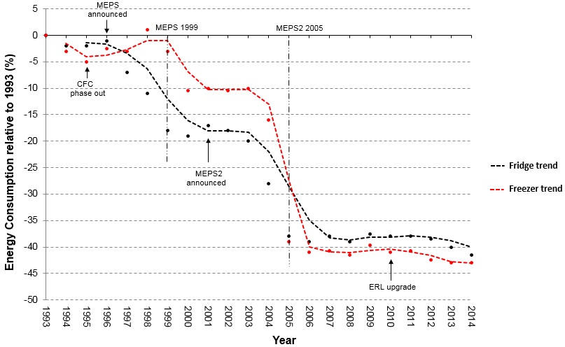

Source: Energy Efficient Strategies (2016) *Whitegoods Efficiency Trends*

Figure : Improvements to refrigerator and freezer efficiency in New Zealand (2002-2015)

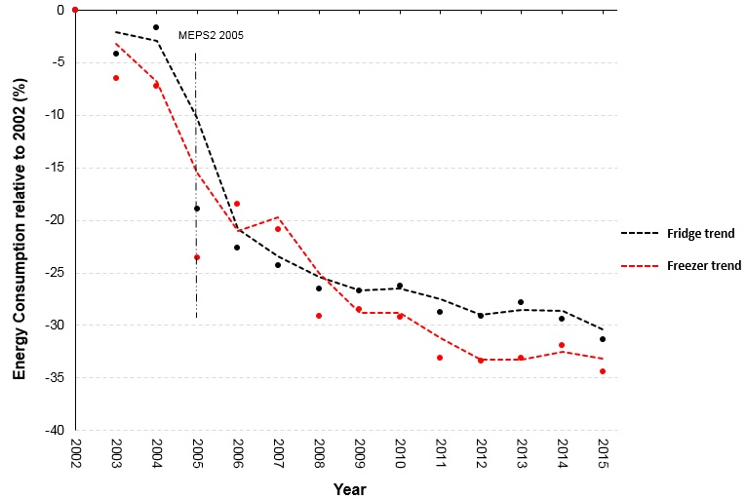

Source: Energy Efficiency and Conservation Authority (2016)

### 1.3 The Market

Australian manufacturing of whitegoods, including refrigerators and freezers, ceased in April 2016 and New Zealand also ceased whitegoods manufacturing in late 2016. Since then, all refrigerating appliances have been imported into Australia and New Zealand with refrigerators predominantly coming from China, Thailand, South Korea, the US, Germany, Brazil, Japan, Mexico and Taiwan. The majority of freezers are imported from China. Manufacturers and importers bring in appliances and supply them to retailers.

#### 1.3.1 Characteristics of appliances

Approximately 120 brands of refrigerators and freezers are registered for supply in Australia and New Zealand. Major refrigerator brands include Samsung, Westinghouse, Fisher and Paykel, Hisense and LG. Major freezer brands include: Westinghouse, Fisher and Paykel, Hisense, Haier and Changhong. There are approximately 1,170 of refrigerators and 370 models of freezers registered for supply in Australia and New Zealand.

The average storage volumes of these appliances have continued to increase slightly over the past 20 years. As shown in **Table 4**, the average total volume of a refrigerator (refrigerator/freezer configuration) purchased in 2014 was 401 litres and average freezer volume was 208 litres.

Table 4: Typical refrigerator and freezer characteristics

|  |  |  |
| --- | --- | --- |
| **Characteristic** | **Refrigerator** | **Freezer** |
| Fresh food volume (litres) | 282 | - |
| Freezer volume (litres) | 116 | 208 |
| Other volume (litres) | 3 | - |
| **Average total volume (litres)** | **401** | **208** |
| Label energy usage (kWh/year) | 453 | 352 |
| Average star rating (rounded) | 2.5 | 2.5 |
| Price (AU$2014) | $1,060 | $618 |

Source: Energy Efficient Strategies (2016) *Whitegoods Efficiency Trends*, pages 30 and 40

#### 1.3.2 Stock

In 2015, it is estimated that the Australian stock of household refrigerators was approximately 12.5 million units and freezer stock was 3.3 million. New Zealand stock levels are estimated to be 2.3 million and 1.1 million resepectively.[17] Stock estimates have been derived using Australian Bureau of Statistics and Statistics New Zealand data and estimates of household refrigerator and freezer ownership levels. Stock levels are a function of sales adding to existing stock and old appliances being retired. Industry estimates that the average refrigerator life is approximately 15-17 years while freezers have a life expectancy of approximately 21-25 years.

#### 1.3.3 Sales

In 2015, the five major refrigerator brands accounted for approximately 74 per cent of Australian sales and the five major freezer brands accounted for approximately 78 per cent of sales.[18] According to 2015 sales data, approximately 900,000 refrigerators and 150,000 freezers were sold in Australia valued at approximately $1 billion.[19] As shown in **Table 5**, groups 5T and 5B dominate Australia’s refrigerator market with approximately 75 per cent of sales, with group 2 (small bar refrigerators) capturing approximately 10 per cent and group 5S holding about nine per cent.[20]

Table 5: Australian refrigerator sales (2015)

|  |  |
| --- | --- |
| **Refrigerator Group** | **Percentage of Sales** |
| 1 | 5.2% |
| 2 | 10.2% |
| 3 | 0.9% |
| 4 | 0.2% |
| 5B | 35.7% |
| 5S | 8.7% |
| 5T | 39.1% |

Source: GfK sales data

As shown in **Table 6**, group 6C (chest freezers) accounts for about 47 per cent of Australia’s freezer sales and group 7 (frost free vertical) holds about 33 per cent of sales.

Table 6: Australian freezer sales (2015)

|  |  |
| --- | --- |
| **Freezer Group** | **Percentage of Sales** |
| 6C | 46.8% |
| 6U | 20.3% |
| 7 | 32.9% |

Source: GfK sales data

In 2016, approximately 212,800 refrigerators and freezers were sold in New Zealand.[21] As shown in **Table 7**, groups 5T and 5B lead the New Zealand refrigerator market with approximately 61 per cent of sales, group 2 captures approximately 18 per cent and group 5S holds about 10 per cent.[22]

Table 7: New Zealand refrigerator sales (2015)

|  |  |
| --- | --- |
| **Refrigerator Group** | **Percentage of Sales** |
| 1 | 1.5% |
| 2 | 18.1% |
| 3 | 0.9% |
| 4 | 8.3% |
| 5B | 37.2% |
| 5S | 9.9% |
| 5T | 24.1% |

Source: Energy Efficiency and Conservation Authority (2016)

As shown in **Table 8**, group 6C accounts for about 61 per cent of New Zealand’s freezer sales and group 7 holds about 26 per cent of sales.

Table 8: New Zealand freezer sales (2015)

|  |  |
| --- | --- |
| **Freezer Group** | **Percentage of Sales** |
| 6C | 61.4% |
| 6U | 26.5% |
| 7 | 12.1% |

Source: Energy Efficiency and Conservation Authority (2016)

#### 1.3.4 Prices

The real average prices of household refrigerating appliances in all product groups have trended down over time. **Table 9** provides the average price in Australia for the typical refrigeration appliance in each group (detailed time‑series price data is at Attachment A). It is understood that these trends have also been occurring in New Zealand.

Table 9: Average prices - Australia

|  |  |
| --- | --- |
| **Group** | **Average price (2014$)** |
| 1 | $1,003 |
| 2 | $234 |
| 3 | $321 |
| 4 | $591 |
| 5B | $1,672 |
| 5S | $1,646 |
| 5T | $769 |
| 6C | $479 |
| 6U | $374 |
| 7 | $1,039 |

Source: Energy Efficient Strategies (2016) *Whitegoods Efficiency Trends*, Detailed Output Tables

Australian sales data indicates that improved energy efficiency does not necessarily carry a price premium. In some instances, refrigerators and freezers with greater efficiencies retail for lower prices. **Table 10, Table 11** and **Table** 12**,** show that while there is generally a price premium (per litre) for more energy efficient group 2 refrigerators, energy efficient group 5B and 5T refrigerators do not necessarily carry a price premium, and in some groups, more efficient refrigerators are cheaper (e.g. on a per litre basis, a 3.0‑star 5B refrigerator is cheaper than a 2.0‑star refrigerator and a 3.5‑star 5T refrigerator is cheaper than a 1.5‑star). These tables need to be carefully interpreted because some table cells have have few models and, in these cases, characteristics may not be representative of the group.

Table 10: Group 2 star/price comparison

|  |  |  |  |  |  |  |
| --- | --- | --- | --- | --- | --- | --- |
| **Star Rating** | **1** | **1.5** | **2** | **2.5** | **3** | **3.5** |
| **Number of Models** | 43 | 19 | 11 | 3 | 3 | 1 |
| **Average Volume (litres)** | 100.0 | 100.2 | 113.4 | 83.4 | 86.8 | 49.0 |
| **Average Price (2013$)** | $217 | $186 | $241 | $238 | $388 | $239 |
| **Energy** | 279.7 | 245.3 | 214.6 | 185.4 | 157.4 | 130.0 |
| **$/litre** | $2.17 | $1.86 | $2.13 | $2.85 | $4.47 | $4.87 |

Source: Energy Efficient Strategies (2016) *Whitegoods Efficiency Trends*, page 95

Table 11: Group 5B star/price comparison

|  |  |  |  |  |  |  |
| --- | --- | --- | --- | --- | --- | --- |
| **Star Rating** | **1** | **1.5** | **2** | **2.5** | **3** | **3.5** |
| **Number of Models** | 7 | 38 | 54 | 29 | 17 | 9 |
| **Average Volume (litres)** | 436.4 | 604.6 | 501.3 | 530.8 | 481.5 | 451.1 |
| **Average Price (2013$)** | $1,470 | $2,173 | $1,612 | $1,530 | $1,350 | $1,288 |
| **Energy** | 670.4 | 708.3 | 579.2 | 542.6 | 435.9 | 381.9 |
| **$/litre** | $3.37 | $3.59 | $3.21 | $2.88 | $2.80 | $2.85 |

Source: Energy Efficient Strategies (2016) *Whitegoods Efficiency Trends*, page 99

Table 12: Group 5T star/price comparison

|  |  |  |  |  |  |  |  |
| --- | --- | --- | --- | --- | --- | --- | --- |
| **Star Rating** | **1** | **1.5** | **2** | **2.5** | **3** | **3.5** | **4** |
| **Number of Models** | 4 | 16 | 73 | 90 | 10 | 11 | 2 |
| **Average Volume (litres)** | 436.2 | 222.8 | 327.0 | 430.8 | 416.7 | 321.9 | 461.4 |
| **Average Price (2013$)** | $954 | $464 | $614 | $840 | $921 | $660 | $1,588 |
| **Energy** | 706.6 | 413.4 | 444.8 | 464.7 | 395.2 | 302.9 | 335.1 |
| **$/litre** | $2.19 | $2.08 | $1.88 | $1.95 | $2.21 | $2.05 | $3.44 |

Source: Energy Efficient Strategies (2016) *Whitegoods Efficiency Trends*, page 98

There are similar observations for certain groups of freezers as shown in **Table 13** and **Table 14** with 3.0 star and 3.5‑star group 6C freezers cheaper than 2.0 and 2.5-star freezers and 3.0-star group 6U freezers cheaper than 1.0 to 2.5-star freezers, on a price per litre basis.

Table 13: Group 6C star/price comparison

|  |  |  |  |  |  |  |
| --- | --- | --- | --- | --- | --- | --- |
| **Star Rating** | **1** | **1.5** | **2** | **2.5** | **3** | **3.5** |
| **Number of Models** | 0 | 0 | 17 | 40 | 9 | 2 |
| **Average Volume (litres)** | - | - | 388.4 | 207.5 | 193.4 | 159.2 |
| **Average Price (2013$)** | - | - | $790 | $442 | $343 | $314 |
| **Energy** | - | - | 474.9 | 327.4 | 270.4 | 232.1 |
| **$/litre** | - | - | $2.03 | $2.13 | $1.77 | $1.97 |

Source: Energy Efficient Strategies (2016) *Whitegoods Efficiency Trends*, page 101

Table 14: Group 6U star/price comparison

|  |  |  |  |  |  |  |
| --- | --- | --- | --- | --- | --- | --- |
| **Star Rating** | **1** | **1.5** | **2** | **2.5** | **3** | **3.5** |
| **Number of Models** | 1 | 6 | 18 | 6 | 6 | 1 |
| **Average Volume (litres)** | 165.0 | 82.3 | 111.3 | 130.7 | 179.1 | 96.0 |
| **Average Price (2013$)** | $450 | $209 | $290 | $433 | $409 | $2,142 |
| **Energy** | 461.0 | 299.2 | 289.9 | 265.0 | 279.5 | 169.0 |
| **$/litre** | $2.73 | $2.54 | $2.61 | $3.31 | $2.28 | $22.31 |

Source: Energy Efficient Strategies (2016) *Whitegoods Efficiency Trends*, page 102

As shown in **Figure 3** and **Figure 4**, regulatory measures have resulted in appliances consuming considerably less energy while real costs have continued to trend downwards. For example, in 1993 the average price (in $2014) of an average‑sized refrigerator sold in Australia was approximately $1,600 and in 2014, the average price had fallen to approximately $1,050. Similarly, the average price (in $2014) of an average-sized freezer sold in Australia has fallen from approximately $1,000 in 1993 to about $600 in 2014.[23]

Figure : Refrigerator energy and real price trends - 1993-2014 (Australia)

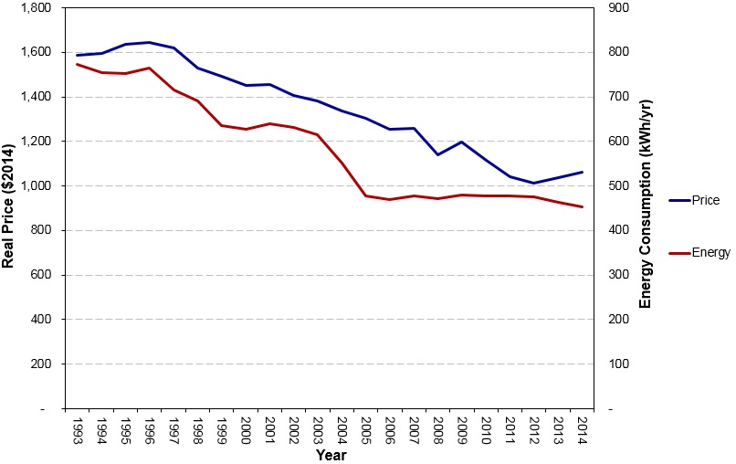

Source : Energy Efficient Strategies (2016) *Whitegoods Efficiency Trends*, page 5

Figure : Freezer energy and real price trends - 1993-2014 (Australia)

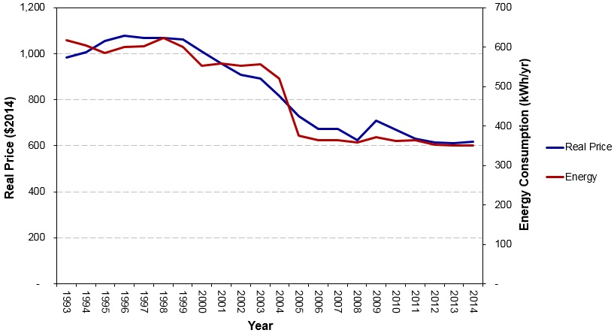

Source: Energy Efficient Strategies (2016) *Whitegoods Efficiency Trends*, page 6

These trends are not unique to Australia and New Zealand and similar effects have been reported in other countries.[24] Observed real price reductions are understood to be driven by a combination of factors:

* Competition between manufacturers;
* Improvements in manufacturing efficiencies; and
* Reductions in materials costs.

# The Problem

The current regulatory requirements applicable to household refrigerators and freezers have promoted the development and supply of more energy efficient appliances in Australia and New Zealand than would have been the case under BAU. However, there is scope to make significant simplification and harmonisation changes to the regulations that can address adverse consequences and improve energy efficiency. In this section, these regulatory issues are discussed.

In Australia and New Zealand, energy efficiency regulations in the form of the ERL and MEPS have been introduced to address market failures (information failure and negative externalities as discussed in Section 1.2) associated with household refrigerators and freezers. However, there have only been marginal improvements in the energy efficiency of refrigerators and freezers supplied in Australia and New Zealand beyond the regulatory levels set in 2005, compared to what is technically achievable. It is likely that in the absence of more stringent MEPS levels, further efficiency gains in these markets will be slow to materialise.

### 2.1 MEPS

Since 2005, the US and European Union (EU) have both tightened their MEPS levels, stimulating product energy efficiency improvements, reducing emissions and reducing consumers’ energy costs. Consequently, Australia’s and New Zealand’s MEPS levels have again lagged behind those adopted by other countries as shown in **Table 15**.

Table 15: Converted (standardised) MEPS levels (kWh/annum)

|  |  |  |  |  |
| --- | --- | --- | --- | --- |
|  | **Appliance** | | | |
| **Country/Region** | Small refrigerator | Small refrigerator‑freezer | Medium refrigerator‑freezer | Chest freezer |
| EU | 183 | 258 | 370 | 211 |
| US | 224 | 294 | 360 | 329 |
| Mexico | 298 | 408 | 499 | 346 |
| Australia/New Zealand | 315 | 448 | 540 | 384 |
| China | 332 | 394 | 575 | 404 |
| India | - | 522 | 628 | - |

Source: CLASP (2014) *Improving Global Comparability of Appliance Energy Efficiency Standards and Labels*

Note: The standardised MEPS values in this table specify the maximum allowable power consumptions per annum that broad categories of refrigerators and freezers must not exceed for them to be allowed to be offered for supply in indicated markets. The lower the number, the less energy used by the appliance.

Efficiency improvements in the US and EU have been achieved by incorporating mature technologies (such as vacuum insulation panels and more efficient compressors) that could also easily be incorporated into refrigerating appliances sold in Australia and New Zealand and would deliver considerable emissions abatements and energy cost savings to consumers.

When MEPS2 levels were agreed for Australia and New Zealand, a cost benefit analysis was undertaken to determine the optimum mandated efficiency levels, weighing up the costs associated with more efficient appliances with potential energy savings. This level was assessed as appropriate for the market conditions prevailing at the time. However, since 2005 when MEPS2 levels were decided:

* Large markets in the EU, US and elsewhere have tightened MEPS levels and are now supplied with more energy efficient refrigeration appliances using mature technologies that were not available in 2005. Therefore, a wide variety of more energy efficient appliances are also available for Australian and New Zealand consumers;
* Australia’s electricity prices have increased significantly over the past five years; and
* Real appliance prices have continued to fall, making higher levels of efficiency even more cost effective.

**Figure 5** indicates that E3 product registration data shows the majority of refrigerators and freezers registered for sale in the Australian and New Zealand markets cluster near to the MEPS cut-off point and have a 2.0‑2.5 star rating. However, manufacturers already produce and supply considerably more energy efficient models to other international markets, but relatively few of such models are supplied to our markets. For example, there are only seven models (of approximately 1,540 models registered) that have attained 5 stars of a possible 10 stars provided for by the ERL. No supplier has registered a model that exceeds five stars, despite products that exceed this efficiency level being supplied in other markets.

Figure 5: E3 refrigerator and freezer registrations (star ratings)

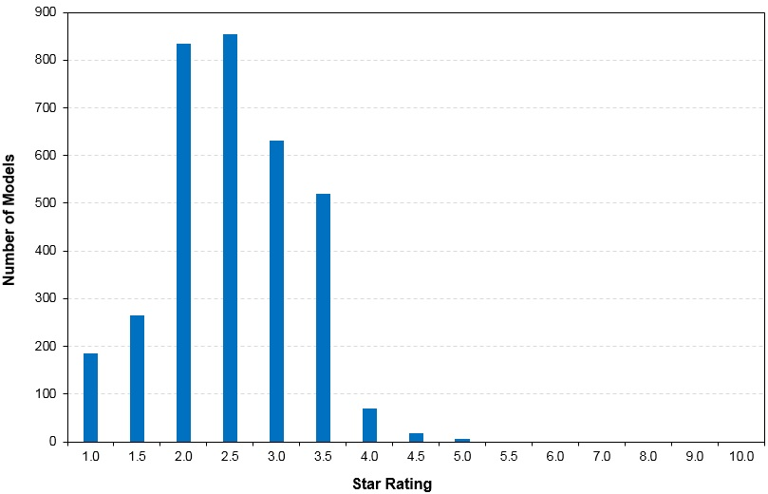

Source: Equipment Energy Efficiency registration database, <http://reg.energyrating.gov.au/comparator/product_types>

***For the reasons above, a regulatory failure exists because current MEPS levels are set too low for Australia’s and New Zealand’s markets. In an environment where we now have access to a wider variety of cheaper and more efficient appliances, increased electricity costs mean that it is cost‑effective to mandate tighter MEPS levels. This will reduce consumers’ net costs of refrigeration ownership and also reduce the negative externality of GHG emissions.***

In recognition that there is value in undertaking further work to stimulate demand for the purchase of more energy efficient refrigerating appliances, the E3 Program is pursuing avenues to achieve continued appliance energy efficiency gains. These initiatives include behavioural insights work underway that is examining consumer behaviour to better understand and influence consumers’ purchasing decisions toward more energy efficient appliances.

However, such work streams are newly commenced and it will take several years to effect any possible changes. Currently, the energy efficiency of products in the global market is primarily driven by MEPS regulations and, as a small market of approximately two per cent of global sales, Australia and New Zealand need to use the existing MEPS policies to address the existing market failure.

The international application of appliance energy efficiency standards via MEPS and energy efficiency labelling programs were introduced in the 1970s and are now applied in more than 80 countries as indicted in **Figure 6.** While the design and coverage of these measures vary according to nations’ individual policies and circumstances, they provide central components of most national energy efficiency and climate change mitigation programs.[25]

Figure : Nations with MEPS and/or ERLs

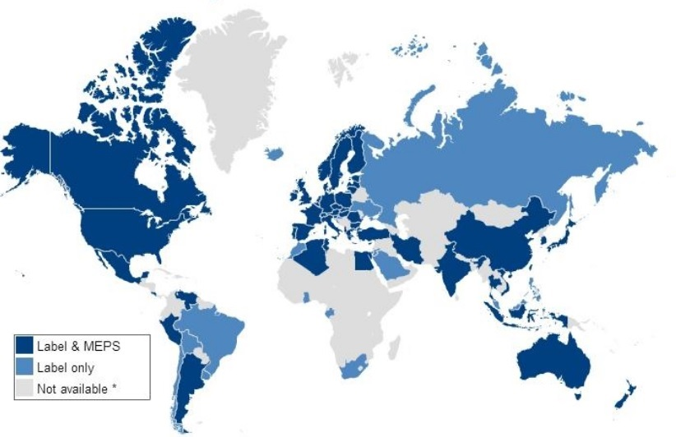

Source: IEA (2014) *Energy Efficiency Standards and Labeling*

There is now an opportunity to align Australia’s and New Zealand’s MEPS with international best practice and realise significant energy savings for consumers and reduce carbon dioxide (CO2) emissions. As discussed in the Impacts section of this document, delaying the adoption of MEPS3 by one year will result in lost savings to 2030 of about AU$102 million to Australian consumers and conservatively NZ$8 million to the New Zealand economy.

### 2.2 Test standard

Another problem with the current regulatory framework is that Australia and New Zealand use a unique regional standard when testing the energy efficiency of household refrigerating appliances to assess whether appliances meet MEPS. However, because several countries, who are major household refrigerating appliances suppliers to the Australian and New Zealand markets (notably China, Japan and Thailand), have already adopted test methods similar to the International Electrotechnical Committee (IEC) test method *62552-1:2015* *Household refrigerating appliances - Characteristics and test methods - Part 1: General requirements*, the requirement to also test to our regional standard imposes an unnecessary regulatory burden on suppliers. In addition, the Australian and New Zealand standard measures energy consumption at an ambient temperature of 32°C while the IEC standard measures energy consumption at both 16°C and 32°C (IEC 62552-3:*2015*). Testing at two different temperatures can provide improved information on the likely field performance of appliances and provides an opportunity to recalibrate the ERL to better reflect the expected energy consumption during normal use in Australia and New Zealand.

***For the reasons above, a second regulatory failure exists because Australia and New Zealand require product suppliers to use a unique test method when testing appliances for MEPS and labelling requirements, rather than using an internationally recognised and employed test method, and therefore businesses face unnecessary regulatory costs.***

# Objective

**Why is government action needed?**

The proposed government actions to: exclude the least energy efficient household refrigeration products from the Australian and New Zealand markets; and adopt an internationally recognised test procedure have the following objectives for Australia and New Zealand:

* Encourage the entry of more energy efficient household refrigerators and freezers to the national stock;
* Reduce greenhouse gas emissions and assist both countries to meet climate change related commitments;
* Mitigate the growth in energy demand thereby defer the need to invest in new energy supply infrastructure;
* Reduce consumers’ energy costs;
* Deliver national benefits;
* Reduce product suppliers compliance costs by removing the need to test to a regional standard; and
* Ensure that regulation remains relevant and effective over time.

Without government action the regulatory failures identified in this consultation RIS will persist.

For Australia, the objectives of this RIS are consistent with Principle 6 of the Council of Australian Governments (COAG) RIS Guidelines. This principle seeks the review of regulation “…with a view to encouraging competition and efficiency, streamlining the regulatory environment, and reducing the regulatory burden on business arising from the stock of regulation”. The proposals in this consultation RIS are also aligned with the *Australian Government Industry Innovation and Competitiveness Agenda (2014)* principle to reduce regulatory burden by removing inefficient regulation and simplify compliance.[26]

It is considered that the COAG RIS guidelines are broadly in line with the requirements of the New Zealand Government for Regulatory Impact Analysis.

# Options

The following policy options are considered to address the problems identified in this RIS:

* Option A: No changes to the existing requirements - BAU
* Option B: Adopt MEPS3
* Option C: Adopt MEPS3 and the IEC test standard

### 4.1 Option A: BAU

This option would see no changes to the current regulatory requirements. MEPS would remain unchanged and therefore the energy efficiency benefits of the existing requirements would continue to accrue as the existing stock of household refrigerators and freezers is turned over and replaced by products that meet current MEPS levels. It can be expected that there will likely be marginal improvements in the energy efficiency of appliances supplied to the Australian and New Zealand markets due to manufacturers’ abilities to produce more energy efficient appliances to comply with the energy efficiency policies instituted in countries that have tighter MEPS. However, as previously discussed, efficiency improvements are likely to be slow to materialise in the absence of tighter MEPS. For example, over the nine-year period from 2005 (when MEPS2 came into force) to 2014, refrigerators’ and freezers’ energy efficiencies only improved by approximately 10 per cent.

This option also involves the continued use of AS/NZS4474.1 *Performance of household electrical appliances – Refrigerating appliances – Part 1: Energy consumption and performance*, as the applicable test standard in Australia and New Zealand. Appliance suppliers will continue to refer to AS/NZS 4474.2 *Performance of household electrical appliances – Refrigerating appliances – Part 2: Energy labelling and minimum energy performance standard requirements*, to reference the minimum product performance and energy labelling requirements.

**E3 seeks feedback from stakeholders regarding:**

1. ***Do stakeholders support no changes to energy efficiency regulations for household refrigerating appliances? If yes, then please provide supporting arguments.***

### 4.2 Option B: Adopt MEPS3

This option would require Australia and New Zealand to adopt MEPS3 levels, equivalent to those adopted in the US as at 15 September 2014. US MEPS levels are complicated due to the use of 42 different product groups, known as product classes. In the past, the classes defined by the US have been rationalised and condensed when adapted for Australia and New Zealand by the use of allowances for features such as through the door (TTD) icemakers. Many of the US product categories (such as built-in products that account for 11 categories) are rare in Australia and New Zealand and therefore no specific group has been created for them in the Australian and New Zealand contexts, but an equivalent energy allowance has been provided.

As detailed in the Consultation section of this RIS, there have been several years of extensive consultations with stakeholders about how to best apply US MEPS levels in the Australian/New Zealand contexts. While there is general consensus concerning many of the details involved with adopting US MEPS levels, some details remain unresolved and these issues are discussed below.

**4.2.1 Product coverage**

Option B maintains the status quo regarding the products that are in scope of the Determination/Regulations and there is no proposal to expand the coverage of the Determination/Regulations to include products such as wine coolers or other beverage coolers. E3 notes the US has recently applied new MEPS regulations[27] (that come into force in 2019) to these and other types of refrigerating appliances[28] and in the future Australia and New Zealand may also consider expanding the scope of the Determination/Regulations to cover these types of products.

**4.2.2 MEPS Levels**

**Table 16** shows the equivalence between US product classes and Australian/New Zealand product groups.

Table 16: MEPS levels for AS/NZS Groups

|  |  |  |  |
| --- | --- | --- | --- |
| **AS/NZS group** | **US Class** | **Percentage of sales (2015)** | |
| **Australia** | **New Zealand** |
| **Refrigerators** |  |  |  |
| 1 | 3A | 5.2% | 1.5% |
| 2 | 1A | 10.2% | 18.1% |
| 3 | 1 | 0.9% | 0.9% |
| 4 | 2 | 0.2% | 8.3% |
| 5B | 5 | 35.7% | 37.2% |
| 5s | 4 | 8.7% | 9.9% |
| 5T | 3 | 39.1% | 24.1% |
| **Freezers** |  |  |  |
| 6C | 10 | 46.8% | 61.4% |
| 6U | 8 | 20.3% | 26.5% |
| 7 | 9 | 32.9% | 12.1% |

Sources: E3 (2011) *Household Refrigeration Paper 1 - MEPS for Household Refrigeration, Summary of new MEPS levels in the USA;* GfK sales data

The introduction of MEPS3 would significantly lower the maximum allowable energy consumption of refrigerators and freezers and would result in substantial energy reductions. In broad terms, the impact would be comparable to the initial introduction of MEPS levels in Australia and New Zealand. On average, the energy consumption of non‑compliant appliances will need to decrease by approximately 30 per cent to meet MEPS3 levels.

**4.2.3 Performance standard**

Currently, the Determination/Regulations call up the Australian/New Zealand performance standard AS/NZS 4474.2 that, among other things, specifies the MEPS levels for refrigerators and freezers. Changes to MEPS levels would therefore require either:

* Retaining AS/NZS 4474.2 as a standard and revising it accordingly through established processes via Standards Australia’s EL-060 Household Refrigerating Appliances Committee; or
* Incorporating the contents of AS/NZS 4474.2 into the Determination/Regulations (as a schedule) and revising it accordingly via an appropriate stakeholder engagement process.

The first option would require stakeholders to continue purchasing AS/NZS 4474.2 to access MEPS levels and other requirements whereas the second option would mean stakeholders could freely access this information via the Determination/Regulations and therefore reduce regulatory burden.

E3’s preference is to, where appropriate, incorporate performance standards into Determinations (and for New Zealand to refer to this) for a number of reasons including:

* Timely enacting the COAG Energy Council’s and the New Zealand Cabinet’s decisions following appropriate consultation; and
* Ensuring consistency between policy objectives and technical details.

For refrigerators and freezers, E3 propose to incorporate all relevant material from AS/NZS 4474.2 into the Determination/Regulations to ensure that the objectives above are met. E3 would establish a consensus-based, transparent and consultative process (that was comparable to existing Standards Australia processes) and would include a process to allow stakeholders to review the final draft Determination prior to Ministerial approval.

**E3 seeks feedback from stakeholders regarding:**

1. ***What are the advantages/disadvantages of incorporating the contents of AS/NZS 4474.2 into the Determination/Regulations rather maintaining the status quo and leaving it as a standard?***
2. ***Do stakeholders support incorporating the contents of AS/NZS 4474.2 into the Determination/Regulations and if not then why?***

**4.2.5 Performance parameters**

E3 has led past work to draft a revised AS/NZS4474.2 to reflect MEPS3 levels and other technical parameters. Stakeholder consultations have been held and feedback has been incorporated into a draft AS/NZS4474.2. Once a decision is made to adopt MEPS3, this work will need to be continued by a Technical Working Group that will be established. **Table 17** lists aspects of performance parameters (from draft AS/NZS4474.2) that have been generally agreed during stakeholder consultations, if adopting MEPS3 only.

Table : Generally agreed performance parameters (MEPS3 only)

|  |  |  |
| --- | --- | --- |
| **Parameter** | **Reference Clause of draft AS/NZS4474.2** | **Notes** |
| Scope | Clause 1.1 | Inclusion of all refrigeration products for labelling and MEPS (specifically cooled appliances) |
| Exclusions | Clause 1.2 | Current exclusions remain unchanged |
| Built in products | Clause 1.6.3 | Use US definition for a built in product modified with local industry suggestion - MEPS only |
| Compact products | Clause 1.6.6 | Use local industry definition for a compact product (i.e. small footprint) - MEPS only |
| Refrigerating Appliance Designation | Clause 1.6.16 | From AS/NZS4474.1 |
| Refrigerating Appliance Group | Clause 1.6.17 | From AS/NZS4474.1 |
| Humidity maps | Clause 2 | US humidity map for MEPS and AS/NZS humidity maps for energy labelling |
| Number of units to test | Clause 3.2.1 | Testing 3 units (no change) |
| Pull down requirement | Clause 4.3 | Pull down time of six hours as per current AS/NZS4474.1 requirement at an ambient of 43°C |
| Storage test | Clause 4.4 | Temperature operation test as per AS/NZS4474.1 |
| Adjusted volume | Clause 4.5 | Applied for MEPS and labelling as defined in AS/NZS4474.2 |
| Projected MEPS energy consumption | Clause 4.6 | Endorsed |
| MEPS levels | Clause 4.7 | Including levels for standard products and compact products |

Source: Generally agreed during stakeholder consultations as detailed in the Consultation section of this document.

Notes: Built in and compact type products are currently regulated in Australia and New Zealand and clauses 1.6.3, 1.6.6 and 4.7 will align the MEPS treatment of these products with that used in the US.

**E3 seeks feedback from stakeholders regarding:**

1. ***Do stakeholders support adopting Option B measures? If not, please provide arguments supporting your position accompanied with quantitative evidence as appropriate.***

### 4.3 Option C: Adopt MEPS3 and IEC test standard

In addition to adopting MEPS3 as discussed in Option B, Option C would involve replacing the regionally specific AS/NZS4474.1 test standard with the IEC test standard, IEC 62552 parts 1 to 3, published February 2015.[29]

This proposed change would mean that product suppliers would no longer need to purchase, interpret and comply with the Australian/New Zealand test standard. Further, suppliers would no longer need to test appliances in accordance with AS/NZS4474.1 and test reports that have been generated using the IEC test methodology could be used to register products for sale in Australia and New Zealand. For many suppliers, the test reports based on the IEC test standard are already being produced for registering products in other markets.

The Implementation section details how product registrations will be handled during the transition period between when the new Determination/Regulations receive Ministerial approval and when they come into effect and how suppliers’ inventories will be effected after the Determination/Regulations come into effect.

Australia was actively involved with the development of the IEC standard and recommendations made by Australia (and other stakeholders) to improve the standard have been accepted by the IEC. There are several arguments that support adopting the IEC test method (62552 1.0b published February 2015). These include:

* In cases where industry already tests their appliances against IEC 62552, requiring them to also test according to our unique regional standard imposes an unnecessary regulatory burden and associated costs may be passed on to consumers.
* Industry broadly supports Australia and New Zealand aligning their appliance test procedures with the IEC standards.
* The Australian and New Zealand Governments’ policies are to, where appropriate, generally harmonise electrical product test standards with the best-practice standards applied by our major trading partners.
* When the US introduced MEPS3 it made changes to their test method that substantially aligned it with the IEC’s and therefore the allowances that will need to be made to adopt MEPS3 will be smaller and provide higher confidence concerning alignment.
* China, Japan and Thailand have adopted test methods similar to the IEC’s and the EU has a process underway that is likely to see it substantially adopt the IEC test method.
* IEC 62552 allows measurement of energy consumption at ambient temperatures of 32°C (the current Australia and New Zealand ambient temperature) and 16°C as well as providing a processing efficiency test which will enable products to be tested for energy consumption in a manner closer to their normal use.
* Adopting IEC 62552 would not impact on Australia’s and New Zealand’s abilities to maintain ERLs.

**4.3.1 Product coverage**

Option C maintains the status quo regarding the products that are in scope of the Determination and there is no proposal to expand the coverage of the Determination to include additional products. E3 notes the US has applied MEPS regulation to other types of refrigerating appliances and in the future, Australia and New Zealand may also consider expanding the scope of the regulation to cover these types of products in the future.

**4.3.2 IEC test parameters**

Numerous consultation processes (see Consultation section) have been undertaken to compare the parameters and requirements of the: IEC test standard; US test standard (that is largely based on IEC 62552), and Australia/New Zealand test standard. There has been general agreement that there would not be any insurmountable problems should we adopt the IEC 62552. Further, full stakeholder consultations would be held as necessary to decide on how to best address identified and residual issues should Australia and New Zealand adopt IEC 62552.

**Table 18** lists performance parameters (from draft AS/NZS4474.2) that have been generally agreed during stakeholder consultations, if adopting MEPS3 and the IEC test method.

Table : Generally agreed performance parameters (MEPS3 & IEC test method)

|  |  |  |
| --- | --- | --- |
| **Parameter** | **Reference Clause of draft AS/NZS4474.2** | **Notes** |
| Scope | Clause 1.1 | Inclusion of all refrigeration products for labelling and MEPS (specifically cooled appliances) |
| Exclusions | Clause 1.2 | Current exclusions remain unchanged |
| Built in products | Clause 1.6.3 | Use US definition for a built in product modified with local industry suggestion - MEPS only |
| Compact products | Clause 1.6.6 | Use local industry definition for a compact product (i.e. small footprint) - MEPS only |
| Refrigerating Appliance Designation | Clause 1.6.16 | From AS/NZS4474.1 |
| Refrigerating Appliance Group | Clause 1.6.17 | From AS/NZS4474.1 |
| Humidity maps | Clause 2 | US humidity map for MEPS and AS/NZS humidity maps for energy labelling |
| Number of units to test | Clause 3.2.1 | Testing of a single product in lieu of addition testing load in IEC (flagged Oct 2013) |
| Star Rating Index | Clause 3.7 | Broad agreement to reduce ERF to 0.20 as set out in Option 4 of Energy Efficient Strategies (2015) |
| Volume | Clause 4.2 | IEC volume measurement in IEC62552-3 Annex H |
| Pull down requirement | Clause 4.3 | Pull down test as per IEC62552.2 Annex A at an ambient of 43°C with performance requirement of six hours to be specified in Part 2 or Determination |
| Storage test | Clause 4.4 | Temperature operation test IEC62552.2 Clause 4 |
| Adjusted volume | Clause 4.5 | Included in the Part 2 or Determination for IEC test conditions |
| Projected MEPS energy consumption | Clause 4.6 | Endorsed |
| MEPS levels | Clause 4.7 | Includes levels for standard products and compact products |

Source: Generally agreed during stakeholder consultations as detailed in the Consultations section of this document.

Notes: Built in and compact type products are currently regulated in Australia and New Zealand and clauses 1.6.3, 1.6.6 and 4.7 will align the MEPS treatment of these products with that used in the US.

**Table 19** lists aspects of the IEC test method that have been broadly agreed by stakeholders.

Table 19: Generally agreed test parameters

|  |  |  |
| --- | --- | --- |
| **Parameter** | **Reference Clause** | **Notes** |
| Definitions | IEC62552-1 Clause 3 | Endorsed |
| Climate classification | IEC62552-1 Clause 4 | Temperature will be tested to the SN Standard for the storage test. Pull down will be tested to the T Standard. Informative note may be required for clarity |
| Instrumentation | IEC62552-1 Annex A | Voltage and frequency specified in Part 2 or Determination |
| Setup, preparation | IEC62552-1 Annex B | Endorsed |
| Freezer test packs | IEC62552-1 Annex C | Only used for storage test |
| Sensor locations | IEC62552-1 Annex D | Air sensor positions |
| Storage test | IEC62552-2 Clause 4 | Only 500g test packages are permitted, equivalent to temperature operation test in AS/NZS4474.1 |
| Pull down test | IEC62552-2 Annex A | Pull down time specified in Part 2 or Determination (no pull down limit in IEC standard) at an ambient of 43°C |
| Energy target temps | IEC62552-3 Clause 5 | Note that these are different to AS/NZS |
| Daily energy | IEC62552-3 Clause 6 | Annual energy defined in Part 2 or Determination |
| Circumvention | IEC62552-3 Clause 7 | Principles same as AS/NZS |
| Set up for energy tests | IEC62552-3 Annex A | Ice storage bin left in place, see (1) below |
| Steady state power | IEC62552-3 Annex B | Endorsed |
| Defrost and recovery | IEC62552-3 Annex C | Endorsed |
| Defrost interval | IEC62552-3 Annex D | Endorsed |
| Interpolation | IEC62552-3 Annex E | Endorsed |
| Ambient controlled anti-condensation heaters | IEC62552-3 Annex F | Humidity map to be specified by region |
| Load processing test | IEC62552-3 Annex G | Only 32°C test is an option for labelling but values at 16°C and 32°C are encouraged |
| Volume determination | IEC62552-3 Annex H | Endorsed |
| Analysis without steady state between defrosts | IEC62552-3 Annex K | Only where Annex B cannot be applied |

Note (1) Under IEC62552-3 A.2.5 the position of manually switched anti condensation heaters can be specified in regional requirements. Part 2 proposed that these shall be set in the ON position or in the maximum (highest energy) position where there is a variable control (this is a permitted variation with IEC) for both energy labelling and MEPS energy Determination.

Source: Generally agreed during stakeholder consultations as detailed in the Consultations section of this document.

**Table 20** lists aspects of the IEC test method that are proposed to not be included in the Australian or New Zealand requirements.

Table 20: Test parameters that are proposed to not be included

|  |  |  |
| --- | --- | --- |
| **Parameter** | **Reference Clause** | **Notes** |
| Compartment marking | IEC62552-1 Clause 4 | IEC symbols and markings for compartments are optional (these are not normative) |
| Cooling capacity test | IEC62552-2 Clause 5 | Not included, only applies to fresh food, pull down test covers the requirements |
| Freezing capacity test | IEC62552-2 Clause 6 | Not included, only applies to freezers, pull down test covers the requirements |
| Automatic ice-making capacity test | IEC62552-2 Clause 7 | Not included in requirements |
| Temperature rise test | IEC62552-2 Annex C | Not required |
| Water vapour condensation test | IEC62552-2 Annex D | Not required |
| Ice making energy test for tank type icemakers | IEC62552-3 Annex F | No test yet for icemakers connected to mains water supply, covered by load processing test |
| Load processing test | IEC62552-3 Annex G | 16°C test is optional for labelling |

Source: Generally agreed during stakeholder consultations as detailed in the Consultations section of this document.

Some issues with adopting the IEC standard have been identified including:

* The freezer temperature specified in the IEC standard is -18°C that is colder than the current freezer temperature specified in the Australian/New Zealand standard (-15°C) and the requirement to test at -18°C will result approximately 10 per cent more energy consumption. Further, if manufacturers are required to set default freezer temperatures at -18°C and consumers do not select warmer freezer temperatures, then freezers may consume more energy and undermine the policy intent of reducing energy consumption.
* The fresh food temperature specified in the IEC standard is +4°C which is warmer than many organisations recommend for the safe storage of food and warmer than the current refrigerator temperature specified in the Australian/New Zealand standard (+3°C) and therefore this may only result in reducing energy consumption by a few percent.
* Adopting the IEC test method will generally result in slightly lower measured volumes for the same model due to a simplified and transparent approach for measurement. This is due in part to the volume of some ducts and spaces around evaporators that are included in the gross volume calculation in AS/NZS are excluded when measuring in accordance with IEC. Adopting the IEC measurement methodology will result in a small reduction in the measured volume for some unfrozen compartments (up to five per cent) and a more significant impact for some frost-free freezer compartments (in the range 10 to 20 per cent reduction). There will be little or no impact on most manual defrost freezers.

These issues will need to be discussed and resolved in consultation with a Technical Working Group that would be established.

**4.3.3 Adjusted volume**

Adjusted volume (and normalised volume) are critical elements used to determine the overall efficiency metric used to assess and compare similar products. The measured or rated volume, by compartment type (and operating temperature), is used to determine the relevant volume parameter, which in turn defines the energy intensity in kWh/adjusted litre (for MEPS) or kWh/normalised litre (for labelling). The energy intensity is a core part of MEPS and energy labelling as they are used to determine MEPS levels and star rating. The overall impact on adjusted volume of adopting IEC is generally expected to be less than a 10 per cent reduction in measured volumes when compared to the methodology prescribed in AS/NZS 4474.1. This issue has been discussed at length with stakeholders and it is well understood that the adjusted volumes of products within specific groups will all be subject to similar impacts so no product will be significantly disadvantaged when compared to other products within the same group.

### 4.4 ERL algorithm

The last ERL algorithm re-grade occurred in 2010 and was designed to be relevant for at least 10 years from the time of introduction. However, the adoption of the IEC test method would have a significant impact on the star ratings of appliances, if the algorithm is not modified. Further, past consultations with stakeholders have made it clear that a new algorithm should not be a typical re-grading of the star ratings, but the new algorithm should move the label energy closer to a value that more closely represents typical or normal product use. This will encourage suppliers to optimise energy consumption and performance under normal use conditions, which is likely to stimulate additional energy savings in practice. E3 also want to, as far as practical, ensure that currently registered products that will also meet MEPS3 will have comparable ERL ratings when registered using the IEC test standard and will not receive a penalty following adoption of a new algorithm. This approach will maintain some comparability between products currently registered against AS/NZS 4474.1 and new products registered against the IEC test standard.

**4.4.1 Algorithm parameters**

In June 2015, E3 officials released the options paper, *Household Refrigeration Appliances: New Star Rating Algorithm Proposal for the IEC Test Method*, to whitegoods stakeholders outlining four potential algorithms that could use the IEC 62552 test standard when determining ratings for the ERL. In August 2015, E3 officials met with stakeholders to discuss options outlined in the paper. There was general stakeholder consensus to adopt Option 4 for a new algorithm using the parameters as contained in **Table 21**.

Table 21: Proposed ERL algorithm parameters

|  |  |  |  |
| --- | --- | --- | --- |
|  | **Groups** | | |
| **Parameter** | **1, 2, 3** | **4, 5T, 5B, 5S** | **6C, 6U, 7** |
| Fixed allowance factor (Cf)kWh/a | 130 | 200 | 150 |
| Variable allowance factor (Cv) kWh/a | 2.3 | 5.8 | 5.5 |
| Energy reduction factor (ERF) | 0.18 | 0.18 | 0.18 |

Where:

* Cf and Cv are used to determine the base energy consumption (BEC), the energy consumption of a product with a star rating index (SRI) of 1.0.
* ERF represents the reduction in the comparative energy consumption (CEC), the energy consumption figure that appears on the ERL, to gain each additional star. It effectively represents the percentage energy reduction need to gain an extra star.

A full discussion of how these parameters are used to determine a product’s SRI can be found in the document *Household Refrigeration Appliances: New Star Rating Algorithm Proposal for the IEC Test Method*.

**E3 seeks feedback from stakeholders regarding:**

1. ***Do stakeholders support adopting Option C measures? If not, please provide arguments supporting your position accompanied with quantitative evidence as appropriate.***
2. ***Do stakeholders support adopting the proposed performance, test and algorithm parameters? If not, then please outline issues you may have.***

# Impacts

This section will identify the groups of stakeholders likely to be affected by each option and outline the associated benefits and costs, as well as the distribution of these costs and benefits. In analysing each option, this RIS will assess the impact on those issues identified in the problem section, and whether the identified objectives can be achieved.

### 5.1 Option A - BAU

Under Option A, there is no change to the current regulatory requirements for refrigerators and freezers. This means the energy efficiency benefits arising from the existing requirements continue to accrue. The service life of appliances means that older, less energy efficient products are replaced over time with newer products that meet the current energy efficiency requirements. Product development driven by competition among suppliers and consumer demand will likely result in some energy efficiency improvements, albeit at likely a relatively slow rate as experienced since the introduction of MEPS2, as shown in **Figure 1** and **Figure 2**.

It is worth noting that this option, when compared to the other options below, would see Australian consumers experiencing annual lost savings amounting to approximately AU$116 million and the New Zealand economy not realising NZ$7.6 in national benefits. There would also be a lost opportunity to reduce CO2 emissions.

### 5.2 Option B – Adopt MEPS3

Option B would require Australia and New Zealand to increase their MEPS levels to MEPS3 and would result in the impacts outlined below.

**5.2.1 Suppliers**

Increasing MEPS levels to MEPS3 will either have:

* No or minimal impact on suppliers whose current products would already meet MEPS3
* Greater impacts if existing products require modification/s to meet MEPS3
* Greatest impacts if new products needed to be developed to meet MEPS3.

In cases where existing products need to be modified or new products need to be developed, the following categories of costs may be incurred:

* Product design and development work
* Compressor and other components evaluation activities
* Capital costs associated with required plant upgrades.

E3 understands that some manufacturers have already made investment decisions in anticipation of the higher MEPS levels and therefore modelling of the costs and benefits incurred in some earlier years are included in the analysis. It is recognised that the costs to upgrade existing, non-compliant refrigerators to meet MEPS 3 will be different for each manufacturer and model.

**5.2.2 Consumers**

For consumers, increasing MEPS levels will result in less efficient appliances being removed from the market and therefore consumers will only be able to purchase more energy efficient products. The consumer impacts differ depending on what products they will purchase.

Regarding product price impacts, for consumers that would purchase:

* Existing products that would already meet MEPS3 levels, there are not expected to be any impacts.
* Existing products that would require relatively minor upgrades to meet MEPS3, impacts may vary from none to relatively modest product price increases, depending on the extent of the modifications and the extent to whether:

1. product design and manufacturing improvements that result in cost reductions (discussed in the Background section) that offset efficiency improvement costs; and
2. competitive forces resulting in suppliers absorbing relatively modest costs increases.

* New MEPS3 compliant products, the impacts would be the greatest and these products may be priced higher than comparable MEPS2 compliant products that are the same/similar brand and/or size having the same/similar features.

Regarding consumers’ energy costs, in cases where the introduction of MEPS3 will reduce consumers’ energy consumption, they will pay lower energy costs. For the average product in each product group, the net effect on consumers that are expected to pay higher average product prices for more efficient products, will differ depending on the product type (e.g. product group). Regardless of product type, all consumers who purchase more expensive energy efficient products, due to the change in MEPS, will be more than compensated over time due to lower running costs for those appliances. **Table 22** shows the expected reduction in sales weighted energy usage by group in response to the introduction of MEPS3 in Australia and New Zealand.

Table 22: Expected reduction in energy by group - MEPS3 (sales weighted)

|  |  |  |
| --- | --- | --- |
| **Group** | **Australia** | **New Zealand** |
| 1 | 14% | 13% |
| 2 | 27% | 27% |
| 3 | 1% | 7% |
| 4 | 15% | 20% |
| 5B | 12% | 15% |
| 5S | 26% | 26% |
| 5T | 22% | 26% |
| 6C | 15% | 15% |
| 6U | 19% | 20% |
| 7 | 13% | 21% |

Source: Energy Efficient Strategies estimates (2016)

**Table 23** and **Table 24** show the estimated price impacts to upgrade appliances on ‘average’ and associated energy savings for current products that do not meet MEPS3. The prices are based on the general price difference between efficient and less-efficient appliances based on a full market analysis of Australian products in 2013 (see Energy Efficient Strategies 2016).

As noted in **Table 5** and **Table 7**, group 2, 5B and 5T dominate refrigerator sales and the typical payback periods for these groups are range between approximately 10 months (group 2) and two years and three months (group 5B) for Australia and 11 months (group 2) and two years and six months (group 5B) for New Zealand. Although the payback period for group 1 refrigerators is about 10 years, sales of these refrigerators are relatively small accounting for only 1.5 per cent of New Zealand sales and about five per cent of Australian sales.

As noted in **Table 6** and **Table 8**, freezer sales are dominated by group 6C freezers and the typical payback period for this group is about one year.

Table 23: Average retail price increase and energy savings for MEPS3 in 2018 – Australia (AU$)

|  |  |  |  |
| --- | --- | --- | --- |
| Group | Average price increase | Average annual saving | Typical payback period (years) |
| 1 | $108 | $11 | 10.28 |
| 2 | $14 | $16 | 0.85 |
| 3 | $0 | $0 | N/A |
| 4 | $13 | $11 | 1.18 |
| 5B | $24 | $11 | 2.23 |
| 5S | $61 | $39 | 1.57 |
| 5T | $24 | $20 | 1.20 |
| 6C | $11 | $11 | 0.98 |
| 6U | $95 | $15 | 6.43 |
| 7 | $27 | $9 | 2.85 |

Sources: Energy Efficient Strategies estimates (2016), historical price trends to 2018; projected price increases as a result of MEPS3; and an electricity tariff of 28 cents/kWh

Table 24: Average retail price increase and energy savings for MEPS3 in 2018 – New Zealand (NZ$)

|  |  |  |  |
| --- | --- | --- | --- |
| **Group** | Average price increase | Average annual saving | Typical payback period (years) |
| 1 | $98 | $9 | 10.57 |
| 2 | $14 | $15 | 0.91 |
| 3 | $3 | $4 | 0.73 |
| 4 | $17 | $17 | 1.01 |
| 5B | $29 | $12 | 2.46 |
| 5S | $55 | $32 | 1.68 |
| 5T | $28 | $22 | 1.30 |
| 6C | $13 | $13 | 0.96 |
| 6U | $101 | $15 | 6.75 |
| 7 | $63 | $25 | 2.56 |

Sources: Energy Efficient Strategies estimates (2016), historical price trends to 2018 and projected price increases as a result of MEPS3.

**CONSUMER BENEFITS OF MORE EFFICIENT APPLIANCES**

Tighter MEPS levels will mean that less efficient appliances will no longer be sold in Australia and New Zealand. While this may mean that consumers may generally pay slightly more for particular refrigerating products, the money they will save from future energy savings will generally quickly offset potential product price increases.

For example, Australian consumers may pay an average $24 extra for a 5B refrigerator but could expect to save about $11 per year in reduced electricity costs. For this product group, consumers could expect a payback period of about two years and three months, and over the life of the product (approximately 16 years), consumers could save about $150 in reduced energy costs (based on an electricity tariff of 28 cents/kWh.

However, it is unclear to what extent manufacturers will pass through potential product price increases to consumers given competitive pressures and the historic falls in real product prices.

**5.2.3 Competition impacts**

Initial consultations with suppliers that have significant market shares or refrigerator and freezer sales in Australia and New Zealand indicate that the introduction of MEPS3 is not expected to impact on the breadth of their product offerings. However, some small volume, speciality products may not meet MEPS3 levels and the suppliers of these products will need to source compliant products. However, given past experience of the tightening of MEPS levels in the Australian and New Zealand contexts, no material effect on competition is expected. For example, past tightenings of MEPS levels have precluded less efficient products from sale but not prevented sustained reductions in the prices of other MEPS-compliant products nor prevented suppliers from sourcing alternative MEPS‑compliant products or improving the quality or other features of their products. When MEPS2 levels were announced in 2001, no products on the market met the new levels. By 2005, more products were registered for energy labelling and MEPS2 than were on the market in 2001.

From an international perspective, few countries have mandated appliance energy efficiency product registration regimes that also publically provide details of registered products. However, the Canadian Government does publish appliance energy efficiency details.[30] This data shows there are approximately 3,800 refrigerators and freezers that meet Canada’s MEPS thresholds and are registered for sale in Canada. It is likely that at least this many refrigerating appliances would also be compliant and available in the US market. In the US, the Association of Home Appliance Manufacturers (AHAM) has an industry-certified list of refrigerators and freezers and this totals around 1,950 models[31] and many more models that are not certified are also supplied to the US market.

This demonstrates that manufacturers are capable of producing a wide array of MEPS3 compliant products and it can be reasonably assumed that Australia and New Zealand would continue to be supplied with a diverse range of products if MEPS3 levels were adopted.

**Table 25** shows the modelled impacts of Option B and indicates that the net benefits of adopting MEPS3 to Australia are approximately AU$1,778 million and NZ$69 million to New Zealand and the benefit cost ratios are 5.90:1 and 2.73:1 respectively. Further details of the modelling and assumptions are at Attachment B.

Table 25: Evaluation of impacts – Option B (MEPS3)

|  |  |  |
| --- | --- | --- |
| **Indicator** | **2015 to 2030** | |
|  | **Australia** | **New Zealand** |
| Energy savings (cumulative) | 7,214 GWh | 1,211 GWh |
| Emissions savings (CO2-e cumulative) | 6.11 Mt | 167 kt |
| Benefits | AU$2,140.43 m | NZ$108.25 m |
| Costs | AU$362.48 m | NZ$39.64 m |
| Net present value | AU$1,777.95 m | NZ$68.61 m |
| Benefit cost ratio | 5.90:1 | 2.73:1 |

Notes: Benefits of energy savings beyond 2030 are included in the benefits, if the product was sold before 2030. New Zealand modelling results are based on partial economic modelling whereas the Australian results are based on financial modelling of consumer impacts.

**E3 seeks feedback from stakeholders regarding:**

1. ***E3 understands that the actual consumer price impacts on each product group from introducing MEPS3 are likely to be different to those presented in this RIS. E3 seeks feedback from suppliers/manufacturers on the average price increases for each product group following the adoption of MEPS3 levels.***
2. ***Increased MEPS levels will result in some less-efficient models being removed from the market and increased supply of new/updated more efficient models. E3 seeks feedback from suppliers/manufacturers on whether the adoption of MEPS3 levels would have a material impact on competition?***

### 5.3 Option C – Adopt MEPS3 and IEC test standard

Option C would require Australia and New Zealand to adopt MEPS3 levels and the IEC test standard. In addition to the impacts discussed above relating to the introduction of MEPS3, there would other impacts outlined below.

**5.3.1 Suppliers**

Suppliers would no longer need to access, interpret and comply with the regionally-specific Australian/New Zealand test standard and need to:

* Purchase the IEC standard (which will be required for export to other regions in any case) rather than purchasing both the IEC and Australian/New Zealand test standards
* Have appliances tested against the IEC standard (which will be required for export to other regions in any case) instead of the Australian/New Zealand standard
* Incur administrative costs associated with interpreting and complying with the Australian/New Zealand regulations.

**E3 seeks feedback from stakeholders regarding:**

1. ***Adopting the IEC test standard will have impacts on suppliers that include changes to administrative and laboratory costs. E3 seeks a better understanding of these and related costs and requests that, where possible, suppliers provide estimates of cost differences that would be experienced if only required to test appliances to the IEC test standard, rather than to the Australian/New Zealand test standard.***

**5.3.2 Consumers**

Under this option, consumers are expected to experience very similar impacts as described in Option B because MEPS3 impacts are substantially higher than those that would occur from adopting of the IEC test standard.

However, in addition to the modelled energy reductions from MEPS3, the new ERL based on the range of available IEC test components will enable the ERL to better reflect normal use in Australian and New Zealand homes. This will encourage manufacturers to further improve the efficiency of their products under normal use as they will be rewarded with a higher star rating for such improvements, which is expected to lead to further significant energy savings. Savings during normal use are not quantified in the current test method and manufacturers get no reward from the current energy labelling or MEPS system if their product saves more energy in homes where the temperature is generally closer to 16°C rather than 32°C. These are significant non-quantified benefits from Option C.

**Table 26** shows the modelled impacts of Option C and indicates net benefits to Australia are approximately AU$1,781 million and NZ$69 million to New Zealand and the benefit cost ratios are 5.95:1 and 2.77:1 respectively. Further details of the modelling and assumptions are at Attachment B.

Table 26: Evaluation of impacts – Option C (MEPS3 + IEC test standard)

|  |  |  |
| --- | --- | --- |
| **Indicator** | **2015 to 2030** | |
|  | **Australia** | **New Zealand** |
| Energy savings (cumulative) | 7,214 GWh | 1,211 GWh |
| Emissions savings (CO2-e cumulative) | 6.11 Mt | 167 kt |
| Benefits | AU$2,140.43 m | NZ$108.25 m |
| Costs | AU$359.63 m | NZ$39.08 m |
| Net present value | AU$1,780.80 m | NZ$69.18 m |
| Benefit cost ratio | 5.95:1 | 2.77:1 |

Notes: Benefits of energy savings beyond 2030 are included in the benefits, if the product was sold before 2030. New Zealand modelling results are based on partial economic modelling whereas the Australian results are based on financial modelling of consumer impacts.

**5.3.3 Distributional impacts**

Distributional impacts of either Option B or Option C are expected to vary according to region. For Australian refrigerator owners, the impacts (that are positive due to generally modest appliance price increases that are soon offset by reduced energy costs) are expected to be greatest on households in the Northern Territory because ownership rates are highest in that region (approximately 1.6 refrigerators per household) and lowest in Tasmania (approximately 1.3 refrigerators per household), as indicated in **Figure 7**. However, the impact will overwhelmingly affect households main refrigerators, which form the vast bulk of new purchases. Most secondary refrigerators in households are either retained after the purchase of a new product or are acquired second hand so the impacts of MEPS3 on secondary refrigerators is very indirect and will be spread over the next 10 to 20 years. From this perspective, the distribution of impacts for refrigerators is expected to be fairly uniform across states.

Figure : Refrigerator ownership trends and projections (Australia and New Zealand)

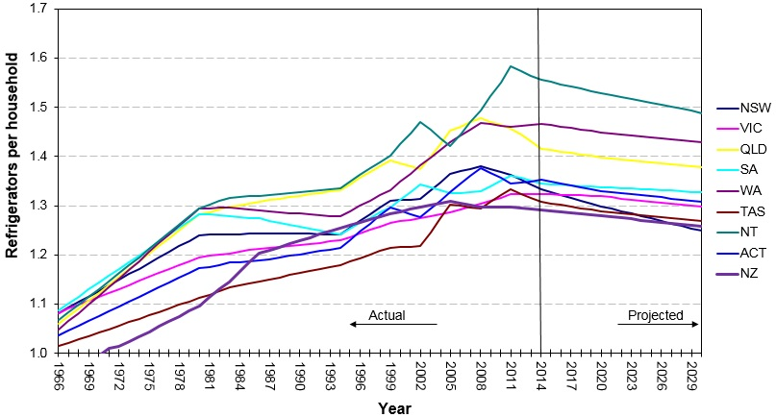

Source: Energy Efficient Strategies estimates (2016)

For Australian freezer owners, the impacts are expected to be greatest on households in Tasmania because ownership rates are highest in that state (approximately 0.6 freezers per household) and lowest in the Australian Capital Territory (approximately 0.3 freezers per household), as indicated in **Figure 8**. However, despite the variations in regional impacts, low and declining ownership rates result in very low replacement rates for freezers. This is reflected in the total sales of freezers, which are less than 15 per cent of sales of refrigerators despite an ownership of about half. This is also a reflection of the longer lifetime of freezers.

Figure : Freezer ownership trends and projections (Australia and New Zealand)

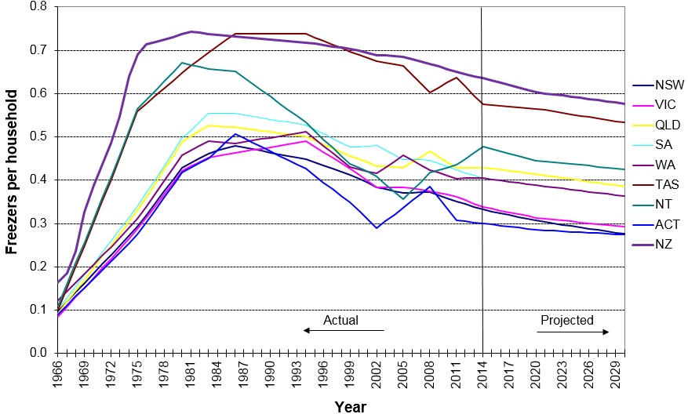

Source: Energy Efficient Strategies estimates (2016)

Detailed cost/benefit results, energy savings and emissions reductions by state/region, product category and sensitivity scenarios are at Attachment B.

# Conclusion

### 6.1 Recommended option

Based on the current analysis, Option C is the recommended policy option because it would:

* Deliver the greatest net benefit to the Australian and New Zealand economies - AU$1,780.80 million and NZ$69.18 million respectively
* Provide the best benefit cost ratios – 5.95:1 and 2.77:1 respectively
* Significantly reduce Australia’s and New Zealand’s CO2-e emissions - 6.11 Mt and 167 kt respectively.

This policy option remains effective if the discount rate is increased to 10 per cent in the Australian case (cost benefit ratio of 4.97:1) or increased to 8 per cent in the New Zealand case (cost benefit ratio of 2.45:1).

Because this option would only require that industry use the IEC 62552 Part 1 to 3 test standard rather than the regionally-specific Australia/New Zealand standard, it would also reduce regulatory burden for industry.

For Australia, a regulatory offset has not been identified to accompany Option C. However, the Commonwealth Department of the Environment and Energy is seeking to pursue net reductions in compliance costs and will work with affected stakeholders and across Government to identify regulatory burden reductions where appropriate.

# Implementation and review

### 7.1 Implementation

Once submissions for this RIS have been received and public consultations have been held, the comments received will be assessed and further stakeholder consultations held as required. E3 will then prepare a decision RIS, that will contain a summary of submissions received, and will recommend a preferred policy option.

The decision RIS will be considered by Energy Ministers in Australia and New Zealand. If Ministers agree to regulatory change, a technical working group will be formed (including industry stakeholders and Government officials) to consider what actions will be necessary to introduce the changes.

The expected implementation date (the commencement date) when MEPS3 levels will become effective is 1 December 2019, one year after a new Determination receives Ministerial approval. However, this timing will depend (to some extent) on how quickly any technical issues can be resolved and translated into firm requirements within the Determination/standard.

It is recognised that the eventual timing will depend on how long it will take to run processes to resolve any issues associated with implementing the agreed option. This could include adopting the IEC test method and changing the Determination/standard and Regulations to reflect new MEPS levels.

### 7.2 MEPS3 ERL

To encourage suppliers to bring MEPS3 compliant products to the market ahead of the mandated MEPS3 commencement date, it is proposed that suppliers will have the option to voluntarily register new or existing MEPS3‑compliant products using the IEC test method and the new algorithm to generate a new ERL, prior to mandated MEPS3 levels coming into effect.

In Australia, to allow voluntary MEPS3 registrations ahead of mandated MEPS3 levels, the labelling component of Determination would become effective when the Determination was signed. The MEPS3 levels would become effective 12 months later. In this transition period, suppliers could either:

* voluntarily register MEPS3-compliant products using the IEC test method to generate an ERL that carried an indication that the product met MEPS3 requirements; or
* register MEPS2-compliant products using the AS/NZ test method to generate an ERL compliant with the current regime.

For New Zealand, suppliers wishing to use the new test method before it is mandatory, can voluntarily register their models tested with the IEC test method, and label accordingly. Both the requirements for labelling and IEC test method, will be changed in law at the same time in New Zealand (2019). Any check-testing undertaken before the law is mandatory will use the test methods and MEPS levels that these models are registered to.

To differentiate products registered under the existing ERL requirements and MEPS3 labelling requirements, a variant of the current label will need to be used. One option for the new MEPS3-compliant label would be to include a coloured band on the bottom of the label as shown in **Figure 9**.

Figure : ERL design

|  |  |
| --- | --- |
| The existing refrigerator/freezer ERL design.  Current ERL design | An indicative refrigerator/freezer MEPS3 ERL design that is similar to the existing design but incorporates a green band at the bottom.  Indicative MEPs3 ERL design |

**E3 seeks feedback from stakeholders regarding:**

1. ***Ahead of mandated MEPS3 levels commencing, do stakeholders support proposed provisions to allow the registration of MEPS3-compliant products using the IEC test method and the new algorithm?***
2. ***Do stakeholders support proposed changes to the ERL design? If not then please outline what would be a preferable design.***

**Table 27** provides an indicative timeline of the milestones involved to complete the proposed process.

Table 27: Indicative implementation timeline

|  |  |
| --- | --- |
| **Date** | **Item** |
| 13 April 2017 | Consultation RIS released |
| 8-19 May 2017 | Public consultations held |
| 28 May 2017 | Consultation RIS submission period closes |
| December 2017 | Decision RIS to COAG and New Zealand energy Ministers for decision |
| January-November 2018 | Technical Working Group established and new Determination/standard drafted via a consensus-based, transparent and consultative process |
| December 2018 | Determination/Regulations to Ministers for approval |
| December 2018-November 2019 | MEPS3 labelling elements of the Determination/Regulations commence and suppliers have the option to register MEPS3 appliances using IEC test method and new algorithm |
| December 2019 | Mandated MEPS levels commence and suppliers must register using IEC test method and all appliances imported must meet MEPS3 |

Given the E3 Program’s experience with implementing or revising energy efficiency requirements, the risks associated with implementation are considered low. Any transitional arrangements will be developed in close consultation with industry.

**E3 seeks feedback from stakeholders regarding:**

1. ***Do stakeholders agree with the proposed timing for the introduction of MEPS3? If not, please advise of alternative timing with detailed, supporting rationale.***

**Australia**

In Australia:

* From the date the Determination receives Ministerial approval, and prior to the Determination coming into effect, it is intended that suppliers will have the option to register new or existing MEPS3 compliant products using the IEC test method using the new algorithm to generate a star rating.
* If a product that was registered prior to the Determination’s coming into effect would meet MEPS3, it can continue to be imported/supplied for the remaining period of its existing registration. It will not need to be re‑registered.
* If a product was registered prior to the Determination’s commencement date but it does not meet MEPS3, no more of that product can be imported after the new Determination comes into effect, but the products in the country at that time can be distributed/sold/retailed until its stock is depleted.

**New Zealand**

In New Zealand:

* Any policy proposals will need to be approved by Cabinet before they can be adopted under the *Energy Efficiency (Energy Using Products) Regulations 2002.*
* Approval of Cabinet is required for any proposed regulatory option. At least six months’ notice will be given to industry before they can come into force.

In New Zealand, once the changes are in force:

* Registered products imported or manufactured prior to the law change that don’t meet the new requirements may only be sold until stock is depleted. New import of these products is not permitted.
* Registered products imported or manufactured prior to the law change that already meet the new requirements, may continue to be supplied. Their registrations will be re-validated and updated.
* Suppliers wishing to import models that are not already registered, but meet the new requirements, will need to complete a registration application and lodge it with EECA, the New Zealand Regulator.
* Unregistered products that fall within the scope of the law, are not permitted to be supplied, or used for any purpose at any time.

### 7.3 Review

**7.3.1 Compliance monitoring**

Australian and New Zealand regulators undertake compliance activities, involving education, surveys, store inspections and checking claims in media. They also purchase products using a risk based approach, for the purpose of laboratory check testing, to assess whether efficiency claims made in registrations are accurate. Regulators also checking that in-store and supplied products appropriately display ERLs. In Australia, compliance activities are undertaken by the GEMS Regulator while in New Zealand, these activities are undertaken by EECA.

**7.3.2 Evaluation**

The E3 Program uses various sources of information to evaluate both the effectiveness of the program and product category requirements. This includes retrospective reviews to compare the effect of policies versus what was projected in RIS analysis; analysing sales data to understand consumer awareness and usage of energy efficiency labelling; tracking hits on the Energy Rating website ([www.energyrating.gov.au](http://www.energyrating.gov.au)); and utilising Australian Bureau of Statistics data and other survey results of consumer intent and consideration of energy efficiency in purchase decisions.

In New Zealand, after a year of trading under new laws, product suppliers are requested to supply sales data on how many products they sold and various energy efficiencies, so that energy savings can be tracked against predictions.

# Consultation

**Purpose**

Stakeholder feedback is sought on the policy options presented in this consultation RIS. This is to ensure that any recommendation and/or decision to change the current energy efficiency requirements is based on an understanding of the full range of stakeholder views.

### 8.1 Consultation events and written submissions

Public consultation events on this RIS will be held in:

**Australia**

8 May 2017: 10am-12pm

Sydney

Cliftons - Level 13, 60 Margaret Street

9 May 2017: 10am-12pm

Melbourne

Parkroyal - Melbourne Airport

**New Zealand**

19 May 2017: 10am-12pm

Auckland

Cliftons - Level 4, 45 Queen Street

To register your interest in attending an Australian consultation session, please e-mail [energyrating@environment.gov.au](mailto:energyrating@environment.gov.au) noting the names of attendees and the location of the meeting you wish to attend.

To register interest in attending a session in New Zealand, please e-mail [regs@eeca.govt.nz](mailto:regs@eeca.govt.nz).

The closing date for written submissions is **12pm AEDT Sunday 28 May 2017** and e-mails should include in the subject**: ‘**Consultation RIS – Refrigerators and Freezers’. Submissions should be sent via e-mail to:

* Australia: [energyrating@environment.gov.au](mailto:energyrating@environment.gov.au)
* New Zealand: [regs@eeca.govt.nz](mailto:regs@eeca.govt.nz)

Feedback from the submissions received on the consultation RIS will inform the preparation of a decision RIS. The decision RIS is the final document presented to Energy Ministers on which they make a decision about any changes to the current requirements.

***In making submissions, stakeholders are requested to provide details, preferably supported by quantitative evidence, about the costs and benefits associated with each option to inform the development of policy positions.***

***Stakeholders are requested to provide a breakdown of the costs of the options to their individual businesses, including operational and financing costs. If necessary, this could be in a separate, commercial-in-confidence document. E3 will aggregate any information on costs to gain an industry-wide perspective and the data will not be able to be attributed to a single entity. Stakeholders should focus on providing evidence of the potential impacts of the options under consideration.*** ***Where appropriate, E3 will publish how evidence was used to inform the development of the final policy position as part of the decision RIS.***

***Stakeholders’ submissions will be subject to confidentiality considerations and commercial-in-confidence requests will be honoured. Accordingly, stakeholders should clearly indicate whether a submission should remain confidential, either in whole or in part. Stakeholder submissions will be published on the Energyrating website unless marked as confidential.***

### 8.2 Consultation Questions

Stakeholders are encouraged to provide feedback on any matter in relation to this RIS. Questions that stakeholders may wish to consider responding to in their submissions are listed throughout this document and are reproduced below.

1. Do stakeholders support no changes to energy efficiency regulations for household refrigerating appliances? If yes, then please provide supporting arguments.
2. What are the advantages/disadvantages of incorporating the contents of AS/NZS 4474.2 into the Determination/Regulations rather maintaining the status quo and leaving it as a standard?
3. Do stakeholders support incorporating the contents of AS/NZS 4474.2 into the Determination/Regulations and if not then why?
4. Do stakeholders support adopting Option B measures? If not, please provide arguments supporting your position accompanied with quantitative evidence as appropriate.
5. Do stakeholders support adopting Option C measures? If not, please provide arguments supporting your position accompanied with quantitative evidence as appropriate.
6. Do stakeholders support adopting the proposed performance, test and algorithm parameters? If not, then please outline issues you may have?
7. E3 understands that the actual consumer price impacts on each product group from introducing MEPS3 are likely to be different to those presented in this RIS. E3 seeks feedback from suppliers/manufacturers on the average price increases for each product group following the adoption of MEPS3 levels.
8. Increased MEPS levels will result in some less-efficient models being removed from the market and increased supply of new/updated more efficient models. E3 seeks feedback from suppliers/manufacturers on whether the adoption of MEPS3 levels would have a material impact on competition?
9. Adopting the IEC test standard will have impacts on suppliers that include changes to administrative and laboratory costs. E3 seeks a better understanding of these and related costs and requests that, where possible, suppliers provide estimates of cost differences that would be experienced if only required to test appliances to the IEC test standard, rather than to the Australian/New Zealand test standard.
10. Ahead of mandated MEPS3 levels commencing, do stakeholders support proposed provisions to allow the registration of MEPS3-compliant products using the IEC test method and the new algorithm
11. Do stakeholders support proposed changes to the ERL design? If not then please outline what would be a preferable design.
12. Do stakeholders agree with the proposed timing for the introduction of MEPS3? If not, please advise of alternative timing with detailed, supporting rationale.

### 8.3 Past Consultations

Between October 2011 and August 2015, numerous consultations relating to this RIS process were held between stakeholders and the Commonwealth. A summary of actions includes:

* **October 2011** – E3 Committee released information and technical papers for public comment announcing that Australia and New Zealand intended to align MEPS levels for refrigerators and freezers to US 2014 MEPS
* **August 2012** – E3 Committee released a further three discussion papers outlining details of the proposal and E3’s position
* **September 2012** – Technical aspects of five industry submissions were reviewed by consultant. A total of 16 recommendations were made
* General industry support for proposal was found. Concerns surrounding the testing method and timing/transition were outlined. Other concerns were of a technical nature
* **February 2013** – E3 released:
* Three papers for stakeholder review
* Revised draft GEMS Determination for Household Refrigerators
* Draft comparison of AS/NZ standards with IEC standards
* **March 2013** – Whitegoods Forum workshop of refrigerator and freezer MEPS.
* Industry consensus was gained to link to the US energy standards in the future
* A commitment from the Commonwealth was sought by industry to provide not less than 12 months’ notice for labelling and other mandatory changes
* A commitment of three years from the Commonwealth was sought by industry to develop products to meet new performance standard
* **April 2013** – Three stakeholder submissions received
* Generally, stakeholders not opposed to adoption of IEC 62552 test standard
* Four technical issues were raised
* E3 agreed to devote resources to support labelling transition
* **May 2013** –Voting on IEC refrigerator test method opened
* Australia submitted positive votes plus 74 written comments
* **July 2013** – Stakeholder workshop with six discussion papers circulated
* Consensus obtained on most points outlined in draft of AS/NZS 4474.2:2015 *Performance of household electrical appliances—Refrigerating appliances, Part 2*
* There were outstanding issues over algorithm and load processing
* **August – November 2013** – Round Robin testing of refrigerators
* Testing at six test laboratories undertaken between August 2013 and January 2014.
* Workshop held with round robin participating test laboratories
* Workshop was held with industry, consumer groups, test laboratories, efficiency advocates and government officials from Australia and New Zealand
* Presentations were given by national and international experts. Updates on progression of IEC test method, round robin and regulatory proposals were provided
* Round robin report submitted to IEC
* **December 2013 – IEC SC59M Committee meeting in Auckland, New Zealand.**
* IEC accepted Australasian and other national committees’ recommendation concerning improvements to the IEC test standard
* **October 2014** – Final draft international standard (FDIS) of IEC62552.1, IEC62552.2 and IEC62552.3 released for voting by national committees
* **February 2015** – IEC62552.1, IEC62552.2 and IEC62552.3 published
* **June – November 2015** – ERL algorithm development
* Options paper released outlining algorithms for Energy Rating Label that could be instigated.
* Commonwealth met with industry stakeholders to discuss options
* General stakeholder consensus on the preferred Option 4 be included in this RIS
* **November 2016** – Industry interviews
* The Commonwealth met with representatives of manufacturers who accounted for approximately 75‑85 per cent of household refrigeration sales
* Capital costs and appliance costs required to meet MEPS3 were discussed
* Anticipated model availability and regulatory costs were also discussed

Attachment D provides more details of each stakeholder event, including issues raised and subsequent actions.

Implementation of any policy changes will be informed by the results of feedback from this Consultation RIS and ongoing additional consultation. E3 is committed to continual engagement with a range of stakeholders - for example through Air Conditioner and Commercial Refrigeration Advisory Committee (ACRAC), the E3 Review Committee and Standards Australia.

**Consumer Electronics Suppliers Association (CESA)**

E3 representatives regularly meet with industry through CESA. CESA meetings are held annually and allow industry members to receive regular updates on E3 activities, to discuss issues and make submissions to E3.

**E3 Review Committee**

E3 representatives also meet with key stakeholder groups (industry and consumer bodies) through the E3 Review Committee. The E3 Review Committee is a forum for key stakeholder groups to provide advice to government across the entire E3 Program and meets twice per year.

# Attachment A – Trends

### A.1 Sales Trends

The sales of refrigerators and freezers are a function of economic growth and consumer/business product preferences. **Figure 10** shows actual sales data from published and unpublished sources and forecast sales are estimated based on current trends.

Figure 10: Annual sales of refrigerators and freezers (Australia and New Zealand)

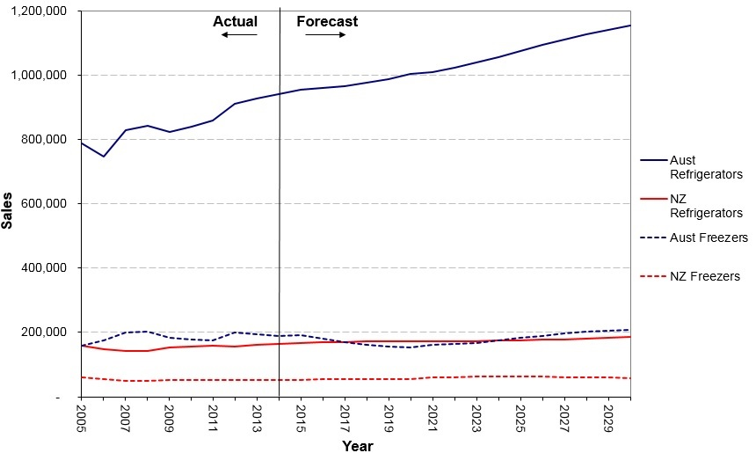

Source: Energy Efficient Strategies estimates (2016)

### A.2 Stock Trends

The estimated stocks of refrigerators and freezers for Australia and New Zealand over the period 1966 to 2030 are shown in **Figure 11** and **Figure 12**.

Figure 11: Refrigerator stock (Australia and New Zealand)

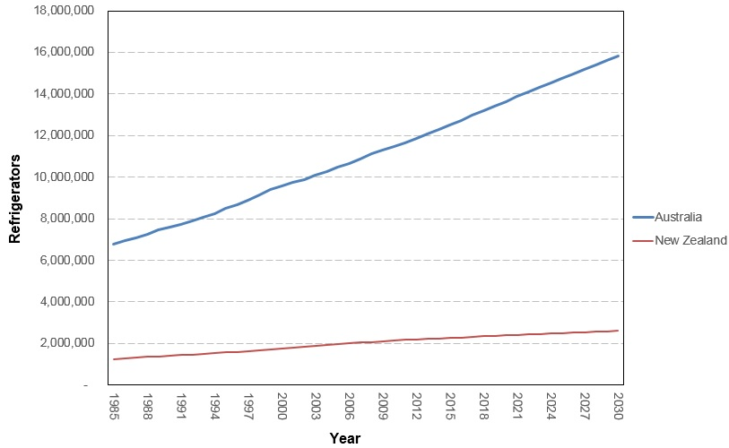

Sources: ABS 3236-2015 Series III; Statistics New Zealand Dwelling and Household Estimates; and unpublished data

Figure 12: Freezer stock (Australia and New Zealand)

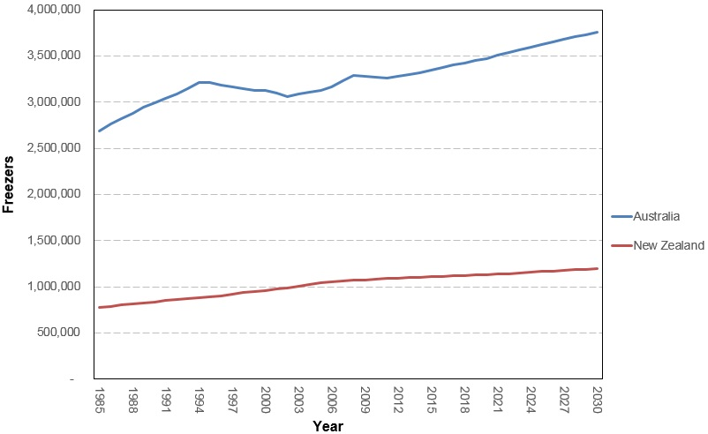

Sources: ABS 3236-2015 Series III; Statistics New Zealand Dwelling and Household Estimates; and unpublished data

### A.3 Price Trends

Australian retail price trends for all refrigerator and freezer groups over the period 1993-2014 are shown below.

Figure 13: Average group 1 prices (Australia)

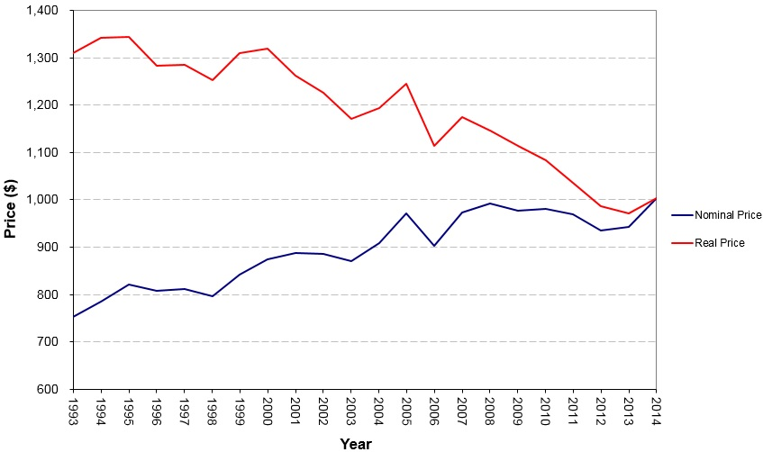

Source: Energy Efficient Strategies estimates (2016)

Figure 14: Average group 2 prices (Australia)

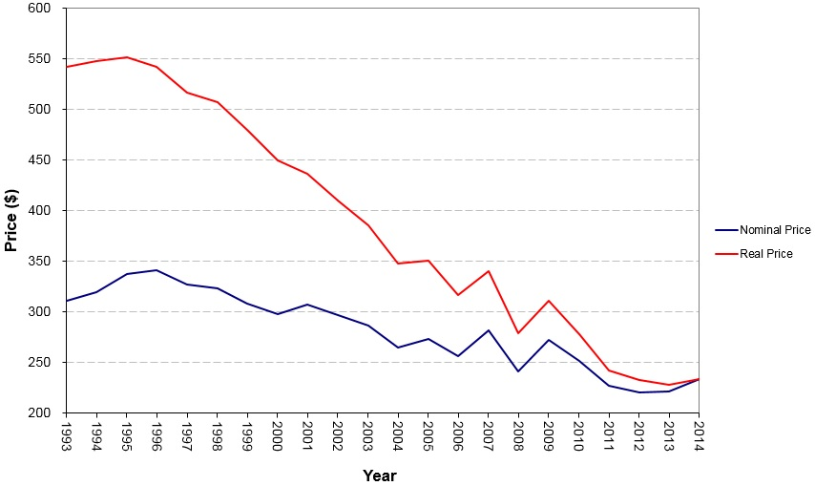

Source: Energy Efficient Strategies estimates (2016)

Figure 15: Average group 3 prices (Australia)

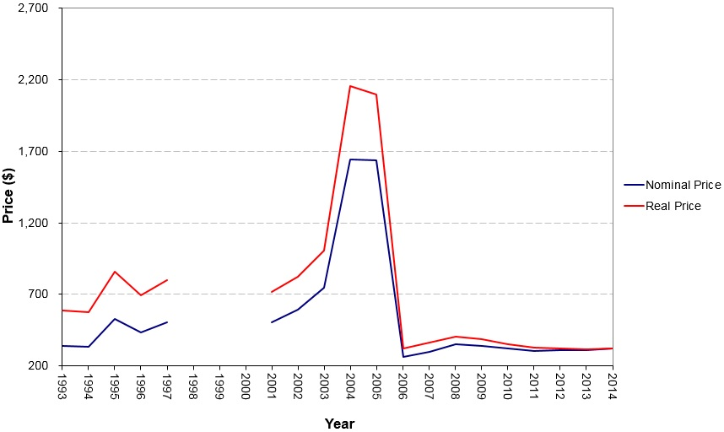

Source: Energy Efficient Strategies estimates (2016)

Note: The discontinuities in prices for this group are artefacts of the data set provided by GfK which was for a small collection of models

Figure 16: Average group 4 prices (Australia)

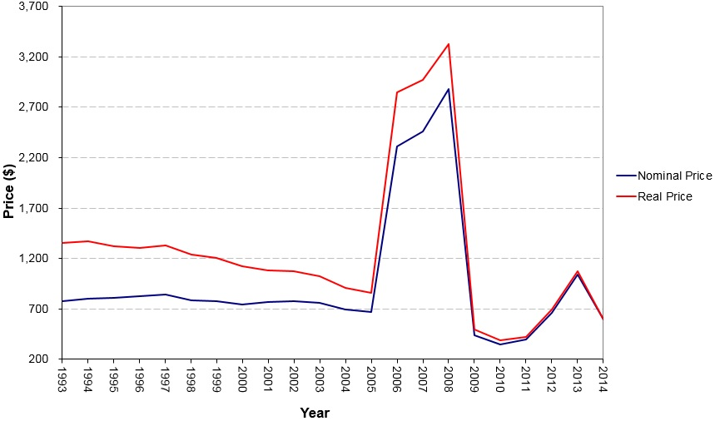

Source: Energy Efficient Strategies estimates (2016)

Note: The discontinuities in prices for this group are artefacts of the data set provided by GfK which was for a small collection of models

Figure 17: Average group 5B prices (Australia)

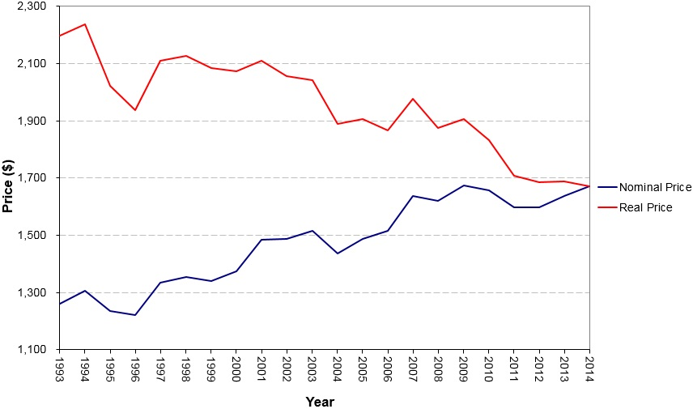

Source: Energy Efficient Strategies estimates (2016)

Figure 18: Average group 5S prices (Australia)

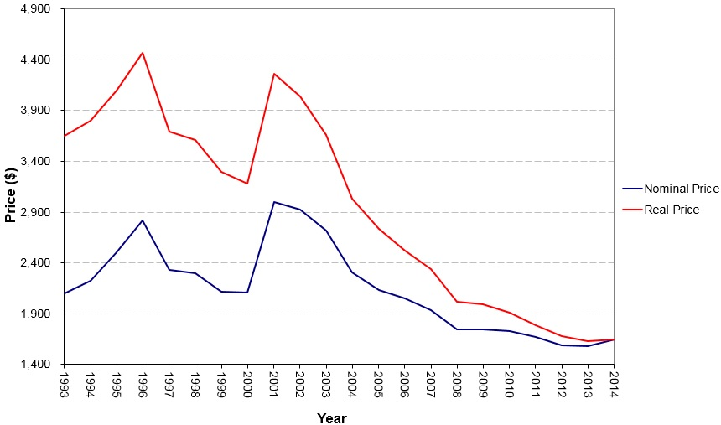

Source: Energy Efficient Strategies estimates (2016)

Note: The discontinuity in prices from 2000 to 2001 for this group is an artefact of the data set provided by GfK which was for a small collection of models to 2000 and all models from 2001. See Energy Efficient Stategies (2016) for more details.

Figure 19: Average group 5T prices (Australia)

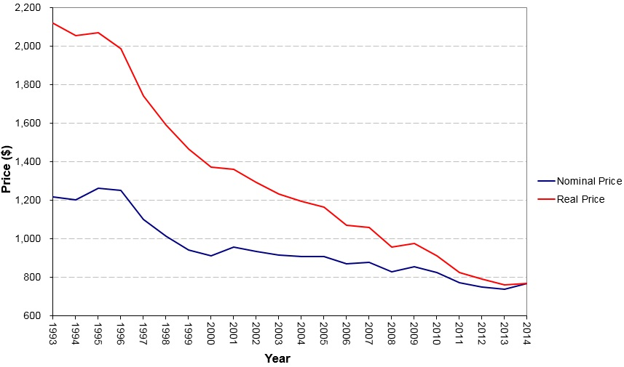

Source: Energy Efficient Strategies estimates (2016)

Figure 20: Average group 6C prices (Australia)

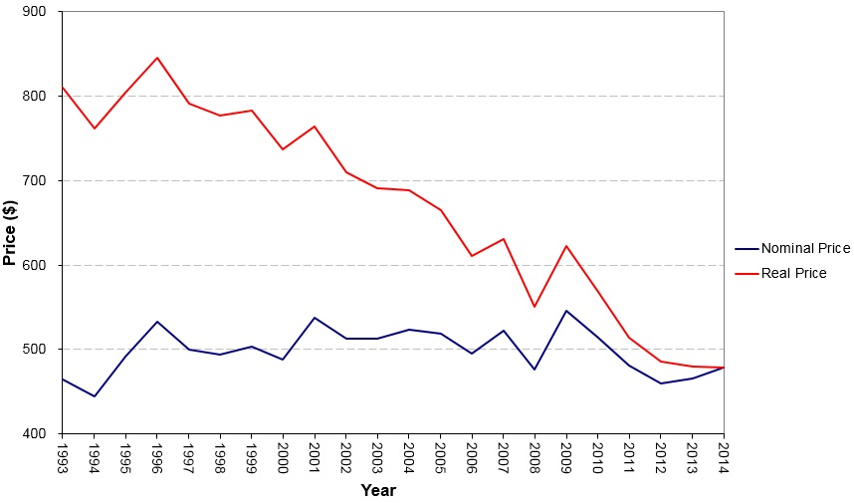

Source: Energy Efficient Strategies estimates (2016)

Figure 21: Average group 6U prices (Australia)

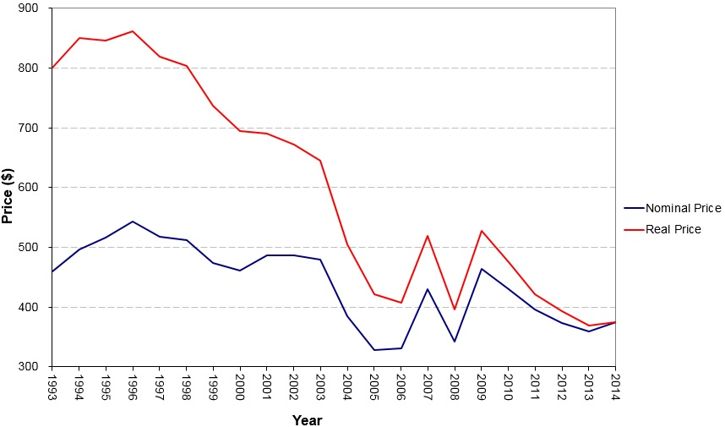

Source: Energy Efficient Strategies estimates (2016)

Note: There was a signifciant decline in average product size across this period

Figure 22: Average group 7 prices (Australia)

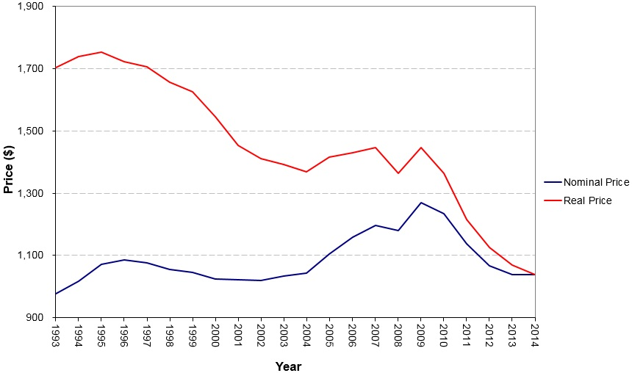

Source: Energy Efficient Strategies estimates (2016)

# Attachment B – Modelling

This attachment provides supporting technical and modelling assumptions and outputs to assist with the consideration of this consultation RIS affecting household refrigerators and freezers. It presents the methods used for the cost benefit analysis for the policy options proposed and documents the data sources used.

A financial analysis model has been built to review the overall costs and benefits related to each proposal being considered. Proposals are compared to BAU where there is no policy intervention to the refrigerator and freezer market. Both costs and benefits are evaluated from 2015 (the likely year that some manufacturers started to spend money to eventually become compliant with MEPS3) to 2030. They include the following:

Benefits

* Energy saving for consumers/the economy due to improved efficiency of refrigerators and freezers as well as the resulting reduced electricity costs.
* Reduced emissions as a result of energy savings from policy (not monetised).
* Additional energy savings from adoption of a new energy label that better estimates energy consumption during normal use in homes under Option C (not quantified or monetised).
* The energy savings of household refrigerators and freezers used in commercial settings are not within the scope of this RIS (not quantified or monetised).

Costs

* Increase in the purchase price of energy efficient refrigerators and freezers when regulation restricts sales of products that are unable to meet MEPS3 requirements.
* Regulatory cost for the industry (including any additional administrative resources, test costs and registration costs as a result of new policy proposals).

### B.1 Cost benefit analysis key parameters and inputs

Table : Modelling assumptions and parameters

|  |  |
| --- | --- |
| **Assumptions** | **Parameters** |
| Scenarios | * Option A: BAU * Option B: increase MEPS levels to MEPS3 * Option C: increase MEPS levels to MEPS3 and adopt IEC test standard |
| Sales | * Australian historical sales data based on GfK sales data from 1993 to 2014 * New Zealand historical sales data based on EECA data * Forecast sales based on projected trends |
| Stock | Australian and New Zealand refrigerator and freezer stock levels have been estimated by Energy Efficient Strategies using:   * Australian household projections: Australian Bureau of Statistics (2015) * New Zealand household projections: Statistics New Zealand (2016a and 2016b) * Refrigerator/freezer ownership rate over time   The survival and retirement rates of refrigerators and freezers are assumed to follow a normal distribution. For refrigerators, the mean lifetime is 15 years with a standard deviation of three years. For freezers, the mean lifetime is 21 years with a standard deviation of four years. |
| Projection period | Impacts have been modelled to 2030 |
| **Assumptions** | **Parameters** |
| Industry costs | All incremental capital/development costs are assumed to be passed on to consumers |
| Product prices | Australia: Retail product prices were used.  New Zealand: Wholesale product prices were used.  Price impacts of increased MEPS levels on the price of refrigerators and freezers were modelled according to assumed price to efficiency ratios (price coefficients) – see **Table 29**.   * A price-efficiency regression was undertaken using sales data up to 2014. * For some groups, no correlation between price and energy was found. For some other groups, a positive correlation was found, implying that more efficient appliances were cheaper. For these groups, price coefficients were set with default values of -0.10. * For other groups that had statistically significant negative correlations, the observed price coefficients were used in the modelling. For example, -1.0 was used for group 7 products which means that a one per cent decrease in energy consumption from the introduction of MEPS3 is assumed to result in a one per cent price increase at an individual model level. |
| Registration administration costs and compliance costs | Government administration costs are made up of salary, program administration, check testing, consumer information/education and miscellaneous (market research, etc.). As all product categories are already regulated for MEPS and labelling, there no increases in government costs.  The incremental administration costs for Australia and New Zealand are assumed to be marginal over the modelling period if Option C is adopted and therefore have not included. |
| Energy consumption | Historic and future trends in energy efficiency for all refrigerator and freezer groups based on sales weighted trends of sales data mentioned above.  The stock model used contains information on the numbers, capacity, efficiency and energy consumption of refrigerators and freezers. Energy consumption estimates for the BAU baseline established, and then the energy consumption under different policy options are calculated and compared to the BAU consumption.  Products are retired from the stock according to a survival function which includes some early breakdowns, most fridges retiring around the average and some fridges having and extended life.  Energy prices used are:   * Australia: based on state/territory residential electricity price index, from Australian Energy Market Operator (AEMO) 2014 (see Attachment C). * New Zealand: based on long-run marginal electricity cost Energy Information and Modelling Group's 2011 Energy Outlook results, Reference Scenario (see Attachment C). |
| GHG emissions | GHG emissions have been accounted for as carbon dioxide equivalent units (CO2-e)  Australia:  Projected GHG Factors from 2015 - derived from 2013 National Greenhouse Account (NGA) factors but varied by trends in Electricity Sent out emission intensity by state, the No Carbon Scenario, from The Treasury and the Department of Industry, Innovation, Climate Change, Science, Research and Tertiary Education, 2013.  New Zealand:  Ministry of Business, Innovation and Employment, New Zealand’s Electricity Demand and Supply Generation Scenarios 2016 (see Attachment C). |
| Sensitivity analysis | NPV:  Australia – seven per cent real discount rate, with sensitivity tests at zero per cent, three per cent and 10 per cent.  New Zealand – six per cent real discount rate, with sensitivity tests at zero per cent, three per cent and eight per cent. |
| Key assumptions | * Reduction in energy use is due to new policy options described above. * Although GHG abatements have been estimated, the financial/economic benefits of lower levels of greenhouse gas emissions have not been quantified in the analysis. |

Price coefficients estimates for the different groups of refrigerators and freezers supplied to Australia are provided in **Table 29**. These figures will be updated during the decision RIS stage to ensure the most recent data is used. These coefficients have been used to estimate the corresponding retail price impact from the mandatory reduction of energy by group for MEPS3 in 2019.

Table : Price coefficients - Australia

|  |  |  |  |
| --- | --- | --- | --- |
| Group | Price Coefficient (MEPS 2005 RIS) | Price coefficient (2008 RIS) | Price coefficient (This RIS) |
| 1 | -0.20 | -0.10 | -0.77 |
| 2 | -0.20 | -0.10 | -0.10 |
| 3 | -0.20 | -0.10 | -0.10 |
| 4 | -0.20 | -0.10 | -0.10 |
| 5B | -0.15 | -0.40 | -0.40 |
| 5S | -0.25 | -0.15 | -0.85 |
| 5T | -0.15 | -0.60 | -0.77 |
| 6C | -0.25 | -0.20 | -0.60 |
| 6U | -0.35 | -0.30 | -0.30 |
| 7 | -0.40 | -0.90 | -1.00 |

Source: Energy Efficient Strategies estimates (2016)

For New Zealand modelling, price coefficients have been adjusted taking into account the differentials between retail prices (used in the Australian modelling case) and wholesale prices (used in the New Zealand modelling case).

### B.2 Sensitivity analysis

Several sensitivity analyses were undertaken to examine the impact of changing discount rates and costs on the modelling outcomes.

The discount rate sensitivity analysis shows that all proposals considered for Australia and New Zealand will have substantial positive net benefits, regardless of the discount rates selected ae shown in **Table 30** and **Table 31**.

For example, the net benefit for Option C in Australia is projected to be between AU$4,648.24 million (zero per cent discount rate) and AU$1,259.52 million (10 per cent discount rate), with benefit cost ratios between 9.94 and 4.97. This means that the benefits from projected energy use reduction and related reduction in running costs for consumers are expected to exceed the costs of implementing the proposal by at least 4.97 times.

Table : Discount rate sensitivity analysis – Australia

|  |  |  |  |  |
| --- | --- | --- | --- | --- |
|  | **Discount rate (real)** | | | |
|  | 0 per cent | 3 per cent | 7 per cent | 10 per cent |
| **Option B** | | | | |
| Total Benefits (NPV, $M) | $5,168.04 | $3,432.84 | $2,140.43 | $1,576.40 |
| Total Costs (NPV, $M) | $524.23 | $441.57 | $362.48 | $319.30 |
| Net Benefits (NPV, $M) | $4,643.81 | $2,991.27 | $1,777.95 | $1,257.10 |
| Benefit Cost Ratio | 9.86 | 7.77 | 5.90 | 4.94 |
| **Option C** | | | | |
| Total Benefits (NPV, $M) | $5,168.04 | $3,432.84 | $2,140.43 | $1,576.40 |
| Total Costs (NPV, $M) | $519.80 | $437.94 | $359.63 | $316.87 |
| Net Benefits (NPV, $M) | $4,648.24 | $2,994.90 | $1,780.80 | $1,259.52 |
| Benefit Cost Ratio | 9.94 | 7.84 | 5.95 | 4.97 |

Note: seven per cent is the base case

For New Zealand, Option C is projected to be between NZ$175.86 million (zero per cent discount rate) and NZ$52.12 million (eight per cent discount rate), with benefit cost ratios between 4.30 and 2.45. This means the benefits to the New Zealand economy from implementing Option C are expected to exceed the costs of implementing the proposal by at least 2.45 times.

Table : Discount rate sensitivity analysis – New Zealand

|  |  |  |  |  |
| --- | --- | --- | --- | --- |
|  | **Discount rate (real)** | | | |
|  | 0 per cent | 3 per cent | 6 per cent | 8 per cent |
| **Option B** | | | | |
| Total Benefits (NPV, $M) | $229.13 | $153.51 | $108.25 | $87.98 |
| Total Costs (NPV, $M) | $54.10 | $45.84 | $39.64 | $36.37 |
| Net Benefits (NPV, $M) | $175.03 | $107.67 | $68.61 | $51.61 |
| Benefit Cost Ratio | 4.24 | 3.35 | 2.73 | 2.42 |
| **Option C** | | | | |
| Total Benefits (NPV, $M) | $229.13 | $153.51 | $108.25 | $87.98 |
| Total Costs (NPV, $M) | $53.27 | $45.16 | $39.08 | $35.86 |
| Net Benefits (NPV, $M) | $175.86 | $108.36 | $69.18 | $52.12 |
| Benefit Cost Ratio | 4.30 | 3.40 | 2.77 | 2.45 |

Note: six per cent is the base case

### B.3 Charts

The figures belowshow refrigerator and freezer sales trends for Australia and New Zealand over the period 1966‑2030.

Figure 23: Refrigerator sales trend by group (Australia)

The chart shows Australian refrigerator sales trends over the period 1966 to 2014 and projections for the period 2015 to 2030. 
Group 1 sales have fallen from approximately 12% of sales in 1966 to 4.5% in 2014 and are assumed to remain relatively flat over the projection period. 
Group 2 sales have fallen from approximately 29% of sales in 1966 to 12% in 2014 and are assumed to remain relatively flat over the projection period. 
Group 3 sales have fallen from approximately 29% of sales in 1966 to 1.5% in 2014 and are assumed to gradually decline further over the projection period. 
Group 4 sales have fallen from approximately 29% of sales in 1966 to 0.2% in 2014 and are assumed to decline further over the projection period. 
Group 5T sales have grown from approximately 0.5% of sales in 1982 to 42% in 2014 and are assumed to gradually decline to 34% over the projection period.
Group 5B sales have fallen from approximately 0.1% of sales in 1982 to 29% in 2014 and are assumed to gradually increase to 42% over the projection period.
Group 5S sales have fallen from approximately 0.1% of sales in 1966 to 10% in 2014 and are assumed to gradually decline to 7% over the projection period.

Sources: GfK sales data and Energy Efficient Strategies estimates

Figure 24: Freezer sales trend by group (Australia)

The chart shows Australian freezer sales trends over the period 1966 to 2014 and projections for the period 2015 to 2030. 
Group 6U sales have fallen from approximately 43% of sales in 1966 to 25% in 2014 and are assumed to gradually decline to 20% over the projection period.
Group 6C sales have fallen from approximately 57% of sales in 1966 to 43% in 2014 and are assumed to remain relatively flat over the projection period.
Group 7 sales have risen from approximately 0.7% of sales in 1982 to 31% in 2014 and are assumed to gradually increase to 37% over the projection period.

Sources: GfK sales data and Energy Efficient Strategies estimates

Figure 25: Refrigerator sales trend by group (New Zealand)

The chart shows New Zealand refrigerator sales trends over the period 1966 to 2014 and projections for the period 2015 to 2030. 
Group 1 sales have fallen from approximately 12% of sales in 1966 to 3.5% in 2014 and are assumed to remain relatively flat over the projection period. 
Group 2 sales have fallen from approximately 29% of sales in 1966 to 18% in 2014 and are assumed to remain relatively flat over the projection period. 
Group 3 sales have fallen from approximately 29% of sales in 1966 to 1.5% in 2014 and are assumed to gradually decline further over the projection period. 
Group 4 sales have fallen from approximately 29% of sales in 1966 to 1.5% in 2014 and are assumed to gradually decline over the projection period. 
Group 5T sales have grown from approximately 0.6% of sales in 1976 to 18% in 2014 and are assumed to gradually decline to 14% over the projection period.
Group 5B sales have fallen from approximately 1% of sales in 1971 to 51% in 2014 and are assumed to gradually increase to 60% over the projection period.
Group 5S sales have fallen from approximately 0.1% of sales in 1982 to 8.5% in 2014 and are assumed to gradually decline to 5% over the projection period.

Sources: EECA sales data and Energy Efficient Strategies estimates

Figure 26: Freezer sales trend by group (New Zealand)

The chart shows New Zealand freezer sales trends over the period 1966 to 2014 and projections for the period 2015 to 2030. 
Group 6U sales have grown from approximately 0.1% of sales in 1982 to 18.5% in 2014 and are assumed to gradually decline to 17% over the projection period.
Group 6C sales have fallen from approximately 100% of sales in 1966 to 68% in 2014 and are assumed to remain relatively flat over the projection period.
Group 7 sales have risen from approximately 0.5% of sales in 1971 to 14% in 2014 and are assumed to gradually increase to 17% over the projection period.

Sources: EECA sales data and Energy Efficient Strategies estimates

The figures belowshow the average energy consumption over time of each group, given the policy scenario. These trends demonstrate the projected energy savings from cost benefit analysis. Current observed trends in energy efficiency projected for all refrigerators and freezers based on sales weighted trends up to 2014. Projections for 2015 and beyond are estimated based on the policy scenario.

Figure 27: Energy consumption by group - BAU (Australia)

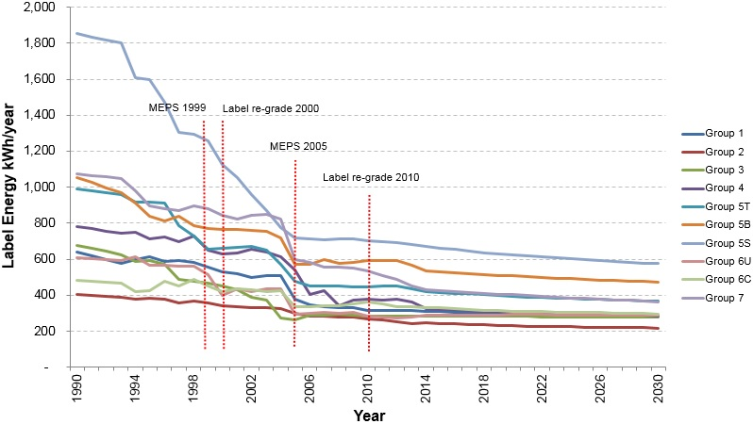

Source: Energy Efficient Strategies modelling results

Figure 28: Energy consumption by group - MEPS3 (Australia)

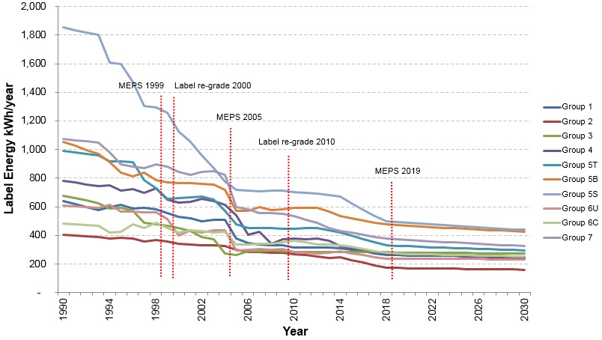

Source: Energy Efficient Strategies modelling results

Figure 29: Energy consumption of by group - BAU (New Zealand)

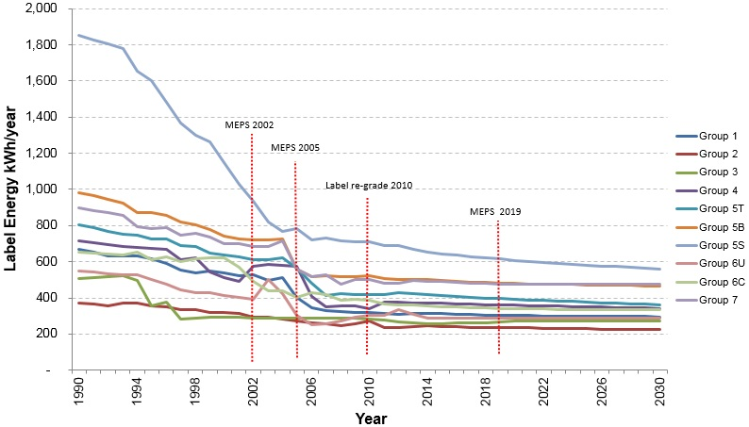

Source: Energy Efficient Strategies modelling results

Figure 30: Energy consumption by group - MEPS3 (New Zealand)

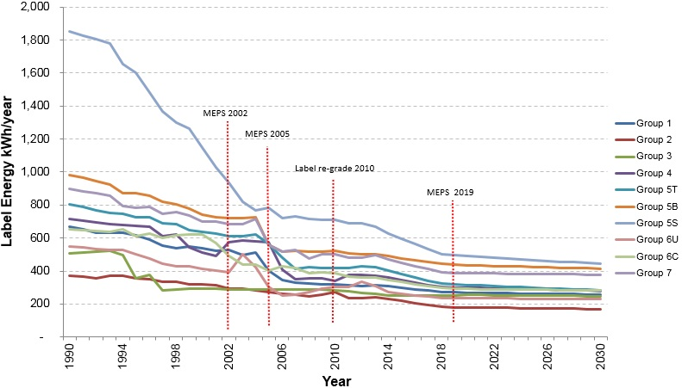

Source: Energy Efficient Strategies modelling results

The figures below show the lifetime assumptions for refrigerators and freezers used in the modelling.

Figure 31: Refrigerator life time

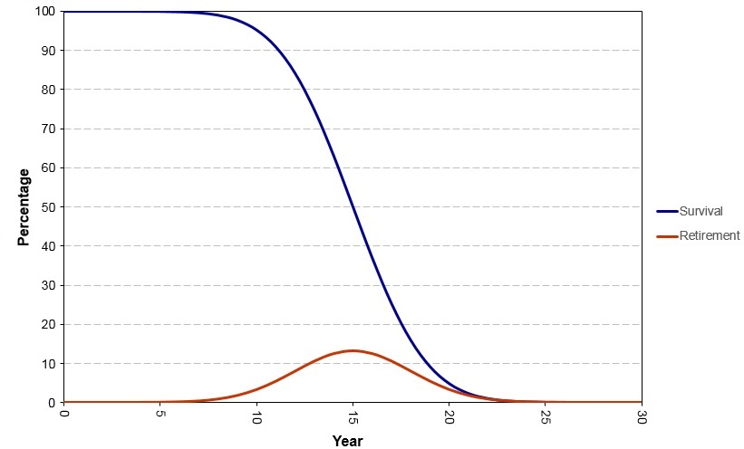

Source: Energy Efficient Strategies modelling results

Figure 32: Freezer lifetime

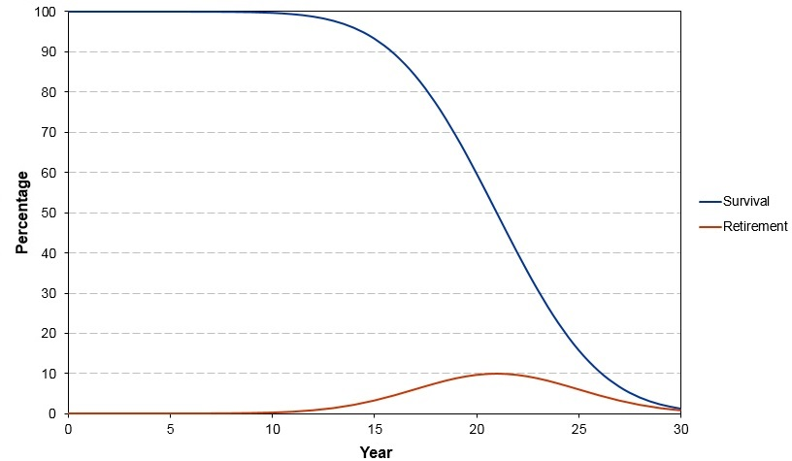

Source: Energy Efficient Strategies modelling results

# Attachment C – Electricity prices and GHG emissions factors

Table 32: Residential electricity tariffs for Australia (real Au 2014 cents/kWh)

|  |  |  |  |  |  |  |  |  |  |  |  |  |  |  |  |  |
| --- | --- | --- | --- | --- | --- | --- | --- | --- | --- | --- | --- | --- | --- | --- | --- | --- |
|  | **2015** | **2016** | **2017** | **2018** | **2019** | **2020** | **2021** | **2022** | **2023** | **2024** | **2025** | **2026** | **2027** | **2028** | **2029** | **2030** |
| NSW | 27.00 | 27.25 | 27.50 | 27.96 | 28.45 | 28.99 | 29.44 | 31.12 | 31.44 | 31.68 | 31.97 | 32.25 | 32.51 | 32.68 | 32.94 | 33.21 |
| VIC | 28.41 | 28.57 | 28.82 | 29.29 | 29.80 | 30.33 | 30.79 | 32.12 | 32.34 | 32.46 | 32.73 | 33.10 | 33.38 | 33.57 | 33.77 | 34.07 |
| QLD | 26.69 | 30.06 | 29.96 | 27.74 | 28.23 | 28.81 | 27.67 | 29.16 | 29.52 | 29.83 | 30.23 | 30.63 | 30.95 | 31.23 | 31.51 | 31.86 |
| SA | 28.93 | 29.14 | 29.34 | 29.76 | 30.26 | 30.80 | 31.26 | 32.35 | 32.56 | 32.66 | 32.89 | 33.20 | 33.45 | 33.61 | 33.82 | 34.17 |
| WA | 24.60 | 25.86 | 25.86 | 25.73 | 24.77 | 24.30 | 24.96 | 24.86 | 24.74 | 24.38 | 24.28 | 24.24 | 24.23 | 24.24 | 24.24 | 23.85 |
| TAS | 25.86 | 26.15 | 26.39 | 26.87 | 27.39 | 27.94 | 28.40 | 29.71 | 29.96 | 30.10 | 30.40 | 30.77 | 31.09 | 31.29 | 31.52 | 31.83 |
| NT | 25.60 | 26.92 | 26.91 | 26.78 | 25.78 | 25.29 | 25.98 | 25.87 | 25.75 | 25.37 | 25.27 | 25.23 | 25.22 | 25.23 | 25.23 | 24.82 |
| ACT | 18.09 | 18.25 | 18.43 | 18.74 | 19.06 | 19.42 | 19.73 | 20.85 | 21.06 | 21.23 | 21.42 | 21.61 | 21.78 | 21.90 | 22.07 | 22.25 |

Table 33: Long-run marginal electricity cost for New Zealand (real NZ 2014 cents/kWh)

|  |  |  |  |  |  |  |  |  |  |  |  |  |  |  |  |  |
| --- | --- | --- | --- | --- | --- | --- | --- | --- | --- | --- | --- | --- | --- | --- | --- | --- |
|  | **2015** | **2016** | **2017** | **2018** | **2019** | **2020** | **2021** | **2022** | **2023** | **2024** | **2025** | **2026** | **2027** | **2028** | **2029** | **2030** |
| NZ | 8.73 | 8.73 | 8.73 | 8.73 | 8.73 | 8.73 | 8.73 | 8.73 | 8.73 | 8.73 | 8.73 | 8.73 | 8.73 | 8.73 | 8.73 | 8.73 |

Table 34: GHG emission factors for electricity for Australia and New Zealand (kg CO2-e/kWh)

|  |  |  |  |  |  |  |  |  |  |  |  |  |  |  |  |  |
| --- | --- | --- | --- | --- | --- | --- | --- | --- | --- | --- | --- | --- | --- | --- | --- | --- |
|  | **2015** | **2016** | **2017** | **2018** | **2019** | **2020** | **2021** | **2022** | **2023** | **2024** | **2025** | **2026** | **2027** | **2028** | **2029** | **2030** |
| NSW | 0.840 | 0.840 | 0.840 | 0.840 | 0.840 | 0.840 | 0.840 | 0.840 | 0.840 | 0.840 | 0.840 | 0.840 | 0.840 | 0.840 | 0.840 | 0.840 |
| VIC | 1.120 | 1.120 | 1.120 | 1.120 | 1.120 | 1.120 | 1.120 | 1.120 | 1.120 | 1.120 | 1.120 | 1.120 | 1.120 | 1.120 | 1.120 | 1.120 |
| QLD | 0.790 | 0.790 | 0.790 | 0.790 | 0.790 | 0.790 | 0.790 | 0.790 | 0.790 | 0.790 | 0.790 | 0.790 | 0.790 | 0.790 | 0.790 | 0.790 |
| SA | 0.560 | 0.560 | 0.560 | 0.560 | 0.560 | 0.560 | 0.560 | 0.560 | 0.560 | 0.560 | 0.560 | 0.560 | 0.560 | 0.560 | 0.560 | 0.560 |
| WA | 0.760 | 0.760 | 0.760 | 0.760 | 0.760 | 0.760 | 0.760 | 0.760 | 0.760 | 0.760 | 0.760 | 0.760 | 0.760 | 0.760 | 0.760 | 0.760 |
| TAS | 0.120 | 0.120 | 0.120 | 0.120 | 0.120 | 0.120 | 0.120 | 0.120 | 0.120 | 0.120 | 0.120 | 0.120 | 0.120 | 0.120 | 0.120 | 0.120 |
| NT | 0.670 | 0.670 | 0.670 | 0.670 | 0.670 | 0.670 | 0.670 | 0.670 | 0.670 | 0.670 | 0.670 | 0.670 | 0.670 | 0.670 | 0.670 | 0.670 |
| ACT | 0.840 | 0.840 | 0.840 | 0.840 | 0.840 | 0.840 | 0.840 | 0.840 | 0.840 | 0.840 | 0.840 | 0.840 | 0.840 | 0.840 | 0.840 | 0.840 |
| NZ | 0.130 | 0.140 | 0.143 | 0.150 | 0.151 | 0.134 | 0.135 | 0.129 | 0.105 | 0.100 | 0.100 | 0.096 | 0.093 | 0.092 | 0.092 | 0.091 |

# Attachment D – Consultations to date

Over the past six years, the Commonwealth has liaised extensively with stakeholders regarding alignment to existing international energy efficiency and product testing standards. This work has focused on potentially aligning MEPS for refrigerators and freezers, currently at MEPS2, with those implemented by the US in September 2014, known as MEPS3. This work also includes potentially adopting the IEC test method for domestic refrigerators and freezers (IEC 62552‑1:2015). Details concerning consultations relating to proposed changes outlined in this document are detailed below.

| **Date** | **Item** | **Details** | **Issues Raised** | **Actions** |
| --- | --- | --- | --- | --- |
| October 2011 | Whitegoods Forum Melbourne  Issues papers released | * E3 officials announced that Australia and New Zealand intended to align with US 2014 MEPS levels for refrigerators and freezers. * Release of papers that set out technical aspects of the US regulatory requirements and the MEPS proposal. * *Paper 1 - MEPS for Household Refrigeration: Summary of new MEPS levels in the USA, October* 2011 * *Paper 2* - *MEPS for Household Refrigeration: Roadmap for MEPS 3 in Australia and New Zealand*, October 2011 |  |  |
| August 2012 | Issues and discussion papers released | * Release of papers setting out more details of the proposal and E3 position paper. * *Paper 3 - Household Refrigeration: MEPS3 in Australia and New Zealand – Preliminary Impact Assessment of New MEPS Levels in 2015,* August 2012 * *Paper 4 - Household Refrigeration: Technical Support Document on MEPS and Labelling for 2015 for Energy-using Refrigeration Equipment,* August 2012 * *Regulatory Discussion Document – Government agency proposed pathway to regulate refrigeration equipment sold to consumers in Australia and New Zealand from about April 2015,* October 2012 |  |  |
| September 2012 | Stakeholder submissions received | * Five industry stakeholder submissions received from: * Consumer Electronics Suppliers’ Association (CESA). * Electrolux Australia * Fisher and Paykel Appliances * Mitsubishi Electric Australia Pty Ltd * Black Diamond Technologies (New Zealand agents for Mitsubishi) * Technical aspects of industry submissions were reviewed by Energy Efficient Strategies and 16 recommendations were made. | * General support for the proposal * Concerns about implementation timing and transition arrangements * Some general concerns regarding IEC test method * Costs, research and development, beverage cooler labels issues * Technical issues raised were: * capacity * humidity * proposals for compact products * range of other minor issues | * Energy Efficient Strategies considered submissions and made decisions on each of the substantive matters in November 2012 * These decisions were included into documents released in early 2013. |
| February 2013 | Whitegoods Forum papers released | * Documents released for discussion were: * Information Paper - AS4474*.2-2013 (V0.4) - Performance of Household Electrical Appliances – Refrigerating Appliances,* February 2013 * Information Paper *- Domestic Refrigeration – Proposed Regulatory Changes Explanatory Guide to the proposed AS/NZS4474, Part 2,* February 2013 * Information Paper - *Household Refrigerators – Energy Labelling Algorithm in Draft AS/*NZS4474*.2-2013*, February 2013 * Draft - *Revised 2015 GEMS Determination for household refrigerators,* February 2013 – (*AS/NZS 4474.2:2015 Performance of household electrical appliances – Refrigerating appliances, Part 2*) * *Comparison of AS/NZ standards and regulatory requirements with EN and IEC standards for refrigerating appliances in draft*, February 2013 |  | * Issues to be discussed during Whitegoods Forum |
| March 2013  March 2013 (cont.) | Whitegoods Forum | * Stakeholders given formal opportunity to raise issues with government officials arising from the previously circulated documents. * Officials sought stakeholder views on linking future MEPS for refrigerators and freezers to future MEPS changes within the US. | * Industry seeking three years to develop products to meet new MEPS * Industry sought a commitment to not less than 12 months’ notice of labelling changes, administrative arrangements and other mandatory requirements in Determinations * Industry agreed that officials present E3 a consensus that refrigeration products regulation should be linked to US developments in the future * Stakeholders sought more opportunities to input to future RIS processes * Participants sought commitment from officials to have Australian representation at IEC refrigerator committee meetings by experts from our region * Various technical issues were discussed | * A milestone approach would be adopted rather than fixed dates driving future regulation commencement * Agreed by all parties to have both government and industry representation |
| April 2013 | Invitation for formal stakeholder submissions | * Submissions requested to support verbal positions from Whitegoods Forum. * Three industry stakeholder submissions received: * Electrolux Home Appliances Australia * Fisher and Paykel Appliances * Australian Industry Group (AIG) | * Submissions requested sufficient formal notice regarding regulatory changes – project milestones and project planning considered important so that industry can securely make large investments required to meet new MEPS levels * Government requested to provide adequate resources to support proposed labelling transition – including adequate communication and marketing * Cautious but not opposed to adoption of testing standard IEC62552 * Supportive of a more realistic energy value on label * Technical input received * Technical Issues raised * humidity * testing analysis * labelling algorithm |  |
| May 2013 | IEC released draft refrigerator test method for voting | * Draft voting open for three months * Comments and votes closed on 16 August 2013 | * Australia submitted positive votes plus 74 written comments |  |
| July 2013 | Stakeholder Workshop | * Six papers circulated: * *Paper 1 -* *Refrigerator and Freezer MEPS3 and IEC Migration Documentation (recap of documents to date)* * *Paper 2 - IEC Migration Position Differences – CESA and AIG* * *Paper 3 - AS/NZS4474.2 (V0.5) – incorporating whitegoods forum discussions and industry submission from April 2013* * *Paper 3a - Summary of the edits undertaken on AS/NZS4474.2 (V0.5)* * *Paper 4 -* *Refrigerator Round Robin Testing – First Concept Draft* * *Paper 5* - *How does the energy efficiency of Australian whitegoods compare internationally?* * *Paper 6 - Guide to undertaking tests to IEC SC59M/24/NP – Energy Consumption of Household Refrigerators* * Key task was to review part 2 Version 0.5 | * Review of draft of *AS/NZS 4474.2:2015 Performance of household electrical appliances – Refrigerating appliances, Part 2* * Consensus on most points * Some issues on algorithms and load processing need further work * Technical advisory group to consider * Stakeholders agreed on value of round robin testing * Supported by officials |  |
| August 2013  August 2013 (cont.) | Round robin of test laboratories commences | * Government sponsored laboratory testing of two specified model refrigerators to the IEC test standard * Checked that requirements of the standards (both IEC and AS/NZS 4474 draft) were clear, unambiguous and not onerous * Purpose of testing is to support adoption of IEC test method IEC62552 in Australia and New Zealand as well as preparing testing facilities to adapt to testing to support the new regulatory requirements in 2017 through the requirements of AS/NZS4474.2 * Six test laboratories contracted including two manufacturers’ laboratories (one in Australia and one in New Zealand) and four independent accredited laboratories in Australia * Testing was conducted over the period August 2013 to January 2014 * Results were compared for consistency and issues identified * Participant workshop held on October 2013 | * Australia and New Zealand prepared detailed technical comments about specific issues identified with the IEC standard aimed at making the test method more practical and workable |  |
| October 2013 | International Whitegoods Workshop - Melbourne | * Two day workshop with over 60 stakeholders including industry, consumer groups, test laboratories, efficiency advocates and government officials from Australia and New Zealand. * Updates on IEC test method, round robin results presented and the regulatory proposal were discussed * Several experts in energy efficiency matters presented: * *Bilateral comparisons of Historical Trends in US and Australian Refrigerators* (Robert Van Buskirk, PhD) * *IEC Refrigerator Round Robin : Concept and Objectives* (Lloyd Harrington, Ian Forte and Lindsey Roke) * *Refrigerator testing: IEC 62552 Ed 2 Development and Australian/New Zealand Round Robin Testing* (Martien Janssen) * *US DOE Misc. Refrigeration Products Coverage* (Robert Van Buskirk, PhD) * *Australian Efforts at Copying US Refrigerator MEPS* (Lloyd Harrington) |  |  |
| November 2013 | Finalise round robin testing to IEC standard in Australasia finalised | * Participating laboratories reviewed draft round robin test report * A range of proposals to make testing easier and more efficient were included * Final report was submitted to the IEC |  |  |
| December 2013 | IEC SC59M Committee meeting – Auckland | * IEC SC59M Committee reviewed and resolved comments made by Australasian and other national committees concerning the IEC test standard | * SC59M committee accepted all recommendations | * IEC prepared FDIS over the period December 2013 – February 2014 |
| June 2015 | Options paper released to whitegoods stakeholders | * Options paper outlining four potential algorithms that could use the IEC 62552 test standard when determining rating for ERL was circulated for consideration |  |  |
| October 2014 | FDIS released | * FDIS standards of IEC62552-1, IEC62552-2 and IEC62552‑3 were released for vote | * None |  |
| February 2015 | IEC standard published | * IEC62552-1, IEC62552-2 and IEC62552-3 published | * Unanimous ‘Yes’ vote from National Committees |  |
| August 2015 | Whitegoods stakeholder meeting | * Discussion of algorithm options outlined in June 2015 * General stakeholder consensus on the preferred algorithm option that has been included in this RIS |  |  |
| November 2016 | Stakeholder Meetings | * Discussions on capital and other costs and assumptions used in modelling |  |  |

# References

Australian Bureau of Statistics (2015) *3236.0 - Household and Family Projections, Australia, 2011 to 2036* [online] <http://www.abs.gov.au/ausstats/abs@.nsf/mf/3236.0>, accessed 11 February 2017

Australian Bureau of Statistics (2016) *6401.0 - Consumer Price Index, Australia* [online] <http://www.abs.gov.au/ausstats/abs@.nsf/mf/6401.0>, accessed 11 February 2017

Australian Government (2012) *Greenhouse and Energy Minimum Standards Act 2012* [online] <https://www.legislation.gov.au/Details/C2012A00132>, accessed 11 February 2017

Australian Government (2012) *Greenhouse and Energy Minimum Standards (Household Refrigerating Appliances) Determination 2012* [online]<https://www.legislation.gov.au/Details/F2012L02126>, accessed 11 February 2017

Australian Government (2013) *Your Home - Appliances* [online] <http://www.yourhome.gov.au/energy/appliances>, accessed 16 May 2016

Australian Government (2014) *Industry Innovation and Competitiveness Agenda Report: An action plan for a stronger Australia* [online] <http://www.dpmc.gov.au/publications>, accessed 8 November 2016

CLASP (2014) *Improving Global Comparability of Appliance Energy Efficiency Standards and Labels*

E3 (2016) *Refrigeration - Domestic* [online] <http://www.energyrating.gov.au/products/domestic-refrigeration>, accessed 27 January 2017

E3 (2011) *Household Refrigeration Paper 1 - MEPS for Household Refrigeration, Summary of new MEPS levels in the USA* [online] [www.energyrating.gov.au/document/discussion-paper-paper-1-summary-new-meps-levels-usa](http://www.energyrating.gov.au/document/discussion-paper-paper-1-summary-new-meps-levels-usa), accessed 11 February 2017

E3 (2011) *Household Refrigeration Paper 2 - MEPS for Household Refrigeration, Roadmap for MEPS 3 in Australia and New Zealand* [online] www.energyrating.gov.au/document/discussion-paper-paper-2-roadmap-meps-3-australia-and-new-zealand, accessed 11 February 2017

E3 (2012) *Household Refrigeration Paper 3 - MEPS3 in Australia and New Zealand – Preliminary Impact Assessment of New MEPS Levels in 2015* [online] <http://www.energyrating.gov.au/document/household-refrigeration-paper-3-meps3-australia-and-nz-preliminary-impact-assessment-new>, accessed 11 February 2017

E3 (2012) *Household Refrigeration Paper 4 - Technical Support Document on MEPS and Labelling for 2015 for Energy-using Refrigeration Equipment* [online] http://www.energyrating.gov.au/document/household-refrigeration-paper-4-technical-support-document-meps-and-labelling-2015-energy, accessed 11 February 2017

E3 (2012) *Regulatory Discussion Document - Government agency proposed pathway to regulate refrigeration equipment sold to consumers in Australia and New Zealand from about April 2015* [online] <http://www.energyrating.gov.au/document/discussion-document-government-agency-proposed-pathway-regulate-refrigeration-equipment>, accessed 11 February 2017

E3 (2015) *Household Refrigeration Appliances: New Star Rating Algorithm Proposal for the IEC Test Method* [online] [*www.energyrating.gov.au/document/report-household-refrigeration-appliances-new-star-rating-algorithm-proposal-iec-test*](http://www.energyrating.gov.au/document/report-household-refrigeration-appliances-new-star-rating-algorithm-proposal-iec-test)*,* accessed 11 February 2017

Energy Efficiency and Conservation Authority (2017) *Energy savings under E3,* [online] <https://www.eeca.govt.nz/standards-ratings-and-labels/equipment-energy-efficiency-programme/energy-savings-achieved-under-e3>, accessed 27 January 2017

Energy Efficient Strategies (2015) *Household Refrigeration Appliances: New Star Rating Algorithm Proposal for the IEC Test Method* [online] <http://www.energyrating.gov.au/document/report-household-refrigeration-appliances-new-star-rating-algorithm-proposal-iec-test>, accessed 11 February 2017

Energy Efficient Strategies (2016) *Whitegoods Efficiency Trends: A report into the energy efficiency trends of whitegoods in Australia 1993* – 2014 [online] <http://www.energyrating.gov.au/news/whitegoods-efficiency-trends-1993-2014>, accessed 12 May 2016

International Electrotechnical Commission (2015) *IEC 62552-1:2015 Household refrigerating appliances - Characteristics and test methods - Part 1: General requirements* [online] <https://webstore.iec.ch/publication/21805>, accessed 11 February 2017

International Electrotechnical Commission (2015) *IEC 62552-2:2015* *Household refrigerating appliances - Characteristics and test methods - Part 2: Performance requirements* [online] <https://webstore.iec.ch/publication/21804>, accessed 11 February 2017

International Electrotechnical Commission (2015) *IEC 62552-3:2015 Household refrigerating appliances - Characteristics and test methods - Part 3: Energy consumption and volume* [online] <https://webstore.iec.ch/publication/21803>, accessed 11 February 2017

International Energy Agency (2014) *Energy Efficiency Standards and Labeling*

International Energy Agency (2015) *Energy Efficiency Market Report*

Level (2016) *Selecting energy-efficient appliances* [online] <http://www.level.org.nz/energy/appliances/selecting-energy-efficient-appliances>, accessed 16 May 2016

Standards Australia (2011) *AS/NZS 4474.1:2007 Performance of household electrical appliances - Refrigerating appliances - Energy consumption and performance* including Amdt1:2008 and Amdt2:2011, [online] <http://infostore.saiglobal.com/store/Details.aspx?ProductID=383878>, accessed 11 February 2017

Standards Australia (2014) *AS/NZS 4474.2:2009 Performance of household electrical appliances – Refrigerating appliances – Part 2: Energy labelling and minimum energy performance standard requirements* including Amdt1:2011 and Amdt2:2014, [online] <http://infostore.saiglobal.com/store/details.aspx?ProductID=1114739>, accessed 11 February 2017

Statistics New Zealand (2016a) *Dwelling and Household Estimates* [online] <http://www.stats.govt.nz/browse_for_stats/population/estimates_and_projections/dwelling-and-household-estimates-info-releases.aspx> accessed 11 February 2017

Statistics New Zealand (2016b) *National Population Projections: 2016(base)–2068* [online] <http://www.stats.govt.nz/browse_for_stats/population/estimates_and_projections/NationalPopulationProjections_HOTP2016.aspx>, accessed 11 February 2017

Sustainability Victoria (2017) *Refrigerator Retrofit Trial* [online] <http://www.sustainability.vic.gov.au/services-and-advice/households/energy-efficiency/toolbox/reports/technical-reports>, accessed 3 March 2017

United States Department of Energy (2011) *Using the Experience Curve Approach for Appliance Price Forecasting* [online] <https://www1.eere.energy.gov/buildings/appliance_standards/pdfs/experience_curve_appliance_price_forecasting_3-16-11.pdf>

Weiss, M.P.; Martin K.; Junginger, Martin; Blok, Kornelis (2010) *Energy Policy 38(2)* ‘Analyzing price and efficiency dynamics of large appliances with the experience curve approach’, pages 770-783

United States Government (2016) *Energy Conservation Program: Energy Conservation Standards for Miscellaneous Refrigeration Products*, Federal Register, 10CFR430, Vol. 81, No. 209 [online] <https://www.federalregister.gov/documents/2016/10/28/2016-24759/energy-conservation-program-energy-conservation-standards-for-miscellaneous-refrigeration-products>, accessed 11 February 2017

**A joint initiative of Australian, State and Territory and New Zealand Governments**

**Consultation Regulation Impact Statement**

**Household Refrigerators and Freezers  
www.energyrating.gov.au**

1. Energy Efficiency and Conservation Authority (EECA) 2017
2. These stock levels exclude household products used in commercial settings for domestic purposes (e.g. offices), which could account for an additional 10 per cent of the stock.
3. New Zealand modelling results are based on partial economic modelling whereas the Australian results are based on financial modelling of consumer impacts. See Attachment B for further details.
4. GHG emissions have been accounted for as carbon dioxide equivalent units (CO2-e).
5. Based on the purchase price of an average 5B refrigerator (i.e. a refrigerator compartment on the top of the unit and freezer compartment on the bottom) with a payback period of about two years and a product life of approximately 16 years and an electricity tariff of 28 cents/kWh.
6. AS/NZS 4474.2 refers to the Australia/New Zealand standard AS/NZS 4474.2:2009 *Performance of household electrical appliances – Refrigerating appliances – Part 2: Energy labelling and minimum energy performance standard requirements* including Amdt1:2011 and Amdt2:2014.
7. http://www.yourhome.gov.au/energy/appliances, accessed 16 May 2016
8. http://www.level.org.nz/energy/appliances/selecting-energy-efficient-appliances, accessed 16 May 2016
9. Some Australian states regulated refrigerators and freezers for energy labelling as early as 1986.
10. A negative externality is a cost that is incurred by a third party as a result of an economic transaction. In the case of refrigerators and freezers, negative externalities relate to the costs incurred by third parties due to emissions associated with the production and supply of electricity to power refrigerators and freezers.
11. For example, the Determination applies to household refrigerators and freezers used in a commercial context.
12. A ‘compartment’ which means a storage area with a separate external door or an internal sub-compartment.
13. AS/NZS 4474.2:2009 *Performance of household electrical appliances - Refrigerating appliances - Energy labelling and minimum energy performance standard requirements*
14. http://www.energyrating.gov.au/suppliers/registration
15. For example, Sustainable Victoria recently published its *Refrigerator Retrofit Trial* report that shows significant energy savings can be achieved when replacing older fridges (often pre-MEPS) with newer, more efficient appliances.
16. Unpublished Department of the Environment and Energy figures.
17. See Attachment A for time-series estimates of stock levels and Attachment B for stock assumptions.
18. GfK retail sales data which includes most products installed in offices and factories but does not cover direct wholesale purchases by large companies (e.g. developers or hotel chains). However, this data covers approximately 95 per cent of the market and is the best available source of sales data.
19. GfK sales data and Energy Efficient Strategies (2016) *Whitegoods Efficiency Trends*, Detailed Output Tables
20. See Attachment A for Australian refrigeration and freezer time-series sales data
21. Energy Efficiency and Conservation Authority (2016)
22. See Attachment A for New Zealand refrigeration and freezer time-series sales data
23. In Australia, real prices have been calculated using the Cost Price Index for all capital cities as published by the Australian Bureau of Statistics (ABS 6401.0).
24. For example see: US Department of Energy (2011) *Using the Experience Curve Approach for Appliance Price Forecasting* and Weiss, M.P.; Martin K.; Junginger, Martin; Blok, Kornelis ‘Analyzing price and efficiency dynamics of large appliances with the experience curve approach’ Energy Policy (2010) 38(2), pages 770-783.
25. See IEA 2015, for example
26. [www.dpmc.gov.au/publications](http://www.dpmc.gov.au/publications)
27. US Government (2016)
28. Referred to as miscellaneous refrigeration in the US
29. The terms IEC test method and IEC standard are used interchangeably in this RIS.
30. See <http://www.nrcan.gc.ca/energy/products/12509>
31. See <http://rfdirectory.aham.org/AdvancedSearch.aspx>