Lighting: Updated policy positions

Supplementary consultation document

September 2017

This work is licensed under the Creative Commons Attribution 3.0 Australia Licence. To view a copy of   
this license, visit [the creative commons website.](http://creativecommons.org/licences/by/3.0/au)

The Department of the Environment and Energy on behalf of the Equipment Energy Efficiency   
Program asserts the right to be recognised as author   
of the original material in the following manner:



© Commonwealth of Australia (Department of   
the Environment and Energy) 2017.

The material in this publication is provided for general information only, and on the understanding that the Australian Government is not providing professional advice. Before any action or decision is taken on the basis of this material the reader should obtain appropriate independent professional advice.

This document is available at [the Energy Rating website.](http://www.energyrating.gov.au)

While reasonable efforts have been made to ensure that the contents of this publication are factually correct, E3 does not accept responsibility for the accuracy or completeness of the content, and shall not be liable for any loss or damage that may be occasioned directly or indirectly through the use of, or reliance on, the contents of this publication.

Contents

Contents iii

Updated policy proposals 5

Introduction 5

Consultation RIS – updated proposals 7

1. Introduce MEPS for LED lamps and integrated luminaires 9

2. Introduce MEPS for non-integrated commercial luminaires 12

3. Increase incandescent and halogen MEPS (Australia only) to remove the most inefficient lamps 13

4. Mandatory labelling 14

Other comments 14

International Context 16

Attachment A: Proposed LED MEPS Lamps 18

Introduction 18

Scope (extract from draft MEPS for LED lighting) 18

Timing 19

Simplified registration for small volumes 19

Key parameters and tests 19

Registration Process 21

Attachment B: ASEAN LED lamp test results 23

Attachment C: LED MEPS Efficacy 26

Attachment D: Compliance Approach 29

Attachment E: Cost benefit analysis 35

Attachment F: Regulatory costs and GEMS fees 41

Attachment G: Offer to Supply 47

Attachment H: Phase out of incandescent and halogen lamps (Australia only) 49

Attachment I: Lumen maintenance testing 56

Background 56

Theoretical basis behind testing 58

Test Methods and Analysis 62

Conclusion 63

Attachment J: Draft Minimum Energy Performance Standards (MEPS) for LED Lighting 65

List of TABLES

Table 1: Policy options 8

Table 2: Timeline for LED MEPS and Efficacy Levels 19

Table 3: Summary of additional testing under LED MEPS 20

Table 4: Updated proposal for efficacy levels for LED lamps 28

Table 5: Cost benefit analysis – Australia (Real discount rate: 7%) 36

Table 6: Cost benefit estimates – New Zealand (Real discount rate: 6%) 36

Table 7: shows the additional regulatory costs for Option A (Commonwealth’s portion) 44

Table 8: Proposed phase out of halogen and incandescent lamps 50

List of figures

Figure 1: ASEAN Benchmark Test Results for LED A-shape Lamp - efficacy 23

Figure 2: ASEAN Benchmark Test Results for LED A-shape Lamp - CRI 24

Figure 3: ASEAN Benchmark Test Results for LED A-shape Lamp – colour consistency 24

Figure 4: ASEAN Benchmark Test Results for LED A-shape Lamp – Power Factor 25

Figure 5: efficacy dataset for non-directional LED lamps 27

Figure 6: Efficacy dataset for directional LED lamps 27

Figure 7: Example of different LED lumen depreciation rates and associated L70 values 56

Figure 8: Lumen depreciation and life of different lamp technologies 57

Figure 9: Manufacturer's designation of the Temperature Measurement Point 58

Figure 10: Measured LED lumen depreciation rates for LED module at different operating temperatures but same drive current 59

Figure 11: Predicting the LED depreciation rate for LED module at same drive current but different operating temperature 60

Figure 12: Determining the lumen maintenance (L70) of LED module at fixed drive current by extrapolation 61

Figure 13: Determining the lumen maintenance (L70) of LED module at a different operating temperature but same drive current 61

Figure 14: LED Package with TMP identified 64

Figure 15: LED Module with TMP identified 64

Updated policy proposals

Introduction

The Equipment Energy Efficiency (E3) Program published a Consultation Regulation Impact Statement (CRIS) in November 2016 that outlined policy options to improve the energy efficiency of residential and commercial lighting in Australia and New Zealand. For additional details and background on the proposals discussed in this paper, refer to the CRIS which is at available at the [Energy Rating](http://www.energyrating.gov.au/consultation/consultation-ris-lighting) website.

Stakeholder consultation sessions on the CRIS were held in Sydney, Melbourne, Brisbane, Adelaide, Perth and Auckland between 31 January and 13 February 2017, and a webinar was held on 24 February. Around 100 stakeholders attended the consultation sessions, with 22 written submissions received in response.

The submissions provided policy input and technical information about the CRIS proposals. Since then, further consultation has been underway with stakeholders to clarify and explore the issues raised. This position paper responds to the feedback received. It should be considered in conjunction with the CRIS and not as a standalone document. It provides stakeholders with the opportunity to provide further feedback, where the proposals have been modified, are not recommended to continue, and where additional input or information is sought.

Any feedback on this paper will inform preparation of the Decision RIS (DRIS). The DRIS will be submitted to the Council of Australian Governments’ (COAGs) Energy Council and the New Zealand Government for a decision about whether to implement any of the policy proposals and update and introduce new energy efficiency regulations for lighting products. The DRIS is expected to be considered by Energy Ministers at the November 2017 meeting.

Changes to energy efficiency regulations are under consideration because:

* Consumers are being exposed to inferior LED products that are negatively impacting on consumer confidence and uptake of this more efficient technology, reducing potential energy savings and reduction in emissions
* Minimum energy performance standards (MEPS) have not kept pace with improvements in lighting technology and international best practice and therefore are no longer achieving their purpose of removing the least efficient lamps from the market
* Imperfect information, combined with an increased diversity of lighting alternatives, that makes it difficult for consumers to meaningfully compare the energy efficiency, quality and performance of lighting technologies or be motivated to do so given the low purchase price
* Split incentives whereby commercial and rental property owners and some builders have no incentive to purchase more efficient, higher quality, but higher upfront cost products as there is no incentive for them to reduce electricity or replacement costs.

E3 would appreciate any feedback you have on the policy proposals in this paper. The closing date for written submissions is **12 October 2017**. Submissions should include the subject ‘Lighting – Updated policy positions’ and be sent via email to EERLighting@environment.gov.au for Australia or to [regs@eeca.govt.nz](mailto:regs@eeca.govt.nz) for New Zealand. Submissions will be published unless otherwise requested.

Broad questions stakeholders may wish to consider in providing feedback include:

* Are there any implementation barriers or possible unintended consequences of any of the policy positions or proposals under consideration?
* Is the analysis of the policy proposals considered reasonable, including data and assumptions used?
* Will the proposals have any adverse effects that have not been considered?

In providing feedback, please be specific by clearly outlining the rationale of any concerns, suggested amendments and evidence to support alternative positions posed.

Questions about specific or technical issues are included in the relevant section of the paper.

Consultation RIS – updated proposals

For Australia, the preferred option presented in the CRIS was Option F that included introduction of MEPS for light-emitting diode (LED) lamps, LED luminaires and non-integrated commercial luminaires; and increasing incandescent MEPS to phase out remaining incandescent and halogen lighting.

For New Zealand, the preferred option presented in the CRIS was introduction of MEPS for LED lamps, LED luminaires and non-integrated commercial luminaires (Option B).

Table 1 below shows changes to the CRIS policy proposals based on stakeholder feedback. New and altered policies are marked in red and eliminated options crossed out. High level reasons for the changes are outlined in this section to provide an overview of the feedback received and E3’s position (whether unchanged or revised), with the attachments exploring each option and technical details.

In summary, for Australia the preferred option is to introduce MEPS for LED lamps (March 2019), phase out halogen light bulbs (excluding downlights) (October 2019) and make changes to the *Greenhouse and Energy Minimum Standards (GEMS) Act* to facilitate MEPS on LED luminaires to allow the phase out of halogen downlights (anticipated by 2021).

Changes to the GEMS Act will be considered as part of the GEMS Legislative Review project which is scheduled to commence in late 2017.

In parallel with this review and legislative change, a Lighting CRIS will be released to consult on the proposed LED MEPS for luminaires and the phase out of mains voltage and low voltage halogen downlights. The Lighting DRIS and associated determinations for this second stage are anticipated to be in place by 2020, commencing in 2021.

For New Zealand, the preferred option is to introduce MEPS for LED lamps (March 2019). As a second stage, New Zealand also proposes to introduce MEPS on LED luminaires around the same time as Australia.

Table 1: Policy options

| Policy proposal | Options | | | | | |
| --- | --- | --- | --- | --- | --- | --- |
|  | A | B | C | D | E | F |
| 1. **Introduce MEPS for LED lamps** ~~and integrated luminaires~~. This includes requirements for efficacy[1] as well as a range of other performance parameters. Minimum performance levels would be based on available market analysis, product testing and expert advice, including the work of the International Energy Agency (IEA) 4E Solid State Lighting Annex. The MEPS will also specify a mandatory set of information to be included on product packaging ~~with the option to introduce a standardised information label.~~ Given the rapid improvements in LED lighting, this option includes a timetable of efficacy increases over several years. Specifications for testing of LED lighting will also be developed drawing upon international test standards. The introduction of MEPS for integrated luminaires would commence following changes to the GEMS Act to facilitate this (targeted for 2021). | X | X | X | X | X | X |
| ~~2.~~ **~~Introduce MEPS for non-integrated commercial luminaires~~**~~. This proposal would apply to standard linear commercial luminaires and recessed cans and will make use of a simple test based on photometry information already available to manufacturers in order to minimise compliance costs. This would achieve energy savings in the cheap end of the commercial market where fluorescent lighting is likely to be used as the least cost option in new builds for some years to come, as well as addressing a potential regulatory imbalance if MEPS is applied only to LED integrated luminaires.~~ |  | ~~X~~ | ~~X~~ |  |  | ~~X~~ |
| 3. **Increase incandescent and halogen MEPS (Australia only) to remove the most inefficient lamps** including a number of categories of halogen lamps (~~including mains voltage and low voltage~~excluding downlights), as well as additions to the categories of incandescent lamps subject to MEPS. This will involve revisions to the current incandescent MEPS to make adjustments to product definitions and scheduling of when these products will be phased out of the market. The phase out of halogen downlights would occur later following the introduction of MEPS for LED luminaires: phase out of mains voltage downlights (2021) and low voltage downlights(2021,pending compatibility issues). |  |  |  |  | X | X |
| ~~4. Introduce mandatory labelling for lamp products primarily used in the residential sector including directional and non-directional lamps and small integrated luminaires. This would apply to all technologies.~~ |  |  | ~~X~~ | ~~X~~ |  |  |
| 5. **Introduce voluntary MEPS for integrated luminaires**. This includes requirements for efficacy as well as a range of other performance parameters. Minimum performance levels would be based on available market analysis, product testing and expert advice, including the work of the International Energy Agency (IEA) 4E Solid State Lighting Annex. The MEPS will also specify a mandatory set of information to be included on product packaging or specification sheet/online where the product is not offered for sale in retail. Given the rapid improvements in LED lighting, this option includes a timetable of efficacy increases over several years. Specifications for testing of LED lighting will also be developed drawing upon international test standards. |  | X |  |  |  | X |

1. Introduce MEPS for LED lamps and integrated luminaires

Feedback:

There was broad support for LED MEPS on lamps (non-directional, directional, linear) in Australia. Some stakeholders raised concerns regarding the breadth of performance parameters proposed, arguing that the performance requirements should only relate to energy efficiency.

Several submissions specifically did not support mandatory minimum marking requirements; however, it appears that there may have been some confusion between the concept of a mandatory label of specific design and a set of minimum packaging information requirements (no specified design).

Industry stakeholders have asked for a longer introduction period than the proposed six months.

Lighting Council New Zealand (LCNZ) argued against the introduction of MEPS for LED lamps in New Zealand in the absence of the phase out of incandescent lamps and inclusion of lighting efficiency in building code requirements in New Zealand.

Many submissions from industry stakeholders expressed concern about the impact of MEPS for integrated luminaires (small directional; small non-directional; planar, battens and troffers; and large).

Concerns relate to the high numbers of integrated luminaire models currently available (estimates from stakeholders on the overall number of LED products on the market at any time range from 150,000 to one million in Australia, most being integrated luminaires) and the short product development and market periods (6-10 months), with the resulting compliance burden not being commercially viable for many suppliers. High end lighting suppliers and lighting designers are concerned about the compliance burden upon the ‘professional’ lighting market which deals in higher value low volume luminaires, arguing that MEPS levels restrict the supply of high end tailored lighting products, stifling creativity, obstructing ‘efficient’ directed and designed lighting solutions, and impacting upon business models. Expensive, low volume products may also be removed from the market due to registration and compliance costs. Stakeholders also suggested that there was insufficient evidence of poor performance with LED luminaires and raised the difficulty in enforcing MEPS in such a large market while suggesting that ACCC Law provides adequate consumer protection.

Some submissions also noted a perceived overlap with the power density requirements in section J6 of the National Construction Code and the NZS 4243: Energy Efficiency Large Buildings - Part 2: Lighting design standard (which is referenced in the New Zealand building code) and the need to update this.

Position:

**Lamps**

Adoption of LED MEPS for lamps (see scope in Attachment A) will be recommended in the DRIS for Australia and New Zealand.

If approved, a new Greenhouse and Energy Minimum Standards (GEMS) determination would be created for this product type, with equivalent regulation created in New Zealand under the *Efficiency (Energy Using Products) Regulations*. It is proposed that both the MEPS performance parameters and test method (referencing international standards where available) would be included in the GEMS determination, and referred to by the New Zealand regulation, as opposed to creation of a new Australian/New Zealand Standard.

The E3 Program considers that the proposed phase out of halogen lamps (Australia only) will require the inclusion of other minimum performance quality parameters for LEDs, in addition to energy efficiency, in order to ensure that efficient and effective lighting alternatives are available when halogens are phased out. This is consistent with the approach adopted for MEPS on Compact Fluorescent Lamps (CFLs) with the phase out of tungsten filament lamps. In addition, photo biological safety and flicker are recommended for inclusion in order to protect the public from exposure to poor quality lamps that may cause health impacts such as retinal damage, or impact photosensitive epileptics and people with photosensitive skin conditions.

Minimum marking of values such as lumens, Watts, efficacy and colour temperature are considered necessary to enable consumers to correctly select a replacement light bulb and compare products. See Attachment E of the CRIS for more background information on current LED packaging.

In response to the feedback from LCNZ, it is noted that in New Zealand, there is no plan to phase out incandescent lighting, however there is agreement to ensure that within individual lighting technologies products are on the market are of reasonable quality. The New Zealand Energy Efficiency Conservation Authority (EECA) accepts the feedback related to the commercial building lighting density, and has a project underway to update NZS 4243 which will address some of the concerns raised.

Attachment A includes a summary of the LED MEPS for lamps proposal and references the draft LED MEPS document (Attachment J), and an explanatory paper on lumen maintenance (Attachment I).

Attachment B includes a summary of recent testing of LED lamps conducted by ASEAN SHINE. This more recent testing supplements the test results presented in the CRIS, further demonstrating that quality issues exist in the market.

Attachment C includes analysis of LED lamps against the proposed MEPS level of 65lm/W (2018) in the CRIS, and recommends an increase in MEPS efficacy with 2019 start date. The E3 program seeks feedback from lamp suppliers on revised levels and if considered too high/low an alternative position with supporting data.

Attachment D summarises the compliance approach for LED lamps.

Attachment E includes a summary of cost benefit modelling for MEPS on LED lamps (Australia and New Zealand)

Attachment F includes an assessment of costs to comply with proposed MEPS on LED lamps and proposed GEMS fees for LED lamps (Australia only).

Attachment G provides guidance on the circumstances where product registration would be required with introduction of MEPS for LED products.

Stakeholders are requested to review and provide comments on the attachments, to further inform the DRIS.

**Timing**

The DRIS will recommend that LED MEPS for lamps becomes effective 12 months after publication of the determination (expected by March 2018).

**Luminaires**

The policy proposal to include LED MEPS on the broad scope of integrated luminaire products defined in the CRIS (small directional; small non-directional; planar, battens and troffers; and large) will not be recommended for immediate commencement in the DRIS.

The DRIS will recommend the staging of MEPS on LED lighting products, starting with LED lamps. It will specify that as part of the GEMS Legislative review, (commencing in 2017), the review consider changes to the GEMS Act to facilitate MEPS on integrated lighting products (by allowing greater flexibility to manage large numbers of models and customised/bespoke products to reduce compliance costs) to allow the introduction of MEPS on integrated lighting products.

Following the CRIS stakeholder feedback, the Department sought to negotiate a reduced scope for integrated luminaires to focus on recessed integrated downlights which are a direct replacement for halogen downlights. Introduction of MEPS on these products, in addition to downlight lamps, would then facilitate the phase out of halogen downlights in Australia. Whilst the Department sought to provide greater flexibility to reduce supplier costs (such as a broader definition of family of models for registration purposes), some stakeholders considered that the compliance burden of this proposal remained high, due to the large number of products in-scope and complexity involved in registration and compliance activities.

The GEMS Act requires product model level registration, including specifying all models where a family registration is used. This creates a particular compliance burden for suppliers who are offering a large range of models for sale, or providing customised products to order. Some commercial lighting suppliers have differentiated themselves by providing custom made products to order, assembled and dispatched in Australia to the customer within 4 weeks (often at low volume). Requiring upfront model registration would be costly to these businesses in terms of administrative costs. Whilst providing for the registration of large families and allowing a simplified registration of products with limited supply are both means to reduce compliance costs, this does introduce an added level of complexity for both suppliers, in determining family groupings, and the regulator in assessing if these groupings are valid. Large families also introduce complexity in compliance and enforcement activities.

A further proposal is to make available voluntary registration for integrated luminaires (downlights, high bay, low bay, planar, battens and troffers). This may be of value to some suppliers concerned about quality in the broader market, and may also serve as a one-stop registration for state based white certificate programs if supported by relevant state programs. This will be discussed further with relevant state and territory governments prior to the DRIS. Stakeholder feedback on the value of this option is also invited.

2. Introduce MEPS for non-integrated commercial luminaires

Feedback:

Stakeholders were generally of the view that non-integrated commercial luminaires will be gradually removed from the market over the next several years.

Some stakeholders agreed that there may be a case for a simple MEPS level to be introduced to accelerate this removal and to also prevent some backwash into cheaper, lower quality non-integrated products at the lower end of the commercial building market if MEPS was introduced for LED alternatives (such as planar luminaires), locking in inefficient lighting in these buildings for years to come.

Lighting Council Australia (LCA) did not support the introduction of MEPS for these products.

LCNZ argued against the introduction of MEPS for non-integrated commercial luminaires in New Zealand on the basis that the updating of the lighting design energy performance standard NZS4243: Part 2:2007 and building code energy limits for commercial and industrial buildings is a higher priority in this area. There is a project underway to update NZS4243.

This option was presented to serve a dual purpose of achieving energy savings in the lower end of the commercial market where there is no incentive for the agent to install efficient luminaires, as well as addressing a potential regulatory imbalance if MEPS is applied only to LED integrated luminaires.

The latter rationale is no longer applicable for the DRIS, with LED MEPS not being proposed on LED planars etc. until further investigation is carried out to address the regulatory issues.

Position:

In the absence of strong evidence to support the need to regulate these products out of the market, this policy proposal will not be recommended in the DRIS. Sales trends will be reviewed in 2019 to reassess if there is a need for regulation.

3. Increase incandescent and halogen MEPS (Australia only) to remove the most inefficient lamps

Feedback:

There was broad support for the phase out of incandescent and halogen lighting. Some submissions have raised concern with the availability of LED replacements for particular incandescent and halogen lamp types.

Position:

This proposal will be recommended in the DRIS, excluding the immediate phase out of halogen downlights.

This recommendation takes account of the feedback received from stakeholders on exemptions or delayed introduction of the phase out for some product types, as well as consideration of compatibility issues.

Refer to Attachment H for phase out details and Attachment E for cost benefit modelling for the proposed phase out.

The phase out of mains voltage and extra low voltage halogen downlights (MR11 shape or MR16 shape or GU10 cap) has been deferred in the absence of LED MEPS on integrated recessed downlights. LED downlight lamps and LED integrated downlight luminaires are both direct replacement products for halogen downlights. The integrated LED downlight luminaire products are already mainstream in retail and trade outlets and heavily promoted by trades. While some consumers are already choosing to voluntarily convert to either LED lamps or integrated downlight luminaires, the phase out of halogen downlights would result in all remaining households converting to one of the LED alternatives. The reputational risk for Government in phasing out halogen downlights without having minimum quality standards in place for all replacement products was considered too high. With no regulation on LED integrated luminaires, consumers could be exposed to purchasing inferior LED product in the absence of being able to purchase halogen light bulbs and the benefits to the community in terms of electricity and replacement savings could not be assured. Delaying the phase out of low voltage halogen downlights will also allow technology improvements to reduce the incidence of compatibility problems with the legacy installed stock of transformers.

4. Mandatory labelling

Feedback:

The proposal for a mandatory label for lighting products was not supported by LCA, LCNZ and most other submissions. The inclusion of the mandatory label option in the CRIS was in the context of a fall back option in the absence of the halogen phase out.

Position:

This proposal will not be recommended in the DRIS. As noted above, it is proposed that the LED MEPS include mandatory product and package marking requirements.

Other comments

Feedback:

Consultation

Some submissions, in particular from the lighting designer fraternity, were concerned that there had been inadequate consultation on this proposal, despite the three month consultation period.

Position:

Notifications regarding the CRIS were sent out in the following ways:

* IESANZ, as a leading lighting professional association, has been kept informed of our work including the CRIS and previous LED product profile released in 2015. A nominated representative of IESANZS has participated in our LED technical working group and we understand that reminders about the CRIS have been included in numerous updates that IES has sent out to members.
* Lighting Councils in Australia and New Zealand – we asked each organisation to send announcements to their members. We understand that LCA sent several updates on the RIS out to members including all CEOs of member organisations as well as about 200 technical level contacts. We have also presented to several LCA meetings over the last few years.
* We also understand that China Association of Lighting Industry notified their members at our request.
* Information was sent to a number of trade and specialist media outlets, which has resulted in some articles covering the release of the CRIS
* Article included in the lites.asia newsletter
* All lighting suppliers registered under the GEMS Act were notified via email
* A range of other lighting stakeholders we have previously had contact with were notified.
* Notification on the Energy Rating [website](http://www.energyrating.gov.au/consultation/consultation-ris-lighting) and our [newsletter](http://us7.campaign-archive1.com/?u=ecf76969c9bb59ca68f99ab9b&id=9c8b677926&e=%5bUNIQID%5d), the Efficiency Standard
* Further EECA put a notice in the EECA January products news which was distributed to 300 subscribers, posted a notice on their website that consultation was open and sent several emails to all known stakeholders advising that consultation was open on the CRIS and upcoming workshops and webinar.

Feedback:

Test facilities

There was some concern relating to the availability of test laboratories to undertake the required performance testing.

Position:

E3 consider that this has been addressed by:

* Twelve month lead-in to LED MEPS coming in to effect
* Not requiring the use of third party and/or accredited test laboratories for product registration. Use of overseas labs also allowed
* Allowing registration in large product families and only requiring one product to be tested per family
* The staggered approach to introduction of LED MEPS (lamps first) will reduce the pressure on test laboratories
* Providing training opportunities for test laboratories via the IEA 4E SSL Annex Interlaboratory comparison exercises
* Referencing international test standards wherever possible, in many cases with multiple test methods accepted
* Allowing submission of LED module/package and driver test data for some parameters.

Feedback:

Compliance

Submissions such as LCA and LCNZ also expressed concerns about the cost of product registration (including registration fees) as well as urging that more compliance and enforcement activity needs to be undertaken if compliant companies are to be subject to a regulatory burden.

Submissions are concerned that while compliant companies will spend money on product design, testing and registration, other suppliers may choose to avoid registration and continue to sell non-compliant products – without a comprehensive compliance program they will flourish due to low prices.

LCA is also of the view that given the large numbers of LED luminaires on the market (as opposed to lamps), it would be impractical to put in place a compliance regime with sufficient resources required to ensure compliance.

The short market life of individual LED products (meaning that often a product will no longer be on the market by the time non-compliance is picked up through testing) means that the Regulator will have to more often step up to more stringent activity in the first instance. This may include the imposition of penalties in place of warnings in Australia, and instructions to remove non-compliant products from the market.

Position:

The GEMS compliance team have commenced the development of an LED compliance strategy which addresses these concerns and will also be linked with raising industry awareness around the introduction of LED MEPS. Trial product testing against the draft LED MEPS is also commencing.

Attachment D provides information on the compliance approach for LED MEPS.

International Context

China, EU, Malaysia, USA and Singapore have MEPS in place for some LED lamps.

The proposed LED MEPS refers to international test standards wherever possible. Where these are not available we have defaulted to available regional standards. Minimum performance levels are not included in international lighting standards. The proposed MEPS levels have been based on performance requirements developed by a group of nine countries under the IEA Solid State Lighting Annex (including experts from Australia, USA, UK, France, China, Sweden and South Korea). Revisions have then been made in response to comments during the stakeholder consultation process.

Internationally there is a move to further transition to efficient lighting through the phase out of incandescent and halogen lamps. Several countries including Australia, the EU, China, Hong Kong, South Korea, Malaysia, Mexico, Singapore and the USA have phased out some or all incandescent lighting. The European Union (EU) has commenced a phased approach with mains voltage halogen reflector lamps phased out in 2016. Korea has phased out non-directional halogen lamps. The E3 Program understands that the US plans to phase out most halogens in 2020, China is currently considering some halogen lamp types, while the Japanese Top Runner program is expected to effectively remove most halogens from the market between 2017-2020.

No MEPS are currently known to apply to LED Luminaires. The EU is revising lighting MEPS with a proposal first released in late 2015 to apply one MEPS level to all light sources, potentially applying to integrated luminaires. The broad MEPS would also apply to halogen and fluorescent lamps as well as other technologies such as metal halide that Australia has not regulated, along with a much broader range of LED luminaires than is proposed in Australia. The Department is in contact with the consultants working for the European Commission and are working to align requirements where possible, noting that the significant difference in approach makes 100 per cent alignment impractical.

Attachment A: Proposed LED MEPS Lamps

Introduction

The scope, performance parameters and marking requirements are defined in the ‘Draft Minimum Energy Performance Standards for LED Lighting’ (Attachment J).

The draft MEPS has been developed in consultation with a technical working group of stakeholders from lighting and control supply, government programs and test laboratories, and was issued for stakeholder comment in July 2016 and November 2016 (as part of the CRIS). Further revisions have been made after consideration of comments on the CRIS.

The E3 program requests stakeholders to consider the LED MEPS on lamps and provide specific feedback on any amendments required including rationale for change and alterative approach, with supporting evidence.

Following comments from stakeholders on the supplementary paper, the LED MEPS Technical Working Group will meet to finalise parameters and test methods for lamps. Stakeholders will have the opportunity to comment on the draft determination prior to approval by the Energy Ministers (expected by March 2018).

Scope (extract from draft MEPS for LED lighting)

Non-directional LED lamps

Lamps with LED light sources of all shapes with lamp caps B15, B22, E14, E27, E39, E40, GU5.3, GU10, GX10, GU24, GX53, G9 and ELV lamp bi-pin caps G4, that emit ≥ 100 lm.

Directional LED lamps

Lamps with LED light sources of all shapes with lamp caps B15, B22, E14, E27, E39, E40, GU10, G9 and R7, and ELV lamp bi-pin caps GU5.3, GX5.3, G6.35, GX53, that emit ≥ 100 lm.

Linear LED lamps

Linear LED lamps double-capped LED lamps including G5 and G13 caps, intended for replacing fluorescent lamps (as defined in IEC 60081) with the same caps (as defined in IEC 60081) or caps specific for double-capped linear LED lamps (related to IEC 60838-2-3) with a nominal length of 550 mm to 1500 mm.

Family of models definition

To reduce regulatory costs, a broad definition of family models for lamps is proposed, allowing up to 75 models in a LED lamp family.

Timing

If approved the regulation is planned to commence in March 2019, with the Australian determination, and the test standard to be published twelve months prior to provide time for industry to implement this change. New Zealand will implement the MEPS by incorporation into the *Energy Efficiency (Energy Using Products) Regulations* around this time.

Table 2: Timeline for LED MEPS and Efficacy Levels

| Product Scope | 2019 | 2020 | 2021 | 2022 | 2023 |
| --- | --- | --- | --- | --- | --- |
| Lamp Non Directional | 80 lm/W |  | 90 lm/W |  | 100 lm/W |
| Lamp Directional | 80 lm/W |  | 90 lm/W |  | 100 lm/W |
| Lamp Linear | 100 lm/W |  | 110 lm/W |  | 120 lm/W |

Note: non-directional and directional lamp efficacy levels have been increased since the CRIS on the basis of a 12 month delay in commencement date and analysis of recent data that supports that the initially proposed levels were too low. Concessions are now proposed for directional lamps, narrow beam angle, high CRI and ≤ 3000K colour temperature. Refer to Attachment C for further details.

Simplified registration for small volumes

For lamp models which have low volume sales of up to 200 annual units, a simplified registration may be submitted, including supply of manufacturer’s datasheet, without demonstration of full compliance with MEPS[2]. This would be for individual models only (as opposed to a family).

Import/production volumes to be provided annually for duration of registration.

Where this upper sales limit is exceeded, the supplier may either withdraw the product from sale; or alternately complete product testing and a full product registration (demonstrating compliance with MEPS).

Key parameters and tests

The proposed performance requirements for MEPS on lamps includes:

* 13 mandatory performance parameters that involve seven tests (note that some of these parameters only apply to certain lamp types).
* Of the seven tests, at least five are understood to already be undertaken by reputable suppliers. It is also likely that tests for the other two parameters (photo biological safety and flicker) will be required by other regulators overseas.

Below is a summary of the four tests proposed that some suppliers may not currently include in their usual set of tests. We expect that reputable suppliers will already have access to data for lumen maintenance and endurance (please advise if this assumption is incorrect). Costs are based on completing testing through a third party test lab. Thus, actual costs are likely to be lower for many suppliers who are undertaking in-house testing.

Third party accreditation testing is not required. Where the use of module, LED package or driver test data is allowed, this must be from an accredited (but not necessarily third party) laboratory.

Test results for registration will only be required for the model with the lowest energy efficiency in the proposed family.

The Department welcomes feedback from suppliers on test costs to further inform industry compliance costs. Further cost estimates to comply with the regulation are included at Attachment F.

Dominant light modulation frequency (including flicker effects) is a parameter where there is currently no one agreed international test standard. The requirements currently included in the MEPS document is based on the IEEE 1789:2015 test method, however following stakeholder feedback, the proposed threshold values have been adjusted. Further discussions will be held with the LED MEPS Technical Working Group to review the available methodologies and agree on the most appropriate option for this parameter in terms of testing and threshold requirements. Stakeholders will have the opportunity to comment on the draft determination prior to approval.

A lumen maintenance requirement is included to prevent consumers from being exposed to products where the light output significantly degrades (below 70%) over the expected life of the product and thus unable to provide the expected lighting service. The MEPS allows the use of an abbreviated test methodology including ISTMT junction temperature tests and module/package test reports which is significantly less onerous than 6,000 hr test required for CFLs. Attachment I provides further background to the approach to lumen maintenance testing.

Table 3: Summary of additional testing under LED MEPS

| **New Tests** | **Rationale** | **Comment** | **Est third party lab test cost** |
| --- | --- | --- | --- |
| Photo-biological Safety  Blue Light hazard & UV hazard | To prevent consumers from being exposed to harmful light (note: Excessive blue light causes retinal damage) and prevent UV exposure for vulnerable groups where a UV LED chip is used. | UV hazard test not required if the light source does not contain a UV LED chip  Awaiting publication of IEC 62471 update to see if test is necessary where light source is below 6500K  No additional equipment  Test time: 2 hours | $500 (for the required one sample) |
| Dominant light modulation frequency (includes flicker effects) | To prevent consumers from being exposed to a level of flicker that can have adverse health effects or cause annoyance. (note: Some people have light sensitive medical conditions) | No additional equipment  Test time: 2 hours  Test still under development | $500 (for the required one sample) |
| Lumen maintenance | To prevent consumers from being exposed to products where the light output significantly degrades (below 70%) over the expected life of the product and thus unable to provide the expected lighting service. | Use of ISTMT junction temperature tests and module/package test reports is significantly less onerous than 6,000 hr test required for CFLs. **We expect reputable suppliers would have this data.**  No additional equipment.  Time: 3.5 hours | $840 |
| Endurance | Early failure test (mainly for the electronic components and solder), to ensure that lifetime benefits with phasing out halogen through reduced replacement costs are achieved. | Test data from module and driver accepted  Uses IEC 62612: 2013, and IEC 62717: 2014 - **we expect reputable suppliers would have this data.**  No additional equipment  Test time: 1000 hours | $1,450 (for the required three samples) |
|  |  |  |

Registration Process

System features that make product registration easier include:

* Bulk product upload - a template spreadsheet that pre-populates data
* Uploaded test report available for selection for other product registrations
* Drop down menus to allow easy population of fields with details previously provided by a registered supplier (e.g. supplier and brand details, test lab details etc.).

For *lamp product family registrations* the following details would be required:

* **Supplier details** (entered once for all registrations by supplier – name, address, contact details, manufacturer, brands)
* **Registration type** (product type (e.g. LED linear lamp), single or family registration, regulatory authority (Aus. or NZ)
* **Model details** (model ID (unique identifier on the product and packaging) – brand, manufacturer, family name(if relevant))
* **Rated values for all models** (noting that data is pre-populated based on the first model entered so this would require only manual update of variations).
* **Tested values** for the model which has been tested (nominated as least efficient model in family)
* **Uploaded test report/s** (for the least efficient model)
* **Test laboratory details** (including name, address, contact name)
* **Supplier declaration** that equipment they are supplying meets the requirements of the GEMS Act and relevant determination.

**Processing times**

On average registrations are processed within 3 to 5 days of submission.

**Supplier time spent on registering a product family**

It is estimated to take a supplier 2 hours to complete a product family registration (after a product family list is developed). This accounts for obtaining access, information collection, approval, payment and confirmation.

This time would be significantly reduce once suppliers are familiar with the process.

Completion of data entry in the form is expected to take approximately 15 minutes.

Attachment B: ASEAN LED lamp test results

In December 2016 240 residential LED lamps (A shape) were collected from nine ASEAN countries (Cambodia, Indonesia, Lao PDR, Malaysia, Myanmar, Philippines, Singapore, Thailand and Vietnam) for an LED benchmarking exercise, funded by the Australian government, as part of [ASEAN SHINE – Lighting](http://www.aseanshine.org/page/lighting), a United Nations Environment Programme supported project. As indicated by earlier testing of products purchased in Australia and New Zealand (referred in the CRIS), testing of these products demonstrated that while good quality LED products are available, significant numbers of poor quality products remain available in the market.

The following is an overview of some of the test results.

Efficacy ranged from 116 lm/W down to 17 lm/W with 11 per cent of the products below the proposed MEPS level of 65 lm/W. Tested luminous flux varied by as much as 397 lm above and 531 lm below the rated luminous flux.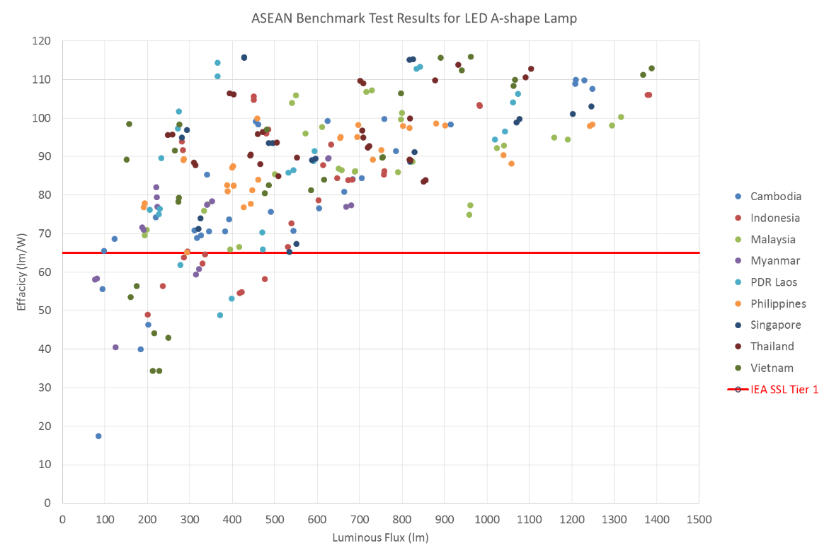

Figure 1: ASEAN Benchmark Test Results for LED A-shape Lamp - efficacy

Tested vs. rated power varied by as much as 63 per cent, colour temperature varied by as much as 4,500 Kelvin (many products were unmarked), with test results as high as 13,290 Kelvin.

CRI as low as 60 were found, with 30 per cent of lamps tested below 80 CRI (generally accepted as the minimum recommended level for residential lighting), and 2 per cent below 70 CRI.

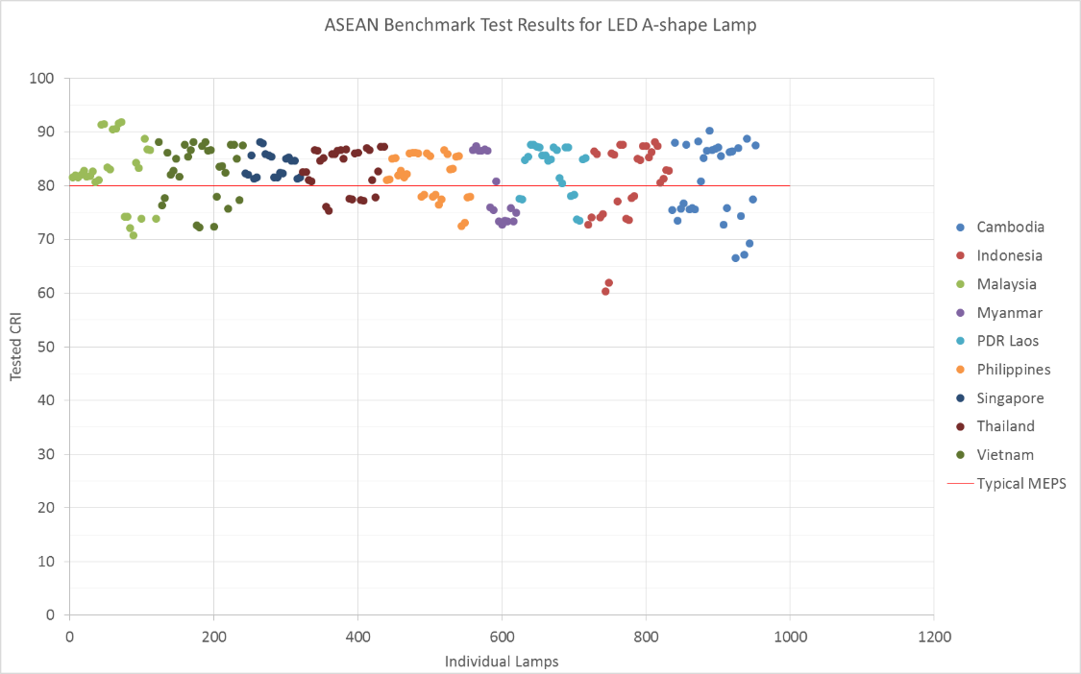

Figure 2: ASEAN Benchmark Test Results for LED A-shape Lamp - CRI

82 products (34 per cent) were found to be outside the 7 step SDCM MacAdam ellipses (IEC) and 49 products (20 per cent) were outside the ANSI quadrangles for colour consistency.

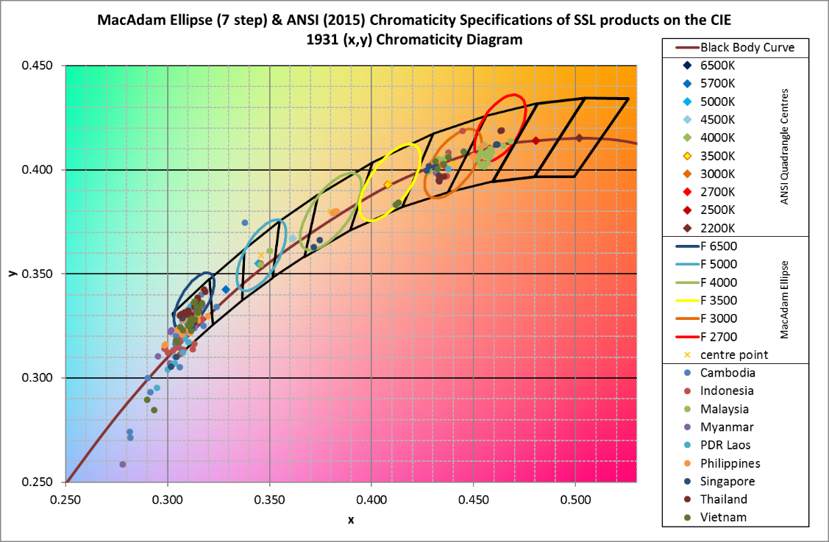

Figure 3: ASEAN Benchmark Test Results for LED A-shape Lamp – colour consistency

Power factor was quite poor for many lamps. All countries had lamps with power factors < 0.5. Six (6) countries had lamps with power factor below 0.2. These require more than 4.5x the current of a lamp with pf=0.9. The worst lamp was 0.08. This lamp requires more than 10x the current of a lamp with pf=0.9.

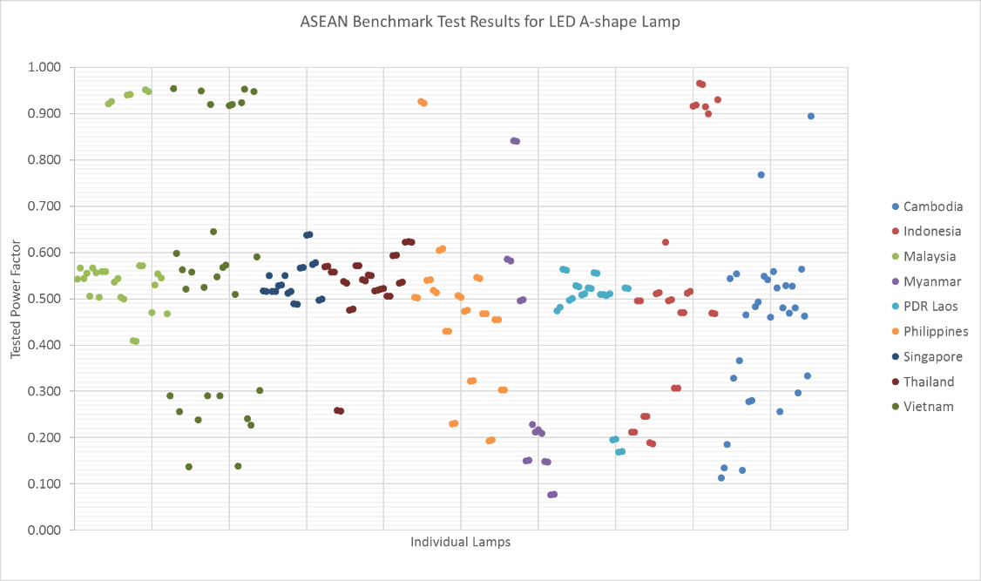

Figure 4: ASEAN Benchmark Test Results for LED A-shape Lamp – Power Factor

Overall it appears that the two South-East Asian countries with LED MEPS currently in place (Singapore and Malaysia), had better test results. For example, none of the products found to be under 65 lm/W were purchased in these two countries. These countries also had less variations in terms of rated vs. tested power and CRI.

Attachment C: LED MEPS Efficacy

**LED MEPS Efficacy**

The minimum performance efficacy levels proposed in the Consultation Regulation Impact Statement (CRIS) were based on existing international work, primarily from the IEA 4E Solid State Lighting Annex. This was supported by analysis of test results of a range of LED testing commissioned in Australia (2009, 2010, 2012, 2013, 2014 and 2016[3]), as well as overseas testing. Analysis of this data supported the introduction of a MEPS efficacy level in 2018 of 65lm/W for non-directional and directional lamps and 100lm/W for linear LED lamps.

In responding to the CRIS, some stakeholders queried whether the proposed MEPS levels were high enough to be effective in removing the least efficient (generally 20%) of lamps from the market. This input, combined with the proposed 12 month delay in the commencement date to March 2019, has led to further analysis of updated data which supports that the initially proposed levels for non-directional and directional lamps would not have been effective in removing lower performing lamps from the market.

Data used in this updated analysis includes:

* 2016 Australia LED testing
* Rated values from over 1800 LED lamps sourced from online catalogues of 45 suppliers to the Australian market
* Test data of 240 residential LED lamps (A shape) purchased in December 2016 from nine ASEAN countries as part of an Australian funded UNEP study (see Attachment B)
* Rated values of products sold in retail supermarkets
* Reporting on product trends from the US Department of Energy CALiPER program.

Figure 5 charts the efficacy dataset for non-directional LED lamps. Note that the proposed MEPS excludes lamps that emit less than 100lm.

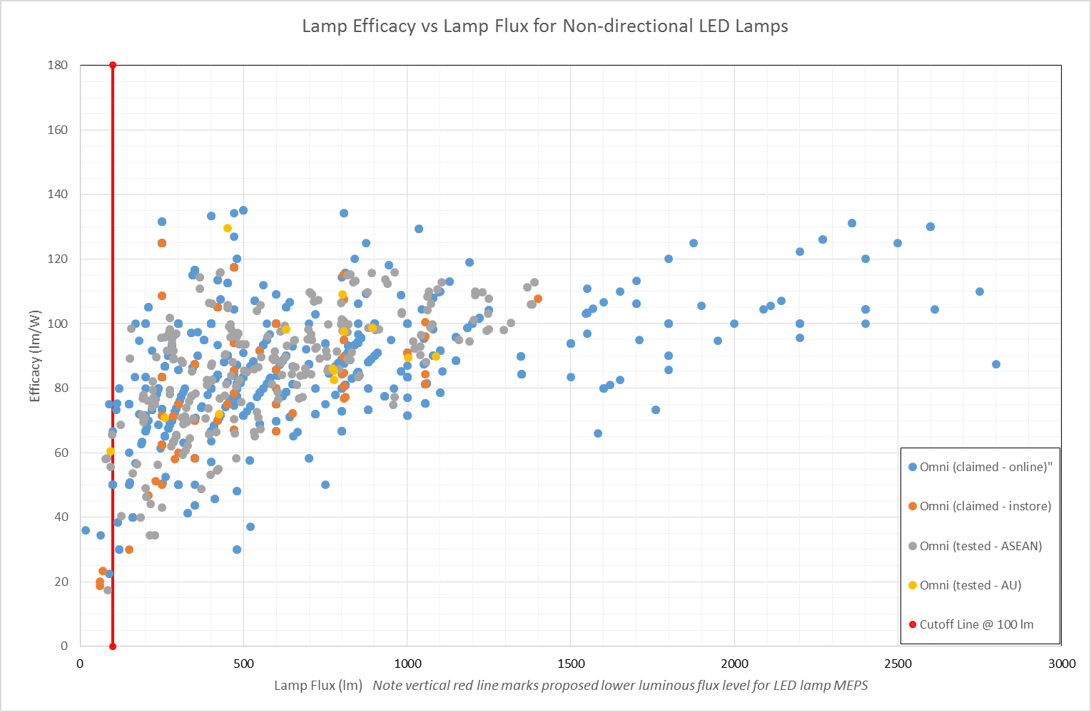

Figure 5: efficacy dataset for non-directional LED lamps

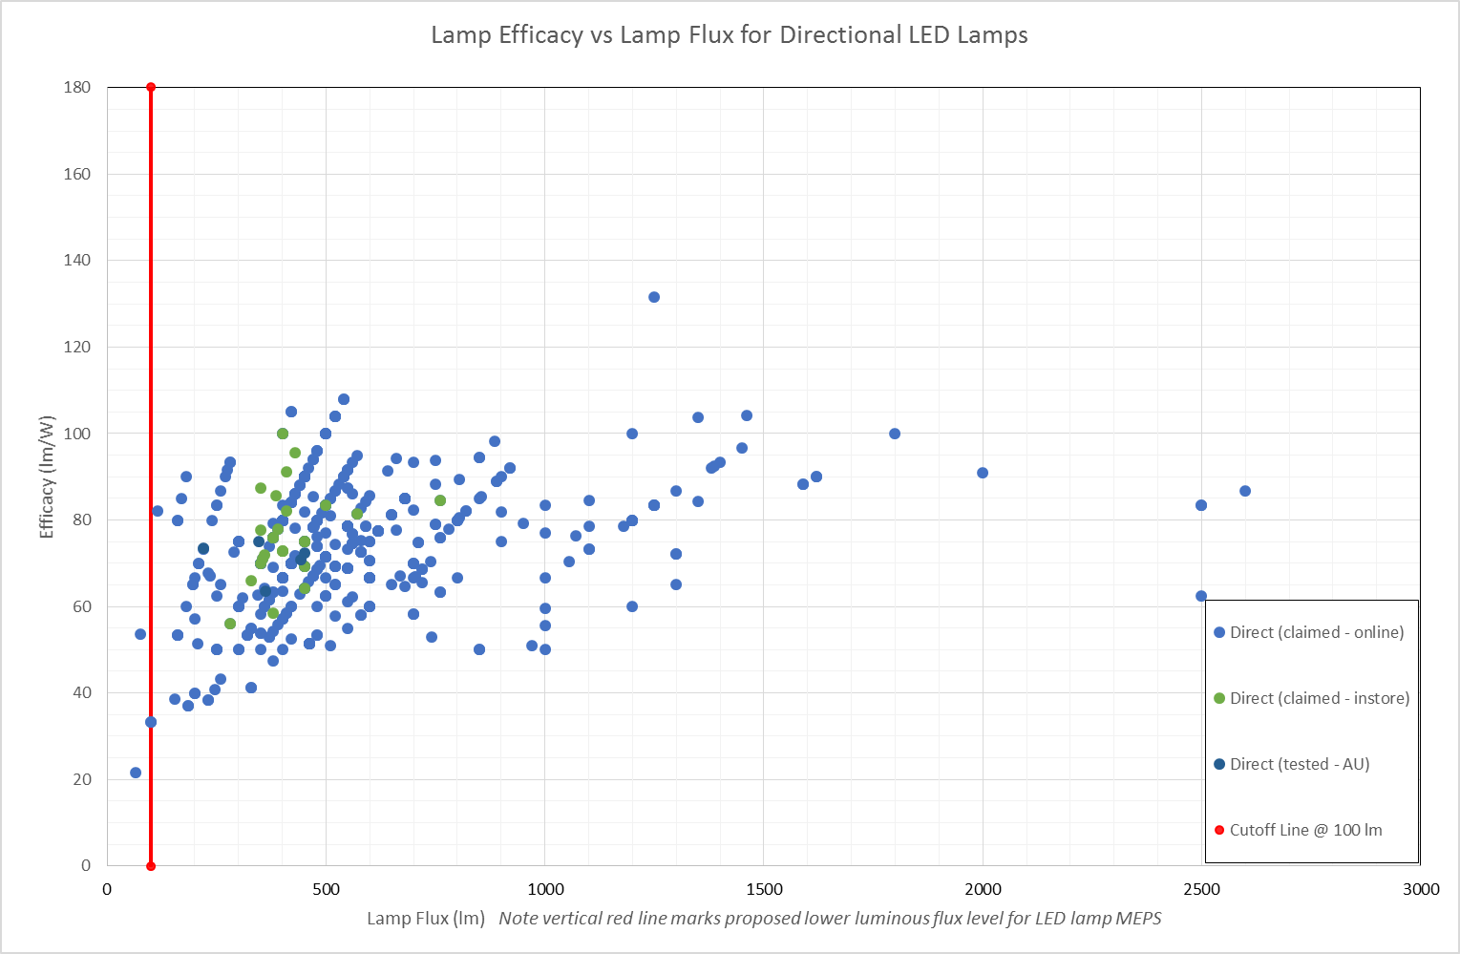

Figure 6: Efficacy dataset for directional LED lamps

Table 4: Updated proposal for efficacy levels for LED lamps

| **Product Scope** | **2019** | **2021** | **2023** |
| --- | --- | --- | --- |
| Lamp Non Directional | 80 lm/W | 90 lm/W | 100 lm/W |
| Lamp Directional | 80 lm/W | 90 lm/W | 100 lm/W |
| Lamp Linear | 100 lm/W | 110 lm/W | 120 lm/W |

In considering an increase in minimum efficacy for LED lamps, as shown in Table 4, the data analysis has indicated that some lamp types with specific features would have more difficulty in meeting these higher levels. As a result, the LED lamp MEPS has also been revised to include the following concessions for LED lamps (non-directional and directional):

1. Directional lamps (10%)
2. Beam Angle < 30º (10%)
3. 90 ≤ CRI < 100 (10%)
4. CCT ≤ 3000K (10%)

With these concessions applied, based on the available 2016-17 product data, the overall pass rate for non-directional lamps is 77% and for directional lamps 72%. Sub categories such as narrow beam angle, high CRI and low CCT all had similar pass rates after concessions were applied. With a further 1.5 years before implementation of the MEPS, it can be expected that these pass rates will further improve.

Attachment D: Compliance Approach

Purpose

This section outlines the Regulator’s compliance approach to ensure models of LED lamps will comply with MEPS requirements. The first part of the section applies to Australia only, and discusses the GEMS Regulator and the GEMS Act. In New Zealand, EECA follows a risk led compliance approach that is informed by the *Energy Efficiency (Energy Using Products) Regulations*. Many of the issues identified below around the need for engagement and education are the same, however the specific powers of the New Zealand Regulator vary. This is discussed further in the last part of Attachment D.

Background

Whilst not yet regulated, models of LED product are already supplied, offered for supply, or used for commercial purposes in Australia through a range of channels including:

* wholesalers
* retailers
* tradespersons importing and installing
  + for example; builders, electrical contractors, etc.
* commercial users importing or manufacturing for use in their own business
  + for example; mining entities undertaking fitouts of worker accommodation

Available models are often quickly replaced or updated, usually within a 6 to 12 month period.

The diversity of supply channels and rapid turnover of models require an agile and multi-faceted approach to compliance in order to discourage or remove non-compliant models from the market in a timely manner.

The Approach

The GEMS Regulator is committed to:

* assisting responsible parties understand the requirements of the GEMS Act
* monitoring responsible parties’ compliance with the requirements
* actively pursuing those who opportunistically or deliberately contravene the Act

Identifying Potential Suppliers

In the lead up to, and after, the implementation of LED product requirements, GEMS inspectors will conduct environmental scans to identify potential suppliers and commercial users via avenues such as:

* the collection and analysis of import data
  + LED tariff codes are now in place and analysis has commenced on the first LED product suppliers report
* collaboration with peak industry bodies
  + for example, NECA, and other trade channels
* information and data provided by the likes of the Lighting Council Australia, Electrical Regulatory Authorities Council, and others
* online and on site market surveillance
  + LED product included in the 2017/2018 GEMS Inspector Market Surveillance Program

Engaging and Educating

All identified potential suppliers will be engaged, however, using an intelligence led, risk based approach, engagement and education will be initially focused on tradesperson suppliers, specifically individuals or companies directly importing and installing models of LED product into the likes of residential, retail, or commercial buildings, where information suggests the risk of non-compliance is high.

These, and other suppliers, will be the subject of a communication strategy highlighting GEMS Act requirements, the GEMS Regulator’s compliance monitoring plan, GEMS Act enforcement responses, and the consequences of non-compliance. Communication avenues include:

* LED product tariff code alert messages
* email campaign direct to LED product importers
* email campaign to LED product retailers
* email campaign to lighting suppliers already registered under the GEMS Act
* lighting, electrical, trade, and construction peak industry bodies
* energyrating.gov.au

Monitoring Compliance with the Requirements

After the implementation of LED product requirements the GEMS Regulator will monitor compliance via:

GEMS Inspector Market Surveillance

GEMS inspectors will conduct market surveillance both online and on site to determine if models of LED product are registered and meet GEMS labelling requirements. Given the rapid turnover of models, the focus on registration and labelling compliance allows the GEMS Regulator to more immediately identify non-compliant models and quickly implement appropriate enforcement responses.

GEMS Inspector Powers

The GEMS Act allows GEMS inspectors to:

* inspect public areas of GEMS business premises via consent
  + includes the powers to inspect products, purchase products, and inspect or collect written information
* enter any premises and exercise monitoring powers, via consent or warrant
  + includes the powers to search, examine, take measurements, photograph, inspect documents, make copies
* enter any premises and exercise investigation powers, via consent or warrant
  + in addition to the powers mentioned above, includes the powers to search (under consent and warrant) and seize evidence (under warrant only)

Most often, GEMS inspectors use the inspection/monitoring powers via consent. Where access has been refused, communication with supplier management resolves most issues. If access is refused, and cannot be obtained via communication, GEMS inspectors may apply to the courts for monitoring or investigations warrants granting access.

The GEMS Act also empowers:

* GEMS inspectors to ask questions and seek production of documents
* the GEMS Regulator to require a person to provide information
* the GEMS Regulator to require a person to appear before a GEMS inspector

Failure to comply may result in a contravention of the GEMS Act.

Suppliers

Importing or manufacturing models of non-compliant LED product does not contravene the GEMS Act; there must be a supply, offer to supply, or commercial use of these models in Australia. Given that, most models of LED product are imported by the likes of:

* wholesalers who supply to the general public, retailers, tradespersons, or contractors
* tradespersons who first supply and then install as part of their trades services
* retailers who supply to the general public, tradespersons, or contractors

GEMS inspectors will use GEMS inspector powers to inspect, monitor, and investigate any premises where models of LED product may be supplied; for example, importer or wholesaler warehouses, tradesperson shop fronts, or retail stores.

In relation to residential, retail, or commercial buildings under construction or recently completed, where models of non-compliant LED product may be installed, GEMS inspectors will use GEMS inspector powers to enter via consent, or if necessary, via warrant. There is no GEMS Act provision for a person to give a product of a model to the GEMS Regulator to determine GEMS registration or labelling requirements. In these circumstances, GEMS inspectors may collect written information, take photographs, purchase a product or, if appropriate, seize one under an investigations warrant.

Market surveillance also includes the ongoing collection and analysis of import data to identify new suppliers and will also assist with the selection of models of LED product for check testing.

Check Testing

Check testing is undertaken to ensure models of LED product meet GEMS level (MEPS) requirements, with models selected using an intelligence led, risk based approach.

In order to ensure products selected are representative of the models registered with the GEMS Regulator, the Regulator, where possible, sources products anonymously and directly from the market. The GEMS Regulator may also require a registrant to give a product to a GEMS inspector. However, this does not apply if the model is not registered and the person is not a registrant. In these circumstances, the GEMS Regulator may purchase a product from the market or, if appropriate, seize one under an investigations warrant.

Traditionally, lighting product check testing has been a lengthy process. Given the rapid turnover of models of LED product in the market, the GEMS Regulator acknowledges a more streamlined process is required to identify and respond to models suspected of being unable to meet MEPS. As such, check testing processes and MEPS requirements are being reviewed to ensure a balance between the integrity of the check test and LED product shelf life. However, if a model of LED product is no longer supplied when check test results are known, the GEMS Regulator still has the enforcement options listed in paragraph 2.4 available.

The Receipt of Allegations of Suspected Non-compliance

Allegations of suspected non-compliance may be sent to [E3.Compliance@environment.gov.au](mailto:E3.Compliance@environment.gov.au) where they will be assessed, and if appropriate, investigated.

Enforcement

The GEMS Act provides the GEMS Regulator with educative, administrative, civil, and criminal response including:

* suspending a model’s registration
  + if a “family” registration, all models within the registration are suspended
* cancelling a model’s registration
  + if a “family” registration, all models within the registration are cancelled
* enforceable undertakings
  + commitment by a supplier to do, or refrain from, some specified action, which can be enforced in court.
* infringement notices
  + simpler and faster response than formal civil or criminal proceedings
  + non-payment may result in other responses such as enforceable undertakings or applications to the courts to pay a higher amount under a civil penalty order, or be subject to criminal prosecution if the alleged contravention also constitutes an offence
* criminal strict liability offences.

The GEMS Act also allows the GEMS Regulator to publicise certain offences, contraventions, and adverse decisions including the names of registrants and the reasons for the decision.

It is important to note, the above enforcement responses are available to the GEMS Regulator even if the model previously supplied, offered for supply, or used for commercial purposes, is no longer in the market.

Enforcement Examples

The following examples are a guide only:

* a product of a model is offered for supply on site and appears to be unregistered
  + section 17 GEMS Act – Supplying GEMS products – model not registered, may apply
  + as model is unregistered, it cannot be supplied or offered for supply, therefore, suppliers must remove all products of the model from shop floors or shelves
  + GEMS Regulator will consider a supplier’s history, behaviour, motivation, and intention and determine an enforcement response proportionate to the risk posed by the non-compliance.
* a product of a model is observed on site and appears to be unregistered, does not meet GEMS level requirements, or does not meet GEMS labelling requirements and a large number have already been installed
  + assumes we are talking about residential, retail, or commercial buildings under construction or recently completed where products of the model may be installed
  + section 17 GEMS Act – Supplying GEMS products – model not registered, and/or section 16 GEMS Act – supplying GEMS products – complying with GEMS determinations, may apply
  + as model is unregistered, or does meet GEMS level or labelling requirements, it cannot be supplied or offered for supply, therefore, suppliers must remove all products of the model from shop floors or shelves if supplied this way
  + there is no GEMS Act provision for GEMS inspectors or suppliers to uninstall already supplied products
  + GEMS Regulator will consider a supplier’s history, behaviour, motivation, and intention and determine an enforcement response proportionate to the risk posed by the non-compliance
    - enforceable undertaking may be used to commit a supplier to, for example, uninstall products or compensate for products already supplied and installed.

Compliance in New Zealand

Compliance with MEPS regulations is carried out by the Energy Efficiency and Conservation Authority, in accordance with the *Energy Efficiency (Energy Using Products) Regulations* 2002. These regulations, as well as the Energy Efficiency and Conservation Act are available to download from the [New Zealand Legislation](http://www.legislation.govt.nz/) website. The regulations detail the duties of manufacturers/importers, and persons dealing directly with consumers.

EECA employs a risk based model to compliance activities, and aims to ensure that activities are proportionate to the type of non-compliance. EECA uses a New Zealand cross agency guide (Achieving Compliance: A Guide for Regulators, DIA 2011) as a basis for their work, as well as looking to work closely with the GEMS regulations team at the Department of the Environment and Energy.

EECA compliance activities can range from informal activities and compliance advice letters to educating suppliers of their non-compliance through to settlements and prosecutions. For newly registered products, EECA will often initially take an educative approach.

As discussed above, in areas such as LED lighting where there is rapid product change, EECA will look to take a flexible approach to market screening and check testing, and will develop a test schedule that reflects this.

Attachment E: Cost benefit analysis

The estimated impacts of the preferred option for Australia and New Zealand to 2030 are shown in Table 5 (Australia) and Table 6 (New Zealand) below in terms of costs/benefits, energy savings and greenhouse gas emission reductions.

For Australia, introduction of MEPS for LED lamps (March 2019) and the phase out of halogen light bulbs (excluding downlights) (October 2019) is estimated to save approximately 11,058 giga-watt hours (GWh) and 7.5 million tonnes (Mt) of greenhouse gas (GHG) emissions cumulative to 2030. This option provides a net benefit of an estimated $1.40 billion.

For New Zealand, introduction of MEPS for LED lamps (around March 2019) is estimated to save approximately 618 GWh and 0.05 Mt of greenhouse gas (GHG) emissions cumulative to 2030. This option provides a net benefit of an estimated $25 million.

Following release of the CRIS, the following changes were made to the cost-benefit analysis:

* Change of product scope and timing, as described in this document (including a subsequent reduction in costs of dealing with compatibility issues for Australia, due to halogen downlight lamps no longer being phased out, discussed below)
* New tariffs available for Australia (AEMO 2016) have been used to estimate benefits. Otherwise modelling methodology and assumptions for Australia remain unchanged from the CRIS.
* New Zealand amended their modelling methodology to use long run marginal tariffs instead of consumer prices and a new tariff is now available for use which explains the significant variance in savings from the CRIS. While the benefits for New Zealand look comparatively modest, the modelling is conservative, with a good cost benefit ratio.

Table 5: Cost benefit analysis – Australia (Real discount rate: 7%)

|  |  |  |  |  |  |  |  |
| --- | --- | --- | --- | --- | --- | --- | --- |
| **Australia** |  |  |  |  |  |  |  |
| **Proposal** | **Sector** | **Energy Saved  (cumulative GWh)** | **GHG Emissions Reduction (cumulative Mt)** | **Total (Gross) Benefit (NPV, $M)** | **Total Investment  (NPV, $M)** | **Net Benefit (NPV, $M)** | **(Gross) Benefit to Cost Ratio** |
| **MEPS LED Lamps** | Res | 1,382 | 0.8 | 195 | 0 | 195 |  |
| Com | 2,055 | 1.4 | 210 | 0 | 210 |  |
| **Phase Out Halogen** | Res | 7,622 | 5.3 | 1,185 | 168 | 1,018 | 7.1 |
| **Industry + Govt Costs** | Admin |  |  |  | 14 | -14 |  |
|  |  |  |  |  |  |  |  |
| **Total Res** |  | **9,003** | **6.1** | **1,380** | **168** | **1,212** | **8.2** |
| **Total Com** |  | **2,055** | **1.4** | **210** | **0** | **210** |  |
| **Total Industry/Govt** |  |  |  |  | **14** | **-14** |  |
| **Grand Total** |  | **11,058** | **7.5** | **1,590** | **182** | **1,408** | **8.7** |
|  |  |  |  |  |  |  |  |
|  |  |  |  |  | **Net benefit per tonne:** | **-187** |  |

Table 6: Cost benefit estimates – New Zealand (Real discount rate: 6%)

|  |  |  |  |  |  |  |  |
| --- | --- | --- | --- | --- | --- | --- | --- |
| **New Zealand** |  |  |  |  |  |  |  |
| **Proposal** | **Sector** | **Energy Saved  (cumulative GWh)** | **GHG Emissions Reduction (cumulative Mt)** | **Total (Gross) Benefit (NPV, $M)** | **Total Investment  (NPV, $M)[4]** | **Net Benefit (NPV, $M)** | **(Gross) Benefit to Cost Ratio** |
| **MEPS LED Lamps** | Res | 216 | 0.013 | 9 | 0.0 | 9.2 |  |
| Com | 402 | 0.034 | 20 | 0.0 | 19.8 |  |
| **Industry Costs** | Admin |  |  |  | 3.7 | -3.7 |  |
|  |  |  |  |  |  |  |  |
| **Grand Total** |  | **618** | **0.047** | **29** | **3.7** | **25.3** | **7.8** |

Costs and benefits have been assessed to 2030. In order to show the impacts in each sector, residential and commercial sectors are modelled separately for the LED MEPS proposal. The phase out proposal largely applies to the residential sector and has been modelled as such. The following costs and benefits are included in the financial modelling:

Costs:

* To the consumer, due to transitional costs in upgrading existing lighting systems to be compatible with LED lighting. It is noted that there are no costs to the consumer for improving LED lamps due to an overall downward trend in price.
* To the product supply businesses for complying with the new or modified regulatory requirements
* To government for implementing and administering the requirements.

Benefits:

* To the consumer, due to improved energy efficiency of available products resulting in avoided electricity costs
* To consumers due to longer life of LEDs, leading to reduced replacement costs (not included in financial modelling)

The policy options can also reduce the cost to Australia and New Zealand of meeting greenhouse gas abatement targets by providing cost positive emission abatement. For Australia, the cost of abatement for the recommended option is around $-196/tonne[5]. This abatement cost is much lower than the average price of around $12 that the Australian Government is paying for abatement under the Emissions Reduction Fund.

The benefits to society from reduced GHG emissions have not been accounted for in the financial modelling.

Consumer costs (Australia only) include the estimated costs for households to upgrade their dimmer systems, where their existing dimmer(s) currently used with standard halogen light bulbs (non-directional) do not work effectively with an LED replacement light bulb (the light bulb flickers, does not dim satisfactorily or makes a noise).

The Department in consultation with suppliers has undertaken further testing on the most common legacy dimmers installed in Australian homes with LED standard light bulbs (non-directional) available on the market. A number of light bulbs were found to be highly compatible with the majority of dimmers tested. Test results identified that 18 of 18 dimmers work with at least one light bulb on the market, 16 work with at least two and 10 work with at least three. Three of the dimmers worked with six of the light bulbs tested and two dimmers worked with seven of the light bulbs tested. The Department will be releasing a lookup tool for electricians and households to assist in identification of compatible products by the end of the year.

It is estimated that approximately 1.2M households have dimmers in use with standard halogen light bulbs[6]. Informed by recent dimmer test results of legacy dimmers with standard LED light bulbs, it is estimated that 40 per cent of households will need to upgrade their dimmer system to retain dimming.

Estimated cost to replace 3 dimmers – dimmer purchase ($165) plus install ($140) = $305. Assumptions: dimmer cost $55 each, average house has 3 dimmers.[7]

An additional 20 per cent households are expected to need to engage an electrician ($140) to determine their dimmer model to identify a compatible product (for those households who are unsuccessful with trialling an LED light bulb).

Total estimated consumer cost to resolve dimmer compatibility issues = (480,000 x $305) + (240,000 x $140) = $180M

Benefits achieved from more energy efficient long lasting LED lamps offset the upfront cost with the household better off in a 5 to 7 year period through electricity and replacement savings (pending number of lights and usage). Households can also avoid/defer the upgrade cost and still use their LEDs if they are willing to set the dimmer to 100 per cent. Confirmed via testing, this will work in the majority of cases. Scheduling the dimmer upgrade with the next electrician job will also reduce costs.

As specified in the CRIS, it is assumed that MEPS on LED lamps will not increase the price of LED lamps for consumers. Price of LED lamps continue to decline with improvements in technology, manufacturing and competition in the market. The cost of LED MEPS on lamps for suppliers is assumed to be offset by these factors as opposed to being passed on to consumers through a price increase. Because of this, there is no consumer cost in New Zealand at all.

Regulatory costs for supply businesses are detailed in Attachment F and equate to $14M over 10 years for Australian suppliers and $3.7M over 10 years for New Zealand suppliers (NPV). This equates to an average of $7,000 per supplier per annum (excludes GEMS fees).

Government administration costs (costs to the taxpayer) are made up of salary, program administration, check testing, consumer information/education and miscellaneous (market research, etc.). Total incremental cost to Government per annum for Australia and New Zealand are estimated at $200,000 per annum. Establishment costs to government in Australia and New Zealand to prepare the RIS and introduce the new regime are assumed to be $350,000. An additional $2 million over a three year period is included to deliver the supporting communication campaign in Australia (2018/19, 2019/20, 2020/21). This adds up to total taxpayer costs of $4.35 million over the ten-year assessment period.

Refer to the CRIS for further information on the modelling approach and assumptions.

The further phase out of halogen lighting (mains voltage and low voltage downlights) in Australia (planned in 2021) is estimated to save an additional 6,000 giga-watt hours and 3.5 million tonnes of greenhouse gas emissions cumulative to 2030.

**Consumer benefits**

The case studies below provide a summary of average savings for households that replace halogen light bulbs with LED light bulbs[8]. The number of halogen lights for replacement is based on the predicted mix of lighting technology (halogen, fluorescent and LED) existing in townhouses and detached homes[9]. Savings will vary pending the number of lights replaced with LED and usage.

A family living in a townhouse that replaces 7 standard halogen light bulbs (non-directional) with LED replacements would spend $29 extra on light bulbs (difference in total purchase cost between halogen and LED), and would save an estimated $43 annually on their electricity bill. The estimated electricity bill for a townhouse in 2017/18 is $969 – this family would be **$464 better off over 10 years** through savings in energy and replacement costs.

A family living in a detached house that replaces 10 standard halogen light bulbs (non-directional) with LED replacements would spend $40 extra on light bulbs (difference in total purchase cost between halogen and LED), and would save an estimated $61 annually on their electricity bill. The estimated electricity bill for a detached house in 2017/18 is $1529 – this family would be **$664 better off over 10 years** through savings in energy and replacement costs.

A family living in a townhouse that chose to replace all of their 11 halogen light bulbs (standard or downlight) with LED light bulbs would spend $45 extra on light bulbs (difference in total purchase cost between halogen and LED), and would save an estimated $61 annually on their electricity bill. The estimated electricity bill for a townhouse in 2017/18 is $969 – this family would be **$658 better off over 10 years** through savings in energy and replacement costs.

A family living in a detached house that chose to replace all of their 18 halogen light bulbs (standard or downlight) with LED light bulbs would spend $79 extra on light bulbs (difference in total purchase cost between halogen and LED), and would save an estimated $102 annually on their electricity bill. The estimated electricity bill for a detached house in 2017/18 is $1529 – this family would be **$1091 better off over 10 years** through savings in energy and replacement costs.

Attachment F: Regulatory costs and GEMS fees

The regulatory costs associated with the updated policy options were estimated for Australia using the Australian Government’s Regulatory Burden Measurement Framework (RBM). Regulatory costs counted under the RBM include the administrative costs incurred complying with the regulations. The Australian Government requires any new regulatory costs to be offset by a corresponding reduction in regulatory costs elsewhere.

As required by the RBM, fees for GEMS registrations are excluded from this costing.

Please provide any feedback on the assumptions and estimates of costs incurred complying with the regulations, so that the cost estimates can be improved for the DRIS.

Estimate of affected suppliers and GEMS registrations

Suppliers

The number of suppliers is significantly higher than business as usual (BAU) (58), increasing to an estimated 200 suppliers for LED lamps.

This estimate has been informed by LED lamp import data, electrical safety registration data and market research. The number of suppliers importing LED lamps into Australia, based on these products being classified by import brokers under the LED lamp classifications for the period January 2017 to May 2017 is 419[10]. The 200 estimate has been arrived at by reviewing the import data and setting a threshold on import numbers per supplier (to account for personal use), and reducing by a factor on the assumption that some suppliers will choose to no longer import following the introduction of regulation. The E3 Program has identified over 180 lighting companies (suppliers/wholesalers/retailers) supplying lamps. Other players in the market include electrical contractors and builders directly importing products.

The regulatory costs involved for individual suppliers to comply with the proposed LED MEPS on lamps is generally consistent with the administrative and test costs currently incurred by suppliers who are required to register regulated lighting products (fluorescent and halogen lamps).

The major difference between BAU and LED technology is the number of registrations over the 10 year period. Many suppliers are advising that new models are being released every 6 to 12 months. This means that product costs are incurred more frequently than under BAU. A broader family definition is proposed to reduce costs and allow some flexibility to update an existing family on release of a new model (at a reduced fee).

Average testing costs are also expected to be $1,000 per product family (this excludes the costs of those tests already understood to be undertaken by reputable suppliers and where suppliers are understood to already have access to the additional required test data). This is a net increase of $314 over BAU test costs which are estimated at $668 per product family.

Simplifications over the current BAU approach that will reduce costs include:

* reduced endurance test from 6,000 hours (required for CFLs) to 1,000 hours proposed for LED
* LED performance and test method to be included in the GEMS determination, as opposed to a new Australian standard, reducing supplier costs by around $600 each
* improvements to the registration system to streamline the process.

Registrations

The estimated LED lamp registrations for the first year is estimated at 2400. Estimated registrations over the 10 year period is estimated at 12,000 (noting there is potentially a large margin of error in projecting forward over this period).The average number of LED lamp registrations is estimated at 12 per supplier.

The Department has conducted a review of lamps being offered for sale by a number of suppliers, this included 45 suppliers and over 1800 lamp models. The average number of families identified was 11.42, with the minimum being 2 and maximum being 38. Six case studies are presented below with estimated number of families based on analysis of available catalogue data:

Supplier 1: 49 products in scope, 13 families

Supplier 2: 29 products in scope, 13 families

Supplier 3: 19 products in scope, 9 families

Supplier 4: 86 products in scope, 19 families

Supplier 5: 57 products in scope, 15 families

Supplier 6: 15 products in scope, 7 families

Business As Usual Costs

Under BAU, there were estimated to be 58 suppliers (registrants) of 789 registered models of lighting products (based on the E3 program’s registration database as at June 2016) that directly incur administrative costs in complying with the existing regulations. This includes meeting minimum performance standards and package marking requirements. Estimated registrations over the 10 year period is estimated at 1800 (from commencement).

There were estimated to be another group of 50 downstream suppliers/retailers that incur compliance costs in the supply of lighting. This estimate includes retail groups/chains, online suppliers and other specialist stores/store chains. A retail chain is counted once in the estimate, as it is assumed regulatory compliance is dealt with by a central/head office. Installers and many other specialist stores that supply products downstream (that are advertised through brochures and online) are not included in this count, as it is assumed they source products from upstream suppliers that ensure products comply with the regulations.

The compliance costs for these businesses (both registrants and downstream suppliers) were estimated by multiplying labour costs (wage costs plus on costs) by the time spent performing a particular task. For example, for one administrative officer to complete an online registration form that takes two hours to complete, the cost is estimated as 1 x $53 x 2 = $106. The assumed labour costs (including on costs) were:

* administrative officer: $53.00
* non managerial employees: $60.00
* manager: $73.00
* legal officer: $76.50

Administrative compliance costs (per year) associated with the existing regulations were estimated as:

* reviewing/understanding legislative requirements - $4,000 per registrant/supplier (including standard costs of $1,000)
* time spent registering a product (not including the registration fee) - $250 per product
* internal compliance assurance - $350 per registrant/supplier
* data collection for reporting - $3,250 per registrant/supplier
* record keeping - $2,550 per registrant/supplier
* testing - $668 per product
* downstream suppliers (i.e. retailers and specialist stores) - $1,400 per retailer

The estimated annual costs of BAU is $231,100, accounting for supplier, product and downstream supplier costs over 10 years divided by 10, with an average cost of $4,000 per supplier per year.

LED lamp costs

The additional regulatory costs for LED MEPS on lamps compared to BAU are estimated at around $14M over 10 years (NPV), with an average cost of $7,000 per supplier per year. Under this option, an additional 142 registered suppliers and 12,000 models of LED lamps are assumed to be in scope and therefore incur compliance costs. An additional 20 downstream suppliers (i.e. retailers that sell LED lamps) are assumed to be in scope under this option.

For LED lamps, revised estimates from BAU include:

* a $600 reduction in costs to purchase standards is assumed, due to the performance parameters and test method being included in the determination as opposed to creation of a new Australian/New Zealand standard, with standard costs of an estimated $400. (Revised estimate of $3,400 for reviewing/understanding legislative requirements).
* A $332 increase in testing compared with BAU on average per product model ($1000 total).
* A $0 impact on purchase price of LED lamps on the basis of the continued forecast decline in price of these products with improvements in technology and manufacturing and competition in the market, which is assumed to offset any price increase as a result of suppliers passing on compliance costs. See CRIS Modelling for further information on rationale.

Testing costs assumptions for the policy were:

* suppliers already undertake standard tests, highlighted in the MEPS document, not because of the proposed energy efficiency regulations, thus these are not costed (5 of 7)
* the additional tests (2) required would be done with standard testing, so the additional testing time does not include installation and setup time.
* no additional equipment required.

Table 7: shows the additional regulatory costs for Option A (Commonwealth’s portion)

| Change in costs | Business | Community organisations | Individuals | Total change in costs |
| --- | --- | --- | --- | --- |
| Total, by sector | $ 0.563m | $0 | $ 0 | $ 0.563m |
| Cost offset | Business | Community organisations | Individuals | Total, by source |
| Total, by sector | $0 | $0 | $0 | To be confirmed |
| Are all new costs offset?  Any costs will be offset by drawing on offsets from the Department of the Environment and Energy at the point of decision. | | | | |
| Total (Change in costs – Cost offset) ($ million) = To be confirmed | | | | |

^The average annual regulatory costs were calculated by estimating the total undiscounted (nominal) cost for Option A over the ten year period from 2017 to 2026, and dividing this by ten. The costs shown are based on the Commonwealth’s portion of the GEMS funding agreement, which is 43 per cent.

New Zealand

New Zealand BAU lamp registrations include 131 registrations associated with 33 suppliers. The estimated number of LED lamp suppliers is 50 and estimated number of family registrations is 600 in year one (an estimated 3,600 registrations over 10 years). Supplier regulatory costs are estimated to be similar to costs incurred by suppliers registered under GEMS (an estimated additional regulatory cost of around $3.7M over 10 years (NPV), with an average cost of $7,000 per supplier per year. Because of the similar nature of the markets, this estimate may be on the high end for New Zealand, as many products may be registered already for Australia. There is no registration fee in New Zealand.

GEMS LED lamp registration fees (Australia)

GEMS registration fees are currently under review. The E3 Program released the [GEMS Fees Review 2016-17](http://www.energyrating.gov.au/consultation/gems-fee-review-2016-17-consultation) consultation paper in February 2017 and is in the process of finalising a further consultation paper to consult on fees for *regulated* products. Fees for BAU lighting products (fluorescent and halogen lamps) is currently $440 (set in 2012). The Fees review will not consider fees for proposed regulation, rather this will be determined as part of each DRIS.

Below is the proposed fees for LED lamps. Feedback is sought on this proposal to further inform the DRIS.

* Based on the estimated number of suppliers and estimated number of registrations for lamps and registration and compliance check test costs, the estimated fee for LED lamps is proposed to be in the lowest fee band. This is expected to increase from $440 (set in 2012) to $540 (2018-19). Fee band values to be determined via Fees review.

Below is some further background on how the proposed fee has been arrived at:

* When a model of a GEMS product is registered, registrants are charged a registration fee to recover the costs of providing the registration and compliance monitoring services under the GEMS Act.
* The *Greenhouse and Energy Minimum Standards (Registration Fees) Act* 2012 sets out what matters can be considered by the GEMS Regulator when setting registration fees. The Australian Government’s policy approval for GEMS included an expectation that registration fees would be reviewed every three years to facilitate a move towards full cost recovery over time.
* The Fees review is considering the current fee bands in the context of registration and compliance monitoring cost, including check testing. For lighting products, the fee currently charged has been identified as being too low relative to the registration and compliance costs incurred, with lighting products being cross subsidised by other product types.
* At present, GEMS registration fees cover around 70 percent of the total cost of registration and compliance activities. It is likely that fees will be increased in order to move to full cost-recovery.
* Registration costs include handling registration-related enquiries and assessment for registrations, liaison, decision making and monitoring. Two key activities for GEMS registration are outsourced to service providers. This includes the GEMS Registration System and Assessment Services.
* Compliance costs include education and engagement, market surveillance, product check testing and enforcement action. Fees do not cover policy development work such as the development of the RIS, this supplementary paper or other development work.

Attachment G: Offer to Supply

What is ‘Offer to Supply’?

Background

Product registration is required for products in Australia subject to GEMS level, labelling, and other GEMS requirements under the *Greenhouse and Energy Minimum Standards Act 2012* (GEMS Act) where products are “supplied, offered for supply, or used commercially”. Suppliers submit product registrations on the [Energy Rating Website](http://www.energyrating.gov.au/registration).

In New Zealand the rules around which products need to comply are laid out in the *Energy Efficiency (Energy Using Products) Regulations 2002*. The New Zealand Regulations use a slightly different phrase, ‘make available for sale.’

Note that the below is currently framed around the Australian regulation. While the intent is for both countries to have similar provisions, specific details will differ in accordance with the requirements of the relevant regulation.

LED MEPS is proposed for a range of LED lamps and later, integrated luminaires capable of being tuned to within the specified white region in any mode of operation.

In the development of the proposal for LED Minimum Energy Performance Standards (MEPS), it has become apparent that LED integrated luminaires in particular are offered for sale and supplied in a more diverse manner than some other products subject to energy efficiency regulation. In this diverse market, some suppliers offer large product ranges where only a small proportion may ever be sold in Australia or New Zealand, including linkages to third party product catalogues that the supplier has rights to supply from.

The following information provides some initial guidance on the circumstances where product registration would be required if MEPS for LED products is put in place to ensure compliance with the GEMS Act. Note that a supplier may choose to register a product or product family in advance of the circumstances outlined below.

What is ‘offer to supply’ for LED products?

General: Offer to supply includes advertising products as available for sale, display of products for sale in retail or wholesale outlets, listing of products as available for sale on websites or in catalogues, and installation of products in premises offered for sale. Registration is required before an offer to supply is made.

Custom made products: In cases where a supplier offers a service to custom make an LED product either to the customer’s specifications or to specifications developed in consultation with the customer (and the specific product design does not exist before this interaction) the concept of ‘offer to supply’ would be triggered when the supplier and the customer agrees on the final specifications to be used. At this point the product should be registered (including any testing to demonstrate compliance required for registration) prior to an order being made.

Overseas catalogues referenced by suppliers to Australia: The act of referencing a third party overseas catalogue by a supplier to the Australian market is not in itself considered an offer to supply provided: stock is not held in Australia; and the Australian supplier website or catalogue indicates that the availability of these products for the Australian market needs to be confirmed before supply can be made.

Offer to supply occurs when availability for the Australian market is confirmed. The product should be registered prior to this point (including any testing to demonstrate compliance required for registration), and prior to an order being made.

Australian catalogues of overseas products: The act of providing lists of overseas products on the website or catalogue of a supplier to the Australian market is not in itself considered an offer to supply provided: stock is not held in Australia; and the website or catalogue indicates that the availability of these products for the Australian market needs to be confirmed before supply can be made.

Offer to supply occurs when availability for the Australian market is confirmed. The product should be registered prior to this point (including any testing to demonstrate compliance required for registration), and prior to an order being made.

Direct supply by overseas suppliers: To be clear, a direct offer of available products by either an Australian or overseas supplier, including via online or catalogue order forms is considered an offer to supply and registration is required.

How does this vary in New Zealand?

As mentioned above, in New Zealand the rules around which products need to comply for product registration are laid out in the Energy Efficiency (Energy Using Products) Regulations 2002. The New Zealand Regulations use a slightly different phrase, ‘make available for sale.’

It is up to suppliers to make their own judgments, however, as in Australia, where a product is advertised as available for sale, displayed for sale in retail or wholesale outlets, listed as available for sale on websites or in catalogues, or similar, the product should be registered.

Attachment H: Phase out of incandescent and halogen lamps (Australia only)

Introduction

The proposal to increase incandescent and halogen MEPS (Australia only) to CFL levels to remove the most inefficient lamps from the market was broadly supported by stakeholders.

Below is the proposed phase out of a range of halogen light bulbs, excluding downlights and accounting for feedback received from stakeholders on exemptions or delayed introduction of the phase out for some product types. The target date for the phase out of these products is October 2019.

Suppliers could continue to import these products types and distribute for sale up until the start date of the new MEPS level. Previously imported products could continue to be sold on the market until stock is depleted.

The phase out of halogen downlights has been deferred in the absence of LED MEPS on integrated recessed downlights, which like LED lamp downlights are a direct replacement product. These integrated products are mainstream in retail and trade outlets and heavily promoted by trades. The reputational risk for Government in phasing out halogen downlights without having minimum quality standards in place for all replacement products was considered too high. With no regulation on these products, consumers could be exposed to purchasing inferior LED product in the absence of being able to purchase halogen light bulbs and the benefits to the community in terms of electricity and replacement savings could not be assured. Delaying the phase out of low voltage halogen downlights will also allow technology improvements to reduce the incidence of compatibility problems with the legacy installed stock of transformers.

Following the introduction of LED MEPS on integrated luminaires, the intention is to phase out all remaining halogen lamps (pending remaining compatibility issues for extra low voltage lamps). LED MEPS on integrated luminaires and the phase out of halogen downlights will be the subject of a separate CRIS and DRIS but it is anticipated to occur in 2021.

Understanding the costs of this option include analysis of the extent of compatibility of LED products with existing dimmer systems. Dimmer compatibility issues and associated consumer costs are covered in Attachment E.

The E3 program requests stakeholders to consider the phase out plan and provide feedback, including any potential unintended consequences or impacts that have not been considered to further inform the DRIS.

Timing

The DRIS will recommend that the staged phase out of halogen and incandescent lamps commences 6 months after the start date of LED MEPS (allowing time to address quality issues). Commencement would also be dependent on the replacement Incandescent MEPS determination being released twelve months prior to the date of effect, allowing time for industry to alter supply chains and minimise wastage of materials that are no longer needed. It is expected that the phase out will occur in October 2019.

Scope and staged approach

The revised proposal has taken account of the feedback received from stakeholders on proposed exemptions or delayed introduction of the phase out for some product types, including consideration of compatibility issues.

The table below provides information on the proposed phase out for different lamp technologies/type. Note: Class refers to the product classes referenced in the GEMS Incandescent Determination.

Table 8: Proposed phase out of halogen and incandescent lamps

| **Technology and/or type** | **Proposal** | **Timing** |
| --- | --- | --- |
| Tungsten incandescent and halogen Pilot lamps | **Greater or equal to 10w to be phased out in 2019** | 2019 |
| Tungsten Incandescent and halogen lamps 25W and below (candle, fancy round decorative)[11]  (Class 3,4,5)  Caps: E14, E26, E27, B15 or B22d | **Greater or equal to 10w to be phased out** | 2019 |
| Mains voltage Tungsten Incandescent  and halogen non-reflector (class 6)  Caps: E14, E26, E27, B15 or B22d | **All to be phased out in 2019** | 2019 |
| Mains voltage halogen capsules  Caps: G9 bi-pin | **All to be phased out in 2019** | 2019 |
| Mains voltage halogen non-reflector  Caps: double ended linear R7 (currently unregulated) | **R7 cap lamps exempt until 2020.** At this time, this lamp type will be included in the phase out scope, unless testing of the market explicitly reveals that LED replacement options are still not suitable (or other valid reason for continuing the exemption exists).  **Justification**:  LED replacements currently do not emit enough light and/or are too bulky to fit inside conventional halogen floodlights.  This type of floodlight has a shrinking penetration, in favour of integrated LED floodlights.  This type of floodlight has perceived limited operating hours (e.g. used for backyard barbeques, etc.) | 2020 |
| Mains voltage reflector  incandescent lamps (includes halogen)  Caps: E14, E26, E27, B15, B22d or GU10 | Currently unregulated. **All to be phased out in 2019.** | 2019 |
| Downlight reflector  halogen lamps (Class 7)  Types: MR11 shape or MR16 shape or GU10 cap | **Exempt until 2021** | 2021 |
| ELV non-directional  (product class 2)  Caps: Bi-pin (including G4, GY6.35 caps) | Increase MEPS in 2021, delay due to limited product on the market at high lumen output  **Justification**  LED replacements currently do not emit enough light and/or are too bulky (especially for higher power halogen lamp replacements).  Transformer compatibility issues exist.  Desk lamps (a popular application) have a shrinking penetration, in favour of integrated LED units, and low operating hours. | 2020 |

Exemptions (2019 phase out)

The cap types listed below are proposed to be exempt from the 2019 phase out for the reasons outlined below. At this time, these lamp types will automatically be included in the phase out scope in 2020; with downlight reflector halogen light bulbs targeted for 2021, unless testing of the market explicitly reveals that LED replacement options are still not suitable (or another valid reason for continuing the exemption exists).

**R7 Tubular halogen lamps**

Justification:

* Currently available LED replacements do not emit enough light and/or are too bulky to fit inside conventional halogen floodlights.
* This type of floodlight has a shrinking penetration, in favour of integrated LED floodlights.
* This type of floodlight has perceived limited operating hours (e.g. used for backyard barbeques, etc.), thus the temporary delay in phase out will not be a large loss in energy savings.

**G4 and GY6.35 ELV halogen capsules**

Justification:

* LED replacements currently do not emit enough light and/or are too bulky (especially for higher power halogen lamp replacements).
* Transformer compatibility issues exist.
* Desk lamps (a popular application) have a shrinking penetration, in favour of integrated LED units.

**Current Exceptions in the Incandescent Lamps for General Lighting Services Determination**

The following exceptions listed in sub section 5(2) of the Determination are proposed to remain:

* Automotive lamps
* Traffic lights
* Lamps used for air and sea navigation
* Oven lamps
* Infra-red heat lamps

The following exceptions listed in sub section 5(2) of the Determination are proposed to be removed:

* Rough use or vibration lamps, on the basis that LED are superior under these conditions and thus the exception is no longer necessary
* Incandescent crown reflector lamps, unless advice from stakeholders reveals that LED replacement options are not suitable (or other valid reason for continuing the exemption exists).

Crown reflector lamps were not referenced in the CRIS for phaseout – E3 program requests information from stakeholders on any reasons why these products should continue to be exempt. Crown reflector lamps reflect light towards the base of the lamp. As the beam is controlled it can achieve dramatic effects and low glare. These lamp types can be used in a range of applications, such as fitted around a mirror frame, over a dining table to reflect light back up to the ceiling, in retail stores, or simply used as decorative lighting. LED filament replacements are available that emit 450 lumens, equivlanent to about a 35W halogen.

Examples of crown-reflector LED lamps:

<https://www.amazon.co.uk/dp/B01MXFLPHR/ref=asc_df_B01MXFLPHR43477927/?tag=lion0d29-21&creative=22374&creativeASIN=B01MXFLPHR&linkCode=df0>

<https://www.lampsandlights.com/uploads/products/2948/LB06silver-LED-ES-data.pdf>

<http://www.megaman.cc/products/lamps/led-lamps/decorative/crown-silver?voltage=220-240V&lampbase=All&lampshape=All&max_luminous=&beamangle=&color_temp=&dimming=&eca>

Transitional issues

Dimmer compatibility with LED

Some LED lamps may not be compatible with existing lighting systems that include a dimmer circuit, resulting in the LED lamp not operating satisfactorily (flickers, restricted dimming). Options where incompatibility occurs includes trying another model of LED lamp (preferably with advice from a lighting retailer or supplier), or engaging a qualified electrician to upgrade the dimmer system. An estimate of consumers costs associated with this issue is included in Attachment E.

Two wire devices

Some LED lamps may not be compatible with existing light fixtures that have a sensor function (a two wire device), resulting in the LED lamp operating unsatisfactorily (lamp stays on in off state, flickers).

There is a large range of lighting products available with sensors. Motion sensors are generally installed on lights for security or ease of use reasons including outdoor lighting. The sensors are usually sold as a package with one or more lamps controlled by a single sensor. Advice from the Compatibility working group is that some LED lamps do not work with two wire devices. Non-compatibility can be resolved through purchase of a new unit or alternatively an electrician can modify the load so the existing unit works satisfactorily.

Informal advice from industry is that manufacturers of these sensor products moved to three wire designs from 2010, making these more recent products highly compatible with LED. Outdoor sensor lights are often exposed to the elements and therefore have a shorter life span of between 5 to 10 years. On the assumption that many two wire products will be due for replacement by 2018 (purchased before 2010), the costs of upgrading sensor lights have not been accounted for.

**Controls**

For impacted households, options include:

* Deferring costs in the short term by keeping spare halogen lamps on hand
* Replacing the sensor or timer or modifying the load, seeking to incorporate this job with the next electrician visit to reduce costs.

Ripple control filtering

Some consumers in certain geographic areas in Australia may notice that their LED lamps flicker for a short period (approximately 2-3 minutes), as ripple control signals are sent several times a day from distribution network service providers to control off peak tariff hot water, street lamps and space heating. The impact may vary due to the strength of the ripple current signals experienced, which can be locally amplified due to resonance in the network resulting from reactive loads.

The problem may occur in LED lighting due to their electronic design, possibly combined with an increase in the signal strength being experienced in the network. This is an existing issue that has also been reported to affect other household electrical products (including humming in electric fans, fast electric clocks and unintended operation of ovens).

The Department has established a Ripple Control working group that includes membership from LCA, Lighting Council New Zealand, Energy Networks Association, University of Wollongong and energy network and lighting manufacturers, to understand the geographical areas affected, conditions when this can occur and options to resolve. It is anticipated that options to address this problem can developed with the various parties involved before October 2019.

Attachment I: Lumen maintenance testing

Background

**Lumen maintenance (or lumen depreciation) is the reduction in light output of a light source over time.** It is one form of parametric failure of LED light sources. The typical parameter used to quantify lumen maintenance is the L70 which is defined as the time duration at which the emitted luminous flux from a light source has reduced to 70% of the initial luminous flux emitted, Figure 7. Other metrics such as L85 and L90 representing 85% and 90% respectively of the initial luminous flux have also been provided by manufacturers.

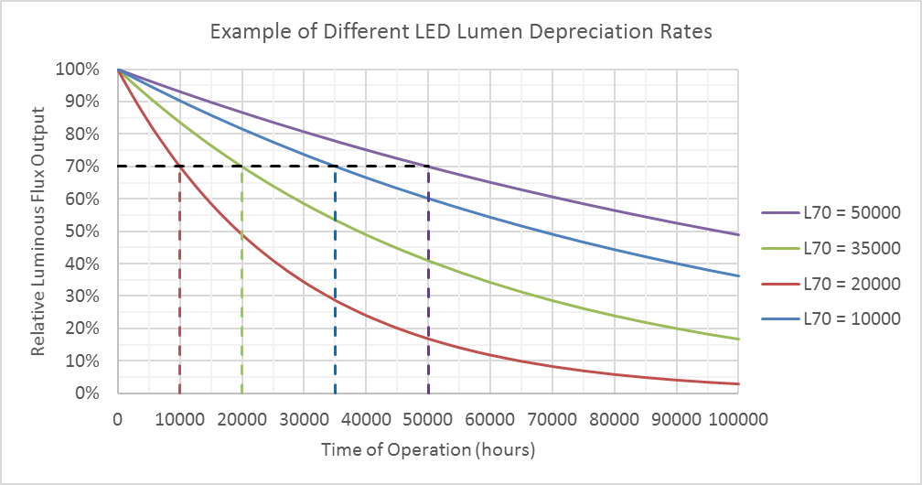

Figure 7: Example of different LED lumen depreciation rates and associated L70 values

For an LED product, the L70 is typically stated as the median (50th percentile) and is represented by L70B50. This is where 50% of test samples of the product will have failed due to their light output having dropped below 70% of the initial light output. Higher lumen maintenance levels such as L90, are sometimes stated on high-end professional products but also accompanied with a much lower failure proportion such as 10%, (and signified as L90B10).

With conventional light sources, lumen maintenance was determined by operating product samples under test conditions until half (ie 50th percentile) the samples reached the target depreciation level. But due to the extremely long operating time generally required for an LED light source to reach 70% of the initial luminous flux emitted, **physical testing of LED products until they reach this point is impractical**.

LED light sources are known to experience greater lumen depreciation than conventional light sources such as incandescent and fluorescent technology lamps, Figure 8. Thus, while LED lighting might offer a longer life product, once the lumen maintenance has reached L70, the product is no longer considered to be providing the desired lighting service satisfying the original intent. This means that the useful life of the product may be significantly less than the actual time to failure (ie no light output) of the LED product.

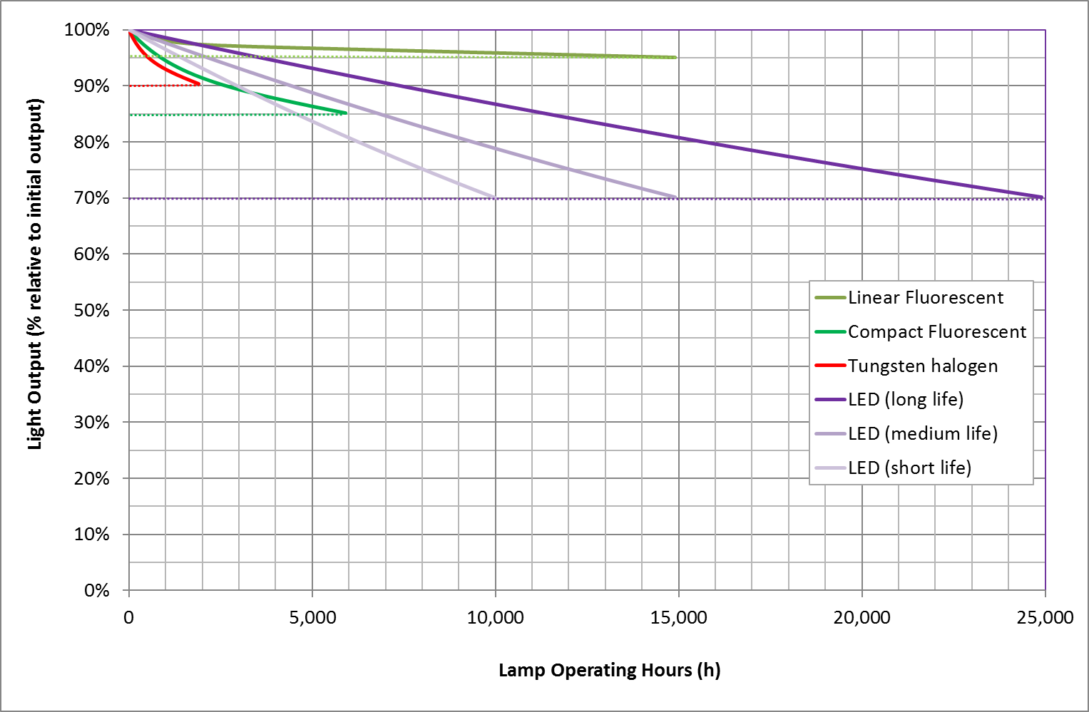

Figure 8: Lumen depreciation and life of different lamp technologies

**The initial and long-term performance characteristics of LED chips and the phosphors used to create the white light are sensitive to temperature.** The initial luminous flux and the lumen depreciation rate will change for different operating temperatures of the LED package/module. The initial luminous flux will decrease and the rate of lumen depreciation will increase (i.e. shorter L70) with higher LED package/module temperatures (which have a correlation with the junction point temperature of the LED chip. For the LED package/module the stabilised operating temperature is the combination of effects from the drive current and the capacity (based on package/module design) for thermal dissipation. Thus, to manage the lumen depreciation rate of an LED package/module within an LED luminaire, its in-situ temperature must be able to be measured and controlled.

Temperature measurement point

LED package/modules have a temperature gradient that will be highest at the heat generating source, the LED chip. Measurement of the temperature at the LED chip most likely will not be possible due to its lack of accessibility within the LED package/module or luminaire. An alternative temperature measurement can be obtained at a more accessible position on the LED package/module which is most representative of the LED chip temperature. This temperature measurement point should be specified by the package/module manufacturer and is a requirement of the relevant LED light source performance and test method standards.

This temperature at this temperature measurement point has varying designations by different publications:

* tLED in IEC 62612 (lamps);
* tp, in IEC standards 62717 (modules) and 62722-2-1 (luminaires);
* Ts in IESNA standards LM-80/TM-21 and LM-84/TM-28; and
* Tc in some manufacturer documentation, Figure 9[12].

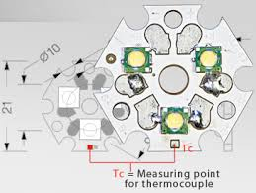

Figure 9: Manufacturer's designation of the Temperature Measurement Point

Theoretical basis behind testing

Lumen maintenance model

Based on the collective research from many manufacturers and research laboratories a mathematical (exponential) model has been developed which describes the lumen depreciation of an LED light source. It is:

$$Φ\left(t\right)=B\exp^{-αt}$$

where: $t$ = operating time in hours

$Φ\left(t\right)$ = luminous flux output at time t

$B$ = initial luminous flux output

$α$ = decay rate constant (i.e. luminous depreciation rate constant)

As stated earlier, since physical testing of products until they reach the target lumen maintenance level is impractical, an alternative test method is required to provide confidence/assurance of a product’s in-service life. The alternative test method developed and published by the Illuminating Engineering Society of North America (IESNA) entails the acquisition of test data for a product (generally an LED package or module) over a relatively short period of time, typically at least 6,000 hours (for various operating conditions) to establish a light output performance profile that can then be used to predict (based on the physics of LEDs) with a level of confidence the typical mean value for that product’s lumen maintenance. This information can then be applied to derive the predicted lumen maintenance of the package or module once installed in a luminaire.

This theory and test methodology are provided in the following sections.

Determining the lumen depreciation rate by data interpolation

Where two identical LED package/modules are operated at the same drive current but installed in different luminaires which have quite different thermal pathways for LED package/module heat dissipation, the stabilised operating temperature of the two modules will be quite different. **The LED module/package with the higher stabilised temperature has a shorter L70.** So, under laboratory conditions, where many samples of the same LED package/module are operated at the same drive current but subgroups of the samples are maintained at a minimum of two different (normally a maximum and a typical low) controlled temperatures (in environment chambers), a lumen depreciation vs temperature profile can be established for an LED package/module for that particular drive current, Figure 10. Note that the initial light output will be lower for the higher temperatures so the lumen depreciation vs temperature profile is typically illustrated using normalised “relative luminous flux output” graphs.

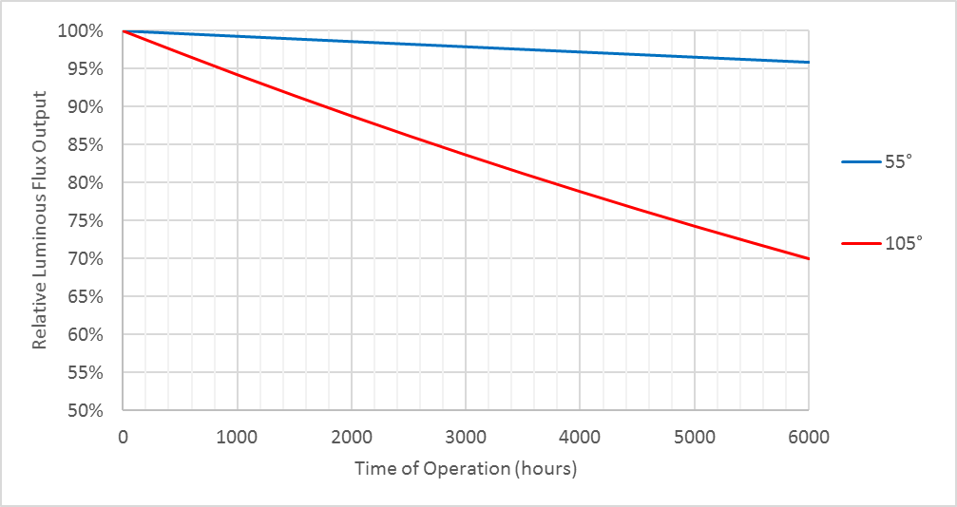

Figure 10: Measured LED lumen depreciation rates for LED module at different operating temperatures but same drive current

These exponential curves are the result of the quantum physics of p-n junctions (which is the basis of an LED) and the in-situ decay rate constant of the exponential function can be mathematically represented by what is known as the Arrhenius Equation.

$$α=A exp\left(\frac{-E_{a}}{k_{B}T_{s}}\right)$$

Where $α$ = in-situ decay rate constant

$A$ = pre-exponential factor

$E_{a}$ = activation energy (in eV)

$k_{B}$ = Boltzmann’s constant (8.6173x10-5 eV/K)

= in-situ temperature (K)

Therefore, by obtaining the lumen depreciation vs temperature profile of an LED package/module, knowing this fundamental equation and solving for the constants of the equation, means that the lumen depreciation rate for any operating temperature of this particular LED package/module within these bounding two temperatures can be interpolated (for the same operating current), Figure 11.

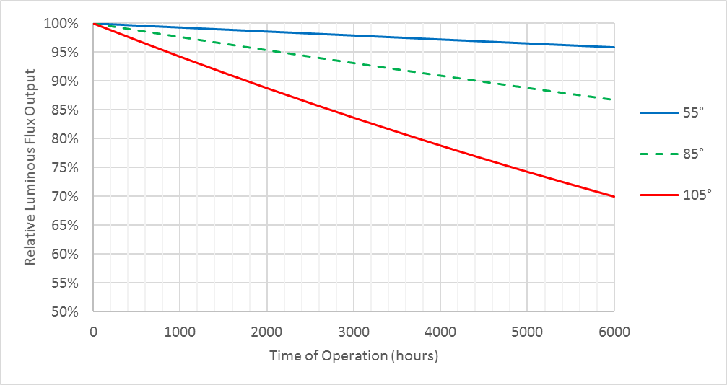

Figure 11: Predicting the LED depreciation rate for LED module at same drive current but different operating temperature

In this example, the operating temperature measured at the temperature measurement point was 85°

Determining the lumen maintenance by data extrapolation

A methodology for predicting the lumen depreciation of LED products has been developed based on the mathematical extrapolation of measured lumen depreciation data from multiple samples of an LED package/module for a minimum duration of 6000h. Due to the statistical genesis of the model and the typical spread in product performance, extrapolation for the purposes of a claimed lumen maintenance value is not permitted beyond 6 times the test duration for a sample set of 20 units of the LED package/module, Figure 12.

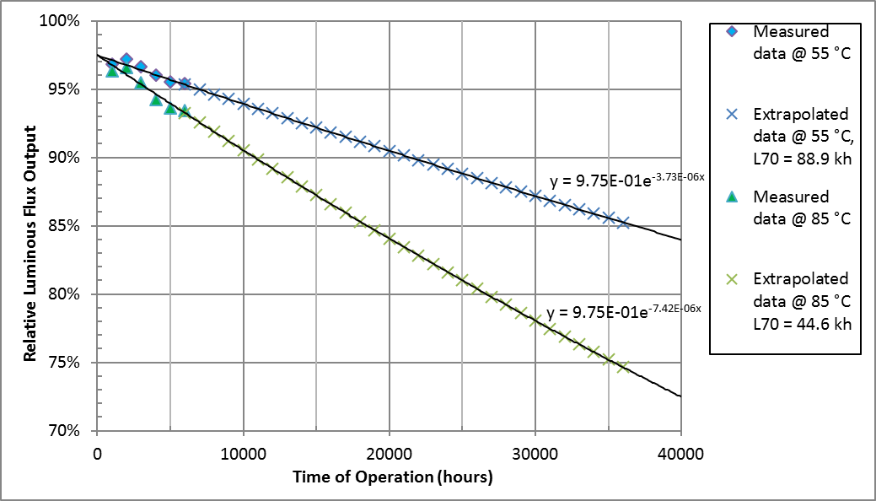

Figure 12: Determining the lumen maintenance (L70) of LED module at fixed drive current by extrapolation

If the LED package/module is operated at the same drive current but a different temperature that is within the lumen depreciation vs temperature profile, then the lumen depreciation curve can be interpolated from the data of the bounding curves, Figure 13.

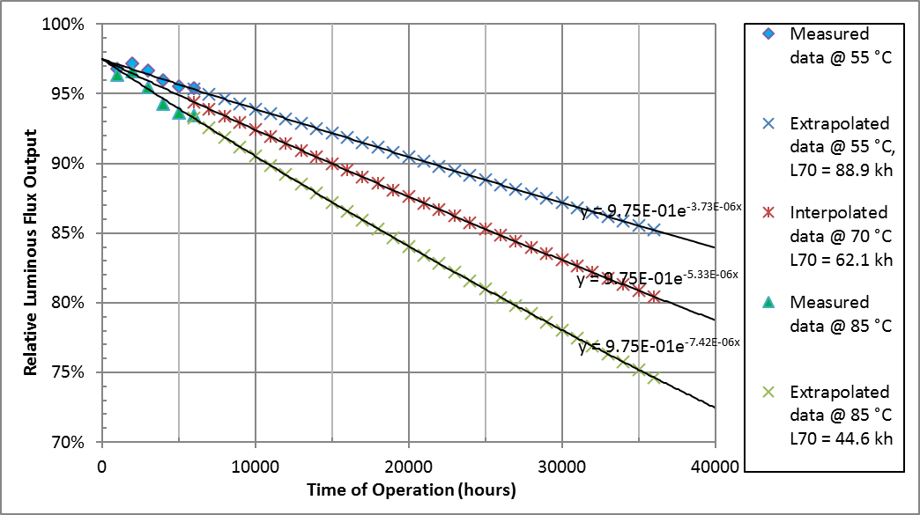

Figure 13: Determining the lumen maintenance (L70) of LED module at a different operating temperature but same drive current

Test Methods and Analysis

When a manufacturer develops an LED luminaire incorporating an LED package/module, they can determine the lumen maintenance of the luminaire by one of three methods.

1. **In-situ Temperature Measurement Test (ISTMT) where a relevant LM-80 Test Report for LED package/module exists.**
   * Conducting an in-situ temperature measurement test (at the designated measurement point) and having available a lumen depreciation vs temperature profile of the LED package/module (i.e. LM-80 Test Report supplied by manufacturer) where the in-situ temperature and drive current of the *LED/package module in the luminaire* are both less than the maximum values reported in this LM-80 Test Report.
   * This is a relatively short test of a couple of hours.
   * The method for projecting lumen maintenance is provided in TM-21.
   * Eligibility of method

| From LED luminaire | Use of LM-80 report and TM-21 projection | |
| --- | --- | --- |
|  | Criteria | Action |
| LED drive current, ILED | < ILED max | Refer to results for first ILED that is higher |
|  | > ILED max | Ineligible |
| Temperature at measurement point, Ts | < Ts min | Use Ts min results for projecting L70 |
|  | > Ts min  < Ts max | Interpolate according to TM-21 and use results for projecting L70 |
|  | > Ts max | Ineligible |

1. **LM-84 Test where a relevant LM-80 Test Report for LED package/module exists.**
   * Conducting a luminous flux maintenance measurement test for a minimum of 3000 but less than 6000 hours and having available a lumen depreciation vs temperature profiles for the LED package/module (i.e. LM-80 Test Report) where the in-situ temperature and drive current of the *LED/package module in the luminaire* are both less than the maximum values reported in this LM-80 Test Report.
   * This test takes approximately 4.5 - 8.5 months.
   * The method for projecting lumen maintenance is provided in TM-28.
   * Similar eligibility requirements as (1) above apply.
2. **LM-84 Test**
   * Conducting a luminous flux maintenance measurement test for a minimum of 6000 hours.
   * This test takes approximately 8.5 months.
   * The method for projecting lumen maintenance is provided in TM-28.

For all test methods, the LED package/module within the luminaire must be operating at below its recommended maximum operating temperature.

Conclusion

Test option (1) and to a lesser extent test option (2) provide convenient abbreviated methods for projecting the lumen maintenance of an assembled LED lamp or luminaire, by making use of more extensive testing that has already been conducted by the LED module/package manufacturer. This provides greater certainty on an LED product’s service life for retailers and consumers, without imposing significant delays upon the manufacturer / supplier of the LED product.

Annex

Examples of LED packages and LED modules where the temperature measurement point (TMP) is identified in the associated product design guide.

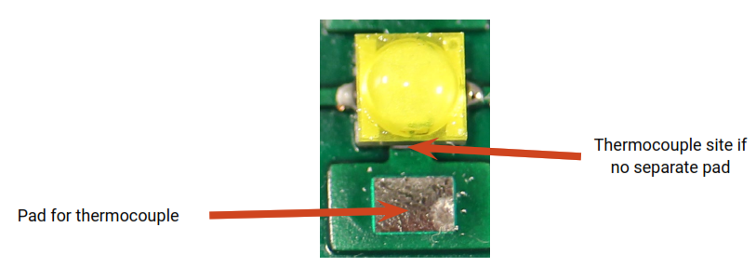

Figure 14: LED Package with TMP identified

(Source: XLampXBD_SH.pdf at [www.cree.com/xlamp](http://www.cree.com/xlamp))

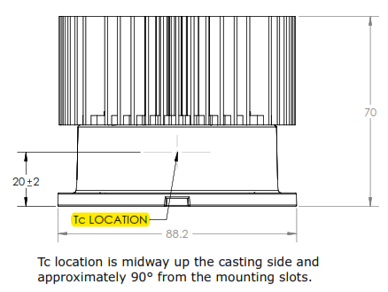

Figure 15: LED Module with TMP identified

(Source: LMH2DesignGuide.pdf at [www.cree.com/modules](http://www.cree.com/modules))

Attachment J: Draft Minimum Energy Performance Standards (MEPS) for LED Lighting

Contents

Scope 66

*All LED Product Categories* 67

*Non-directional LED lamps (table 1)* 67

*Directional LED lamps (table 1)* 67

*Linear LED lamps (table 1)* 68

*Integrated LED Luminaires (table 5)* 68

Scope Exclusions for LED Lamps and Integrated LED luminaires 69

Definition 69

Product Families for Registration 70

Performance requirements 72

Table 1: Lamps (note preferred test standards are highlighted) 72

Table 2: Proposed test methods and nominated parameters 87

Table 3: Proposed product package marking requirements 88

Table 4: Proposed test conditions 91

Table 5: Integrated LED luminaires 94

**Draft Minimum Energy Performance Standards (MEPS) for LED Lighting**

The draft MEPS has been developed in consultation with a technical working group of stakeholders from lighting and control supply, government programs and test laboratories, and was issued for stakeholder comment in July 2016 and November 2016 (as part of [Consultation Regulation Impact Statement (CRIS)).](http://www.energyrating.gov.au/consultation/consultation-ris-lighting)  Further revisions have been made after consideration of comments on the CRIS. The [Supplementary consultation document - Lighting: Updated policy positions](http://www.energyrating.gov.au/consultation) should be read in conjunction with this document.

**Scope**

Proposed to apply to the sale and commercial use of:

* LED Lamps: target to publish March 2018 to come into effect March 2019.

The proposed MEPS detailed in this document will form the basis of the Decision RIS for approval by governments (expected to be considered by Energy Ministers in November 2017). The E3 program requests stakeholders to consider the LED MEPS on lamps detailed below and provide specific feedback on any amendments required including rationale for change and alterative approach, with supporting evidence. The exposure draft of the LED MEPS determination will be released following approval of the DRIS.

* LED luminaires: As referred in the Supplementary consultation document, the GEMS Act will be reviewed to facilitate MEPS on LED luminaires. A separate CRIS (and subsequent Decision RIS) will be released prior to implementation.

Because of the staged approach, this version of the draft MEPS focuses on LED Lamps. The table providing details on the parameters and requirements for integrated luminaires has been moved to the end of the document to allow the reader to focus on the more immediate proposal for lamps.

The MEPS is intended to specify minimum performance levels for lighting efficacy and a number of other performance parameters important in ensuring LED lighting products provide an effective and efficient alternative to other less efficient lighting technologies (tables 1&5). Table 3 lists proposed package marking requirements. Where possible, the test requirements reference relevant international standards by the International Commission on Illumination (CIE), International Electrotechnical Commission (IEC), and regional standards such as the Illuminating Engineering Society of North America. The MEPS levels were originally derived from the International Energy Agency 4E Solid State Lighting Annex Product Quality and Performance Tiers (<http://ssl.iea-4e.org/>) but have been updated with more recent market data. Note that while product test data will be required for product registration, it is proposed that third party accredited testing will not be required. Where the use of module, LED package or driver test data is allowed, this must be from an accredited (but not necessarily third party) laboratory.

*All LED Product Categories*

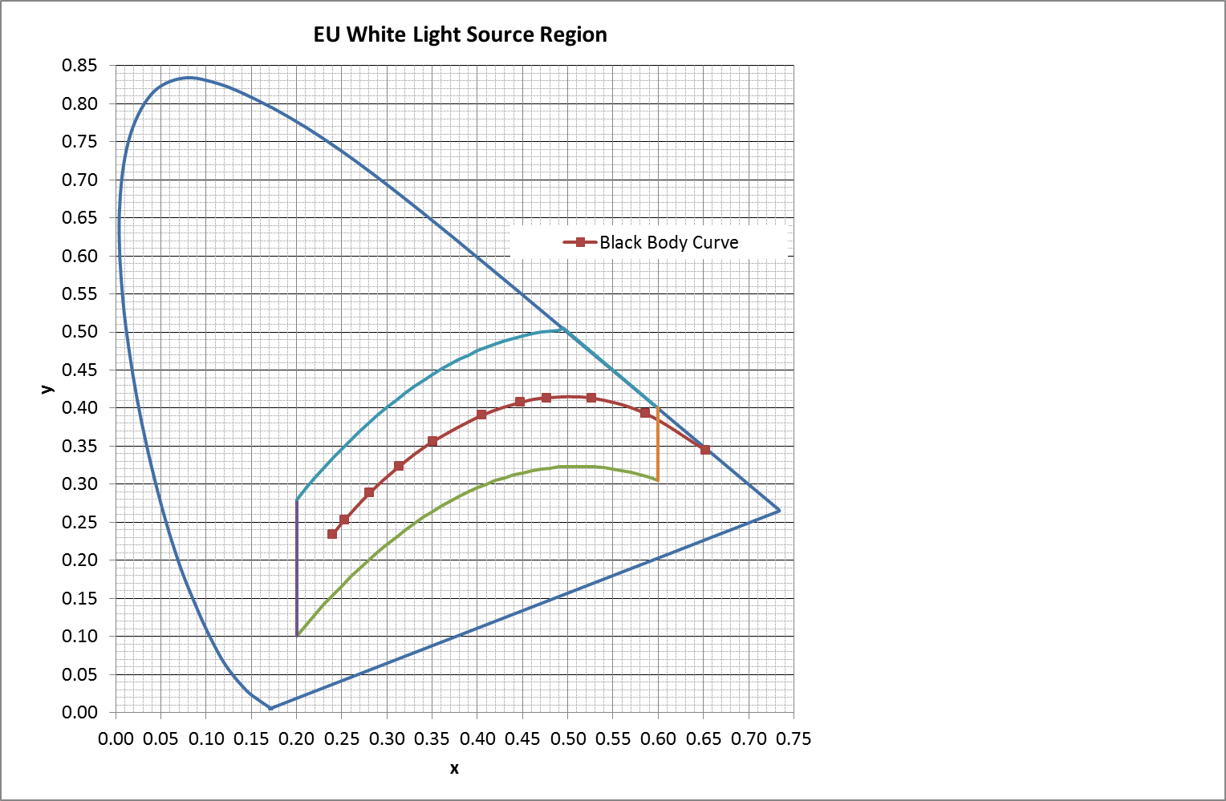As well as the specific scope below, this MEPS applies to lamps and luminaires capable of being tuned to within the specified white region in any mode of operation. This includes fixed white light sources as well as tuneable sources which are capable of being tuned to within the white region specified by the chromaticity coordinates (x and y) range:

* 0,2 < x < 0,6; and
* –2,3172 x² + 2,3653 x – 0,28 < y < – 2,3172 x² + 2,3653 x– 0,1.[13]

In the case of tuneable lamps and luminaires, compliance for photometric parameters will be based on testing at maximum light output (in case the lamps are also dimmable). Testing of tuneable products (for luminous flux, power, CRI and CCT) will be done with the product’s CCT adjusted through operation with software provided with products as sold and updated with latest available software versions. The testing shall include (A) the nominal CCT of 2700 K or the minimum CCT (whichever is higher) and (B) the nominal CCT of 4000K or the maximum CCT (whichever is lower) and for dimmable lamps, be conducted at maximum light output.

*Non-directional LED lamps (table 1)*

Lamps with LED light sources of all shapes with lamp caps B15, B22, E14, E27, E39, E40, GU5.3, GU10, GX10, GU24, GX53, G9 and ELV lamp bi-pin caps G4, that emit ≥ 100 lm.

*Directional LED lamps (table 1)*

Lamps with LED light sources of all shapes with lamp caps B15, B22, E14, E27, E39, E40, GU10, G9 and R7, and ELV lamp bi-pin caps GU5.3, GX5.3, G6.35, GX53, that emit ≥ 100 lm.

*Linear LED lamps (table 1)*

Linear LED lamps double-capped LED lamps including G5 and G13 caps, intended for replacing fluorescent lamps (as defined in IEC 60081) with the same caps (as defined in IEC 60081) or caps specific for double-capped linear LED lamps (related to IEC 60838-2-3) with a nominal length of 550 mm to 1500 mm.

For LED lamp models otherwise within scope which have low volume sales of up to (200) annual units, a simplified registration may be submitted, including supply of manufacturer’s datasheet, without demonstration of full compliance with MEPS. Import/production volumes to be provided annually for duration of registration. Where this upper sales limit is exceeded, the supplier may either withdraw the product from sale; or alternately both complete product testing and complete a full product registration (demonstrating compliance with MEPS).

*Integrated LED Luminaires (table 5)*

The scope for luminaires is yet to be finalised but is likely to include:

* Integrated LED luminaires with a luminous flux of ≥ 250 lm and < 1,500 lm. Note integrated includes a luminaire with remote control gear.
* Planar Luminaires, integrated battens & Troffers
* Large Luminaires (including High / Low Bay integrated Luminaires)

Where an integrated LED luminaire within scope is supplied with either an:

* integrated driver; or
* separate driver provided in the same package; or
* driver supplied in a separate package that is specifically marked to be used with the luminaire;

The integrated LED luminaire will be tested with the specific driver for the purpose of demonstrating compliance.

Where an integrated LED luminaire within scope is not supplied with a driver in one of the configurations specified in the paragraph above, the luminaire will be tested with a nominated driver that is representative of intended drivers for use in Australia with the LED luminaire. (One of the intended drivers for use in Australia and/or New Zealand will also be nominated for compliance testing purposes).

Decorative style integrated LED luminaires otherwise within scope (see definition below) which have low volume sales of up to {250} annual units, or other limited production run luminaires which have low volume sales of up to 75 annual units are not within scope. Where this upper sales limit is exceeded, the supplier may either withdraw the product from sale; or complete product testing and be able to demonstrate compliance with MEPS). Note - where decorative luminaires are designed with lamp holders rather than an integrated light source, any supplied lamp will be subject to MEPS (in a standard registration process) rather than the entire luminaire.

Scope Exclusions for LED Lamps and Integrated LED luminaires

* Theatrical luminaires as defined in AS/NZS 60598.2.17:2006
  + Lamps and luminaires compliant with cyanosis observation index and colour temperature requirements of AS/NZS 1680.2.5:1997 Interior lighting Part 2.5: Hospital and Medical tasks, with package marked ‘For Medical Use Only’.
* Light source products that are battery operated in their fundamental operating state including:
* Portable luminaires for garden use: AS/NZS 60598.2.7:2005 (R2016)
* Hand lamps as defined in AS/NZS 60598.2.8:2005
  + Portable (non-fixed) luminaires (e.g. desk lamps, standard lamps, Portable general purpose luminaires as defined in AS/NZS 60598.2.4:2005, and portable luminaires for children defined in AS/NZS 60598-2-10)
  + Rope lights and string lights (as defined in AS/NZS 60598.2.20:2002) or chain lights defined in IEC 60598-2-21 Rope lights as defined in DR AS/NZS 60598.2.21: (2017?)6 and lighting chains as defined in DR AS/NZS 60598.2.20: (2017?)6
* Non-maintained emergency escape lighting luminaires and illuminated emergency exit signs (as defined in AS/NZS 60598.2.22)
* Outdoor luminaires as defined in IEC 60598-2-5 with an ingress protection rating of IP65 and above
* Road and public space lighting luminaires (as defined in AS/NZS 1158.0).
  + Wall luminaires with up/down lighting of beam angles less than 30 degrees and less than 500lm in either direction (i.e. up or down)
  + Integrated luminaires incorporated into furniture as defined in IEC 60364-7-713 ED. 2.0 Low-voltage electrical installations Part 7-713: Requirements for special installations or locations - Furniture (but not exclude lamps imported with furniture)

Definition

***Light Emitting Diode (LED)***: a PN junction semiconductor device that, by spontaneous emission, emits incoherent optical radiation by injecting electrons and/or holes across the PN junction.

***Integrated LED Luminaire***

Luminaire that:

* satisfies Type A or Type B LED luminaires specified in the scope of IEC 62722.2.1; or
* uses individual LED packages in place of a LED module
* and does not include IEC standardised lamp holders

***Decorative style integrated LED luminaire***

Integrated LED luminaires which are primarily designed for their lighted as well as their unlighted appearance and aesthetic contribution to the space. Such luminaires are typically intended for use where a decorative accent or an aesthetic appearance, not a specified amount of luminaire light output, is desired. The light output of decorative luminaires is typically not intended to independently illuminate a space or a task. (Based on NEMA Lighting Systems Division & American Lighting Association Joint Document: LSD 51-2009)[14]

Note: a photometric quantification of this definition is under investigation for small (residential) decorative luminaires and large (non-residential) decorative luminaires.

Product Families for Registration

**LED Lamps**

(1) Two or more models (up to 75) from a single product class may be registered in the same family of models, when the models:

(a) Are of a single brand;

(b) Rely on the one test report (or the test report of the least efficient family member where (e) applies) that sets out the results of testing conducted in accordance with the Determination;

(c) Have the same physical characteristics that are relevant to complying with the Determination, including, but not limited to, the following: overall size, geometric form factor; and any other dimensions, components or component arrangements that may affect performance. However models within the same family may have different minor physical characteristics (that do not affect energy performance), for example:

* different lamp caps/ cap sizes (lamp size variations attributable to lamp cap variation permitted)
* shape of the outer glass or plastic lamp cover.
* colour or other surface variations to casing areas other than changes to the reflectivity or diffusers of the light emitting components of the product
* an application may include either clear lamps/diffusers and frosted/pearl;

(d) Have the same performance characteristics that are relevant to complying with minimum performance specifications set out in the Determination, including, but not limited to, the following:

(i) efficacy; and

(ii) wattage.

(iii) voltage

(e) Despite paragraph (d), models in the same family may have different luminous flux or efficacy where the difference arises as a result of different colour temperatures, colour rendering index, beam angles or ability to dim. In such cases:

(i) test results for registration purposes will only be required for the model with the lowest energy efficiency in the proposed family; and

(ii) all models in the family must have the same performance characteristics relevant to complying with the specified minimum performance requirements other than efficacy, colour temperature, colour rendering index, diffuser, and beam angle.

(iii) Wattage variations are permitted within 50% variation from nominated least efficient model

(2) For subsection (1), a model cannot be a member of a family if its inclusion in that family would lead to the family consisting of more than 75 lamp models.

(a) Within this limit, additional models may be later added to families at a reduced cost. Where additional models are updates of previous models with updated module or drivers, provided the physical characteristics are the same (as required by paragraph (1)(c)) these models may consume less power (due to more efficient components).

**Performance requirements**

**Table 1: Lamps (note preferred test standards are highlighted)[15]**

|  | Attribute | Requirement | | | | Sample size | Compliance criteria | Test method |
| --- | --- | --- | --- | --- | --- | --- | --- | --- |
| Ref | Non-directional lamps | | Directional lamps | Linear LED (tube) |
|  | Energy Efficiency & Photometric | | | | | | | |
| 1 | Efficacy | ≥ 80 lm/W (2019)  ≥ 90 lm/W (2021)  ≥ 100 lm/W (2023)    Reductions for   1. Directional (10%) 2. Beam Angle < 30º (10%) 3. 90 ≤ CRI < 100 (10%) 4. CCT ≤ 3000K (10%)   The reductions will be cumulative. | | | ≥ 100 lm/W (2019)  ≥ 110 lm/W (2021)  ≥ 120 lm/W (2023) | 10 | Average ≥ value specified | CIE S025  or  LM79 accepted until July 2021  or  EN 13032-4:2015  Where a lamp model is provided with interchangeable/adjustable reflectors or lenses, the test will use the configuration that delivers the narrowest beam angle  Power to be tested as supplied for sale (additional functionality may be supplied not activated). |
| 4 | Light distribution | ONLY IF CLAIMING to be an ‘omnidirectional’ lamp or replacement for a General Lighting Service (GLS) lamp.  Omnidirectional equivalence  No less than 5% of total flux (zonal lumens) shall be emitted in the 130° to 180° zone.  No less than 35% of total flux (zonal lumens) shall be emitted in the 90° to 180° zone. | Beam angle is ± 25% of declared beam angle  and  50% of flux shall be in declared beam angle | | Beam angle is ± 25% of declared beam angle  and  50% of flux shall be in declared beam angle | 10  3 (Linear LED) | No less than 8 lamps (or 3 for linear LED lamps) meet the specified requirements | CIE S025  or  LM79 accepted until July 2021  or  EN 13032-4:2015 |
| 3 | Centre beam luminous intensity | N/A | | For MR or PAR lamps with a beam angle <65°, centre beam intensity should meet equivalent levels using the online tool: <http://www.energystar.gov/ia/products/lighting/iledl/IntLampCenterBeamTool.zip>  For others lamps: ONLY IF CLAIMING  Centre beam luminous intensity ≥ declared value | N/A | 10 | For MR or PAR lamps:  Average ≥ equivalent level  For other lamps:  Average ≥ declared value | CIE S025  or  LM79 accepted until July 2021  or  EN 13032-4:2015 |
| 20 | Maximum high angle Luminance | N/A | | | When the gamma (ɣ) angle exceeds 60 degrees, the light source luminance is no more than 10,000 candela/m2 in C0, C45 and C90 planes | 3 | All lamps satisfy requirements | CIE S025  or  LM79 accepted until July 2021  or  EN 13032-4:2015 |
|  | Colour | | | | | | | |
| 7 | Colour Rendering | Ra ≥ 80 | | | | 10 | Average ≥ value specified | CIE S025 (refers to CIE 13.3)  or  LM79 accepted until July 2021  or  EN 13032-4:2015 |
| 8 | Colour Appearance | Lamp must have one of the following nominal CCTs consistent with the 7-step chromaticity quadrangles and Duv tolerances below.[16]  Th 7-step chromaticity quadrangles range from 2200 to 6500 Kelvin | | | | 10 | All samples shall have Chromaticity values that fall into the rated nominal CCT quadrangle | CIE S025 (refers to CIE S015)  or  LM79 accepted until July 2021  or  EN 13032-4:2015 |
|  | Life | | | | | | | |
| 10 | Endurance | Must survive one switching cycle for every 2 hours of rated life  Must survive temperature cycling test for 1,000 hours  Must survive accelerated operational life test for 1,000 hours | | | | 10 | Satisfy conditions of the test method. | IEC 62612: 2013 Section 11.3.2-4 |
| 11 | Lumen maintenance | Lumen maintenance @ 6000 hrs  Lx,6k ≥ 86.7%  (based on L70B50 ≥ 15,000h)  LED Module or LED package test data (from an accredited lab) may be used, combined with ISTMT junction temperature test of lamp to be registered.[17] | | | Lumen maintenance @ 6,000h  Lx,6k ≥ 91.8%  (based on  L70B50 ≥ 25,000h) | 10 | Average Lx,6k ≥ value specified  Compliance testing may be an ISTMT junction temperature test relating to module/package test report or a full product test. | IESNA LM80/TM21 &  ISTMT (IEC 60598.1 Section 12.4.1 or UL 1598 Clause 14)  or  IESNA LM84/TM28  Note these test methods relate to luminaires. A test “housing” (i.e. representative luminaire) for lamps may be required. Consider allowing use of thermal imaging camera for determining the hotspot for thermocouple attachment points. |
|  | Electrical | | | | | | | |
| 14 | Fundamental Power Factor | Image is a table of recommended values for displacement factor, for several ranges of 'P'.  PF > 0.90 | | | | 10  3 (Linear LED) | Average power factor ≥ value specified | IEC 61000-3-2 (2014)  Test data may be sourced from control gear manufacturer if available |
| 15 | Harmonics | For products 5W < P ≤ 25W: *{text here is pending final approval of amendment to 61000-3-2}*  One of the following three requirements:   1. the harmonic currents shall not exceed the power-related limits of Table 3, column 2,   Table of power-related limits for harmonic currentsor:     1. the third harmonic current, expressed as a percentage of the fundamental current, shall not exceed 86 % and the fifth harmonic current shall not exceed 61 %. Also, the waveform of the input current shall be such that it reaches the 5 % current threshold before or at 60º, has its peak value before or at 65º and does not fall below the 5 % current threshold before 90º, referenced to any zero crossing of the fundamental supply voltage. The current threshold is 5 % of the highest absolute peak value that occurs in the measurement window, and the phase angle measurements are made on the cycle that includes this absolute peak value (see Figure 2). Components of current with frequencies above 9 kHz shall not influence this evaluation. or:      1. the THD shall not exceed 70%. The third order harmonic, expressed as a percentage of the fundamental current, shall not exceed 35%, the fifth order shall not exceed 25%, the seventh order shall not exceed 30%, the ninth and eleventh order shall not exceed 20% and the second order shall not exceed 5%.   If the lighting equipment includes means for control (e.g. dimming, colour), or is specified to drive multiple loads, then the measurement is made only at the control setting and the load of lamps that gives the maximum active input power.  NOTE The preceding requirement is based on the assumption that, for lighting equipment using control other than phase control, the THC decreases when the input power is reduced.  For lighting equipment containing a control module with an active input power ≤ 2 W, the contribution of the control module to the harmonic current of the lighting equipment is disregarded e.g. by testing the equipment with control module fed by a separate mains supply.  For products >25W[18]:  Maximum Permissable Harmonic Current For Products >25W for harmonic orders from N=2  *{text below is pending final approval of amendment to 61000-3-2}*  For the other types of lighting equipment that includes means for control (e.g. dimming, colour), the following conditions apply:   1. the harmonic current values for the maximum active input power condition derived from the percentage limits given in Table 2 shall not be exceeded; 2. at control settings leading to an active input power less than the maximum input power condition, the harmonic currents shall not exceed the limits based on the maximum active input power of:    * below 50W: no limits below 5 W;    * 50 W - 250 W: no limits below 10% of maximum active input power;    * above 250 W: no limits below 25 W. | | | | 1 | Comply with the requirements of IEC61000-3-2 | IEC 61000-4-7  Test data may be sourced from control gear manufacturer if available |
|  | Health | | | | | | | |
| 18 | Photo-biological Safety | Blue Light & UV hazards shall be either RG0 or RG1 unlimited[19][20]  (UV hazard test not required if the light source does not contain a UV LED chip) | | | | 1 | Satisfy conditions of the test method. | IEC 62471 / CIE S009 |
| 19 | Dominant light modulation frequency (f) Modulation percent at this frequency (Mod%)[21]  (Includes Flicker effects) | Maximum flicker modulation at the dominant modulation frequency[22] < 30% | | | | 1 | Satisfy conditions of the test method. | IEEE 1789  or  other if specified in Determination. |
|  | Smart Lamps ONLY - Energy conservation | | | | | | | |
| 5 | Standby Power (For lamps with Standby mode only) | PSTANDBY/PON ≤ 5%  Capped at: < 0.5W  < 0.3W (2023)  (When tested with the latest firmware updates) | | | | 5  3 (Linear LED) | Average ≥ value specified  To be tested as supplied for sale (additional functionality may be supplied not activated). See also smart lamp criteria. | AS/NZS IEC 62301  (or IEA 4E SSL Task 7 2016 publication http://ssl.iea-4e.org/news/stand-by-of-smart-lamps)[23] |
| 6 | Smart Lighting:  on-demand power consumption feature  (smart lamps only) | Device to provide energy consumption reporting that is accessible by owner.  Further revisions may follow outcomes of investigations by the IEA 4E SSL and G20 working groups. | | | | 1 | Require device to provide energy consumption reporting that is accessible by owner | Energy Star Lamps v2 Section 12.9 |
|  | Declaration | | | | | | | |
| 12 | Rated Life Declaration  (relates to packaging requirement) | Packaging declaration of a minimum lifetime of 15,000 hours | | | Packaging declaration of a minimum lifetime of 25,000 hours | N/A | Declaration Only | N/A |
| 17 | ELV converter compatibility  (For ELV Lamps only) | In combination with ELV converter shall operate in a stable manner without observable flicker or light fluctuation. Suppliers do not need to submit tests for registration. [24] Also the manufacturer shall:   1. declare which ELV conditions (e.g. minimum/maximum number of lamps connected to ELVC) under which the lamp will operate 2. provide a webpage address that lists compatible ELV converter makes and models including ELVCs available in the local market. | | | N/A | 3 lamps  3 ELVCs | All lamp/ELVC combinations where compatibility claimed satisfy conditions of the test method. | To be developed  To include tests for flicker (IEEE 1789 or other).  Suppliers do not need to submit tests for registration[25]. Compliance may test. |
| 16 | Dimmer compatibility (Phase cut dimmers only)[26] | Lamp dims smoothly to 30% of light output with no observable flicker. When dimmer is set to 100%, light output ≥ 90% of lamp without dimmer. For dimmable products, the lamp manufacturer shall:     1. declare the conditions under which the lamp will dim 2. declare which conditions (e.g. minimum/maximum number of lamps connected to dimmer) under which the lamp will operate; 3. provide a webpage address that lists compatible dimmer makes and models including (for ELV lamps) compatible makes and models of ELVCs available in the local market; and 4. for each compatible dimmer, the number of lamps that can be dimmed and the range of luminous flux levels a given dimmer-lamp combination can achieve. 5. The webpage may also specify where the Lamp has been tested and meets the requirements of IEC/TR 63037 Ed. 1.0   Note. Condition applies to Lamp | | | N/A | 3 lamps  2 dimmers  (1 ELVC model if required) | All lamp/dimmer/(ELVC, if required) combinations where compatibility claimed satisfy conditions of the test method. | To be developed [27]  To include tests for inrush current[28], maximum cycle current, 30% dim and flicker (IEEE 1789 or other).  Suppliers do not need to submit tests for registration. Compliance may test. |
|  | Claims | | | | | | | |
| 2 | Replacement Lamp Equivalence | ONLY IF CLAIMING  (1) Minimum Lumen output required when claiming equivalence to a specified GLS Tungsten Filament or halogen lamp[29]   |  |  |  | | --- | --- | --- | | Replace  GLS Tungsten Filament | Replace  GLS Halogen | Required  GLS LED in lumens | | 10 W | 7 W | 100 lm | | 15 W | 10 W | 150 lm | | 25 W | 18 W | 250 lm | | 30 W | 21 W | 350 lm | | 40 W | 28 W | 500 lm | | 60 W | 42 W | 800 lm | | 75 W | 52 W | 1000 lm | | 100 W | 70 W | 1500 lm | | 125 W | 88 W | 2000 lm | | 150 W | 105 W | 2500 lm | | 175 W | 123 W | 3000 lm | | 200 W | 140 W | 3500 lm |   (2) Dimensions of the lamp must comply with equivalent lamp’s requirements in the relevant IEC lamp performance specification Standard | | ONLY IF CLAIMING  (1) Minimum lumen output (as a percentage of GLS lamp equivalences of same wattage) required for claimed equivalent wattage reflector filament lamps of stated lamp shapes[30]   |  |  | | --- | --- | | MR11 | 80% | | MR16 | 80% | | AR-111 | 70% | | R | 45% | | PAR | 60% | | R7 (forward lumens) | 55% |   (use linear interpolation between GLS wattage values listed)  (2) Dimensions of the lamp must comply with equivalent lamp’s requirements in the relevant IEC lamp performance specification Standard | ONLY IF CLAIMING  (1) Minimum lumen output required for claimed equivalence to linear fluorescent lamp.  Bare lamp[31]  L ≤ 600mm: 800 lm    *600 < L ≤ 900mm: 1200 lm  900 < L ≤ 1200mm:1600 lm  *1200 < L ≤ 1500mm:2000 lm  [Based on Design Lights Consortium DLC requirements with * extension]  (2) Dimensions of the lamp must comply with equivalent lamp’s requirements in the relevant IEC lamp performance specification Standard | 10  3 (Linear LED) | (1) Average Luminous flux ≥ the specified minimum light output (lm) of the claimed Equivalent wattage  (2) Dimensions comply with Clause 6 of:  IEC 60630 Ed. 2.5 b:2005  “Maximum lamp outlines for incandescent lamps”  Dimensions comply with Clause 1.5.3 of: IEC 60081 Ed. 5.1 b:2002  “Double-capped fluorescent lamps - Performance specifications | CIE S025  or  LM79 accepted until July 2021  or  EN 13032-4:2015 |
| 4 | Light distribution | ONLY IF CLAIMING to be an ‘omnidirectional’ lamp or replacement for a General Lighting Service (GLS) lamp.  Omnidirectional equivalence  No less than 5% of total flux (zonal lumens) shall be emitted in the 130° to 180° zone.  No less than 35% of total flux (zonal lumens) shall be emitted in the 90° to 180° zone. | N/A | | N/A | 10  3 (Linear LED) | No less than 8 lamps (or 3 for linear LED lamps) meet the specified requirements | CIE S025  or  LM79 accepted until July 2021  or  EN 13032-4:2015 |

**Table 2: Proposed test methods and nominated parameters**

| Ref | Test method | Attribute |
| --- | --- | --- |
| 1 | CIE S025  (or  LM79 accepted until July 2021  or  EN 13032-4:2015)  (All refer to CIE S015 & CIE 13.3 for colour measurements) | * Luminous flux * Power * Efficacy * Colour Appearance (CCT, x, y) * Colour Rendering (CRI) * Centre beam luminous intensity (directional lamps only) * Beam Angle (directional lamps only) |
| 2 | 1. IEC 62612: 2013, Section 11.3: Lamps 2. IEC 62717: 2014, Section 10.3: Modules 3. IEC 62722.2.1: 2011, Section 10.3.2-4: Luminaires | Endurance   * Switching cycles test * Temperature cycling test * Accelerated operational life test |
| 3 | IESNA LM80/TM21  &  ISTMT (to IEC 60598.1 Section 12.4.1 or UL 1598 Clause 14)  (or IESNA LM84/TM28) | * Lumen maintenance |
| 4 | IEC 61000-3-2 (2014) | * Power Factor |
| 5 | IEC 61000-4-7 | * Harmonics |
| 6 | IEC 62471/CIE S009 | * Photo biological Safety |
| 7 | IEEE 1789 | * Flicker |
| 8 | AS/NZS IEC 62301  (or IEA 4E SSL Task 7 2016 publication) | * Standby Power (smart lamps only) |
| 9 | Energy Star Lamps v2, Section 12.9 | * Smart Lighting – controlled variations in power consumption (smart lamps only) |
| 10 | To be developed | * Dimmer compatibility |
| 11 | To be developed | * ELV converter compatibility |

**Table 3: Proposed product package marking requirements[32][33]**

| **Ref** | **Attribute** | **Product** | **Package** | **Spec Sheet /website** | **Marked Value Criterion** |
| --- | --- | --- | --- | --- | --- |
| 1 | Lumens | X | X | X | Non-directional LED lamps:  The rated luminous flux should preferably[34] be one of the following values: 100 lm, 150 lm, 250 lm, 350 lm, 500 lm, 800 lm, 1000 lm, 1500 lm, 2000 lm, 3000 lm.[35]  The initial luminous flux of each individual LED lamp in the measured sample shall not be ~~less than the rated luminous flux by more than 10 %, and not be~~ [36]more than the rated luminous flux by more than 10% unless, if the rated value is one of the preferred values listed above, then 20%.  The average initial luminous flux of the LED lamps in the measured sample shall not be less than the rated luminous flux by more than 7.5 %.   Directional lamps:  The initial luminous flux of each individual LED lamp/luminaire in the measured sample shall not be less than the rated luminous flux by more than 10 % and not be more than the rated luminous flux by more than 10%. The average initial luminous flux of the LED lamps in the measured sample shall not be less than the rated luminous flux by more than 7.5 %.   Luminaires:  The initial luminous flux of each individual LED luminaire sample shall not be less than the rated luminous flux by more than 10 % and not be more than the rated luminous flux by more than 10%. |
| 2 | Efficacy (lumens per Watt) |  | X | X | The initial efficacy of each individual LED lamp or luminaire in the measured sample shall be no less than the rated efficacy by more than 10 %.  The average efficacy of the LED lamps in the measured sample shall be no less than the rated efficacy by more than 7.5 %. |
| 3 | Watts (must be in a smaller font than lumens on package) | X | X | X | The initial power consumed by each individual LED lamp in the measured sample shall not exceed the rated power by more than 10 %. |
| 4 | Replacement Lamp Equivalence (directional and non-directional lamps) |  | X | X | Statement of equivalence to a filament lamp (if claim made). Minimum lumen output required when claiming as specified in Table 1 above. |
| 5 | Rated Lifetime |  | X | X | Must be equal or above the specified minimum rated life. May include a qualification for lifetime if used in enclosed luminaires. |
| 6 | Correlated colour temperature | X | X | X |  |
| 7 | CRI |  |  | X | Must be greater than rated CRI - 3. |
| 8 | Beam Angle (for directional lamps & small luminaires) | X | X | X |  |
| 9 | Dimmable | X | X | X |  |
| 10 | Dimmer compatibility information and web link |  | X | X | If claim made that product is dimmable |
| 11 | ELVC converter compatibility information and web link |  | X | X | For ELV products only |
| 12 | Ballast compatibility information and web link (for Linear LED lamps) |  | X | X |  |
| 13 | Website link for disposal information |  | X | X |  |
| 14 | Standby energy use |  | X | X | Only for products with a standby mode |
| 15 | Photo biological Safety |  |  | X | Blue light and UV risk categories. Spec sheet/website only required if above RG0. |
| 16 | Product identification number/code as used for product registration |  | X | X |  |

**Table 4: Proposed test conditions**

| Ref | Attribute | Test method |
| --- | --- | --- |
| 1 | Efficacy | CIE S025  or  LM79 accepted until July 2021  or  EN 13032-4:2015 |
| 2 | Replacement Lamp Equivalence | CIE S025  or  LM79 accepted until July 2021  or  EN 13032-4:2015 |
| 3 | Standby Power (smart lamps only) | AS/NZS IEC 62301  (or IEA 4E SSL Task 7 2016 publication) |
| 4 | Smart Lighting – controlled variations in power consumption  (smart lamps only) | Energy Star Lamps v2 Section 12.9 |
| 5 | Colour Appearance | CIE S025  or  LM79 accepted until July 2021  or  EN 13032-4:2015  (All refer to CIE S015) |
| 6 | Colour Rendering | CIE S025  or  LM79 accepted until July 2021  or  EN 13032-4:2015  (All refer to CIE 13.3) |
| 7 | Lumen maintenance | IESNA LM80/TM21  &  ISTMT (IEC 60598.1 Section 12.4.1 or UL 1598 Clause 14)  Or  IESNA LM84/TM28 |
| 8 | Power Factor | IEC 61000-3-2 (2014) |
| 9 | Harmonics | IEC 61000-4-7 |
| 10 | Dimmer compatibility | To be developed |
| 11 | ELV converter compatibility | To be developed |
| 12 | Photo biological Safety | IEC 62471/CIE S009 |
| 13 | Endurance  Lamps  Modules/packages  Luminaires | IEC 62612: 2013  or  IEC 62717: 2014  or  IEC 62722.2.1: 2011 |
| 14 | Flicker | IEEE 1789 |
| 15 | Centre beam luminous intensity (directional lamps only) | CIE S025  or  LM79 accepted until July 2021  or  EN 13032-4:2015 |
| 16 | Beam Angle | CIE S025  or  LM79 accepted until July 2021  or  EN 13032-4:2015 |

**Table 5: Integrated LED luminaires[37][38]**

|  | Attribute | Requirement | | | | | | Sample size | Compliance criteria | Test method |
| --- | --- | --- | --- | --- | --- | --- | --- | --- | --- | --- |
| Ref | Small | | Large | | | Planar, Battens & Troffers (P/B/T) |
|  | Energy Efficiency & Photometric | | | | | | | | | |
| 1 | Efficacy [39] | Directional ≥ 85 lm/W (2020) ≥100 lm/W (2023)  Non-Directional  ≥ 85 lm/W (2021)  ≥100 lm/W (2023)  Reductions for  (a) 90 ≤ CRI < 100 (10%)  (b) CCT ≤ 3000K (10%)  (c) Beam angles ≤ 30° (10%)  (d) Glare control (Antiglare) 20%  Note: Antiglare is where the luminous intensity 60 degrees and above in gamma angle is less than 5% of the peak intensity of the luminaire  The reductions will be cumulative. | | ≥ 110 lm/W (2020)  ≥ 120 lm/W (2023)  Increase for  (a) 70 ≤ CRI < 80 (10%) | | ≥ 110 lm/W (2021) ≥ 120 lm/W (2023) | | 1[40] | ≥ value specified | CIE S025  or  LM79 accepted until July 2021  or  EN 13032-4:2015  Where a small luminaire model is provided with interchangeable/adjustable reflectors or lenses, the test will use the configuration that delivers the narrowest beam angle.  Tool-less removable shrouds will not be included in test  Power to be tested as supplied for sale (additional functionality may be supplied not activated). |
| 4 | Light distribution | ONLY for Directional luminaires:  Beam angle is:  ± 25% of declared beam angle  and  50% of flux shall be in declared beam angle | | None provided | | | | 1 | All samples meet the specified requirements | CIE S025  or  LM79 accepted until July 2021  or  EN 13032-4:2015 |
|  | Colour | | | | | | | | | |
| 7 | Colour Rendering | Ra ≥80 | | | Ra ≥70 | | Ra ≥80 | 1 | ≥ value specified | CIE S025 (refers to CIE 13.3) |
| 8 | Colour Appearance | Lamp must have one of the following nominal CCTs consistent with the 7-step chromaticity quadrangles and Duv tolerances below.[41]  The 7-step chromaticity quadrangles range from 2200 to 6500 Kelvin | | | | | | 1 | Chromaticity co-ordinates fall into the rated nominal CCT quadrangle | CIE S025 (refers to CIE S015) |
|  | Life | | | | | | | | | |
| 10 | Endurance | Must survive one switching cycle for every 1 hours of rated life[42]  Must survive temperature cycling test for 1,000 hours  Must survive accelerated operational life test for 1,000 hours | | | | | | 3 (Small)  1 (Large & P/B/T) | Satisfy conditions of the test method. | IEC 62722.2.1: 2011 Section 10.3.2-4  Test data from module and driver accepted (IEC 62717 Section 10.3) |
| 11 | Lumen maintenance | Lumen maintenance @ 6,000h  Lx,6k ≥ 93.1%  (based on  L70B50 ≥ 30,000h)  Module or LED package test data (from an accredited lab) may be used, combined with ISTMT junction temperature test of lamp to be registered. | | Lumen maintenance @ 6,000h (Lx,6k)  ≥ 95.4% of initial  (based on L70B50 ≥ 45,000h)  Module or LED package test data (from an accredited lab) may be used, combined with ISTMT junction temperature test of lamp to be registered. | | | | 3 (small)  1 (Large & P/B/T) | Average Lx,6k ≥ value specified  Compliance testing may be an ISTMT junction temperature test and relevant module/package test report or a full product test. | IESNA LM80/TM21 &  ISTMT (IEC 60598.1 Section 12.4.1 or UL 1598 Clause 14)  or  IESNA LM84/TM28  Note testing of small luminaires may require consideration of insulation requirement. Consider allowing use of thermal imaging camera to ascertain hottest point. |
|  | Electrical | | | | | | | | | |
| 14 | Fundamental Power Factor | Image is a table of recommended values for displacement factor, for several ranges of 'P'. | | | | | | 1 | ≥ value specified | IEC 61000-3-2 (2014)  Test data may be sourced from control gear manufacturer |
| 15 | Harmonics | For products 5W < P ≤ 25W:  *{text here is pending final approval of amendment to 61000-3-2}*  One of the following three requirements:   1. the harmonic currents shall not exceed the power-related limits of Table 3, column 2,   Table of power-related limits for harmonic currentsor:     1. the third harmonic current, expressed as a percentage of the fundamental current, shall not exceed 86 % and the fifth harmonic current shall not exceed 61 %. Also, the waveform of the input current shall be such that it reaches the 5 % current threshold before or at 60º, has its peak value before or at 65º and does not fall below the 5 % current threshold before 90º, referenced to any zero crossing of the fundamental supply voltage. The current threshold is 5 % of the highest absolute peak value that occurs in the measurement window, and the phase angle measurements are made on the cycle that includes this absolute peak value (see Figure 2). Components of current with frequencies above 9 kHz shall not influence this evaluation. or:    1. the THD shall not exceed 70%. The third order harmonic, expressed as a percentage of the fundamental current, shall not exceed 35%, the fifth order shall not exceed 25%, the seventh order shall not exceed 30%, the ninth and eleventh order shall not exceed 20% and the second order shall not exceed 5%.   If the lighting equipment includes means for control (e.g. dimming, colour), or is specified to drive multiple loads, then the measurement is made only at the control setting and the load of lamps that gives the maximum active input power.  NOTE The preceding requirement is based on the assumption that, for lighting equipment using control other than phase control, the THC decreases when the input power is reduced.  For lighting equipment containing a control module with an active input power ≤ 2 W, the contribution of the control module to the harmonic current of the lighting equipment is disregarded e.g. by testing the equipment with control module fed by a separate mains supply.  For products >25W[43]:  Maximum Permissable Harmonic Current For Products >25W for harmonic orders from N=2  *{text below is pending final approval of amendment to 61000-3-2}*  For the other types of lighting equipment that includes means for control (e.g. dimming, colour), the following conditions apply:   1. the harmonic current values for the maximum active input power condition derived from the percentage limits given in Table 2 shall not be exceeded; 2. at control settings leading to an active input power less than the maximum input power condition, the harmonic currents shall not exceed the limits based on the maximum active input power of:    * below 50W: no limits below 5 W;    * 50 W - 250 W: no limits below 10% of maximum active input power;    * above 250 W: no limits below 25 W. | | | | | | 1 | Comply with the requirements of IEC61000-3-2 | IEC 61000-4-7  Test data may be sourced from control gear manufacturer |
|  | Health | | | | | | | | | |
| 17 | Photo biological Safety | Blue Light & UV hazards shall be either RG0 or RG1 unlimited  (UV hazard test not required if the light source does not contain a UV LED chip) | | | | | | 1 | Satisfy conditions of the test method. | IEC 62471 / CIE S009 |
| 18 | Dominant light modulation frequency (f) Modulation percent at this frequency (Mod%) [44]  (Includes Flicker effects) | Maximum flicker modulation at the dominant modulation frequency [45]< 30% | | | | | | 1 | Satisfy conditions of the test method. | IEEE 1789  (or other specified in Determination) |
|  | Smart Luminaires ONLY - Energy conservation | | | | | | | | | |
| 5 | Standby Power  (For luminaires with Standby mode only) | PSTANDBY/PON ≤ 5% capped at:  < 0.5W  < 0.3W (2023) | < 0.1.1W  < 0.0.5W (2023)  Note: Where only 1 standby product/parameter is applicable, e.g. DALI, then test data from control gear/module may be used. Where a luminaire incorporates more than standby product/parameter, e.g. DALI and sensor, luminaire is to be measured. | | | | | 1 | ≤ value specified  To be tested as supplied for sale (additional functionality may be supplied not activated) with latest firmware updates. See also smart lamp criteria. | AS/NZS IEC 62301  (or IEA 4E SSL Task 7 2016 publication)[46] |
| 6 | Smart Lighting – controlled variations in power consumption  (smart luminaires only) | Device to provide energy consumption reporting that is accessible by owner.  To be considered following the outcomes of investigations by the IEA 4E SSL and G20 working groups | | | | | | 1 | Require device to provide energy consumption reporting that is accessible by owner | Energy Star Lamps v2 Section 12.9 |
|  | Declarations | | | | | | | | | |
| 12 | Rated Life Declaration  (relates to packaging requirement) | Packaging declaration of a minimum of 30,000 hours | | Packaging declaration of a minimum of 45,000 hours | | | | N/A | Declaration Only | N/A |
| 16 | Dimmer compatibility (Phase cut dimmers only)[47] | Luminaire Dims smoothly to 30% of light output with no observable flicker. When dimmer is set to 100%, light output ≥ 90% of luminaire without dimmer. For dimmable products, the manufacturer shall:     1. declare the conditions under which the luminaire will dim 2. declare which conditions (e.g. minimum/maximum number of luminaires connected to dimmer) under which the luminaire will operate 3. provide a webpage address that lists compatible dimmer makes and models; and 4. for each compatible dimmer, the number of luminaires that can be dimmed and the range of luminous flux levels a given dimmer-luminaire combination can achieve. | | N/A | | | | 1 luminaire  1 dimmer | Satisfy conditions of the test method. | To be developed [48]  To include tests for inrush current, maximum cycle current, 30% dim and flicker (IEEE 1789 or other).  Suppliers do not need to submit tests for registration.  Compliance may test. |
|  | Claims | | | | | | | | | |
| 2 | Replacement Lamp Equivalence | ONLY IF CLAIMING. Where claiming replacement equivalence to a specific lamp based fixture, the luminaire must meet minimum lumen output provided for lamps in table 1. (e.g. for halogen downlights replacements, use equivalence of MR16 directional lamp) | | None provided | | | ONLY IF CLAIMING. Luminaire lumens (per lamp) for claimed number of tubular fluorescent lamp equivalents must meet minimum lumen output provided in the lamp table 1. | 1 | Luminous flux ≥ Claimed Equivalent wattage specified minimum light output (lm) | CIE S025  or  LM79 accepted until July 2021  or  EN 13032-4:2015 |
| 3 | Centre beam luminous intensity | ONLY IF CLAIMING. For luminaires claiming equivalence to MR or PAR lamps with a beam angle <65°, centre beam intensity should meet equivalent levels using the online tool: <http://www.energystar.gov/ia/products/lighting/iledl/IntLampCenterBeamTool.zip>  ONLY IF CLAIMING  Centre beam luminous intensity ≥ declared value | | ONLY IF CLAIMING  Centre beam luminous intensity ≥ declared value | | | N/A | 1 | For MR or PAR lamp claimed equivalence:  ≥ of equivalent level  For other lamp type claimed equivalence:  ≥ of declared value | CIE S025  or  LM79 accepted until July 2021  or  EN 13032-4:2015 |

Lighting: updated policy positions

www.energyrating.gov.au

A joint initiative of Australian, State and Territory and New Zealand Governments

1. Efficacy is a term used to describe the relative energy efficiency of lighting products in lumens per watt.
2. Products accepted for simplified registration will not be subject to compliance testing against MEPS efficacy requirements.
3. Lamp testing was undertaken by an independent accredited test laboratory
4. The Total investment column for New Zealand includes costs to consumers and product supply businesses to implement the option. The proportion of government costs to be incurred by the New Zealand Government has not been accounted for in this table, with all government costs included in the Australian table.
5. Based on the estimated net benefit, divided by the number of tonnes abated cumulative to 2030.
6. *E3 2016 Residential Lighting Report*: 68 of 180 houses fitted with dimmers, 23 of which were connected to mains voltage halogen light bulbs (13%), (no split between directional and non-directional). Extrapolated to the entire Australian housing stock, it is estimated that 1.2 million houses have at least one dimmer connected to a standard halogen light bulb.
7. *E3 2016 Residential Lighting Report*: for houses fitted with dimmers, the average was 3.
8. Based on lamp operating hours of 621 p.a.; $0.26c per kWh; 2,000 hours halogen lifetime and 15,000 hours LED lifetime; $3 standard halogen and $7 LED replacement; $3 halogen MR16 and $7.50 LED replacement; $4 halogen GU10 and $10 LED replacement. Estimated savings are in nominal terms with no escalation applied to costs (conservative).
9. Data from the *E3 2016 Residential Lighting Report and E3 Residential Baseline Study 2015* have been used to extrapolate the average number of halogen light bulbs in townhouses and detached homes.
10. Cleared for disclosure from Department of Immigration and Border Protection under Part 6 of the Australian Border Force Act 2015.
11. Note – all Tungsten filament GLS shape and candle, fancy round decorative >25W are already phased-out
12. Source: <http://www.nectogroup.com/sphbox/fckeditor/fckuserfiles/image/01454-NCT-Moduli-Newlab_newsletter_03_EN_03.jpg>
13. Note: referenced from EU Regulation No244 (2009)
14. A picture-book guide may be produced to assist with scope determination
15. Colour codes – Purple: mandatory test for all products in scope. Green: Tests expected to be available already for most products.
16. As per ANSI C78.377: 2015 Specifications for the Chromaticity of Solid State Lighting Products
17. Refer to Lumen Maintenance Testing Explained paper.
18. IEC 61000-3-2, Table 2, Limits for Class C equipment
19. Based on IEC 62471/CIE S009. Guidance is provided in IEC/TR 62778:2014:Application of IEC 62471 for the assessment of blue light hazard to light sources and luminaires
20. Feedback during stakeholder consultation indicated a preference for this requirement to be retained for all lamps subject to MEPS
21. The requirements are based on IEEE 1789-2015. The priority here is on restricting the visible modulation of light (including flicker) at frequencies ≤ 90 Hz, as more research is required on the effects of light modulation frequencies beyond 90 Hz (i.e. non-visible effects). NOTE1: In some particular instances, there is a strong sub-harmonic or inter-harmonic frequency in the luminance modulation waveform. In this case, the dominant light modulation frequency may not be clearly defined. The requirements should then be met for both the Fourier fundamental frequency and the sub/inter harmonic frequency. NOTE2: Due to the lack of a standard for the photometric measurement of modulated light, the SSL Annex are continuing to work on this issue, consult with stakeholders including CIE TC 1-83 (authors of CIE TN 006:2016), and will issue an update when new guidance becomes available.
22. Based on IEEE 1789:2015 test method part only – and not the threshold values as concerns about stringency noted and may require adjustments to thresholds. See flicker discussion paper.
23. Modified test method to be developed.
24. In the absence of an agreed test method, at the moment we would not require up-front test reports – this is currently designed to ensure that adequate information on transformer compatibility claims is provided.
25. Audible noise is from excessive peak current during supply cycle. Can a limit be set which would stop noise from being generated? (Similar to the new phase cut dimmer compatibility tech Report 63037)
26. In the absence of an agreed test method, at the moment we would not require up-front test reports – this is more designed to ensure that adequate information on dimming claims is provided.
27. IEC Joint Working Committee TC 34 & 23B on the interoperability of dimmers and LED products 34/305/DTR may provide reference Also IEC TC document 34C/1187/DC on in-rush current may provide reference
28. Limits on in-rush current could prevent audible noise and negate concern for trying to test the audible noise directly.
29. GLS halogen replacement wattages are indicative. All lumen values (except >125W) align with IEC62612 and 1:2015 section 9.1 preferred rated luminous flux values
30. Based on IEA 4 E SSL averaged values for directional lamps
31. Based on Design Lights Consortium DLC requirements with * extension
32. Note that the allowed variations between tested and rated values specified below do not apply to compliance with minimum performance requirements.
33. Noting feedback that many types of professional and wholesale luminaires are supplied in plain packaging, the proposed package marking requirements for luminaires will be reviewed. We will examine options to allow package marking requirements to instead be shown on website and/or product data sheet where luminaries are not sold in retail outlets.
34. Stakeholder input sought on whether these values should be mandatory or only encouraged.
35. Note these lumen values (except for the 150W which doesn't exist) align with the IEC62612 and 1:2015 section 9.1 preferred rated luminous flux values
36. We understand that a variation of the rated value below the tested value would not be allowed in EU. To discuss with TWG
37. Note that for maintained emergency lighting luminaires compliance with the performance requirements shall be met when the emergency components are disconnected.
38. Colour codes – Purple: mandatory test for all products in scope. Green: Tests expected to be available already for most products
39. Efficacy levels subject to market review closer to date
40. Sample size for small luminaires to be discussed with TWG
41. As per ANSI C78.377: 2015 Specifications for the Chromaticity of Solid State Lighting Products
42. Note: twice requirement of IEC 62722.2.1
43. IEC 61000-3-2, Table 2, Limits for Class C equipment
44. The requirements are based on IEEE 1789-2015. The priority here is on restricting the visible modulation of light (including flicker) at frequencies ≤ 90 Hz, as more research is required on the effects of light modulation frequencies beyond 90 Hz (i.e. non-visible effects). NOTE1: In some particular instances, there is a strong sub-harmonic or inter-harmonic frequency in the luminance modulation waveform. In this case, the dominant light modulation frequency may not be clearly defined. The requirements should then be met for both the Fourier fundamental frequency and the sub/inter harmonic frequency. NOTE2: Due to the lack of a standard for the photometric measurement of modulated light , the SSL Annex are continuing to work on this issue, consult with stakeholders including CIE TC 1-83 (authors of CIE TN 006:2016), and will issue an update when new guidance becomes available.
45. Based on IEEE 1789:2015 test method part only – and not the threshold values as concerns about stringency noted and may require adjustments to thresholds
46. Modified test method to be prepared.
47. In the absence of an agreed test method, at the moment we would not require up-front test reports – this is more designed to ensure that adequate information on dimming claims is provided.
48. IEC Joint Working Committee TC 34 & 23B on the interoperability of dimmers and LED products 34/305/DTR may provide reference Also IEC TC document 34C/1187/DC on in-rush current may provide reference