**E****nergy efficient lighting and lighting design**

Training guide for lighting retailers

September 2014

|  |
| --- |
| This work is licensed under the [Creative Commons Attribution 3.0 Australia Licence](http://creativecommons.org/licences/by/3.0/au) (http://creativecommons.org/licences/by/3.0/au).  The Department of Industry on behalf of the Equipment Energy Efficiency Program asserts the right to be recognised as author of the original material in the following manner:  Creative Commons Attribution 3.0 Australian Licence  © Commonwealth of Australia (Department of Industry) 2013.  The material in this publication is provided for general information only, and on the understanding that the Australian Government is not providing professional advice. Before any action or decision is taken on the basis of this material the reader should obtain appropriate independent professional advice.  This document is available from the [Energy Rating website](http://www.energyrating.gov.au/) (www.energyrating.gov.au).  While reasonable efforts have been made to ensure that the contents of this publication are factually correct, E3 does not accept responsibility for the accuracy or completeness of the content, and shall not be liable for any loss or damage that may be occasioned directly or indirectly through the use of, or reliance on, the contents of this publication. |

Preface

**Lighting accounts for around 12% of electricity usage in households.** The Australian Government recognises that household lighting is an area where significant energy savings can be made by replacing inefficient lights with more cost-effective and energy efficient alternatives.

The phasing out of inefficient lighting was announced in 2007, and will deliver considerable savings to the environment and the economy. Across the country, the switch to more efficient lighting is expected to save approximately 30 terawatt hours of electricity and 28 million tonnes of greenhouse gas emissions between 2008 and 2020. This is equivalent to permanently decommissioning a small coal-fired power station or taking more than 500,000 cars off the road. Further information on the phase-out is available from the [Department of Industry](http://www.industry.gov.au/Energy/EnergyEfficiency/Lighting/Pages/default.aspx) (www.industry.gov.au/Energy/EnergyEfficiency/Lighting/Pages/default.aspx).

Energy efficiency savings in the home is achieved by a combination of choosing energy efficient lighting products, and efficient and effective design. Lighting retail stores are well positioned to assist customers to make lighting choices that result in more efficient energy use and good light quality for their homes.

**This guide will help retailers and their customers achieve improved energy efficiency outcomes through the selection of more efficient lighting and understanding of better lighting design.**

Contents

Preface iii

Contents iv

1. Introduction to quality lighting 1

1.1. Lighting to suit the lifestyle of the household 1

1.2. General / ambient lighting 2

1.3. Task / accent lighting 3

2. The characteristics of light 4

2.1. The amount (quantity) of light 4

Luminous flux (measured in lumens) 4

Efficacy (lumens/Watt) 4

Luminous intensity (candela) 4

Illuminance (lux) 4

Luminance (candela/m²) 5

2.2. The colour (quality) of light 5

Colour temperature 5

Colour rendering index (CRI) 8

3. All about lamps 9

3.1. Lamp Technologies 9

Tungsten filament incandescent 9

Halogen 9

Fluorescent (Linear, Circular) 10

Compact fluorescent lamp (CFL) 10

Cold cathode fluorescent lamp (CCFL) 11

Light emitting diode (LED) 11

Metal halide 12

Induction 12

3.2. Comparison chart 13

3.3. Conversion chart 14

3.4. Lamp lifespan 14

3.5. Lamp life calculator 15

3.6. Lamp usage cost comparison 16

3.7. Lamp labelling 17

4. Auxiliary equipment 18

4.1. Ballasts 18

4.2. Starters 18

4.3. Transformers/voltage converters 19

4.4. LED drivers 19

4.5. Dimmers 20

5. Using light efficiently 21

5.1. Controls 21

5.2. Multiple switch circuits 21

5.3. Timers 21

5.4. Motion sensors 22

Passive infrared sensors (PIR) 22

Ultrasonic (US) sensors 22

Microwave (MW) sensors 22

5.5. Building management system (BMS) 23

6. Good lighting design 24

6.1. Lamp applications 24

6.2. Omnidirectional 25

6.3. Hemispherical 26

6.4. Directional 26

6.5. Lamp technologies and their applications 27

6.6. Lighting design by room 27

6.6.1. Kitchen 29

6.6.2. Dining/living 29

6.6.3. Bedrooms/studies 29

6.6.4. Bathroom 30

6.6.5. Entrance/security 30

6.6.6. Utility areas 31

7. Basic lighting design calculations 32

7.1. Recommended levels 32

7.2. Basic luminous flux requirement 32

7.2.1. Ambient lighting 32

‘Rule of Thumb’ Lumen Method (less accurate, but a good guide) 33

7.2.2. Specific task lighting 33

Inverse square law equation 34

Off-axis inverse square law equation 34

7.3. Beam angle 35

Beam angle definition 35

7.4. Calculating energy use and costs 37

8. Lighting regulations 38

8.1. Building Code of Australia requirements linked to lighting 38

8.2. Australian Standard on electrical safety 39

9. Lighting for persons with visual impairment 40

9.1. Restricted iris expansion 40

9.2. Cloudiness within the lens or floaters within the vitreous gel 41

9.3. Damage to parts of the retina 41

9.4. Macular degeneration 42

9.5. Tunnel vision 42

9.6. Lighting design for the visually impaired 43

10. Lighting and health 44

10.1. Minimising UV light exposure 44

Enclosed lamp fixtures 44

Indirect lighting 45

Distance 45

Double envelope CFLs 45

10.2. Flicker 45

Photosensitive epilepsy 46

Ménièr’s disease 46

Migraines 46

11. Glossary of basic lighting terminology 47

Ballast 47

Colour rendering 47

Colour temperature 47

Control gear 47

Diffuser 47

Discharge lamp 47

Efficacy (luminous efficacy) 47

Illuminance 47

Intensity (Candela) 47

Kelvin 47

Light output ratio (LOR) 47

Luminaire 47

Lumen 47

Luminance (Candela/m2) 48

Lux 48

Rated average lamp life 48

Re-strike 48

Start-up 48

Universal operating position 48

1. Introduction to quality lighting

**­­**

The need to be energy efficient has never been more topical than it is today – with awareness of the need to reduce greenhouse gas emissions, financial pressures and incentives, and regulatory requirements all encouraging a move towards greater energy efficiency in the household.

In the home there are many opportunities to apply energy efficiency strategies and lighting is one of these. Energy efficiency in lighting is a key part of modern home design, and is a feature of planning and construction regulations for new homes and some renovations. In addition, there is an ever-expanding range and variety of light sources that can be used in the home.

This training guide will provide information about the different types and uses of energy efficient lighting, including how to achieve effective and quality lighting design outcomes.

* 1. Lighting to suit the lifestyle of the household

Lighting should be planned to complement the lifestyle of the household. Consider the activities that occur in each room, the atmosphere that the householder wants to create, and the decorative elements that are to be emphasised.

Advanced lighting design combines multiple daylighting and electrical lighting strategies to optimise the distribution of light inside a building. It considers the energy impacts of the whole building, minimising the building’s overall energy usage and integrating the design of the daylight apertures with the electric lighting design and controls. Effective lighting design means putting light where it is wanted and needed and eliminating light where it is not wanted or needed.

Consideration should be particularly given to areas that serve more than one purpose and require more than one style of lighting (e.g. relaxed entertaining, media viewing, reading/writing, general activity). Lights may need to be on separate switches, and/or dimmers used to create the desired lighting effect.

Room surfaces and furnishings can greatly influence a room’s appearance, for example:

* dark colours absorb light often leading to over-illumination to compensate; and
* light colours reflect light and can be considered as an additional source of illumination.

There is no ‘best’ lamp – each has advantages and disadvantages. By virtue of the way that light is generated by different lamp technologies, one type of lamp may be better suited than another for producing a particular light distribution. Good design utilises the best product for each application.

For example, some compact fluorescent lamps (CFLs) may take a few seconds to start and ‘warm up’ to full brightness, therefore they may be less suitable in areas where lights are required to switch on and off quickly or are only needed for a few seconds (e.g. the kitchen pantry). Even though CFLs are more energy efficient, light emitting diode (LED) lamps or halogen lamps may be a better choice in these circumstances.

Most rooms require two types of lighting: general/ambient lighting and task/accent lighting. Different lamps and light fittings should be used for each purpose.

* 1. General / ambient lighting

**Ambient lighting provides overall, general lighting that radiates at a comfortable brightness level.**

Having a well-placed source of ambient light in all rooms is fundamental to a good lighting plan. The size, shape and purpose of the room will determine how extensive the ambient lighting scheme needs to be. In general terms, smaller rooms having a rectangular shape can be adequately illuminated from a central location. Larger rooms or rooms which have non-rectangular shapes such as an ‘L’ shape will need more than one source of light to ensure even and adequate coverage.

Ambient lighting can be applied in three ways: direct, indirect or direct/indirect combination.

**Direct** lighting means that the light from the light fitting is delivered directly to the main objects in the room. This is an efficient form of lighting as the light reaches the target areas directly; it is not modified or absorbed in anyway. Direct illumination is typified by a ceiling mounted light bulb with the majority of light sent downward into the room.

**Indirect** lighting makes use of room surfaces to ‘bounce’ or reflect light in the room. This is usually the ceiling, but occasionally walls and other surfaces are also used. The light source is commonly mounted in a suspended luminaire from the ceiling, or is wall mounted so that the majority of light is distributed in an upward direction. This modifies the light in two ways:

1. Most surfaces used for this purpose are *diffusing* surfaces that scatter the reflected light in all directions, making the reflected light ‘softer’ so that shadow lines are far less noticeable, if visible at all.
2. The reflecting surface is far larger in size than the primary light source itself, so the reflected light is not only diffuse but is also less bright than the direct illumination source.

The combination of diffuse light radiating from a much larger area greatly reduces harsh shadow lines and provides a smooth uniform illumination. However, some light is absorbed and scattered with each reflection so indirect lighting is generally less efficient than direct. Wall sconce lighting and the uplight floor lamp are both good examples of indirect lighting used in homes.

**Direct/indirect** lighting is simply a combination of both direct and indirect lighting. A typical example is a floor lamp with a barrel style lampshade; this throws a portion of light upward to be reflected from the ceiling, while the rest of the light is directed downward.

Lighting in most household spaces is neither purely direct nor indirect, so rather than trying to classify the type of lighting too rigidly, it is simply important to consider what part of the lighting is most obvious or dominant – direct or indirect.

* 1. Task / accent lighting

**Task lighting**, such as a desk lamp, is used to illuminate specific tasks such as reading, sewing, cooking, homework, games or hobbies.

**Accent lighting** adds drama to a room by creating visual interest. This might mean emphasising paintings, house-plants, collectables, or to highlight the texture of a wall, drapery or outdoor landscaping.

Regardless of the purpose, the fundamental considerations for task and accent lighting are the same:

1. Will I be able to see the task or object of regard clearly?
2. Will the lighting directly interfere with anyone else?
3. Does the lighting generate unintentional and distracting shadows or reflected images?
4. The characteristics of light

When designing a lighting scheme and choosing appropriate light sources for households, there are two key characteristics that need to be understood:

1. the amount (quantity) of light produced; and
2. the colour (quality) of light produced.
   1. The amount (quantity) of light

The amount of light produced is measured in photometric quantities. There are five measures of photometric quantities.

Luminous flux (measured in lumens)

The lumen is a unit of luminous flux, a measure of the total amount of visible light emitted by a lamp. The higher the lumens, the more visible light emitted by a lamp**.**

Efficacy (lumens/Watt)

Efficacy is a word specifically referring to how *efficiently* the light source converts electrical energy into visible light. This word was chosen to separate the process from other forms of efficiency, such as the efficiency of the light fitting reflector system or efficiency of the control gear. It is important to understand that efficacy refers to the power consumed by the light source and the visible light the lamp produces from this consumption. The units of efficacy are lumens/Watt, i.e. how much light is generated per unit of power consumed. By comparing two lamps with a similar luminous flux, the comparative energy efficiency of the products can be evaluated. The higher the efficacy, the more efficient the product.

Luminous intensity (candela)

Intensity is the amount of light radiated in a given direction, measured as Candela (cd). The superseded non-reflector tungsten filament incandescent lamp or its CFL equivalent radiates light equally in all directions, much like the sun. Thus, from any direction the lamp appears to have the same ‘brightness’ or intensity. If we now consider a reflector lamp such as the low voltage MR16 downlight, we can see that it radiates in a specific direction. The reflector gathers some of the light from non-useful directions and projects it in directions that are useful. Intensity becomes a more useful characteristic when we consider directed light such as that from reflector lamps. The higher the candela, the higher the intensity of the light.

Illuminance (lux)

As luminous flux travels outward from a source, it ultimately interacts with surfaces where it will reflect, transmit, and/or be absorbed. Surface illuminance is the portion of emitted luminous flux that falls on a surface area. This yields lumens per square metre, or lux (the most common name for the unit of illumination).

It should be noted that illuminance is never directly visible as a quantity of light. The viewer sees only the reflected light from the surface: this is the *luminance* of a physical surface.

Luminance (candela/m²)

Luminance indicates how bright an object will appear and is measured as candela (intensity) per metre square (m2). Light emanating from a surface is best described by its luminance, which are its lumens within a particular field of view (technically, its lumens per solid angle). The higher the candela/m2 the brighter the object will appear.

**Figure 1** below provides an illustrative definition of the relationship between the main photometric quantities.

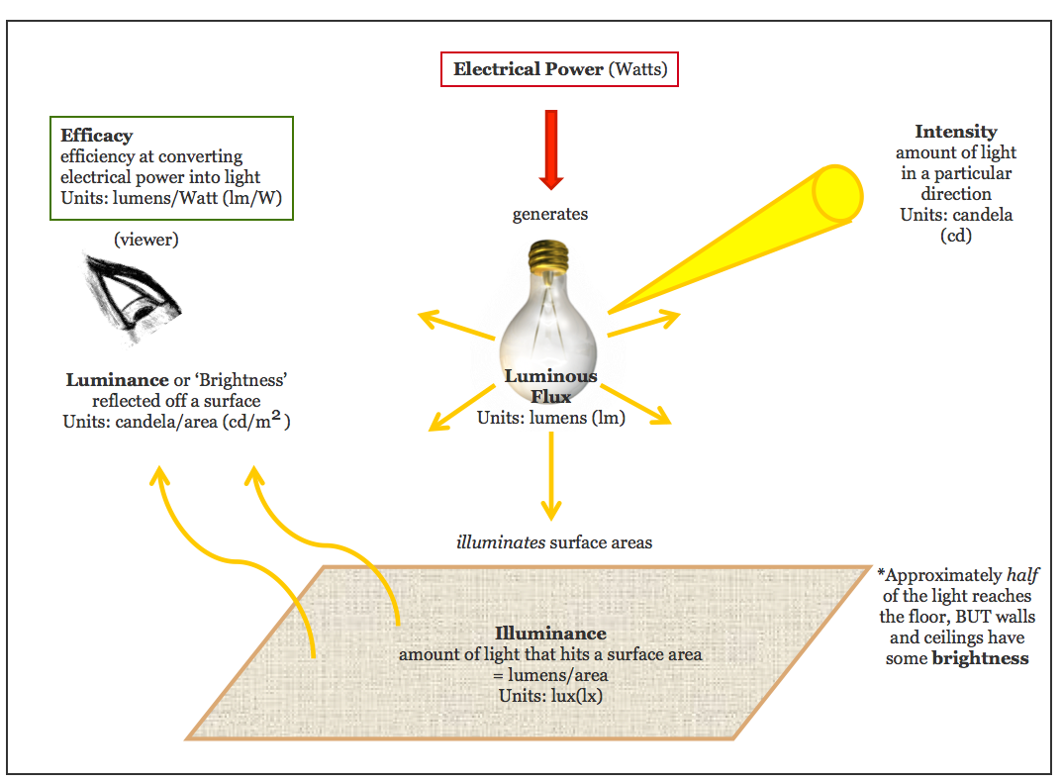

Figure 1. An illustrative definition of how the main photometric quantities are related.

* 1. The colour (quality) of light

There are two very important aspects of light relating to colour: temperature and rendering.

* Colour temperature (or Correlated Colour Temperature, CCT) describes the shade of white light emitted. It is measured in Kelvin.
* Colour rendering rates the ability of the light to accurately portray colours of objects in the space. It is measured by the Colour Rendering Index (CRI).

Colour temperature

CCTis a light quality parameter that describes the colour of the light generated by the light source. The value quoted uses the absolute temperature scale in Kelvin (K) and is typically between 2400K and 10,000K. The rating scale came about as a practical comparison to how a tungsten filament incandescent lamp creates white light. In theory as a piece of metal (for example, a tungsten filament) is heated it glows a certain colour, changing from red through to orange, yellow, white, to a bluish-white as the temperature increases (**Figure 2**).

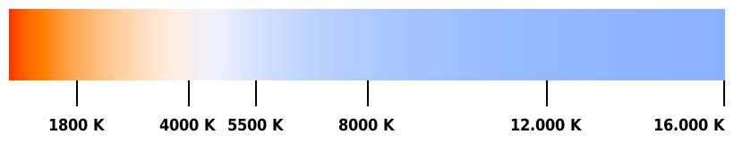

**Figure 2.** Colour temperature of light (CCT range) as measured in Kelvins. Image courtesy Phrood via Wikimedia Commons

The CCT range can be a little misleading in that as the value of the CCT increases the light will progressively appear to contain more blue and less red, a colour shift most people associate with cold temperatures.

The actual appearance of the light from a lamp is described in terms that are thought to be easily understood by the public, such as ‘warm white’, ‘cool white’ or ‘cool daylight’. There are numerous other descriptive terms used by manufacturers to describe the colour of light from a lamp to associate their lamp with a favourable description. However, to remove the potential confusion these descriptive terms have been standardised within an international standard EN 12464-1 as follows (also see **Table 1**).

**Table 1**. Common colour temperatures and optimum locations for use.

| CCT (K)* | Colour designation | Appearance | | Typical uses |
| --- | --- | --- | --- | --- |
| 2700-3300 | Warm White | Warm, yellow/orange light | similar to tungsten filament incandescent | household rooms |
| 3300-5300 | Cool White | neutral, white light | neutral light | offices, garages, workshops, bathrooms, kitchens |
| 5300-6500 | Cool Daylight | Cool, blue light | cold, harsh, unrelaxed light | external areas, laundries |
| *CCT ranges as per EN 12464-1 | | | | |

**Warm white:** This description covers CCT values below 3300K. The lamp colour is characteristic of candle-light or a naked flame (**Figure 3**) and is favoured for lighting household interiors such as living rooms, due to it’s relatively low ambient illumination levels. This term describes all conventional tungsten filament incandescent and halogen sources, as well as certain fluorescent, compact fluorescent and LED lamps.

**Cool white**: This covers the CCT range above 3300K up to 5300K, and would typically include illumination applications that are more utility or functional. Most offices are lit by fluorescent lighting with a CCT in this range. The appearance derived from a cool white lamp is considered pleasant to work under as it lacks any bias at either end of the visible spectrum, so it appears neither too warm (high in red) nor too cool (high in blue) (**Figure 3**).

**Cool Daylight** (sometimes termed ‘Daylight’): This covers the CCT range above 5300K. Not many applications call for such high CCT values, though some like the clinical appearance for utility tasks such as doing laundry, and for external lighting. Typically, daylight is a ‘default’ CCT for interiors that use metal halide lamps, such as factories and warehouses. Some retailers will use the cool appearance of daylight lamps to imply a clinical appearance. Many people mistakenly associate the description of daylight as being ‘natural’ and somehow better; this mistake is common and has no basis in fact.

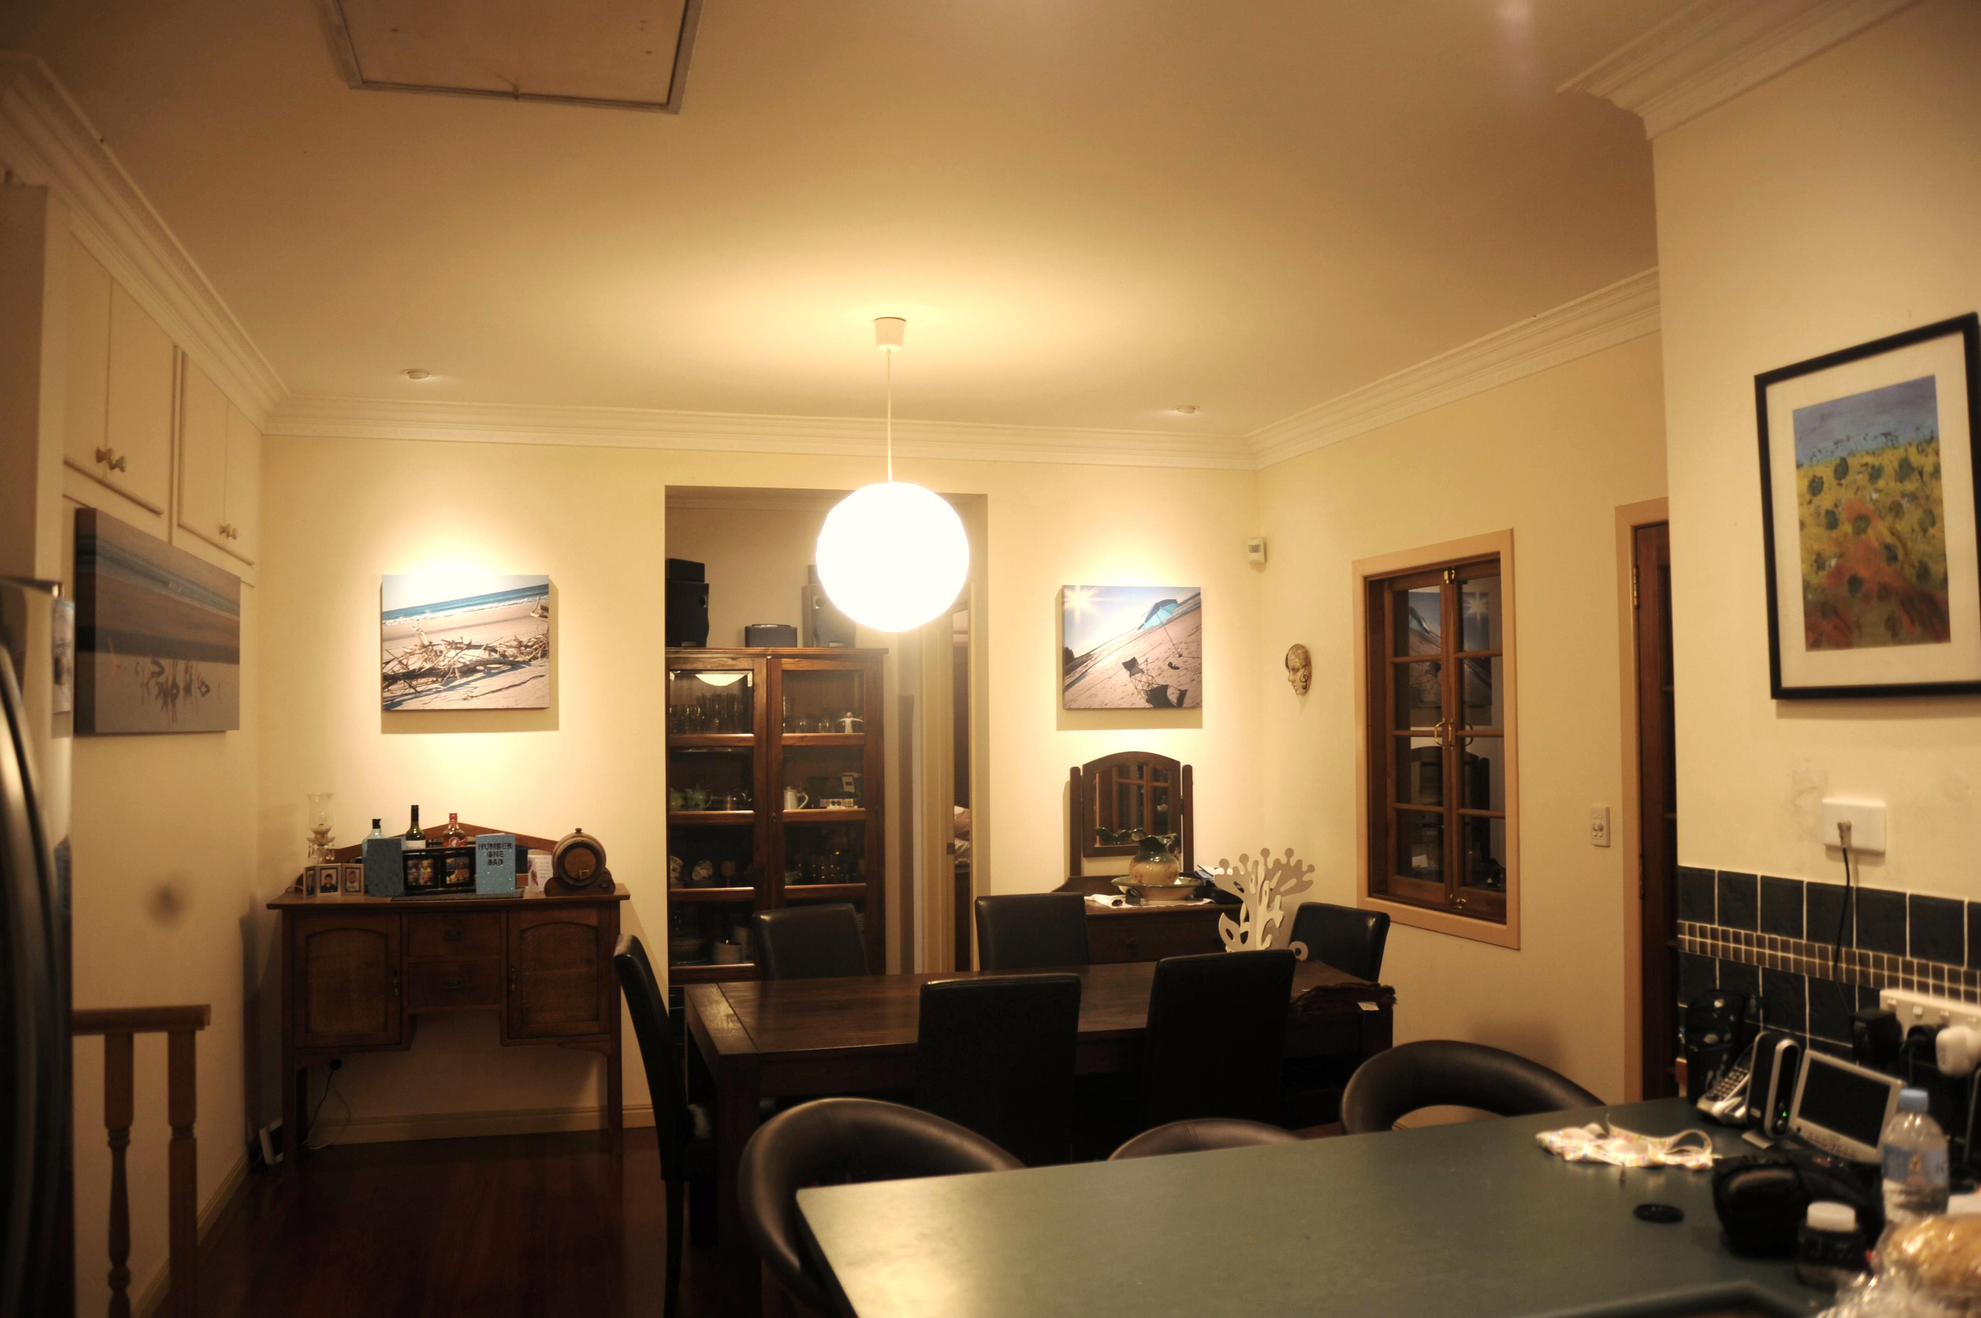 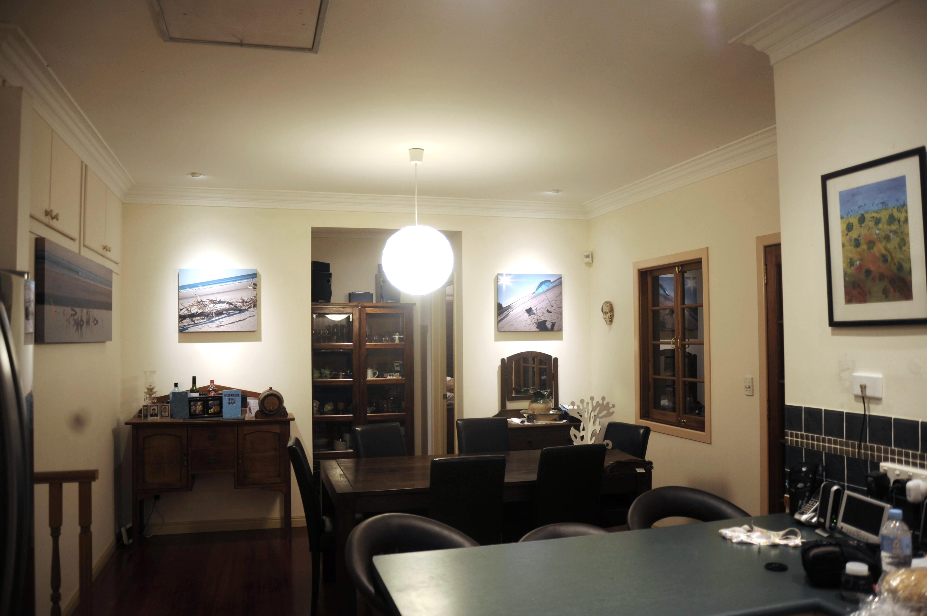

**Figure 3.** Comparison of colour temperatures: cool white (left) and warm white (right).

People’s perception of illuminance ‘comfort level’ also varies with colour temperature (**Figure 4**). For example, an illuminance level of 100 lux is perceived as comfortable when the colour temperature is between 2500K and 3000K.

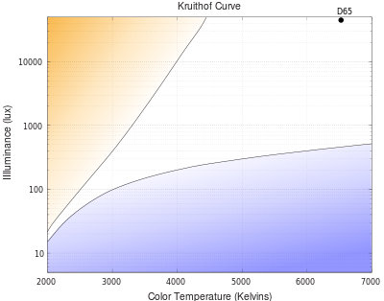

Figure 4. A Kruithof Curve shows the ‘comfort level’ that people perceive when light of a certain colour temperature is applied over a range of illumination levels. Between the lines (white area) is considered to be the area of greatest satisfaction. D65 is a CIE Standard Illuminant corresponding to average daylight in Europe; it has a CCT of 6500K. Image courtesy Hankwang via Wikimedia Commons.

Colour rendering index (CRI)

Lamps of the same colour temperature can vary in their ability to render colours correctly. The CRI is an indicator of how well a light source can reproduce colours (**Figure 5**).

The CRI of a lamp is between 0 and 100, where 100 represents true natural colour reproduction for that particular colour temperature. Anything higher than 80 is usually adequate for general use, but for specialised tasks where colour is important (e.g. food preparation, applying makeup, painting), it is advisable to choose lamps with a CRI above 90.

|  |  |
| --- | --- |
| **CRI: 100** | Plates of fruit and vegetables, a can of soft drink and a colour square chart under a lamp with Colour Rendering Index of 100, meaning that colours are reproduced perfectly. |
| **CRI: 80** | Plates of fruit and vegetables, a can of soft drink and a colour square chart under a lamp with Colour Rendering Index of 80, meaning that colours appear a little duller. |
| **CRI: 60** | Plates of fruit and vegetables, a can of soft drink and a colour square chart under a lamp with Colour Rendering Index of 60, meaning that colours appear duller still. |
| **Figure 5**. Colour Rendering Index (CRI) comparison. Image courtesy Gerben49 via Wikimedia Commons. | |

1. All about lamps

There are a huge variety of different types of lamps (or light bulbs) available on the market today. Energy efficient lighting and good lighting design requires choosing the right lamp for the right purpose. In this section eight different lamp technologies are described, and the four most common are compared in terms of their cost, lifespan and how they are labelled.

* 1. Lamp Technologies

Tungsten filament incandescent

|  |  |
| --- | --- |
| A traditional pear-shaped (general lighting service or GLS) tungsten filament incandescent lamp with bayonet cap A candle shaped tungsten filament incandescent lamp with bayonet cap.  Images courtesy of Australian Government under license. | The tungsten filament incandescent lamp (often referred to as general lighting service, or GLS lamp) was the most common lamp type for domestic lighting for many years. It produces light by heating a tungsten wire filament to a very high temperature by running an electric current through it until it glows brightly. The tungsten filament incandescent lamp is a low efficacy light source and has a relatively short lamp life. Due to these factors, standard omnidirectional tungsten filament lamps (apart from candle, decorative and fancy round lamps 25W and below) are unable to comply with Minimum Energy Performance (MEPS) requirements (see Section 8 *Lighting regulations*) and are therefore not to be sold in Australia. Mains voltage reflector lamps and some special purpose lamps remain available for particular applications that are not relevant to general household lighting. |

Halogen

|  |  |
| --- | --- |
| A traditional pear-shaped halogen lamp with bayonet cap. An MR16 downlight-style 12 volt halogen lamp.  Images courtesy of Australian Government under license. | The halogen lamp also generates light by heating a tungsten wire filament to make it glow brightly. However, the filament is located within a halogen gas-filled capsule in the outer envelope, allowing the filament to burn hotter and brighter, and resulting in a lamp efficacy about 30% higher than tungsten filament lamps. This difference also allows halogen lamps to maintain light output over their lifespan far better than a conventional tungsten filament incandescent lamp, although the actual lifespan of about 2,000 hours is still comparatively short. The image to the far left shows a typical mains voltage (240V) halogen lamp, while the other lamp shown is a typical extra-low voltage (ELV) directional halogen lamp which operates on 12V and requires a transformer (see Section 4.3 *Transformers/voltage converters*). |

Fluorescent (Linear, Circular)

|  |  |
| --- | --- |
| Fluorescent tube  Circular fluorescent tube  Photos courtesy Dmitry G. via Wikimedia Commons; and Australian Government under license. | This family of lamps make light by first creating an electric discharge or arc within a glass tube filled with a low pressure mercury vapour. The arc stimulates the mercury atoms within the vapour, exciting electrons. The energised mercury vapour atoms emit ultraviolet radiation, which in turn excites the phosphor powder coating the glass tube and generates visible light.  All fluorescent lamps generate light in this way, but there are a large variety of lamp types and sizes that make up this family. The images to the left show a linear and a circular lamp, which are the most common in residential applications. Fluorescent lighting has a high efficacy and long lifespan. |

Compact fluorescent lamp (CFL)

|  |  |
| --- | --- |
| A spiral compact fluorescent lamp with bayonet cap A 4-tube compact fluorescent lamp with bayonet cap  A downlight compact fluorescent lamp with GU10 base.A 4-tube non-self-ballasted compact fluorescent lamp  *Please note that these images show only the most common types of CFLs and not all that are currently available.*  Photos courtesy Ulfbastel and Dmitry G. via Wikimedia Commons; Australian Government under license. | CFLs are essentially a smaller version of the linear fluorescent lamp that has been shaped to compact its overall size. The function of the lamp is the same as a conventional fluorescent, and it still requires control gear (see Section 4 *Auxiliary equipment*) for the right electrical requirements.  In the first three images to the left (upper row and middle row left), the lamps have the control gear integral to the whole assembly, so they can be fitted directly within a standard household lamp holder connected to the 240 V mains. The last two lamps (middle row right and lower row) are for use with external control gear as part of the lighting and cannot be connected directly to the mains. For residential applications most lamps will be mainly of the integral gear type.  The key benefit of CFLs is their ability to provide light almost as efficiently as linear fluorescent lamps, but in a much smaller package. CFLs also have a median lifetime of at least 6,000 hours.  IMPORTANT: When using the integral gear type CFL as a replacement for a tungsten filament incandescent lamp within an enclosed fitting or downlight, the lamp information must state that it can be used with this type of enclosed light fixture. |

Cold cathode fluorescent lamp (CCFL)

|  |  |
| --- | --- |
| A Cold Cathode Fluorescent Lamp  Photo courtesy Gazebo via Wikimedia Commons. | Cold cathode fluorescent lamps differ from conventional fluorescent lamps in that they do not heat the electrode to generate the arc. Instead, they apply a higher voltage to achieve the arc. Other than this, the function is similar to a fluorescent lamp. Typically the tube diameter is much narrower than conventional fluorescent and compact fluorescent lamps.  The key benefit of CCFL lamps is they do not generate as much heat as conventional fluorescent lamps and last far longer.  For residential applications most lamps will be mainly of the integral gear type and be configured to resemble a conventional light globe as shown. |

Light emitting diode (LED)

|  |  |
| --- | --- |
| An MR16 replacement LED downlight  A hemispherical LED with eddison screw cap.  An example of a downlight LED  Images courtesy Barryjoosen and Lee, E.G. via Wikimedia Commons. | An LED is made from two ‘doped’ semiconductor materials, a p-type (positive charge) and n-type (negative charge), which are joined to form a ‘p-n’ junction. When attached to an electricity source, charge carriers (electrons and holes) flow across the junction from connected electrodes in the direction of the p-side to the n-side. When an electron meets a hole, it settles into a lower energy state and releases the excess energy as a photon (package of light). This is the basic method by which LEDs generate light.  The wavelength (colour) of the light emitted by the LED is determined by the *band gap width*, which is dependent on the semiconductor materials used to form the diode junction. Typically the light generated by this process is of a single wavelength and not particularly useful for general illumination. Therefore, phosphors are used to change the single wavelength (typically blue or near ultra-violet) into other wavelengths to make white light. In this way, the role of phosphors in LEDs is almost identical to that in fluorescent lamps.  LEDs are very small light sources and often need to be grouped together to generate sufficient light. Their small size allows them to be arranged in many configurations and sizes, as can be seen from the images to the left.  LED lamps generally have a high efficacy level and long life, although product quality can vary.  LEDs need additional components to modify the mains electrical supply (AC) to a form best suited to the LED (DC, at a lower voltage). These components may be integral to the lamp itself or be a discrete item in addition to the lamp, commonly referred to as the ‘driver’. |

Metal halide

|  |  |
| --- | --- |
| Metal Halide Lamp  Image courtesy Gerben49 via Wikimedia Commons. | Metal halide lamps are a group of lamps within a family referred to as High Intensity Discharge (HID) lamps. All HID lamps produce light by passing an electric arc through a gas or metal vapour within a transparent chamber called the *arc tube*. As the gas becomes ionized, free electrons, which are accelerated by the electric field, collide with the gas and metal atoms, which excites some electrons that are in orbit around the atoms. When the excited electron falls back to a lower energy state, it emits a photon (packet of light) of particular energy in the process. As with LEDs, the colour is dependent upon the gas and metal used. The gas and the metal halides themselves are chosen to provide the right blend of wavelengths to be useful for illumination.  Metal halide lamps are known for their high intensity light output and wide spectrum; but are not generally used in interior domestic lighting, as typically they don’t offer any advantages over other lamps on a task-by-task basis and they require special fixtures to operate safely. They are most popular when applied to outdoor/security lighting, photography lighting and for indoor plant/aquarium applications. |

Induction

|  |  |
| --- | --- |
| A circular induction lamp  A screw-base induction lamp  Image courtesy Sabinezhangwang via Wikimedia Commons. | Induction lamps are essentially fluorescent lamps, however they do not pass an electric arc through a gas to make ultra-violet light. Instead the gas is stimulated by an external source of electro-magnetic radiation.  Their main advantages are that there are no electrodes to burn out so they last longer, and they do not deposit electrode material on the inside of the tube (blocking the light) so they stay brighter for longer. It should be noted that these lamps consume more electricity to make the electromagnetic radiation that stimulates the gas than would be consumed by conventional fluorescent lamp ballasts.  These lamps are excellent for use in hard-to-reach locations, as they have very long lifespans; for example, in outdoor fittings or internal fittings such as high ceiling or stairway locations. |

* 1. Comparison chart

In a residential setting, the most typically used lamp types are the LED, CFL, halogen and the remaining tungsten filament incandescent lamps (those not currently within the scope of Minimum Energy Performance Standards – see Section 8 *Lighting regulations*). A comparative summary of attributes for these lamps is found in **Table 2**below.

**Table 2.** Comparison of lamp technology attributes.

| Type | LED* | CFL | Halogen | Tungsten Filament Incandescent |
| --- | --- | --- | --- | --- |
| Typical Omnidirectional lamp and price | Omindirectional LED lamp | Omnidirectional CFL lamp | Omnidirectional Halogen lamp | Omnidirectional tungsten filament candle lamp |
| $40-60 | $4-10 | $4-6 | $1-2 |
| Typical Directional lamp and price | Directional LED lamp | Directional CFL lamp | Directional halogen Lamp | Directional tungsten filament lamp |
| $20-80 | $4-10 | $3-6 | $2-20 |
| Basic Description | LEDs within a shell that match common lamp types. The driver may be integral or remote to the lamp. A number of lamp shapes and bases are available. | Fluorescent tube formed to fit within common lamp types. The control gear may be integral or remote to the lamp. A number of lamp shapes and bases are available. | Halogen capsule within GLS envelope or within MR16 reflector. Most MR16 are low voltage and require a transformer. A number of lamp shapes and bases are available. | Wire filament within a glass envelope. Use mains power without control gear. A limited number of lamp shapes and bases are available due to regulatory restrictions. |
| Positive attributes | Low power consumption  Long life  Small size  Good colour properties | Low power consumption  Long life  Small size  Good colour properties | Small size  Good colour properties | Low cost  No control gear  Good light quality |
| Negative attributes | Many poor quality lamps currently in the market – examine claims carefully and/or choose known brands from reputable sellers. | Reflector types not very effective in providing directional light compared to other small reflector lamps. | Run hotter – ceiling insulation must have minimum clearance from fitting. Short life, low efficacy. | Due to GLS phase-out will become increasingly difficult to get. Not very efficient. Short lamp life. |
| Lamp Efficacy | 15-85 lm/W | 38-75 lm/W | 13-22 lm/W | 11-15 lm/W |
| Colour Temperature Range | Warm White to Cool Daylight | Warm White to Cool Daylight | Warm White | Warm White |
| Colour Rendering (CRI) | 80–95 | 75-90 | 100 | 100 |
| Dimmable** | Selected brands | Selected brands | Yes | Yes |
| Life span | 30,000 hrs | 6000-15,000 hrs | 2000-4000 hrs | 1,000 hrs |
| Replacement globes (over 10 years) | 1 | 3 | 10 | 30 |

*An alternative to lamp replacement is to replace the complete light fixture. This is an option with LED fixtures, but these are more expensive than LED lamps and require an electrician to install.  
**Most standard fluorescent and many LED lamps cannot be dimmed (although this is improving), but special dimmers and lamps are available (check packaging or manufacturer’s website for information on compatibility).

* 1. Conversion chart

The ongoing research and development in lamp technologies means that efficacies are continually improving and changing, making comparisons between the performances of old and new lamp types challenging. As at time of writing the figures indicated in **Table 3**offer a realistic comparison of power that a lamp technology will consume in order to produce a given light output (in lumens).

**Table 3.** Lamp wattage conversion chart.

| Light output  (in Lumens) | Light Emitting Diode (LED) | Compact Fluorescent Lamp (CFL) | Mains Voltage Halogen (MVH) | Tungsten Filament Incandescent |
| --- | --- | --- | --- | --- |
| 220 Lm | 4-7 W | 5-7 W | 18 W | 25 W |
| 420 Lm | 7-10 W | 7-8 W | 28 W | 40 W |
| 720 Lm | 10-13 W | 11-12 W | 42 W | 60 W |
| 930 Lm | 12-19 W | 13-18 W | 52 W | 75 W |
| 1300 Lm | 16-24 W | 18-23 W | 70 W | 100 W |

Many consumers will traditionally refer to lamp wattage when choosing a lamp, however with the increased diversity of lamp technologies available, this reference is becoming less useful. While less familiar, light output in lumens is the most accurate and reliable method of comparing the light output of different lamps. Note that presently, despite the claims of some LED lamp manufacturers, a good quality LED lamp which can produce equivalent lumen output to a CFL will consume approximately the same amount of power to achieve this performance, i.e. good quality LED lamp efficacy ≈ CFL efficacy. However, LED efficacy is expected to continue to improve in the future.

* 1. Lamp lifespan

The rated lamp lifespan provided by the lamp manufacturer (often found on packaging) indicates the predicted number of hours of lamp operation. As it is based on the average life expectancy of the lamp, it means that it is possible for some lamps to fail after a short amount of time and for some to last significantly longer than the rated life.

The actual lifetime of any particular lamp depends on many factors, including:

* operating voltage (higher voltages run lamps harder = shorter lifetime);
* exposure to [voltage spikes](http://en.wikipedia.org/wiki/Voltage_spike);
* manufacturing defects;
* [mechanical shock](http://en.wikipedia.org/wiki/Shock_%28mechanics%29);
* frequency of switching on and off (fluorescents are particularly susceptible, however Australian regulations set a minimum switching withstand requirement for CFLs of 3,000 switches);
* lamp orientation (fluorescent lamps, including CFLs work most efficiently when the lamp is oriented downwards, with the base up. This is because the efficiency of the bulb depends on the temperature of the coldest part of the lamp, which is the end furthest away from the ballast. Since heat rises, a base-up lamp will be coolest at the bottom, producing the greatest amount of light); and
* ambient operating temperature (e.g. LEDs lose lifetime and efficiency significantly as temperature increases).
  1. Lamp life calculator

A simple and fast way to calculate the number of years of lamp life is by using a lamp life nomogram and a ruler (**Figure 6**). On a nomogram, the two scales on the outside represent known values – in this case the rated/typical lamp life (hours), and number of hours of lamp use per day. The result is read on the third scale in the middle.

In this example, the rated lamp life is 16,000 hours (left-hand scale), and the lamp is estimated to be switched ON for 1.5 hours per day (right-hand scale). Joining these two points with a line, the intersection with the middle line (red dot) shows the typical life of that lamp to be approximately 30 years.

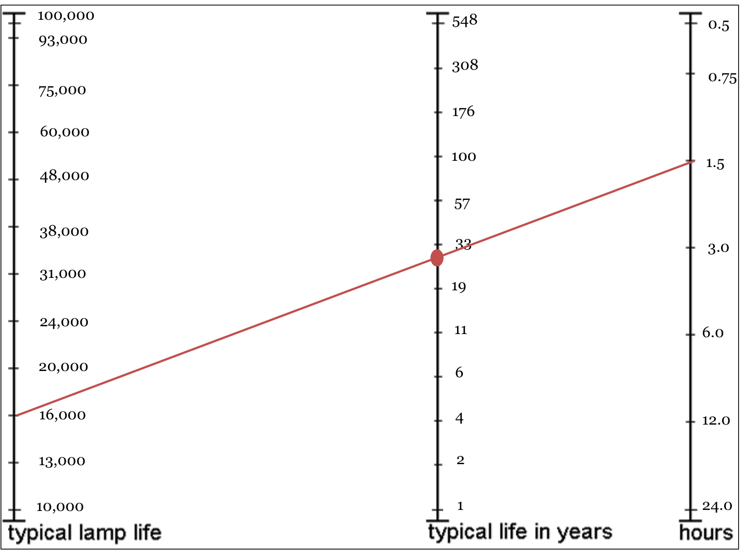

**Figure 6**. Nomogram for Typical Lamp Life in Years.

* 1. Lamp usage cost comparison

A comparison of lamp cost (operating and replacement) between technology types is shown in **Figure 7**. CFLs are currently the most cost-effective technology available, primarily due to the high purchase cost of good quality LED lamps. Halogens have a higher power usage and also require more frequent replacement due to their shorter lifetime, and are only marginally more cost effective than the phased-out tungsten filament incandescent.

The time scale in **Figure 7** is based on lamp use of 5 hours per day, which is typical for commonly used areas such as kitchens and lounge rooms (see Section 6.6 *Lighting design by room*). In other rooms where the hours of use are less, the cost shown on the graph will decrease by the same proportion (e.g. halving the hours of use per day will halve the cost at each point in time on the graph).

Lamp technology operating / replacement cost comparison. Note all lamps have equivalent light output, and the use of a banned 75W incandescent is for reference only.

After 1000 hours of use, or 0.5 years (based on 5 hours use per day) CFLs are cheapest, then halogen, then incandescent and LED is the most expensive. 

After 5000 hours of use, or 2.5 years (based on 5 hours use per day) CFLs are cheapest, then LEDs, then halogen and incandescent is the most expensive.

After 10000 hours of use, or 5 years (based on 5 hours use per day) CFLs are cheapest then LEDs, then halogen and incandescent is the most expensive.


**Figure 7**. Comparison of tungsten filament incandescent, halogen, LED and compact fluorescent lamp operating and replacement costs, assuming 5 hours use per day. Comparison is based on lifetimes of 25,000 hours for LED, 8000 hours for CFL, 2000 hours for halogen and 1000 hours for tungsten filament incandescent lamps; an LED price of $50, CFL price of $6, halogen price of $4 and tungsten filament incandescent price of $1; and electricity rate of 25.378¢ per kWh (Tariff 11, Origin Energy, July 2012).

* 1. Lamp labelling

Lamp characteristics may be displayed on the packaging. It is mandatory for tungsten filament incandescent and halogen lamps to have the light output in lumens, wattage and lamp lifetime marked on the packaging. CFLs must have the same information on their packaging, along with the mercury content in milligrams. Other typical performance information that may be included on lamp packaging is the efficacy and CCT (an example is given in **Figure 8**). Some LED lighting may have additional information regarding the [Solid State Lighting (SSL) Quality Scheme Label](http://www.lightingcouncil.com.au/site/ssl/overview.php) promoted by Lighting Council Australia (www.lightingcouncil.com.au/site/ssl/overview.php). These labels provide a wider range of information about product performance but are not an endorsement of the product meeting a minimum level of product quality.

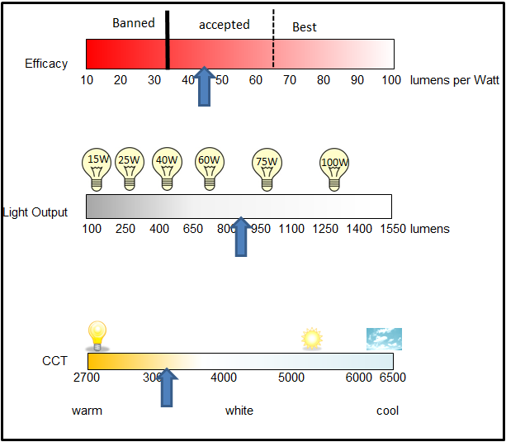

**Figure 8**. An example of how lamp performance (e.g. colour correlated temperature) information could be displayed on packaging.



1. Auxiliary equipment

The energy efficiency of a lighting system depends not only on the luminous efficacy of the lamp, but also on the efficiency of the auxiliary equipment. This equipment includes ballasts, starters, transformers, drivers and dimmers.

* 1. Ballasts

|  |  |
| --- | --- |
| A Ballast  Image courtesy Brown, D. via Wikimedia Commons. | The ballast controls the amount of electrical current supplied to linear fluorescent, compact fluorescent and HID lamps. Once started and the arc is established in the lamp, it progressively becomes a better conductor of electricity and increasingly more current is able to flow. The current becomes excessive within seconds (fluorescent lamps) to minutes (HID lamps) and could easily destroy the lamp. The ballast keeps this current rise under control so the lamp always receives the right current and voltage to function at its best. They do not perform this function without cost as they consume a small amount of power in the process. |

* 1. Starters

|  |  |
| --- | --- |
| A Starter | The full function of the starter switch in switch start fluorescent lamp circuits is beyond the scope of this document. It is important to note they are only used to start the lamps and perform no function in the normal, light producing stage of operation. They can, however, affect how long the lamp will last. Conventional starter switches are thermally operated and are not synchronised with the power supply. They may operate at a point in the sine wave of the power supply that places an excessive strain on the electrodes, reducing the lamp’s efficiency and ability to perform at their best on the next start cycle and diminishing the lamp’s operational life. In contrast, electronic starter switch operation is synchronised to the supply waveform and will always trigger the starting pulse at the most effective point for starting the lamp. This synchronised operation greatly reduces damage to the electrodes and extends the operational life of the lamp by between 80-100%. |

* 1. Transformers/voltage converters

|  |  |
| --- | --- |
| A transformer | Most people are familiar with the operation of a transformer that changes the mains voltage (240V) to a lower voltage (typically 12V). The MR16 halogen lamps are all 12V and need to run from a transformer (also known as extra low voltage converters or ELVC). Until fairly recently the MR16 transformers were all true transformers with copper windings on an iron core, but electronic transformers have largely replaced these. The advantage is that they are cheaper and lighter than conventional transformers. When used with LED MR16 replacements, ensure that the transformer operates at the lower power consumption and is compatible with the LED product. Some electronic transformers see the lower power consumption of the LED (typically 10W for a 50W halogen or 35W IRC halogen) as a fault and will switch off. The wide range of transformers installed for halogen MR16 lighting systems in Australian homes means that it is also important to investigate whether retrofit LED lamps are compatible with installed transformers. Some suppliers will provide a list of transformers that their product has been tested with. |

* 1. LED drivers

|  |  |
| --- | --- |
| A LED Driver | LEDs use direct current (DC) electrical power at low voltage. An LED driver is a power regulation unit with outputs designed to match the specific electrical characteristics of an LED or LED array. Typical LED lamps work most efficiently and safely with a ‘constant current’ drive as opposed to conventional mains power supply or supply from a transformer, which is regulated to provide a ‘constant voltage’. Presently there are no industry standards for what current (amperage) an LED must be run at, so understanding the electrical characteristics of the LED/array is essential for correct selection of a driver.  Drivers may offer dimming via pulse width modulation (PWM) circuitry or a reduction in forward current; they may also enable colour changing and on/off sequencing. |

* 1. Dimmers

|  |  |
| --- | --- |
| A dimmer control | Most domestic dimmers in use today will be one of two types – leading edge or trailing edge. In operation they are identical in that they control the power delivered to the lamp by only switching on at a certain point in the mains voltage waveform. The difference is the location on the supply waveform they begin to activate – leading edge dimmers control the rising side of the wave form as it approaches maximum, and trailing edge dimmers activate on the falling side of the waveform as it falls away from maximum. With iron core transformers, the best dimmer to use is the leading edge type. For electronic transformers it is best to apply the trailing edge dimmer. |

Dimming for fluorescent lamps requires specifically designed control gear. This applies equally to all CFLs as well (see **Table 4**below).

**Table 4.** Dimming capabilities of lamps.

| Lamp Type | Dimmable (typical domestic dimmers) | Dimming Range | Special Controls required |
| --- | --- | --- | --- |
| Tungsten Filament Incandescent/Halogen | Yes | 100% - 1% | No |
| CFL | Few | 100% - 5% | Yes |
| CCFL | Few | 100% - 5% | Yes |
| LED | Some | 100% - 20% | Yes |
| Linear/Circular Fluorescent | No | N/A | Yes |

1. Using light efficiently

Thoughtful, energy efficient lighting design combines multiple daylighting and electrical lighting strategies to optimise the distribution of light inside the building. It considers whole building energy impacts, minimising the building’s overall energy usage and integrates the use of daylight (through windows and skylights) with electric lighting, along with controls.

**Effective lighting design means putting light where it’s wanted and needed and reducing or eliminating light elsewhere. Remember, power is only consumed when the lights are ON.**

* 1. Controls

The control of lighting is very important for energy efficiency; even the most efficient light source available is wasteful if it is ON when it does not need to be. Control of lighting in its simplest form is the light switch, which has a simple on/off function. Taking this one step further the ON/OFF function can be automated by the following:

* A photocell switching on when the light level is low.
* A timer to switch on or off at certain times of day.
* A motion detector sensing someone entering or leaving a room.
* A system combining any or all of the above.

The simple on/off function can be applied to all lamp types as they are designed to be switched on and off. However, some controls are not compatible with fluorescent lamps and some sources like CFLs are not suited to frequent, short duration on/off cycles. Most lamps can be used with other controls – although some must be specifically designed for use with dimmers (e.g. CFLs and LEDs). The designer or installer should always refer to the product packaging or contact the manufacturer for product-specific information.

* 1. Multiple switch circuits

Multiple switches should be provided to control the different elements of the lighting (i.e. ambient, feature or task) within a room where all lights may not be required to be ON all the time. The use of one switch to regulate all of the lights in a large room is inefficient. The choice of switching groups should always begin with lighting that needs to be provided for the most common purpose, such as over the kitchen benches, then working backward to the least used locations. Place switches at the room exits and use two-way switching to encourage lights to be turned off when leaving rooms with more than one exit point.

* 1. Timers

For greater efficiency, timers, daylight controls and motion sensors should be used to switch outdoor security lights on and off automatically. Timers are particularly useful for common areas in multi-unit housing, such as hallways, corridors and stairwells.

* 1. Motion sensors

‘Smart’ light switches and fittings use movement sensors to turn lights on and off automatically as a person enters and exits the room. These are useful in rooms used infrequently where lights may be left ON by mistake, or for elderly or disabled people. Motion sensors should have a built-in daylight sensor so that the light doesn’t turn on unnecessarily. Models which must be turned on manually and turn off automatically, but with a manual over-ride, are preferable in most situations.

Motion sensors for lighting control utilise infrared (IR), ultrasonic (US) or microwave (MW) motion detectors, and often in a combination of these technologies. An occupancy sensor is the combination of a motion sensor integrated with a timing device so that when it senses an absence of movement over the specified period, a light extinguishing signal is generated. These devices will prevent unnecessary illumination of unoccupied living spaces, and should be employed as energy saving controls.

Passive infrared sensors (PIR)

All objects emit heat (radiation in the infrared spectrum), and infrared sensors measure heat radiating from objects in the field of view. Apparent motion is detected when an IR source of a different temperature passes in front of a background IR heat source, such as a wall. PIR sensors are passive as they do not emit any infrared light they only accept incoming IR radiation.

Benefits of PIR sensors include:

* An effective range of approximately 10 metres up to 30 metres (relatively long range).
* The field of view may be broad (110°) or narrow angular coverage. PIR sensors can achieve a relatively wide field of view because infrared energy is a form of light, and this can be focussed using lenses in front of the sensor.

Limitations of PIR sensors include:

* They have line-of-site sensing only.
* Light interference (such as sunlight) and proximity to heating, ventilation, air-conditioning (HVAC) outlets can affect true sensing.

Ultrasonic (US) sensors

US sensors generate high frequency sound waves and then ‘listen’ for an echo bouncing off objects in a space. They calculate the time interval between sending the signal and receiving the echo, to determine distance from objects. As they both send and receive information, US sensors are ‘active’ sensors.

A benefit of this technology is that light interference or target colour differences do not affect their operation. Sensing ranges can be 30 millimetres to 10 metres.

Limitations of US sensing include:

* Any acoustic noise (whistle, the hissing of relief valves, compressed air or pneumatic devices) at the frequency to which the US sensor is receptive may interfere with that sensor's output.
* Acoustical crosstalk can occur between sensors of the same frequency located close together.

Microwave (MW) sensors

MW sensors, also known as RADAR or Doppler sensors, have been used to activate automatic doors for decades. This sensor is active, and similar to the US sensor sends out a high frequency electromagnetic wave - when the wave returns at a different frequency the sensor knows there is a moving object within the detection zone.

Benefits of the MW sensor include:

* Its small size allows the MW sensor to be mounted almost anywhere.
* MW technology does not require line-of-sight like most PIR units; therefore, the MW sensor can hide behind plastic, wood, fibreglass, cloth, glass, etc. and does not interfere with installation aesthetics.
* They are resistant to false detections caused by high temperature, pressure, vibration or dust.

One major disadvantage of microwave techniques for monitoring is the relative high initial purchase cost.

* 1. Building management system (BMS)

BMSs are a group of control systems with a range of capabilities from simply ON/OFF to sophisticated scene storage and recall. The degree of sophistication depends on the system and can include the light fitting itself as part of that control. Essentially, BMS take control input from a number of sources (internal clock, room switches, motion sensors, etc.) and apply the appropriate lighting based upon what it has been programmed to do.

Currently the use of BMS is not common in domestic lighting. However, it is anticipated that as the technology available in commercial and industrial lighting control systems becomes more widespread, their use in domestic settings will increase.

1. Good lighting design

**Lighting design is the selection and placement of lighting within a space. Good lighting design means putting the right light, in the right place, at the right time.**

In this section we look at the different ways lamps can be applied to achieve general/ambient lighting and task/accent lighting. We also discuss different lighting design requirements for different rooms and basic lighting design calculations.

* 1. Lamp applications

The best lighting designs will use a combination of omnidirectional and directional lamps (**Figure 9**) in positions where they are most appropriate. In general, no single lamp type is most appropriate for all lighting tasks. For example, downlights are a poor choice for creating general ambient room illumination. If downlights are to be used for general lighting, lamps and luminaires should be selected that will produce a hemispherical direction of output (90-160° output; **Figure 9**) rather than a typical directional spot or flood light (10-60°). Below are some tips for positioning of omnidirectional and directional lights.

|  |  |  |
| --- | --- | --- |
| An LED omnidirectional replacement lamp which only has a hemispherical light output, e.g. within a 180 degree angle | An omnidirectional CFL which shows the light output in a near full 360 degree angle | A directional MR16-style lamp with light output restricted in the targeted direction. |

**Figure 9**. Direction of light output: Hemispherical (left); Omnidirectional (centre); and Directional (right).

* 1. Omnidirectional

|  |  |
| --- | --- |
| General lighting  **Omnidirectional lamp being used in the centre of the room**  *Omnidirectional lamp used for ambient lighting in centre of the room.* | This describes a lamp that radiates light in virtually all directions more or less equally and can be applicable to all light technologies, as each has omnidirectional lamps in their range.  Omnidirectional lamps are often used in the centre of the room to provide ambient light. They can also be used in multiple fixtures or as part of a grid.  The light fitting in which the lamp is used (see **Figure 10**) may modify the lamp’s light by either concentrating and reflecting it; diffusing it or refracting it through a prismatic lens; or simply acting as a mount for the lamp and not modifying the light in any way.  Key considerations when choosing omnidirectional lamps are:   * Is the light source and wattage suitable for the application? * Will the lamp fit within the light fitting and not exceed the maximum power rating of the light fitting? * Which colour temperature range will best suit its application? * If the lamp is visible within the fitting, is its shape acceptable? |
| |  |  |  | | --- | --- | --- | | lamp in semi-reflector pendant  Image courtesy Housing Works Photos via Creative Commons. | Spherical paper lamp shade diffuser  Image courtesy of Kertesz, J. via Wikimedia Commons. | bare lamp pendant  Image courtesy Zimmerman, R. via Wikimedia Commons. |   **Figure 10**. Examples of light fittings for omnidirectional lamps: semi-reflector pendant (left); a paper lamp shade diffuser fitting (centre); and a simple bare lamp in pendant (right). | |

* 1. Hemispherical

|  |  |
| --- | --- |
| Graphic representation of a hemispherical lamp | This describes the output from a typical ‘omnidirectional’ LED lamp. As the LED chip has directional light emission, and the chip needs to be mounted on a flat plate inside the lamp globe, most LED lamps have only 180° output.  When replacing an omnidirectional lamp with a hemispherical one, light will not be distributed toward the cap end, so an area of shadow will result. This may have negative implications for certain types of lamp shade; however in most fittings this small loss of light distribution is unnoticeable. |

* 1. Directional

|  |  |
| --- | --- |
| Fixed accent or task lighting  Six directional downlight lamps being used for task lighting is a kitchen  *Directional lamps used over task surface to reduce shadows and reflections.*  Directional lamps used for accent lighting in a bedroom to light artwork on the wall  *Directional lamps used for accent lighting.* | Directional lamps are light sources contained within a reflector system, or using a combination of reflector and lenses that are all packaged and provided as a discrete lamp ready for use. Most light technologies can be found in a directional form but are not all suited to domestic lighting. The MR16 in either halogen or LED is well suited to domestic lighting because it is small in size, and has excellent colour rendering and colour temperature. Typically such lamps are used in recessed downlights, some of which offer a degree of aiming the direction of light output, or they are contained in spotlights mounted to ceilings, walls or on mobile floor stands.  The characteristics to consider in the selection of directional lamps are the same as those for omnidirectional lamps, plus an additional characteristic called **beam angle**. Beam angle refers to the angle between rays from the lamp that have luminous intensity values half that of the maximum luminous intensity (**Figure 11**).  Directional lamps are typically not the best choice for achieving general ambient lighting and are particularly ineffective when much of the directional light is aimed downward and lost in dark or low reflectance floors (e.g. recessed ceiling downlights). This misapplication increases the number of lights required and the energy used to produce a satisfactory level of illumination and is unfortunately commonly seen in many modern Australian homes. |

The photometric qualities of a directional lamp. Virtually all of the light (around 90%) reaches the surface the lamp is directed towards. But very little light reaches other surfaces (quite dark ambience).

The beam angle is the angle where the light intensity drops to 50% of it's maximum. The area illuminated and illuminance level can be calculated if you have: beam angle, centre beam intensity, installation height / distance from illuminated surface.

Figure 11. Photometric qualities of a directional lamp.

* 1. Lamp technologies and their applications

Due to the way that light is generated by different lamp technologies, certain types of lamps are more suited to producing particular light distributions (**Table 5**).

**Table 5.** Light distribution of common lighting technologies.

| Light distribution | CFL | Halogen | LED | Circular/Linear Fluorescent | Metal Halide |
| --- | --- | --- | --- | --- | --- |
| General illumination with omnidirectional lamp Omnidirectional | Yes | Yes | Few products | Yes | Yes |
| Hemispherical illumination Hemispherical | Yes | No | Yes | No | No |
| Directional illumination with fixed accent or task lighting Directional | No | Yes  (e.g. MR16 or GU10) | Yes | No | No |

* 1. Lighting design by room

When designing a lighting scheme for a room the required level of illumination needs to be decided, as this sets the type and quantity of lighting, and ultimately how much energy will be consumed when in use. **Whilst it may seem obvious, it is nonetheless very important to realise that no matter what lighting is used it consumes no energy if it is switched OFF**. Switching off lighting when it is not required is an excellent way to conserve energy and prolong the life of the lighting equipment.

The key information to consider early in any lighting scheme will be the tasks performed in each room and how visually demanding these tasks are. As the task detail gets smaller, such as reading, food preparation or personal grooming, the more illumination will be required.

Minimum illumination levels listed in Section 7.1 *Recommended levels* would be considered as base levels of illumination expected in the average home, but there are numerous instances where higher illumination is necessary. Rooms such as the bedroom or study often need to provide for reading; in these instances, localised lighting can be provided by table or reading lamps.

The residential case studies provided as part of this training package identify what lighting is applied in a specific room or location in the home. The lighting power consumption is also modelled for a year of typical use to arrive at an overall energy consumption profile for that home and lighting treatment. The case studies consist of hypothetical examples and a real-life lighting retrofit.

The hypothetical lighting schemes examined are based upon typical homes: apartments for single person occupancy; two bedroom, single storey house for small families; and four bedroom multi-level homes for larger families. These cover most of the homes found in Australia and contain sufficient information to allow the concepts to be applied to other homes that do not precisely fit these typical situations. Three lighting treatments are examined, with each level being an increase in design sophistication and quality, and with an associated increase in the cost outlay.

**Level 1 (basic):** Lighting is provided primarily from surface mounted fluorescent solutions applying either compact or tubular fluorescent lamps. This scheme is the most elementary lighting scheme applying more energy efficient lamps in surface light fixtures that are capable of delivering suitable levels of illumination for the various rooms within the house. The lighting is not intended to provide accent or effect, rather simply general illumination for way finding and non-demanding visual tasks and has only rudimentary on/off controls.

**Level 2 (high efficiency):** Lighting is provided by a mix of recessed and surface lighting fittings applying energy efficient light sources including fluorescent, compact fluorescent, halogen and cheaper LED lamps. The lighting design includes the provision of accent lighting to emphasise features within a room, more specific lighting in working areas such as kitchen benches, and dimming within its controls strategy.

Whilst the lighting applied in these schemes increases the quantity of light fittings and so increases the maximum potential electricity consumption when all lights are on, the quantity and placement of such lighting does allow for a reduction in electricity consumption when a maintained lighting presence is required. Many homes are designed with an open plan allowing view of areas not occupied from ones that are. When lighting is OFF in the non-occupied areas they will be dark. This is often not appealing and can give rise to feelings of insecurity, especially with the very young. By use of selective switching of only one or two lights in an array of six, for example, a lit presence can be maintained in these areas. The use of dimmers can reduce the electricity consumption of these maintained light fittings even further and offers variety to the lit effect.

**Level 3 (high quality and efficiency):** Lighting is a combination of currently available leading edge, energy efficient lamp technologies such as LED and T5 linear fluorescent lamps with the degree of switching of Level 2 schemes. The resulting treatment provides ambient and accent lighting with sophisticated controls that can generate a range of scenes for the lit interior.

These treatments are provided with no express or implied preference, as each has its own pros and cons. The intention is to put forward options to consumers for lit interiors that have demonstrable energy efficiency and aesthetic appeal for consideration. Beyond these range of options, more sophisticated lighting outcomes may be available by seeking advice from a lighting design professional.

* + 1. Kitchen

As a functional area where food is prepared and cooked, the kitchen necessitates that there be good visibility and high colour rendering.

|  |  |
| --- | --- |
| General illumination | A basic lighting treatment would apply a single powerful source of light located centrally to provide good general illumination; however, this can create shading on the benches where people are working. Using additional sources of light will alleviate this effect. |
| Fixed accent or task lighting | For the best levels of light exactly where they are needed, use directional lights in fixed positions above the bench tops or install under-cabinet lighting to directly light the work surface below. This will negate the shadow effect and not over-light the rest of the space. Position lighting to avoid distracting reflections from dark shiny surfaces. |
| Lighting controls. | Having an option to switch between general and task lights can create a low-key lit presence in the room and eliminates the ‘dark corner’ effect during times when the kitchen is not being used as a task area. This can instil a sense of security and safety, particularly with children, elderly or infirm people. |

* + 1. Dining/living

The living and dining areas are both functional and social. Dining is a social activity and while food is a key part of enjoying the meal, so is the ability to clearly see dining companions. Lounge rooms are places of relaxation. Activities include watching television, listening to music, and entertaining guests - and lighting that is conducive to such activities is important.

|  |  |
| --- | --- |
| General illumination | Good general lighting is needed to maximise use of the entire room. |
| Local task lighting | For flexibility and variation in room appearance, introduce portable lighting for tasks such as reading. With all overhead lighting off the addition of floor standing lamps can still provide sufficient ambient light for way finding. |
| Lighting controls | There are opportunities for switching to reduce general lighting. Dimmers can also offer a great deal of control over how a room will appear. |
| Note: Large television screens are also a significant source of light. | |

* + 1. Bedrooms/studies

Bedrooms are predominantly occupied for rest and sleep, can be a place to perform personal grooming and are often also utilised as a study. With multiple uses a variety of lighting is required, and this should typically include a fixed lighting scheme for general illumination and local task lighting where needed.

Personal grooming usually involves a mirror, and the lighting needs to provide clear illumination of the face and body to allow its reflected image to be seen clearly. For this purpose, lamps with a CRI greater than 85 should be chosen. Front-on lighting that surrounds the mirror is the best relationship between the light source, the person and the mirror.

|  |  |
| --- | --- |
| General illumination | Good general lighting is important. |
| Local task lighting | Bedside lamps are a good and easy alternative to overhead lighting, providing local illumination for reading with control that is easily accessible from the bed. Study areas require illumination at sufficient levels for reading and writing – this is often satisfied by portable lighting such as a desk lamp, which can be positioned to suit the individual and task. |

* + 1. Bathroom

A key bathroom task is to illuminate faces for applying makeup and shaving; other tasks such as bathing have varied lighting requirements. All these tasks generally need light that can show colours faithfully and illuminate with even light from a number of sources and directions while keeping shadows to a minimum.

An issue unique to bathrooms is the quantity and placement of light fittings. The combination of activities requiring high light levels, and a space that is small in size and often irregular in shape, creates a conflict between achieving adequate coverage with an installed layout that is pleasing to the eye but does not lead to over-illumination and excessive power use.

Bathrooms are often finished with glazed, ceramic wall tiles that are highly reflective, behaving like mirrors under certain conditions. Light colours are far better than darker colours at reducing how obvious any distracting reflected images can become. Appropriate location of lighting is particularly important near mirrors as distracting reflections of bright light sources can make it difficult to use a mirror effectively.

|  |  |
| --- | --- |
| General illumination | Good general illumination from highly reflective surfaces for quick location of items and avoidance of trip hazards (e.g. discarded towels and clothing). |
| Fixed accent or task lighting | Key task points like basins, bath, etc. are ideal for fixed task lighting. |

* + 1. Entrance/security

Entry lighting should be sufficient to allow the homeowner to readily identify any visitor, so good lighting which clearly shows the visitor’s face is important. Beyond this, the function of entry lighting is way finding. Many home owners also wish to make a good first impression - one way to achieve this is with directed illumination of features such as paintings, photographs or other artwork.

|  |  |
| --- | --- |
| General illumination | Good general lighting at the threshold is important for facial recognition and safe navigation. |
| Fixed accent or task lighting | There is also opportunity to emphasise features and artwork. |

* + 1. Utility areas

Garage and laundry spaces provide storage for vehicles and the washing machine, and usually other items such as tools, chemicals, gardening equipment and items that are too large to be stored within main living spaces of the house. Lighting for utility areas should be designed for general way finding and the quick location of relatively large items; it is not intended for extended reading or similar tasks. A single, centrally located light fitting is usually adequate unless the garage is particularly large, has an irregular shape or contains internal partition walls; in which case multiple locations will be necessary. Note that some tasks in these spaces may require high visual proficiency, such as reading faded labels on laundry, so task lighting may be necessary.

It is also beneficial to consider whether parked vehicles inside the garage will block light from the installed light fitting/s such that the lighting needs are compromised; if so, a number of lower powered light fittings may be a better solution.

|  |  |
| --- | --- |
| General illumination | Good general lighting is needed for reading garment/chemical product labels, for safe navigation and location of stored items. |
| Fixed accent or task lighting  Local task lighting | The use of machinery and tools is commonplace in utility areas; consider the use of fixed task lighting for well-defined working locations like benches and portable lighting for other instances where good vision may be necessary.  Task lighting may be necessary for reading faded labels or detailed inspection of garments. |

1. Basic lighting design calculations

This section provides guidance on basic lighting design calculations which can help to determine the appropriate lighting design solutions for a household.

* 1. Recommended levels

The *AS/NZS 1680 Interior lighting* standard provides guidance on recommended illuminance (lux) levels for different rooms in a building. In a residential setting, the values are as listed in **Table 6***.*

**Table 6.** Recommended illuminance (lux) levels by room type.

| **Room/Zone Type** | **Recommended Average Illuminance (lux)** | |
| --- | --- | --- |
| **Initial** | **Maintained** |
| Kitchen workbench | 300 | 240 |
| Kitchen | 200 | 160 |
| Kitchen/Living | 200 | 160 |
| Living/Dining | 100 | 80 |
| Bathroom | 100 | 80 |
| Bedroom | 100 | 80 |
| Entry/Corridor/Stairs | 50 | 40 |
| In the design phase, initial illuminance levels must be slightly higher than the recommended levels for a particular space (approximately 125% maintained lux) to account for inevitable lamp lumen depreciation | | |

* 1. Basic luminous flux requirement

There is a simple and relatively accurate means of determining how many light fittings will be required to provide a given illumination level in a given size of room. With a given quantity of light fittings, the calculation can also be used to determine the illumination level in a room. The **lumen method** simply looks at how much light is needed in a room to get the expected illumination level.

* + 1. Ambient lighting

First, a thought experiment: say you want 80 lux in your lounge room which measures 5 x 5 metres, how many 18 W CFL lamps are needed?

* 80 lux is 80 lumens per square metre; the lounge room is 25 m² so it may seem that all you would need is 80 x 25 = 2000 lumens in total; since each 18 W CFL can generate between 1100-1200 lumens, it looks as though you would only require 2 lamps. HOWEVER, not all the light from the lamp will reach the desired surfaces; some will be absorbed by the light fitting, some is projected in directions away from the target area and so on.

For the size/shape of most rooms found in homes a large percentage of the light from lamps does not reach the target surface (e.g. table, floor). To account for this loss more lighting is necessary.

Typically, you will require double or even triple the amount of light you think you need.

Knowing this, let us look at the lounge room calculation again using the ‘Rule of Thumb’ Lumen Method.

‘Rule of Thumb’ Lumen Method (less accurate, but a good guide)

This begins with applying a factor called the Coefficient of Utilisation (CoU), which accounts for how well the light fitting can deliver the light from its lamp/s to the target surface. The value is usually between 0.3 and 0.7, depending upon the room size and shape and the efficiency of the light fitting. However, for most purposes **0.5 for surface light fittings** and **0.3 for recessed downlights** are a good enough guide for rooms in the home.

$$Total lamp lumens required=\frac{Recommended average illuminance \left(for room type\right)×Floor area}{CoU}$$

$$Number of lamps=\frac{Total lamp lumens required}{Lamp lumens (of the selected lamp)}$$

For the lounge room example given above, the Rule of Thumb Lumen Method is applied as follows:

|  |  |
| --- | --- |
| Surface mounted lamps $$\frac{80×25}{0.5}=4000 \text{lumens}$$ 18W CFL lamps generate 1200 lumens $$\frac{4000}{1200}=3.3 nearest whole number 4$$ | Recessed downlight lamps $$\frac{80×25}{0.3}=6666 \text{lumens}$$ 18W CFL lamps generate 1200 lumens $$\frac{6666}{1200}=5.6 nearest whole number 6$$ |

NOTE: 18W CFL recessed downlights have been used in this example to compare the usefulness of the same lamp depending on the fitting. A typical home has 35W MR16 lamps installed in the downlight fittings. When the Rule of Thumb method is applied using a CoU of 1 (since MR16s act as luminaires), the lounge room example would require 4 recessed downlights, the same number of fittings as for surface mount lamps using 18W CFLs. However, the surface mounted CFL lamps would only have a total energy consumption of 72W compared to 140W when using four 35W MR16s in recessed downlights.

Therefore, by taking into account loss of light in the lounge room example given above, you would actually need 4 surface mounted or 6 recessed lamps to sufficiently illuminate the room.

Note, this equation can also be rearranged to determine the illumination levels in a room with a given quantity of light fittings:

$$Average illuminance (approx)= \frac{Sum of all lamp Lumens×CoU}{Floor area}$$

The above series of calculations show a simplified version of the lumen method that uses a rule of thumb, rather than the more rigorous approach where CoU is defined in a table for numerous situations. However the principle of the lumen method applies and it is a good guide for the situation. For a full calculation of the lumen method refer to The IESNA Lighting Handbook (Rea, M.S.,2000, *The IESNA Lighting Handbook: Reference & Application*. Ninth ed., United States of America: Illuminating Engineering Society of North America), or other reliable lighting texts.

* + 1. Specific task lighting

The basic illuminance calculations above can provide a good estimation of the average illumination levels but does not provide accuracy for calculating illumination levels at discrete points from a light source. For this, the **inverse square law** must be applied.

Inverse square law equation

The general form of the inverse square law is to calculate the illumination level directly beneath a light fitting. With this arrangement, simply divide the intensity projected by the light fitting (at the centre beam or nadir) by the square of the distance between the light source and surface.

Example:The peak intensity of a downlight is 800 Candela (cd), which occurs directly beneath the fitting. The target surface is 1.4 m from the light source. What illumination level can be expected from the light on the target surface?

$$E=\frac{I}{d^{2}}=\frac{800 cd}{{1.4}^{2}}=408 \text{lux}$$

*E* = illumination level.

*I* = intensity in the direction being considered ~ dependent on light distribution.

*d* = distance from the lamp to surface (perpendicular).

This is the simplest form of the inverse square law - it only covers the area of calculation directly beneath the fitting and is facing the light source directly. What happens when the point lies off centre by 20°?

Off-axis inverse square law equation

Take a surface that is not directly beneath the light source, so that the incident light is at an angle of *θ* to the normal (perpendicular) line (**Figure 12**). Assuming the light source still projects 800 cd in the vertical direction, the inverse square law calculation changes to include an additional factor created by the angle at which the beam now strikes the surface as shown in **Figure 12**below.

The inverse square law (left)  is used to calculate the illuminance directly below the light source. Distance (d) from the lamp to the target surface is equal to h, the perpendicular height from the lamp to the surface.

The off-axis inverse square law (right) is used to calculate the illimuninance of a target not directly under the light source. A long description of calculating the off-axis inverse square law equation is given in the body text.

**Figure 12.** Illumination varies with angle of the surface to incident light.

Given that it might be more useful to write the equation in terms of the distance from the lamp to the target, *d*; the perpendicular height of the source above the surface of interest, *h*; and/or the horizontal distance, *x*; the following relationships are recalled:

|  |  |
| --- | --- |
| $$\cos{θ=\frac{h}{d}}$$ | $d{=\sqrt{x^{2}+h^{2}}}$ |

So the inverse square law equation can be modified to give the horizontal illuminance at the new target point as any one of these options, depending on if you want to use *d*, *h* or *x*:

$$E_{h}=\frac{I cos θ}{d^{2}}= \frac{I\cos^{3}θ}{h^{2}}= \frac{I h}{d^{3}}$$

*h* = perpendicular height from the lamp to the surface (not distance from the lamp to the target, *d*).

Using the same intensity value as above and applying the additional factors for the new target point (not directly beneath the light source), the new illumination level can be found:

$$E_{h}=\frac{800 cd×{\left(\cos{20°}\right)}^{3}}{{1.4}^{2}}=339 \text{lux}$$

Note that this off-axis intensity value is rarely the same as at nadir.

* 1. Beam angle

Beam angle is the angle where light intensity drops to 50% of centre beam intensity. Note that virtually all (around 90%) of the light from a directional lamp is in the beam and therefore, very little light reaches other surfaces outside the path of the beam. This provides a quite dim ambience.

* Basic rule: for the same wattage lamp, the smaller the beam angle the brighter the surface illuminated will be, but the area that is illuminated is smaller.
* Select appropriate beam angle by determining the largest dimension of the feature to be lit and the distance from it. The packaging of most directional lamps generally provides a simple graphic to assist with selecting the appropriate beam angle (as per **Figure 13**).

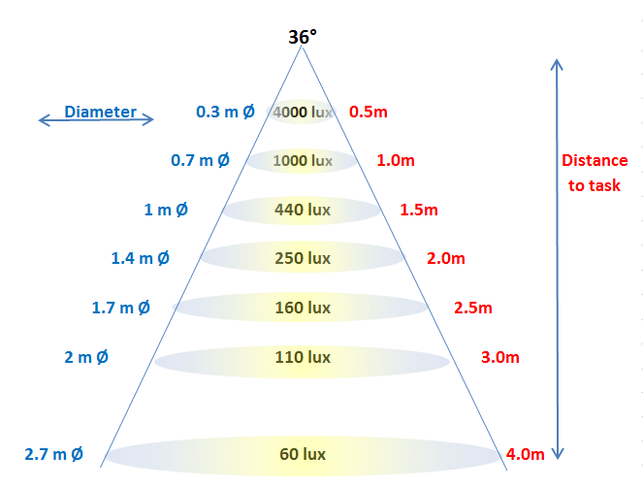

**Figure 13**. Illuminance (lux) at different distances (metres) from a 36° beam angle lamp. Note: Edge lux ≈ half Centre lux.

Beam angle definition

The following abbreviations may be found on lamp packaging or technical data:

* VNSP (very narrow spot): less than 8 degrees
* NSP (narrow spot): 8-15 degrees
* SP (spot): 15-22 degrees
* NFL (narrow flood): 24-32 degrees
* FL (flood): 35-45 degrees
* WFL (wide flood): 50-60 degrees
* VWFL (very wide flood): 60 degrees or more

**Figure 14** provides an illustration of the difference in projected output from directional lamps with three different beam angles. The width/diameter of the beam spot at different distances for the most commonly available beam angle lamps is given in **Table 7***,* and illuminance values at the beam edge is given in **Table 8**.

|  |  |  |
| --- | --- | --- |
| Narrow spot beam | Narrow flood beam | Wide flood beam |

Figure 14. An illustration of the differences in projected output from directional lamps with three different beam angles - (left) narrow spot; (centre) narrow flood; and (right) wide flood.

Table 7. Diameter of beam angle spot (in metres) at given distances from the lamp source.

|  |  | Distance (m) | | | | | | |
| --- | --- | --- | --- | --- | --- | --- | --- | --- |
|  |  | 0.5 | 1 | 1.5 | 2 | 2.5 | 3 | 4 |
| Beam Angle (°) | 10-12 | 0.1 | 0.2 | 0.3 | 0.4 | 0.5 | 0.6 | 0.8 |
| 22-24 | 0.2 | 0.4 | 0.6 | 0.8 | 1.0 | 1.2 | 1.6 |
| 36-38 | 0.3 | 0.7 | 1.0 | 1.4 | 1.7 | 2.0 | 2.7 |
| 55-60 | 0.5 | 1.1 | 1.6 | 2.2 | 2.7 | 3.3 | 4.4 |
| 90 | 1.0 | 2.0 | 3.0 | 4.0 | 5.0 | 6.0 | 8.0 |

**Table 8.** Provides an indication of illuminance values at the beam edge achieved at different distances by lamps of typical beam angles (per 1000 cd at the centre beam, known as nadir).

|  |  | Distance (m) | | | | | | |
| --- | --- | --- | --- | --- | --- | --- | --- | --- |
|  |  | 0.5 | 1 | 1.5 | 2 | 2.5 | 3 | 4 |
| Beam Angle (°) | 10-12 | 1970 | 490 | 220 | 120 | 80 | 50 | 30 |
| 22-24 | 1880 | 470 | 210 | 120 | 80 | 50 | 30 |
| 36-38 | 1700 | 420 | 190 | 110 | 70 | 50 | 30 |
| 55-60 | 1350 | 340 | 150 | 80 | 50 | 40 | 20 |
| 90 | 710 | 180 | 80 | 40 | 30 | 20 | 10 |

For a lamp that is rated as having an intensity of 1500 cd at the centre-beam, multiply the horizontal illuminance values in **Table 8** by 1.5 (1500 divided by 1000) to find the actual illuminance levels.

$$E_{c}=value in Table 7 (horizontal illuminance)×\frac{I_{c}}{1000}$$

*Ec* = illuminance at centre beam.

*Ic* = centre beam intensity.

Finding edge illuminance is a very easy calculation from here:

$$E_{e}=\frac{E_{c}}{2}$$

*Ee* = illuminance at the edge of the beam.

* 1. Calculating energy use and costs

We are charged for our energy consumption (electricity) in amounts of kilowatt-hours (kWh). To determine the amount of energy used by a lamp each day:

*Energy use = Lamp Power/1000 × Average daily hours of use*

*= __________ kWh*

If unsure about the average daily hours of use, refer to the values provided in **Table 9**from an Australian survey conducted by the Australian Government of typical hours of use (per day) of lights in various rooms within a home.

**Table 9**. Typical hours of lighting use per day in Australian homes (Australian Government, 2013, Australian Residential Lighting Survey – Pilot. E3 Program)

| **Room** | **Typical hours use/day** |
| --- | --- |
| Kitchen/Living room (open plan) | 6.4 |
| Kitchen | 5.2 |
| Living room | 4.0 |
| Bedroom | 4.8 |
| Bathroom | 3.0 |
| Hallway | 1.2 |
| Utility | 1.1 |
| Garage | 0.7 |
| Outside (deck areas/boundary lighting) | 4.1 |

To then calculate the electricity cost of running these lights, multiply by the electricity price provided by the electricity supply retailer (this will be displayed on your bill) as ¢/kWh. Otherwise a typical figure of 25¢/kWh could be used.

*Electricity cost = Energy use × 25¢/kWh*

*= ___________ ¢ / day*

1. Lighting regulations

The Greenhouse and Energy Minimum Standards (GEMS) Act 2012 came into effect on 1 October 2012. The GEMS Act specifies the requirements for MEPS for lighting, including offences and penalties if a party does not comply with the requirements. MEPS for energy efficiency and light quality are in place for specific lighting products: tungsten filament incandescent, halogen, compact fluorescent and linear fluorescent lamps; ballasts for fluorescent lamps; and extra low voltage transformers and converters. These requirements are regulated by the Australian Government. Products subject to MEPS regulation must be registered on the Energy Rating website and comply with MEPS and labelling requirements. Further information is available on the [Energy Rating website](http://www.energyrating.gov.au/) (www.energyrating.gov.au).

MEPS levels are set to remove the least efficient products from the market while ensuring more efficient products are available. In the case of MEPS for some lighting products, other quality parameters are also specified such as lifetime. For CFLs the MEPS sets minimum levels for a broader range of light quality related parameters such as colour rendering, colour temperature, switching withstand and start-up time in order to ensure a satisfactory minimum lighting quality in these energy efficient products.

Other lamp technologies are currently not subject to standards and regulation. As a consequence, there is a high variation in quality of developing products such as LED lamps. A Consumer’s Guide to Buying LEDs is included as part of this training package and is also available from the [Department of Industry](http://www.industry.gov.au/Energy/EnergyEfficiency/Lighting/Pages/default.aspx) (www.industry.gov.au/Energy/EnergyEfficiency/Lighting/Pages/default.aspx). Further information on LEDs is available in Section 3 *Lamp technologies*.

Energy efficiency of homes, including lighting, has also been incorporated in the Building Code of Australia (BCA) for many years now (see below). These requirements are regulated by the State governments, which may be offered with alternate solutions in the State-based residential building codes.

* 1. Building Code of Australia requirements linked to lighting

The matters addressed by the BCA are access to daylight and its impact on heat gain or loss, and the installed power density of artificial lighting and associated controls.

Since May 2011, any new home or significant renovation of an existing home must have an aggregate lamp power density of hard-wired electric lighting that does not exceed:

* 5 Watts/m² for internal areas;
* 4 Watts/m² for exterior areas such as the verandah or balcony; and
* 3 Watts/m² for garages.

Concessions to this rule exist for certain lighting controls depending on their application (see BCA Vol. 2, Part 3.12.5.5).

External lighting around the perimeter of the building must also be controlled by a daylight sensor or have an average efficacy of at least 40 lumens/W.

Other aspects of the BCA to consider are:

* the provision of light to habitable rooms including minimum area for windows and skylights (Part 3.8.4);
* the heat gains and losses from loss of insulation with downlight (Part 3.12.1.2) and skylight installations (Part 3.12.1.3); and
* the external glazing performance and shading (Part 3.12.2).

An [energy efficiency lighting calculator](http://www.abcb.gov.au/en/major-initiatives/energy-efficiency/lighting-calculator) is available from the Australian Building Codes Board (www.abcb.gov.au/en/major-initiatives/energy-efficiency/lighting-calculator). The calculator has been designed to assist with the Deemed-to-Satisfy energy efficiency provisions for lighting in the BCA.

* 1. Australian Standard on electrical safety

Australian standards specify requirements for the safety of electrical appliances including lighting products. State and territory governments regulate these requirements and further information is available from the [Electrical Regulatory Authorities Council (ERAC)](http://www.erac.gov.au/) (www.erac.gov.au).

Important safety aspects of electric lighting are also covered within Australian Standards, as detailed above.

One important element of electric lighting associated with fire safety is the separation of combustible objects and bulk insulation from recessed lights that penetrate into the ceiling space. *AS/NZS 3000: 2007/Amdt 2:2012 Electrical Installations* (also known as the Australian/New Zealand Wiring Rules) provides clear information on this matter. Recessed halogen luminaires must have a minimum clearance of 200 mm above the luminaire as well as sideways to combustible building elements, and 50 mm clearance to the supply transformer and bulk thermal insulation (**Figure 15***)*.

The insulation requirements for recessed luminaires give the minimum clearance around the recessed luminaire to various elements. The minimum clearances are:
A – clearance above luminaire to the combustible building element above the fitting is 200 mm.
B – Side clearance to a combustible building element is 200 mm
C – Side clearance to bulk thermal insulation is 50 mm
D – Clareance to auxiliary equipment (transformer for example) is 50 mm.
A fixed guard is required between the thermal insulation and recessed luminaire where: insulation materials are not secured in position; loose materials are present (See 4.5.2.3.3(e) and (f) of the Australian/New Zealand Wiring Rules).

**Figure 15**. Insulation requirements for recessed luminaires, as per AS/NZS 3000: 2007/Amdt 2:2012 Electrical installations (Australian/New Zealand Wiring Rules).

1. Lighting for persons with visual impairment

Generally the visual requirements of people with age or health-related visual disabilities are different from young or visually-abled people. Recognising these effects and understanding their implications on vision helps gain an insight into relatively simple and practical lighting solutions, which make a world of difference to the inherent safety and quality of life of those affected by vision impairment.

Generally, impairment to vision is due to three basic conditions which relate to different areas within the eye: (**Figure 16**).

1. Restricted iris expansion limits the amount of light entering the eye through the pupil.
2. Cloudiness within the lens or floaters within the vitreous gel causes scattering of normally focussed light before it reaches the retina.
3. Damage to parts of the retina either produces a blotchy, cropped or punctured image of the scene.

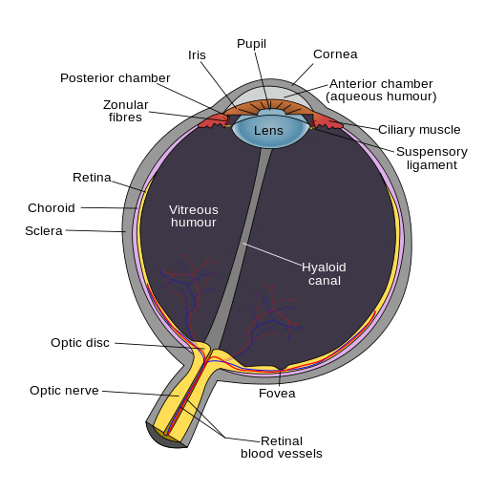

**Figure 16**. Schematic cross section of the human eye. Image courtesy of Wikimedia Commons.

These conditions are dealt with differently in terms of lighting, and are discussed separately.

* 1. Restricted iris expansion

Restricted iris expansion is typical in older people. As we progress from 20 to 60 years of age, the lighting needs of people with normal vision increases by a factor of three. This is a result of a tendency for the eye’s pupil to become smaller with age (less ability to open their iris) as well as a gradual clouding of the eye’s media, particularly the lens. Lighting needs become even more demanding for persons over 60 years of age.

The main effect of restricted iris expansion is a lack of light reaching the retina. This can be rectified by increasing the amount of light available (i.e. increase light levels for general lighting within a room or in task areas such as a reading nook and over kitchen benches).

* 1. Cloudiness within the lens or floaters within the vitreous gel

Cataracts are the loss of clarity (causing scattering of light) and stiffening of the lens of the eye (causing some loss of focussing; **Figure 17**). Cataracts appear as cloudiness in a person’s vision (Figure 18) and the effects are:

* blurred images;
* colours become washed out; and
* loss of contrast.

Scattering is most pronounced when high intensity light sources are present. With the light source being the brightest object in the room (by a few magnitudes), the resulting scattered light within the eye can also be brighter than objects of interest within the room (**Figure 18**). Therefore not having any bright light sources visible within the space is important.

Cross-sections of the eye showing how light is received as a single beam by someone with normal vision, and how light is received as scattered beams by someone with a cataract


**Figure 17**. The images show the way light is received by the eye of someone with normal vision (left) and with a cataract (right). Image courtesy of Huang Ophthalmology Center Inc.

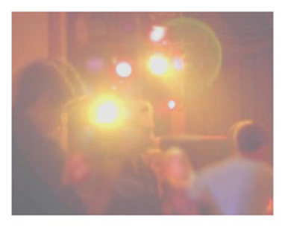

Figure 18. Impressions of the blurred vision of someone with cataracts (left); and how scattering of light within the eye appears from a bright light source – note the glare and double vision (right). Images courtesy of Wikimedia Commons.

Floaters are cellular debris within the vitreous. They may be seen as strings, streaks, clouds, bugs, dots, dust, or spider webs. These objects appear to be in front of the eye, but they are really floating in this fluid, and at the same time, casting their shadows on the retina and causing scattering on incoming light to the eye.

* 1. Damage to parts of the retina

The retina is a mesh of light receptors that provide the nervous signals allowing the brain to form an image of a scene. Any damage to receptors means that those parts of the image will not be created by the brain (i.e. black spots or holes in the image or, in more extreme circumstances, a cropped or centre punctured image). Macular degeneration and tunnel vision are examples of retinal damage and the resulting visual impairment manifests itself in three main forms:

1. reduction in visual acuity (clearness of vision);
2. limitations in the visual field (loss of central, peripheral or speckled vision); and
3. reduction of sensitivity to colour or luminance contrast.

The location of damaged receptors within the retinal mesh determines the best remedial measures that can be provided through lighting. The central area of the retina sees colour, needs relatively high levels of light to operate and has very high visual acuity (can see fine detail). Conversely, the peripheral area of the retina doesn’t see colour (only grey scale) and is very sensitive to light, so it operates in very low light levels but has low visual acuity (i.e. you cannot read with your peripheral vision). Losing either of these retinal regions means that lighting solutions should concentrate on lighting qualities which elevate the performance attributes of the remaining retinal region.

* 1. Macular degeneration

The macular is the area of the retina that is in the central part of our vision. It is the most sensitive to detail and provides most of our visual information. As it degenerates there is a loss of the central area of vision (**Figure 19**) and a person must become increasingly reliant upon peripheral vision. The effects include:

* way finding becomes increasingly difficult;
* signs are almost impossible to read; and
* most colour vision is lost because the cells receptive to colour are largely concentrated in the macular.

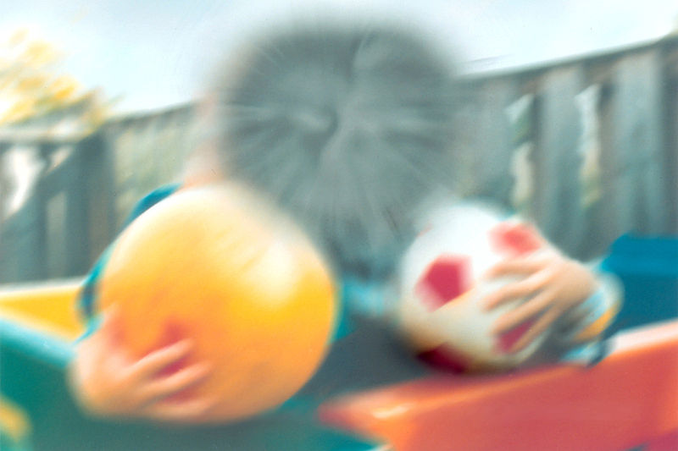

**Figure 19**. An impression of the image that someone suffering from macular degeneration may see. Image courtesy of Wikimedia Commons.

* 1. Tunnel vision

Tunnel vision can have a number of causes including glaucoma, retinitis pigmentosa and cataracts. The central part of vision remains but peripheral vision is virtually non-existent due to peripheral retinal cell damage (**Figure 20**). The effects include:

* loss of advanced warning of potential hazards in peripheral vision, making navigational progress slow; and
* very limited night vision as most of the cells receptive at low light levels are in the peripheral vision part of the retina.

The vision that someone suffering tunnel vision may see, with the outer area of vision missing


**Figure 20**. An impression of the image that someone suffering tunnel vision may see. Image courtesy of Wikimedia Commons.

* 1. Lighting design for the visually impaired

Below are the main lighting design features that will typically assist visually impaired people.

1. Relatively high and uniform light levels. Illuminances in rooms are recommended to be maintained at approximately twice the level listed in the regular design standard (see Australian Standard (AS) *1428 Design for access and mobility*).
2. Indirect lighting systems are recommended to avoid ‘spot’ lights and associated sensitivity to glare.
3. No flickering lights (either due to incompatibility of new LED and CFL light sources with dimmer switches, or lights situated in the ceiling behind rotating fan blades).
4. Use of good colour and luminance contrast for hand rails, doorway frames, wall switches and way finding signage. Luminance or grey scale contrast is particularly required for people with macular degeneration as their colour vision is failing. *AS 1428* specifies a minimum 30% luminance contrast between the key elements listed above and their adjacent surfaces.
5. Limit use of highly reflective (specular) surfaces (floors, bench tops, cabinetry, etc.), which may cause surface glare from sunlight and light sources.
6. Glass doors are difficult to identify (whether open or shut) particularly in an unfamiliar space. Additional safety markings/labels on the glass may be required with the features recommended in (d) above.
7. Direct sunlight entering the space should be minimised, as this will cause significant glare and non-uniformity.
8. In bedrooms there should be at least one light switch next to the bed, connected to a lamp, which is sufficient for safe navigation. Overhead lighting is preferred and two-way switches are also desirable.

**Note: If you have any doubts at all about an appropriate level of lighting for your client’s eyesight you should request that they seek the advice of their optometrist or doctor. Do not be tempted to simply increase light levels; while this may work there could also be unforeseen consequences for your client.**

1. Lighting and health

A number of health concerns were raised by the public during the initial phase-out of inefficient lighting, including ultra-violet (UV) exposure and the effects of flicker. These health concerns are primarily related to fluorescent lighting, in particular CFLs.

It is important to note that CFLs are not being mandated and mains voltage halogen (MVH) lamps may be used as an alternative. However, they are not as energy efficient as CFLs.

* 1. Minimising UV light exposure

Nearly all light sources emit UV radiation. Sitting close to a CFL or halogen lamp, and being able to see the exposed lamp means that some UV radiation will be received from the lamp.

While it is true that some CFLs do emit slightly more UV light than incandescent lamps, these emissions are not significant if the CFLs are installed more than 25 centimetres away from people, such as in ceiling fittings.

People concerned about UV exposure should minimise the time spent closer than 25 centimetres from CFLs or use 'double envelope' or 'covered' CFLs – these types of lamps look similar to 'pearl' incandescents.

While most people will not be affected by the minimal amount of UV radiation emitted by these lights, a person who is sensitive to UV and/or blue light, such as those who suffer from systemic lupus erythematosus, may need to consider using some of the following techniques or lamps to minimise the UV radiation reaching them.

Using a combination of the methods described below will reduce the UV levels to their lowest levels using practical and cost effective techniques. Visible light levels and lighting quality within the room does not need to be compromised to reduce UV exposure.

Enclosed lamp fixtures

The level of exposure to UV emissions can be reduced by filtering the UV from the light. This can be achieved by simply using a common lampshade, as most are UV absorbent. As a general rule, plastics are more absorbent of UV than glass shades. The lamp needs to be shaded in such a way that it is not possible to directly see the bare lamp unobstructed from any position in the room.

The best type of fixture is one that completely encloses the lamp within the fixture, for example, an opal sphere or globe fixture (**Figure 21**). It is important to ensure the CFL is recommended for use in an enclosed fixture, as some are not designed for this purpose and may overheat.

Filtered light from an enclosed spherical pendant lamp shade to a person sitting at a dining table
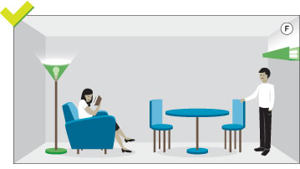

**Figure 21**. Examples of filtered light from a CFL enclosed in an opal sphere lamp shade (left) and indirect lighting (right).

Indirect lighting

Reflecting light from a lamp off an interior surface to light a room will significantly reduce UV levels. This lighting arrangement is commonly achieved through cove or torchiere-style lighting, where the lamp is obscured from the occupants by a pelmet or lamp fixture (**Figure 21**). The light from the fixture reflects off the wall or the ceiling, and in doing so minimises the UV because paint absorbs a significant amount of UV radiation.

Distance

UV levels rapidly decrease as a person moves further away from any light source. By doubling the distance between a person and the lamp, UV exposure can be reduced by 75 per cent. Simply moving a desk lamp or bedside lamp slightly further away is a very effective method of reducing UV exposure. However, it will depend on the person’s level of sensitivity, and how much UV is emitted from the lamp.

Double envelope CFLs

Double envelope CFLs (**Figure 22**) have a cover such as a second layer of glass or plastic over the spiral or bent glass tube. The cover makes them look like a traditional pear-shaped light bulb. This second envelope can block most of the UV emitted from the lamp. The amount of UV blocked by the second layer varies between products, however some models have been found to be lower in UV emissions than incandescent lamps of an equivalent visible light output.

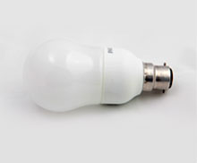

**Figure 22.** A double envelope CFL.

* 1. Flicker

As part of their normal operation fluorescent lamps flash on and off very rapidly – CFLs ‘flicker’ at a rate of more than 20,000 times per second (Hertz or Hz), modern linear fluorescent tubes at more than 5000 Hz, and older style linear fluorescents at 100 Hz. These rates of flickering of modern lamps are well above the level detectable by the human brain.

Photosensitive epilepsy

Photosensitive epilepsy is the name given to epilepsy in which all, or almost all, seizures are provoked by flashing or flickering light, or some shapes or patterns. Both natural and artificial light may trigger seizures. Various types of seizure may be triggered by flickering light.

**The frequency of flashing light most likely to trigger seizures varies from person to person. Generally it is between 8-30 Hz. CFLs ‘flicker’ at a rate well above this sensitive range and do not pose a hazard to sufferers of photosensitive epilepsy.**

Ménièr’s disease

Ménière's disease is a condition where excess fluid in the inner ear upsets the ear’s balance and hearing mechanisms. This produces symptoms such as vertigo (dizziness), tinnitus (ringing in the ears) and hearing loss.

There is no scientific evidence to suggest CFLs (or any fluorescent lights) can exacerbate or initiate symptoms of Ménière's disease. There are however, anecdotal reports that sufferers of Ménière's disease are more sensitive to flashing lights than others (because of their impaired balance systems), and so may be more susceptible to a phenomenon known as flicker vertigo.

**Flicker vertigo may arise from flicker rates in the range of 4–30 Hz. CFLs ‘flicker’ at a rate well above this sensitive range and so should not affect Ménière's sufferers.**

Migraines

Migraine is a common ailment which can be triggered by many different things, including stress, exercise, certain foods, bright light, flickering light, loud noises, strong smells, lack of sleep or too much sleep.

If light is suspected as the triggering event for migraines, ordinary headaches, or even eyestrain, the primary cause is likely to be glare, highly contrasting light, or inappropriate light levels. These problems are a result of poor lighting design rather than a feature of fluorescent lamps and can occur with any lighting technology if used inappropriately. Light fittings that enclose lamps and distribute light evenly without compromising light output and efficiency can help avoid these problems.

**While light sources with a detectable flicker can trigger migraines in susceptible individuals, CFLs 'flicker' at a rate well above that detectable by the human brain and so should not affect migraine sufferers.**

The [Department of Industry](http://www.industry.gov.au/Energy/EnergyEfficiency/Lighting/Pages/default.aspx) website provides further information regarding lighting and health (www.industry.gov.au/Energy/EnergyEfficiency/Lighting/Pages/default.aspx).

1. Glossary of basic lighting terminology

Ballast

A component of conventional control gear. It controls the current through the lamp, and is used with discharge lighting, including fluorescent and high intensity discharge lamps. The term is sometimes used loosely to mean control gear. Also called a choke.

Colour rendering

An indicator of how accurately colours can be distinguished under different light sources. The colour rendering index (CRI) compares the ability of different lights to render colours accurately with the measurement of 100 considered to be excellent. A value of 80 and above is good and appropriate for most situations where people are present. Where colour identification is important, a value of 90 or above should be used.

Colour temperature

Also known as colour appearance, the colour temperature is the colour of ‘white’ the light appears. It is measured in Kelvin (K), and ranges from 1800K (very warm, amber) to 8000K (cool). 6500K is daylight. There are many colours of ‘white’ available. For general use these are: warm white (2700–3300K), cool white (3300–5300K) and cool daylight (5300–6500K).

Control gear

A ‘package’ of electrical or electronic components including ballast, power factor correction capacitor and starter. High-frequency electronic control gear may include other components to allow dimming etc.

Diffuser

A translucent screen used to shield a light source and at the same time soften the light output and distribute it evenly.

Discharge lamp

A lamp which produces illumination via electric discharge through a gas, a metal vapour or a mixture of gases and vapours.

Efficacy (luminous efficacy)

The ratio of light emitted by a lamp to the power consumed by it, that is, lumens per Watt. When the control gear losses are included, it is expressed as lumens per circuit Watt. The higher the efficacy the more efficient the product.

Illuminance

The amount of light falling on an area, measured in lux. 1 lux is equal to one lumen per square metre. The higher the Lux, the more visible light on a surface area.

Intensity (Candela)

Intensity is the amount of light radiated in a given direction, measured as Candela (cd). The higher the Candelas the more intense the light.

Kelvin

A measure of colour temperature for lamps.

Light output ratio (LOR)

The ratio of the total amount of light output of a lamp and luminaire to that of just the bare lamp.

Luminaire

A light fitting and lamp including all components for fixing and protecting the lamps, as well as connecting them to the supply.

Lumen

Unit of luminous flux, used to describe the amount of light produced by a lamp. The higher the lumens, the more visible light emitted by the lamp.

Luminance (Candela/m2)

Luminance indicates how bright an object will appear and is measured as candela (intensity) per m2. The higher the luminance the brighter the object will appear.

Lux

An international unit of measurement of illuminance intensity of light.

Rated average lamp life

The number of hours after which half the number of lamps in a batch fail under test conditions.

Re-strike

The time taken for a lamp to illuminate after being switched off and then on again.

Start-up

The time taken for a lamp to illuminate after being switched on from cold.

Universal operating position

Refers to a lamp that can be oriented in any way without affecting light quality.

**E3 Energy efficient lighting and lighting design: training guide for retailers**

**www.energyrating.gov.au**