

**__________________________________________________________**

**Technical appendix to consultation paper:**

**Technical Working Group recommendations**

**Recommendation 1: Adoption of EU efficiency levels for refrigerated display cabinets**

**Proposed efficiency levels for refrigerated display cabinets in Australia and New Zealand**.

The proposed AU/NZ efficiency levels for Refrigerated Display Cabinets are based on minimum efficiencies aligned with previously published European levels with adjustments to one cabinet category. These are shown in the appended summary table. The intention is to base the efficiency requirements on the EU Efficiency Regulations (See Option 4: Consultation RIS July 2016 Page 27).

Proposed efficiency levels follow the policy option 4 proposals apart from IRV-4, Integral Refrigerated Vertical Cabinet with Glass doors that follows a modified policy option 4 to take into account the change from a volume based metric back to a TDA based metric. The efficiency levels, based on an Energy Efficiency Index (EEI) together with the dates of introduction, are shown in the table below:

|  |  |
| --- | --- |
| Proposed EU energy efficiency levels for refrigerated display cabinets | |
| Introduction | Specific refrigerated display cabinets |
| From 1 December 2019 | EEI < 130 |
|
|

**Specific display cabinets**

Efficiency levels for the majority of refrigerated display cabinets will be covered by the test methods set out in ISO 23953:2015.

The EN standard covering test methods for Beverage Coolers (Item 3 in the table below) has not been included, based on the recommendation not to adopt the EN 16902 standard. Therefore cabinets that would have been covered by EN 16902 will still have a separate group but will be included with refrigerated display cabinets and be covered by the test methods set out in ISO 23953, with local amendments. Other test methods for more specialised cabinets such as small Ice-Cream Freezers and Gelato Scooping Cabinets have been agreed upon with minor local changes.

Efficiency in the form of an Energy Efficiency Index (EEI) is determined using the daily energy consumption of a cabinet in kWh, the metric of refrigerated net volume of the cabinet in litres, and formulae including constants as set out in regulations.

An Energy Efficiency Index (EEI) provides a direct measure of performance of an energy using product by comparing the actual power consumption of a product with a reference or standard power consumption for the same type of product.

The reference power consumption is based on a calculation from a set formula using total display area or refrigerated storage volume and constants established for groups of cabinets. The constants were established from analysis of test results and to some extent normalises the reference power consumption within groups of products.

As an example if the actual energy consumption of a tested cabinet is measured and found to be 15 kWh/24h and the calculated reference energy consumption is determined to be 22 kWh/24h. The EEI would be:

EEI = 15/22 x 100/1

= 68.2

The energy consumption of this example is 68.2% of the energy consumption of the reference cabinet.

The EEI of display cabinets is a ratio of their Annual Energy Consumption compared to a Standard Annual Energy Consumption, to 1 decimal place:

**EEI = (AEC/SAEC) × 100**

Where:

**AEC=E24h × 365**

**SAEC= (M + N × Y) × 365 [1]**

The M and N values of constants for specific refrigerated display cabinets and proposed MEPS levels are shown in the **tables below**.

Note that Small ice-cream freezers are included in Item 5, Group IFH-5 and Ice-cream and gelato scooping cabinets are shown separately as Item 16.







**Recommendation 2: Adoption of EU efficiency levels for refrigerated storage cabinets**

**Proposed efficiency levels for refrigerated storage cabinets in Australia and New Zealand.**

The proposed efficiency levels for Refrigerated Storage Cabinets are those currently applied in Europe which were implemented under Commission Regulation (EU) 2015/1095 on 5 May 2015 (see Consultation RIS July 2016 Page 27).

The efficiency levels based on an Energy Efficiency Index (EEI) together with the dates of introduction are shown in the table below:

|  |  |  |
| --- | --- | --- |
| Proposed EU energy efficiency levels for refrigerated storage cabinets | | |
| Introduction | Refrigerated storage cabinets  Light and Normal Duty | Heavy duty cabinets |
| 1 December 2019 | EEI < 95 | EEI < 115 |
|
|

For regulatory purposes, Refrigerated Storage Cabinets are grouped into four categories based on physical characteristics:

* + Vertical Chilled
  + Vertical Frozen
  + Counter Chilled
  + Counter Frozen

These products are then further classified by a Duty Rating based on the ambient conditions in which the cabinets are intended to operate:

* Light duty
* Normal duty
* Heavy duty

The standard detailing the test method for these cabinets is EN 16825:2016, *Refrigerated storage cabinets for professional use – Classification, requirements and test conditions.*

Testing to determine the temperature performance is carried out as follows:

* Light duty cabinets are tested at Climate Class 3 (25oC and 60% RH), and must not be capable of attaining Climate Class 4 (30oC and 55% RH).
* Normal duty cabinets are tested at Climate Class 4 (30oC and 55% RH),
* Heavy Duty cabinets at Climate Class 5 (40oC and 40 % RH).

Measurement of energy consumption for the purposes of determining energy efficiency is carried out at as follows:

* Light duty cabinets are tested at Climate Class 3 (25oC and 60% RH). [2]
* Normal duty and heavy duty cabinets are tested at Climate Class 4 (30oC and 55% RH).[3]

The efficiency in the form of an Energy Efficiency Index (EEI) is determined using the daily energy consumption of the cabinet in kWh, the metric of refrigerated net volume of the cabinet in litres, and formulae including constants as set out in the regulations.

The method of calculation as set out in the EU Regulations uses the method and formulae as shown in the following which also includes a hypothetical example:

**Equations required to calculate the Energy Efficiency Index (EEI) of RSC’s**

EEI = (AEC/SAEC) ×100[1]

Where:

AEC=E24h ×*af* ×365 [2]

AEC = Annual Energy Consumption of the cabinet in kWh/year

E24h = energy consumption of the cabinet over 24 hours

*af* = adjustment factor to be applied only for light-duty cabinets

(For chillers *af* = 1.1 and for freezers *af* = 1.2)

SAEC= M × VN +N[3]

SAEC = Standard Annual Energy Consumption of the cabinet in kWh/year

VN = net volume of the appliance, which is the sum of net volumes of all compartments of the cabinet, expressed in litres.

M and N = constant coefficients.

Storage cabinets have defined M and N coefficients for different types of cabinet as shown in the table below:

**M and N values of constants for refrigerated storage cabinets.**

|  |  |  |  |
| --- | --- | --- | --- |
| M and N coefficient values for calculating SAEC of refrigerated storage cabinets | | | |
| Category |  | Value for M | Value for N |
| Vertical Chilled (VC) | | 1.643 | 609 |
| Vertical Frozen (VF) | | 4.928 | 1472 |
| Horizontal counter Chilled (HC) | | 2.555 | 1790 |
| Horizontal counter, Freezer (HF) | | 5.840 | 2380 |

For the purposes of a graduated implementation system and also for European energy labelling a series of Energy Efficiency Classes based on EEI tiers was developed.

While mandatory labelling has been discounted for Australia and New Zealand, the graduated EEI tiers do provide a good guide and series of defined steps for future improvements in efficiency levels.



**Example calculation of EEI**

Calculation of the Energy Efficiency Index (EEI) of a Refrigerated Storage Cabinet

As an example a Vertical Refrigerated Storage Cabinet (VC) with a Net Volume (VN) of 576 litres when tested has a measured energy consumption per day (E24h) of 4.13 kWh.

(1) The Annual Energy Consumption (AEC) would be calculated using the formula [2] with E24h = 4.13 kWh:

AEC = E24h × *af* ×365

= 4.13 x 365

= 1507.45 kWh/year.

(2) The Standard Annual Energy Consumption (SAEC) is then calculated using the coefficients in the Table, for type VC being M = 1.643 and N = 609; and VN = 576 using formula [3]:

SAEC = M × VN +N

= (1.643 x 576) + 609

= 1555.37 kWh/year.

(3) To calculate the EEI using formula [1]:

Where from the above step (1) AEC = 1507.45 and (2) SAEC = 1555.37

EEI = (AEC/SAEC) × 100

= 1507.45/1555.37 x 100

= 96.9

This example cabinet would not be compliant after the December 2019 implementation date as the regulated EEI will be 95.[4]

**Recommendation 3: Three defined registration channels**

1. Single Model registrations
2. Family model registrations
3. Deemed to Comply registrations

**FAMILY OF MODELS - Definition**

A family of models is a range of models of the same brand.[5] Each family is based on a ‘parent’ model that has undergone a certified performance test and is registered on the energyrating.gov.au website. All other models in the family must have the same or better energy rating characteristics than the ‘parent’ model. The parent model certified performance test documentation is required to be uploaded at point of registration, along with (physically identifiable) model number variations for all models that are being registered as members of the same family. A maximum of 20 family member models are permitted in a family registration.

**Models that are part of a family**

To be included as a member of a family, all of the following conditions must be met:

1. At point of registration the least efficient model is selected as the parent model and the registration individually identifies all other same or better efficiency models in the family; and,
2. Family member models must not exceed the allowable maximum energy consumption[6] (TEC/TDA) in kWh/day/m2 or (TEC/VN) in kWh/day/m3 of the parent model; and,
3. Family member models must have an identical or warmer product temperature range (M-package temperature) than the parent model; and,
4. Family member models must be of an identical cabinet type and use the same method of access to products being displayed or stored as the parent model (either all open or all closed cabinets).

**Parent model of a family of self-contained cabinets**

To assist in determining the model to be selected as the ‘parent’ of a family of self-contained cabinet models, the following guidelines in the below table set out criteria which can be applied to identify the model that would be subjected to the most onerous test conditions, and will produce the highest allowable maximum energy consumption and thus be the least energy efficient.

|  |  |
| --- | --- |
| **Self-contained commercial display cabinets – Energy performance characteristics of families** | |
| **Performance affecting criteria** | **Rule applied to give most onerous conditions** |
| Maximum allowable energy consumption (TEC/TDA) in kWh/24h/m2or (TEC/VN) in kWh/day/m3.  Also known as Standard Energy Consumption (SEC). | The model with the highest or equal highest maximum allowable energy consumption (TEC/TDA) or (TEC/VN) must be the parent model. |
| M-Package temperature class (e.g. M1, M2, etc. for Medium temperature and L1, L2, etc. for Low temperature.) as defined in the relevant standard. | The cabinet with the coldest M-package temperature class relevant to the temperature application must be the parent model. |
| Climate Class (e.g. Climate Class 3, 4, 5, etc.) as defined in the relevant standard. | The climate class rating must include the climate class prescribed for energy rating purposes by the relevant  Standard or Regulations (i.e. generally Climate Class 3 or Climate Class 4). |
| Cabinet Type | Cabinets must be of the same type and configuration as the parent model (e.g. all open cabinets or all closed cabinets with doors or lids). |
| Air curtain on open cabinets[7] | The cabinet with the largest vertical opening height (air curtain) must be the parent model. |
| Doors on closed cabinets[8] | Where doors are fitted they must be of the type that results in the worst energy consumption (i.e. hinged/swing without magnetic seals, or sliding or hinged/swing with magnetic seals). |
| Electrical components | The cabinet with the greatest aggregate electrical energy consumption of the electrical components must be the parent model. |
| Refrigeration system components  (Non-electrical) | Refrigeration system components must have the same or better efficiency as the parent model. |
| Cabinet depth | The cabinet with the greatest depth must be the parent model. |
| Cosmetic appearance/finish[9] | Any cabinet may be the parent model providing the cosmetics or finish do not have an effect on the energy performance characteristics. |

**Parent model of a family of remote cabinets**

To assist in determining the model to be selected as the ‘parent’ of a family of remote cabinet models the following guidelines set out criteria which can be applied to identify the model that would be subjected to the most onerous test conditions and will produce the highest allowable maximum energy consumption and thus be the least energy efficient.

|  |  |
| --- | --- |
| **Remote commercial display cabinets – Energy performance characteristics of families** | |
| **Performance affecting criteria** | **Rule applied to give most onerous conditions** |
| Maximum allowable energy consumption (TEC/TDA) in kWh/24h/m2.  Also known as Standard Energy Consumption (SEC). | The model with the highest or equal highest maximum allowable energy consumption (TEC/TDA) must be the parent model. |
| Modular cabinet lengths | Cabinets that are of modular construction must have a total display area (TDA) that is directly proportional to the cabinet length. |
| Electrical components | The cabinet with the greatest aggregate electrical energy consumption of electrical components must be the parent model. |
| M-Package temperature class (e.g. M1, M2, L1, L2, etc.) as defined in the relevant standard. | The cabinet with the coldest M-package temperature class must be the parent model. |
| Climate Class (e.g. Climate Class 3, 4, 5, etc.) as defined in the relevant standard. | The climate class rating must include the climate class prescribed for energy rating purposes by the relevant standard or regulations (i.e. generally Climate Class 3 or Climate Class 4). |
| Cabinet Type | Cabinets must be of the same type and configuration as the parent model (e.g. all open cabinets or all closed cabinets with doors or lids). |
| Air curtain on open cabinets | The cabinet with the largest vertical opening height (air curtain) must be the parent model. |
| Doors on closed cabinets | Where doors are fitted they must be of the type that results in the worst energy consumption (i.e. hinged/swing without magnetic seals or sliding or hinged/swing with magnetic seals). |
| Cabinet depth | The cabinet with the greatest depth must be the parent model. |
| Refrigeration system components  (Non-electrical) | Refrigeration system components must have the same or better efficiency than the parent model. |
| Cosmetic appearance/finish | Any cabinet may be the parent model providing that the cosmetics or finish do not have a detrimental effect on the energy performance characteristics. |

**Alternative components in models that are part of a family**

Alternative components are permitted to be substituted in a family registration provided the components have the same or better specification and performance. Compliance activity and check testing will be used to ensure registered performance is maintained.

**DEEMED TO COMPLY**

Deemed to comply is an alternative registration method for cabinets that are produced in low quantities (i.e. one-offs, bespoke/custom or built in) that cannot be tested in a standard testing facility.

**Deemed to Comply Pathway to Registration**

A certified performance test to a recognised standard is the most certain method for a risk free assessment but the practicalities and relative costs are prohibitive with low volume cabinets and generally outweigh the overall benefits. In this scenario, a simple method of analysing the energy characteristics of a design to demonstrate the energy efficiency of a cabinet relative to the regulated minimum efficiency level is a more viable approach.

ISO 23953.2:2015 (Annex D) sets out a method for establishing data requirements for Standard Ratings and evaluating alternative components for both remote and self-contained refrigerated display cabinets based on the AHRI 1200 Standard.[10] This method is also incorporated into Annex B of EN 16838:2016.

These methods have conditions. For example, if an electrical component increases energy consumption then the cabinet efficiency must be revised based on actual measurements. If there has been an energy reduction, the calculation or measurement method can be used.

Using Annex D the following information would be required:

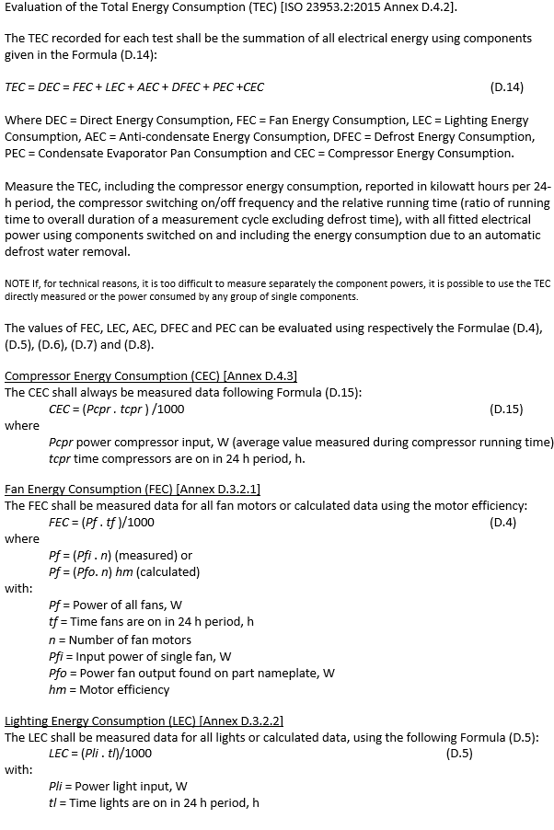

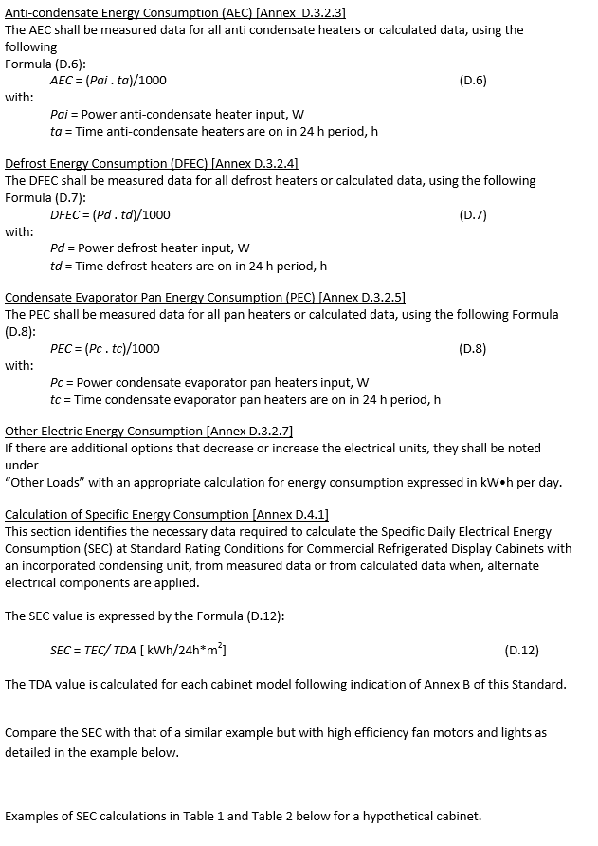

Please note that these examples are applicable to integral self-contained cabinets only. For remote cabinet Deemed to Comply, calculations up to and including formula D7 are used followed by the Carnot formula for REC as detailed in ISO 23953.2:2015 Cl 5.3.6.3.3 (Also AS1731.12 Cl 6.3 and shown below:

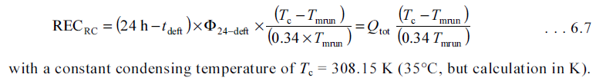

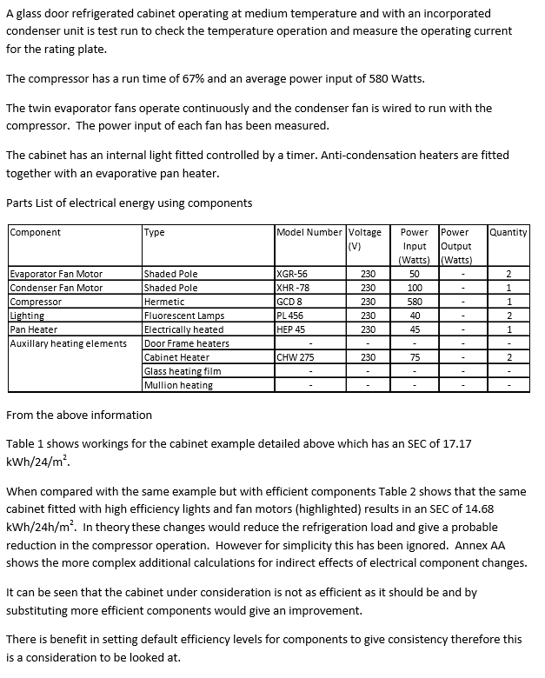

When submitting efficiency data for a cabinet that has been calculated rather than by an actual test it is expected that a calculation adjustment factor of an additional 15% would be added to the energy consumption to take into account real-world operation.

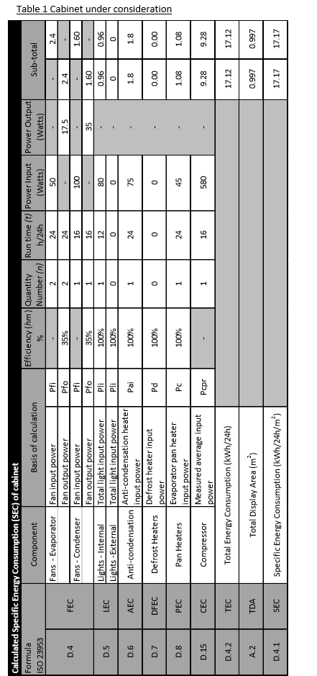

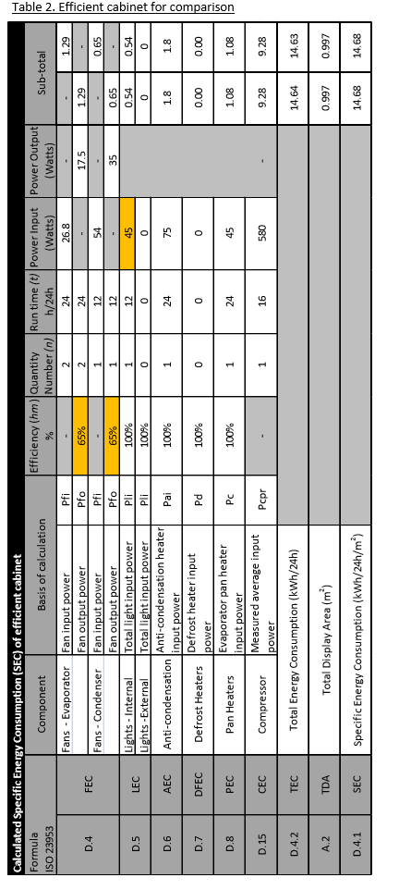

**Summary of Technical Working Group inputs into proposed standard test methods**

The Technical Working Group (TWG) was formed in the second half of 2016 with the purpose of providing stakeholder input into the proposed international standards and aligned test methods based on the European Directive for regulating the efficiency of electrical energy using appliances and equipment. Initially a face-to-face meeting of all stakeholders was held in Sydney, Australia in November 2016. This was followed by six web-conferences of stakeholders with interests in specific technical areas and cabinet types and a further face-to-face meeting of all stakeholders held in Sydney in June 2017.

The following technical standards were reviewed by the TWG. In some instances the TWG proposed amendments to improve the suitability of these standards for use in Australia and New Zealand as test methods for evaluating the energy efficiency of refrigerated display cabinets and refrigerated storage cabinets:

**ISO 23953.1:2015** *Refrigerated Display Cabinets— Part 1: Vocabulary*

**ISO 23953.2:2015** *Refrigerated Display Cabinets— Part 2: Classification, requirements and test conditions*

**EN 16825: 2016** *Refrigerated storage cabinets and counters for professional use —*

*Classification, requirements and test conditions*

**EN16901:2016** *Ice-cream freezers — Classification, requirements and test conditions*

**EN 16838:2016** *Refrigerated display scooping cabinets for gelato – Classification, requirements and test conditions.*

The following technical standard was reviewed by the Technical Working Group and determined that, even with amendments, it would not be suitable as a practical test method for regulating the energy efficiency of refrigerated cabinets for displaying beverages:

**EN 16902:2016** *Commercial beverage coolers — Classification, requirements and test conditions*

In addition, the TWG reviewed and discussed possible solutions to provisions in the regulations that are not covered specifically by technical standards for:

**Deemed to Comply pathway to registration**

**Family registrations**

The required provisions as agreed by the Technical Working Group are summarised as follows:

**ISO 23953.1 Test requirements for Australia and New Zealand (Recommendation 6)**

ISO 23953.1:2015 *Refrigerated Display Cabinets— Part 1: Vocabulary* was discussed and accepted as suitably descriptive to quantify energy efficiency of Refrigerated Display Cabinets in Australia and New Zealand with the following provisions.

**Clause**

**3.4.11** Removal of a redundant definition of VPA or Visibility of Foodstuffs using the Arc Method.

The relevant Appendix in ISO 23953.2 referring to the VPA method has been removed in the 2015 edition.

AS 1731 incorporates an Appendix E, which also relates to VPA but has never been called up and has caused confusion as it is in the standard and not used.

3.4.11 *Delete* clause. No longer applicable

**3.7.1** Addition of a Note to clarify that ‘product family’ in ISO 23953 refers to what is known as product ‘Types’ in AS 1731.

A ‘product family’ in this case is a group of products with similar physical characteristics such as HC1, HC2, VC4 etc where as an example VC4 are Vertical glass door chillers with any number of vertical doors.

3.7.1Addition of a note

NOTE 2 to entry: Referred to in AS 1731 as Types

**ISO 23953.2 Test requirements for Australia and New Zealand (Recommendation 7)**

ISO 23953.2:2015 *Refrigerated Display Cabinets— Part 2: Classification, requirements and test conditions*  was discussed and accepted as a suitable test method for energy efficiency of Refrigerated Display Cabinets in Australia and New Zealand with the following provisions:

**Clause**

**4.1.1.6** Removal of the requirement for specific minimum dimensions for sneeze guards and replace with a Note regarding specific designs or dimensions may be required in some jurisdictions, which aligns with AS 1731.2 requirements. There are a large number of types of cabinets and sneeze guards designs possible and it is doubtful if a single diagram of a specific type of product would cover all variations.

4.1.1.6 *Delete* the last sentence.

*Delete* Figure 1 diagram.

*Insert* a Note after the last paragraph:

NOTE 1 to entry: Specific designs or dimensions for sneeze guards may be required in some jurisdictions.

**4.1.5** ISO 23953.2 does not include requirements for light switches to be fitted, therefore additional wording was proposed, similar to that used in AS 1731, toencourage, although not mandate, energy reduction through the use of controls to enable all or part of the lighting to be controlled. Testing with lights on continuously and without lights for twelve hours on would show up energy reduction possible and highlight effect of not having controlled lighting. Addition of a Note to highlight testing with and without lighting that might be required.

4.1.5After the existing text *add* the following text and a NOTE:

Cabinets should incorporate a means of controlling all or part of the lighting using a manual switch, sensor, time clock or a similar automatic device.

NOTE 1 to entry: Cabinets without lighting controls would be required to be tested with the lighting operating continuously during 5.3.2.7.

**4.1.6** ISO 23953.2 does not take into account remote temperature monitoring and actual industry practice therefore additional wording was proposed to include the means of remote monitoring to indicate correct operation of the system and a Note referring to the possible requirements of local jurisdictions for food safety and health reasons.

4.1.6*Replace* the existing paragraph with the following text:

The cabinets shall incorporate a temperature display instrument, or a means of temperature monitoring, showing the air temperature in the

Refrigerated Display abinets to provide an indication of the operation and functioning of refrigerating equipment and information on its operating state.

After the existing note, *add* an additional Note 2:

NOTE 2 to entry: Certain jurisdictions may have specific requirements for temperature displays for health and food safety reasons.

**5.3.2.3.2** Revert to the requirements of AS 1731 regarding the loading height of test packages for closed chillers. Test evidence was produced that showed the full height loading between shelves was more onerous that the existing half height loading, noticeably increasing the energy usage of a cabinet and increasing the temperature spread of the product. This would result in products effectively needing to be retested and also overdesigned to comply with the ISO requirements and resulting in increased energy consumption. Historical use of AS 1731 as a test method has not proved any need to make this test more onerous.

5.3.2.3.2*Replace* (b) with the following text:

(b)For open cabinets with a minimum of two superimposed refrigerated shelves, the loading height shall be equal the free height between the refrigerated shelves minus 25 mm, with a tolerance of +0/−25 mm (see Figures 20 to 24 and Figure 26).

*Replace* (d) with the following text:

(d) For all closed vertical cabinets, the loading height shall be equal to half of the maximum free height above the refrigerated shelf, with a tolerance of +25/-0 mm (see Figure 27).

*Replace* the description of Figure 27 with the following text:

Figure 27 - Vertical closed cabinet (4 shelves) with glass door

**5.3.3.2 (i)** Revert to the requirements of AS 1731 regarding the door opening frequency for closed chillers. Test evidence was produced that showed the increased door/lid opening frequency and opening time caused a significant increase in the energy consumed by a typical self-contained cabinet. This would result in large numbers of products requiring to be retested, effectively needing to be overdesigned to comply with the ISO requirements, and resulting in increased energy consumption. Further evidence was produced showing the energy consumption of a number of existing products being used in an unusually high turnover field situation was actually less than the energy consumption measured during testing to AS 1731. This shows that the door opening frequency currently specified in AS 1731 is realistic for trans-Tasman field applications and that there is no evidence to suggest a more onerous test is required for closed chillers. When ISO 23953:2012 was being developed, European interests pushed for the more onerous test as they felt in supermarket situations it was needed - a position which the joint Australia/NZ committee for AS 1731 felt at the time was not reflective of the actual use of closed self-contained chillers.

**5.3.3.2 (ii)** Remove the last sentence of the clause that states ‘For closed cabinets only the test of 5.3.2.7.1 (b) is required’ i.e. with cabinet lighting switched on for 12 hours and off for 12 hours.

This apparent relaxation conflicts with a number of other clauses: 5.3.2.7.1, 5.3.3.1, 5.3.5.1 and 5.3.6.1 that state ‘Lighting and night covers, if any, shall be manipulated according to 5.3.2.7.’ This would be taken to mean that both 5.3.2.7.1 a) and b) conditions need to be tested. In some instances, depending on the lighting control system used, it may only require a single test.

Currently AS 1731 requires lighting and anti-sweat heaters to be running continuously unless controlled by an automatic device such as a time-clock or sensor. See also 4.1.5 above.

In addition, 5.3.5.2 and 5.3.5.3 state that the TEC and DEC should be measured ‘.....with all fitted electrical power-using components switched on.’

Maximum energy consumption and minimum efficiency should be determined as the worst case.

5.3.3.2*Replace* the existing clause with the following new text:

The test for closed refrigerated cabinets shall always be carried out on the complete cabinet, regardless of the number of doors or lids. Each door or lid shall be opened six times per hour. Doors that are used for

service, cleaning or loading of the cabinet only shall not be opened during this test. Where more than one door or lid pertains to the cabinet under test, the sequence in which the doors and lids are opened shall be staggered, i.e. in the case of two doors: door 1 at 0 min, door 2 at

5 min, door 1 at 10 min, door 2 at 15 min, etc.

Hinged lids and doors shall be opened beyond an angle of 60°. Sliding glass doors or lids shall be opened beyond 80 % of the maximum area which can be opened.

The door or lid shall be opened for a total of 6 s. During this opening period, the doors or lids shall be kept open beyond the minimum required opening for 4 s.

Prior to the start of the 12-h period of door opening, each door or lid shall be opened once for 3 min.

Where a cabinet is provided with more than one door or lid, each door or lid shall be opened once for 3min consecutively.

Within the test period, the doors or lids shall be opened cyclically for 12 h within 24 h. The 12-h cycle of door or lid opening shall start at the beginning of the test period.

**EN 16825 Test requirements for Australia and New Zealand (Recommendation 8)**

EN 16825:2016 *Refrigerated storage cabinets and counters for professional use — Classification, requirements and test conditions* was discussed and accepted as a suitable test method for energy efficiency of Self-Contained Refrigerated Storage Cabinets in Australia and New Zealand with the following provisions:

**Clause**

**4.2.3.** To align with the requirements of ISO 23953 an additional requirement was proposed that cabinet performance shall not be impaired by water vapour condensation.

4.2.3*Replace* the existing clause with the following text:

The performance of cabinets shall not be impaired by water vapour condensation. The amount of water vapour condensation shall be verified according to the conditions and test methods specified in 5.3.5.

**5.3.2.8** To allow the continued the useof thealternative (Australian) test filler packages an additional clause with wording similar to that used in ISO 23953 and aligning with AS 1731 was proposed.

This will allow test facilities that have been using alternative test filler packages to continue with their use. They have been shown by Australian tests to be equivalent to the ISO test filler packages and also accepted as an alternative in ISO 23953.

5.3.2.8*Add* new clause 5.3.2.8:

5.3.2.8 Alternative for filling test packages

Alternative filling test packages having the dimensions shown in Table 4 and density of (480 ± 80) kg/m3 can be used, except for rows and columns on transverse section containing M-packages.

This test package may be a box made of plastic material of any density, and of 1 mm nominal thickness. Cellular or foam material shall not be used. The case shall not incorporate any protrusions that would cause the vertical separation of packages in a stack. Opposite faces shall be substantially parallel, and moulding draft shall be the minimum practicable. Seams or joints shall not result in protrusions sufficient to cause significant air gaps between adjacent packages.

Colour can be important if dark enough to be affected by ambient heat radiation; however, a pastel colour, e.g. light pink, pale blue or green, shall have no significant effect in normal surroundings.

The contents shall be water containing 0.08 % of para-chlorometa-cresol and 0.5 % of sodium chloride, soaked into a porous material such as a natural, plastics or cellulose sponge.

**5.3.3.3.1** Additional wordingto refer to new clause 5.3.2.8 to permit loading of cabinets with alternative (Australian) test filler packages.

5.3.3.3.1 *Replace* the first sentence of the existing clause with the following text:

The cabinet shall be loaded with test packages (see 5.3.2.4 and 5.3.2.8) and M-packages (see 5.3.2.5) up to half the load limit, as illustrated in Figures 5 to 8.

**5.3.5.1** Introduce revised requirements for Water Vapour Condensation test to test cabinets at the climate class that they are intended to be operated at, instead of more onerous humidity conditions that differ from the defined climate classifications for Light, Normal and Heavy duty. It appears that the outcome of the tests is for information only and not used as Pass/Fail performance criteria. This is not clear in the Standard as written.

Retain the more onerous test requirements but purely as an option for information only, and with renumbered clauses 5.3.5.5, 5.3.5.6 and 5.3.5.7. Possibly with less onerous test room conditions for Light duty and Normal duty cabinets at Climate Class 6 instead of Climate Class 7.

Introduce revised requirements that all of the condensation tests are carried out with the cabinets loaded with test packages instead of either loaded or empty as this test variable can have an effect on the outcome of the test and thus could make the results non-reproducible unless multiple tests in each condition are carried out.

The ambiguity in the standard and unusual test requirements to be queried with the EN committee/project group for EN 16825 with a view to at least correct the conflicting requirements and definitions.

5.3.5.1 *Replace* the existing clause with the following text:

5.3.5.1 Test conditions for all cabinets

The cabinet shall be located and loaded in accordance with 5.3.1 and 5.3.2, operated in accordance with the manufacturer’s instructions at the conditions appropriate to the test room climate class for which it is intended (see Table 3), and then once stable conditions have been reached operated for the test period of not less than 24 h.

The test may be carried out during the temperature test.

If anti-condensation heaters are provided, which can be switched on and off by the user, they shall be switched off. If, however, running water appears externally when the cabinet is subjected to the water vapour condensation test, the test shall be repeated with the anti-condensation heaters switched on.

Before starting the test period, all external surfaces of the cabinet shall be carefully wiped dry with a clean cloth. If the cabinet is fitted with automatic defrosting equipment this test period shall be selected during the period when condensation is most likely to occur.

**5.3.5.4** Reworded to follow the clearer and more logical test requirements brought about by the change to 5.3.5.1 which includes reporting areas of condensation exhibiting fog and droplets in addition to those depicting running water at the climate class conditions the cabinets are intended to operate in.

5.3.5.4 *Replace* the existing clause with the following text:

5.3.5.4 Expression of results and test report

A coded sketch shall be made showing the maximum area and degree of condensation appearing during the test on all external surfaces; the codes shown in Figure 13 shall be used to indicate this.

The test report shall also indicate the selected test period and the duration of the period of observation and shall state whether any manual switch provided for anti-condensation heaters was switched on or off.

**5.3.5.5, 5.3.5.6** and **5.3.5.7.** Additional requirements toinclude the optional high humidity water vapour condensation test to follow the clearer and more logical test requirements brought about by the change to 5.3.5.1.

Following Figure 13 *Add* new clause after Figure 13.

5.3.5.5 High humidity water vapour condensation test (optional)

The cabinet shall be located and loaded in accordance with 5.3.1 and 5.3.2, operated in accordance with the manufacturer’s instructions at the following test room climate class conditions (as listed in Table 3):

Light duty and normal duty cabinets: Climate Class 6

Heavy duty cabinets: Climate Class 7

Once stable conditions have been reached, cabinets shall be operated for the test period of not less than 24 h.

If anti-condensation heaters are provided, which can be switched on and off by the user they shall be switched off. If, however, running water appears externally when the cabinet is subjected to the water vapour condensation test, the test shall be repeated with the anti-condensation heaters switched on.

Before starting the test period, all external surfaces of the cabinet shall be carefully wiped dry with a clean cloth. If the cabinet is fitted with automatic defrosting equipment this test period shall be selected during the period when condensation is most likely to occur.

**5.3.5.6** *Add* new clause:

5.3.5.6 Observations

During the test period, external surface areas exhibiting fog, droplets or running water shall be outlined and coded by the letters “A”, “B” and “C”, respectively (see Figure 13).

**5.3.5.7** *Add* new clause:

5.3.5.7 Expression of results

A coded sketch shall be made showing the maximum area and degree of condensation appearing during the test on all external surfaces; the codes shown in Figure 13 shall be used to indicate this.

The test report shall also indicate the selected test period and the duration of the period of observation and shall state whether any manual switch provided for anti-condensation heaters was switched on or off.

**5.3.6.2** Addition of a Note to highlight the need for manually switched anti-condensation heaters to be switched on during the electrical energy consumption test. Otherwise, the most onerous condition with all energy using components active will not be measured.

5.3.6.2 After the existing text *add* the following Note:

NOTE 1 to entry: Manually switched anti-condensation heaters shall be switched on during the test.

**6.4.4** A revised Table 11is required to ensure that the modified reporting of results of the Water Vapour condensation test is correctly recorded.

6.4.4 *Replace* existingTable 11 with new Table 11.

|  |  |  |  |
| --- | --- | --- | --- |
| **Table 11 - Water vapour condensation tests** | | | |
| **Sub-clause no.** | **Description** | **Symbol** | **Unit** |
| 5.3.5.1 | Whether any manual switch provided for anti-condensation heaters was switched off | - | - |
| 5.3.5.3 | The duration of the period of observation | - | h |
| Coded sketches as defined in 5.3.5.4 | - | - |
| 5.3.5.5 | Whether any manual switch provided for anti-condensation heaters was switched off | - | - |
| 5.3.5.6 | The duration of the period of observation | - | h |
| Coded sketches as defined in 5.3.5.7 | - | - |

**EN 16901 Test requirements for Australia and New Zealand (Recommendation 9)**

**EN16901:2016** *Ice-cream freezers — Classification, requirements and test conditions* was discussed and accepted as a suitable test method for energy efficiency of small self-contained ice cream freezers in Australia and New Zealand without any changes specifically for AU and NZ conditions although the following provisions would apply:

**Clause**

**3.3.6.** The abbreviation for net volume VN is not shown in the defined terms. This is referenced in Annex B and Annex C although with differing symbols in each instance.

3.3.6*Add* abbreviation under description of term

VN

**4.** The title of the clause is incorrect. It refers to Symbols and abbreviated terms that are referenced in the body of the standard not just symbols alone. There are a number of other abbreviations and symbols that are used in the standard but not listed in Clause 4.

4.*Replace* the title of the clause:

Symbols and abbreviated terms

The symbolfor net volume VN should be added to this clause.

4.*Add* new symbol

VN net volume

There are a number of other abbreviations that should also be included in this section which are not in Clause 4 but are in the body of the standard.

**6.3.5.1** The description of Figure 5 is incorrect. The illustration shows the location of an ice-cream freezer within the test room.

6.3.5.1 *Replace* the title of Figure 5 with the following description:

Figure 5 – Ice-cream freezer location within the test room

**6.3.5.1** The cross section C-C in Figure 5 illustrates a type of freezer that is not covered by this standard. It shows a freezer, with evaporator coils of the gravity flow type in the cabinet storage area, and these types are specifically excluded from the scope of this standard. This could be confusing to those reading the standard and using it for interpretation of a small ice cream freezer. The correct illustration should be used.

6.3.5.1 *Replace* the cross section C-C in Figure 6 with the correct diagram.

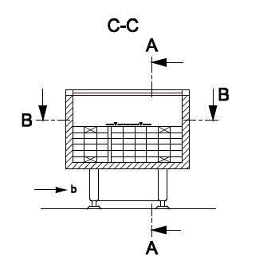

**7.1** The symbol for net volume(VN)should be added to the second column in Table 10 as the appropriate symbol for net volume.

**Annex B**. The symbol for net volume (Vn) conflicts with that used in Annex C for net volume (NV).

These should be consistent for correct interpretation of the standard. For consistency use the symbol (VN) from EN 16825 and add the symbol to the definition 3.6.6 and to the list in 4.

Annex B*Replace* the first sentence with the following:

The net volume (VN) shall be calculated as the sum of the individual volumes obtained within the load limits, excluding any basket(s).

**Annex C.** The symbol for net volume (NV) conflicts with that used in Annex B (Vn) for net volume.

These should be consistent for correct interpretation of the standard. For consistency use the symbol (VN) from EN 16825 and add the symbol to the definition 3.6.6 and to the list in 4.

Annex CReplace the equation C.1 and the following two lines with the following:



Where

Net volume (VN) defined as in Annex B

**EN 16902 Test requirements for Australia and New Zealand (Recommendation 10)**

**EN 16902:2016** *Commercial beverage coolers — Classification, requirements and test conditions* was not accepted as a suitable test method for energy efficiency of Refrigerated Beverage Coolers in Australia and New Zealand.

The standard was discussed at length by the TWG. A number of alterations and clarifications were reviewed and agreed upon, however the end result being that it was felt that this standard was not suitable for adoption or adaption because of fundamental differences in the method of simulating normal use of a display cabinet from the existing test methods and because it lacked any door opening tests. In addition, the majority of cabinets sold into the local market would require multiple tests because they were intended for use both as display cabinets and beverage cabinets. It was decided that beverage cabinets should be tested as refrigerated display cabinets to ISO 23953.

However, the following modifications to EN 16902 were discussed and noted and would have been required to enable the standard to be used as a reproducible test method:

**Clause**

**3.4.4** *Delete* Note 2 to entry

**3.4.5** *Replace* the existing clause

Active mode

State in which commercial beverage coolers fitted with an energy management device (EMD) are in the average temperature defined for the product class, also lighting and/or other energy-using systems are on.

**6.3.3.2** *Addition* of new clause

Filler cans

When tests are carried out, test packages in the form of cans having height 115 mm and diameter 66 mm shall be used. Cans shall be filled with 330 ml of a 33 % Propylene Glycol / 67 % water mixture (based on weight percentage), pasteurised water, carbonated water or carbonated beverage.

The tolerances for test packages shall be:

± 2 mm for linear dimensions 25 mm to 50 mm,

± 4 mm for linear dimensions 100 mm to 200 mm, and

Due to the frequency of use and to the loading pressure, the packages could change in dimensions and weight. Test packages shall be checked annually for conformity with the following lifetime tolerances.

When a test package is found to exceed one of the following tolerances, it shall be replaced:

a) Loss of mass: − 5 %.

b) On the wrapper: visible hole.

c) Change in linear dimensions:

± 4 mm for dimensions 25 mm and 50 mm; and,

± 8 mm for dimensions 100 mm and 200 mm.

**6.3.5.2.1** *Add* the words ‘filler cans’after ‘....double stack of’ in the first sentence.

**6.3.8** Figure 24*Delete* the first box in the flow chart.

*Delete* the second box in the flow chart.

*Replace* the boxes in Figure 24 with two tests (a) 24 h and (b) 12/12 h

*Replace* the title of Figure 24 to:

Figure 24 - Lighting and night-cover test procedure for beverage coolers without an Energy Management Device (EMD) fitted.

**6.3.11** *Rewrite* 6.3.11.1, 6.3.11.2, 6.3.11.3 and 6.3.11.4

**6.3.13** *Rewrite* 6.3.13.1, 6.3.13.2 and 6.3.13.3.

**EN 16838 Test requirements for Australia and New Zealand (Recommendation 11)**

**EN 16838:2016** *Refrigerated display scooping cabinets for gelato – Classification, requirements and test conditions* was discussed and accepted without any specific changes as a suitable test method for energy efficiency of refrigerated gelato scooping display freezers in Australia and New Zealand.

There were no specific comments about the addition of ice-cream scooping cabinets to the scope of the standard other than there may be other stakeholders needing to become involved in the efficiency requirements that have up until now been unaffected by GEMS/MEPS regulation.

It is therefore proposed that this standard will be suitable as a test method for ice-cream scooping cabinets.

1. AEC = Annual Energy Consumption of the cabinet in kWh/year. E24h = the energy consumption of the cabinet over 24 hours. SAEC = Standard Annual Energy Consumption of the cabinet in kWh/year. Y = volume of the small ice-cream freezer being the net volume expressed in litres, and for gelato scooping cabinets: Y = total display area, which is the sum of the display areas of all compartments of the cabinet, expressed in square meters (m2).
2. Note that for Light Duty cabinet an adjustment factor ‘*af* ‘is used to normalise the energy consumption with Climate Class 4 to match the other duty ratings. For chillers *af* = 1.1 and for freezers *af* = 1.2
3. Note that for Light Duty cabinet an adjustment factor ‘*af* ‘is used to normalise the energy consumption with Climate Class 4 to match the other duty ratings. For chillers *af* = 1.1 and for freezers *af* = 1.2
4. In terms of MEPS by Net Volume, for this particular cabinet, the maximum allowable yearly energy consumption SAEC/VN would be 1555.37/0.576 = 2700 kWh/year/m3. And maximum allowable daily energy consumption would be TEC/VN = 1555.37/(365 x 0.576) = 7.399 kWh/24/m3.
5. For registration purposes, an identical energy rating specification cabinet can be given an alternative trading brand and model number provided that the manufacturer supplies a declaration stating the products are identical in energy rating performance and identical to the model in test report number XYZ. This declaration must be on the product manufacturer’s letter head, dated and signed in PDF electronic format and uploaded on the product registration website page along with the test documentation.
6. Minimum energy performance requirements in terms of the ‘maximum allowable energy consumption’ of a model expressed as the total energy consumption (TEC) per 24 hours of total display area (TDA) (Units: kWh/24h/m2) or net volume (Units kWh/24h/m3). An energy efficiency factor of a particular model can be determined by comparing the actual total energy consumption per unit display area or unit volume with the maximum allowable energy consumption as specified by regulation.
7. The model with the largest vertical height of air curtain will have the most infiltration and therefore the most onerous condition for testing.
8. Sliding doors and swing/hinged doors are affected by airflow in a test room in different ways. Swing/hinged doors tend to direct airflow into the cabinet while sliding doors cannot open to the same extent. Therefore swing/hinged doors may result in more onerous test conditions. Likewise doors without magnetic seals may result in more infiltration and greater heat loss.
9. 9 Changes to the cosmetic appearance or aesthetics of a cabinet can result in unforeseen effects on airflow, cooling or total display area which may alter the efficiency characteristics of a cabinet. These need to be carefully evaluated before including such model variations in a family of models.
10. Air-Conditioning, Heating and Refrigeration Institute (US) – Performance Rating of Commercial Refrigerated Display Merchandisers and Storage cabinets.